Smart Delivery Robot AI
Code Explanation, Functions, Q&A, Libraries, and Improvement Points
Version: smart_delivery_robot_refactor_v4_2 | Created: 2026-05-26
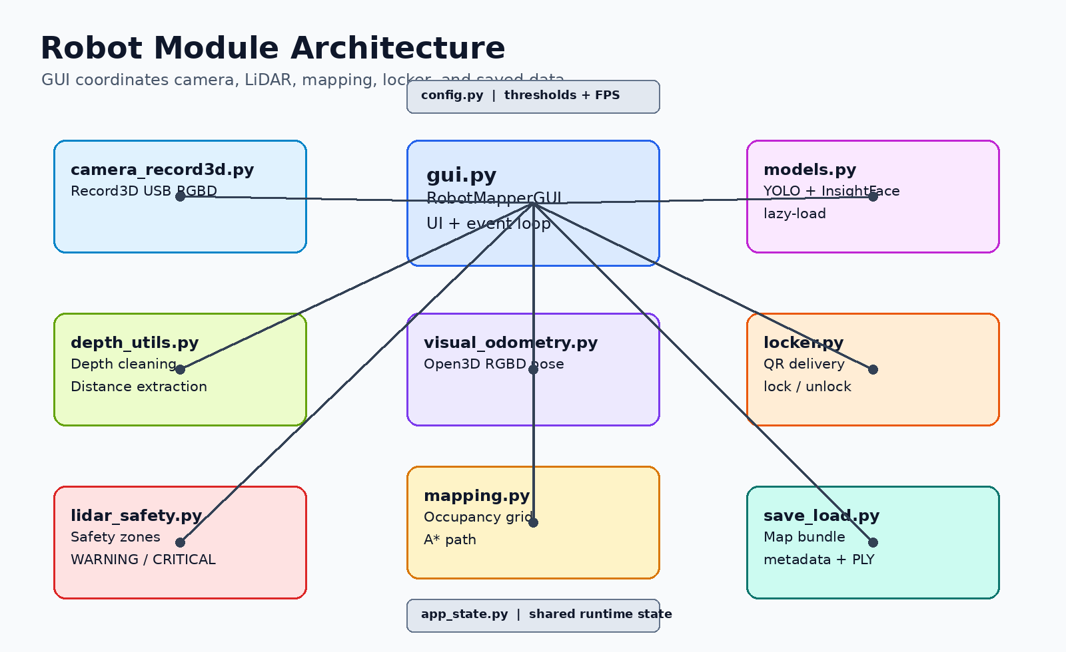
Figure 1. Modular architecture overview

1. Project overview 2
2. Runtime workflow diagrams 3
3. File-by-file explanation 5
3.1 main.py - Application entry point 5
3.2 config.py - Central configuration 5
3.3 app_state.py - Shared runtime state 6
3.4 camera_record3d.py - Record3D USB RGBD camera wrapper 8
3.5 models.py - Lazy AI model manager 9
3.6 depth_utils.py - Depth processing helpers 10
3.7 lidar_safety.py - Front safety zone logic 12
3.8 visual_odometry.py - Open3D RGBD visual odometry 13
3.9 mapping.py - Occupancy grid mapping and path planning 14
3.10 locker.py - Delivery locker and QR unlock system 16
3.11 gui.py - Main GUI controller and application loop 17
3.12 face_recognition_utils.py - Face embedding comparison and registration 18
3.13 drawing.py - OpenCV overlay drawing 20
3.14 dialogs.py - Tkinter modal dialogs 21
3.15 save_load.py - Save/load map sessions 22
3.16 pointcloud.py - PLY point cloud export 24
3.17 requirements.txt / run_windows.bat / README.md - Project support files 25
4. Library/dependency explanation 25
5. Questions that may be asked 26
6. Improvement roadmap 26
Appendix: Key code patterns 26
Start/Stop camera pattern 26
Frame dropping for realtime 27
QR payload generation and fallback QR image 27

1. Project overview
This project is a modular Python prototype for an indoor smart delivery robot. It uses an iPhone with Record3D as an RGBD/LiDAR-like sensor, OpenCV for image/depth processing, Open3D for visual odometry, a lightweight occupancy grid for mapping, and a Tkinter GUI for control.
The current design separates DRIVE mode and MAP mode. DRIVE mode prioritizes low latency and front safety. MAP mode enables heavier mapping and visual odometry actions only when the user starts them.
The delivery demo locks a simulated locker, generates a QR code, and unlocks the locker when the same QR payload is scanned by the robot camera.
Important limitation: this is not a complete autonomous delivery robot yet. It is a strong demo framework for sensing, safety, mapping, and locker workflow.

2. Runtime workflow diagrams
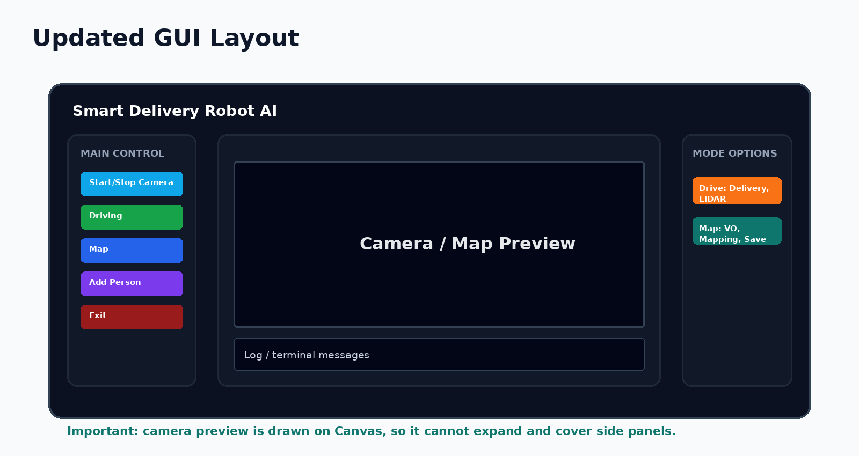
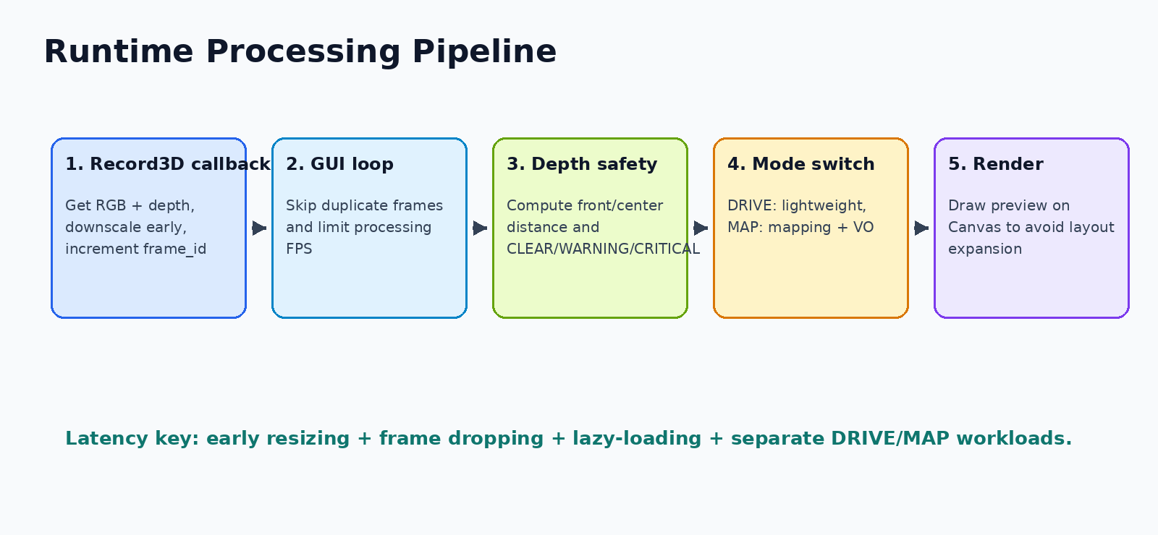
Figure 2. GUI layout

Figure 3. Processing pipeline

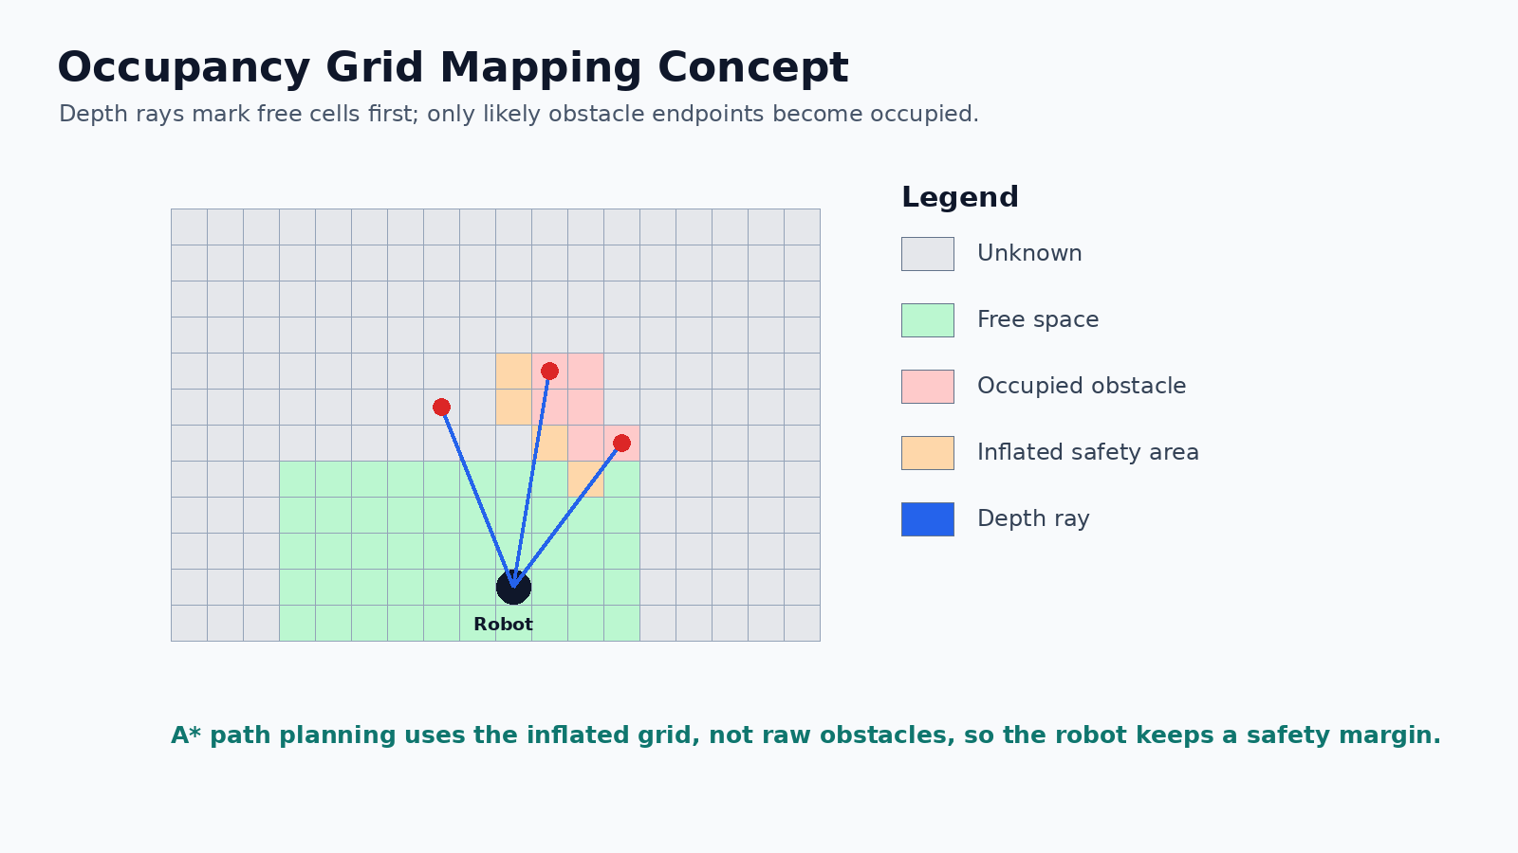
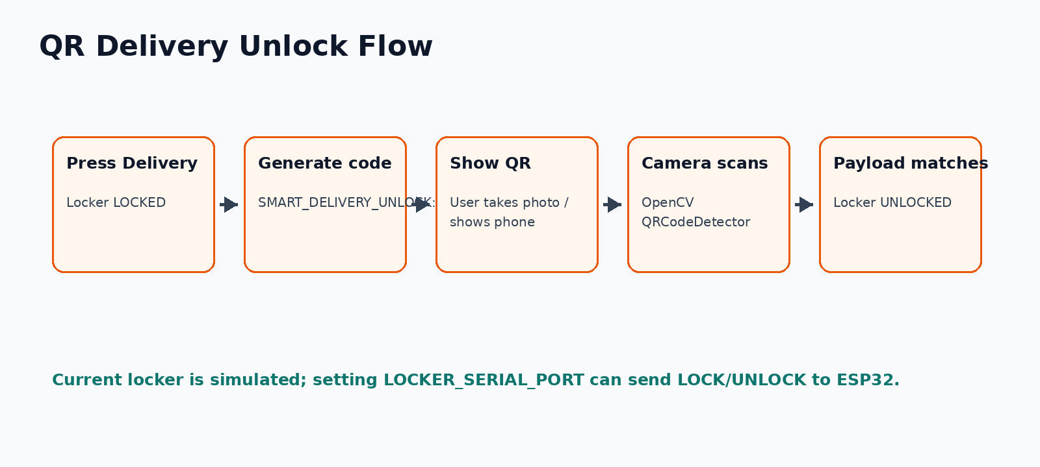
Figure 4. Occupancy grid mapping concept

Figure 5. QR delivery flow

3. File-by-file explanation

3.1 main.py - Application entry point
Starts the Tkinter application and keeps startup code separate from the real robot logic.

Main responsibilities
- Imports RobotMapperGUI from gui.py.
- Uses the main guard so the app starts only when main.py is executed directly.
- Keeps future CLI flags or startup checks in one place.

Important functions/classes
Function / Class | Purpose
RobotMapperGUI() | Creates the main window and starts the event loop through app.mainloop().

Code example
from gui import RobotMapperGUI
if __name__ == "__main__":
print("Starting modular GUI version...")
app = RobotMapperGUI()
app.mainloop()

Questions you may be asked
Question | Good answer
Why is main.py so small? | Because complex logic belongs in modules; main.py only launches the app.
Why use if __name__ == "__main__"? | It prevents accidental GUI startup when another file imports main.py.

Possible improvements
- Add command-line options such as --no-camera or --debug.
- Add startup dependency checks before opening the GUI.

3.2 config.py - Central configuration
Stores thresholds, FPS limits, GUI sizes, mapping constants, YOLO settings, and mode profiles.

Main responsibilities
- DRIVE_CONFIG disables heavy mapping/AI by default for lower latency.
- MAP_CONFIG enables slower mapping and VO operations.
- Distance thresholds are tuned for a small indoor demo robot.

Important functions/classes
Function / Class | Purpose
Constants only | No functions; this file is intentionally used as a single source of truth.

Code example
# Performance settings for two modes
DRIVE_CONFIG = {
"name": "DRIVE",
"yolo_every": 999999, # real-time first; enable manually in config if needed
"face_every": 999999,
"local_map_every": 999999,
"global_map_every": 999999,
"draw_map_every": 999999,
"depth_step": 64,
"yolo_imgsz": YOLO_IMG_SIZE_DRIVE,
"show_camera": True,
"show_local_map": False,
"show_global_map": False,
"show_depth": False,
"use_vo": False,
"vo_every": VO_EVERY_N_FRAMES_DRIVE,
}
MAP_CONFIG = {
"name": "MAP",
# Mapping mode disables heavy camera AI and focuses on depth + optional VO + map.
"yolo_every": 999999,
"face_every": 999999,
"local_map_every": 16,
"global_map_every": 32,
"draw_map_every": 32,

Questions you may be asked
Question | Good answer
Why not hard-code constants in each file? | Central config prevents hidden inconsistent values and makes tuning easier.
What should be changed to improve FPS? | Lower MAX_PROCESS_FRAME_W, lower DISPLAY_MAX_FPS, increase yolo_every/vo_every/map step.

Possible improvements
- Move values to YAML/JSON so non-programmers can tune the robot.
- Create separate config profiles for laptop demo, Jetson, and final robot.
- Add comments documenting how each threshold was measured.

3.3 app_state.py - Shared runtime state
Keeps mutable objects that must be seen by several modules, such as map arrays, UI toggles, safety history, and VO pose.

Main responsibilities
- Modules import it as import app_state as st so updates stay visible.
- Stores local/global occupancy arrays as NumPy arrays.
- Stores safety history and visual odometry state.

Important functions/classes
Function / Class | Purpose
No functions | The module behaves like a shared state container.

Code example
"""Shared mutable runtime state.
Modules import this file as `import app_state as st` so changes remain visible
across the whole app.
"""
from collections import deque
import numpy as np
from config import (
DRIVE_CONFIG, LOCAL_GRID_H, LOCAL_GRID_W, GLOBAL_GRID_H, GLOBAL_GRID_W,
SAFETY_HISTORY,
)
config = DRIVE_CONFIG.copy()
# Occupancy maps
local_occ = np.zeros((LOCAL_GRID_H, LOCAL_GRID_W), dtype=np.float32)
local_free = np.zeros((LOCAL_GRID_H, LOCAL_GRID_W), dtype=np.float32)
local_occ_hits = np.zeros((LOCAL_GRID_H, LOCAL_GRID_W), dtype=np.uint8)
global_occ = np.zeros((GLOBAL_GRID_H, GLOBAL_GRID_W), dtype=np.float32)
global_free = np.zeros((GLOBAL_GRID_H, GLOBAL_GRID_W), dtype=np.float32)
global_occ_hits = np.zeros((GLOBAL_GRID_H, GLOBAL_GRID_W), dtype=np.uint8)
global_pose_available = False
global_robot_pose = (0.0, 0.0, 0.0)
# Safety state
safety_history = deque(maxlen=SAFETY_HISTORY)
last_alert_state = "CLEAR"

Questions you may be asked
Question | Good answer
Why import app_state as st instead of from app_state import local_occ? | Importing the module keeps references consistent when state changes.
Is global state dangerous? | It is acceptable for a prototype, but a dataclass/app context would be cleaner for large projects.

Possible improvements
- Replace module-level globals with a dataclass RobotState.
- Add locks around data that can be written by different threads.
- Add reset_state() for testing.

3.4 camera_record3d.py - Record3D USB RGBD camera wrapper
Connects to the iPhone Record3D stream, receives RGB/depth frames, downscales them early, and exposes read_latest().

Main responsibilities
- Uses callback on_new_frame() from Record3DStream.
- Converts RGB to OpenCV BGR.
- Stores a frame_id so GUI can skip duplicate frames.
- Provides stop() to disconnect/clear cached frames.

Important functions/classes
Function / Class | Purpose
Record3DCamera.start() | Finds a Record3D USB device and connects.
on_new_frame() | Reads RGB/depth, resizes, optionally updates intrinsics/pose, then stores the latest frame.
read_latest() | Returns the most recent RGBD frame plus frame_id.
stop() | Attempts graceful stream stop across different SDK method names.

Code example
def on_new_frame(self):
rgb = self.stream.get_rgb_frame()
depth = self.stream.get_depth_frame()
if rgb is None or depth is None:
return
self.callback_count += 1
frame_bgr = cv2.cvtColor(rgb, cv2.COLOR_RGB2BGR)
frame_bgr, depth = self._resize_rgbd(frame_bgr, depth, CAMERA_STORE_MAX_W)
# Reading intrinsics/pose can be non-trivial. Reuse previous values between
reads.
intrinsics = self.intrinsics
if self.callback_count == 1 or self.callback_count %
INTRINSICS_READ_EVERY_N_FRAMES == 0:
try:
intrinsics = self.stream.get_intrinsic_mat()
except Exception:
intrinsics = self.intrinsics
pose = self.pose
if self.callback_count % POSE_READ_EVERY_N_FRAMES == 0:
pose = self.try_get_pose()
with self.lock:
self.rgb_frame = frame_bgr
self.depth_frame = depth
self.intrinsics = intrinsics
self.pose = pose
self.frame_id += 1
def on_stream_stopped(self):
print("Record3D stream stopped.")

Questions you may be asked
Question | Good answer
Why resize in the camera callback? | It reduces CPU and memory before the GUI, mapping, and QR code work starts.
Why use a lock? | The Record3D callback and Tkinter loop run on different timing paths and must not read/write frames simultaneously.

Possible improvements
- Add automatic reconnect if USB drops.
- Add camera health counters and user-friendly errors.
- Use a one-frame queue with overwrite to avoid backlog.

3.5 models.py - Lazy AI model manager
Loads YOLO, InsightFace, and face database only when they are actually needed.

Main responsibilities
- Prevents slow startup by not loading models immediately.
- Caches models in private module variables.
- Face database is loaded/saved with pickle.

Important functions/classes
Function / Class | Purpose
get_yolo_model() | Loads and returns YOLO only on first call.
get_face_app() | Loads InsightFace only on first call.
get_face_db() | Loads face_database.pkl if it exists.
save_face_db() | Writes the face DB back to disk.

Code example
"""Lazy model loading to keep GUI startup fast."""
import os
import pickle
from config import DB_FILE, YOLO_MODEL
_yolo_model = None
_face_app = None
_face_db = None
def get_yolo_model():
global _yolo_model
if _yolo_model is None:
print("Loading YOLO...")
from ultralytics import YOLO
_yolo_model = YOLO(YOLO_MODEL)
return _yolo_model
def get_face_app():
global _face_app
if _face_app is None:
print("Loading InsightFace...")
from insightface.app import FaceAnalysis
_face_app = FaceAnalysis(name="buffalo_l")
_face_app.prepare(ctx_id=0, det_size=(320, 320))
return _face_app
def get_face_db():
global _face_db
if _face_db is None:
if os.path.exists(DB_FILE):
with open(DB_FILE, "rb") as f:
_face_db = pickle.load(f)
else:
_face_db = {}
return _face_db

Questions you may be asked
Question | Good answer
Why lazy-load models? | YOLO and InsightFace are heavy; loading them only when needed makes GUI startup faster.
Why is YOLO disabled by default in DRIVE? | For realtime driving, LiDAR safety is more important than slow object detection.

Possible improvements
- Add GPU/CPU auto-detection.
- Allow model path selection from the GUI.
- Store face embeddings in SQLite instead of pickle.

3.6 depth_utils.py - Depth processing helpers
Cleans depth data, aligns RGB/depth size, extracts center and bounding-box distances, and checks depth quality.

Main responsibilities
- Rejects NaN/inf and values outside MIN_DEPTH_M/MAX_DEPTH_M.
- Uses median/percentile-like robust distance estimates instead of one pixel.
- Depth health prevents mapping when too few depth pixels are valid.

Important functions/classes
Function / Class | Purpose
valid_depth_values() | Filters valid depth samples.
resize_frame_and_depth() | Resizes RGB and depth consistently.
get_center_lidar_depth() | Median depth in a small center region.
get_lidar_distance_in_bbox() | Median depth inside object bounding box.
get_depth_health() | Returns valid ratio and median depth.

Code example
def get_lidar_distance_in_bbox(depth_resized, x1, y1, x2, y2):
if depth_resized is None:
return None
h, w = depth_resized.shape[:2]
x1 = max(0, min(w - 1, int(x1)))
x2 = max(0, min(w - 1, int(x2)))
y1 = max(0, min(h - 1, int(y1)))
y2 = max(0, min(h - 1, int(y2)))
if x2 <= x1 or y2 <= y1:
return None
box_w = x2 - x1
box_h = y2 - y1
cx1 = x1 + int(box_w * 0.28)
cx2 = x2 - int(box_w * 0.28)
cy1 = y1 + int(box_h * 0.25)
cy2 = y2 - int(box_h * 0.20)
if cx2 <= cx1 or cy2 <= cy1:
return None
roi = depth_resized[cy1:cy2, cx1:cx2]
valid = valid_depth_values(roi)
if valid.size < 20:
return None
return float(np.median(valid))
def get_distance_status(distance_m):
if distance_m is None:
return "UNKNOWN", (160, 160, 160)
if distance_m < DANGER_DISTANCE_M:
return "CRITICAL", (45, 45, 230)

Questions you may be asked
Question | Good answer
Why use median depth? | Median reduces noise from single bad depth pixels.
Why is depth resized with INTER_NEAREST? | Depth values are measurements; interpolation can create fake distances.

Possible improvements
- Add temporal smoothing for distance values.
- Calibrate depth scale against real measured distances.
- Mask floor better using camera angle or plane detection.

3.7 lidar_safety.py - Front safety zone logic
Calculates obstacle danger using left/center/right/low zones and draws compact safety overlays.

Main responsibilities
- Uses multiple zones to avoid relying on a single center pixel.
- Uses voting and short hold time to reduce flickering warnings.
- Can hide overlays during mapping for a clean preview.

Important functions/classes
Function / Class | Purpose
zone_distance() | Computes distance and near-object ratios inside a normalized zone.
get_front_safety() | Combines zone results into CLEAR/WARNING/CRITICAL.
apply_safety_hold() | Keeps warning briefly to avoid rapid flicker.
draw_front_zones() | Draws small, consistent zone rectangles.

Code example
import time
import cv2
import numpy as np
import app_state as st
from config import (
DANGER_DISTANCE_M, WARNING_DISTANCE_M, FRONT_PERCENTILE,
DANGER_RATIO_THRESHOLD, WARNING_RATIO_THRESHOLD, SAFETY_HOLD_SEC,
DRAW_LOW_LIDAR_ZONE,
)
from depth_utils import valid_depth_values
# Smaller and more even debug zones. They are only a visual guide; safety still uses
depth values.
SAFETY_ZONES = {
# LEFT / CENTER / RIGHT are equal-size visual boxes.
# LOW is kept for safety calculation but hidden by default to avoid a messy camera
view.
"LEFT": (0.20, 0.38, 0.40, 0.72),
"CENTER": (0.41, 0.59, 0.40, 0.72),
"RIGHT": (0.62, 0.80, 0.40, 0.72),
"LOW": (0.41, 0.59, 0.74, 0.92),
}
def toggle_lidar_zones():
st.show_lidar_zones = not st.show_lidar_zones
print(f"LiDAR zone display: {'ON' if st.show_lidar_zones else 'OFF'}")
def zone_distance(depth_frame, x1f, x2f, y1f, y2f):
if depth_frame is None:

Questions you may be asked
Question | Good answer
Why are there multiple zones? | A robot needs to know if danger is left, center, or right, not only the exact center.
What is the difference between WARNING and CRITICAL? | WARNING means close; CRITICAL means stop immediately or too close.

Possible improvements
- Tune zones based on final camera mounting position.
- Make thresholds speed-dependent.
- Send stop command to ESP32 when CRITICAL occurs.

3.8 visual_odometry.py - Open3D RGBD visual odometry
Estimates camera movement from consecutive RGBD frames when Record3D does not expose ARKit pose.

Main responsibilities
- Builds Open3D RGBDImage from BGR/depth frames.
- Uses an approximate intrinsic if camera intrinsics are missing.
- Rejects large VO jumps to avoid corrupting the map.

Important functions/classes
Function / Class | Purpose
make_rgbd_o3d() | Converts OpenCV images to Open3D RGBD format.
compute_rgbd_visual_odometry() | Computes transformation between two RGBD frames.
update_visual_odometry() | Updates global pose stored in app_state.
extract_pose_xytheta_from_matrix() | Converts 4x4 matrix to 2D pose.

Code example
def compute_rgbd_visual_odometry(prev_rgbd, curr_rgbd, intrinsic):
if prev_rgbd is None or curr_rgbd is None or intrinsic is None:
return False, np.identity(4)
option = o3d.pipelines.odometry.OdometryOption()
odo_init = np.identity(4, dtype=np.float64)
try:
success, trans, info = o3d.pipelines.odometry.compute_rgbd_odometry(
prev_rgbd,
curr_rgbd,
intrinsic,
odo_init,
o3d.pipelines.odometry.RGBDOdometryJacobianFromHybridTerm(),
option
)
except Exception as e:
print("VO error:", e)
return False, np.identity(4)
if not success:
return False, np.identity(4)
translation = np.linalg.norm(trans[:3, 3])
if translation > VO_MAX_TRANSLATION_M:
print(f"VO rejected jump: {translation:.3f}m")
return False, np.identity(4)
return True, trans
def update_visual_odometry(frame_bgr, depth_frame, intrinsics):
curr_rgbd = make_rgbd_o3d(frame_bgr, depth_frame)
intrinsic = make_intrinsic_o3d(320, 240, None)
if curr_rgbd is None:
st.vo_last_success = False
return None

Questions you may be asked
Question | Good answer
Is this true SLAM? | No. It is visual odometry plus occupancy mapping; it can drift and has no loop closure.
Why does mapping need pose? | A global map needs to know where the camera was when each depth ray was measured.

Possible improvements
- Use ARKit pose from Record3D if available.
- Use RTAB-Map/ORB-SLAM/ROS2 for stronger SLAM.
- Fuse IMU/wheel odometry to reduce drift.

3.9 mapping.py - Occupancy grid mapping and path planning
Maintains local/global map arrays, updates free/occupied cells from depth rays, inflates obstacles, and runs A* path planning.

Main responsibilities
- Depth rays mark free cells before obstacle endpoints.
- Obstacle endpoints require repeated hits to reduce noise.
- A* runs on inflated obstacles to keep safety margin.
- Global map requires pose/VO.

Important functions/classes
Function / Class | Purpose
update_map_from_depth() | Main depth-to-map update.
add_local_obstacle()/add_global_obstacle() | Confirm and add occupied cells.
update_*_free_ray_only() | Marks free space along measured rays.
get_map_layers() | Builds free, occupied, and inflated layers.
astar() | Finds a grid path from robot to goal.
draw_grid_map() | Visualizes map layers.

Code example
def update_map_from_depth(depth_resized, frame_w, frame_h, step, robot_pose=None,
update_global=False):
if depth_resized is None:
return
st.local_occ[:] *= OCC_DECAY
st.local_free[:] *= FREE_DECAY
if update_global:
st.global_occ[:] *= OCC_DECAY
st.global_free[:] *= FREE_DECAY
clear_area_around_robot(robot_pose if update_global else None)
y_start = int(frame_h * 0.20)
y_end = int(frame_h * 0.95)
obstacle_y_min = int(frame_h * OBSTACLE_MARK_Y_MIN)
obstacle_y_max = int(frame_h * OBSTACLE_MARK_Y_MAX)
floor_ignore_y = int(frame_h * FLOOR_IGNORE_Y_RATIO)
for y in range(y_start, y_end, step):
row = depth_resized[y]
for x in range(0, frame_w, step):
z = float(row[x])
if not np.isfinite(z) or z < MIN_DEPTH_M or z > MAX_DEPTH_M:
continue
normalized_x = (x - frame_w / 2.0) / (frame_w / 2.0)
lateral_m = normalized_x * z * LATERAL_SCALE
forward_m = z
update_local_free_ray_only(lateral_m, forward_m)
if update_global and robot_pose is not None:
update_global_free_ray_only(lateral_m, forward_m, robot_pose)
likely_floor = y >= floor_ignore_y
likely_obstacle_by_region = obstacle_y_min <= y <= obstacle_y_max
likely_obstacle_by_distance = z <= NEAR_OBSTACLE_MARK_M
should_mark_obstacle = (not likely_floor) and (likely_obstacle_by_region or
likely_obstacle_by_distance)
if not should_mark_obstacle:
continue
if z < WARNING_DISTANCE_M:

Questions you may be asked
Question | Good answer
Why does the map sometimes fail without VO? | Without pose, the app cannot know how the camera moved globally.
Why inflate obstacles? | The robot has physical size; inflation prevents paths that are too close to walls or objects.

Possible improvements
- Replace prototype mapping with ROS2 Nav2 costmap.
- Add real wheel odometry and IMU fusion.
- Add map save versioning and coordinate origin control.

3.10 locker.py - Delivery locker and QR unlock system
Simulates or controls locker locking, generates QR unlock payloads, displays QR, saves QR images, and decodes QR from camera frames.

Main responsibilities
- Locker is simulated by default for safety.
- If LOCKER_SERIAL_PORT is set, it can send LOCK/UNLOCK text commands to ESP32.
- QR payload includes a prefix and random code.
- OpenCV QRCodeDetector scans frames for matching payload.

Important functions/classes
Function / Class | Purpose
LockerController.lock()/unlock() | Changes locker state and optionally sends serial command.
make_delivery_code() | Creates random code.
make_delivery_payload() | Builds scan payload.
create_qr_image() | Creates QR using qrcode or OpenCV fallback.
decode_qr_from_frame() | Scans camera frame for QR text.

Code example
class LockerController:
def __init__(self):
self.locked = False
self.mode = "SIMULATED"
self._serial = None
if LOCKER_SERIAL_PORT:
try:
import serial
self._serial = serial.Serial(LOCKER_SERIAL_PORT, LOCKER_BAUD,
timeout=0.2)
self.mode = f"SERIAL:{LOCKER_SERIAL_PORT}"
except Exception as e:
self.mode = f"SIMULATED (serial error: {e})"
self._serial = None
def _send(self, command):
if self._serial is not None:
self._serial.write((command + "\n").encode("utf-8"))
def lock(self):
self.locked = True
self._send("LOCK")
def unlock(self):
self.locked = False
self._send("UNLOCK")
def close(self):
try:
if self._serial is not None:
self._serial.close()
except Exception:
pass
def make_delivery_code(length=8):
alphabet = string.ascii_uppercase + string.digits
return "".join(random.choice(alphabet) for _ in range(length))

Questions you may be asked
Question | Good answer
Is the locker really locked? | Currently it is simulated unless ESP32 serial is connected.
Why use a payload prefix? | It prevents random QR codes from accidentally unlocking the locker.

Possible improvements
- Use one-time tokens with expiration.
- Hash/sign payload instead of plain text.
- Add ESP32 acknowledgement so GUI knows the physical lock moved.

3.11 gui.py - Main GUI controller and application loop
Builds the two-column/three-panel GUI, manages camera start/stop, switches DRIVE/MAP options, runs processing loop, and coordinates all modules.

Main responsibilities
- Camera starts OFF and connects only after Start Camera.
- Right panel changes based on DRIVE or MAP mode.
- Stop Camera clears camera state, stops mapping/VO, and unlocks locker if delivery was active.
- process_one_frame() drops duplicate frames and limits FPS.
- Delivery mode locks locker, shows QR, and unlocks on matching scan.

Important functions/classes
Function / Class | Purpose
on_start_camera()/on_stop_camera() | Connects/disconnects Record3D safely.
set_mode_ui() | Rebuilds right-side mode options.
start_delivery()/complete_delivery_unlock() | QR delivery workflow.
process_one_frame() | Main camera/depth/safety/map/QR pipeline.
render_preview() | Draws resized preview on Canvas without layout expansion.

Code example
def on_stop_camera(self):
if self.camera_connecting:
messagebox.showinfo("Camera", "Camera is still connecting. Wait a moment,
then stop again if needed.", parent=self)
return
if self.camera is not None:
try:
self.camera.stop()
except Exception as e:
self.log(f"Camera stop warning: {e}")
if self.delivery_active:
self.delivery_active = False
self.delivery_code = None
self.delivery_payload = None
self.locker.unlock()
self.log("Camera stopped during delivery. Locker UNLOCKED for safety.")
self.camera = None
self.camera_started = False
self.last_camera_frame_id = -1
self.last_frame = None
self.last_depth = None
self.vo_enabled = False
self.mapping_enabled = False
self.mapping_status = "Mapping paused"
reset_visual_odometry()
self.start_camera_btn.configure(text="Start Camera", state="normal",
bg="#0EA5E9")
self.info_label.configure(text="Camera stopped")
self.status_text.set(f"Camera: OFF\nMode: {st.config.get('name')}")
self.render_placeholder("Camera is OFF\nClick Start Camera to connect Record3D
via USB")
self.set_mode_ui()
self.log("Camera stopped.")
def set_mode_ui(self):
mode = st.config.get("name", "DRIVE")
for child in self.mode_options_container.winfo_children():
child.destroy()
if mode == "DRIVE":

Questions you may be asked
Question | Good answer
Why use a right panel? | It keeps the left side clean and only shows relevant functions for the current mode.
Why use Canvas for preview? | Canvas has fixed layout behavior; Label with a large image can expand and cover other panels.

Possible improvements
- Move processing_one_frame into a RobotPipeline class for easier testing.
- Add a camera settings panel for FPS/resolution.
- Use a worker thread/process for heavy mapping/VO to keep Tkinter smoother.

3.12 face_recognition_utils.py - Face embedding comparison and registration
Compares InsightFace embeddings, recognizes stored people, and adds new face profiles through GUI.

Main responsibilities
- Uses cosine similarity on normalized embeddings.
- Supports older DB formats: ndarray, list, or dict.
- Adds multiple samples for the same name when possible.

Important functions/classes
Function / Class | Purpose
cosine_similarity() | Computes similarity between two vectors.
recognize_face() | Finds best matching stored embedding.
add_new_person_with_name() | Detects largest face and saves embedding.

Code example
def recognize_face(embedding):
face_db = get_face_db()
best_name = "Unknown"
best_score = -1.0
for name, data in face_db.items():
if isinstance(data, np.ndarray):
embeddings = [data]
elif isinstance(data, list):
embeddings = data
elif isinstance(data, dict) and "embedding" in data:
embeddings = [data["embedding"]]
elif isinstance(data, dict) and "embeddings" in data:
embeddings = data["embeddings"]
else:
continue
for saved_embedding in embeddings:
score = cosine_similarity(embedding, saved_embedding)
if score > best_score:
best_score = score
best_name = name
if best_score >= SIMILARITY_THRESHOLD:
return best_name, best_score
return "Unknown", best_score
def add_new_person_with_name(frame, name):
"""Register a face using a GUI-provided name."""
if frame is None:
return False, "No camera frame available."

Questions you may be asked
Question | Good answer
Why normalize embeddings? | Normalized vectors make cosine similarity stable and comparable.
Why threshold 0.45? | It is a practical demo threshold; it must be tested with real users and lighting.

Possible improvements
- Store 5-10 samples per person.
- Add consent/privacy handling.
- Add liveness check to avoid photo spoofing.

3.13 drawing.py - OpenCV overlay drawing
Contains reusable drawing helpers for panels, labels, dashboard text, and compact safety badge.

Main responsibilities
- Keeps visual overlay code out of gui.py.
- Uses small badges instead of huge warning panels.
- Makes overlay style easier to tune.

Important functions/classes
Function / Class | Purpose
draw_panel() | Draws translucent rectangles.
draw_simple_label() | Draws label boxes for detections.
draw_dashboard() | Top status line.
draw_safety_badge() | Small warning badge.

Code example
import cv2
def draw_panel(img, x1, y1, x2, y2, color, border_color=None, alpha=0.75):
overlay = img.copy()
cv2.rectangle(overlay, (x1, y1), (x2, y2), color, -1)
cv2.addWeighted(overlay, alpha, img, 1 - alpha, 0, img)
if border_color:
cv2.rectangle(img, (x1, y1), (x2, y2), border_color, 1)
def draw_simple_label(img, x, y, text, color):
# Smaller object label so the camera view does not become crowded.
y_top = max(0, y - 24)
x2 = min(img.shape[1] - 1, x + 260)
cv2.rectangle(img, (x, y_top), (x2, y), (20, 20, 20), -1)
cv2.rectangle(img, (x, y_top), (x2, y), color, 1)
cv2.putText(img, text, (x + 6, y - 7), cv2.FONT_HERSHEY_SIMPLEX, 0.40, (255, 255,
255), 1)
def draw_dashboard(frame, mode_name, humans, obstacles, path_found, center_depth,
safety_distance, safety_state, fps, pose_ok, pose_source):
"""Compact HUD.
The old one-line dashboard became too long and overlapped the camera preview.
This version uses a small two-line box in the top-left corner.
"""
h, w = frame.shape[:2]
panel_w = min(w - 12, 360)
panel_h = 42
x1, y1 = 8, 8
x2, y2 = x1 + panel_w, y1 + panel_h
if safety_state == "CRITICAL":
border = (0, 0, 255)
elif safety_state == "WARNING":
border = (0, 210, 255)
else:
border = (90, 120, 160)
draw_panel(frame, x1, y1, x2, y2, (15, 18, 24), border, 0.62)
center_text = "--" if center_depth is None else f"{center_depth:.2f}m"
front_text = "--" if safety_distance is None else f"{safety_distance:.2f}m"

Questions you may be asked
Question | Good answer
Why separate drawing helpers? | It reduces gui.py complexity and makes UI changes easier.
Why use small overlays? | Large overlays caused clutter and made the camera view hard to understand.

Possible improvements
- Add automatic font scaling based on preview size.
- Create a central UI color/theme dictionary.

3.14 dialogs.py - Tkinter modal dialogs
Provides small pop-up forms for saving maps and registering face profiles.

Main responsibilities
- SaveMapDialog collects operator name, project note, and autosave interval.
- AddPersonDialog collects a person name before face registration.
- Dialog validation prevents empty name and invalid autosave values.

Important functions/classes
Function / Class | Purpose
SaveMapDialog | Modal save form.
AddPersonDialog | Modal face-name form.

Code example
class SaveMapDialog(tk.Toplevel):
"""Modal form for saving map information."""
def __init__(self, parent):
super().__init__(parent)
self.title("Save Map Information")
self.configure(bg="#111827")
self.resizable(False, False)
self.result = None
self.transient(parent)
self.grab_set()
wrapper = tk.Frame(self, bg="#111827", padx=22, pady=20)
wrapper.pack(fill="both", expand=True)
tk.Label(wrapper, text="Save Mapping Session", bg="#111827", fg="#F9FAFB",
font=("Segoe UI", 16, "bold")).grid(row=0, column=0, columnspan=2,
sticky="w", pady=(0, 14))
self.name_var = tk.StringVar(value="Tuan")
self.note_var = tk.StringVar(value="Indoor mapping test")
self.autosave_var = tk.StringVar(value="0")
self._add_field(wrapper, 1, "User / Operator name", self.name_var)
self._add_field(wrapper, 2, "Project note", self.note_var)
self._add_field(wrapper, 3, "Autosave minutes (0 = off)", self.autosave_var)
btns = tk.Frame(wrapper, bg="#111827")
btns.grid(row=4, column=0, columnspan=2, sticky="e", pady=(18, 0))
tk.Button(btns, text="Cancel", command=self._cancel, bg="#374151", fg="#F9FAFB",
activebackground="#4B5563", relief="flat", padx=18, pady=8, font=("Segoe
UI", 10, "bold")).pack(side="left", padx=(0, 10))
tk.Button(btns, text="Save", command=self._ok, bg="#2563EB", fg="#FFFFFF",
activebackground="#1D4ED8", relief="flat", padx=22, pady=8, font=("Segoe
UI", 10, "bold")).pack(side="left")
self.bind("<Return>", lambda e: self._ok())
self.bind("<Escape>", lambda e: self._cancel())
self.wait_window(self)
def _add_field(self, parent, row, label, var):

Questions you may be asked
Question | Good answer
Why use dialogs instead of console input? | GUI apps should not depend on terminal input for user data.
Why modal dialogs? | They prevent the user from continuing before required information is entered.

Possible improvements
- Add Vietnamese/English language toggle.
- Use ttk widgets for native styling.
- Add recent operator/project presets.

3.15 save_load.py - Save/load map sessions
Saves map arrays, preview image, metadata JSON, and optional point cloud; loads saved map arrays later.

Main responsibilities
- Uses .npy for NumPy map arrays.
- Uses metadata.json to remember session information and pose source.
- Generates map preview PNG for quick inspection.

Important functions/classes
Function / Class | Purpose
save_map_bundle() | Writes local/global maps, metadata, preview, and PLY.
load_map_bundle() | Restores saved map arrays and metadata.
build_camera_map_preview() | Combines camera and map views for MAP mode.

Code example
def save_map_bundle(info, last_local_map, last_global_map, last_frame, last_depth,
last_intrinsics, pose_source, robot_pose):
ensure_save_root()
ts = datetime.now().strftime("%Y%m%d_%H%M%S")
folder_name = f"{ts}_{sanitize_name(info.get('user_name', 'operator'))}"
folder = os.path.join(SAVE_ROOT, folder_name)
os.makedirs(folder, exist_ok=True)
np.save(os.path.join(folder, "local_occ.npy"), st.local_occ)
np.save(os.path.join(folder, "local_free.npy"), st.local_free)
np.save(os.path.join(folder, "global_occ.npy"), st.global_occ)
np.save(os.path.join(folder, "global_free.npy"), st.global_free)
preview = build_map_preview(last_local_map, last_global_map)
cv2.imwrite(os.path.join(folder, "preview.png"), preview)
metadata = {
"timestamp": ts,
"user_name": info.get("user_name", ""),
"project_note": info.get("project_note", ""),
"autosave_minutes": info.get("autosave_minutes", 0),
"mode": st.config.get("name", "UNKNOWN"),
"pose_source": pose_source,
"robot_pose_xytheta": None if robot_pose is None else [float(robot_pose[0]),
float(robot_pose[1]), float(robot_pose[2])],
"vo_pose_ok": bool(st.vo_pose_ok),
"map_resolution": {
"local_m_per_cell": LOCAL_GRID_RESOLUTION_M,
"global_m_per_cell": GLOBAL_GRID_RESOLUTION_M,
},
"map_shape": {
"local": list(st.local_occ.shape),
"global": list(st.global_occ.shape),
},
"files": {
"local_occ": "local_occ.npy",
"local_free": "local_free.npy",
"global_occ": "global_occ.npy",
"global_free": "global_free.npy",
"preview": "preview.png",
"point_cloud": "pointcloud.ply",
}
}
with open(os.path.join(folder, "metadata.json"), "w", encoding="utf-8") as f:

Questions you may be asked
Question | Good answer
Why save .npy instead of images only? | Images are only visual; .npy preserves numeric occupancy values for future use.
Why include metadata? | It makes saved sessions traceable and easier to debug.

Possible improvements
- Save each session as a zip file.
- Add map format version to prevent incompatible loads.
- Add a thumbnail browser for saved maps.

3.16 pointcloud.py - PLY point cloud export
Converts RGBD frames into colored 3D points and saves an ASCII PLY file.

Main responsibilities
- Uses depth and camera intrinsics to back-project pixels into 3D points.
- Stores RGB color for each point.
- Stride reduces output size.

Important functions/classes
Function / Class | Purpose
save_point_cloud_ply() | Writes colored XYZRGB point cloud in PLY format.

Code example
def save_point_cloud_ply(filename, frame_bgr, depth_frame, intrinsics=None, stride=5):
if frame_bgr is None or depth_frame is None:
print("No RGBD frame to save.")
return
frame_h, frame_w = frame_bgr.shape[:2]
depth_resized = resize_depth_to_frame(depth_frame, frame_w, frame_h)
fx = frame_w * 0.9
fy = frame_w * 0.9
cx = frame_w / 2.0
cy = frame_h / 2.0
if intrinsics is not None and np.array(intrinsics).shape == (3, 3):
K = np.array(intrinsics, dtype=np.float32)
if float(K[0, 0]) > 1 and float(K[1, 1]) > 1:
fx = float(K[0, 0])
fy = float(K[1, 1])
cx = float(K[0, 2])
cy = float(K[1, 2])
points = []
for v in range(0, frame_h, stride):
for u in range(0, frame_w, stride):
z = float(depth_resized[v, u])
if not np.isfinite(z) or z <= MIN_DEPTH_M or z > MAX_DEPTH_M:
continue
x = (u - cx) * z / fx
y = (v - cy) * z / fy
b, g, r = frame_bgr[v, u]
points.append((x, -y, z, int(r), int(g), int(b)))
with open(filename, "w", encoding="utf-8") as f:
f.write("ply\n")
f.write("format ascii 1.0\n")
f.write(f"element vertex {len(points)}\n")
f.write("property float x\n")
f.write("property float y\n")
f.write("property float z\n")

Questions you may be asked
Question | Good answer
What is a point cloud? | A set of 3D points reconstructed from RGB and depth.
Why use stride? | Saving every pixel is slow and creates huge files.

Possible improvements
- Use binary PLY for smaller files.
- Add voxel downsampling and outlier removal.
- Export to .pcd for ROS/Open3D workflows.

3.17 requirements.txt / run_windows.bat / README.md - Project support files
requirements.txt lists Python dependencies, run_windows.bat starts the app on Windows, and README.md gives quick setup instructions.

Main responsibilities
- requirements.txt should be installed in the same Python environment used to run main.py.
- run_windows.bat is a convenience launcher.
- README.md is useful for future users or project demo setup.

Important functions/classes
Function / Class | Purpose
requirements.txt | Package list.
run_windows.bat | Windows launcher.
README.md | Human setup notes.

Code example
opencv-python
numpy
open3d
ultralytics
insightface
record3d
Pillow
qrcode
pyserial

Questions you may be asked
Question | Good answer
Why list dependencies? | It lets another machine recreate the environment.
Why should we use a virtual environment? | It avoids package conflicts with other Python projects.

Possible improvements
- Pin tested versions, for example opencv-python==x.y.z.
- Add a requirements-jetson.txt if Jetson needs different packages.
- Add screenshots to README.

4. Library/dependency explanation
Library | Import | Used for | Possible improvement
opencv-python | cv2 | Camera image processing, drawing overlays, QR detection, depth resizing. | Use opencv-contrib for extra algorithms; build with CUDA on Jetson if needed.
numpy | np | Fast arrays for depth frames, maps, and vector math. | Use consistent dtype and avoid unnecessary copies for speed.
open3d | o3d | RGBD visual odometry and point cloud workflows. | Consider RTAB-Map/ROS2 for stronger SLAM.
ultralytics | YOLO | Optional object/person detection. | Use YOLOv8n/YOLOv11n small models or TensorRT on Jetson.
insightface | FaceAnalysis | Face embedding extraction and recognition. | Add consent/liveness and store embeddings securely.
record3d | Record3DStream | USB RGBD stream from iPhone/Record3D. | Prefer ARKit pose if SDK exposes it; add reconnect handling.
Pillow | Image, ImageTk | Tkinter image display and QR window images. | Keep references to PhotoImage to avoid garbage collection.
qrcode | QRCode | Generates scannable QR images. | Use one-time, expiring, signed tokens for real security.
pyserial | serial | Optional ESP32 locker serial control. | Add ACK/timeout and robust command protocol.

For a stable final demo, pin tested versions in requirements.txt. Example: opencv-python==4.x.x.

5. Questions that may be asked
Question | Suggested answer
Is this true autonomous driving? | Not fully. It is a prototype demonstrating RGBD sensing, safety zones, mapping, and QR locker workflow. Full autonomy needs motor control, localization, navigation, and testing.
Why split DRIVE and MAP modes? | Because realtime driving and mapping have different CPU requirements. DRIVE is light; MAP is heavier and user-controlled.
Why is YOLO disabled by default? | YOLO is useful but expensive. For a small indoor robot, immediate depth safety is more important than slow object detection.
Why is mapping not perfect? | A single moving RGBD camera needs accurate pose. VO can drift and the prototype has no loop closure or wheel odometry yet.
How does QR unlock work? | The app generates a random code with a payload prefix, displays a QR, and unlocks only when the camera reads the exact payload.
Is the locker secure? | It is secure enough for a classroom demo, not for production. Real security needs signed tokens, expiration, and physical lock feedback.
What causes lag? | High resolution, model inference, VO, mapping updates, and rendering can all cost CPU. The code reduces lag by resizing early, dropping duplicate frames, and lazy-loading models.
How would you connect ESP32? | Set LOCKER_SERIAL_PORT and let LockerController send LOCK/UNLOCK; later extend the same idea for motor commands and acknowledgements.

6. Improvement roadmap
1. Short term: add Stop/Start stability testing, QR scan feedback overlay, FPS/resolution controls, and clearer camera error messages.
2. Hardware integration: connect ESP32 for locker servo/solenoid and motor control; require ACK messages from ESP32.
3. Mapping/navigation: add wheel encoders, IMU, or ARKit pose; move toward ROS2 Nav2 or RTAB-Map for real navigation.
4. Performance: use Jetson GPU, TensorRT model export, OpenCV CUDA build, and separate heavy processing from Tkinter.
5. Security: replace plain QR payload with signed one-time tokens and expiration time.
6. Testing: create unit tests for depth filtering, QR payload matching, map save/load, and locker serial command handling.

Appendix: Key code patterns

Start/Stop camera pattern
def on_start_camera_button(self):
if self.camera_started or self.camera_connecting:
self.on_stop_camera()
else:
self.on_start_camera()
def on_start_camera(self):
if self.camera_started or self.camera_connecting:
return
self.camera_connecting = True
self.start_camera_btn.configure(text="Connecting...", state="disabled",
bg="#64748B")
self.info_label.configure(text="Connecting to Record3D via USB...")
self.status_text.set("Camera: connecting...\nMode: " + st.config.get("name",
"DRIVE"))
self.log("Connecting to Record3D via USB...")
def worker():
try:
cam = Record3DCamera()
cam.start()
self.after(0, lambda: self._camera_connected(cam))
except Exception as e:
self.after(0, lambda: self._camera_failed(e))
threading.Thread(target=worker, daemon=True).start()
def _camera_connected(self, cam):
self.camera = cam
self.camera_started = True
self.camera_connecting = False
self.last_camera_frame_id = -1
self.start_camera_btn.configure(text="Stop Camera", state="normal",
bg="#DC2626")
self.info_label.configure(text="Camera connected. Waiting for RGBD frame...")
self.log("Connected to Record3D via USB.")
def _camera_failed(self, error):
self.camera_connecting = False
self.start_camera_btn.configure(text="Start Camera", state="normal",
bg="#0EA5E9")

Frame dropping for realtime
if frame_id == self.last_camera_frame_id:
return
self.last_camera_frame_id = frame_id
now = time.time()
if MAX_PROCESS_FPS > 0 and (now - self.last_process_ts) < (1.0 /
MAX_PROCESS_FPS):
# Drop frames instead of building UI/processing backlog.
return
self.last_process_ts = now
self.frame_count += 1
dt = now - self.last_time
if dt > 0:
self.fps = 0.85 * self.fps + 0.15 * (1.0 / dt)
self.last_time = now
frame, depth_frame = resize_frame_and_depth(frame_raw, depth_raw,
MAX_PROCESS_FRAME_W)
self.last_frame = frame.copy()
self.last_depth = depth_frame.copy()
self.last_intrinsics = intrinsics
frame_h, frame_w = frame.shape[:2]
depth_ok, depth_valid_ratio, depth_median = get_depth_health(depth_frame)

QR payload generation and fallback QR image
def create_qr_image(payload, box_size=10, border=4):
"""Return a PIL RGB image containing a real scannable QR payload.
Primary generator: python-qrcode.
Fallback generator: OpenCV QRCodeEncoder, so the QR still appears even if
the user forgot to run `pip install qrcode`.
"""
if qrcode is not None:
qr = qrcode.QRCode(
version=None,
error_correction=qrcode.constants.ERROR_CORRECT_M,
box_size=box_size,
border=border,
)
qr.add_data(payload)
qr.make(fit=True)
return qr.make_image(fill_color="black", back_color="white").convert("RGB")
# Robust fallback: use OpenCV's built-in QR encoder.
# This creates a real QR, not just text.
try:
encoder = cv2.QRCodeEncoder_create()
qr_arr = encoder.encode(payload)
if qr_arr is not None and qr_arr.size > 0:
qr_arr = cv2.resize(qr_arr, (420, 420), interpolation=cv2.INTER_NEAREST)
if len(qr_arr.shape) == 2:
rgb = cv2.cvtColor(qr_arr, cv2.COLOR_GRAY2RGB)
else:
rgb = cv2.cvtColor(qr_arr, cv2.COLOR_BGR2RGB)
return Image.fromarray(rgb)
except Exception:
pass
# Last resort: show clear instructions and the code.
# This screen is not scannable, but should almost never be used.
img = Image.new("RGB", (420, 420), "white")
arr = np.array(img)
cv2.putText(arr, "QR generator missing", (28, 165), cv2.FONT_HERSHEY_SIMPLEX, 0.75,
(0, 0, 0), 2)
cv2.putText(arr, "Run: pip install qrcode[pil]", (22, 215),
cv2.FONT_HERSHEY_SIMPLEX, 0.55, (0, 0, 0), 1)
cv2.putText(arr, payload[-8:], (102, 270), cv2.FONT_HERSHEY_SIMPLEX, 1.1, (0, 0, 0),
2)
return Image.fromarray(arr)

