

**Green University of Bangladesh**

**Department of Computer Science and Engineering (CSE)**

Faculty of Sciences and Engineering

Semester: (Summer, Year:2022), B.Sc. in CSE (Day)

**PROJECT REPORT**

Course Title: Physics ⅱ

**Course Code: PHY 103 Section: D6**

**Project Title: ‘Rain Indicator’**

Submitted by:

|  |  |  |
| --- | --- | --- |
| Sl. | Name | Id |
| 1. | Shawmin Azmi Etu | 221002352 |
| 2. | Tanjil Rahaman Opu | 221002069 |
| 3. | Hasebul Hasan | 221002104 |
| 4. | Md. Shohail | 221002528 |
| 5. | Mazaharul Islam | 221002538 |
| 6. | Suraiya Jahan | 221002282 |

Submitted to:

**AKM Shahabuddin**

Lecturer

Green University of Bangladesh

s

**TABLE OF CONTENTS**

1. Abstract…………………………………………………………………………
2. Description……………………………………………………………………..
3. Principle………………………………………………………………………..
4. Project Components……………………………………………………………
5. Circuit Diagram & Working Process………………………………………….
6. Discussion on structural application ………………………………………….
7. Advantages ……………………………………………………………………
8. Dis-advantages………………………………………………………………….
9. Picture of the project…………………………………………………………...
10. Conclusions…………………………………………………………………….
11. **Abstract:**

Rain Alarm Project is a simple but very useful project that detects Rain (Rain Water) and automatically triggers an alarm or buzzer. Water is a basic need in every one’s life. Saving water and proper usage of water is very important. Here is an easy project which will give the alarm when there is rain, so that we can make some actions for rain water harvesting and also save the rain water for using it later. With the help of saving this rain water through rain water harvesting, we can increase the levels of underground water by using underwater recharge technique.

This project will trigger the alarm when it rains so we can make some actions for rain water harvesting and also to save the rain water for using it later for agriculture in fields. It can also use in automobiles when the detector detects the rain it will automatically activates the windshield wipers of the vehicles. It can also be used in household for harvesting the rain water and increasing ground water storage instead of flowing it into drainage. So, the main purpose of this project is to prevent the material from rain, can be used in automobiles and in many other purposes. It is an easy and simple reliable circuit which can be constructed at a low cost.

1. **Description:**

Rain water detector will detect the rain and make an alert; rain water detector is used in the irrigation field, home automation, communication, automobiles etc. Here is the simple and reliable circuit of rain water detector which can be constructed at low cost. In this project, we have designed a simple Rain Alarm Circuit, which, upon detecting rain, will activate a buzzer. Based on the buzzer, So that we can take necessary actions.

1. **PRINCIPLE:**

If there is no rain, the resistance between the contacts will be very high as there will be no conduction between the wires in the sensor.

If there is rain, the water drops will fall on the rain sensor, which will form a conductive path between the wires and it also decreases the resistance between the contacts.

As a result, the wires on the sensor board will conduct and trigger the NE555 timer through the transistors circuitry. Once NE555 is triggered, it will make the output pin high and which will make the buzzer to make alarm.

1. **Project Components:**

1. Battery (9V),

2. Buzzer,

3. LED Light,

4. Resistor (300K),

5. Transistor (BC547B),

6. Wooden Board,

7. Paper Board,

8. Coper wire.

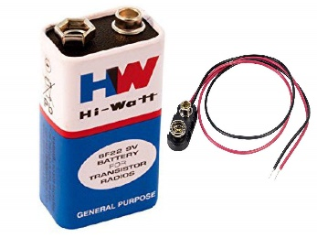

1. 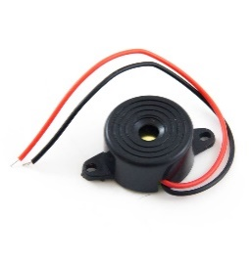**Battery:** Battery is a device that supplies electric power to an electrical load. The term is most commonly applied to electric power converters that convert one form of electrical energy to another, though it may also refer to devices that convert another form of energy (mechanical, chemical, solar) to electrical energy. A regulated power supply is one that controls the output voltage or current to a specific value; the controlled value is held nearly.
2. 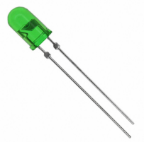**Buzzer:** Buzzer is an electrical device that makes a buzzing noise and is used for signaling.
3. **LED Light:** Small LED loght is also needed for this project.

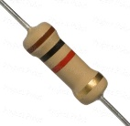

1. 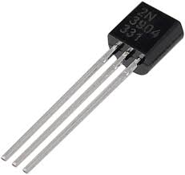**Resistor:** A resistor is a passive two-terminal electrical component that implements electrical resistance as a circuit element. In electronic circuits, resistors are used to reduce current flow, adjust signal levels, to divide voltages.
2. **Transistor:** A transistor is a semiconductor device used to amplify or switch electrical signals and power.
3. **CIRCUIT DIAGRAM & WORKING PROCESS:**

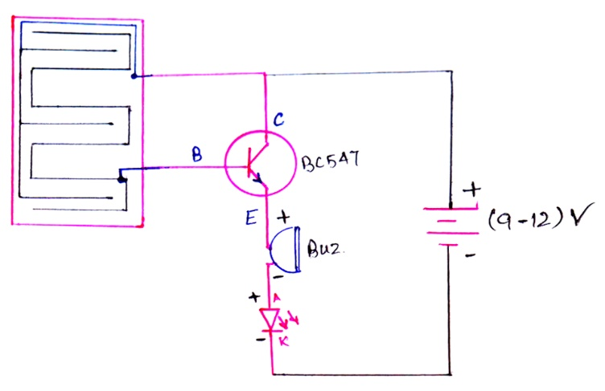 The rain sensor alarm circuit is shown below. This circuit can be designed with different components like rain sensor module, 9V supply, buzzer, variable resistor -300K, BC547B transistor, etc.

In the following circuit, the BC547B transistor is an essential component that works like a switch in this circuit. The rain sensor is very responsive to water drops or rainfalls. The circuit sensitivity can be adjusted through a variable [resistor](https://www.watelectronics.com/resistor-construction-working-applications/). Once the rain falls onto the sensor strips then the circuit will be activated because water is a great electricity conductor.

The voltage is supplied to the transistor, to turn ON the [transistor](https://www.watelectronics.com/junction-field-effect-transistor-working-characteristics-applications/) then it activates the buzzer which is connected to it. Here, the buzzer in this circuit works like an alarm to alert the user. For better performance, the sensor strip must be connected very close to the circuit. This sensor can be designed through different methods based on your choice & convenience.

1. **Discussion on structural application:**
2. In the irrigation, it will detect the rain and immediately alert the farmer.
3. In automobiles, when the rain detector detects the rain, it will immediately active the wiper sand in form the driver.
4. In communications, it will boost the power of the antenna and increase the signal strength to send or receive the signals.
5. In normal house hold, with the help of rain water detector we can automatically save the rainwater. (This can be done only when home automation is done and there is proper equipment to save the rain water. In this, rain water detector will detect the rain and helps to switch ON the equipment which will automatically save rain water for different purposes).
6. This can also be used if there is a chemical rain also. This is very common in industrial areas
7. **ADVANTAGES:**

* The rain sensor is used to save money by disabling the irrigation system once it rains. So that electricity consumption can be reduced.
* Simple operating principle
* It operates with less power
* The cost of an individual sensor is less
* Rain sensor-based systems installation is very simple
* The life of different systems based on rain sensors will be extended like irrigation systems, car wipers through running them simply once it is needed.

1. **DISADVANTAGES:**

* It does not talk about the speed of the rain which is fallen on the roof.
* It will send signal or the led will be glowing until the detector becomes wet.
* It something is over that then the detector will not work until it gets wet.
* There are so many problems that you will face when you will make this circuit

1. **Picture of the project:**

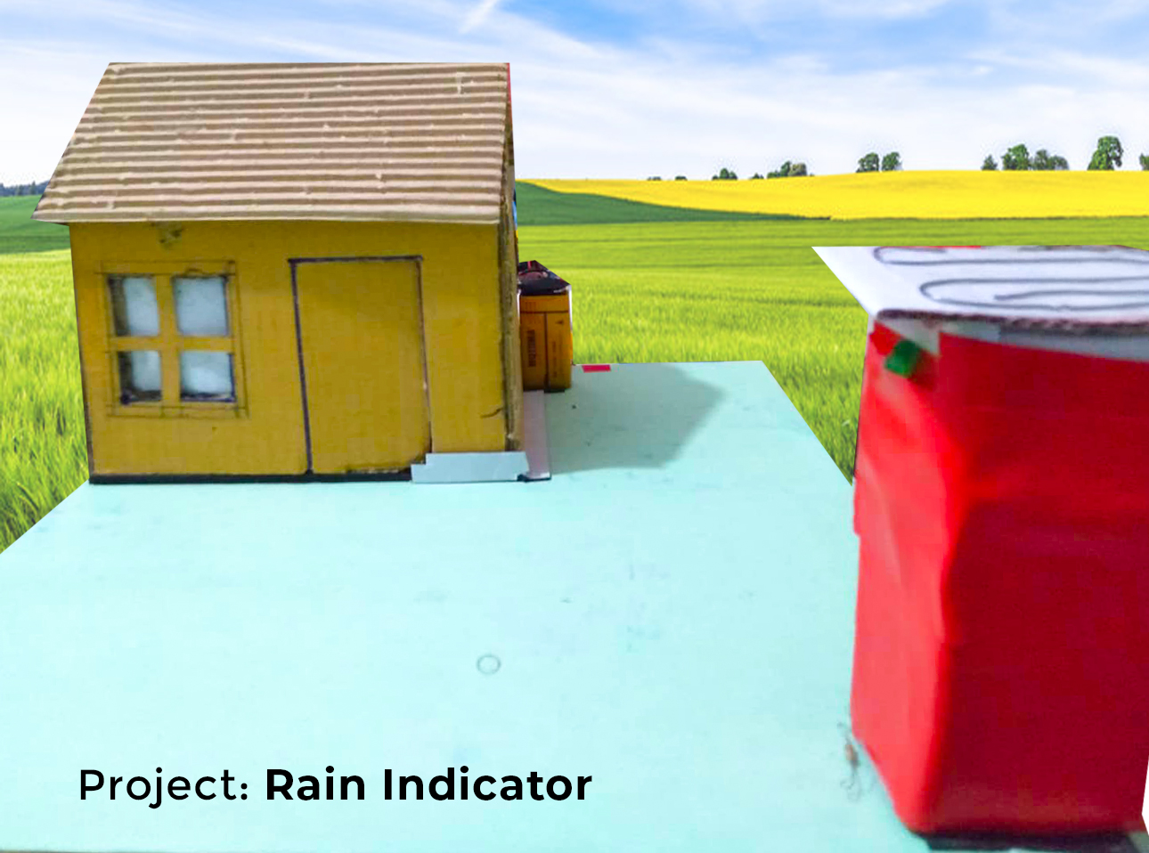

1. **CONCLUSIONS:**

It is cheap to make. This circuit help us to alarm from the rain. The circuit sets in the laboratories, scientific society centers etc. The water sensor is set on the roof and when the rain water fall on it, the LED start glowing and the buzzer start beeping. By designing this circuit, we can check the level of water.

Using more appropriate rain sensor we can make precise automatic rain sensing system.by adding microcontroller-based system we can implement some security features for farmer.