## Episode 0: Welcome (Tutorial)

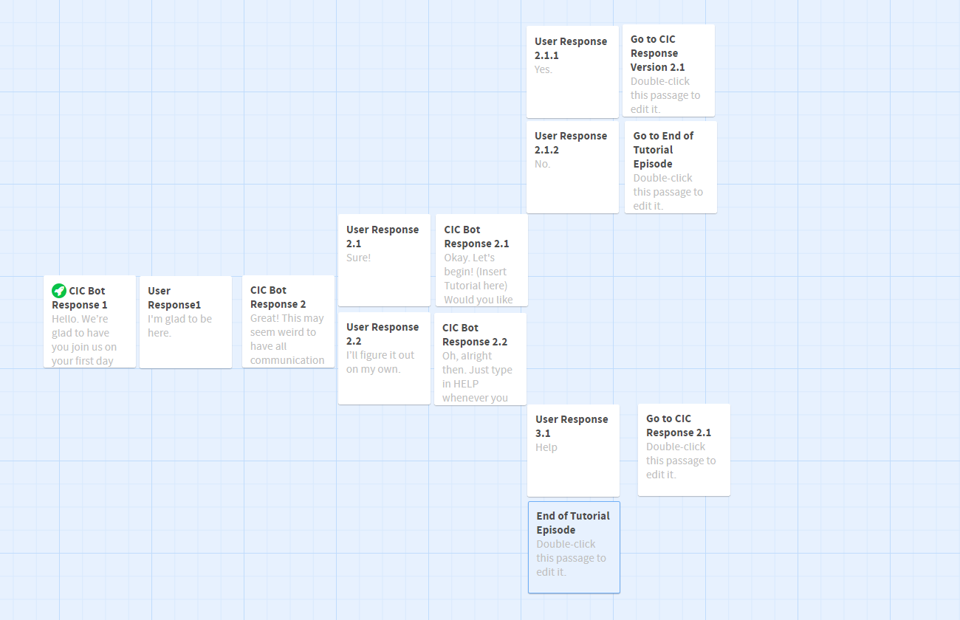

Notes

* Leader is always positive, but can come off as inconsiderate to employees.
* Pat is a normal person
* Episode number is displayed before each episode. Chatroom resets with necessary characters as if it is a new chat.
* **C**: Choice
  + **WH**: Workaholic Ending Point
  + **WR**: Well-Rounded Ending Point
* New character chatting will be notified by clicking the single button displayed in the chat box and representing text between asterisks.

Outline

* Episode 0
  + Protag is welcomed to CIC via chatroom by Leader. Leader encourages Protag to work up the ranks over time.
  + Leader explains that chatroom format is for convenience, to help foster good relations among workforce while facilitating increased productivity
  + **C-00**
    - **WH**: “I like it. I think this is efficient.”
    - **WR**: It seems a little impersonal, but I’ll get used to it.”
  + Leader says they look forward to seeing Protag at work.
* Episode 1
  + Protag remotely sends documents to Leader. They chat while documents are downloading/printing.
  + Leader asks how Protag’s experience has been at work so far.
  + **C-01**
    - **WH**: “Going well. Happy to contribute.”
    - **WR**: “Things move very fast. Very busy. Honestly, it’s hard to keep up sometimes.”
  + Leader encourages Protag to adapt quicker. The workload won’t let up any time soon.
  + **C-02**
    - **WH**: “I’ll do my best.”
    - **WR**: “I just hope we’ll get this done soon.”
  + Leader is happy to know Protag is doing well acclimating to the environment.
  + Leader says they just received the documents. There is an error on the document that needs to be corrected.
  + **C-03**
    - **WH**: “Right away!”
    - **WR**: “I’ll get it done after my lunch break.”
  + Leader tells Protag that he/she doesn’t care about when they get it done. He/she wants it now.
  + Leader tells Protag that he/she will be working with coworker Pat on another project.
  + Pat greets Protag. They exchange pleasantries.
* Episode 2
  + Pat and Protag talk together after a successful presentation. Pat thanks Protag for the help.
  + **C-04**
    - **WH:** “I’m happy to be of help. Don’t worry about it.”
    - **WR:** “It’s kind of weird that you just had a panic attack like that.”
  + Pat apologizes for the panic attack that happened during the meeting. Pat tells Protag that the Leader pulled Pat aside and extensively reprimanded Pat about it.
  + **C-05**
    - **WH:** “You should toughen up. That’s why he was so hard on you. You’ll do a better job next time.”
    - **WR:** “Hey, the stress can get to any of us. At least we got past it and you got the job done. Silver lining.”
  + Pat acknowledges the response and asks if Protag has time to go out and eat with the rest of the group members as a celebration.
  + **C-06**
    - **WH:** “Sure!”
    - **WR:** “Sorry, but there’s other work for Leader that I’ve got to catch up on.”
  + Pat acknowledges the answer and says, “See you next time.”
* Episode 3
  + Leader applauds Protag for completing work in a timely manner.
  + **C-07**
    - **WH:** “Of course. What’s the next project you need me to work on?”
    - **WR:** “Not gonna lie. This took longer than I thought, but I’m happy you think it’s well done.”
  + Leader notes that Pat’s efficiency has been waning. Leader hopes such behavior isn’t rubbing off on Protag.
  + **C-08**
    - **WH:** “Don’t worry. Pat’s still been working hard. Efficiency will improve eventually.”
    - **WR:** “Is Pat doing alright? Hasn’t been talking much lately.”
  + Leader assures Protag that steps are being taken considering Pat. So, Leader asks if Protag is interested in replacing Pat as a full-time employee.
  + **C-09**
    - **WH:** “I’m interested. If Pat has been lacking, I promise to pick up the slack.”
    - **WR:** “I’m honored for the offer, but is Pat really doing that badly?”
  + Leader doesn’t confirm whether Protag would replace Pat or what would become of Pat. Instead, Leader asks Protag to stay in the office late tonight.
  + **C-10**
    - **WH:** “You got it, boss.”
    - **WR:** “If it’s that important, sure.”
  + Leader thanks Protag for all their hard work.
* Episode 4
  + Protag has been at work for some time when Pat makes contact. Protag is confused and is told that he/she and Pat have been locked in their respective offices. Pat thinks Leader did this.
  + **C-11**
    - **WH:** “Nonsense. Leader wouldn’t do something so careless.”
    - **WR:** “What? Why would you think that?”
  + Pat emphasizes that Leader might be mad about their performances at work lately.
  + **C-12**
    - **WH:** “Maybe he’s mad at you, but I’ve been putting in the effort as much as I could. Why would he be mad at me?”
    - **WR:** “Come on. Leader’s a bit of a workaholic, but he wouldn’t mess with us like that
  + Pat suddenly asks if Protag is supposed to be Pat’s replacement. Pat’s getting hysterical, spamming messages.
  + **C-13**
    - **WH:** “Yes. He asked me because you obviously need time off.”
    - **WR:** “Yes, he asked me about that, but maybe we should focus more on getting our doors unlocked.”
  + Pat goes on a rant about never being good enough, for disappointing Leader and the company.
  + **C-14**
    - **WH:** “Calm down. Spamming me isn’t going to get anything done. You’re only proving Leader’s point by doing this”
    - **WR:** “Slow down. I’m sorry, Pat. Talk to me. What exactly is going on?”
  + Pat doesn’t respond.
* Episode 5
  + Protag has been in a locked room for a long time when Leader makes contact. Protag has been feeding on snacks and bottled water in his/her office. Leader asks if progress has been made on another project.
  + **C-15**
    - **WH:** “Yeah, I got that done since I had nothing better to do, but why am I still locked up?”
    - **WR:** “Of course I haven’t worked on it! Do you have the master key or a locksmith to get me out of here?”
  + Leader ignores the answer and says that he had such high hopes for Pat, but Protag may be able to surpass Pat.
  + **C-16**
    - **WH:** “I’m flattered, but what are you talking about?”
    - **WR:** “What about Pat? What did you do to Pat?”
  + Leader notes that everyone in the company is devoted to progress and efficiency, to completing their work. Pat was also a recent hire, but the pressure got to him/her. Protag, however, while imperfect, has done such a good job.
  + Leader offers Protag the power to be rid of both physical and emotional “defects” in him/herself. If the Protag is of the right state in mind, then a drug can be consumed to have Protag become a model employee, and never risk becoming as stressed and hysterical as Pat. Of course, Protag may lose his/her sense of self, but that’s a worthy cost of success.
  + **C-17**
    - **WH:** “What are the benefits of this drug?”
    - **WR:** “Screw that. Let me out of here. Now.”
  + Leader thanks the Protag for answering, but Leader says that Protag made the choice long ago. Gas is released in Protag’s office. Leader leaves a message for Protag in chat. When Protag wakes up, Protag’s first duty is to beat down the door to open it and go about fixing it, regardless of what injuries and fatigue may be affecting Protag.
* Epilogue
  + **Workaholic**
    - Protag is now Pat’s superior. Pat is still as nervous but not as stressed. Protag demands efficiency but isn’t as heartless as Leader. However, it’s mentioned that Leader died under mysterious circumstances. Rumors tell of Leader being part of some criminal conspiracy. Protag explains that Leader thought he held all the power.
  + **Well-Rounded**
    - When Protag wakes up and escapes office, he/she goes to police. The company is investigated. Leader and others are arrested. Pat and Protag have a conversation that recounts this information. At the end of the conversation, they agree to have another outing together.

## Final Script

### Episode 0: The Beginning

Peter: Hello, [insert name]. Welcome to the Collective Intelligence Company, or CIC for short. We are so excited to have you here with us.

Peter: As you already know, I’m your leader Mr. Pearson. And as you can see, we will be using this chatroom for much of our communication. It’s not only convenient but also helps us foster good relations among the workforce while facilitating increased productivity.

Option 1: “I like it. I think this is efficient.”

Option2: : “It seems a little impersonal...”

Peter: Well, I’m sure you’ll be a pro at this in no time. I look forward to seeing how well you work.

### Episode 1:

Option Null: *send documents*

Option Null: *send documents*

*The document’s download status is seen on the screen during the conversation.*

Peter: Ah, [insert name]. I was going to ask you about those documents. I’m glad that you are working efficiently. Say, how do you like the company so far?

Option 1: “Going well. Happy to contribute.”

Option 2: “It’s hard to keep up sometimes.”

Peter: It’s best that you adapt yourself to work quicker. The workload isn’t slowing down any time soon.

Option 1: “I’ll do my best!”

Option 2: “I just hope I can get it done soon.”

*The download is complete.*

Peter: I’m glad that you are at least acclimating to our environment.

Peter: Hm, I just received your documents and there’s an error in it. All the calculations are wrong because of it. Get this corrected, will you?

Option 1: “Right away!”

Option 2: “I’ll get it done after lunch.”

Peter: I want it done now. I don’t care if you have to skip lunch or stay late for it.

Peter: Anyways, I want to let you know that we have a big presentation for a project coming up and you will be working with Pat. You’ve heard of him?

Option 1: “No, I haven’t gotten a chance to meet with him because I’ve been too occupied with work.”

Option 2: “I’ve talked to him during lunch. He’s pretty cool. It’s weird that he’s the only one who was willing to talk with me though...”

Peter: Well, whatever your thoughts on him are, you’ll be working with him. He’s one of our new full times but he’s new like you.

*A new chat opens up between Player and Pat.*

Pat: Hi, [insert name]. It’s so nice to be working with you!

Option Null: “Yeah, let’s get started on the presentation.”

Option Null: “Likewise! So, what should we do first?”

### Episode 2:

Pat: [insert name], I can’t thank you enough. If it weren’t for you, we wouldn’t have such a successful presentation.

Option 1: “Your panic attack almost compromised it.”

Option 2: “I’m happy to be of help. Don’t worry about it.”

Pat: I’m really sorry about my panic attack. It just happens when I get very nervous and stressed out. Mr. Pearson actually pulled me aside afterwards and I got an earful from him.

Option 1: “You should toughen up, Pat. That’s why he’s always so hard on you. You need to do better next time.”

Option 2: “Hey, stress can get the best of us. At least it’s all over and the job is done. Silver lining.”

Pat: I promise I’ll be better at it.

Pat: Say, let’s go celebrate after work! My treat.

Option 1: “I have some work that I want to finish. So, no thanks.”

Option 2: “Sure!”

Pat: Well, see ya.

### Episode 3:

Peter: Hi, [insert name]. I just want to personally congratulate you for completing that project in such a timely manner.

Option 1: “Of course. What’s the next project on? Send it to me right away!”

Option 2: “I’m happy you think it’s well done. It did take longer than I thought...”

Peter: I’m glad I have an employee like you. You’re such a hard-worker despite being an intern! You’ve exceeded my expectations. Unlike that incompetent Pat. Always having nervous breakdowns, not dedicating himself fully to our company...

Peter: Pat’s efficiency has been waning. He is not performing as well as the company and I personally think is good enough. I hope this behavior doesn’t rub off on you.

Option 1: “I’m sure Pat is still a hard-worker. Efficiency will improve eventually.”

Option 2: “Is Pat okay? I haven’t heard much from him lately.”

Peter: Pat will be dealt with accordingly. But that being said, we may have to consider replacing him if he keeps this up.

Peter: So, would you like to replace Pat? It’s more responsibilities but I think you’re way better than Pat himself.

Option 1: “I’m interested. If Pat has been lacking, I promise to pick up the slack.”

Option 2: “I’m honored for the offer, but is Pat really doing that badly?”

Peter: Also, I almost forgot. I need you to stay in the office late. We have a major project coming up that needs to be done ASAP.

Option 1: “You got it, sir!”

Option 2: “If it’s that really important, sure.”

Peter: Thank you for your hard work. It’s good to have a hard-working employee like you. And don’t worry about sleep. We’ll be setting up a bed for you in your office space before 3pm today.

### Episode 4:

Pat: Dude. I think Mr. Pearson locked me in.

Option 1: “Nonsense… Our leader Mr. Pearson wouldn’t do such a thing.”

Option 2: “What? Why would you think that?”

Pat: I swear this is his plan. I can’t get out of my office. Why would he make me stay here?

Option 1: “Maybe he’s mad at you, but I’ve been putting in the effort as much as I could. Why would he be mad at me?”

Option 2: “Come on. Mr. Pearson’s a bit of a workaholic, but he wouldn’t mess with us like that.”

Pat: What in the world did I do wrong?

Pat: Wait, are you behind this?

Pat: You and Mr. Pearson have been talking to each other a lot lately? I’ve read your conversations whenever I pass by your computer.

Pat: Tell me that I didn’t actually see yours and Mr. Pearson’s exchange about replacing me.

*A long pause between the player and Pat happens. Pat realizes what they heard was true.*

Pat: [insert name]

Pat: ARE YOU SERIOUS?

Pat: answer me, [insert name]!

Pat: HEY!

Pat: [insert name]!

Pat: asdopabpaewagalsdkjnbfjoiij

Pat: You can’t do this to me!

Pat: Tell me this isn’t true. You actually replaced me?

Option 1: “Yes. He asked me because you obviously need time off.”

Option2: “Yes, he asked me about that, but maybe we should focus more on getting our doors unlocked. I found out he locked me in too.”

Pat: Gosh, am I ever good enough for this company?

Pat: This is what it comes down to?

Pat: What have I done wrong, [insert name]?

*Pat’s text becomes disoriented. Something is wrong.*

Pat: I did my damn har har hard ess t.

Pat: I dd ev erything he a sked me, an yet ths happpens … wh a why…

Option 1: “Calm down. Spamming me isn’t going to get anything done. You’re only proving Mr. Pearson’s point by doing this”

Option 2: “Slow down. I’m sorry, Pat. Talk to me. What exactly is going on?”

*Suddenly Pat stops responding.*

Option Null: “Pat? Where are you?”’

Option Null: “Pat? Are you still there?”’

### Episode 5:

Peter: Hello, [insert name]. How is the progress on that project I sent to you last Friday?

Option 1: “Yeah, I got that done since I had nothing better to do, but why am I still locked up?”

Option 2: Of course I haven’t worked on it! Do you have the master key or a locksmith to get me out of here?”

Peter: I’m sure there was enough food and water to sustain you for the past two weeks. You know, I had such high hopes for Pat. I really thought Pat would be my number one worker. But you’ve proven to me that I should have been looking at you, [insert name].

Option 1: “I’m flattered, but what are you talking about?”

Option 2: “What about Pat? What did you do to Pat?”

Peter: [insert name], you know that CIC is dedicated to progress and efficiency when it comes to completing the necessary work. We don’t just want the best; we want perfection. You, unfortunately, are not as perfect as we expected, but you’ve proven to yourself that you strive for it. I just want to tell you that you can achieve perfection.

Option Null: “What is it?”’

Option Null: “What is it?”’

Peter: You know all those physical and emotional “defects” everyone has? Whether they get sleepy after staying up longer than usual or cry after receiving too much pressure? Well, we found a way to get rid of that with this drug we made called Talos. Take it, and you’ll become the model employee everyone should become. Never become someone as incapable as Pat. You may lose our sense of self but it’s a reasonable cost for success.

Option 1: “That sounds fantastic. Am I really worthy to receive this?”

Option 2: “Screw that. I demand you let me go. NOW.”

Peter: You’ve made your choice long ago. Just know that it’s easier to consume it if you’re in the right state of mind. I’ll see you once the drug takes into effect.

Option Null: “Wait, why is there smoke coming out of the ventilators?”’

Option Null: “Wait, why is there smoke coming out of the ventilators?”’

*Time passes as the gas knocks the player to sleep, leaving a period of silence. The player awakens after being knocked out by the gas and finds a message left on the message board.*

Peter: Good morning, [insert name]. I hope you have now become the perfect employee. We’re counting on you to do the right thing. All you gotta do is open the door.

Option 1: “Yes, sir.”

Option 2: “Oh, I will open that door.”

### Ending A: Workaholic

Pat: Hey, boss. I’m sorry about what happened in the last meeting.

Player: Pat, your nerves almost got the best out of you in the last meeting.

Pat: I know. I know. I promise I’ll do better. Thanks to your talks on efficiency, I think I’m becoming a better worker!

Player: I hope so.

Pat: Boss, can I ask you something?

Pat: What ever happened to Mr. Pearson?

Player: What about Peter?

Pat: You don’t have to be so callous about it. After all, Peter was our boss.

Player: Was. He thought he held all the power. But he was wrong.

Pat: But isn’t it weird that we never heard from him right before the company said you were promoted? And when we did, it was from the news saying that he was found in the river nearby the office? I heard from the other workers that there’s something fishy about it. Like some sort of conspiracy.

Player: Pat, spreading rumors is a waste of time. Get back to work.

Pat: Right, of course. I do have to say, I kinda like you better than Mr. Pearson. You’re nicer.

Player: Only because I know how to use it. Get me that report ASAP.

### Ending B:

Pat: Woah, you’re still on here?

Player: Yeah. I’m surprised this thing is still open. I wouldn’t rely on it as a way for us to maintain communication though.

Pat: Especially with what happened.

Player: I’m glad that you got out alive.

Pat: Same here! Did you hear the results of the court hearing? Peter and the higher-ups of CIC are sentenced to life!

Player: Pat, I was there with you. LOL.

Pat: Right, I forgot about that. I’m sorry.

Player: Hey, no need to apologize. Being with CIC really affected all of us. Let’s at least be grateful that justice was served.

Pat: Hey, [insert name] can I ask you something? How did you escape the office? When you came to get me, you looked like you went through a lot… What did they do to you?

Player: Oh, don’t worry about it. Just a few bruises. Let’s plan an outing. My treat. Does Brad’s Cafe sound good?

Pat: Yeah! See you there tomorrow at 2?

Player: Definitely.