Ryzen 5800X vs Apple M1: Programming-focused benchmarks

tuhdo

Table of Contents
1. Test System
2. Java Renaissance (Less is better)
3. Java SciMark 2.0 (Higher is better)
4. Java DaCapo (Less is better)
5. Python PyPerformance (Less is better)
6. Go (golang.org/x/benchmarks - Less is better)
7. Redis
8. JavaScript Web Tooling Benchmark (v8) (Higher is better)
9. JavaScript Octane 2.0 (Higher is better)
10. Conclusion
Apple is making all the rage with the recent M1 SoC released on Mac Mini, MacBook Air and MacBook Pro. Benchmarks were done and amont them, this article attracted my attention as it is focused on programming. It performed various micro-benchmarks on various popular programming languages (no C/C++/Rust though, sadly but that's fine nevertheles). The data depicted that older x86 CPUs were no match for M1 and it is correct. However, there is one major flaw: the author did not perform benchmarks on Ryzen 5000 series CPUs, yet concluded that x86 CPU is no match for M1. I was curious whether it's true and decided to run the same sets of benchmarks on my newly AMD Ryzen 5800X.
All the test data are here.

Test System
- CPU: Ryzen 5800X (8 cores 16 threads) tuned (Curve Optimizer set to -25)
- RAM: 64 GB DDR4 overclocked to 3733 MHz, stress testing 24 hours stable
- OS: ClearLinux stock, scaling_available_governors set to performance.
Curve Optimizer is a new way to undervolt Ryzen 5000 CPUs. Settings to -25, the CPUs can dynamically undervolt from 75 mV - 125 mV depends on current CPU loads. Because voltage is lower, temperature is lowered and max boost can sustain longer.

Java Renaissance (Less is better)
Ryzen 5800x is faster than M1 in most tasks by a large margin.
file:static/5800xm1charts/Java Renaissance Benchmarks.png

Java SciMark 2.0 (Higher is better)
In the SOR benchmark, the 5800X is more than twice as fast. For others, the 5800X is slightly faster, with the exception of Monte Carlo Integraton scored 2.7% lower than M1.
file:static/5800xm1charts/Java SciMark 2.0 Benchmarks (NIST).png

Java DaCapo (Less is better)
5800X is mostly faster by a significant margin, except for the H2O benchmark which is more than twice slower.
file:static/5800xm1charts/Java DaCapo Benchmarks (309e1fa).png

Python PyPerformance (Less is better)
In this benchmark, the following benchmarks are ommited as I could not run successfully:
- sqlalchemydeclarative
- sqlalchemyimperative
- sqlitesynth
Overall, the execution time is roughly the same, with the 5800X slightly faster. Probably a faster Python implementation like PyPy can highlight the differences better.
file:static/5800xm1charts/PyPerformance Benchmarks.png
file:static/5800xm1charts/PyPerformance Benchmarks (Total Seconds Elapsed).png

Go (golang.org/x/benchmarks - Less is better)
The 5800X performs significantly better in all benchmarks, around 30% faster in most benchmarks and some are twice as fast.
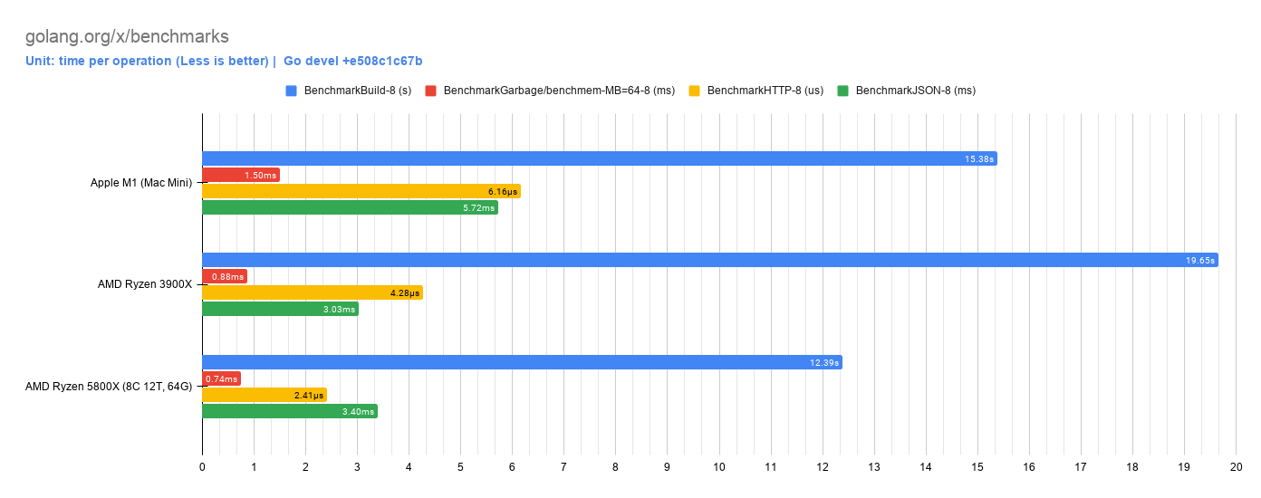

Redis
The 5800X performs significantly better in all benchmarks:
file:static/5800xm1charts/Redis v6.0.9 Benchmark (1,000,000 Requests).png

JavaScript Web Tooling Benchmark (v8) (Higher is better)
The 5800X is significatnly faster in most benchmarks:
file:static/5800xm1charts/JavaScript Web Tooling Benchmark (v8).png

JavaScript Octane 2.0 (Higher is better)
Same story as above:
file:static/5800xm1charts/JavaScript Octane 2.0.png
file:static/5800xm1charts/JavaScript Octane 2.0 Overall.png

Conclusion
While M1 is indeed very powerful for its size, when comparing it to the high-end x86 desktop, it is still slower. To conclude that it performs better than the existing x86 CPUs, is a mistake. Zen 3 CPUs are manufactured on 7nm TSMC process with 12nm IO Dies from Global Foundry, so power consumption certainly does take a hit, but is acceptable on a desktop platform where the upper limit could be as high as 300W.
The future Ryzen CPU still got more room to grow with the future 5nm, 3nm and 2nm from TSMC along with CPU architectural changes. For that reason, x86 is still a formidable opponent for non-x86 ISAs in a forseeable future.

