Artificial Intelligence Final Project Report
Build a Solution for Sustainable Development Goal (SDG)

1. Project Title
EduMentor AI
AI-Powered Personalized Learning Platform for Quality Education

2. Student Details
- Name: Tuhin Ghorui
- Course: BCA
- Semester: Second Year
- Subject: Artificial Intelligence Final Project
- Project Type: Web Development + AI Prototype

3. Selected SDG and Reason for Selection
Selected SDG:
SDG 4 – Quality Education
What SDG 4 Focuses On:
SDG 4 aims to ensure inclusive and equitable quality education and promote lifelong learning opportunities for all. It focuses on making education accessible, affordable, and effective for students across the world.
Why This Issue is Important:
Education is the foundation of personal growth, employment, innovation, and national development. However, millions of students still lack access to personalized guidance, tutors, and modern learning tools. Many students struggle due to limited support outside classrooms.
Therefore, improving education using Artificial Intelligence can help students learn smarter and faster.

4. Problem Statement
Many students face difficulties in learning because they do not receive enough personalized academic support.
What is the Problem?
Students often struggle with:
- No personal tutor available after class
- Difficulty understanding subjects like coding, mathematics, science
- Lack of proper study planning
- No instant doubt-solving support
- No career guidance
Where Does This Problem Exist?
This problem exists in:
- Rural areas
- Small towns
- Government schools
- Colleges with limited faculty support
- Homes where private tutoring is expensive
Who is Affected?
- School students
- College students
- Competitive exam aspirants
- Beginners learning technical skills
Why is it Serious?
Without proper support:
- Students lose confidence
- Academic performance decreases
- Dropout chances increase
- Career opportunities reduce
If Not Solved:
The education gap between privileged and underprivileged students will continue increasing.

5. Project Objective
The objective of EduMentor AI is to create an AI-powered education platform that provides personalized learning assistance anytime, anywhere.
Main goals:
- Improve access to quality education
- Help students solve doubts instantly
- Offer personalized study support
- Increase learning efficiency
- Make education smarter using AI

6. Proposed Solution
What is EduMentor AI?
EduMentor AI is a smart educational web application designed to assist students with AI-powered learning tools.
It acts as a virtual tutor that is available 24/7.
How the System Works
- User opens website
- User enters question in chatbot
- AI analyzes the query
- Smart educational response is shown
- Student continues learning interactively
How It Solves the Problem
- Instant doubt solving
- Personalized responses
- Anytime learning support
- Better study motivation
- Structured dashboard progress
Who Will Use It?
- School students
- College students
- Self learners
- Coding beginners
- Exam preparation students

7. Project Features
1. Modern Homepage
Professional landing page introducing the platform with call-to-action buttons.
2. AI Chat Tutor
Students can ask questions related to coding, math, exams, etc. and receive instant responses.
3. Personalized Learning Paths
Guided learning according to student goals and knowledge level.
4. Quiz Generator
AI can generate quizzes to test learning progress.
5. Study Planner
Helps students organize study schedules effectively.
6. Career Guidance
Suggests future career paths in technology and education.
7. 24/7 Learning Support
Students can learn anytime without depending on tutor timings.
8. Dashboard Analytics
Shows:
- Progress %
- Weekly Goals
- Skills Improving
- Completed Quizzes
9. Testimonials Section
Displays student feedback for trust and motivation.
10. Contact Section
Allows users to send inquiries or feedback.

8. Technology Stack
Frontend:
- HTML5
- CSS3
- JavaScript
UI Design:
- Responsive Layout
- Modern Cards
- Animations
- Dark Mode Toggle
AI Logic Prototype:
- JavaScript simulated chatbot responses
Development Tools:
- VS Code
- GitHub Copilot
Version Control:
- GitHub

9. Project Screenshots (Proof of Work)
Screenshot 1: Homepage Hero Section
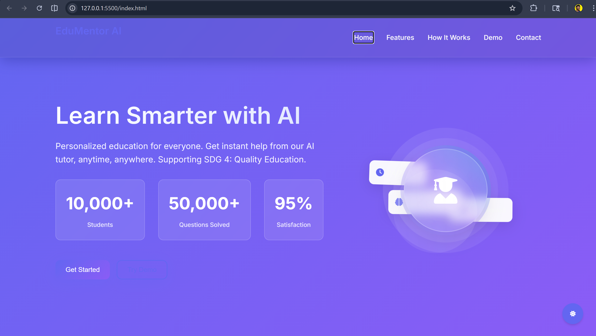
Screenshot 2: Features Section
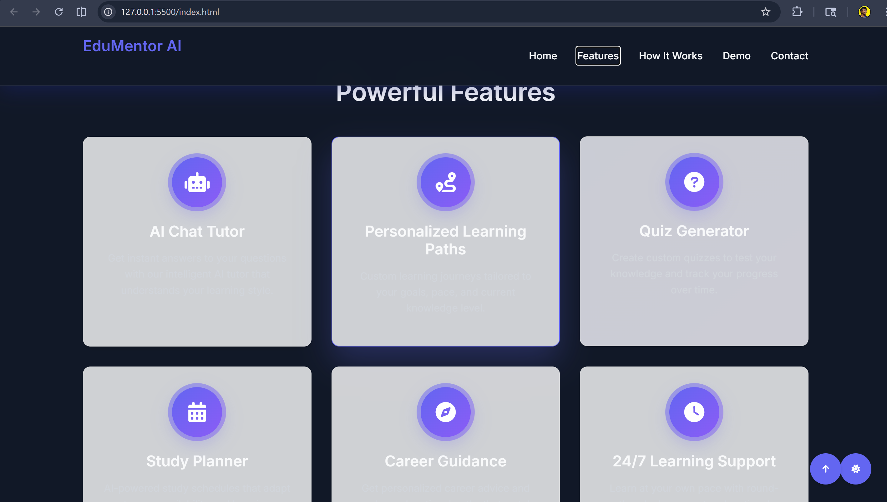

Screenshot 3: How It Works Section
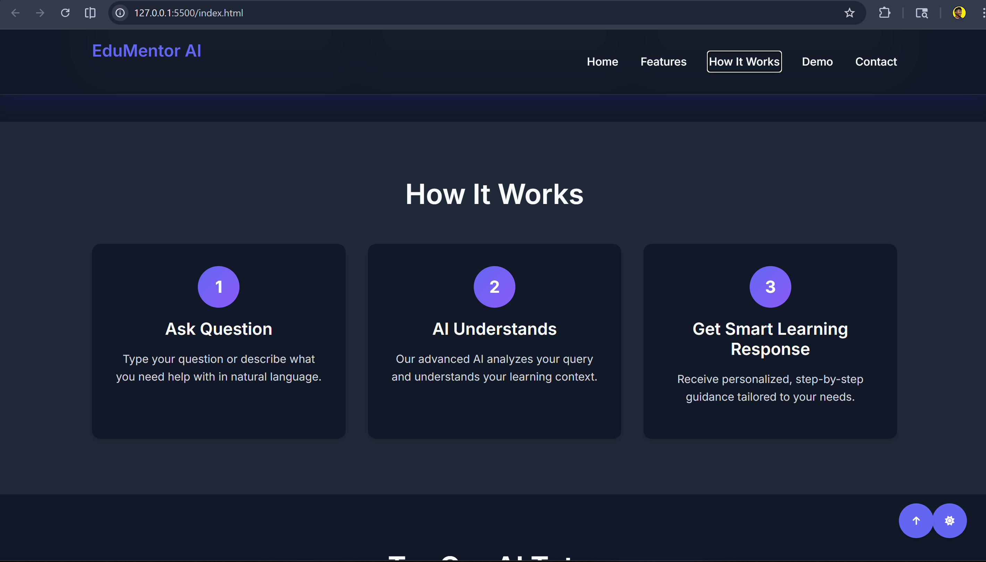Screenshot 4: AI Chat Tutor
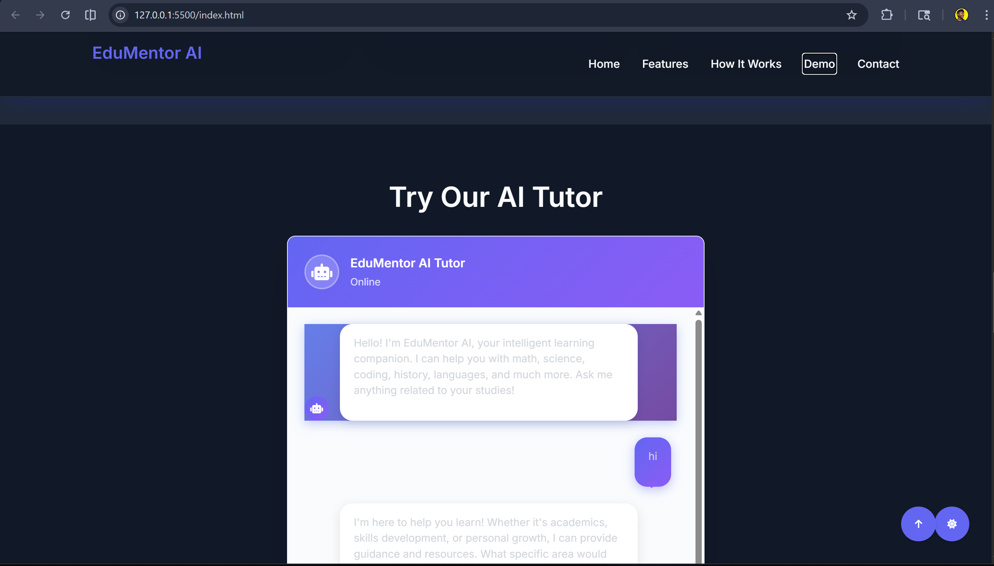

Screenshot 5: Dashboard Section
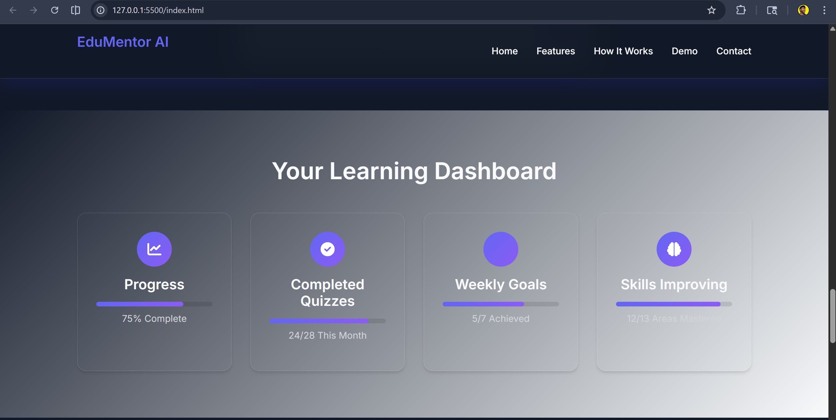Screenshot 6: Testimonials Section
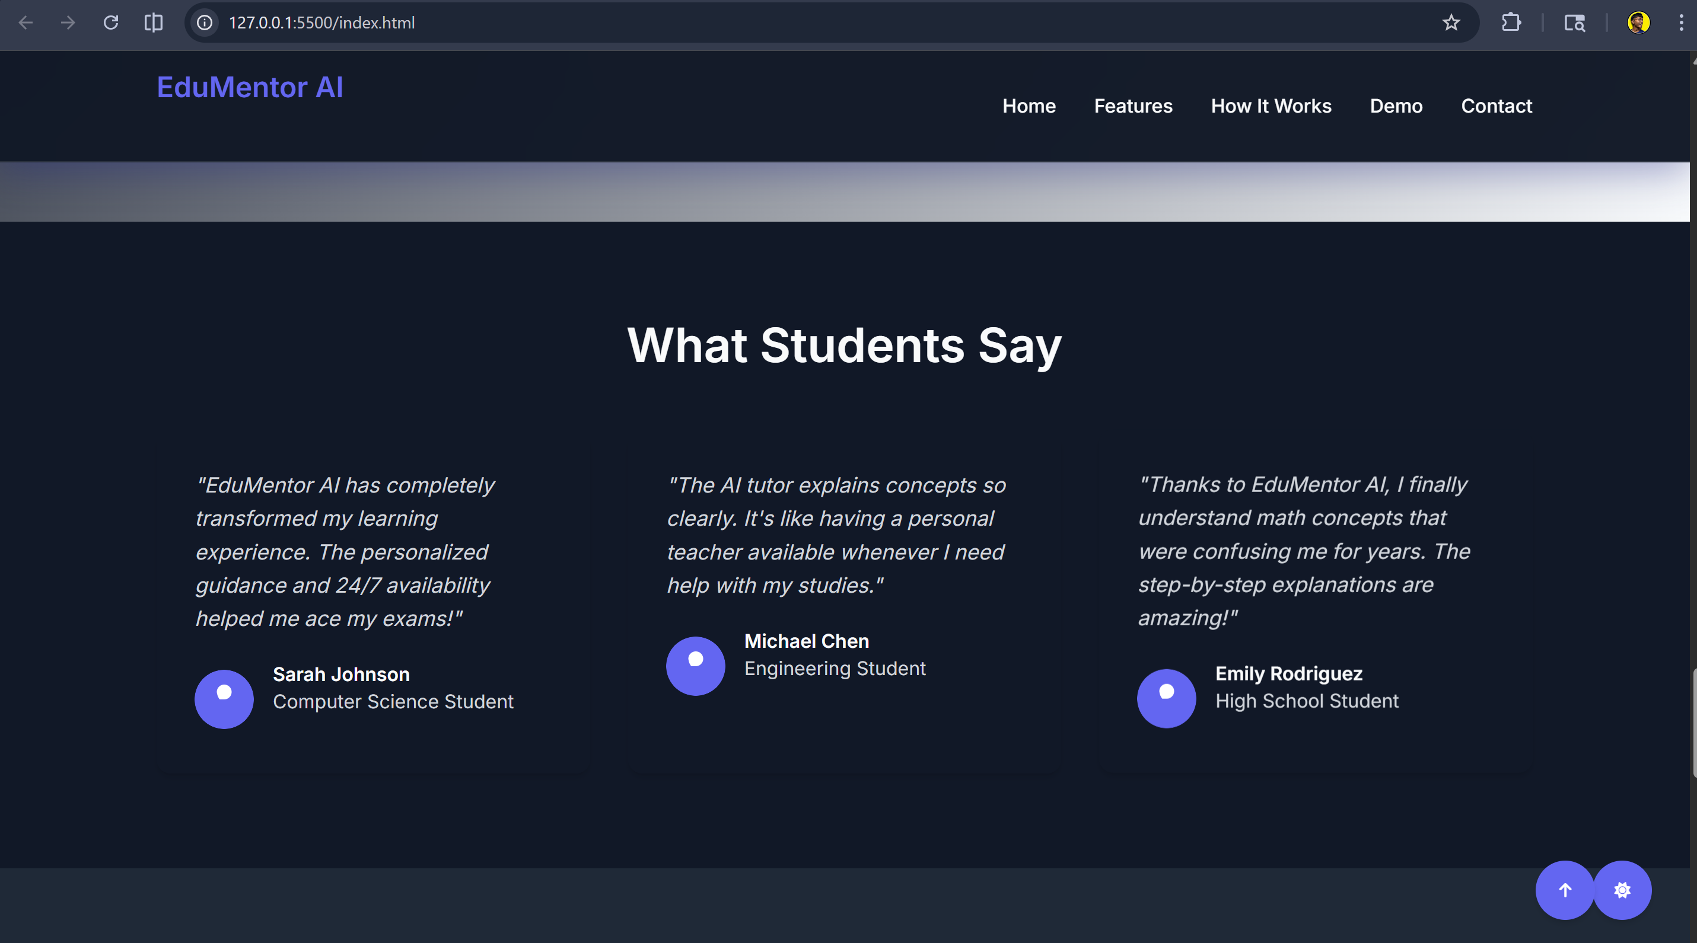

Screenshot 7: Contact Page
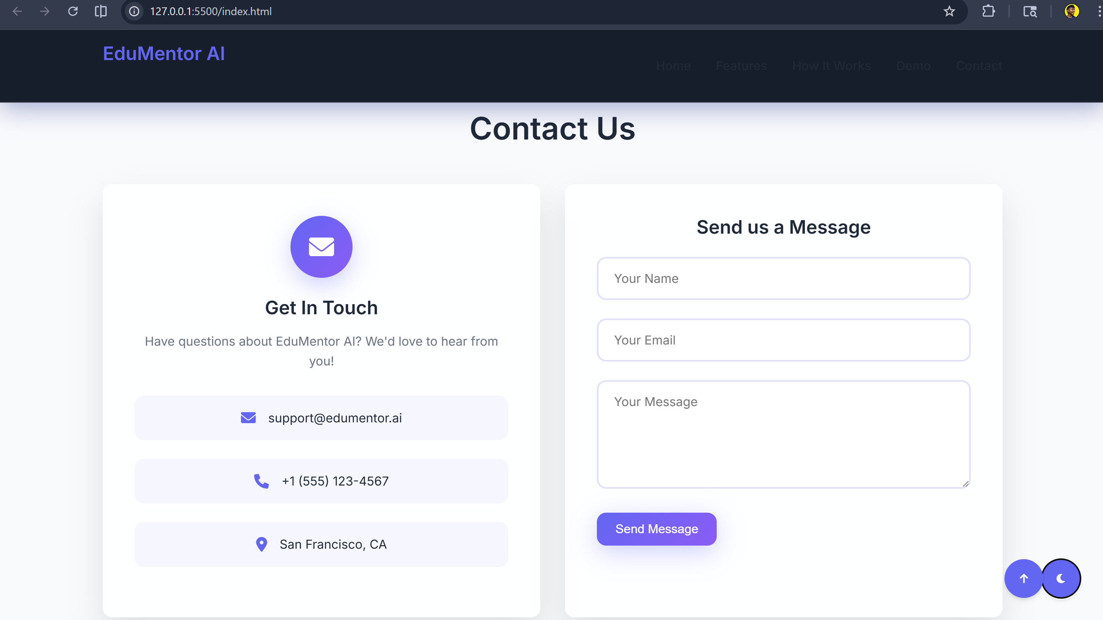

10. Open Source Repository
GitHub Repository Link:
https://github.com/tuhin-ghorui/EduMentor-AI/

11. Future Scope
EduMentor AI can be improved in future by adding:
Advanced AI Integration
Use OpenAI API / GPT for real intelligent tutoring.
Voice Assistant
Students can speak questions instead of typing.
Mobile App
Android / iOS version for wider access.
Multi-language Support
Useful for regional language students.
Real Student Accounts
Login system with saved progress.
Live Teacher Connect
Hybrid model of AI + human tutors.
Smart Analytics
Track weak subjects and suggest improvements.

12. Conclusion
EduMentor AI is an innovative AI-based education platform supporting United Nations SDG 4: Quality Education.
This project demonstrates how Artificial Intelligence can solve real-world educational problems by providing affordable, scalable, and smart learning assistance.
It has strong future potential as a real startup product and social impact solution.

