**Kubeflow Setup on Google Cloud Platform:**

* We create a docker file

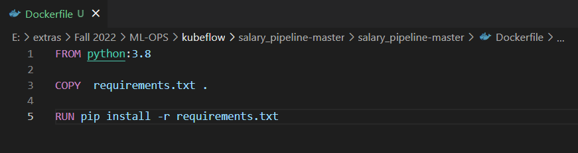

* We create a docker image using the docker file locally and export it to google cloud.
* We use the base image of python 3.8 along with the requirement file we created.
* The requirement file contains python libraries needed for code execution.

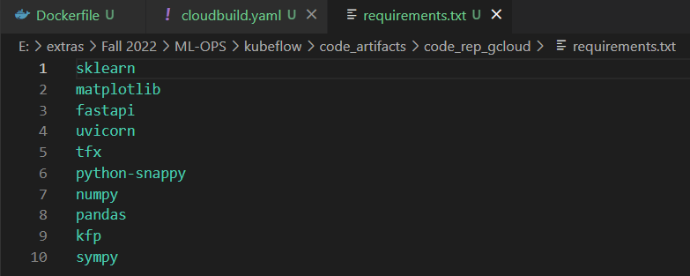

* Yaml file (cloud build) to specify the steps for build order

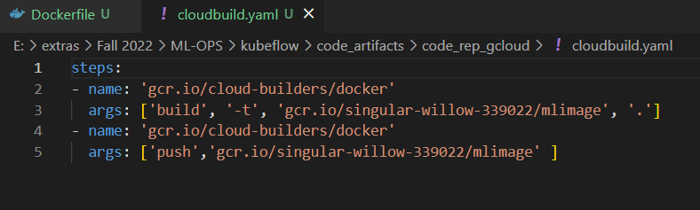

* Using cmd prompt, we run commands to build the docker image on google cloud using the yaml config file.
* To run the google cloud commands on cmd, we first need to instal the google cloud SDK.
* Google cloud SDK can be installed on local windows machine by running power shell commands provided on <https://cloud.google.com/sdk/docs/install>

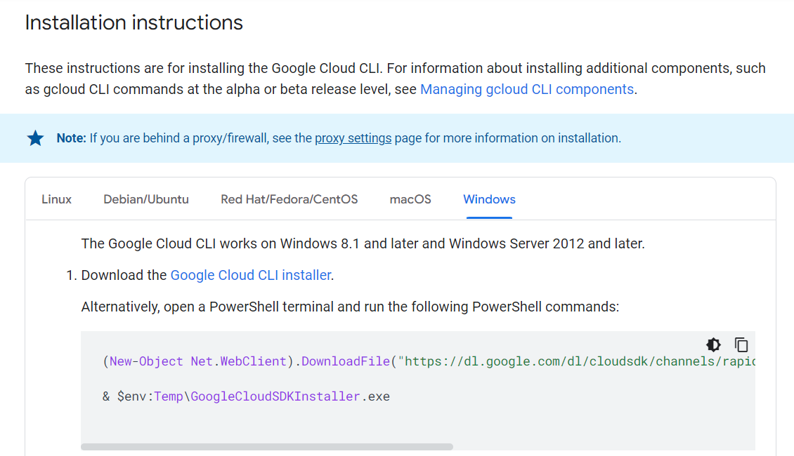

**Power Shell Command:**

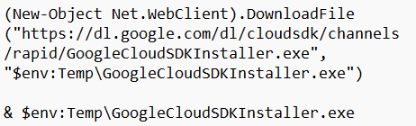

(New-Object Net.WebClient).DownloadFile("https://dl.google.com/dl/cloudsdk/channels/rapid/GoogleCloudSDKInstaller.exe", "$env:Temp\GoogleCloudSDKInstaller.exe")

& $env:Temp\GoogleCloudSDKInstaller.exe

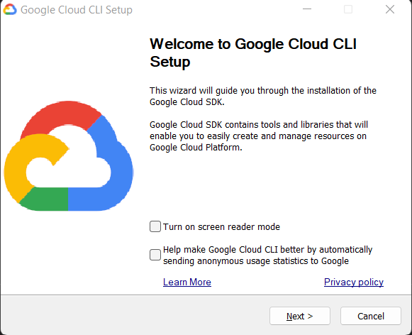

* Proceed by clicking on next till the end. On the finish page, select the ‘run gcloud.init to configure the Cloud SDK’ option and click on finish.
* Once the google cloud SDK is installed, the google cloud command line can be opened by running the ‘gcloud init’ command on command prompt.
* During the first login, we are asked to sign into our GCP account. Once the initial sign in is done, restart the terminal.

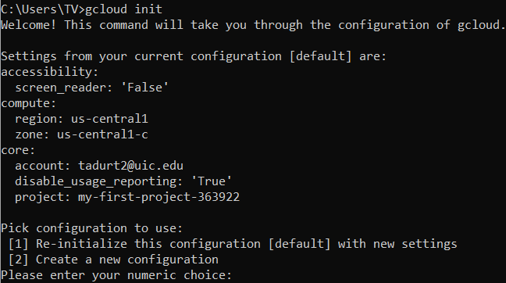

* On restarting the terminal, we can verify the gcp account linked and the gcp project we signed in to.
* On powershell, run the following command:
* gcloud builds submit --config configbuild.yaml . --timeout=10000

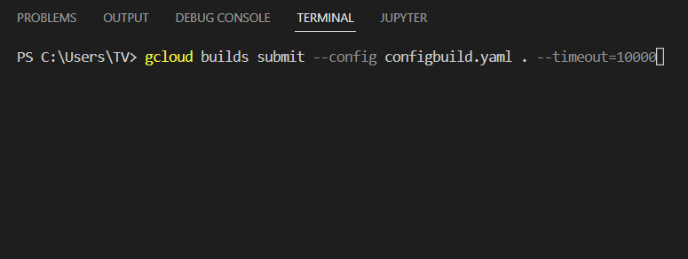

* This command builds our docker file into an image, exports it to our GCP project and runs the container.
* Go to GCP

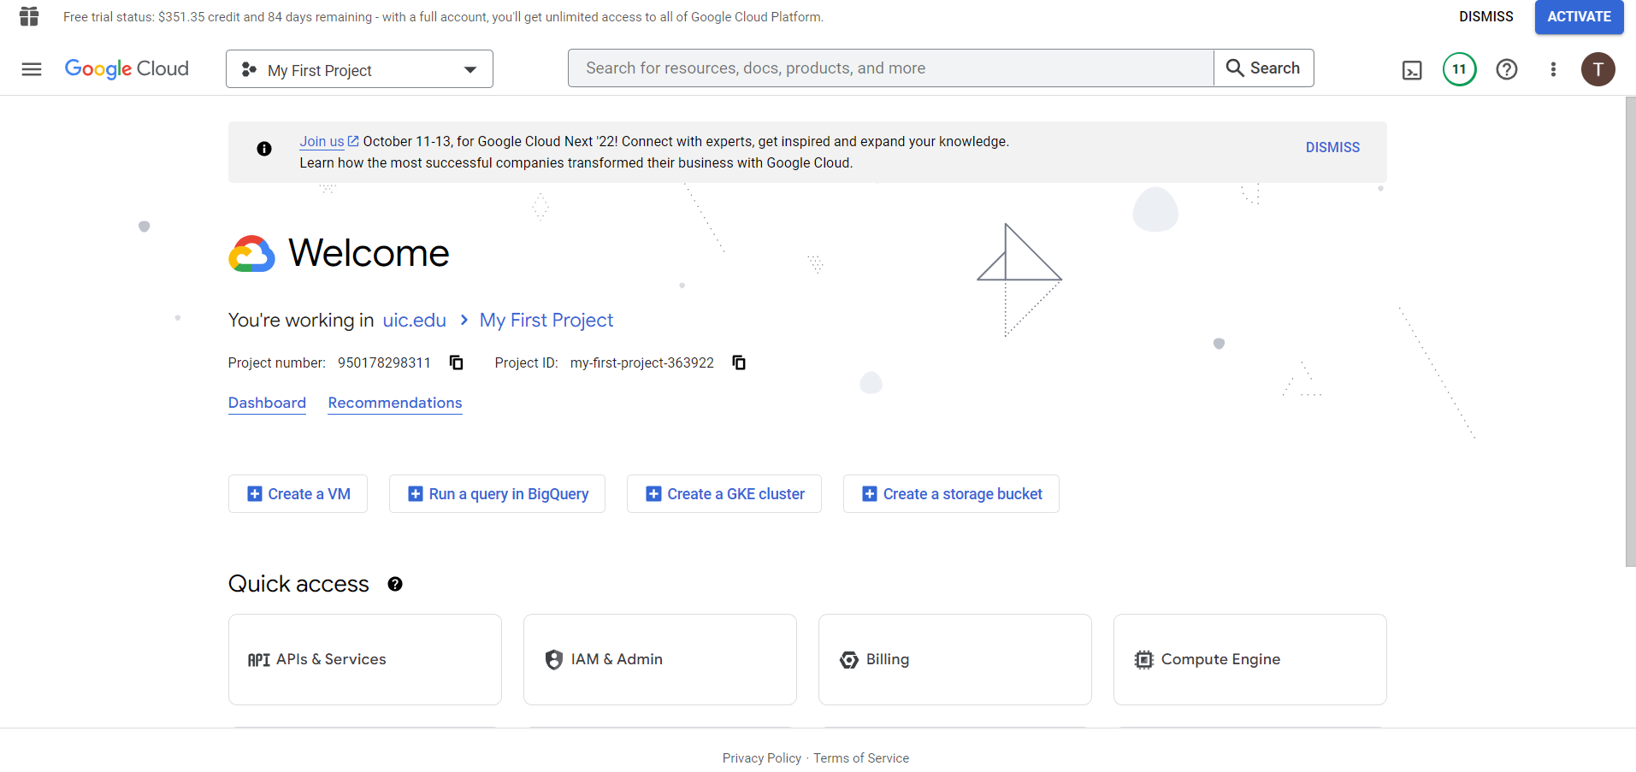

* Open container registry

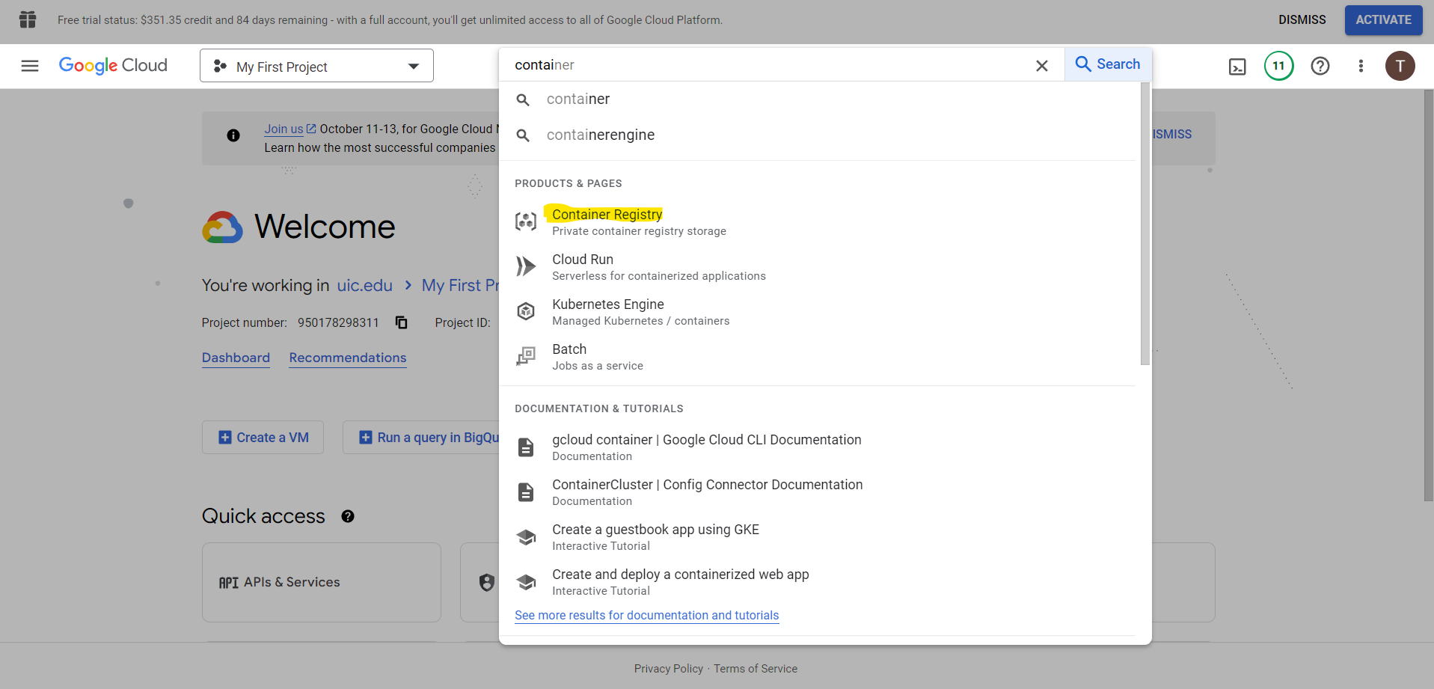

* Container of the image built locally and exported can be verified.

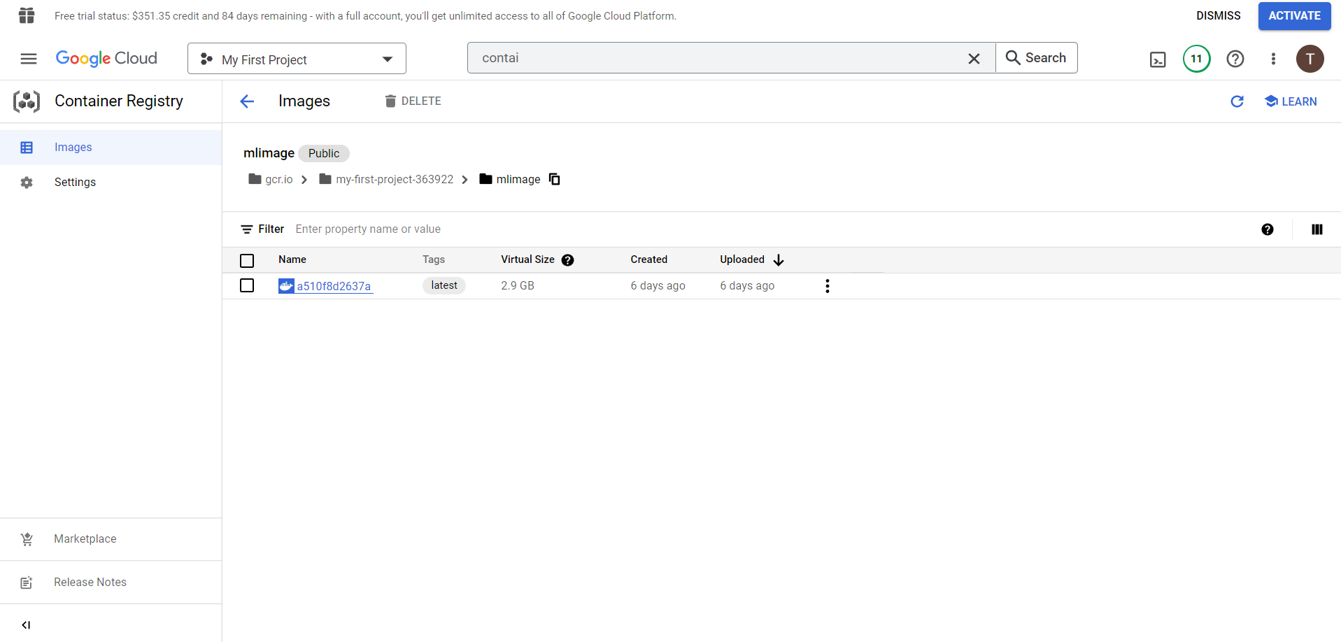

* Select the Kubernetes product, then select the clusters option

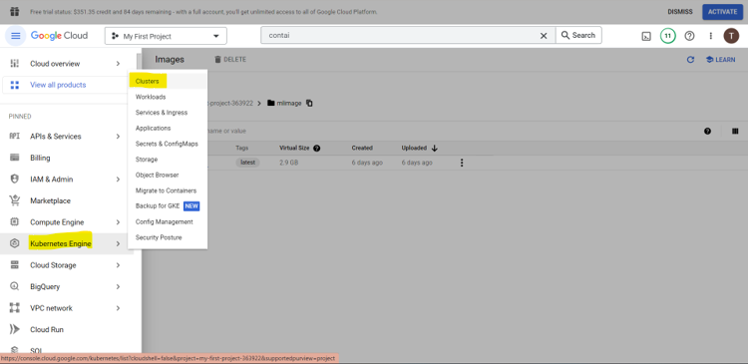

* On this page, the Kubernetes cluster can be created.

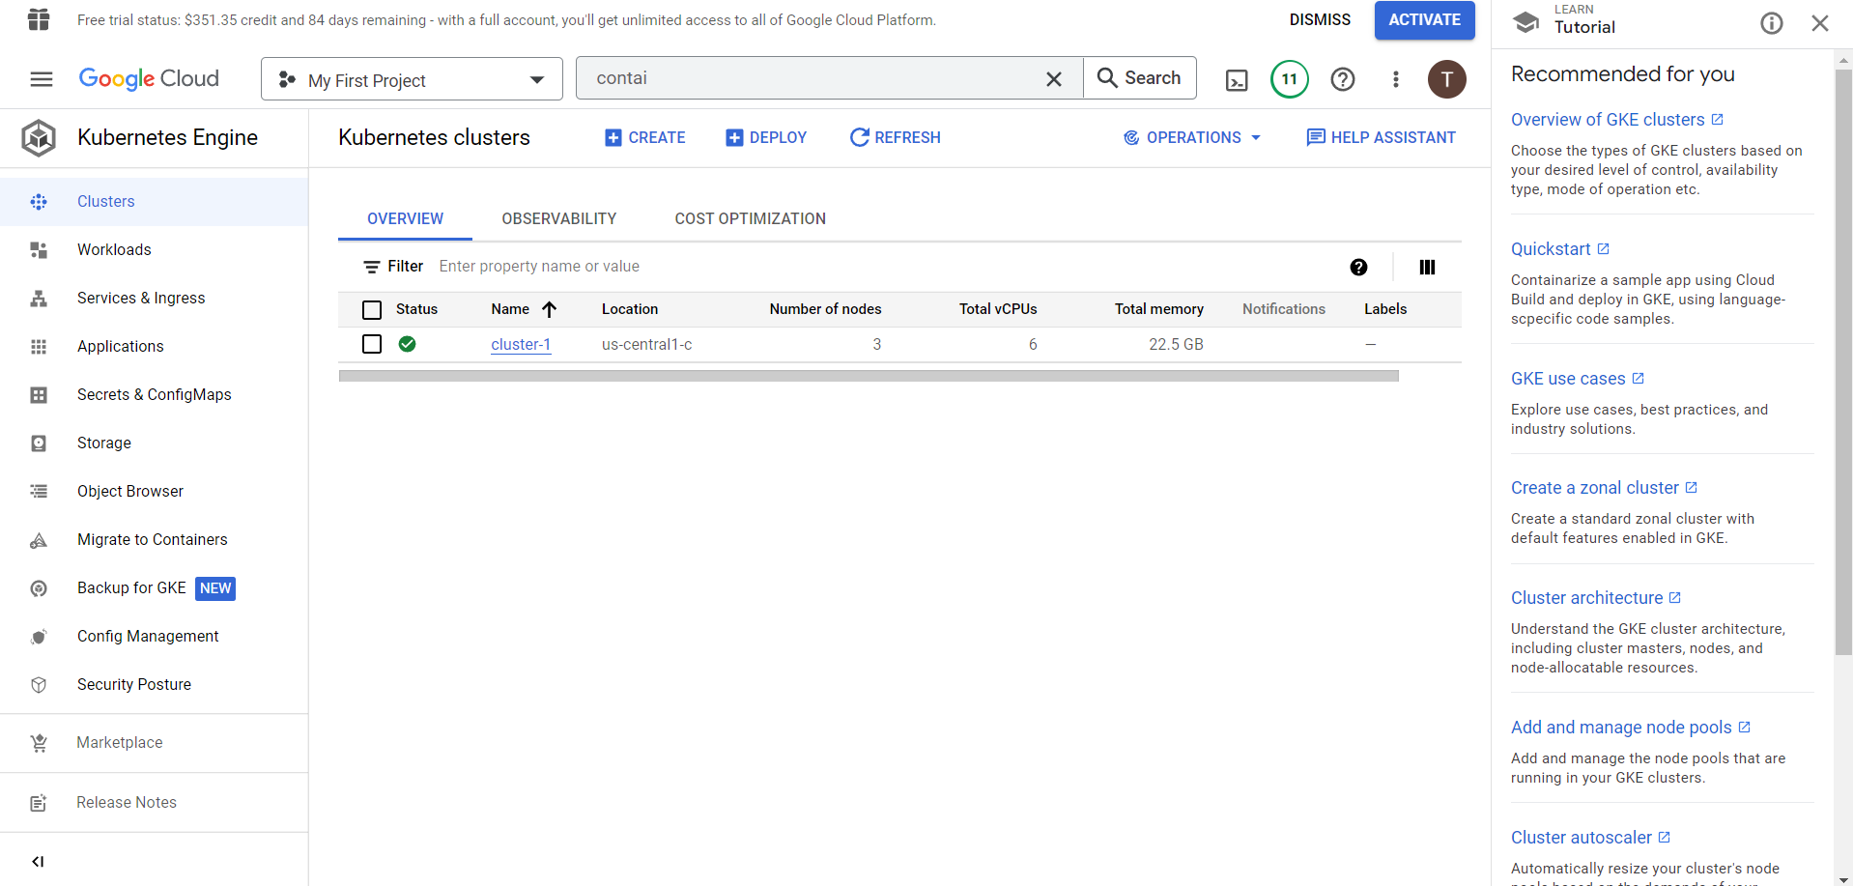

* Go to AI Platform and select pipelines

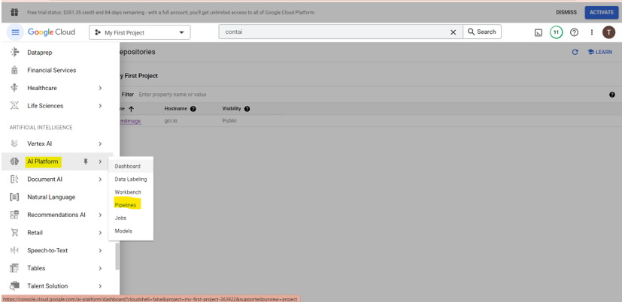

* We create new Kubeflow pipelines through this UI

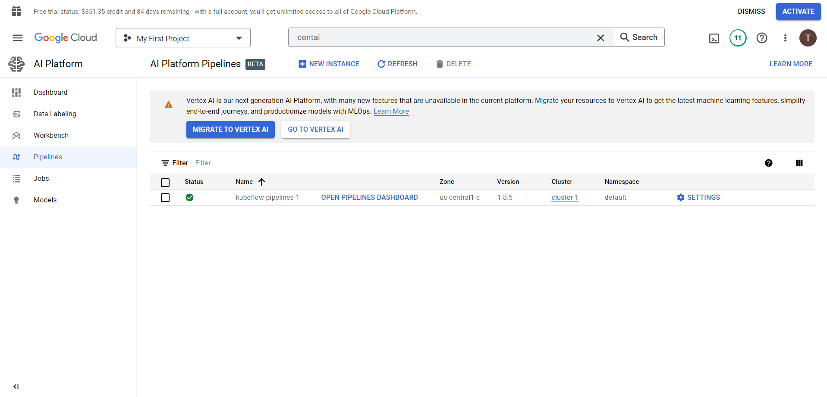Click on “Open Pipeline Dashboard” 