**Kubeflow Setup on Local Host**

* Install kind on command prompt and follow the below mentioned commands (can also be seen in the screenshots given below):
  + curl.exe-Lo kind-windows-amd64.exe <https://kind.sigs.k8s.io/dl/v0.16.0/kind-windows-amd64>
  + curl.exe -Lo kind-windows-amd64.exe https://kind.sigs.k8s.io/dl/v0.16.0/kind-windows-amd64
  + Move-Item .\kind-windows-amd64.exe c:\kind\kind.exe

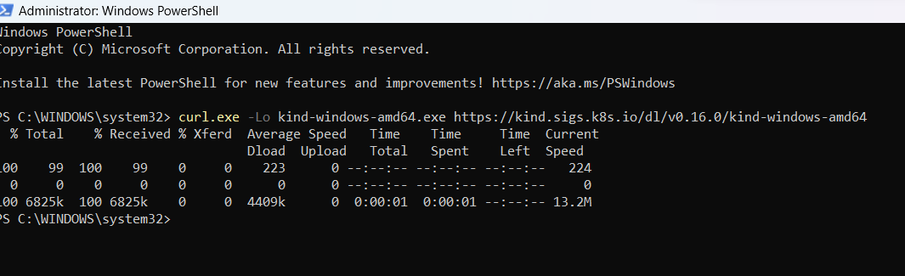 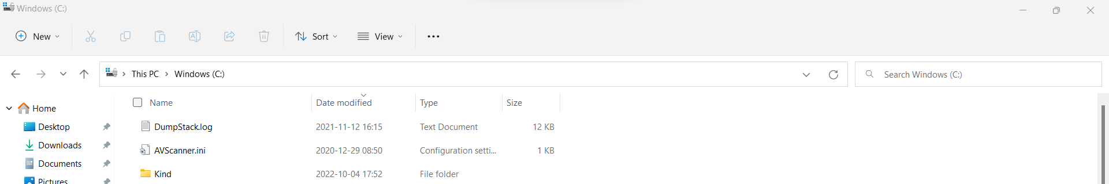 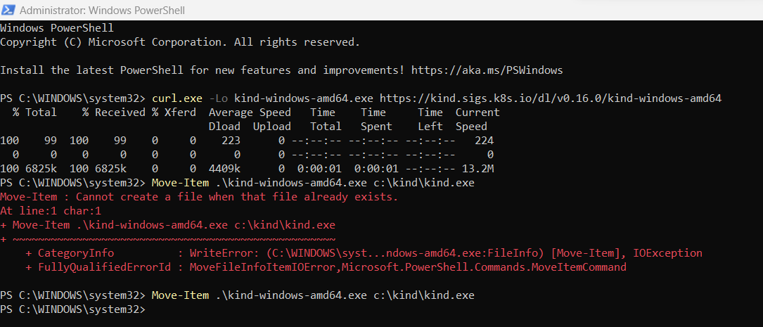 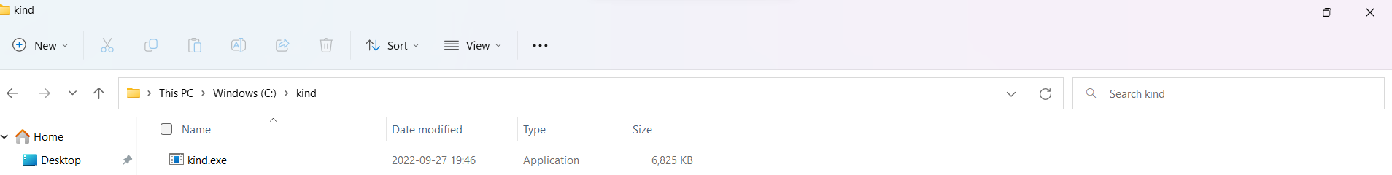

* Install Docker Desktop on Windows and follow the link given: https://docs.docker.com/desktop/install/windows install/

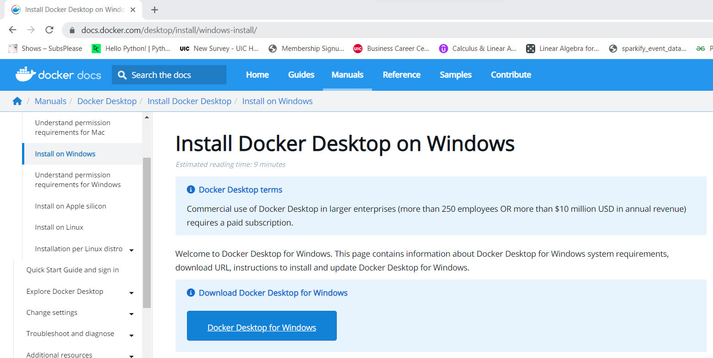

- Open the command prompt

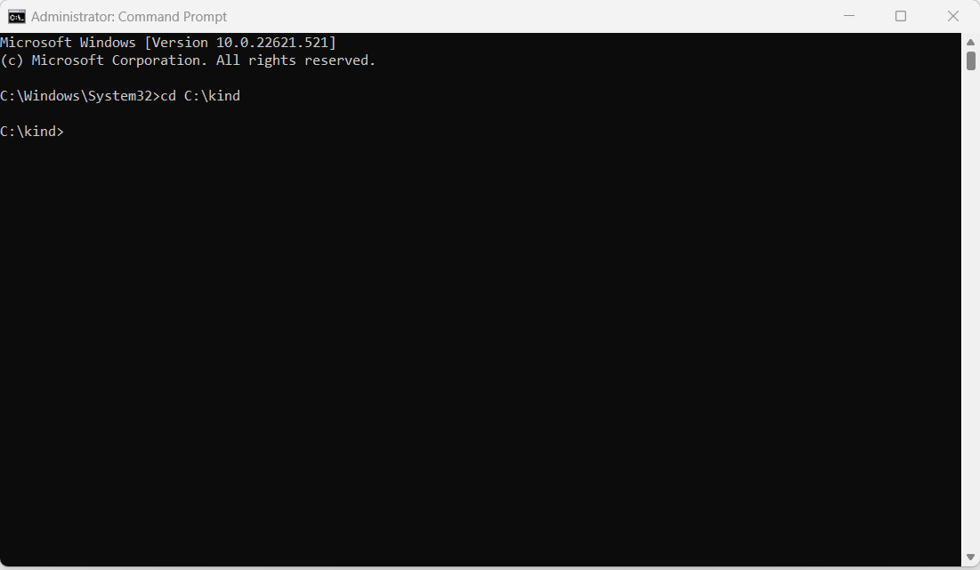

* Change your directory to where you have installed the kind (kind’s directory) and create clusters.

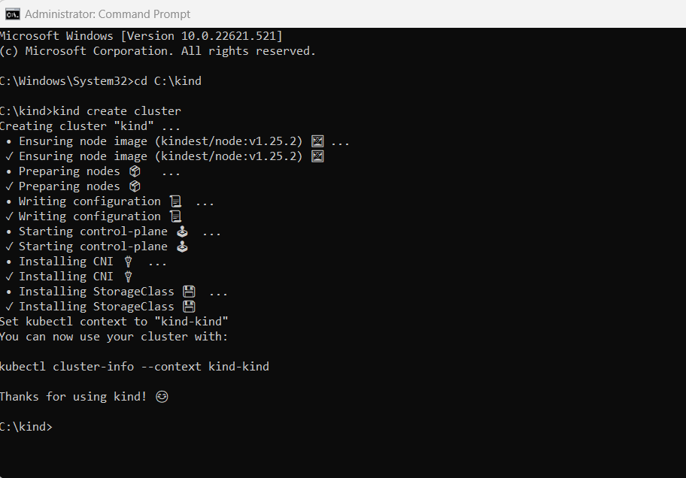

-Open docker for desktop, you can see your container as can be seen below: 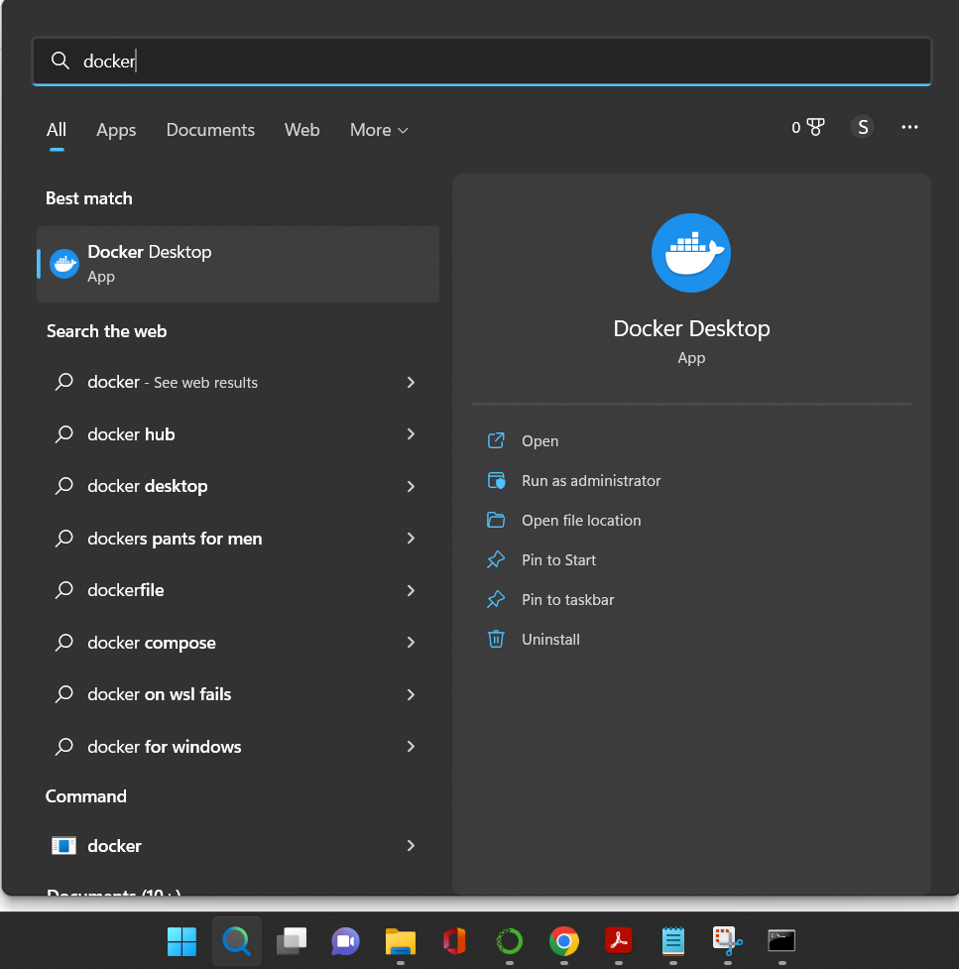 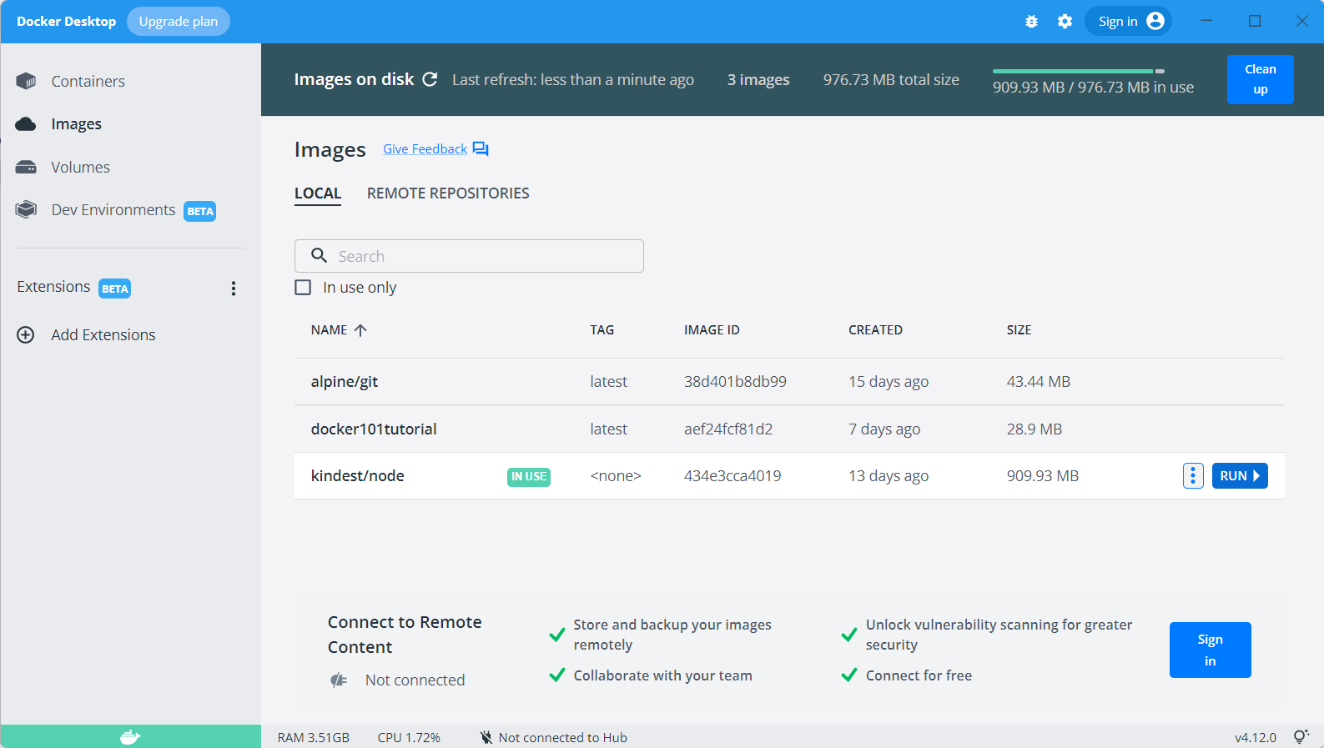 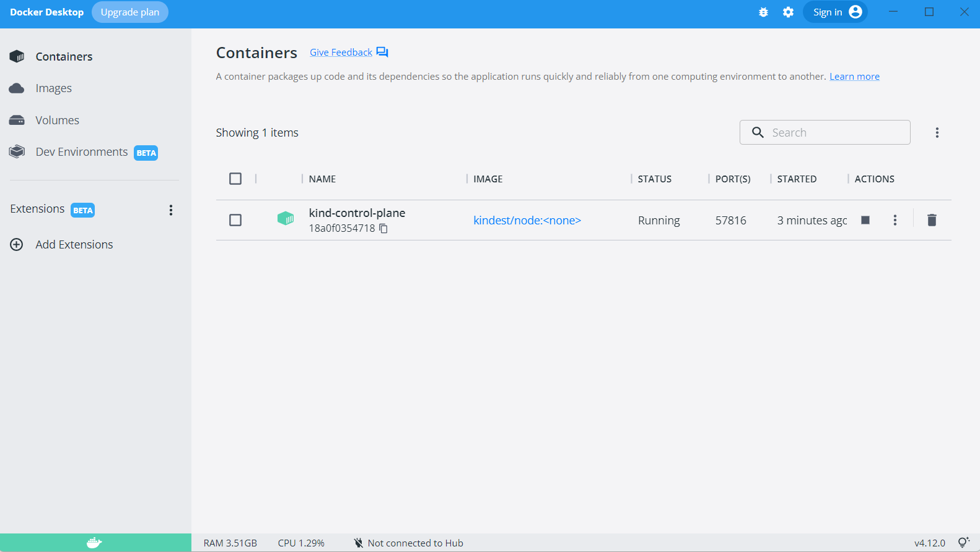

* Execute the following commands to deploy the Kubeflow Pipelines as illustrated below:
  + kubectl apply -k "github.com/kubeflow/pipelines/manifests/kustomize/cluster-scoped-resources?ref=1.8.5"
  + kubectl wait --for condition=established --timeout=60s crd/applications.app.k8s.io
  + kubectl apply -k "github.com/kubeflow/pipelines/manifests/kustomize/env/platform-agnostic-pns?ref=1.8.5"

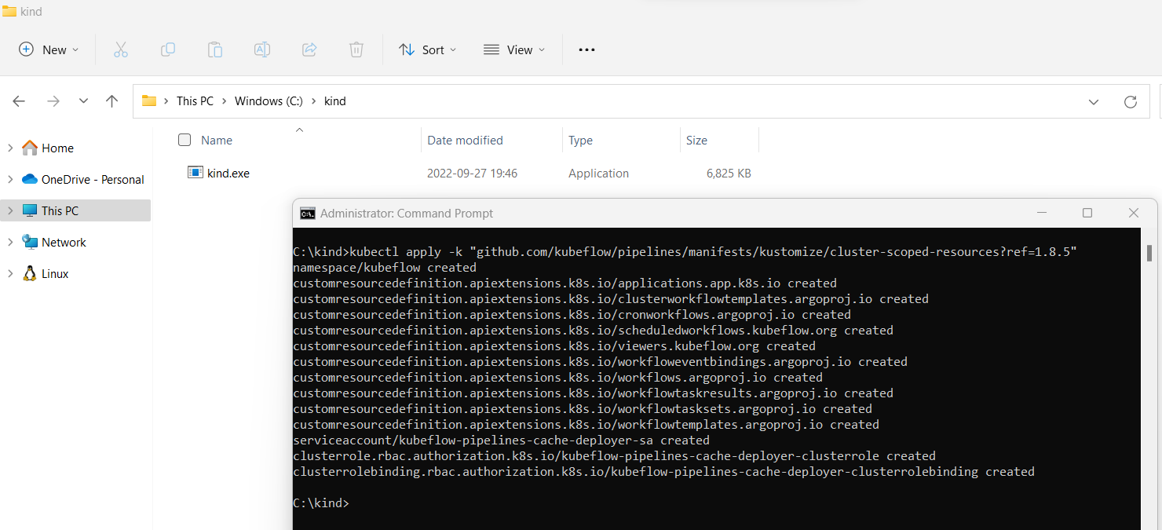

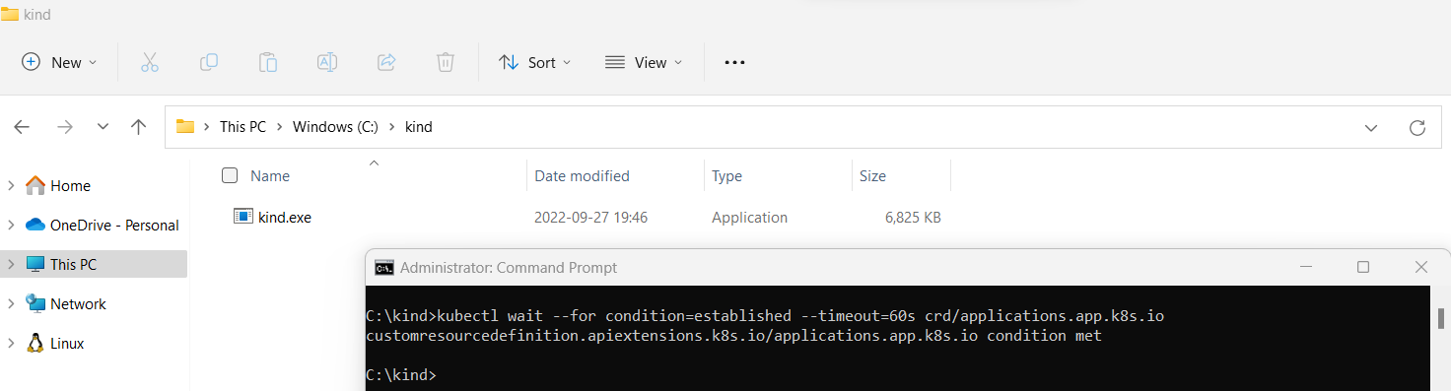 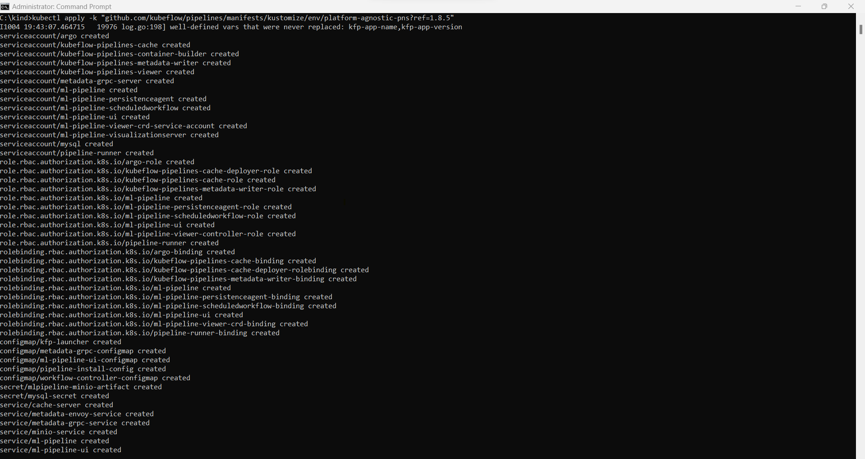

* By port-forwarding, confirm that the Kubeflow Pipelines UI is reachable:
  + kubectl port-forward -n kubeflow svc/ml-pipeline-ui 50112:80

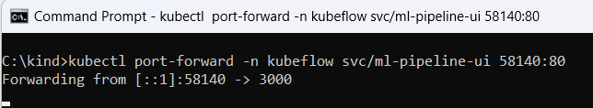

* Go to the Kubeflow Pipelines UI by going to <http://localhost:50112/>

* Creating a new pipeline taking .yaml file:

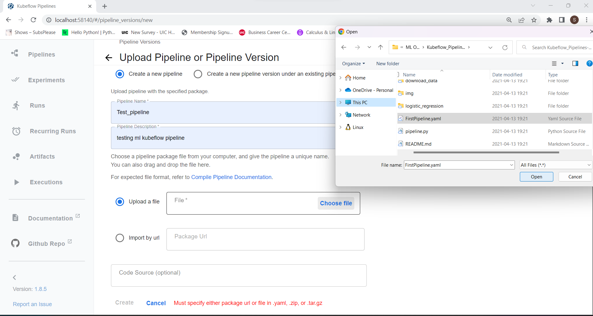

* - Testing the pipeline

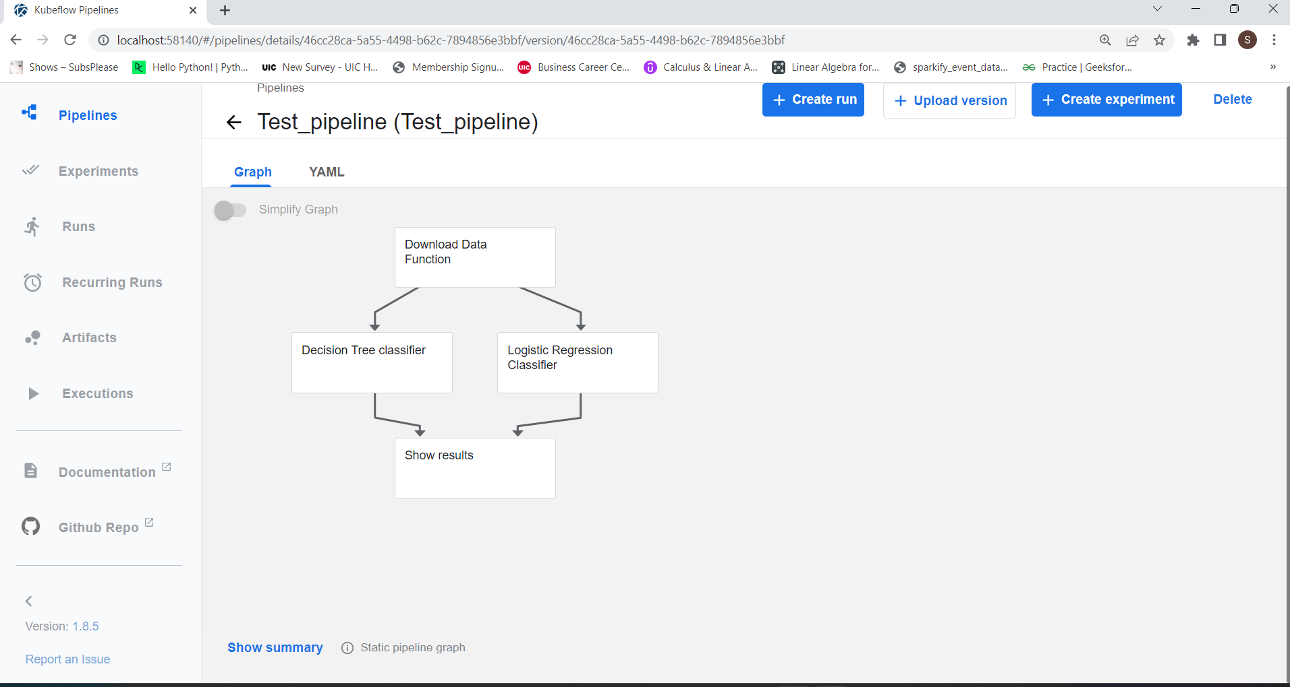 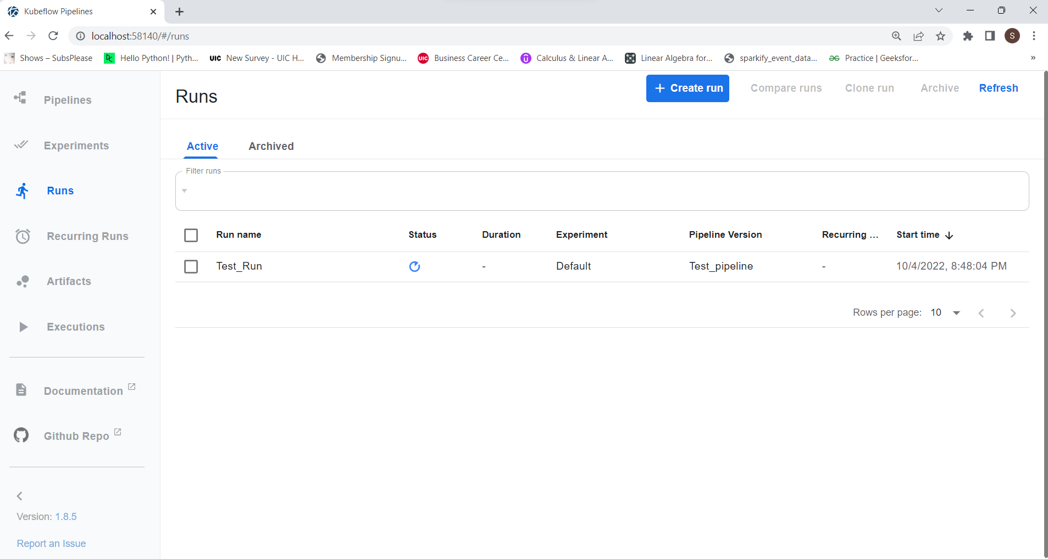

* Test Run (Finding the Accuracy)

