Assignment-based Subjective Questions

1. From your analysis of the categorical variables from the dataset, what could you infer about their effect on the dependent variable?

Ans. Categorical variables have significant effects on the dependent variables.
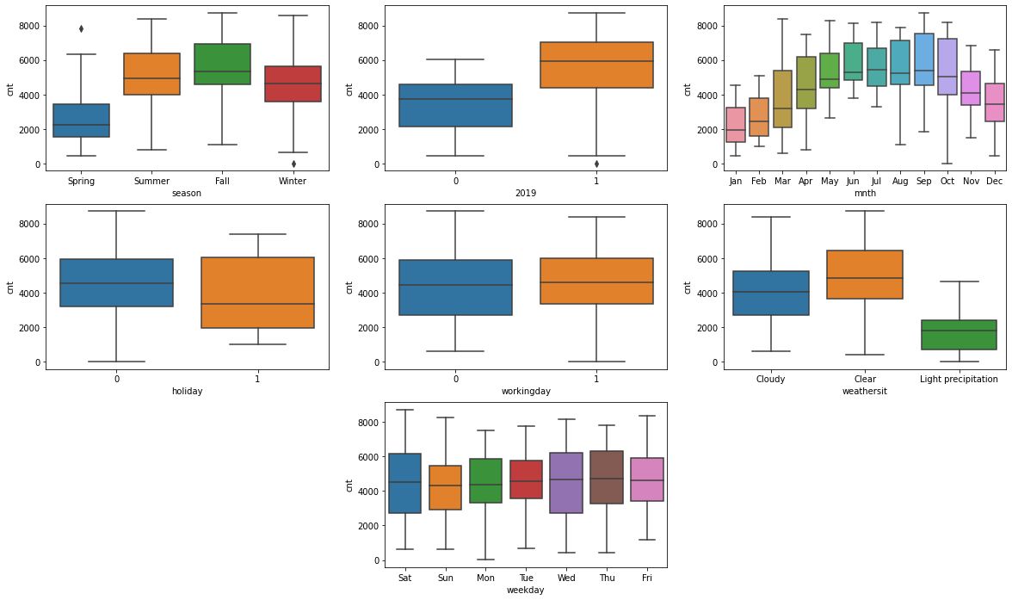

As could be seen from the set of box plots, ‘workingday’ and ‘workday’ do not have any significant difference in their medians and hence, do not play any important role. Therefore, instead of taking ‘workingday’, ‘holiday’ has beeen considered as a relevant feature in the model.
Whereas, ‘year’, ‘months’, ‘seasons’ have drastic effects on the target variable. In ‘weathersit’, it can be clearly seen that there is no rental during heavy precipitation, i.e., Heavy Rain, Ice Pallets, Thunderstorm, Mist, Snow, or Fog, Most of the rentals have occurred during clear weather condition followed by clody and light precipitation weather conditions.

2. Why is it important to use drop_first=True during dummy variable creation?

Ans. During dummy variable creation, as many numbers of variables are there (value counts), that many columns generated.
The following table displays that the first row suggests red, second row suggests blue whereas the thir row suggests blue.
Red | Green | Blue
1 | 0 | 0
0 | 0 | 1
0 | 1 | 0

But in actual practice we can work out with one column less than the columns generated. If there are n number of variables, (n-1) numbers of columns are practically required.
Green | Blue
0 | 0
0 | 1
1 | 0

Now, the first row suggests that it is neither green nor blue, so it must be red given that there are only three colours available. Second row suggests blue and third row suggests green.
Hence it is important to use drop_first=True during dummy variable creation since it increases efficiency and lets us work with lesser number of features.

3. Looking at the pair-plot among the numerical variables, which one has the highest correlation with the target variable?

Ans. It is obvious for ‘registered’ to have the highest correlation but since ‘registered’ and ‘casual’ are directly involved in the target variable (‘casual’ + ‘registered’ = ‘cnt’), ‘temp’ should be considered rather to have the highest correlation with the target variable.

4. How did you validate the assumptions of Linear Regression after building the model on the training set?

Ans. The assumptions are validated in the following ways :-

- Linear relationship between X and Y : Linear Regression refers to a group of techniques for fitting and studying the straight-line relationship between two variables. Linear regression estimates the regression coefficients β₀ and β₁, β₂ ,………, β_{p} in the equation

where X_{1,} X_{2 ,…….,} X_{p} are the independent variable, Y is the dependent variable, β₀ is the Y intercept, β₁, β₂ ,…, β_{p} are the slopes, and ε is the error.
All these factors is clearly visible in the following model summary and the Residual Sum of Errors calculated (provided below respectively) :
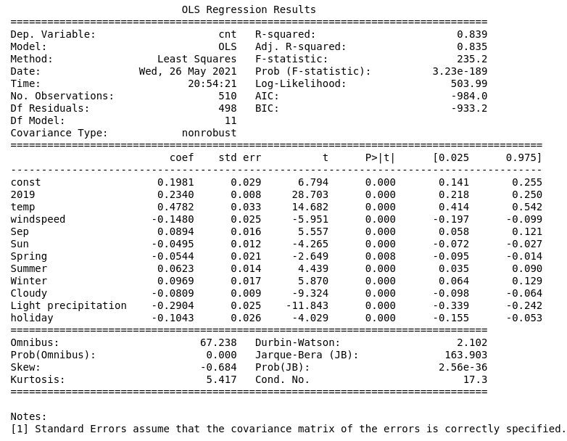

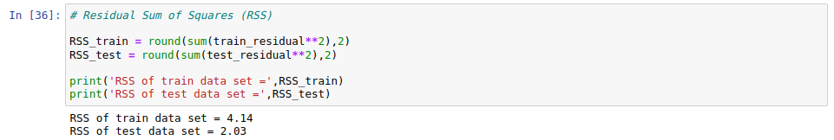
- Error terms are normally distributed (not X, Y) : It can be observed by plotting the frequency of occurrence of error terms in both train and test data set. Moreover, plotting a Q-Q plot of test data set residuals is also helpful.
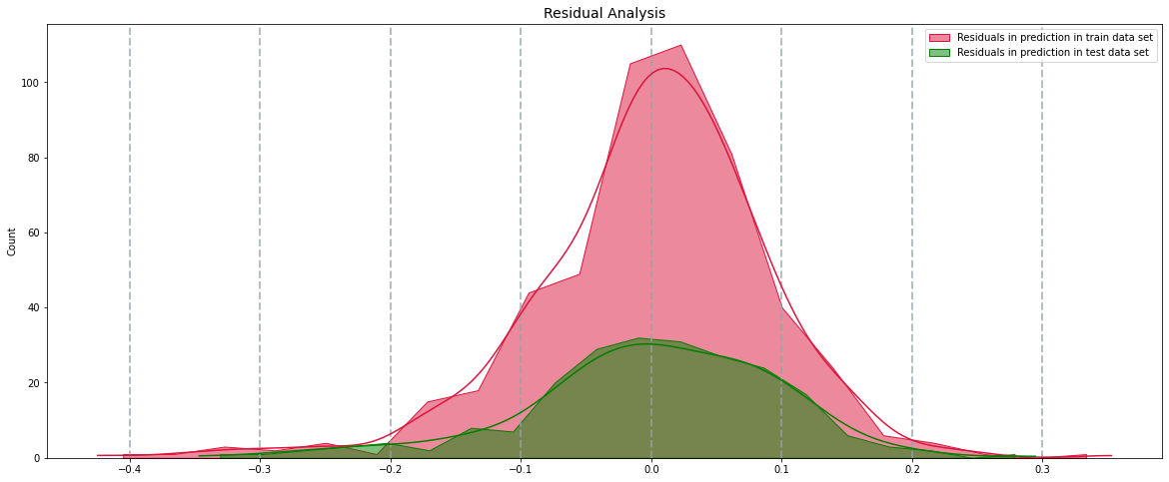

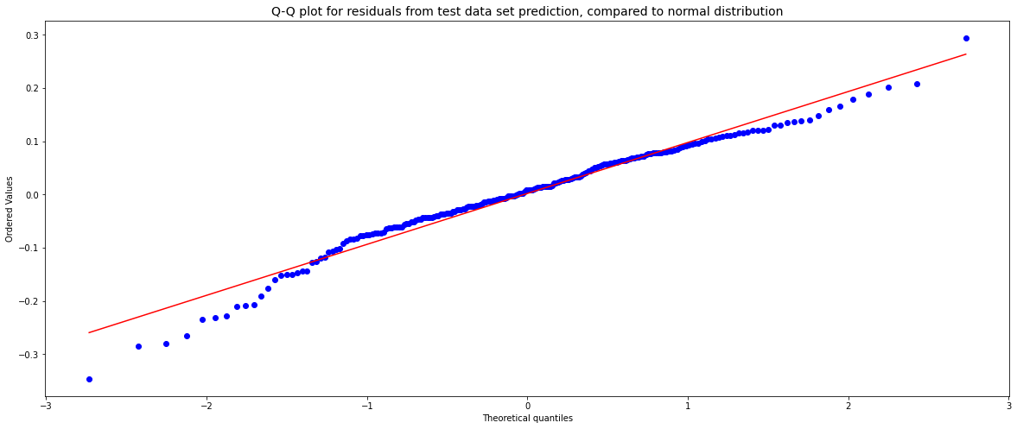

- Zero mean assumption,
- Error terms are independent of each other,
- Error terms have constant variance (homoscedasticity) : All of these assumptions can be validated by plotting the distribution of residuals. The error points are entirely random and hardly is there any best fit line passing through the error points in both train and test data sets apart from y=0.
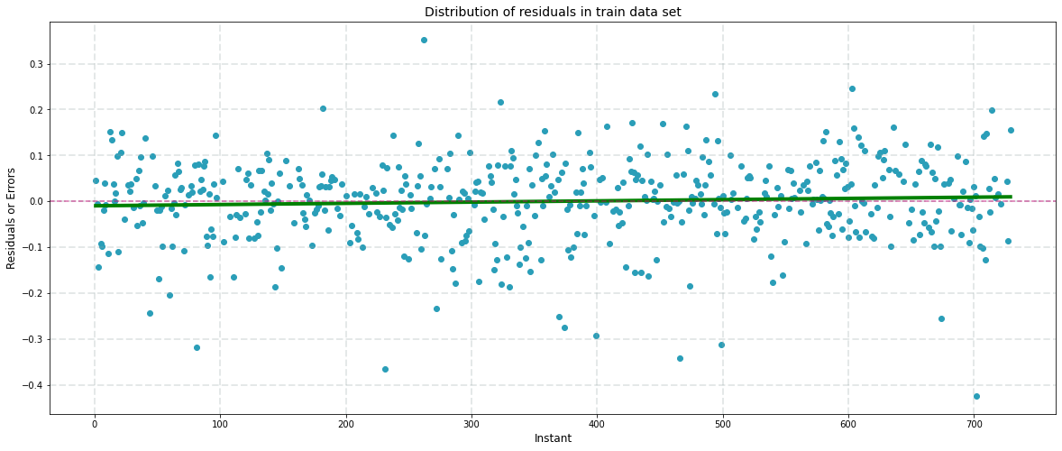

5. Based on the final model, which are the top 3 features contributing significantly towards explaining the demand of the shared bikes?

Ans. The top 3 features contributing significantly towards explaining the demand of the shared bikes are as follows (not in any sorting order) :-

- Temperature – It is named as ‘temp’ in the data set which has a positive coefficient of 0.4782 and 14.682 t-score. This feature provides temperature in Celsius.

- Light Snow, Light Rain, Thunderstorm , Scattered clouds, Light Rain, Scattered clouds weather situation – It is named as ‘Light precipitation’ in the data set which has a negative coefficient of 0.2904 and -11.843 t-score. This feature classifies an instant with the corresponding weather condition.

- The year 2019 – It is named as ‘2019’ in the data set which has a positive coefficient of 0.2340 and 28.703 t-score. This feature classifies an instant with the corresponding year.

General Subjective Questions

1. Explain the linear regression algorithm in detail.

Ans. Linear Regression refers to a group of techniques for fitting and studying the straight-line relationship between two variables. Linear regression estimates the regression coefficients β₀ and β₁, β₂ ,………, β_{p} in the equation

where X_{1,} X_{2 ,…….,} X_{p} are the independent variable, Y is the dependent variable, β₀ is the Y intercept, β₁, β₂ ,…, β_{p} are the slopes, and ε is the error.

Let,
Y_{i} = Actual target value
Y_{pred} = Predicted target value

In case of Simple Linear Regression,
ε = Y_{i} - Y_{pred}
=> ε = Y_{i} - (β₀ + β₁X₁)
=> ε² = [Y_{i} - (β₀ + β₁X₁ )] ²
Similarly, in case of Multiple Linear Regression,
∴ RSS = [Y_{i} - (β₀ + β_{i}X_{i} )] ²

The RSS is minimized using gradient descent. The suitable RSS value then leads to the building of a model with lowest residuals and errors.

Let, ȳ = mean of all data points in the actual target values
TSS = [Y_{i} - ȳ] ²

R² is the value that is calculated to determine the coverage of data variance. The quality of the model is directly proportional to R².
R² = 1 – (RSS / TSS)

For any feature, the null hypothesis is taken equal to 0 and alternate hypothesis not equal to 0.
Hₒ = 0
H₁ ≠ 0
Now, the P-value is calculated based on the t-score,
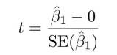

If P-value < 0.5, the null hypothesis can be rejected and hence the feature is significant.

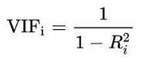
In the prepared model, there could be multicollinearity which refers to how a predictor variable is related to other variables excluding the target variable. Multicollinearity is measured using Variance Inflation Factor (VIF).

Features with VIF values greater than 5 are generally ignored.

Based on the above factors, it is possible for multiple models to have been created each with different combinations and numbers of features, R-squared values and feature VIFs. Among all the models, the best one is chosen based on Adjusted R-squared term rather than R-squared.
This is because R-squared always increases with addition of features. It is obvious to cover more data variance with increase in features but it does not consider the number of predictor variables involved in the model.
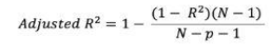

Based on all the above factors, a suitable and efficient Linear Regression model is built.

2. Explain the Anscombe’s quartet in detail.

Ans. In 1973, an English statistician, Francis Anscombe came up with the concept that even though the statistical properties like mean, variance, correlation, etc. of different data sets are similar, the look very different when plotted during visualization.
Till then it was a common misconception among statisticians that once the data has been crunched into properties, it is useless to plot them anymore since they assumed them to be similar.
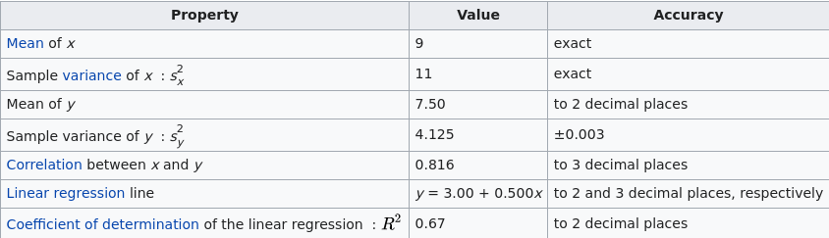
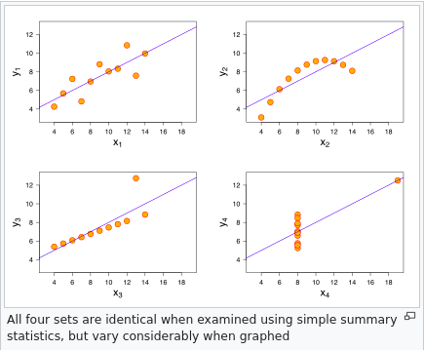
Refer to the following two images (Image source: https://en.wikipedia.org/wiki/Anscombe%27s_quartet) for Francis Anscombe’s work on four data sets used by him to prove his postulate :-

3. What is Pearson’s R?

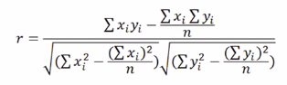
Ans. Pearson’s r measures the strength of the linear relationship between two variables. It is calculated using the following formula.

The maximum and minimum value of pearson’s r value could be 1 and -1 respectively. It is also referred to as Pearson correlation coefficient (PCC), denoted by ρ. Refer to the following image (Image source: https://en.wikipedia.org/wiki/Pearson_correlation_coefficient) for detailed understanding :-
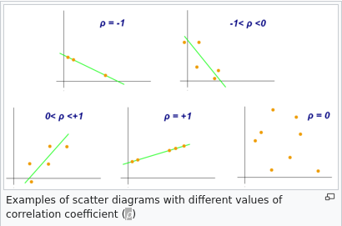

4. What is scaling? Why is scaling performed? What is the difference between normalized scaling and standardized scaling?

Ans. Scaling is the process of converting the variables in same comparable order. In other words, it is the process of increasing or decreasing the values of variables maintaining their ratios.
It is done in order to make the each variable values comparable to each other. Usually it may happen that in a data set, one column is in order of millions whereas others in order of hundreds or ones. In such cases the coefficients will be large and will be complicated for those variables to work with. Therefore, scaling is performed on all variables. There are other reasons too for scaling which include ease of interpretation and faster convergence for gradient descent methods.
There are basically two types of scaling. Difference between them is summarized as below :
Normalized Scaling | Standardized Scaling
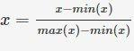  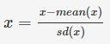  The variables are scaled in such a way that all the values lie between zero and one using the maximum and the minimum values in the data. This is also called MinMax scaling. | The variables are scaled in such a way that their mean is zero and standard deviation is one.

5. You might have observed that sometimes the value of VIF is infinite. Why does this happen?

Ans. VIF is the measure of multicollinearity. Multicollinearity is the relation between two independent variables. Value of VIF is directly proportional to the multicollinearity.
We know,

R-squared is the factor of VIF of a certain feature, i.e., the R-squared value while considering that particular feature to be target variable and other features to be predictor variable.
From the equation it is clear that VIF can be zero only when the denominator is zero on the left hand side, that is,
1 - R_{i}² = 0
R_{i}² = 1
or, R_{i} = 1
Therefore for VIF to be infinite, R-squared has to be equal to 1.
Again,
R² = 1 – (RSS / TSS)
According to the above equation, for R-squared to be 1, RSS has to be equal to 0.
RSS = 0
This is plausible only if there is no residual error or no difference between actual and predicted values. This happens when there are columns with specific mathematical relationship between them. In simple terms, if one feature is a mathematically transformed or deduced value of another feature.
It can happen if two values have exact same values, i.e., one column is multiple of 1 of the other column.
Refer to the following image where VIF is calculated for some columns that inclued two similar columns ‘Sep’ with exact same values. They have infinite VIF values.
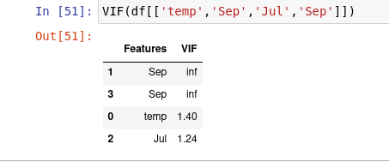

6. What is a Q-Q plot? Explain the use and importance of a Q-Q plot in linear regression.

Ans. A Q-Q plot, also known as Quantile-Quantile plot is a graphical technique for determining if a data set belongs to a population with any common distribution. A Q-Q plot is a plot of the quantiles of the first data set against the quantiles of the second data set.
The Q-Q plot is prepared by marking the quantiles in a data set and marking them with respective quantiles of another population from any specific distribution. This gives some data points in scattered format with a best fit line along with. More accurate the fit, more the target data set is comparable to the distribution chosen.
Following is an example of Q-Q plot used to validate if the error terms are normally distributed which is one of the assumption of linear regression. In fact, it is one of the major importance of a Q-Q plot in linear regression.

