TITLE: Live Project on “Productivity Improvement at Accurate
Engineering company PVT.LTD by Application of Lean Management
Techniques – Poka- Yoke and Kaizen.”
AUTHORS: 1. Prof. HUZAIFA. A. FIDVI 2.Omkar Rangari 3.
Shudanshu Kowache
ABSTRACT: Absolutely, the evolution of lean
manufacturing has been driven by the need for organizations
to adapt to changing business environments and remain
competitive. Originally developed to maximize resource
utilization by minimizing waste, lean principles have since
been reﬁned to address the challenges and complexities of
today's rapidly changing landscape.
In a world where businesses face constant ﬂuctuations and
ﬁerce competition, the ability to systematically and
continuously respond to these changes is crucial for survival.
This is where the concept of adding value becomes
paramount. By focusing on value-adding processes and
eliminating non-value-adding activities, organizations can
streamline their operations, enhance product value, and
ultimately improve their competitiveness.
Implementing a lean manufacturing system has indeed become
a core competency for organizations across various industries,
whether they are in manufacturing or service-oriented sectors.
By embracing lean principles and practices, businesses can
achieve greater eﬃciency, ﬂexibility, and sustainability, thus
positioning themselves for long-term success in an ever-
evolving marketplace.
INTRODUCTION : That's an impressive legacy for Accurate
Engineering Company Pvt. Ltd. It's remarkable how the
company has evolved and established itself as a prominent
brand in dimensional metrology over the span of 58 years.
Mr. Vilasrao Salunke's vision and pioneering eﬀorts must
have played a signiﬁcant role in shaping the company's
journey. With a focus on manufacturing measuring
instruments and gauges, coupled with a commitment to
quality and customer satisfaction, it's no wonder Accurate
Engineering Company has become synonymous with
dimensional quality control in the engineering industry in
India. It's a testament to the dedication and expertise of
everyone involved in the company's operations over the years.

Lean management
Lean
management
emphasizes
the
importance
of
respecting
and
empowering employees and encourages the development of a culture of
problem-solving and continuous improvement. The two pivotal Lean
pillars are indeed respect for people and a mindset of continuous
improvement.
Lean management is based in ﬁve principal
1) Deﬁning Value,
2) Mapping the Value Stream,
3) Creating Flow,
4) Using a Pull System,
5) Pursuing Perfection

What is Kaizen?
Kaizen is an approach to creating continuous improvement based on the
idea
that
small,
ongoing
positive
changes
can
reap
signiﬁcant
improvements. Typically, it is based on cooperation and commitment
and stands in contrast to approaches that use radical or top-down
changes to achieve transformation. Kaizen is core to lean manufacturing
and the Toyota Way. It was developed in the manufacturing sector to
lower defects, eliminate waste, boost productivity, encourage worker
purpose and accountability and promote innovation.

JISHU HOZEN
Jishu Hozen is a Japanese word, when translated to English it means
autonomous maintenance. “Jishu” loosely stands for independence or
autonomy, while “Hozen” means preservation, integrity or conservation.
Jishu Hozen is one of the eight pillars of Total Productive Maintenance.
Deﬁnition of Kobetsu Kaizen
Kobetsu Kaizen is a Japanese term that translates to “focused
improvement.” It is a continuous improvement approach that involves
making small, incremental changes to speciﬁc processes or machines in
a manufacturing plant to achieve sustainable improvements in
productivity, quality, and eﬃciency.
MACHINE NO : 01
Power Source: Electric Motor 80 Ton C Frame Power Press Machine
Capacity 80 Ton
Usage/Application Industrial
Power Source Electric Motor
Automation Grade Manual
Type Of Press C-Frame Press
C-Frame Power Press, capacity 80 Tons.Highly durable machine perfect for hich production.

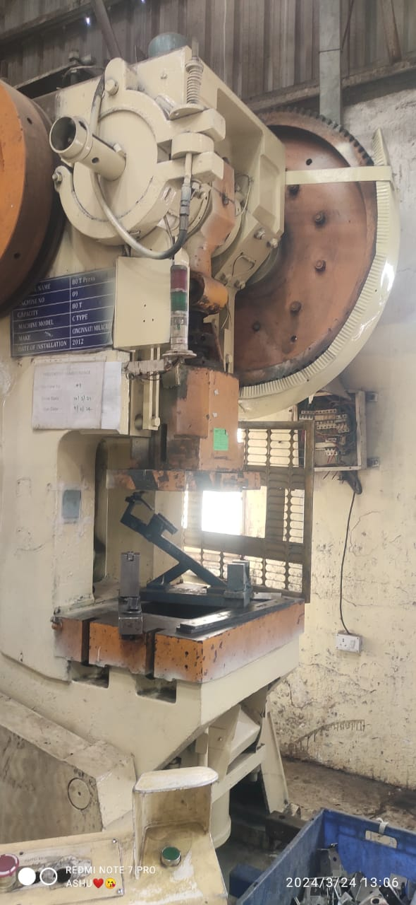

PROBLEMS :

1. main motor line broken:

Protecting against overvoltage and overload is critical for
maintaining the integrity and functionality of equipment in a
robotic weld cell:
1. Overvoltage Protection: Install surge protection devices to
safeguard against damage caused by voltage surges. These
devices are designed to divert excess voltage away from
sensitive components, preventing electrical failures and
potential downtime.
2. Overload Protection: Implement overload protection
systems to safeguard motors and other components from
excessive mechanical loads. These systems monitor voltage
and current levels, automatically shutting down or adjusting
operations if predeﬁned thresholds are exceeded. Regularly
check voltage and current levels for signs of electrical
overload, and consider recent process changes that may
contribute to mechanical overload.

2. pressure relay not work:

To ensure the optimal performance and longevity of the
relay in a robotic weld cell, follow these best practices:
1. Secure Mounting: Install the relay securely and away from
areas prone to shock or vibration to minimize mechanical
stress.
2. Regular Maintenance: Adhere to the manufacturer's
guidelines for cleaning, adjusting, and lubricating the relay
to prevent degradation over time.
3. Lifecycle Considerations: Monitor the relay's lifespan and
consider replacing it if it's approaching the end of its service
life to prevent unexpected failures.
4. Prevent Contamination: Keep the relay free from
contaminants, as they can cause premature failures.
Regular cleaning and inspection can help mitigate this risk.
5. Proper Usage: Use the relay within its speciﬁed load
capacity and avoid dropping or disassembling it, which can
lead to damage.
6. Wiring Inspection: Regularly check the control circuit to
ensure it provides the correct voltage, current, and proper
wiring connections to the relay.
7. Relay Coil Veriﬁcation: Verify that the relay coil receives
the appropriate voltage to ensure proper functioning.

SOLUTION:

1. Main motor line maintenance shoud be done periodically.

2 .Adjusting air pressure.

CONCLUSION:
Absolutely, you've highlighted some key beneﬁts of applying
Lean management principles within an organization. Let's break
down some of these beneﬁts:
Improved
Flexibility
and
Quality
of
Operations:
Lean
management focuses on streamlining processes and eliminating
waste, which enhances the organization's ability to adapt to
changes in demand and market conditions while also improving
the quality of products or services.
1. Reduction of Inventory: By implementing Lean practices
such
as
Just-in-Time
(JIT)
inventory
management,
organizations can minimize excess inventory levels, reduce
storage costs, and improve cash ﬂow.
2. Enhanced Process Functionality: Lean methodologies help
identify and eliminate ineﬃciencies in processes, leading to
smoother operations and improved overall performance.
3. Elimination
of
Non-Value-Adding
Activities:
Lean
management targets activities that do not contribute to
value creation and aims to eliminate or reduce them,
thereby optimizing resources and improving eﬃciency.
4. Better Utilization of Human Resources: Lean principles
empower
employees
to
contribute
ideas
for
process
improvement,
leading
to
increased
engagement,
productivity, and job satisfaction.
5. Improved
Organization
of
Work:
By
standardizing
processes and creating visual management systems, Lean
management helps organize work in a way that is more
eﬃcient and easier to understand, reducing errors and
delays.
6. Increased Customer Satisfaction: Ultimately, by delivering
higher quality products or services, with shorter lead times
and
greater
responsiveness
to
customer
needs,
Lean
management contributes to increased customer satisfaction
and loyalty.

Regarding the Kaizen method, you've rightly pointed out its
eﬀectiveness in problem-solving and continuous improvement.
Kaizen, with its focus on small, incremental changes driven by
both qualitative and quantitative data, is a powerful tool for
addressing various challenges across diﬀerent industries. Its
versatility and applicability make it a valuable asset for
organizations
striving
for
continuous
improvement
and
excellence in their operations.

