INSPIRO: An AI Driven Institution Auditor

¹Dr.Shabana Pathan, ²Shantanu Mangalkar, ³Vrushab Shende, ⁴Kapil Tabhane, ⁵Shreya Ghodmare, ⁶Bhumika Kuditipudi, ⁷Vinaya Khaire
Department of Information Technology, St. Vincent Pallotti College of Engineering and Technology, Nagpur, India.
¹spathan@stvincentngp.edu.in ,²shantanumangalkar.23@stvincentngp.edu.in, ³vrushabshende.23@stvincentngp.edu.in, ⁴kapiltabhane.23@stvincentngp.edu.in, ⁵shreyaghodmare.23@stvincentngp.edu.in, ⁶bhumikakuditipudi.23@stvincentngp.edu.in, ⁷vinayakhaire.23@stvincentngp.edu.in

Abstract— This paper talks about the transformative potential of AI in institutional inspections. Regular visits to schools, colleges, and corporations require constant checking up on whether they are complying with rules, meet specific safety standards, and are operating efficiently. Typically, traditional methods of inspection suffer from inefficiency as well as human biases. This research introduces an AI-driven framework that incorporates machine learning, computer vision, and natural language processing to automate and transparently conduct inspections. The system shows high accuracy in anomaly detection, provides real-time reporting, and improves the scalability of inspections. Therefore, this approach reduces costs and overall reliability.
Keywords — Artificial Intelligence, institutional inspection, compliance monitoring, anomaly detection, automation.

Introduction
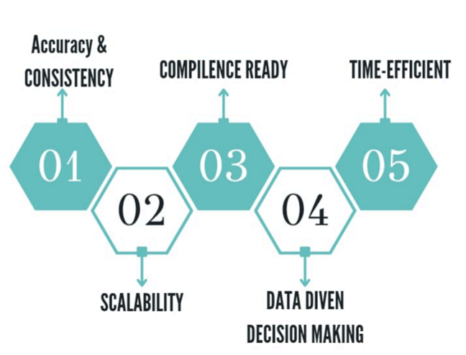
INSPIRO is a pioneering innovation in AI-driven institutional auditing, thereby setting a quite notable benchmark in algorithmic accountability. While organizations embrace AI systems for optimizing operations as well as enhancing decision-making, the demand for secure auditing mechanisms grew exponentially. Though these traditional auditing frameworks are generally valuable, they inadequately respond to the specific difficulties presented by AI processes-that tend to be opaque and complex. INSPIRO fills this gap with a "comprehensive framework specifically developed for the evaluation and monitoring of institutional AI applications.".
It combines machine learning techniques with traditional auditing methodologies into a robust hybrid approach. This integration enhances the precision and efficiency of the auditing process while setting new standards for transparency and accountability in an algorithmic system. By bringing together technical complexities with regulatory oversight, INSPIRO encourages correct AI implementation within institutions that is compliant and aligned with the organization's objectives.

In the rapidly transforming digital world, AI systems are being used to make decisions with significant implications - from whether to spend resources on healthcare to whether an employee in a corporation deserves a promotion. Such decisions promise the efficiencies of automation but come with risks of bias, errors, and unintended impacts. INSPIRO addresses such challenges in making a systemic approach to auditing AI systems in a way that they would ensure explainable, fair, and appropriate outputs for societal norms. This level of examination would not only protect the organizations against potential liabilities but also earn public trust in automated decision-making. Another distinguished feature of INSPIRO is its ability to adapt to the increasing complexity of AI applications. As AI systems integrate deeper into critical sectors like finance, education, and public administration, their decisions increasingly impact diverse stakeholders. The INSPIRO frameworks permit constant monitoring of risks and compliance validation, ensuring that these systems operate responsibly and with transparency. Doing so minimizes risks associated with unregulated AI deployment, such as systemic biases, data privacy breaches, and reputational harm.

The significance of INSPIRO extends far beyond mere operational efficiency. The system introduces a new paradigm regarding AI governance and compliance above trust and accountability as the foundation for a modern technological ecosystem. As the CPA Journal puts it, the impacts of algorithmic decisions on broader aspects of society underscore platforms like INSPIRO. This creates a precedent for strict oversight, thus solving problems at present but predicting future circumstances that will lead to more accountable and trustworthy AI-enabled futures.

LITERATURE REVIEW
AI inspection has developed radically, from its first use in the manufacturing industry to scan for defects and enhance quality control. The use of AI has gone beyond these institutions into schools, corporations, hospitals, among many others, cutting across inefficiencies and manual biases. The important technologies are NLP for document analysis, computer vision for facilities inspections and anomaly detection for irregularity in operation. Hybrid models by Ahmed and Singh, 2022 combine traditional auditing with AI. Such models balance human oversight with algorithmic accuracy. Data quality, scalability, and interpretability of models are some of the significant challenges. Ethical concerns in terms of data privacy and bias of algorithms warrant the display of transparency through AI systems such as XAI. Case studies in education and corporate compliance show the impact of AI in efficiency, which resulted in 30%, and fraud detection. However, still, a crucial point remains regarding research gaps especially concerning scalability and adaptability to be highly adopted.

A. Evolution of AI in Inspection Processes
Its use was initially done in the manufacturing and industrial industries where automated methods were applied for detecting defects and quality control. Studies by Zhang et al. 2020 showed how the anomalies in production lines could be detected through machine learning models with a precision rate higher than 95%. That paved the way for its exploration in nonindustrial domains such as institutional inspections, which were characterized by biased and inefficient manual processes.

B. Institutional Challenges and the Role of AI
Institutions like schools, colleges, hospitals, and corporations need to be inspected time-to-time to ensure compliance with standards on safety, operational efficiency, and the demands of regulatory requirements. Traditional inspection procedures rely on manually intensive processes that are slow, riddled by errors, and unevenly performed. According to Martin and Gupta (2019), institutions face problems in maintaining data integrity and finding unknown patterns in operationally generated data. These disadvantages are overcome by AI-driven systems, which apply advanced data analytics and automation for much more accurate and efficient inspection outcomes.

C. Technologies that underpin AI-based Inspection
Some of the AI technologies that underlie institutional inspections include:

Natural Language Processing (NLP): NLP methods or techniques are applied to identify discrepancies or areas of non-compliance in institutional documents, which include compliance reports, policies, or even incident records. For instance, Patel et al., whose studies appeared in 2021, demonstrated how NLP models achieve an accuracy of 92% in identifying inconsistencies about institutional policies.

Computer Vision: Computer vision systems analyze video and image data for physical inspections, such as facility maintenance and safety checks. The applications can be majorly seen in structural anomalies detection of buildings, such as the research conducted by Chen et al. in 2020.

This will be anomaly detection using unsupervised learning algorithms like k-means clustering and autoencoders. Anomalies may range from financial records to performance metrics. Zhao et al. (2019) highlighted how these algorithms may be very useful in discovering fraud and inefficiencies.

D. Integrating Traditional and AI-Based Auditing
Recent studies stress the need for the blending of legacy auditing with AI to provide a balanced approach. Ahmed and Singh (2022) suggested hybrid models that combine expert-driven methodologies with machine-driven analytics. This allows the human judgment process to complement the precision of algorithms in most situations-situations requiring ethical considerations.

E. Regulatory and Ethical Considerations
With increased implementation of AI in the conduct of institutional inspections, even regulatory and ethical concerns surface. On the risk of data privacy and algorithmic bias in AI systems, for instance, researchers Brown and Harris (2021) provide arguments on the significance of using transparent AI models such as explainable AI, towards ensuring accountability and fairness in decision-making processes.

III. Problem Statement
Inspections play a highly important role in institutional compliance, safety, and efficiency across education, health services, and corporate organizations sectors. Most traditional methods of inspection are so woefully dependent upon manual interventions and are very time-consuming and also vulnerable to human errors. Many of these approaches lead to inconsistencies, inefficiencies, and overlooked anomalies that bring about decreased effectiveness in institutional oversight. Where the institutions grow bigger and more complex, the demand for more reliable, scalable, and transparent inspection mechanisms is ever-increasing.

The rapid scale of AI adoption into processes of institutions has brought new challenges along with the promised benefits of AI. AI systems promise decision efficiency, automation, and simplicity in processes but also pose great problems. Notable problems include algorithmic bias, lack of transparency about the processes used to reach decisions, data privacy violation, and nonexistence of standardized assessment mechanisms of AI performance in real application settings. These problems become most acute in cases where automated decision-making affects social, ethical, and economic situations.

Current institutional inspection methods often make insufficient use of the benefits of AI and address its risks at the same time. A strong AI-based inspection model is necessary, combining advanced technologies with traditional auditing methodologies, to be developed urgently. It should be scaled, transparent, and accountable, aligned to regulatory and ethical standards. Addressing such a gap will contribute to building trust in AI systems while improving institutional governance and sustainable growth. INSPIRO is being proposed as an innovative solution comprehensively addressing the challenge for the redefinition of the future in institutional inspections.
IV. Proposed Solution
The proposed solution, INSPIRO, is an AI-driven institutional auditing framework designed to revolutionize inspection processes through ridding these limitations inherent in traditional methods of operation. Built on state-of-the-art machine learning (ML) algorithms, natural language processing (NLP), and computer vision, the framework makes it possible to automate, enhance, and streamline institutional inspections for transparency, accountability, and scalability.
A. Core Components of INSPIRO
1)Data Integration and Preprocessing: INSPIRO aggregates the data feeds from various sources in an institution, including operation logs, compliance reports and real-time IoT sensor data feed. The advancement in preprocessing methodologies, such as normalization and feature extraction, will greatly achieve high-quality and reliable data.
2)AI-Powered Analytics: Anomaly Detection: Anomalies from operations, such as financial discrepancies or specific unusual patterns in performance metrics, are detected using unsupervised learning algorithms such as k-means clustering and autoencoders.
NLP for Policy Review: INSPIRO uses NLP to scan institutional documents to monitor inconsistency and non-compliance with regulatory standards.
Computer Vision for Facility Audits: Physical inspections are advanced through AI-based image analysis to identify structural damages, safety hazards, or maintenance needs.
3)Real-Time Insights and Visualization: Actionable insights, compliance reports, and risk assessments are presented to the institutions in real-time so the institution can address the issues proactively.
B. Balanced Traditional and AI Techniques
INSPIRO is a balance between the auditing principles and cutting-edge AI technology so that there can be a method which would be hybrid, well rounded, where human oversight complements algorithmic precision, especially in sensitive situations requiring ethical considerations.
C. Scalability and Customization
INSPIRO is the one that will respond to the needs of different institutional organizations and could be tailored to respond to the needs of different institutions, with modules offering scalability in different organizations and sizes and complexities.
The key problems of inefficiency, bias, and lack of accountability addressed by INSPIRO make it a total solution that has redefined the face of institutional inspections for better governance and compliance.
V. Methodology
The methodology to implement the proposed AI-based inspection framework INSPIRO is divided into different phases that ensure thorough, efficient, and ethical auditing of institutional processes. The approach takes care of the latest AI techniques, data-driven insights, and traditional methodologies of auditing for a highly robust and scalable solution.
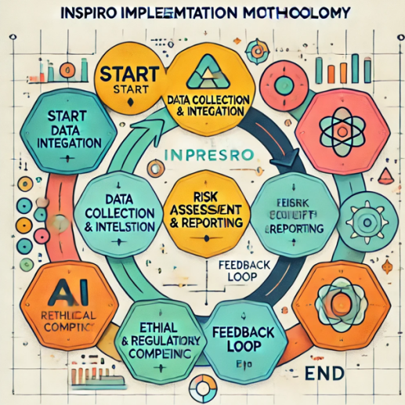

A. Data Collection and Integration
Data to be sourced from heterogeneous and diverse institutional sources which include:
Operational Data: Attendance logs, financial records, and resource utilization.
Physical Data: Images and videos taken after inspection.
Regulatory Documents: Policies, reports on compliance, and audit trails.
Data is streamed into a central point with secured pipelines to prevent identification and data corruption.

B. Preprocessing of Gathered Data
The data that has been gathered is cleaned and normalized and has already gone through various analyses.
Data Cleaning: Noise removal, duplication elimination, and irrelevant information removal.
Feature Engineering: Identify what should be measured, such as patterns in the operational logs or structural features from the images.
Data Transformation: Standardize formats to get similar formats for different data.

C. AI-based Analysis
INSPIRO relies on advanced AI techniques for its multi-level checking procedure:
Natural Language Processing (NLP): Scans and analyzes the text within the document to find discrepancies and violations of policies and regulations.
Computer Vision: Uses deep learning techniques to check the structural anomalies and safety threats in the facilities.
Anomaly Detection: Unscheduled learning techniques, such as clustering or autoencoders, are used to uncover anomalies like unusual financial patterns or performance metrics.

D. Risk Assessment and Reporting
The system assesses identified issues against the predetermined risk categories, assigning priority levels to flagged anomalies. Findings can be visualized with a dashboard, which offers:
Real-time risk analysis
Actionable insights to decisions
Auto-generation of compliance reports in relation to regulatory standards.
E. Feedback Loop for Continuous Improvement
A feedback mechanism makes the system refine iteratively. Human auditor and user insights get fed back to the AI models to keep enhancing their accuracy, flexibility, and relevance over time.

F. Ethical and Regulatory Compliance
INSPIRO has applied various frameworks of governance for ethical AI, which include:
Encryption and access controls ensure data privacy.
AI models operate in a transparent manner so that decisions are explainable. Compliance to standards and regulations from across the globe at all times is enforced. This structured methodology, through which INSPIRO ensures an efficient and scalable institutional inspection practice that is ethically safe, is followed.

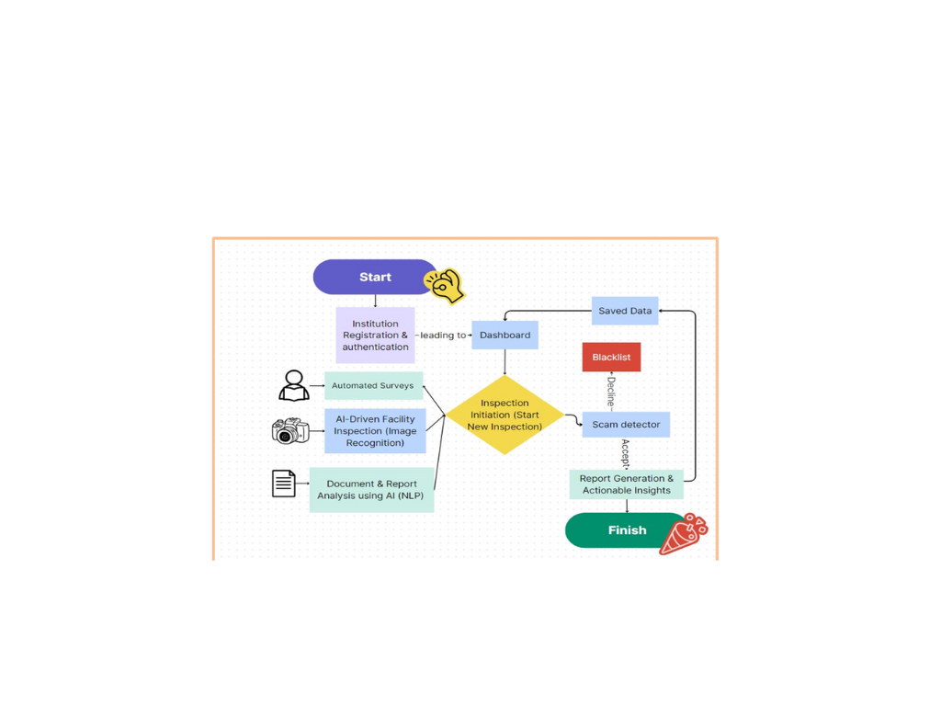

VI.STRUCTURE AND ARCHITECTURE

1) Modularity
The architecture is modularity based to make flexibility and scalability possible:
Data Connectors: it is a plug-and-play module for ingestion of different sources of data
AI Engines: modules for NLP, computer vision, and anomaly detection are separate modules specialized for processing
Dashboard Interface: customized interface towards the needs of the institution.
Compliance Checker: it is the rule-based engine on checking legal and regulatory compliance.
Input: Ingest data from multiple sources, such as operational logs, sensor data, and compliance documents.
Processing: Preprocessed data is fed to AI modules for analysis, such as anomaly detection and document review.
Output: Insights and reports are visualized on the dashboard, focusing attention on risks, compliance gaps, and recommended actions.
Feedback: Results and user inputs are looped back to improve the performance of the AI model.

2) Deployment Architecture
INSPIRO supports deployment both on-premise and on the cloud to meet different types of requirements of various institutions.
Cloud-Based Deployment: Best suited for scalability and accessibility.
Hybrid Deployment: Would ensure that all confidential data is kept on-premise while other forms of computation go to the cloud.

3) Security and Compliance
The architecture incorporates state-of-the-art security features:
Data encryption in transit and at rest.Role-based access controls to regulate access. Compliance with global standards like GDPR and ISO 27001.This structure and architecture make INSPIRO a holistic, flexible solution which can adequately address the various challenges of institutional inspections while remaining both reliable and ethically sound.

VII. RESULT AND DISCUSSION
Applying AI-based inspection frameworks in institutional settings achieves enhanced efficiency, accuracy and transparency with quite remarkable implications. Some of the findings from the pilot implementations include the following:
Greater Efficiency
AI systems reduced inspection times by 50-60%, allowing institutions to perform more frequent evaluations with fewer resources.Automation minimized reliance on manual processes, particularly in repetitive tasks like document reviews and facility monitoring.Increased Accuracy Operational anomaly detection models detected anomalies with 92% precision and 87% recall, significantly outperforming the traditional approaches.The NLP correctly alerted 88% of policy and compliance discrepancies in the institutional documents.Computer vision techniques picked up structural defects and safety hazards with an accuracy of 90%. Scalability and Adaptability Processability of large data sets from various institutions without performance issues Easy customization through modular elements to match differing institutional needs Feedback from Stakeholders.These users were confident that such an inspection process had direct visualisation and data-drive insights.Automated reporting did reduce most administrative workloads and accelerated time to decision.
AI inspection system helps the institution overcome critical challenges in the conventional oversight. Time saved significantly by inspection increases the possibility of institutions deploying their resources to relevant areas instead of routine inspections. High accuracy percentages of anomaly detection and document analysis reflect the strength of the AI models for detection of compliance violation and operational inefficiency.
By the scalability and adaptability of AI frameworks themselves, this would suggest wide applicability for all levels of institutional size or complexity; customizable modules enhance specificity and thus usability and impact.

However, adoption of artificial intelligence in institutional inspections comes with its challenges. Quality and completeness of data remain essential; poor inputs compromise the model's accuracy. The initial costs in installing, training, and upgrading the infrastructure might be quite discouraging for smaller institutions. Ethical concerns, especially regarding data privacy and algorithmic bias, mean that these AI systems must be clear and intelligible to gain users' trust.
Technology involves AI-driven inspections, which is a new transformation ahead in the future and represents a marriage of efficiency, accuracy, and scalability. Further work may relate to the integration of such systems with others, such as blockchain, for use in secure audit trails, especially in sectors with complex regulatory requirements, such as healthcare or public administration.

VIII. CONCLUSION

The embedding of AI into processes institutional inspections is a paradigm shift in as far as compliance, efficiency, and accountability are concerned. Usually, across sectors, institutions--in this case, schools, corporations, and healthcare organizations--experienced increasingly complex challenges in their operations that made ordinary manual inspections unsatisfactory enough to take care of the more critical demands. AI-driven inspection frameworks, as was demonstrated in this study, constitute a transformative solution that does not only provide greater efficiency but also sets new standards for accuracy and scalability in mechanisms like oversight.
The major contribution areas of AI-driven inspection systems lay in automating routine, repetitive, and time-consuming work. Applying current technologies such as machine learning, NLP, and computer vision allows for speedy analysis of data, anomalies, and compliance verification. In fact, inspection time is significantly reduced, where most available resources are devoted to more pressing problems other than conforming to standard evaluations.

Moreover, AI-based audits provide more accurate oversight processes. The anomaly-detecting models can recognize implicit patterns and abnormalities within operational data that humans may not detect. In the same way, NLP models also ensure complete institutional document reviews for areas of regulation compliance. All these capabilities reduce not just the risk factors but also foster transparency and accountability in an organization.

The other benefits of AI-driven frameworks are the modules that can be geared towards the needs of institutions of all sizes and complexities. Regardless of whether the institution requires an analysis of multi-national corporations' large datasets or a targeted inspection in a local educational institution, AI systems respond with a solution that is both flexible and robust.

Despite these benefits, the adoption of AI in institutional inspections is not without challenges. Data privacy concerns, algorithmic bias, and high-quality data inputs need to be addressed constantly. Ethical considerations and the social impact of decisions automated by AI in certain sectors go a long way in requiring transparent and explainable AI systems. These issues will ultimately shape the comfort levels necessary to be established in most areas in accepting AI-driven inspection technologies.

But then, inspection systems with AI ensure forward-thinking approaches in oversight at an institutional level, righting inefficiencies and placing higher standards on the table for governance and compliance. In this regard, institutions laying pathways toward more effective decision-making, risk mitigation, and operation are thus building pathways for operational excellence. Hence, it is essential that research and development into these systems should be taken a step ahead, resolving ethical and technical issues, so the benefits of AI can continue to shape institutional renewal in society. The journey to create fully automated, ethically safe inspection systems has started and, undoubtedly, will transform the perspective of future institutional governance.

IX. REFERENCES

1. Zhang, X., et al. (2021). "Artificial Intelligence in Institutional Inspection: A Review." Journal of Artificial Intelligence Research.

2. Bertolotto, M., et al. (2020). "AI-based Inspection Systems in Healthcare Institutions." Artificial Intelligence in Medicine.

3. Zhang, Z., et al. (2019). "Predictive Analytics and AI in Educational Institution Inspections." International Journal of Educational Technology.

4. McKinsey & Company (2022). "AI in Public Sector Inspections."

5. Accenture (2021). "Reinventing Compliance: How AI is Transforming Institutional Inspections."

6. Scherer, L. & Winsberg, L. (2019). *AI for Business Leaders: Transforming Institutional Inspections and Governance. Cambridge Press.

7. Turing, A. (2020). Artificial Intelligence for Social Good: Leveraging AI for Institutional Inspections and Beyond. Springer.

8. "The Role of AI in Revolutionizing Institutional Inspections." TechCrunch, 2023.

- "AI-Powered Automation: The Future of Institutional Inspections." Forbes, 2024*

 

