BATTEN DISEASE
(NEURONAL CEROID LIPOFUSCINOSES, NCL)
Author Details

Kalpana K, Ph.D scholar Assistant Professor,
Bhaarath College of Nursing, Chennai
Dr.S. Vasantha, Principal, Bhaarath College of Nursing, Chennai
Dr.Abirami.M, Vice Principal, Bhaarath College of Nuring, Chennai

Postal Address:
Kalpana K, Ph.D scholar Assistant Professor,
Bhaarath College of Nursing,
Agaram Main road, Selaiyur,Chennai-600073
Phone No: 9962901954
Email Id:kkalpana.nursing@bnch.in

BATTEN DISEASE
(NEURONAL CEROID LIPOFUSCINOSES, NCL)
Kalpana K, Ph.D scholar Assistant Professor,Bhaarath College of Nursing, Chennai
Dr.S. Vasantha, Principal, Bhaarath College of Nursing, Chennai
Dr.Abirami.M, Vice Principal, Bhaarath College of Nuring, Chennai

ABSTRACT:
Batten disease is the common name for a broad class of infrequent, fatal, inherited disorders of the Central nervous system also known as neuronal ceroid lipofuscinoses. In these diseases, a defect in a specific gene triggers a cascade of problems that interferes with a cell’s ability to recycle certain molecules. The disease has several forms that share few of unchanging features and symptoms but vary in severity and age when symptoms first start to appear. Each form is caused by a mutation in a different gene. Although “Batten disease” originally referred specifically to the juvenile-onset form of NCL, the term Batten disease is increasingly used to describe all forms of NCL. Children with the infantile or late-infantile forms usually show symptoms earlier than age 1 year. Common symptoms for most of the forms include vision loss, seizures, delay and eventual loss of skills previously acquired, dementia, and abnormal movements. As the disease progresses, children may develop one or more symptoms including personality and behaviour changes, clumsiness, learning difficulties, poor concentration, confusion, anxiety, difficulty sleeping, involuntary movements, and slow movement. Over time, affected children may suffer from worsening seizures and progressive loss of language, speech, intellectual abilities (dementia), and motor skills. Eventually, children with Batten disease become blind, wheelchair bound, bedridden, unable to communicate, and lose all cognitive functions. There is no cure for these disorders but a treatment for one of the forms (CLN2 disease) has been approved by the U.S. Food and Drug Administration
KEYWORDS: Batten disease, Neuronal ceroid lipofuscinoses, Dementia, neurodegenerative disease, clinical course, dementia, juvenile.

BATTEN DISEASE
(NEURONAL CEROID LIPOFUSCINOSES, NCL)
Kalpana K, Ph.D scholar
Assistant Professor, Department of Child Health Nursing
Bhaarath College of Nursing, Chennai
Dr.S. Vasantha, Principal, Department of Obstetrics and Gynaecology Nursing
Dr.Abirami.M, Vice Principal, Department of Mental Health Nursing
Bhaarath College of Nursing, Chennai
ABSTRACT:
Batten disease is the common name for a broad class of infrequent, fatal, inherited disorders of the Central nervous system also known as neuronal ceroid lipofuscinoses. In these diseases, a defect in a specific gene triggers a cascade of problems that interferes with a cell’s ability to recycle certain molecules. The disease has several forms that share few of unchanging features and symptoms but vary in severity and age when symptoms first start to appear. Each form is caused by a mutation in a different gene. Although “Batten disease” originally referred specifically to the juvenile-onset form of NCL, the term Batten disease is increasingly used to describe all forms of NCL. Children with the infantile or late-infantile forms usually show symptoms earlier than age 1 year. Common symptoms for most of the forms include vision loss, seizures, delay and eventual loss of skills previously acquired, dementia, and abnormal movements. As the disease progresses, children may develop one or more symptoms including personality and behaviour changes, clumsiness, learning difficulties, poor concentration, confusion, anxiety, difficulty sleeping, involuntary movements, and slow movement. Over time, affected children may suffer from worsening seizures and progressive loss of language, speech, intellectual abilities (dementia), and motor skills. Eventually, children with Batten disease become blind, wheelchair bound, bedridden, unable to communicate, and lose all cognitive functions. There is no cure for these disorders but a treatment for one of the forms (CLN2 disease) has been approved by the U.S. Food and Drug Administration .
KEYWORDS: Batten disease, Neuronal ceroid lipofuscinoses, Dementia, neurodegenerative disease, clinical course, dementia, juvenile.
INTRODUCTION:
Batten disease is the name for a group of hereditary disorders that usually start in childhood and interfere with a cell's ability to recycle a cellular residue called lipofuscin. Batten is commonly being used to describe the many forms of the disease, called neuronal ceroid lipofuscinosis. The many forms of the disease are classified by the gene that causes the disorder with each gene being called CLN (ceroid lipofucinosis, neuronal) and given a different number as its subtype. Because of the different gene mutations, signs and symptoms range in severity and progress at different rates. Symptoms generally include:
- progressive vision loss leading to blindness,
- seizures,
- movement disorder, and
- Dementia.
Developmental skills such as standing, walking, and talking may not be achieved or gradually lost. Other symptoms which continue to worsen over time include learning difficulties, poor concentration and progressive loss of language skills and speech. Most children become bedridden and unable to communicate, develop problems sleeping. (K., July-Sept.,2014)
CAUSES:
Batten disease is an inherited disorder that appears to affect the function of tiny bodies inside cells named lysosomes. Lysosomes are the “recycle bin” of the cell and continually break down waste, proteins and naturally occurring fatty compounds called lipids into smaller components that can be discarded out of the cell or recycled. Lipids include fatty acids, oils, waxes, and sterols. In Batten disease/NCLs, the mutated genes do not produce the proper amounts of proteins important for lysosomal function (Mole, 2020).Each gene (representing a form of the disease) provides information for a specific protein that is in turn, defective and not produced. These proteins are needed for brain cells (neurons) and other cells to work efficiently. The lack of a functional protein causes the abnormal build-up of “junk” material in the lysosomes—as well as the abnormal build-up of the residue called lipofuscin that occurs naturally as part of the lysosomal breakdown of lipids. It is not known whether the lipofuscin itself is toxic or if the build-up is a marker of impaired lysosomal function.

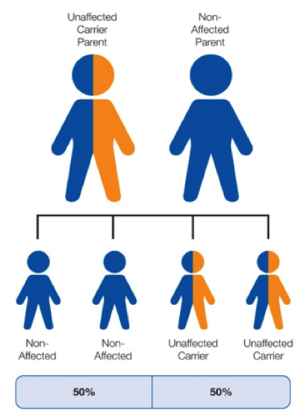
Fig 1 : Inheritance of Batten Disease

SYMPTOMS:
Over period, Batten disease damages the brain and central nervous system. There are four main types and their common symptoms are:
- Seizures
- Changes in personality and behaviour
- Dementia
- Speech and motor skills problems that get worse over period
As the condition progresses, symptoms may worsen and include:
- mood or behaviour changes
- movement or gross motor issues
- muscle spasms or tics
- confusion
- learning difficulties
- total vision loss
- heart problems
- paralysis
- parkinsonism
- spasticity

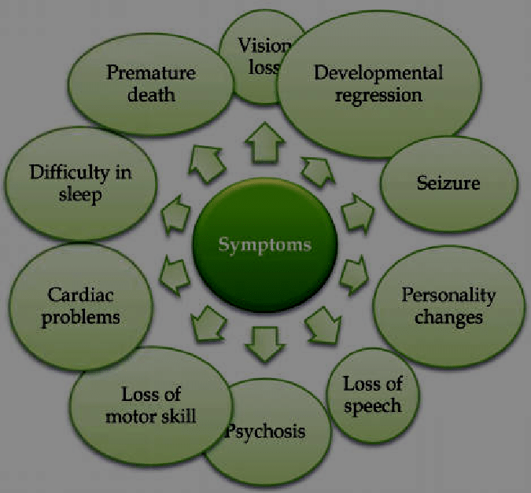

Fig 2 : Symptoms of Batten Disease
CLASSIFICATION:

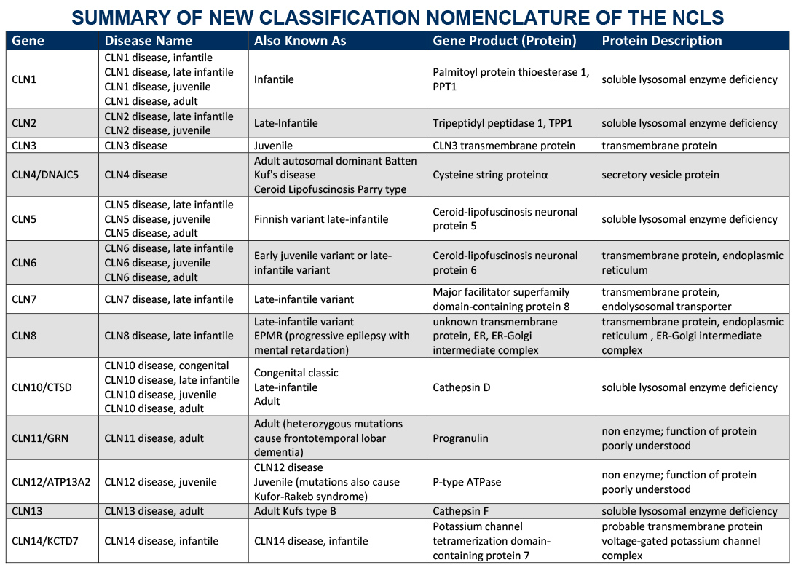

Table 1 : Classification of Batten Disease (Dolisca SB, 2013 Sep;28(9))

DIAGNOSIS:
Genetic testing - Presence of mutated gene that causes NCL disease and prenatal diagnosis of the disease

Measurement of enzyme activity - used to confirm or rule out CLN1 and CLN2 disease
Blood Test - presence of abnormal white blood cells that contain holes called vacuolated lymphocytes (common to certain disease mutations).
Urine test - Elevated levels of a chemical called dolichol are found in the urine of many individuals with NCL

Skin or tissue sampling - shows different shapes formed by lipofuscin accumulation—some look like half-moons , others appear like fingerprint.

Electroencephalograms (EEG) - monitor brain activity through the skull, using electrodes that are placed on the scalp. Tell-tale patterns in the brain's electrical activity suggest an individual has seizures , patterns along with findings on the exam and clinical history may be strongly suggestive of a specific type of NCL disease.

Diagnostic imaging using computed tomography (CT) and magnetic resonance imaging (MRI) scans can help doctors look for changes in the brain's appearance.

Electro retinograms - can identify various eye problems common in several NCLs. The greenish-yellow colour of lipofuscins can sometimes be detected by examining the back of the eye.

Fig 3: Classification of Batten Disease

TREATMENT:
Enzyme replacement therapy
The only treatment approved by the U.S. Food and Drug Administration to treat Batten disease is Brineura (cerliponase alfa), an enzyme replacement therapy designed to slow the loss of walking ability in children with a type of Batten disease called CLN2. This treatment replaces TPP1, the enzyme that is mutated in this type of Batten.
Anti-convulsants
Seizures can sometimes be controlled or reduced using anti-convulsant therapies, such as valproic acid and lamotrigine alone or in combination with clonazepam. These work by reducing the brain activity that causes convulsions. Other anti-convulsant therapies include carbamazepine, oxcarbazepine, and phenytoin.
Immunosuppressants
Immunosuppressive treatments for Batten disease have shown some promise in preclinical studies, but many of these are not recommended for use in children, especially long term. One immune suppressant that has been approved for use in children is CellCept (mycophenolate mofetil).
Experimental therapies
Gene therapy could be a treatment for Batten disease in the form of permanent enzyme replacement. Giving patients an injection of a modified virus that inserts a functional copy of the mutated gene into their cells could “heal” the diseased cells.
Stem cell therapies are another potentially viable treatment option. They involve transplanting healthy human stem cells into the cerebrospinal fluid, the fluid that surrounds the brain and spinal cord. Donor cells could slow or halt the progression of Batten disease. Stem cell transplants would require immunosuppressive treatments to prevent rejection of donor cells. (Tarczyluk & Cooper, 2015)
Other experimental treatments include PLX-200, a therapy that increases the expression of an enzyme lacking in Batten disease, and PLX-100, which is a combination of PLX-200 and retinoic acid.
Other therapies
Physiotherapy and occupational therapy improves patient’s quality of life and mobility. Some studies have indicated treating children with vitamins C and E in combination with diets low in vitamin A, could delay the onset of Batten disease, but not change the outcome.

DIFFERENTIAL DIAGNOSIS:
Differentials include cone-rod dystrophy, inherited retinal dystrophy like Stargardt disease, optic neuropathy, metabolic diseases, mitochondrial disease and ITO syndrome (Bhattacharya Ranjan, Dec 2014)
PROGNOSIS:
Over time affected children suffer cognitive impairment, worsening seizure, progressive loss of sight and motor skills. Children with Batten disease become blind, bedridden and have dementia. Children with Batten disease have a greatly shortened life expectancy. Children with infantile Batten disease often die in early childhood. Children with later onset forms of the disease may live into their teens to thirties, while those who develop the disease in adulthood may have a normal life expectancy.
REFERENCES:
- Batten Disease fact sheet HTTPS://www.ninds.nih.gov. Retrieved 30 November 2020.
- Hobert JA,Dawson G (October 2006). "Neuronal ceroid lipofuscinoses therapeutic strategies: past, present and future". Biochimica et Biophysica Acta (BBA) - Molecular Basis of Disease. 1762 (10): 945–53.
- Rakejha D, Narayan SB, Bennett MJ (September 2007). "Juvenile neuronal ceroid-lipofuscinosis (Batten disease): a brief review and update". Current Molecular Medicine. 7 (6): 603–8
- COOPER JD (June 2008). "Moving towards therapies for juvenile Batten disease?". Experimental Neurology. 211 (2):329–1
- Mole Sare E.; Williams, Ruth E. (1993). "Neuronal Ceroid-Lipofuscinoses – RETIRED CHAPTER, FOR HISTORICAL REFERENCE ONLY". GeneReviews. University of Washington, Seattle.
- Cialone J, Adams H, Augustine EF, et al. (May 2012). "Females experience a more severe disease course in Batten disease". Journal of Inherited Metabolic Disease. 35 (3): 549–55.
- Simonati, A; Williams, RE (2022). "Neuronal Ceroid Lipofuscinosis: The Multifaceted Approach to the Clinical Issues, an Overview". Frontiers in Neurology. 13: 811686. .
- Bozorg, S; Ramirez-Montealegre, D; Chung, M; Pearce, DA (July 2009). "Juvenile neuronal ceroid lipofuscinosis (JNCL) and the eye". Survey of Ophthalmology. 54 (4): 463–71.
- Chena, Angus (October 15, 2019). "A Drug Was Made For Just One Child, Raising Hopes About Future Of Tailored Medicine". Retrieved May 30, 2020.
- Batten (1902). "Cerebral degeneration with symmetrical changes in the maculae in two members of a family". Transactions of the Ophthalmological Societies of the United Kingdom. 23: 386–90.
- (Bhattacharya Ranjan, Dec 2014)
- Worgalll S, Sondhi D, Hackett NR, et al. (May 2008). "Treatment of late infantile neuronal ceroid lipofuscinosis by CNS administration of a serotype 2 adeno-associated virus expressing CLN2 cDNA". Human Gene Therapy. 19 (5): 463–74.
- First recipient of new Batten's disease stem cell cure well enough to go home • PET". PET. 9 June 2009. Retrieved 22 June 2022.
- Neuronal Ceroid Lipofuscinoses: Background, Etiology, Epidemiology [Internet]. [cited 2017 Jun 29]. Available from: http://emedicine.medscape.com/article/1178391-overview
- Bhattacharya Ranjan, C. S. (Dec 2014). A Unique Case of Ito Syndrome presenting with Juvenile Myoclonic Epilepsy and Normal Intelligence. Asian Journal of Nursing Education and Research, 417-420.
- Dolisca SB, M. M. (2013 Sep;28(9)). Batten disease: clinical aspects, molecular mechanisms, translational science, and future directions. J Child Neurol., 1074-100.
- K., A. k. (July-Sept.,2014). An Insight into Assessment and Management of Dementia. . Int. J. Adv. Nur. Management 2(3), 180-182.

