Energy Optimization in water distribution system and pump scheduling

Abstract-Efficient management of water distribution systems are critical for providing consistent water supply while reducing energy usage and operational expenses. This research proposes a unique method for improving water distribution and pump scheduling. The suggested system leverages ultrasonic sensors to monitor water levels in storage tanks, then dynamically changes pump operation and valve settings depending on real-time demand and tank levels. A mobile application gives users remote access to system controls, allowing them to work from anywhere. By combining sensor data with intelligent algorithms, the system optimizes pump scheduling to fulfill water demand while conserving energy and lowering system losses. The creation and implementation of such a system have tremendous potential to improve the performance and sustainability of water distribution networks.
Muthuramalingam E¹, Dharshini S², Jeevan Kumar S³
¹Assistant Professor, Electronics and Instrumentation Engineering, Kumaraguru college of Technology, Coimbatore - 641049, Tamilnadu.
^{2,3} Bachelor of Engineering - Electronics and Instrumentation, Kumaraguru college of Technology, Coimbatore - 641049, Tamilnadu.

Keywords— Pump scheduling, optimization algorithm, IoT, Remote management.

I. INTRODUCTION

A. Proposed Idea
The proposed idea is to implement a smart water distribution system that uses ultrasonic sensors to monitor water levels and a mobile app to regulate pump scheduling and solenoid valves, improving water distribution. Because of increasing in population and the requirement for the water around the world increases, the distribution of water without being wasted or distributed at proper time is quite difficult. Due to manual scheduling of water causes the improper supply in terms of in quantity and time. In this new age of modern world, there is no adequate data available on the internet for analysing the issues like damage in distribution lines, improper consumption, and theft during supply and so on. Through optimization algorithms and real-time data integration, it is possible to enhance energy efficiency, minimize expenses, and ensure the sustainable management of water resources for the population needs.
Optimized water distribution system is more dependable and resilient to demand and supply variations. The probability of system failures, such as pressure drops or water shortages,
can be reduced by monitoring system parameters perpetually and modifying pump operations and valve settings as needed. Optimized systems assist conserve natural resources and minimize greenhouse gas emissions related with water treatment and distribution by reducing energy usage and water waste. Regardless of the location, water utility operators may access system data and control features in real time via mobile applications. This allows operators to remotely monitor system performance, valve operations, which improves operational efficiency and responsiveness.

B. Objectives
- To uniformly distribute the water in required area and minimize the usage of water to the required quantity to prevent water imbalance by efficient use of pump scheduling.
- This system typically involves sourcing water from a treatment plant, pressurizing it using pumps, and then distributing it through a network of pipes to consumers.
- With the help of optimization system, we aim to minimize water wastage and losses within the distribution system.
- By accurately monitoring water levels, controlling pumps and valves based on demand, and promptly addressing leaks or inefficiencies, the goal is to conserve water resources and promote sustainable water management practices.

II. LITERATURE SURVEY

[1] Water-saving issues have garnered more attention in recent years. This study presents the introduction of the particle swarm optimization (PSO) method, an evolutionary approach for optimising water distribution systems. This algorithm solves a typical benchmark problem of the New York water distribution system. Additionally, the optimization technique is utilized to pick various diameters and estimate their costs. The outcome of the experiment confirms that the suggested optimization strategy is effective. [2] The majority of applied optimization issues include many objectives that need to be completed concurrently while adhering to certain restrictions. The problem becomes significantly more complicated when the choice factors are discrete. The current study presents a multi-objective model to address the discrete variable optimisation issue in the water distribution network. A mixed discrete nonlinear programming formulation of the issue exists. To solve the problem, a novel particle swarm optimisation approach is put forth. [3] Hydraulic limits have been taken into consideration to save costs, making water distribution network optimisation one of the most important challenges that scientists have ever considered. Considering other scientists' attempts to mimic uncertainties in various systems, fuzzy uncertainty is modelled in this work using the fuzzy technique. Devices in the water distribution network are also optimised by the application of the Pattern Search algorithm. We may investigate cost changes, heads in nodes, velocity, and discharge pipes, which are known as dependent variables, by using the friction coefficient in the Darcy-Weisbach equation, a demand in nodes, and tank head as independent fuzzy parameters. [4] A model for the optimization of water distribution networks (WDN) is described in this paper. Verification of node pressures, head losses, and fluid flow rate and velocity in each pipe may be done using the created model. The approach, which considers both real and discrete variables and uses objective function penalization to prevent premature convergence to local optima, is based on particle swarm optimization (PSO). The model produces the pipe velocities, node pressures, and the lowest possible network cost. The created model's applicability is tested on a few benchmark challenges, considering WDN for small, medium, and large-scale issues. The results obtained align with the findings reported in the literature. [5] The design optimization of an actual water distribution system using genetic algorithms (GAs) is described in the study. The GA is a method of searching that mimics nature's constant quest for better answers and is based on the evolutionary process. The Newton approach is used for the network's hydraulic analysis, and the GA optimization methodology is used to solve the optimal network design problem for pipe networks. The GA model is modified in this work to optimize pipe sizes. The design of a water distribution system that satisfies nodal pressure limitations is carried out. The suggested method's effectiveness is evaluated on an operational network. Egypt's Suez City network is the subject of the case study. [6] Over the last ten years, several scholars have applied evolutionary techniques to optimum design challenges pertaining to water supply systems (WSS). Among these evolutionary methods is Particle Swarm Optimisation (PSO), which has been effectively adapted despite being primarily created for the treatment of continuous variable optimization issues. in different situations to discrete variable issues. In this study, we used one of the algorithm's variations on two case studies: the water supply tunnel system in New York City and the water distribution network in Hanoi. These two scenarios are common in the relevant literature and offer two typical networks for comparative analysis.

III. METHODS AND MATERIALS

A. Hardware setup

A pipeline, along with a water tank and pump system, has been installed in the laboratory.
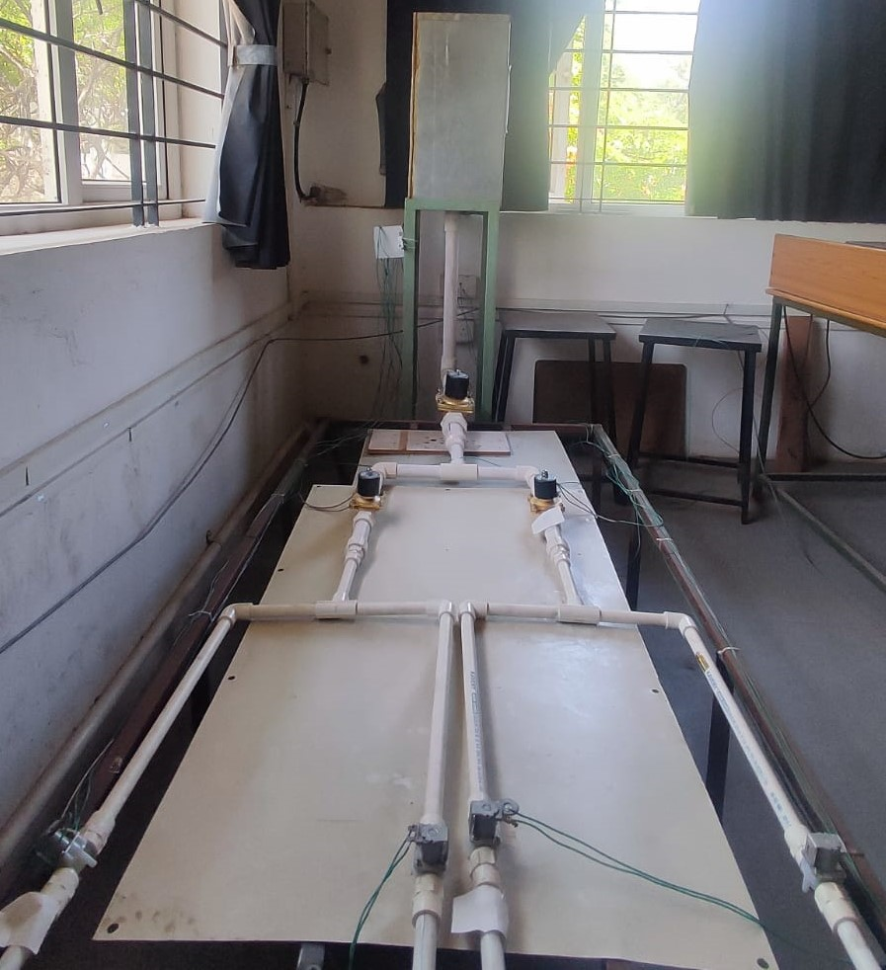

Fig. 1. Hardware setup

The Hardware setup in Fig. 1 has a pipeline with control valve and ultrasonic sensors are mounted at the top the tank.

B. Project working
The project’s functionality begins with pump scheduling and optimizing water distribution system. The pump scheduling has been done using controller and sensor. Ultrasonic sensors are mounted at the top of the main tank and outlet tanks.
Sensors are connected to the controller raspberry pi in which level of the water in the tanks has been monitored. The relay modules are connected to the raspberry pi that controls (on and off) the control valve connected with the pipeline. Based on the water level of the tank, the control valve has been turned on and off. For this, we consider maximum and minimum level of the tank, when the water level reaches the minimum value, the relay start energised, and the control valve is turned on. Once the water level reaches the maximum valve, the relay gets deenergised and the control valve is turned off.
The control valve has been turned on and off by using mobile phone through IoT based remote monitoring and controlling. This has been done using blynk mobile app in which it is restricted to less than five features. It consists of internet access like Ethernet, Wi-Fi module etc. Blynk app has separate server and libraries and no laptop are required. Integration of Internet of Things (IoT) devices and cloud computing platforms to enable seamless communication, data exchange, and remote access to system components. IoT devices facilitate connectivity between sensors, actuators, and the mobile application, while cloud platforms provide scalable storage, processing, and analysis capabilities for large volumes of data.

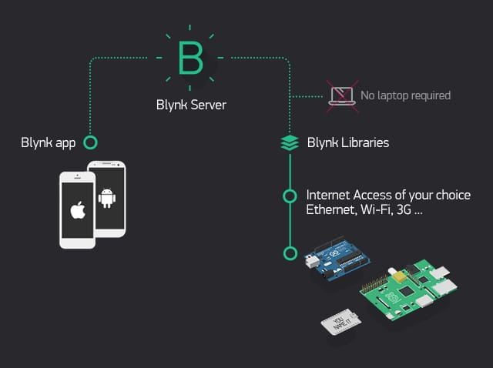

Fig. 2. Mobile app
ACOAs are inspired by the fact that ants are able to find the shortest route between their nest and a food
source, even though they are almost blind. This is accomplished by using pheromone (chemical) trails as a form
of indirect communication. Ants deposit pheromone trails whenever they travel. The path taken by individual
ants from the nest in search for a food source is essentially random (Dorigo et al. 1996). However, when many
ants are searching for a food source simultaneously, the paths taken are affected by the pheromone trails laid by
other ants. When ants encounter pheromone trails, there is a higher probability that trails with higher pheromone
intensities will be chosen. As more ants travel on paths with higher pheromone intensities, the pheromone on
these paths builds up further, making it more likely to be chosen by other ants. The way this form of positive
3
reinforcement can be used to find the shortest path between the nest and a food source can bes

ACOAs are inspired by the fact that ants are able to find the shortest route between their nest and a food
source, even though they are almost blind.
ACOAs are inspired by the fact that ants are able to find the shortest route between their nest and a food
source, even though they are almost blind.
ACOAs are inspired by the fact that ants are able to find the shortest route between their nest and a food
source, even though they are almost blind.
ACOAs are inspired by the fact that ants are able to find the shortest route between their nest and a food
source, even though they are almost blind.
ACOAs are inspired by the fact that ants are able to find the shortest route between their nest and a food
source, even though they are almost blind.
ACOAs are inspired by the fact that ants are able to find the shortest route between their nest and a food
source, even though they are almost blind.
ACOAs are inspired by the fact that ants are able to find the shortest route between their nest and a food
source, even though they are almost blind.
ACOAs are inspired by the fact that ants are able to find the shortest route between their nest and a food
source, even though they are almost blind.
ACOAs are inspired by the fact that ants are able to find the shortest route between their nest and a food
source, even though they are almost blind.
ACOAs are inspired by the fact that ants are able to find the shortest route between their nest and a food
source, even though they are almost blind.
ACOAs are inspired by the fact that ants are able to find the shortest route between their nest and a food
source, even though they are almost blind.
ACOAs are inspired by the fact that ants are able to find the shortest route between their nest and a food
source, even though they are almost blind.
ACOAs are inspired by the fact that ants are able to find the shortest route between their nest and a food
source, even though they are almost blind.
ACOAs are inspired by the fact that ants are able to find the shortest route between their nest and a food
source, even though they are almost blind.
ACOAs are inspired by the fact that ants are able to find the shortest route between their nest and a food
source, even though they are almost blind.
ACOAs are inspired by the fact that ants are able to find the shortest route between their nest and a food
source, even though they are almost blind.
ACOAs are inspired by the fact that ants are able to find the shortest route between their nest and a food
source, even though they are almost blind.
ACOAs are inspired by the fact that ants are able to find the shortest route between their nest and a food
source, even though they are almost blind.
ACOAs are inspired by the fact that ants are able to find the shortest route between their nest and a food
source, even though they are almost blind.
ACOAs are inspired by the fact that ants are able to find the shortest route between their nest and a food
source, even though they are almost blind.
ACOAs are inspired by the fact that ants are able to find the shortest route between their nest and a food
source, even though they are almost blind.
ACOAs are inspired by the fact that ants are able to find the shortest route between their nest and a food
source, even though they are almost blind.
ACOAs are inspired by the fact that ants are able to find the shortest route between their nest and a food
source, even though they are almost blind.
ACOAs are inspired by the fact that ants are able to find the shortest route between their nest and a food
source, even though they are almost blind.
ACOAs are inspired by the fact that ants are able to find the shortest route between their nest and a food
source, even though they are almost blind.
ACOAs are inspired by the fact that ants are able to find the shortest route between their nest and a food
source, even though they are almost blind.
ACOAs are inspired by the fact that ants are able to find the shortest route between their nest and a food
source, even though they are almost blind.
ACOAs are inspired by the fact that ants are able to find the shortest route between their nest and a food
source, even though they are almost blind.
ACOAs are inspired by the fact that ants are able to find the shortest route between their nest and a food
source, even though they are almost blind.
Ant colony optimization algorithms are driven by the fact that ants can locate the shortest path between their nest and a food source while being almost blind. This is performed by employing pheromone (chemical) trails as a means of indirect communication. Ants leave pheromone trails wherever they travel. Individual ants' paths from the colony to a food source are largely unpredictable. However, when many ants are looking for food at the same time, the pathways they follow are influenced by the pheromone trails left by other ants. When ants see pheromone trails, they are more likely to choose those with greater pheromone concentrations. As more ants travel along pathways with greater pheromone intensities, the pheromone on these paths accumulates, increasing the probability that more ants would choose it. This type of positive reinforcement can be best employed to identify the shortest path between the nest and a food supply.
In the ant colony algorithm, the current node determines the next node based on the pheromone concentration of the route and the node's energy. The pheromone concentration of a particular path grows dramatically as more ants travel through it. However, when the pheromone concentration is high, the energy of the node in the route rapidly decreases. Suppose there are two paths, one with a high pheromone concentration and a low residual energy of the node, and the other with a low pheromone concentration and a high residual energy.
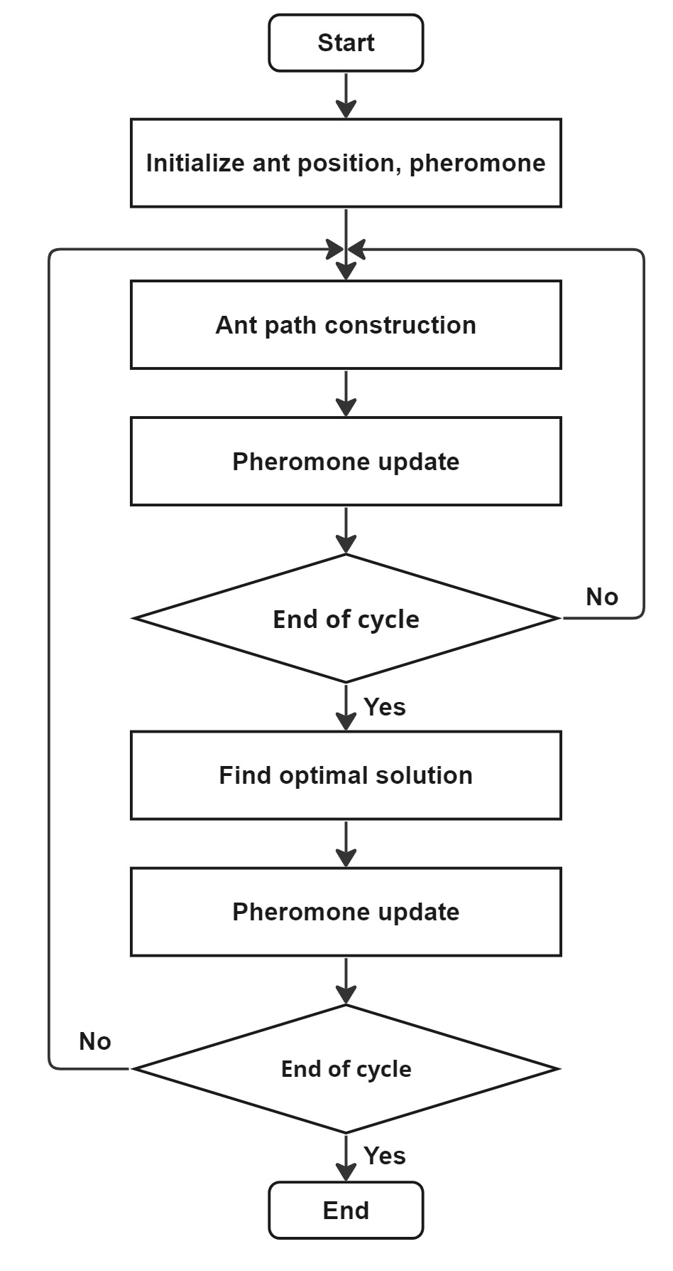

Fig. 3. Flow chart of ACO

According to the traditional ant colony algorithm, ants will continue to choose the path with a high pheromone concentration, and the energy of the node on the path will become extremely low. However, the ants will choose the path with high node residual energy even if the pheromone concentration of that path is relatively low. When the node energy falls below a particular threshold, the current path's pheromone volatilization rate should be raised. When other ants cross this trail, the pheromone concentration rises. Additionally, when the node's leftover energy falls below a certain level, it alerts its neighbour node. As a result, this node has no chance of being picked by its adjacent nodes as the next hop node.

C. Block diagram
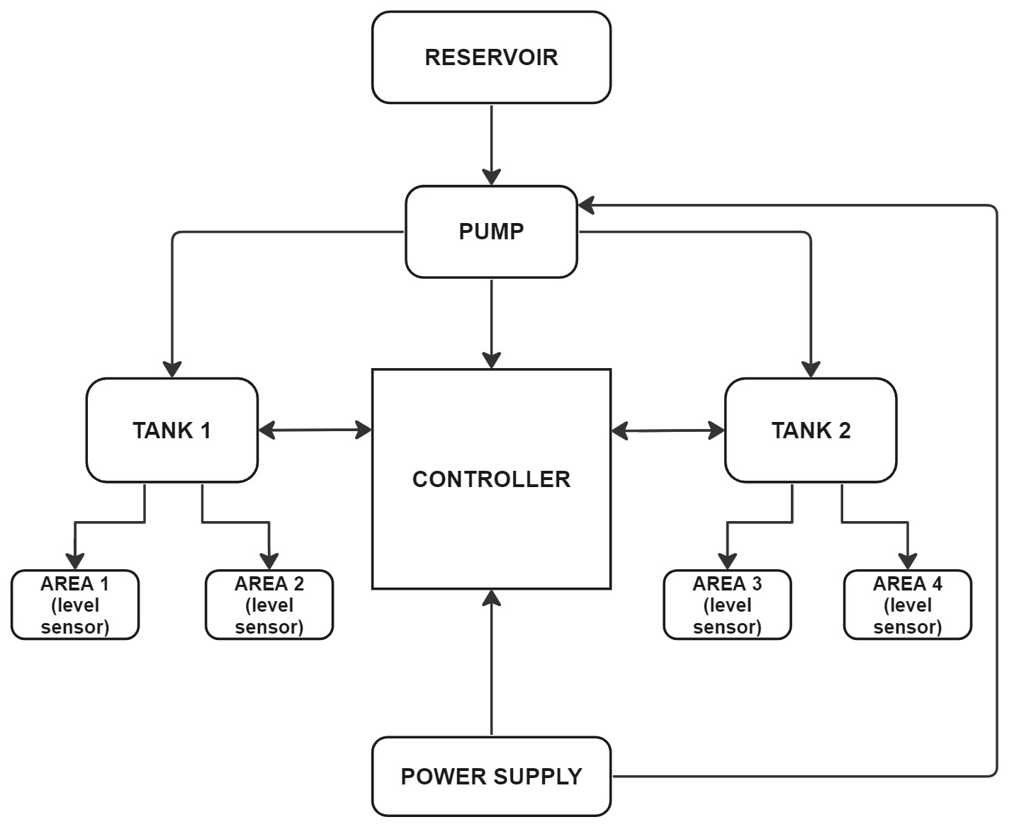

Fig. 4. Block Diagram

D. Components required

1. Controller - Raspberry pi
Raspberry Pi supports various connectivity options including Wi-Fi, Bluetooth, and Ethernet, enabling seamless integration with sensors, actuators, and other devices within the water distribution system. It has Broadcom BCM2837B0, Cortex-A53 (ARMv8) 64-bit SoC @ 1.4GHz 1GB LPDDR2 SDRAM 2.4GHz and 5GHz IEEE 802.11.b/g/n/ac wireless LAN, Bluetooth 4.2, Extended 40-pin GPIO header, 5V/2.5A DC power input. This connectivity facilitates data acquisition, communication, and remote-control functionalities. Raspberry Pi consumes relatively low power, making it suitable for deployment in energy-efficient systems. This is particularly advantageous for projects aiming to minimize energy consumption and operational costs in water distribution systems.

2. Ultrasonic sensor
Ultrasonic sensors do not require direct contact with the water surface to measure its level. This non-contact nature eliminates the need for physical probes or sensors to be immersed in the water, reducing maintenance requirements and potential contamination risks. This sensor provides accuracy and is essential for optimizing pump scheduling and ensuring adequate water supply to meet demand. They can be mounted above the water surface and aimed directly at the target area, simplifying installation, and reducing deployment time. In ultrasonic sensor, one acts as a transmitter that converts the electrical signal into 40 KHz ultrasonic sound pulses. The other acts as a receiver and listens for the transmitted pulses. When the receiver receives these pulses, it produces an output pulse whose width is proportional to the distance of the object in front. This sensor provides excellent non-contact range detection between 2 cm to 400 cm (~13 feet) with an accuracy of 3 mm.

3. Relay
Relays provide a means to control the operation of pumps and valves within the water distribution system. They act as switches that can be remotely activated or deactivated to turn equipment on or off as needed. The operating voltage required to energize the relay coil is 5V DC. This means that when a 5V DC signal is applied to the relay coil, it activates the switch mechanism inside the relay. A typical 5V relay might have contacts rated for switching currents up to 10A at 250V AC or 30V DC. This means it can handle up to 10 amps of current at 250 volts AC or 30 volts DC. In the context of optimization through a mobile application, relays can be controlled remotely via wireless communication protocols such as Wi-Fi or Bluetooth. This allows operators to adjust pump schedules and valve operations from a mobile device, providing greater flexibility and convenience.

4. Solenoid valve
Solenoid valve has Plugged External Leakage and Controllable Internal Leakage Provide Safer Operation. It also has simple operation with easy network connectivity, lightweight responsiveness, energy-saving performance 4. limited regulation accuracy & applicable mediums. It provides Versatile Performance & Wide Application Range. The port size is 3/4” inch female NPT threaded. This Electric Solenoid Valve has 2 way normally closed valve type and can handle low viscosity fluids below 20 cSt. The orifice size is 20mm and the Cv value is 7.6. It can withstand pressure up to 115 psi (8 bar) and temperatures as low as 15°F and as high as 250°F.

5. Centrifugal pump
Centrifugal pumps are known for their efficiency in moving large volumes of water with relatively low energy consumption. A 0.5 HP pump is suitable for applications where moderate flow rates are required, making it efficient for water distribution systems. Three-phase motors, commonly used in centrifugal pumps, allow for variable speed control. By adjusting the motor speed, operators can optimize pump performance based on fluctuating demand, system conditions, or energy efficiency requirements. This pump provides a balance between flow rate and energy consumption, offering flexibility to adapt to varying demand levels within the water distribution system. This allows for efficient operation under different operating conditions without excessive energy usage.

IV. SIMULATION

This project has been simulated using EPANET software in order find the flow rate and pressure of water. EPANET allows to create detailed models of water distribution networks, including pipes, pumps, valves, tanks, and demand nodes. EPANET can be used to predict water demand patterns within the distribution system based on historical data, population growth projections, and other factors. This information is essential for optimizing pump scheduling and valve control to meet fluctuating demand while minimizing energy consumption and operational costs.

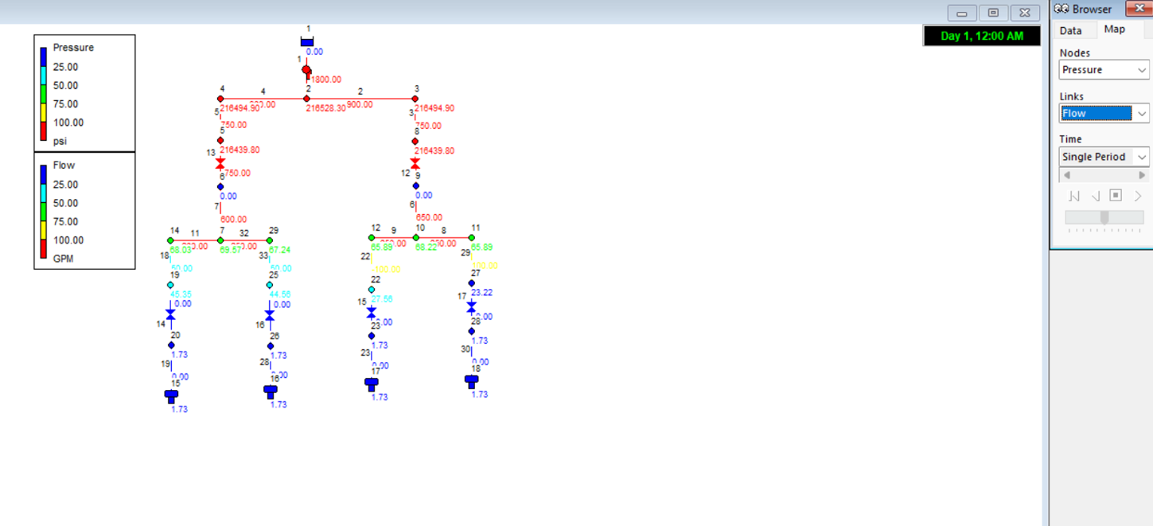
Fig. 5. Flow rate

V. RESULTS AND DISCUSSION

A. Advantages
- Enhanced energy efficiency, leading to cost savings.
- Improved system performance with smoother operation.
- Resilience to demand and energy price variations.
- Superior performance compared to traditional methods.

B. Result
The utilization of the ant colony optimization method with mobile application presents a promising avenue for enhancing energy efficiency and lowering costs within water distribution systems. The flow rate has been analyzed using a EPANET software which has been used for optimization. By leveraging adaptive behavior and collective intelligence, this technique optimizes pump scheduling, thereby improving system performance while conserving energy. Through its implementation, water utilities stand to benefit from significant cost savings and operational effectiveness, ensuring a consistent water supply for customers and bolstering the sustainability and economics of water management.

C. Future Scope
- Integration with emerging smart infrastructure technologies will enable real-time monitoring, control, and optimization of water distribution systems. This integration will allow for greater automation, improved data accuracy, and enhanced system responsiveness.
- Features such as augmented reality (AR) visualization, predictive analytics, and decision support tools will empower operators to make informed decisions on the go.
- Integration with smart grid technologies will enable synergies between water distribution systems and energy networks. By coordinating pump operations with energy demand and renewable energy generation, optimization efforts can maximize energy efficiency, reduce costs, and promote sustainability.

VI. REFERENCES

[1] Nianjia Wei1 et.al (2021), Modeling and Optimization of Pumps Scheduling Considering the Time-of-use Electricity Tariff.
[2] Van Zyl, J.E.; Savic, D.A.; Walters, G.A. Operational optimization of water distribution systems using a hybrid genetic algorithm. J. Water Res. Plan. Man. 2004.
[3] Abdallah, M., and Kapelan, Z., 2017. Iterative extended lexicographic goal programming method for fast and optimal pump scheduling in water distribution networks. Journal of Water Resources Planning and Management, 143.
[4] Behandish, M., and Wu, Z., 2014. Concurrent pump scheduling and storage level optimization using meta-models and evolutionary algorithms. Procedia Engineering.
[5] Jung, D., Kang, D., Kang, M., and Kim, B., 2014. Real-time pump scheduling for water transmission systems: Case study. KSCE Journal of Civil Engineering.
[6] Tsai, F., Katiyar, V., Toy, D., and Goff, R., 2008. Conjunctive management of large-scale pressurized water distribution and groundwater systems in semiarid area with parallel genetic algorithm. Water Resources Management.
[7] A.C. Zecchin, A.R. Simpson, H.R. Maier, J.B. Nixon (2005). Parametric study for an algorithm applied to water distribution system optimization. IEEE transaction evolutionary computation. Vol.9,175-195.
[8] Yazdi (2016). Decomposition based multi objective evolutionary algorithms for design of large-scale water distribution networks water-resource. International journal of engineering research & technology.Vol.30,2789-2766.
[9] Qing shung, Chao Ran huang, Jun wang (2017). Optimization water distribution networks design for resisting cascading failures. Journal of institution of engineers, Singapore.Vol.3.
[10] Sujeet Rote, Adarsh Mourya, Prof.Abhimanyu Yadav, Tanmay Oak (2017). Automatic water distribution system using PLC. International journal of engineering research. Vol.6, Issue.04.

