ACKNOWLEDGEMENT

First of all we thank the Almighty for strengthening us throughout the Miniproject and helping us to complete it successfully.

We find immense pleasure to convey our sincere thanks to our honorable Principal Dr.P.ALLI , for providing necessary facilities in carrying out our project work in our campus.

We would like to express our hearty thanks to our Dean (Academics) and Head of the Department Dr.A SHANMUGA LATHA, M.E., Ph.D., for her constant encouragement.

We take this opportunity to express our sincere and heartfelt thanks to our guide, Mrs . R SARANYA ,B.E., M.E., for her patient guidance, timely suggestion technical and moral support and the immense part of her dedication in completing the project work successfully.

We express our special thanks to other staff members of our department, the non-teaching staff and our friends who assisted us, by their support and encouragement.

We also express our special thanks to our Parents who have sacrificed greatly in our education and welfare. We thank all those who have helped directly and indirectly in doing this project and bringing out this successful report.
ABSTRACT
Solar energy is the most abundant stream of energy. It is available directly as solar isolation and indirectly as wind energy, ocean thermal energy, geothermal energy, tidal energy, wave energy etc. Solar energy has the sources of renewable energy. Its potential is 178 Billion MW, which is about 20,000 times the world’s demand. Sun sends out energy in the form of electromagnets radiation.
In this project we use the solar energy for generation of electrical energy, by using the Solar cells. The solar cells receive the solar energy. The solar cells operate on the photo-electric energy by using solar cells principle. The energy from the cells is used to switch ON the lights.At present solar electric power generation systems are having fixed solar panels whose efficiency of generation is less. The aim of the project is to introduce the SOLAR TRACKING to the existing fixed solar panels, thus we are maintaining the constant maximum power output. Thus by using this tracking system we can increase the conversion efficiency of the solar electric power generation.

LIST OF CONTENTS
CHAPTER NO. | TITLE | PAGE NO.
 | ACKNOWLEDGEMENT | 1
 | ABSTRACT | 2
 | LIST OF CONTENTS | 3
1 | INTRODUCTION | 5
 | 1.1 General | 5
 | 1.2 Objective | 6
 | 1.3 Existing method | 7
2 | LITERATURE SURVEY | 8
3 | PROPOSED SYSTEM | 12

 | 3.1 Block diagram | 12
 | 3.2 Circuit description | 15
 | 3.3 Resistance network | 17
4 | MODULE DESCRIPTION | 18
 | 4.1 Power supply | 18
 | 4.2 Arduino uno controller | 21
 | 4.3 LDR detector | 25
 | 4.4 Solar panel | 30
 | 4.5 L293 Motor Drive | 34
 | 4.6 DC – DC converter | 40
 | 4.7 LCD display | 46
5 | PCB DESIGN AND FABRICATION | 53
 | 5.1 Procedure for making the PCB | 53
6 | SOLDERING | 56
7 | ADVANTAGES AND APPLICATIONS | 58
8 | RESULTS AND DISCUSSION | 59
 | 6.1 Hardware implementation | 59
 | 6.2 Results | 60
 | 6.3 Cost estimation | 61
9 | CONCLUSION | 62
10 | REFERENCES | 63
11 | PUBLICATION

CHAPTER - 1
INTRODUCTION
  - GENERAL
In the actuality a lot of research work has been conducted to improve the use of the sun’s energy. The generation of electricity using photovoltaic solar cells has been one of the most researched and studied. Photovoltaic is the technology that uses solar cells or an array of them to convert solar light directly into electricity. The power produced by the array depends directly form factors that are not controlled by the human being as the cell’s temperature and solar irradiance. Usually the energy generated by these solar cells is used to provide electricity to a load and the remaining energy is saved into batteries. Photovoltaic cells have a single operating point where the values of the current and voltage of the cell result in a maximum power output. These values correspond to a particular resistance which is equal to the division of the maximum voltage and maximum current. By connecting the PV cell directly to a load or a battery, the output power can be severely reduced due to load mismatching or, in case of a battery, load voltage mismatching. Since this operating point depends on factors like temperature, solar irradiance and load impedance, a device capable of tracking the maximum power point and force the PVM to operate at that point is required. A maximum power point tracker (MPPT) is a device capable of search for the point of maximum power and, using moveable solar panel control system, extracts the maximum power available by the cell. By controlling the angle of the panel we can change the equivalent voltage of the cell and by that, its equivalent resistance into the one in which the PVM is in the maximum power operating point.

1.2 OBJECTIVE
The project uses a solar panel coupled to a motor to track the Sun so that maximum sun light is incident upon the panel at any given time of the day. This is better compared to light sensing method that may not be accurate always for example during cloudy days.
Solar energy is the most abundant stream of energy. It is available directly as solar isolation and indirectly as wind energy, ocean thermal energy, geothermal energy, tidal energy, wave energy etc. Solar energy has the sources of renewable energy. Its potential is 178 Billion MW, which is about 20,000 times the world’s demand. Sun sends out energy in the form of electromagnets radiation.
In this project we use the solar energy for generation of electrical energy, by using the Solar cells. The solar cells receive the solar energy. The solar cells operate on the photo-electric energy by using solar cells principle. The energy from the cells is used to switch ON the lights.
At present solar electric power generation systems are having fixed solar panels whose efficiency of generation is less. The aim of the project is to introduce the SOLAR TRACKING to the existing fixed solar panels, thus we are maintaining the constant maximum power output. Thus by using this tracking system we can increase the conversion efficiency of the solar electric power generation.
For this tracking purpose we use solar as a sensor and the input from the sensor is given to the micro controller and according to the program the panel is fixed to the maximum intensity position. Here we are using ARDUINO UNO micro controller. The ATMEGA328 is a low-power, high-performance CMOS 8-bit microcomputer with 32K bytes of Flash Programmable and Erasable Read Only Memory (PEROM).

1.3 EXISTING METHOD
- The design of Solar (photovoltaic) systems is becoming popular day by day.
- To maximize the power output of a solar (photovoltaic) system, we have to align the solar panel with the direction of the sun.
- This is the main drawback of the system till now.
- In remote areas the sun is the cheap source of electricity because instead of hydraulic generators it uses solar cells to produce electricity.
- While the output of the solar cell directly depends on the intensity of sunlight and the angle of incidence.
- It means to get the maximum efficiency; the solar panel must remain in front of sun during the whole day.

CHAPTER – 2

LITERATURE SURVEY
- AUTHOR: Khlaichom,P et al.
YEAR : August 2007
Observed the high-concentration solar requires the sun to be tracked with great precision for maximum output voltage. This paper trend in solar concentrator tracking system is to use an openloop local controller that computes the direction of the solar vector based on geographical location and time. But it is not sufficient accuracy because it has error from computing the sun’s position, mechanical, controller systems and installation. The genetic algorithms (GA) are one technique for solving these problems. In this research, Genetic algorithm increases the accuracy of solar tracking system by using wolf’s theory that receives maximum solar radiation, so the system becomes on-line. The system will manage machine to positions of each answer population from an initial set of accidental solutions and estimate by measure voltage from sensor, then produce the next generation by using intersect operator, mutation operator and selection. In the experimental, statistical method has a great for finding the best parameters of GA. The experiment result shows that the performance increases about 7.084% by using genetic algorithm.

- AUTHOR : Lorenzo,E et al.
YEAR : January 2002
Presented that solar tracking is used in large grid-connected photovoltaic plants to increase solar radiation collection for reducing the cost of delivered electricity. Single vertical axis tracking, also called azimuth tracking has a capacity for energy gains up to 40%, as compare with optimally tilted fully static arrays. This paper examined the theoretical aspects associated with the design process of azimuth tracking, by taking into account of shadowing between different trackers and back-tracking features. Single, horizontal, North–South-oriented axis tracking system is associated with flat-plate modules represent by far the most extended tracking solution in current PV plants. Because of their intrinsic lack of shadowing in the North–South direction, single tracking devices can be drive large surfaces and due to the horizontal axis position, wind loads tend to be relatively low It involves a particularly simple and strong mechanical construction, which is a great advantage of this type of tracking.

- AUTHOR : Helwa,N H et al.
YEAR : 2007
Provided that the output energy from any solar energy system depends on the solar energy input to that system. Solar energy input depends on the type of tracker, because every tracking system has distinct capacity of gaining the solar radiation. A practical study was carried out on different solar tracking systems. The layout of these systems consist of a fixed system facing south and tilted 400 a vertical-axis tracker, a 60 tilted-axis tracker, and a two-axis tracker. All the trackers depend on the microprocessor based controlled systems, and every system has photovoltaic arrays for electric energy generation. The performance of the different systems is based on a complete year input of solar radiation and the electric power output from them. The study also consists of the effect of some operating parameters on the tracking operation. This study showed that the collected solar energy as well as the electrical output energy of the tracking solar systems is more than that of the stationary system.
- AUTHOR: Chicco, G et al.
YEAR : 2008
Presented the performance of grid connected photovoltaic (PV) systems with parallel-connected converters. This paper concentrates the two paths for energy production. The first part concerns the evaluation of the energy production in Sun-tracking configurations, comparing their performance according to fixed PV systems. The second part is related to the harmonic characteristics of a number of converters in PV plants of various sizes. The PV plants of different types (in fixed or Sun-tracking configurations) are increasing diffusion and sizes (from a few kW to several MW) with inverter connection to the grid are requiring detailed analyses concerning their aggregation and the assessment of their performance. The Sun-tracking configurations are capable to provide significant increase in the energy production over fixed systems of equivalent characteristics, provided that the availability of the moving parts can be guaranteed and that mutual shading conditions are avoided. The harmonic and inter harmonic summation ratios have been used to represent the effect of harmonics and inter harmonics of different orders to the assessment of the total current of the PV aggregation. The use of a semi empirical approach for harmonic summation seems more suitable than other statistical techniques in order to create a reference model for evaluating the total current.

CHAPTER 3
PROPOSED SYSTEM

3.1 BLOCK DIAGRAM :

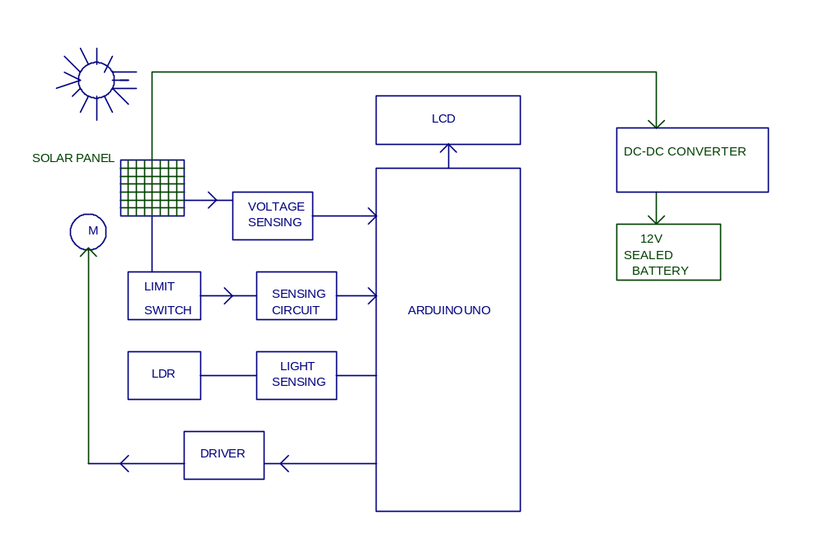 Fig.3.1 Block diagram
BLOCK DIAGRAM EXPLAINATION
In this project, we present an implementation of a maximum power point tracker, based in reaching a reference open circuit voltage, using a electro-mechanical controller to control the angle of the panel in order to force the PV module to operate at its maximum power point, for a given temperature and irradiance, to improve the utilization of the produced energy when connected to a load. For this case the load it’s a battery and a resistance.
In this project we use the solar energy for generation of electrical energy, by using the Solar cells. The solar cells receive the solar energy. The solar cells operate on the photo-electric energy by using solar cells principle. The energy from the cells is used to switch ON the lights.
At present solar electric power generation systems are having fixed solar panels whose efficiency of generation is less. The aim of the project is to introduce the SOLAR TRACKING to the existing fixed solar panels, thus we are maintaining the constant maximum power output. Thus by using this tracking system we can increase the conversion efficiency of the solar electric power generation.
For this tracking purpose we use solar as a sensor and the input from the sensor is given to the micro controller and according to the program the panel is fixed to the maximum intensity position. Here we are using ARDUINO UNO micro controller. The ATMEGA328 is a low-power, high-performance CMOS 8-bit microcomputer with 32K bytes of Flash Programmable and Erasable Read Only Memory (PEROM).

3.1.1 ARDUINO SOFTWARE(IDE):
The Arduino Uno is a microcontroller board based on the ATmega328 . It has 14 digital input/output pins (of which 6 can be used as PWM outputs), 6 analog inputs, a 16 MHz crystal oscillator, a USB connection, a power jack, an ICSP header, and a reset button.

3.1.2 LDR DETECTOR
Here we are using a light sensor which senses the light level emitted from the machines (spark). The output of this sensor is compared with a comparator circuit.
LDR is connected to the non-inverting input. At the same time we have to voltage divider a known reference value at the inverting input terminal. When LDR is subjected to light, its resistance become 10K .
3.1.3 VOLTAGE FOLLOWER
In this, voltage measurement circuit is used to sense the voltage in between the phase and neutral in 3 phase 4 wire system. Here 230V supply given to the input of the primary winding of the potential transformer. In this transformer connected to the rectifier and filter circuit.
3.1.4 SOLAR PANEL
The solar photovoltaic array consists of an appropriate number of solar cells connected in series or parallel to provide the required current and voltage. The array is oriented as to collect the maximum solar radiation throughout the year.
3.1.5 L293 MOTOR DRIVER
L293D is a typical Motor driver or Motor Driver IC which allows DC motor to drive on either direction. L293D is a 16-pin IC which can control a set of two DC motors simultaneously in any direction. It means that you can control two DC motor with a single L293D IC. Dual H-bridge Motor Driver integrated circuit (IC).

3.1.6 DC-DC CONVERTER
The DC-to-DC converters convert one level of DC voltage to another level. The operating voltage of different electronic devices such as ICs, MOSFET.
3.1.7 LIMIT SWITCH DEBOUNCING
For high frequency signal transfer through mechanical operated limit switch will create small surges. This surge will be considered as “1” state by the test sensing semi conductor IC’s.
3.1.8 DC MOTOR
A DC motor is an electric motor that runs on direct current (DC) electricity. In any electric motor, operation is based on simple electromagnetism. A simple 2-pole DC electric motor (here red represents a magnet or winding with a "North" polarization, while green represents a magnet or winding with a "South" polarization).
3.1.9 POWER SUPPLY 12VOLT
This power supply circuit is designed to get regulated output DC voltage. The 0-15 volt centre tape transformer is used to step down the main voltage (230v) into 15 volts. The secondary voltage of transformer is rectified using bridge rectifier.

3.2 CIRCUIT DESCRIPTION:
The mains AC voltage (230v) is step down to 15 volt, using 15v step down transformer. The low value secondary voltage is fed to the rectifier is formed using four no. of IN 4007. For first half cycle, Diodes D1 & D2 come to action and next half cycle diode D3 & D4 come to action, finally unidirectional DC supply is fed to the filter capacitor. The charging & discharging property of capacitor provide pure smooth DC is nearly peak value of the secondary voltage. The pure DC supply is fed to regulator IC’s input terminal. Due to the regulator action, finally the regulated 12volts is available at output terminals.
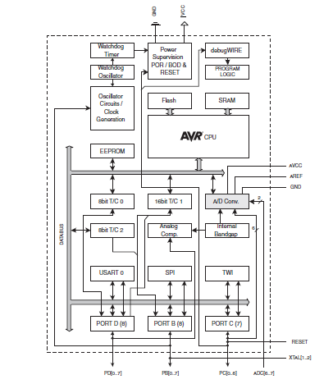
Fig.3.2 Circuit Description
3.3 RESISTANCE NETWORK

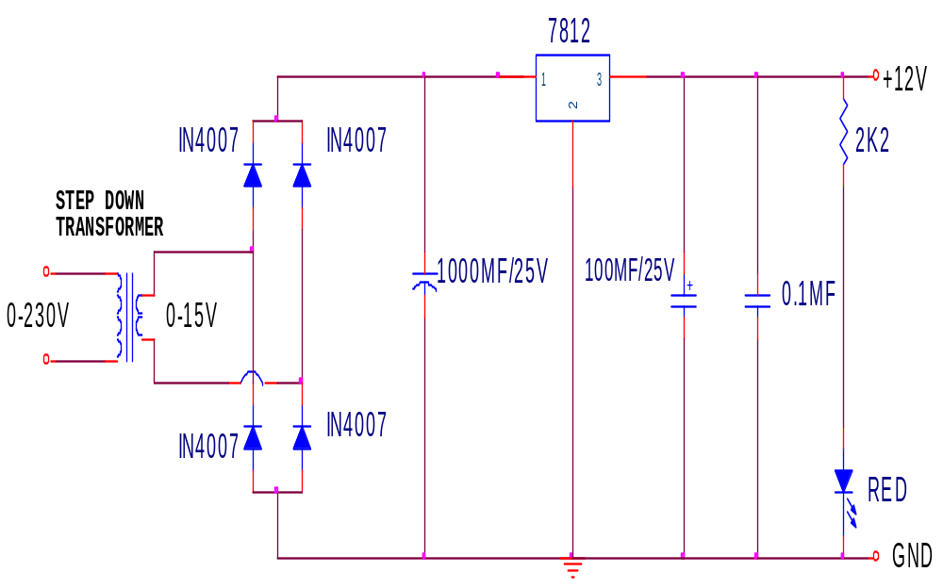
Fig 3.3 Resistance Network

CHAPTER – 4
MODULE DESCRIPTION

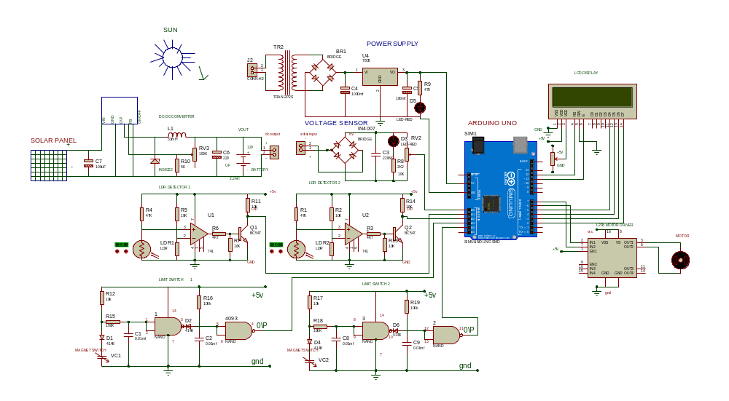
Fig 4.1 Module Description

CIRCUIT DIAGRAM DESCRIPTION
4.1 POWER SUPPLY
DEFINITION
It is an electronics unit. This is used to give regulated power to any electronics system.
BLOCK DIAGRAM DESCRIPTION
1. Transformer : This block consist step-down transformer
For our required ratings.
2. Rectifier : This block consist diode based rectifier
Circuit
3. Filter circuit : This block consist capacitor based filter
Circuit.
4. Regulator : This block consists +ve (and) – ve three
Terminal regulators.

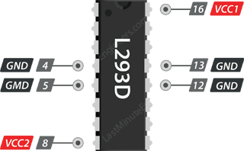
Fig 4.1.1(i)
The L293D motor driver IC actually has two power input pins viz. ‘Vcc1’ and ‘Vcc2’.
Vcc1 is used for driving the internal logic circuitry which should be 5V.
From Vcc2 pin the H-Bridge gets its power for driving the motors which can be 4.5V to 36V. And they both sink to a common ground named GND.
Output Terminals
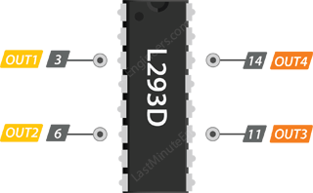
Fig 4.1.1(ii)
The L293D motor driver’s output channels for the motor A and B are brought out to pins OUT1 , OUT2 and OUT3, OUT4 respectively.
You can connect two DC motors having voltages between 4.5 to 36V to these terminals.
Each channel on the IC can deliver up to 600mA to the DC motor. However, the amount of current supplied to the motor depends on system’s power supply.

Control Pins
For each of the L293D’s channels, there are two types of control pins which allow us to control speed and spinning direction of the DC motors at the same time viz. Direction control pins & Speed control pins.

Direction Control Pins
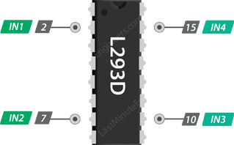
Fig 4.1.1(iii)
Using the direction control pins, we can control whether the motor spins forward or backward. These pins actually control the switches of the H-Bridge circuit inside L293D IC.
The IC has two direction control pins for each channel. The IN1,IN2 pins control the spinning direction of the motor A while IN3,IN4 control motor B.
The spinning direction of a motor can be controlled by applying either a logic HIGH(5 Volts) or logic LOW(Ground) to these pins. The below chart illustrates how this is done.
4.2 ARDUINO UNO CONTROLLER
The Arduino Uno is a microcontroller board based on the ATmega328 . It has 14 digital input/output pins (of which 6 can be used as PWM outputs), 6 analog inputs, a 16 MHz crystal oscillator, a USB connection, a power jack, an ICSP header, and a reset button. It contains everything needed to support the microcontroller. It has 4/8/16/32K bytes of In- System Programmable Flash with Read-While-Write capabilities, 256/512/512/1K bytes EEPROM, 512/1K/1K/2K bytes SRAM, 23 general purpose I/O lines, 32 general purpose working registers, three flexible Timer/Counters with compare modes, internal and external interrupts, a serial programmable USART, a byte-oriented 2-wire Serial Interface, an SPI serial port, a 6-channel 10-bit ADC (8 channels in TQFP and QFN/MLF packages), a programmable Watchdog Timer with internal Oscillator, and five software selectable power saving modes.
The computer with a USB cable or power it with a AC-to-DC adapter or battery to get started. The Uno differs from all preceding boards in that it does not use the FTDI USB-to-serial driver chip. Instead, it features the Atmega8U2 programmed as a USB-to-serial converter. "Uno" means one in Italian and is named to mark the upcoming release of Arduino 1.0. The Uno and version 1.0 will be the reference versions of Arduino, moving forward. The Uno is the latest in a series of USB Arduino boards, and the reference model for the Arduino platform; for a comparison with previous versions,
- Microcontroller : ATmega328
- Operating Voltage : 5V
- Input Voltage (recommended): 7-12V
- Input Voltage (limits) : 6-20V
- Digital I/O Pins : 14 (of which 6 provide PWM output)
- Analog Input Pins : 6
- DC Current per I/O Pin :40 mA
- DC Current for 3.3V Pin : 50 mA
- Flash Memory : 32 KB of which 0.5 KB used by bootloader.
- SRAM : 2 KB
- EEPROM : 1 KB
- Clock Speed : 16 MHz
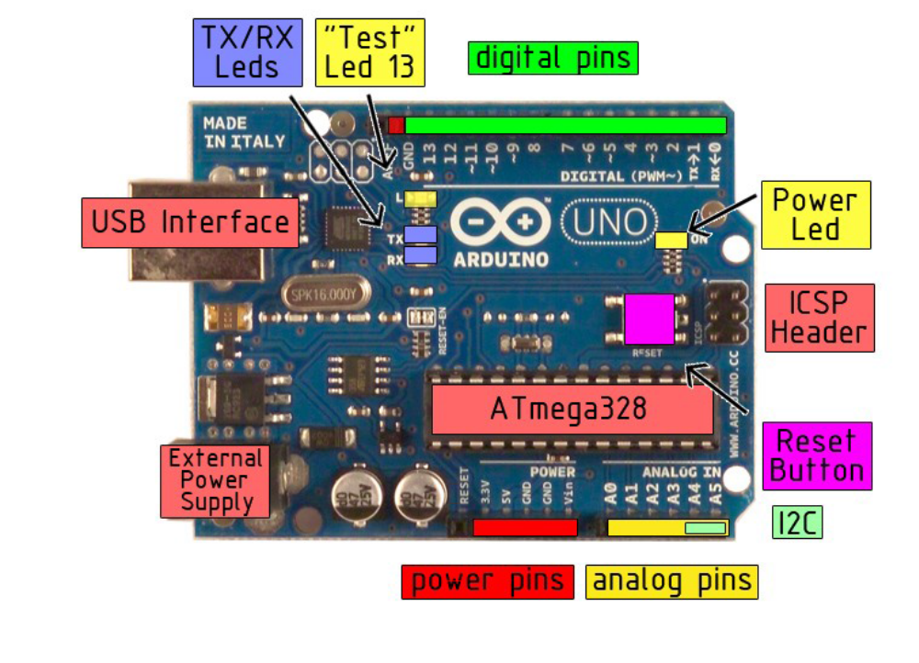
Fig 4.2 Arduidno Controller

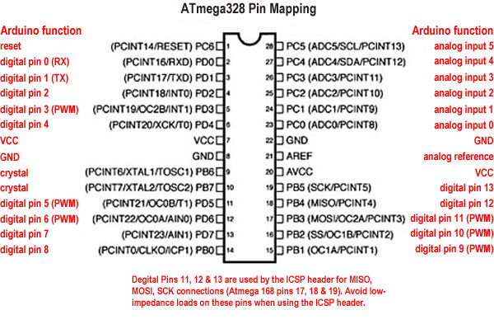
Fig 4.2.1 Pin Diagram
PIN DESCRIPTIONS
4.1.1 VCC
Supply voltage.
4.1.2 GND
Ground.
4.1.3 Port B (PB7:0) XTAL1/XTAL2/TOSC1/TOSC2
Port B is an 8-bit bi-directional I/O port with internal pull-up resistors (selected for each bit). The Port B output buffers have symmetrical drive characteristics with both high sink and source capability. As inputs, Port B pins that are externally pulled low will source current if the pull-up resistors are activated. The Port B pins are tri-stated when a reset condition becomes active, even if the clock is not running. Depending on the clock selection fuse settings, PB6 can be used as input to the inverting oscillator amplifier and input to the internal clock operating circuit. Depending on the clock selection fuse settings, PB7 can be used as output from the inverting oscillator amplifier.
If the Internal Calibrated RC oscillator is used as chip clock source, PB7..6 is used as TOSC2..1 input for the asynchronous timer/counter2 if the AS2 bit in ASSR(Auditory Steady State Response) is set.
4.1.4 Port C (PC5:0)
Port C is a 7-bit bi-directional I/O port with internal pull-up resistors (selected for each bit). The PC5.0 output buffers have symmetrical drive characteristics with both high sink and source capability. As inputs, Port C pins that are externally pulled low will source current if the pull-up resistors are activated. The Port C pins are tri-stated when a reset condition becomes active, even if the clock is not running.
4.1.5 PC6/RESET
If the RSTDISBL Fuse is programmed, PC6 is used as an I/O pin. Note that the electrical characteristics of PC6 differ from those of the other pins of Port C.
If the RSTDISBL Fuse is un programmed, PC6 is used as a Reset input. A low level on this pin for longer than the minimum pulse length will generate a Reset, even if the clock is not running. Shorter pulses are not guaranteed to generate a Reset.
4.1.6 Port D (PD7:0)
Port D is an 8-bit bi-directional I/O port with internal pull-up resistors (selected for each bit). The Port D output buffers have symmetrical drive characteristics with both high sink and source capability. As inputs, Port D pins that are externally pulled low will source current if the pull-up resistors are activated. The Port D pins are tri-stated when a reset condition becomes active, even if the clock is not running.
4.1.7AVCC
AVCC is the supply voltage pin for the A/D Converter, PC3:0, and ADC7:6. It should be externally connected to VCC, even if the ADC is not used. If the ADC is used, it should be connected to VCC through a low-pass filter. Note that PC6..4 use digital supply voltage, VCC.
4.1.8 AREF
AREF is the analog reference pin for the A/D Converter.
1.1.9 ADC7:6 (TQFP and QFN/MLF Package Only)
In the TQFP and QFN/MLF package, ADC7:6 serve as analog inputs to the A/D converter. These pins are powered from the analog supply and serve as 10-bit ADC channels.

4.3 LDR DETECTOR
Light dependent resistor—photo resistor or Cadmium –Sulfide (Cds) cell. As their name suggests, these are resistors whose resistance is a function of the amount of light falling on them. Their resistance is very high when no light is present and is significantly lower when they are illuminated. Under normal conditions, light falls on LDR and in case of a fault the LDR will be subjected to darkness.
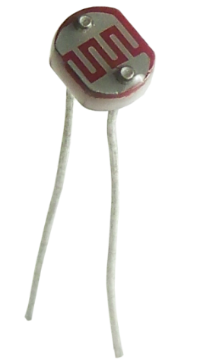
Fig 4.3 LDR Detector
COMPARATOR
ON LIGHT
When LDR is subjected to light, its resistance become10K ; hence the droop at the inverting terminal is less than at the inverting terminal. Hence the output from comparator is –V_{sat} indicating normal condition
ON DARKNESS
When the LDR is subjected to darkness, its resistance 100K , and the thus the drop at the non-inverting terminal than that at the inverting terminal. Hence the output from this +V_{sat} indicating a faulty condition.
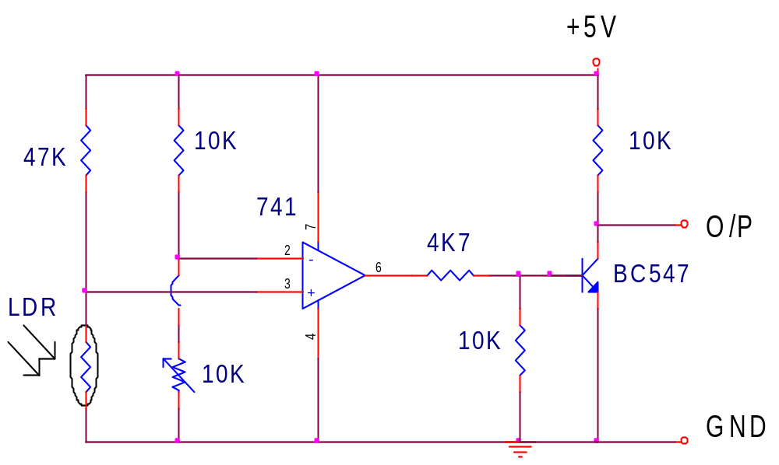
Fig 4.3.1 Comparator

A photo resistor or light dependent resistor or cadmium sulfide (CdS) cell is a resistor whose resistance decreases with increasing incident light intensity. It can also be referenced as a photoconductor. A photo resistor is made of a high resistance semiconductor. If light falling on the device is of high enough frequency, photons absorbed by the semiconductor give bound electrons enough energy to jump into the conduction band. The resulting free electron (and its hole partner) conduct electricity, thereby lowering resistance.
A photoelectric device can be either intrinsic or extrinsic. An intrinsic semiconductor has its own charge carriers and is not an efficient semiconductor, e.g. silicon. In intrinsic devices the only available electrons are in the valence band, and hence the photon must have enough energy to excite the electron across the entire band gap. Extrinsic devices have impurities, also called dopants, added whose ground state energy is closer to the conduction band; since the electrons do not have as far to jump, lower energy photons (i.e., longer wavelengths and lower frequencies) are sufficient to trigger the device. If a sample of silicon has some of its atoms replaced by phosphorus atoms (impurities), there will be extra electrons available for conduction. This is an example of an extrinsic semiconductor.

APPLICATION
Photo resistors come in many different types. Inexpensive cadmium sulfide cells can be found in many consumer items such as camera light meters, street lights, clock radios, alarms, and outdoor clocks .They are also used in some dynamic compressors together with a small incandescent lamp or light emitting diode to control gain reduction .Lead sulfide and indium antimonide LDRs are used for the mid infrared spectral region. Ge:Cu photoconductors are among the best far-infrared detectors available, and are used for infrared astronomy and infrared spectroscopy.
VOLTAGE SENSING CIRCUIT

In this, voltage measurement circuit is used to sense the voltage in the solar is connected to the input of the bridge rectifier and used to capacitor for filtering purpose and the resistor is to reduce the current and flow to the led and connected to the voltage divider and comparator circuit which is used to provide the variable DC milli voltage through variable resistor 10K.
This voltage gives to the actual voltage of the comparator circuit. The input from the voltage measurement is given to non-inverting terminal and the set value of voltage is given to inverting terminal. This can be set by using the variable resistance 10K. At normal 230v, the voltage at the non-inverting terminal is less than reference, so -Vsat (-5V means 0V)is the output from op amp. and the transistor conducts will be cut off (B=0; C=1)and the signal given to microcontroller. When the voltage exceed the specified limit, non-inverting terminal voltage is above the reference voltage of inverting terminal. Hence the opamp output is +Vsat
(+5V )indicating the fault occurrence and transistor conducts (B=1; C=0)and the signal given to the microcontroller.
CIRCUIT DIAGRAM

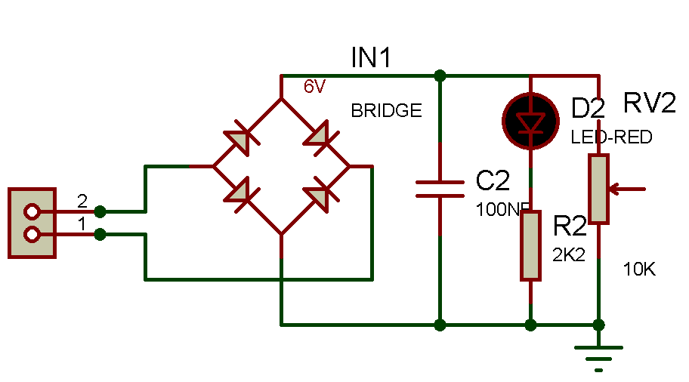
Fig 4.3.2 Voltage Sensing Circuit

4.4 SOLAR PANEL
The solar photovoltaic array consists of an appropriate number of solar cells connected in series and or parallel to provide the required current and voltage. The array is so oriented as to collect the maximum solar radiation throughout the year.
There may be tracking arrays or modules or fixed arrays. A tracking array is defined as one which is always kept mechanically perpendicular to the sun array line so that all times it intercepts the maximum isolation. Such arrays must be physically movable by a suitable prime mover and are generally considerably more complex than fixed arrays. A fixed array is usually oriented east west and tilted up at an angle approximately equal to the latitude of the site. Thus the array design falls into two broad classes:
(i) FLAT PLATE ARRAYS
Solar cells are attached with a suitable adhesive to some kind of substrate structure usually semi rigid to prevent cells being cracked.
This technology springs from the space related photovoltaic technology and many such arrays have been built in various power sizes.
(ii) CONCENTRATING ARRAYS
Whereas suitable optics, e.g. Fresnel lenses, parabolic mirrors are combined with photovoltaic cells in an array fashion. This technology is relatively new to photovoltaic in terms of hardware development and comparatively fewer such arrays have actually been built.

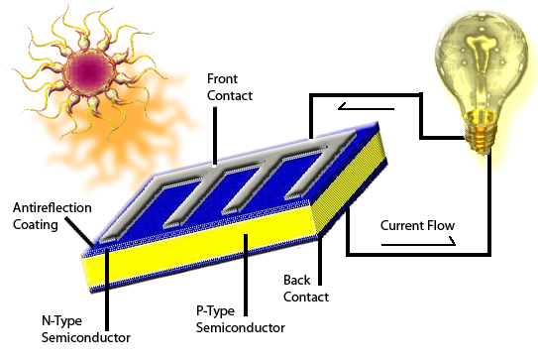
Fig 4.4 Solar Panel
SOLAR
Sun is the primary source of energy. The earth receives 16 x 10¹⁸ units of energy from the sun annually, which is 20,000 times the requirement of mankind on the Earth. Some of the Solar Energy causes evaporation of water, leading to rains and creation of rivers etc. Some of it is utilized in photosynthesis which is essential for sustenance of life on earth. Man has tried from time immemorial to harness this infinite source of energy. But has been able to tap only a negligibly small fraction of this energy till today.
The broad categories of possible large scale applications of solar power are
- The heating and cooling of residential and commercial builders.
- The chemical and Biological conversion of organic material to liquid solid and gaseous fuels.
- Conversion of solar energy to Electricity.
In this project we use the solar energy for the generation of electrical energy, by using solar cells.The solar cell receives the solar energy. The solar cells operate on the photo electrical energy, by using solar cells principle. In basically the cells are placed in an open and fixed manner.
THE ENERGY SCENE
Drastic changes in energy conversion system are anticipated due to shortage of conventional fuels. Fuel deposit in the world will soon deplete by the end of 2020. Fuel scarcity will be maximum. The main reasons for the above are due to increasing demand for electricity, rising population, rapid advance in technology.
It is worth while to mention here that indiscriminate use of commercial energy has lead to serious environment problems like air and water pollutions. Man, when he is embarking on use of alternate sources of energy should bear in mind, his environment. The creation of new source of perennial environmentally acceptable, low cost electrical energy as a replacement for energy from rapidly depleting resources of fossil fuels is the fundamental need for the survival of mankind.
SOLAR ENERGY OPTIONS
Solar energy has the greatest potential of all the sources of renewable energy and it will be one of the most important supplies of energy especially when other sources in the country have depleted. Solar energy could supply all the present and future energy needs of the world on a connecting basis. This makes it one of the most promising of the unconventional energy sources.

Solar Energy can be a major source of power. Its potential is 178 billion mw which is about 20,000 times the worlds demand. The energy radiated by the sun on a bright sunny day is approximately 1kw/m². The problem associated with the use of solar energy is that its availability varies widely with time. The variations in availability occur daily, because of the day-night cycle and also seasonally because of Earth’s orbit around the sun. In addition variations occur at a specific location because of local weather conditions. Consequently the energy collected with the sun is shining must be stored for use during periods when it is not available.
Attempts have been made to make use of this energy in raising steam which may be used in driving the prime movers for the purpose of generation of electrical energy. However due to large space requirement and uncertainty of availability in constant rate this method becomes ineffective.
Photovoltaic cell is an alternate device used for power generation which convert suns radiation directly into electrical power. Thus power generated can be stored and utilized.

The concept
In 1968 Dr. Peter Glaser in the U.S. Published an idea that centered on the fact that in orbit close to earth, 1.43 KW of solar energy illuminates may one square meter which is considerably greater and one more continuous than an anyone square meter on the Earth which, even when perpendicular to the sun can receive only a maximum of 1 kw. His idea was, converting sunlight to electricity to convert to a radio frequency signal and beamed down to the earth carrying significant levels of energy. This electricity is by establishing a very large array of solar cells in geostationary orbit. A receiving antenna station on the earth would convert this radio frequency back into an alternate current which would be fed into a local grid.
The applications of solar energy which are enjoying most success today are :
- heating and cooling of residential buildings
- Solar water heating
- Solar drying of agriculture and animal products
- Solar distillation on a small community scale
- Salt production by evaporation of seawater or inland brines
- Solar cookers
- Solar engines for water pumping
- Food refrigeration
- Bio conversion and wind energy, which are indirect source of solar energy
10) Solar furnaces
11) Solar electric power generation

4.5 L293 MOTOR DRIVER
L293D is a typical Motor driver or Motor Driver IC which allows DC motor to drive on either direction. L293D is a 16-pin IC which can control a set of two DC motors simultaneously in any direction. It means that you can control two DC motor with a single L293D IC. Dual H-bridge Motor Driver integrated circuit (IC). The L293D IC receives signals from the microprocessor and transmits the relative signal to the motors. It has two voltage pins, one of which is used to draw current for the working of the L293D and the other is used to apply voltage to the motors. Motor drivers acts as an interface between the motors and the control circuits. Motor require high amount of current whereas the controller circuit works on low current signals. So the function of motor drivers is to take a low-current control signal and then turn it into a higher-current signal that can drive a motorL293D IC generally comes as a standard 16-pin DIP (dual-in line package). This motor driver IC can simultaneously control two small motors in either direction; forward and reverse with just 4 microcontroller pins (if you do not use enable pins).
CIRCUIT DIAGRAM OF L293 DRIVER
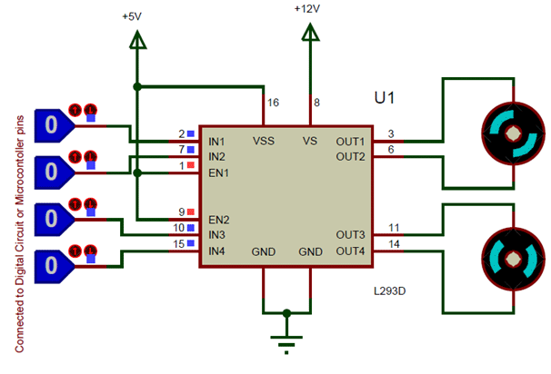
Fig 4.5 L293 Driver
PIN DETAILS OF L293 IC
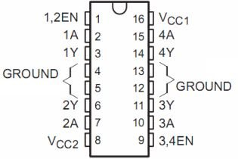
Fig 4.5.1 Pin Diagram of L293 Driver
L293D IC Pin Out
The L293D is a 16 pin IC, with eight pins, on each side, to controlling of two DC motor simultaneously. There are 4 INPUT pins, 4 OUTPUT pins and 2 ENABLE pin for each motor.
Pin 1: When Enable1/2 is HIGH, Left part of IC will work, i.e motor connected with pin 3 and pin 6 will rotate.
Pin 2: Input 1, when this pin is HIGH the current will flow though output 1.
Pin 3: Output 1, this pin is connected with one terminal of motor.
Pin 4/5: GND pins
Pin 6: Output 2, this pin is connected with one terminal of motor.
Pin 7: Input 2, when this pin is HIGH the current will flow though output 2.
Pin 8: VSS, this pin is used to give power supply to connected motors from 5V to 36V maximum depends on Motor connected.
Pin 9: When Enable 3/4 is HIGH, Right part of IC will work, i.e motor connected with pin 11 and pin 14 will rotate.
Pin 10: Input 4, when this pin is HIGH the current will flow though output 4.
Pin 11: Output 4, this pin is connected with one terminal of motor.
Pin 12/13: GND pins
Pin 14: Output 3, this pin is connected with one terminal of motor.
Pin 15: Input 3, when this pin is HIGH the current will flow though output 3.
Pin 16: VCC, for supply power to IC i.e 5V.
In order to have a complete control over DC motor, we have to control its speed and rotation direction. This can be achieved by combining these two techniques.
- PWM – For controlling speed
- H-Bridge – For controlling rotation direction

PWM – For controlling speed
The speed of a DC motor can be controlled by varying its input voltage. A common technique for doing this is to use PWM (Pulse Width Modulation)
PWM is a technique where average value of the input voltage is adjusted by sending a series of ON-OFF pulses.
The average voltage is proportional to the width of the pulses known as Duty Cycle.
The higher the duty cycle, the greater the average voltage being applied to the dc motor(High Speed) and the lower the duty cycle, the less the average voltage being applied to the dc motor(Low Speed).Below image illustrates PWM technique with various duty cycles and average voltages.
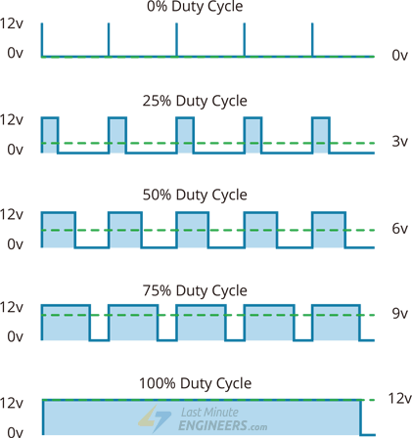
Fig 4.5.2 Duty Cycle
Pulse Width Modulation(PWM) Technique

H-Bridge – For controlling rotation direction
The DC motor’s spinning direction can be controlled by changing polarity of its input voltage. A common technique for doing this is to use an H-Bridge.
An H-Bridge circuit contains four switches with the motor at the center forming an H-like arrangement.
Closing two particular switches at the same time reverses the polarity of the voltage applied to the motor. This causes change in spinning direction of the motor.
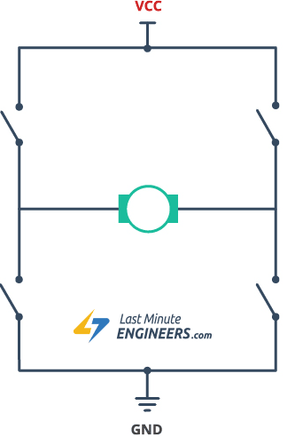
Fig 4.5.3 Working of H-Bridge

L293D Motor Driver IC
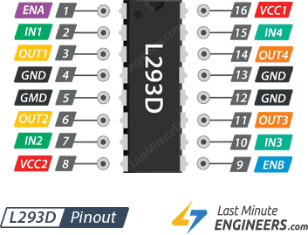
Fig 4.5.4 L293D Motor Driver
The L293D is a dual-channel H-Bridge motor driver capable of driving a pair of DC motors or one stepper motor.
That means it can individually drive up to two motors making it ideal for building two-wheel robot platforms.
4.6 DC –DC CONVERTER
The operating voltage of different electronic devices such as ICs, MOSFET can vary over a wide range, making it necessary to provide a voltage for each device. A Buck Converter outputs a lower voltage than the original voltage, while a Boost Converter supplies a higher voltage.
With the application of DC-to-DC Converters, the circuit’s efficiency, ripple, and load-transient response can be changed. Optimal external parts and components are generally dependent on operating conditions such as input and output specifications. So, while designing the products, the standard circuits must be varied or changed according to and as per the need to their individual specification requirements. Designing the circuit that satisfies the specification and all the requirements needs a great deal of expertise and experience in that field.
The step-up or step-down DC-to-DC Converters are useful in applications where the battery voltage can be above or below the regulator output voltage. The DC to DC converter must be able to operate as a step up or down voltage supplier to provide constant load voltage over the entire battery voltage range through the operation.

Working Principle of DC-DC converter
The working principle of the DC-to-DC converter is very simple. The inductor in the input resistance has an unexpected variation in the input current. If the switch is kept as high (on), then the inductor feeds the energy from the input and stores the energy in the form of magnetic energy.
LIMIT SWITCH DEBOUCING
Limit switches are simple mechanical contact switches. it is used to drive a DC motor for gate open and close. This unit is interfaced with micro controller.
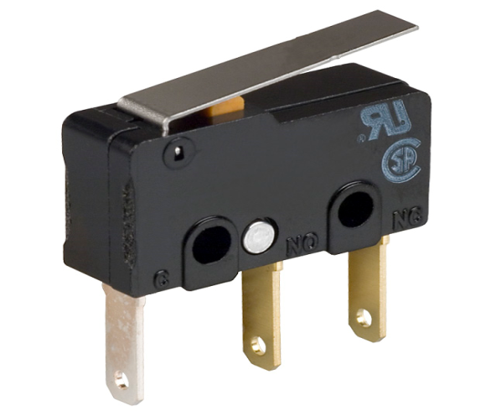
Fig 4.6.1 Limit Switch Debouncing
CIRCUIT EXPLAINATIONS
For high frequency signal transfer through mechanical operated limit switch will create small surges. This surge will be considered as “1” state by the test sensing semi conductor IC’s so to avoid this a time delay is created using the 4093 and gate.
Here for four zones we need 8 and gates for simplicity one zone circuit explained.
Limit switch “NC” state:
In this state D1 & D2 is forward biased and the out of N1 is ‘1’ state. D3 is reverse based because of N1 goes to ‘1’ state and C2 charges from 0v to 5v after reaching full charge N2 goes to ‘o’ state. This time delay can be changed by C1, R3, C2 R4, so signal output is ‘0’ state.
Limit switch “No” state:
In this state D2 is reverse biased so capacitor C1 charge through D1 diode and capacitor reaches RV. N1 goes to ‘o’ state, so D3 forward biased and C2 discharges and N2 input is ‘o’ state so N2 output .
THE SCHMITT TRIGGER CIRCUIT
The Schmitt trigger circuit is employed to shape the waveform from the key switch. The output of the key switch is into a perfect square wave. Therefore before using it for further application on board, we have one Schmitt trigger. When the key is locked in the programmable lock assembly, goes to low level and hence the inventing buffer out put at IC 4093 shifts to high level.
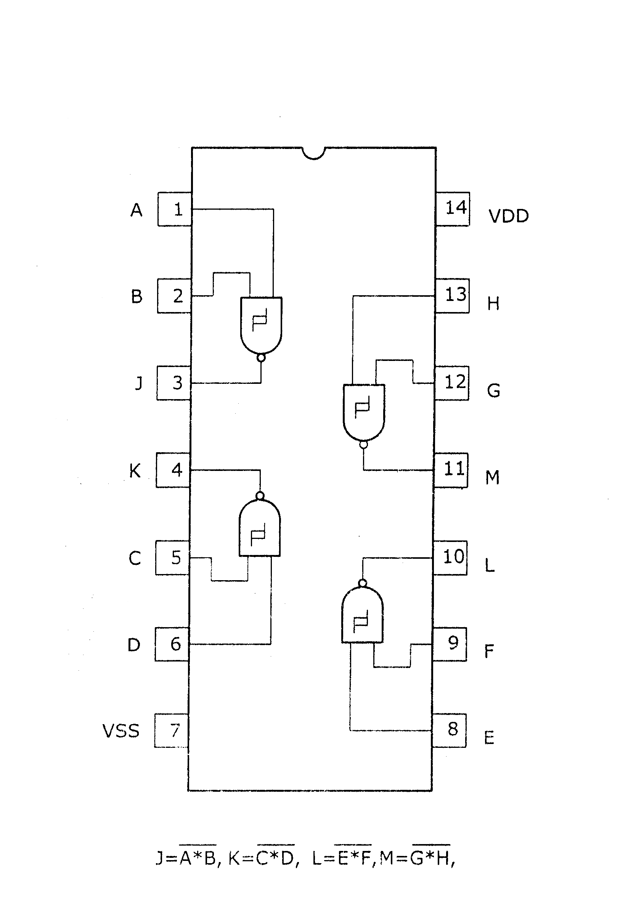
Fig 4.6.2 Schmit Trigger Circuit
IC-4093
All four positive –logic NAND gate may be used independently. While this package can be used as an ordinary NAND gate, internal hysterics on the inputs makes this device ideal for noisy or slowly changing input levels. It is also ideal in astable and monostable applications.
If either or both inputs are low, the output will be high. If both inputs are high, the output will be low.
On a positive –going waveform, the output will change at 2.9 volts with a 5 volts supply and at 5.9 volts a 10-volts supply.
On a negative –going waveform, the output will change at 2.3 volts with a 5 volt supply and at 3.9 volts with a 10-volts supply. Thus the hysterics, dead band, or noise immunity is 0.6 volt with a 5-volt supply and 2 volts with a 1-volt supply.
Propagation delay is 300 nanoseconds at 5 volt supply and 150 nanoseconds at 10 volts. Total package current is 0.4 milli amperes at 5 volts and 0.8 milli ampere at 10volts for a1-magahertz clock frequency.
Device is functionally equivalent to the 74132 (TTL) and 74C132 (CMOS) devices.
LIMIT SWITCH CIRCUIT 1
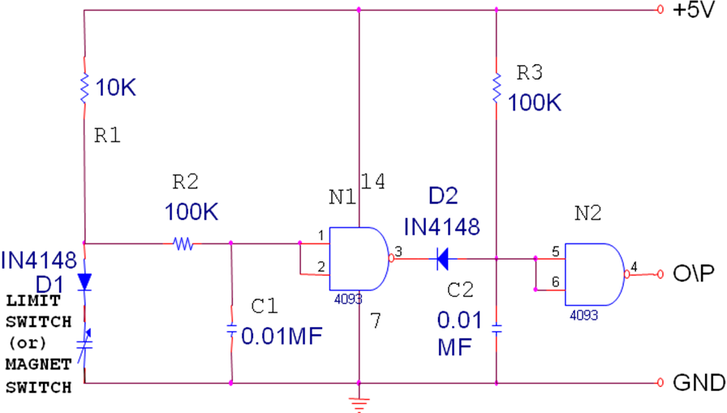
Fig 4.6.3 Limit Switch Circuit(i)

LIMIT SWITCH CIRCUIT 2
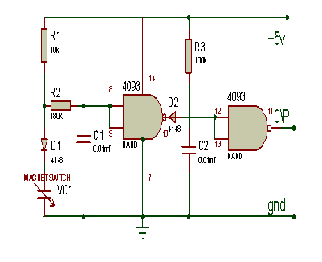
Fig 4.6.4 Limit Switch Circuit (ii)
DC MOTOR
A DC motor is an electric motor that runs on direct current (DC) electricity. In any electric motor, operation is based on simple electromagnetism. A simple 2-pole DC electric motor (here red represents a magnet or winding with a "North" polarization, while green represents a magnet or winding with a "South" polarization).Every DC motor has six basic parts -- axle, rotor (a.k.a., armature), stator, commutator, field magnet(s), and brushes.
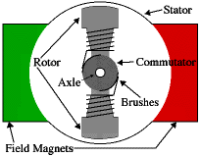
Fig 4.6.5 DC Motor

4.7 LCD DISPLAY
16\2 MATRIX ALPHANUMRIC

This is in contrast to LEDs, which are limited to numbers and characters. The LCDs are light weight with only a few millimeters thickness. Since the LCDs consume less power, they are compatible with low power electronic circuits, and can be powered for long durations. The LCDs don’t generate light and so light is needed to read the display. By using backlighting, reading is possible in the dark. The LCDs have long life and a wide operating temperature range.
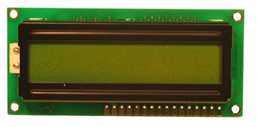
Fig 4.7 LCD Display

Introduction
Liquid Crystal Displays (LCDs) have materials which combine the properties of both liquids and crystals. Rather than having a melting point, they have a temperature range within which the molecules are almost as mobile as they would be in a liquid, but are grouped together in an ordered from similar to a crystal.
An LCD consists of two Glass Panels, with the liquid crystal material sandwiched in between them. The inner surface of the Glass plates is coated with transparent electrodes which define the character, symbols or patterns to be displayed. Polymeric layers are present in between the electrodes and the liquid crystal, which makes the liquid crystal molecules to maintain a defined orientation angle.
One each polarizer’s are pasted outside the two Glass Panels. This polarizer’s would rotate the light rays passing through them to a definite angle, in a particular direction.
When the LCD is in the off-state, light rays are rotated by the two polarizer’s and the Liquid Crystal, such that the light rays come out of the LCD without any orientation, and hence the LCD appears transparent.
When sufficient voltage is applied to the electrodes, the Liquid Crystal molecules would be aligned in a specific direction. The light rays passing through the LCD would be rotated by the polarizer’s, which would result in activating / high lighting the desired characters.
The LCDs are light weight with only a few millimeters thickness. Since the LCDs consume less power, they are compatible with low power electronic circuits, and can be powered for long durations.
The LCDs don’t generate light and so light is needed to read the display. By using backlighting, reading is possible in the dark. The LCDs have long life and a wide operating temperature range.
Changing the display size or the layout size is relatively simple which makes the LCDs more customers friendly.
The LCDs used exclusively in watches, calculators and measuring instruments are the simple seven – segment displays, having a limited amount of numeric data. The recent advances in technology have resulted in better legibility, more information displaying capability and a wider temperature range. These have resulted in the LCDs being extensively used in telecommunications and entertainment electronics. The LCD s has even started replacing the Cathode Ray Tubes (CRTs) used for the display of text and graphics, and also in small TV applications.
LCD is mainly used for display the information. Here we are using 2x16 LCD. Operation of the LCD is
- The declining prices of LCDs.
- The ability to display numbers, characters, and graphics. This is in contrast to LEDs, which are limited to numbers and characters.
- Incorporation of a refreshing controller into the LCD, thereby relieving the CPU of the task of refreshing the LCD. In contrast, the LED must be refreshed by the CPU to keep displaying the data.
- Ease of programming for characters and graphics.
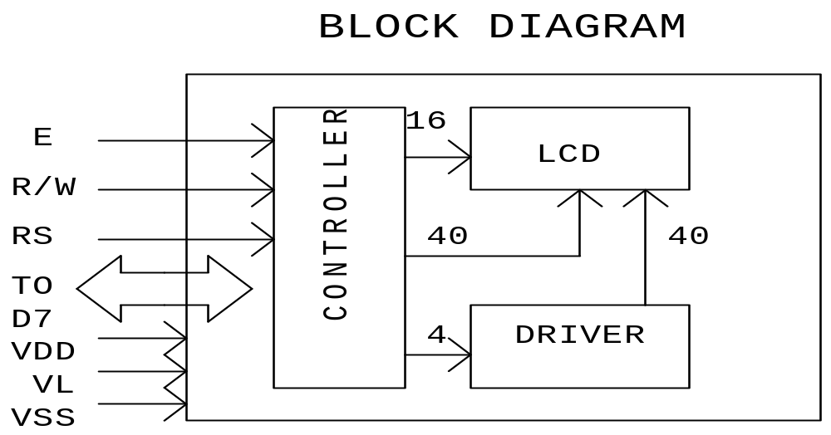
Fig 4.7.1 LCD Block Diagrm

LCD PIN DESCRIPTIONS:
VCC, VSS, and VL (PIN 1 to 3)
While VSS provide Ground Terminal, OV. VCC provide Supply Terminal, +5. VL is a Liquid Crystal Drive Voltage
RS, register select PIN 4)
There are two very important registers inside the LCD. The RS pin is used for their selection as follows. If RS=0 the instruction command code register is selected, allowing the user to send a command such as clear display, cursor at home, etc. if RS=1d the data register is selected, allowing the user to send data to be displayed on the LCD.
R/W read or write (PIN 5)
R/W input allows the user to write information to the LCD or read information from it. R/W =1 when reading; R/W=0 when writing.
E, enable (PIN 6)
The enable pin is used b y the LCD to latch information presented to its data pins. When data is supplied to data pins, high-to-low pulses must be applied to this pin in order for the LCD to latch in the present at the data pins. This pulse is a minimum of 450 ns wide.

D0 – D7 (PIN 7 to 14)
The 8 bit data pins, d0 – d7, are used to send information to the LCD or read the contents of the LCD’s internal registers. Bi-directional data-bus. When interface data length is 8-bits, data transfer is done once through DB0- DB7, when the interface data length is 4-bits, data transfer is done twice through DB4 – DB7.

BACKLIGHT (PIN 15 & 16)
In case of 15 Pin Modules, Pin 15 Is the Supply Voltage (+5V) for the LED. In case of 16 pin Modules, Pin 15 is the Ground (0V) and Pin 16 is the Supply voltage (+5V) for the LED.
Crystal Oscillator
We are using 4Hz Crystal Oscillator which is connected to the pins 11 and 12. Two 22pf capacitors are used across the Crystal Oscillator and are grounded.
POWER SUPPLY

This power supply circuit is designed to get regulated output DC voltage. This unit is used to supply the power to the all circuits. 7812 IC is used to give the constant 12v supply.
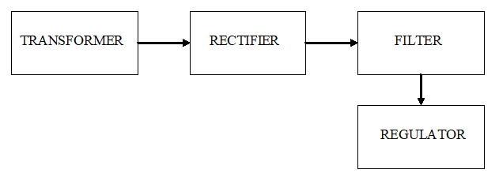
Fig 4.7.3 Power Supply
CIRCUIT DESCRIPTION
This power supply circuit is designed to get regulated output DC voltage. The 15 volt transformer, step down the main voltage (230v) into 15 volts. The secondary voltage of transformer is rectified using bridge rectifier. The rectified unidirectional DC is smoothed by 1000mf filter capacitor. The smooth DC is then fed to the three terminal +ve regulator called 7812 to get 12v DC supply.
Half-wave Rectifier

The transformer (T1) isolates the household voltage and also steps down the household voltage to a more useful voltage level. The diode lets current flow into the load in only one direction. The load current is unidirectional; therefore, it has a significant dc component(or average value).
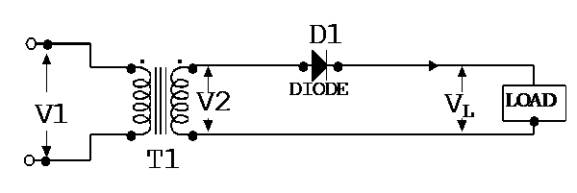
Fig 4.7.4 Half Wave Rectifier
Full-wave Rectifier

The full wave rectifier circuit requires a transformer with two secondary windings. i.e a center-tapped secondary winding.
The secondary windings are 180 out of phase.
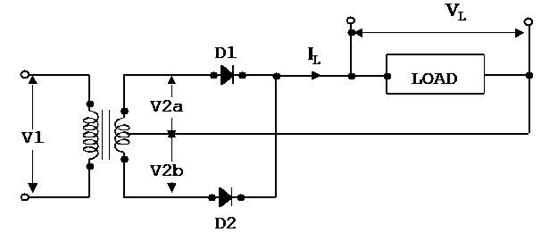
Fig 4.7.5 Full Wave Rectifier

Full Wave
The full-wave bridge rectifier circuit requires four diodes. The transformer has only one secondary winding.
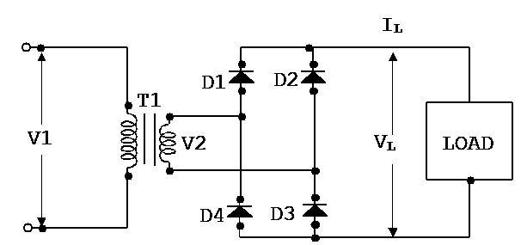
Fig 4.7.8 Full Wave Bridge Rectifier

CHAPTER - 5
PCB DESIGN AND FABRICATION

5.1 PROCEDURE FOR MAKING THE PCB
1. PREPARING OF LAYOUT
With the diagram and all the components at hand, draw a complete layout plan of the circuit on a sheet of a tracing paper. As a model, for laying the circuit, a thermo Cole base may be used to hold components. Avoid over crowding of components while making full space utilization. Keep the ground line on the side of the PCB and the supply line on other side as far as possible. When all the components have been mounted on the tracing paper sheet fixed on a piece of thermo Cole base, take out a Sketch Pen for making in such a way that all the connecting wires are equal in width, termination rounded off. Re-draw it on a fresh paper if required.
2. PAINTING OF PCB
The tracing so prepared has to be imposed over the copper printed circuit board keeping in view that the component would be mounted from the non-clad side of the board. Take a PCB lamination sheet and cur a piece of required size of the board by using hacksaw file edges, put the copper clad sheet on the table keeping side on the runway the dirt grease and oxide with a sand paper with its marked side tracing the carbon paper and other side on top. Since the tracing paper is transformed you can now reproduce a carbon point over a surface but using ball pen on a hard pencil over the drawing on the transparent side. When the carbon print has been obtained over the copper clad board drill ropes in the board using a hand drill. The holes may be draw with 1/32 bit for component leads and the carbon should be raised or wiped by mistake. Paint the Connecting lines with the help of an ordinary paint. Edges should be scratched with tip of razor blade.

3. DEVELOPMENT OF THE PRINTED CIRCUIT DIAGRAM
After painting the board, it will be made by the cool air for sometime. Now take a plastic tray and get some Fe Cl3 chemical powder. The ferric chloride salt is then added with 500ml of water. The color of the solution is pink. Color of the salt is in yellow. Now we add three to five drops of dilute HCL or H2S04. This is necessary to quicken the process.
4. ETCHING OF PCB
Now we take the painted copper clad board and dip it in the solution kept in the tray. After 15 to 25 minutes we see the board, with only printed pattern portion remaining in other places the copper coating is removed due to the chemical action. Then the board is taken out and washes in water. After wash the board by using thinner solution. Now a printed circuit has been formed on the board.
Take fresh water and mix a few teaspoons of Fe CL3 add a few drops of dilute HCL to it, as it speeds the etching process. Shake well immerse the PCB in the solution for about 20 minutes occasionally altering the solution by giving the seesaw reaction to the disk storing reduces the etching time. Observe the changing color on the copper surface. Take out the PCB only when the unpainted portion of the copper surface is completely dissolved in the solution wash the PCB with the water. After the PCB is thoroughly washed remove the paint by soft pieces of the cloth dipped in thinner or turpentine.
5. DRILLING OF HOLES
Then take a drilling machine with 1/32 drill bit to make holes for the incretion of the components use 1/18 drill bit for inset wires and other thick components. Now the PCB is ready to use.

ADVNTAGES
1. Reliability in operation and low cost.
2. Space required becomes less.
DISADVANTAGES:
It can’t withstand larger weight such as transformer.
6. MATERIAL REQUIRED:
- Copper clad sheet [It is made of hylam or nylon board over which the sheet of copper is pressed.]
- “Paint or “Nail polish” or even “PCB Ink”.
- Painting brush, tray.
- Ferric chloride solution and also few drop of dilute HCL or H2SO4.
- Thinner or kerosene or petrol.
- Cotton cloth.
- Trace paper.

CHAPTER - 6

SOLDERING
Solder is an alloy of tin and lead used for using metals relatively low temperature about 260-315k the point where two metal conductors are to be fused is heated and then solder is applied so that it can melt and cover the connection. The reason for soldering connection is that it makes a good blend between the joined metals.
Covering the joint completely is to prevent oxidation. The coating of solder provides protection for practically an in definitive period of time. The trick in soldering is to heat the joint, not the solder. When the joint is not enough to melt the solder the cracks, forming a shifty cover without until the solder has set, which takes only a few seconds. Either a soldering gun can be used, rated at 25-10,000. The gun is convenient for the intermittent operation, since it heats almost instantaneously when for press the trigger. The small pencil iron of 25-4,000 is helpful or small connections where excessive heat can cause damage. This precaution is particularly important when working on PCB boards, where too much heat can soften the plastic form and loosen the printed writing, a soldering iron for F&T devices should have the tip ground to eliminate static charge .The three grades of solder, generally used for electronics work are 40-60, 50-50, 60-40 solder. The 60-40 solders costs more but it melts at the lowest temperature flows more freely takes less time to harder, and generally makes it easier to do a soldering job .In addition to the solder there must be flux to move any oxide film on the metals being joined otherwise they cannot fuse. The flux enables the molten solder to wet the metals so that the solder can stick. The two types are acid flux and rosin flux.
Acid flux is more active in cleaning metals but is corrosive. Rosin flux is always used for the light soldering work in making wire connection.

CHAPTER - 7
ADVANTAGES AND APPLICATIONS

ADVANTAGES

- Maximum utilisation of solar panel is achieved.
- Measures the voltage from solar panel.
- Reduce the battery charging time.
- Increase the accuracy.
- Saving the energy.
- Used for industrial and domestic purpose.

APPLICATIONS

- This system not disturbs already existing frequency.
- Low power consumption, because of electronic devices.
- Factory and electrical stations are used.

CHAPTER – 8
RESULTS AND DISCUSSION

8.1 HARDWARE IMPLEMENTATION
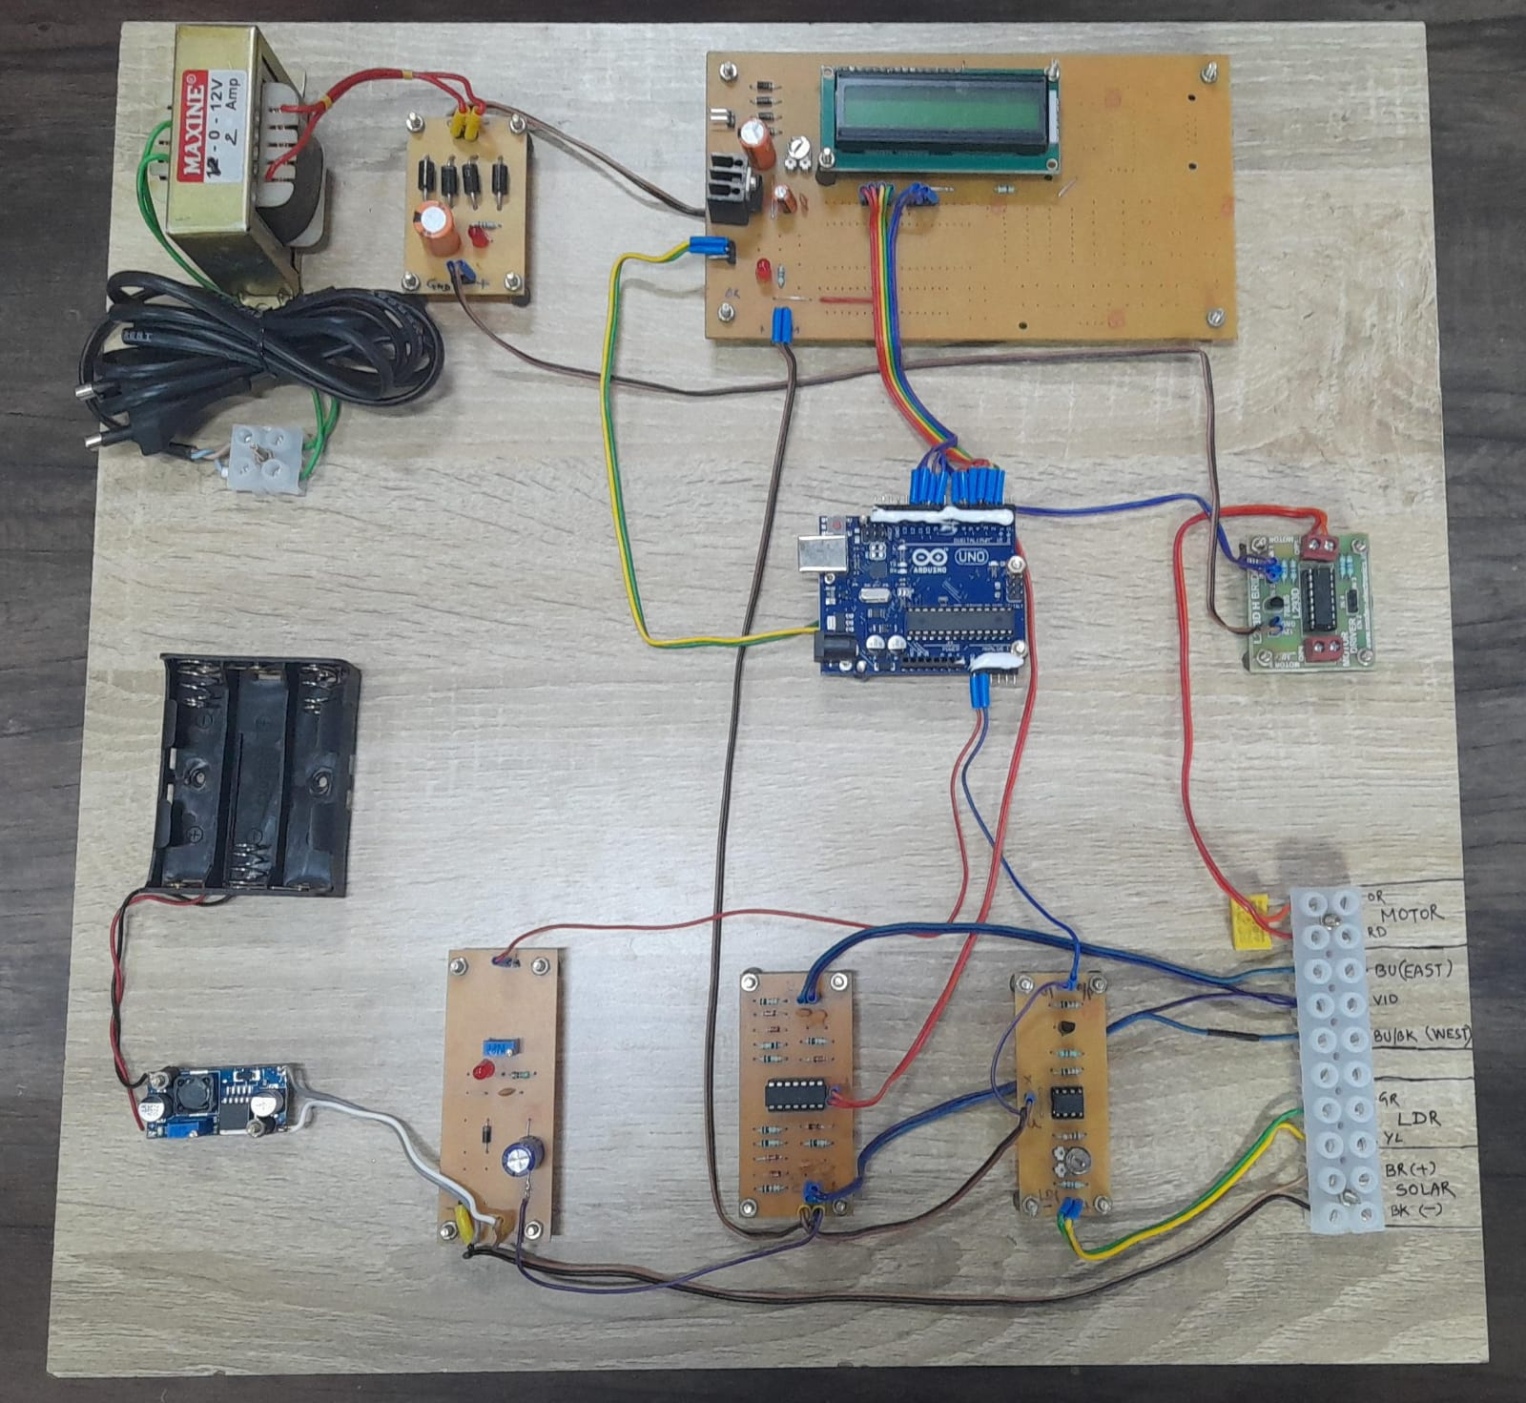
Fig 8.1.1

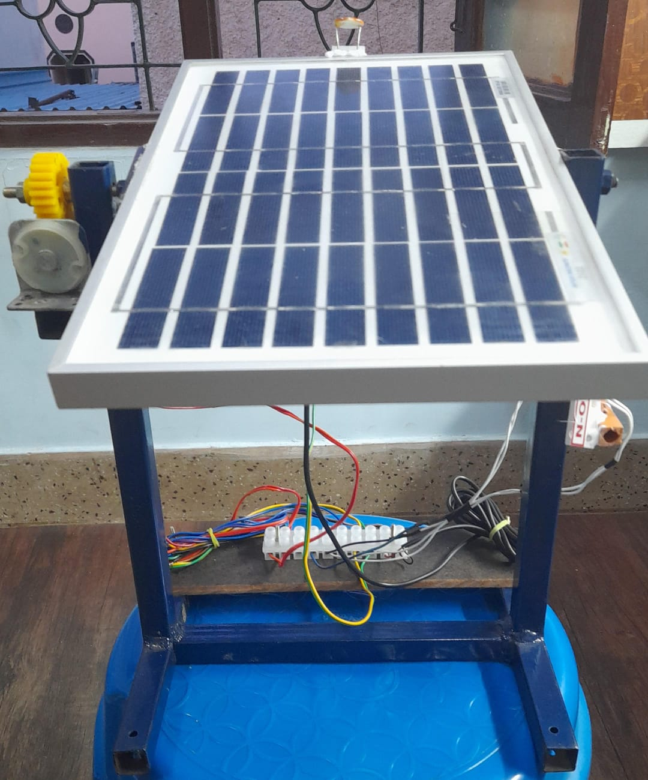
Fig 8.1.2
8.2 RESULTS

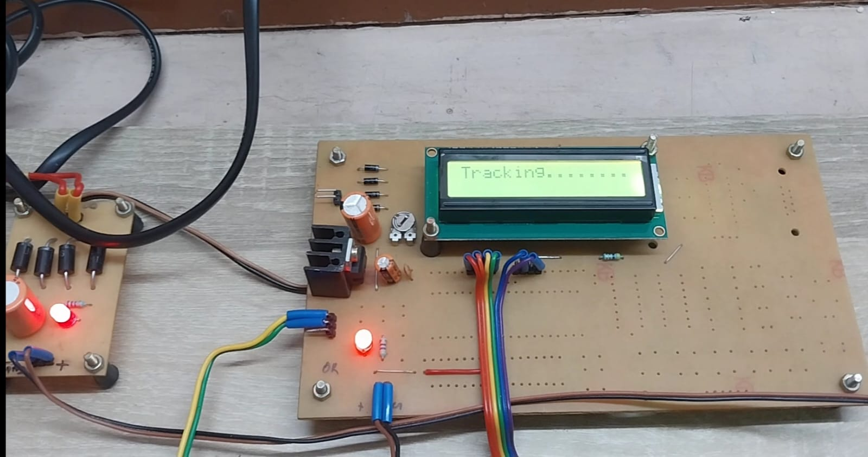

Figure 8.2.1
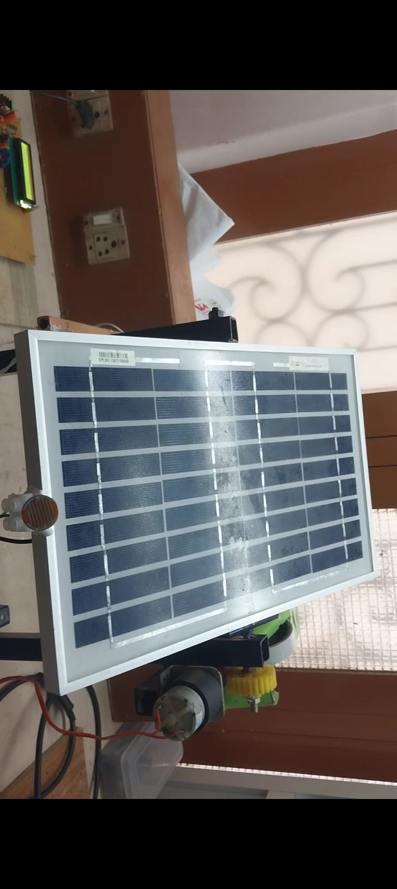
Fig 8.2.2
8.3 COST OF ESTIMATION

COMPONENTS NAME | QTY | RATE |  | AMOUNT
MICRO CONTROLLER WITH LCD AND WOODEN BASIS | 1 | 5000 |  | 5000
ARDUINO UNO | 1 | 500 |  | 500
LDR | 1 | 550 |  | 550
SOLAR PANEL | 1 | 600 |  | 600
RECTIFIER | 1 | 500 |  | 500
L293 MOTOR DRIVER | 1 | 190 |  | 190
DC-DC CONVERTER | 1 | 900 |  | 900
LIMIT SWITCH | 1 |  | 160 | 160
POWER SUPPLY | 1 |  | 300 | 300
VOLTAGE SENSING  MECHANICAL SETUP | 1 |  | 1500+200 | 1500+200
WIRES | WIRING  USAGE |  | 760 | 760
LABOUR WORK,DEMO,REPORT |  | 840 |  |  | 840
 |  | TOTAL |  |  | 12000\-

CHAPTER – 9

CONCLUSION


This project on” SINGLE AXIS SOLAR POWER TRACKING SYSTEM” is working fire, getting the parameter envisaged during the conceptual stage. During the design, as well as during the construction, greater care has been put in to avoid hiccups at the final stage. The PCB layouts were prepared with at most care to incorporate the circuits in a modular manner. The circuit is made as simple as to our knowledge. Also components and cost. It was a very interesting process of developing the prototype, stage by stage and testing the same. We have to go through fairly large pages of data related to the components etc. It was a useful and fulfilling assignment to get the project completed in time. This gave as a sense of satisfaction and accomplishment.

CHAPTER – 10
REFERENCE
- Uit, M. Neeras, T. "Review on a sun-tracking model in solar Photovoltaics (PV) system and their classification" Alochana Chakra Journal, Vol 11 issue 4. PP 5330- 5338, April 2020
- Amandeep K., Goma C., Narinder 5. Astt, S., Kumar, H. K., C.et.all, "Design of a Solar tracking system using AT89C51 microcontroller" International Journal ofAdvanced Engineering Research and Studies, Vol 2, issue 5, PP 709-712, (2017)
- Chaitali M.. Tejas, G., Vivek, P., Piyush, D.et.all, "Dual Axis Solar Tracker Using AVR",International Journal of Engineering and Science (2017)Vol 5, issue 3 PP 1112-1132
- Dhanalakshmi V. V. Lakshmi, Prasanna, H. N. Priyanka, V. Rani, K., J.et.all, "Dual Axis Solar Tracker Using Arduino Uno",International Journal of Solar Energy Engineering (2016) Vol 1 issue 2 PP 406-456.
- Ashwin, R., Joshua, 1, K., Laith, S., C., Ravi, P., P.S Varun, A., K.,et.all "Design and Fabrication of Single Axis Solar Tracking System”, Journal of Mechanical and Production Engineering, (2014)Vol 7, issue 5 ,PP 234-245.
- Sattik Halder, Akash Sharma, Ruchika Doda et.all “Optical Performance of Horizontal Single-Axis Tracked Solar Panels”, International Journal of Production Engineering ,Vol.2 (2022),issue 6, PP.32-33.
- Joysankha Ghosh , Pabak Das et.all “Horizontal Solar Power Tracking System” International Journal of Innovations in Engineering and Science, Vol.1(2021), issue 8 ,PP.162-166.
- Khlaichom ,“A Design of Single Axis Solar Concentrator Tracking System”, International Journal of School of Mechanical Engineering, University Malaysia Perlis Vol.3 (2020),issue 4 ,PP.723-728.
- Lorenzo E, “Single horizontal North-South Oriented Axis Solar Tracking System” Journal of Mechanical and Production Engineering ,Vol.2 (2019), issue 2 ,PP. 249-255.
- Helwa N.H, “Electrical output energy of the Tracking Solar System”, International Journal of Photo energy at Kirkuk Technical College,Vol.4(2018) , issue 1 ,PP.1150-1169.

