SMART TROLLEY WITH LINE FOLLOWING ROBOT AND RFID ITEM TRACKING

V Gayathri  Dept. of Electronics and Communication  MZCE Kadammanitta  Pathanamthitta, Kerala  gayathri9049@gmail.com  Arya S  Dept. of Electronics and Communication  MZCE Kadammanitta  Pathanamthitta, Kerala  Aryasudarsanan2022@gmail.com  Asst. Prof. Shahana Habeeb Mohammed  Dept. of Electronics and Communication  MZCE Kadammanitta  Pathanamthitta, Kerala  Shehu0786@gmail.com | Athira S  Dept. of Electronics and Communication  MZCE Kadammanitta  Pathanamthitta, Kerala  Sathira724@gmail.com  Asst. Prof. Lakshmi Nair  Dept. of Electronics and Communication  MZCE Kadammanitta  Pathanamthitta, Kerala  nair.lakshmi1594@gmail.com

Abstract – This project presents an innovative Smart Trolley System featuring two main sections, each powered by Nodemcu
and Arduino microcontrollers. The first part introduces a Line Following Robot that autonomously navigates predefined paths, thereby enhancing the trolley's mobility within a shopping environment. The second section integrates RFID technology to track and log selected items placed in the trolley. Together, these integrated systems revolutionize the shopping experience, streamlining efficiency and minimizing human effort in item selection and tracking. The fusion of robotics and RFID technology underscores the potential for heightened automation in both retail and logistics. Leveraging IoT-based technology, customers can conveniently purchase items and add them to the trolley. RFID readers detect embedded tags in goods, automatically displaying their prices upon scanning. If customers decide to remove items, scanning their RFID tags deducts the corresponding price. Upon completing the order, the total amount is displayed on the LCD screen, allowing customers to pay directly at the cash counter, bypassing lengthy billing queues. This approach is especially well-suited for supermarkets, as it reduces manpower and enhances the overall shopping experience.

Keywords – Line Following Robot, LCD Display, RFID Technology, Robotics, IOT Technology

I. Introduction

The progressive idea of “Smart trolley with line following robot and RFID item tracking” is implemented for increasing the efficiency and reducing the work done by the customers at the shopping malls. This major cause right now is to assistance a character in purchasing to lessen time even as shopping a merchandise. This trolley system consists of two sessions, the first session is a line following robot and the other one is RFID item tracking system. It is additionally consisting of an LCD display shows the total amount at last of the shopping to the clients. People buy various items from supermarkets and place them on a trolley because that is the simplest way to transport goods in supermarkets. However, customers must manually push the cart throughout the entire shopping experience, and when it comes to paying their bills they must stand in line for a very long timeThis trolley is a collection of technologies, including autonomous, human-guided navigation using an Arduino Microcontroller. A precise, user-friendly smart shopping
cart has been made available to make it easier and more convenient for customers to shop The proposed smart shopping trolley system intends to assist shopping in-person which will minimize the considerable amount of time spent in shopping. It provide the customers with good shopping experience and can save their valuable time by not been in the long queues for the billing purpose.

II. Methodology

In this project, line-based robots and RFID product tracking systems focusing on changing customer transactions were compared. The smart shopping cart concept was designed to make personal shopping easier and reduce the time spent in the purchasing process. It is designed to save customers valuable time by eliminating the need to wait for long periods for delivery. Line-based robots are designed to follow a planned path, reducing the need for human intervention. RFID technology, on the other hand, allows customers to track the total cost of their purchases, thus reducing the need for shipping and saving time, improving overall product quality.

III. Literature Survey

1. Follow Me Multifunctional Automated Trolley
L.S.Y. Dehigaspege et.al. proposed Follow Me Multinational Automated Trolley, which tracked customers steps using sharp IR Sensors. It also contains an Android-powered automatic invoicing system and a tablet that is mounted in front of the trolley to track the items that customers have purchased. Additionally, the upcoming trolley will include several multifunctional features like automatic parking into the slot and automatic charging while the trolley is parked.
2. RFID Based Wireless Intelligent Cart Using ARM7
Suraj S.et al. ARM7 and RFID technology were used to implement an RFID-based wireless intelligent cart. The RFID tag will be scanned by the reader when the consumer places the required products in the trolley, and the product name and prices will appear on the LCD screen. This paper “RFID based wireless intelligent cart using ARM7” put forth an architecture and solution of an innovative system for the acquisition of products in shopping malls.
3. Automated Shopping Trolley for Super Market Billing System
S. Sainath et. Al. created an automated shopping trolley for super market billing system. The system combines a Raspberry Pi, an embedded chip, two barcode scanners, and a battery pack to enable self-checkout at the market. The trolley has a GUI-based Android application attached to it so that it can communicate with the server.
4. Automatic Billing System Using Li-Fi Module
Zubin Thomas et al. Li-Fi module-based proposed automatic billing system is an efficient method of reducing human work Li-fi device is used for billing. The cart section will verify the payment and purchase of products which will again cross check the products by the trolley module when we come out of the exit section of the shopping center. If the product is mismatched at this stage it immediately alerts the owner. This technology is used in this project for finding out the information of the commodities.

IV. Block Diagram
L298 MOTOR DRIVER
MOTOR 3
MOTOR 1

MOTOR 4
MOTOR 2

ARDUINO UNO
IR SENSOR 1

12V BATTERY

IR SENSOR 2

ULTRASONIC SENSOR

Fig:1 Block Diagram of Line Following Section

NODEMCU
ESP8266

RFID
LCD DISPLAY

RFID
NODEMCU
ESP8266

Fig:2 Block Diagram of RFID Section

1. Block Diagram Explanation
The first session comprises of a line following robot that autonomously navigate predefined paths. Here we are using an Ultrasonic sensor and two IR sensors for the movement of the trolley and easily turning of trolley to the right or the left side. Ultrasonic Sensor sense objects in front of it and follow the object at a distance of 25cm. When the person in front of the trolley stops moving the trolley will automatically stop moving. Motor driver is used to drive the four motors in the trolley. We are giving a 12V battery to the system for driving the motors. The second section is a RFID based item tracking session. User interface consists of RFID scanning system by Firebase platform and LCD displays which is wirelessly connected to firebase platform. Here we use two Nodemcu units and two RFID units. One RFID is for addition of the prices and other is for reducing purpose. In the firebase platform, we can see the added price, the reduced price and the total amount. The microcontroller is connected with the RFID reader. RFID reader scans the products tag and shows the price of the product in the LCD display. When a customer wants to buy an item he/she first scans the RFID tag of the product and its price is added in total. At the same way if he/she wants to delete an item that is added, can scan the RFID tag of the product and shows the reduced price in the LCD display. The trolley is also connected with 4 motors for remote operation. LCD display is been used for the display of total amount that has to pay in the counter. At last of the shopping the total amount will display in the LCD display.

V. Circuit Diagram

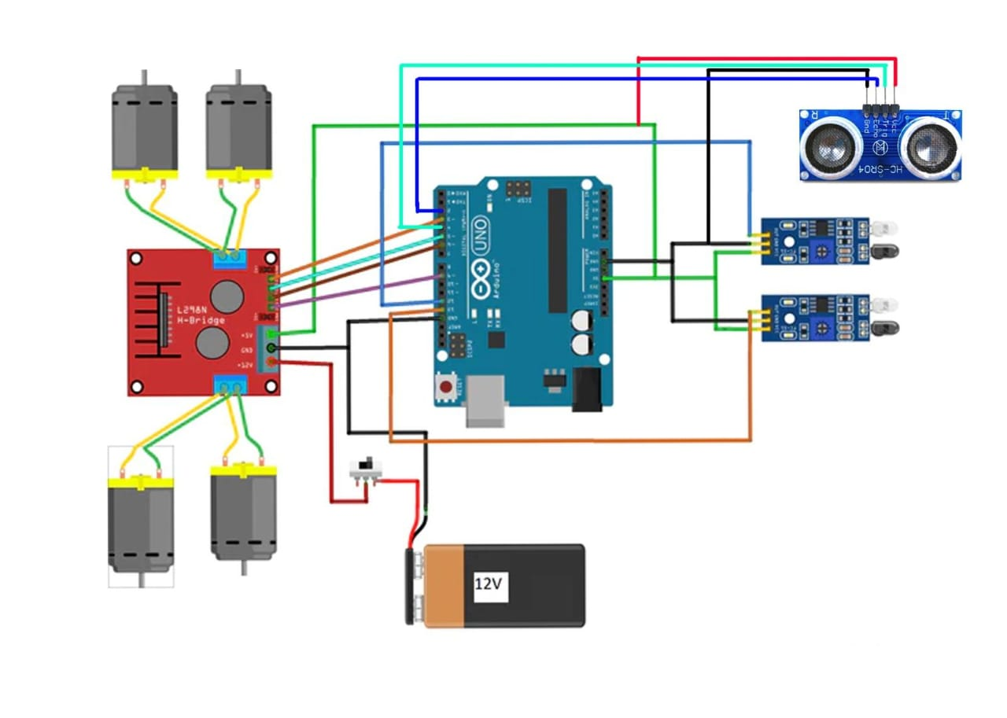
Fig:3 Line Following Section

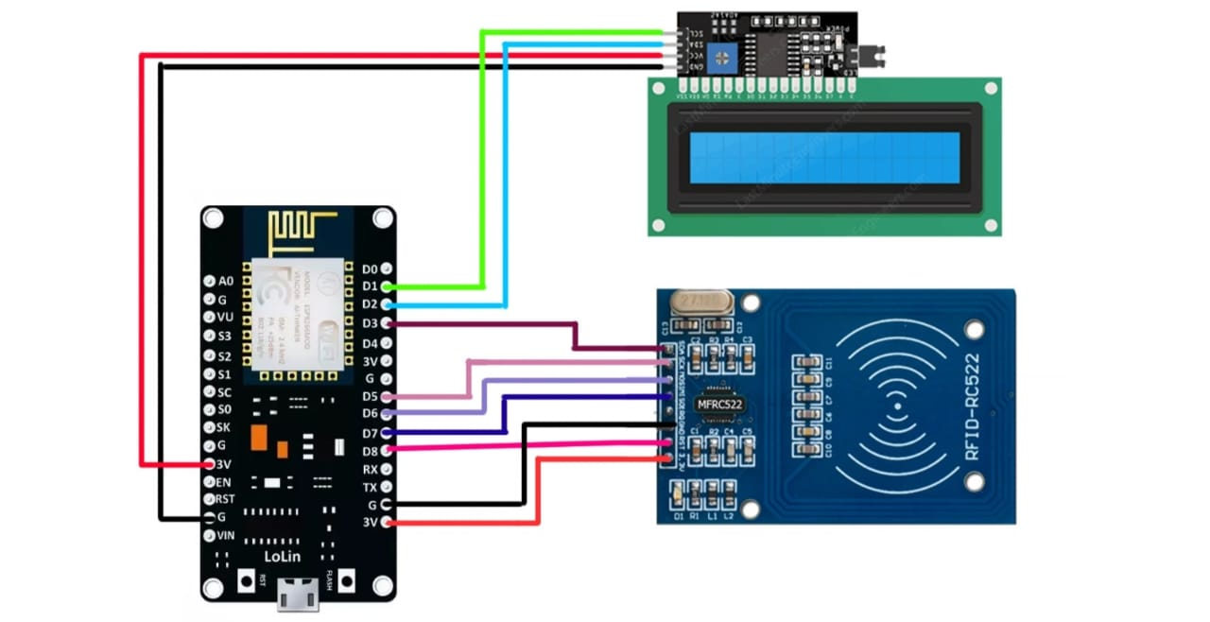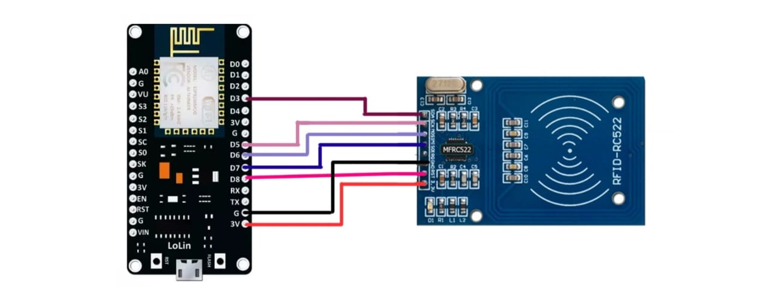

Fig:4 RFID Section

1. Circuit Diagram Explanation
The first session is consisting of a line following robot which is powered by Arudino microcontrollers. The movement is done by using ultrasonic sensors which is placed in front of the trolley. When a customer approaches a smart trolley and turns it on, the trolley will start to follow the user no matter which direction they are walking in and will also detect any obstacles in its path. The Arduino Uno, ultrasonic sensor, and infrared sensor is used in this system. The model uses an ultrasonic sensor to detect people. With a range in the prototype of between 25 cm and 100 cm. The model uses two IR sensors to direct (turn) the trolley: a left-side IR sensor and a right-side IR sensor. When the trolley turns on, an ultrasonic sensor detects a person in front of it. When that person moves, the sensor begins to follow that person while maintaining a 25 cm space between the user and the trolley in the prototype. Additionally, the trolley rotates to the left when a human turns to the left, thanks to an IR sensor on the left side. In a similar manner, when a person turns to the right, an IR sensor on the right side activates, turning the trolley to the right. The trolley automatically stops if the person stops moving. The prototype trolley's range is from 25 cm to 100 cm, so when the person in front of it moves fast that distance, the trolley likewise stops automatically. The second session is consisting of an RFID item tracking system. Here we use two Nodemcu units and two RFID’s. The RFID reader attached to the cart and an RFID tag added to each product if it is in the specified range sends the feedback signal to the reader, and the list is transmitted to the server and also on the LCD display, where the updated facts appear whenever the customer adds, or removes any product on or from the cart and automatically displays the revised bill after the purchasing. (1)

VI. Results and Discussion

This system is comprising of two distinct sessions, a line following robot and an RFID section with LCD display which shows the total amount at last of the shopping. This system improves shopping experience and reduce manpower.
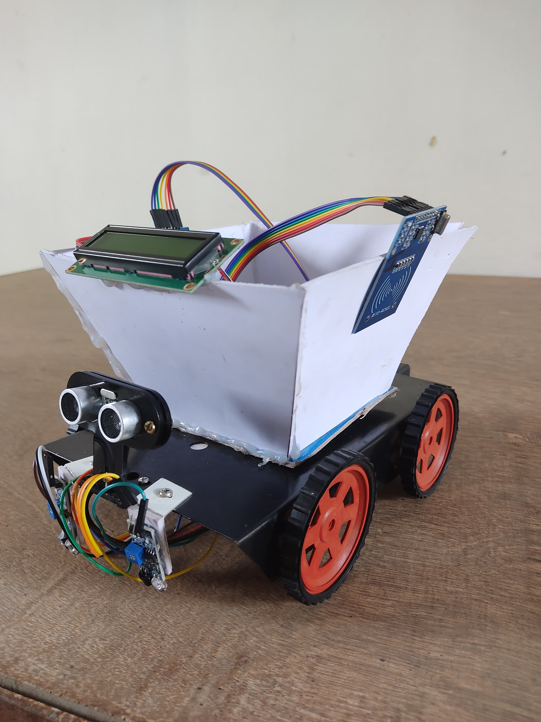

Fig:5 Result

VII. Conclusion

This project implementation will aid individuals shopping in the marketplace by eliminating the need to wait in long queues for billing. The system is user-friendly and doesn't require any assistance. It simplifies the assignment process, is cost-effective, and reduces the time spent at the billing counter. Automated addition and removal of items from the cart enhance the shopping experience. The total payable amount is conveniently displayed on an LCD screen, allowing customers to pay directly at the cash counter, bypassing lengthy billing queues.

References

[1] Sakshi Maurya; Gayatri Sahu; “The IOT-based smart shopping trolley system” IEEE, 2023 International Conference on IOT, Communication and Automation Technology(ICICAT)
[2] Kshitii Naikade, Ramakrishnan Raman. “Enhancing shopping experience with Raspberry Pi and cloud integrated wireless sensor networks for smart trolleys in IOT” IEEE, 2023 International Conference on Self Sustainable Artificial Intelligence Systems(ICSSAS)
[3] M. Saravanan; M. Swetha; “ Design and implementation of an intelligent shopping trolley integrated with a mobile application” IEEE, 2023 International Conference on Sustainable Communication Networks and Application(ICSCNA)
[4] Arpit Jain; Abhishek Bhola; “Secure and smart trolley shopping based on IOT module” IEEE, 2022 5th International Conference on Contemporary Computing and Informatics(IC31)
[5] S. K. Shankar; S Balasubramani; “Smart trolley for smart shopping with an advance billing system using IOT” IEEE, 2021 5th International Conference on computing methodologies and communication(ICCMC)
[6] Sudhir Rao Rupanagudi “A novel video processing based cost effective smart trolley system for supermarkets using FPGA” IEEE, 2015 International conference on communication, information & computing technology(ICCICT)
[7] L.S.Y. Dehigaspege, M. K. C. Liyanage, N. A. M. Liyanage, M. I. Marzook, and Dhishan Dhammearatchi “Follow Me Multifunctional Automated Trolley” International Journal of Engineering Research & Technology (IJERT)Issue 07, July - 2017
[8] S. M. Kalyani Dawkhar, "Electronic Shopping Cart For Effective Shopping based on RFID," International Journal Of Innovative Research In Electrical, Electronics, Instrumentation And Control Engineering, vol. 3, no. 1, pp. 8486, January 2015.
[9] Suraj.S, Guruprasad, V., Pranava, U. R. & Nag, P. S., RFID Based Wireless Intelligent Cart Using ARM7. International Journal of Innovative Research in Science, Engineering and Technology, V (8), 2016.
[10] Kamble, S., Meshram, S., Thoka, R. &Gakre, R., Developing a Multitasking Shopping Trolley Based On RFID Technology. International Journal of Soft Computing and Engineering, 2014.
[11] S.Sainath, K.Surender & Arvind, V., Automated Shopping Trolley for Super Market BIlling System.s.l. International Conference on Communication, Computing and Information Technology, 2014.
[12] Aryan, P., Pise, P. &Tamhane, S., Smart Shopping Cart with Automatic Billing System through RFID and Bluetooth.International Journal for Research in Applied Science & Engineering Technology, 2014.

