Krishimitra: Growing Smarter with AI-Powered Farming

Vatsal Shah
Department of Information and Technology Vidyavardhini’s College of Engineering and Technology,
Mumbai, India
vatsal.202294101@vcet.edu.in

Tanishka Wani
Department of Information and Technology Vidyavardhini’s College of Engineering and Technology,
Mumbai, India
tanishka.202424201@vcet.edu.in
Devyani Bhakare
Department of Information and Technology Vidyavardhini’s College of Engineering and Technology,
Mumbai, India
devyani.201834205@vcet.edu.in

Prof. Vaishali Shirsath
Department of Information and Technology Vidyavardhini’s College of Engineering and Technology,
Mumbai, India
vaishali.shirsath@vcet.edu.in

Abstract— Considering the vast challenges Indian Farmers undergo, a project based on AI-powered farming has been developed. The project offers an all-in-one solution for Indian Farmers. It can quickly detect and diagnose potential crop threats, fertilizer usage and provide accurate weather forecasts. Our crop recommendation system suggests suitable crops based on soil type and climate conditions, helping farmers maximize their profits and come out of Debt traps (in India, the farmers' suicide rate is very high due to debt challenges). We integrate these four essential features with machine learning to revolutionize farming practices and achieve sustainable growth.

Keywords—AI, agriculture, farming, crop recommendation, weather forecast.

Introduction
Modern agriculture faces an array of multifaceted challenges, intricately woven into the fabric of our global food systems. Paramount among these challenges is the pressing need to sustainably feed a burgeoning population amidst the backdrop of climate change-induced volatility. Traditional agricultural practices, while foundational, often reveal their limitations in efficiently navigating these complex challenges. The conundrum of crop diseases, exacerbated by shifting environmental conditions and the overreliance on fertilizers, adds yet another layer of complexity to an already intricate landscape. However, amidst these challenges lies a beacon of promise: the integration of Artificial Intelligence (AI) and its allied technologies. By harnessing the power of AI, agricultural stakeholders stand poised to unlock a realm of innovative solutions capable of reshaping the very foundation of modern agriculture. From predictive analytics to precision farming techniques, AI offers a suite of tools tailored to address the nuanced intricacies of agricultural production and management. As we stand at the precipice of a new era in farming, the fusion of AI and agriculture holds the potential to herald a paradigm shift, paving the way for a more sustainable, resilient, and productive agricultural future.

Literature Review
The future trajectory of India's farming sector and agricultural industry relies heavily on innovative ideas and technological advancements to bolster yields and optimize resource utilization using sophisticated computing tools. Crop models and decision-making aids are increasingly being integrated into agriculture to improve production efficiency and resource management. There exists significant potential for Artificial Intelligence (AI) to revolutionize agriculture by harnessing advanced technologies to predict agricultural productivity. Through AI, farmers can anticipate higher yields by forecasting crop production, selecting suitable crop varieties, managing soil and nutrients effectively, combating plant diseases and pests, controlling weeds, predicting commodity prices, and accessing real-time information on agricultural product marketing. [1]. Agriculture and farming stand as some of the oldest and most vital professions globally, playing a pivotal role in the economic sector [8].
The world is confronting myriad challenges, with population growth being a primary driver of unsustainable development (Mittal, 2013). Effectively managing resources to meet humanity's needs within set parameters is no simple task. Hence, the utilization of artificial intelligence in agricultural management holds promise across multiple fronts. There is a pressing demand for agricultural products that often outstrips production capacity. Introducing artificial intelligence into the farming sector represents a remarkable boon for mankind. By integrating modern technology into agriculture, operations can potentially run round the clock with the aid of diverse equipment and programmed software. Humans inherently seek to expand their knowledge and understanding, underscoring the necessity of acknowledging the significance of embracing technological advancements [2].
Different strategies have been proposed to address the prevailing challenges in agriculture, ranging from database management to the implementation of decision support systems. Among these solutions, those employing Artificial Intelligence (AI) have demonstrated superior performance in terms of accuracy and resilience. Agriculture, being a dynamic domain, requires tailored solutions that can adapt to specific situations rather than relying on generalized approaches. AI techniques have facilitated the ability to discern the nuanced intricacies of each scenario and provide customized solutions that best suit the particular problem at hand. Over time, the advancement of various AI techniques has enabled the resolution of progressively intricate agricultural challenges [3].
Enormous volumes of data are generated daily, both in structured and unstructured formats, encompassing various aspects such as weather patterns, soil analyses, research findings, rainfall measurements, pest vulnerability assessments, and imagery captured through drones and cameras. Internet of Things (IoT) solutions with cognitive capabilities have the potential to perceive, identify, and deliver intelligent solutions aimed at boosting crop yields [4].
Two primary technologies are employed for intelligent data fusion, proximity sensing and remote sensing. High-resolution data derived from these technologies find crucial applications, particularly in soil testing. Proximity sensing differs from remote sensing in that it does not require sensors to be integrated into aerial or satellite systems; instead, it relies on sensors in close contact with the soil. This approach enables the characterization of soil based on its composition beneath the surface in specific regions [4].
In today's agriculture, Smart Farming with IoT and Big Data analytics plays a crucial role. While terminology adoption varies by region, the proliferation of smart machines and sensors drives data-driven farming. Rapid IoT and cloud advancements accelerate Smart Farming's evolution, enabling real-time responses to events like weather warnings. AI techniques, like neural networks, evaluate soil moisture and crop predictions, optimizing resource applications. Nanotechnology and diverse sensors collect precise field data, while integrating non-traditional datasets, such as weather and satellite imagery, enhances monitoring. Continuous advances in sensing technologies, smart systems, and social media expand Big Data and ML applications across environmental fields [5].
The direction of the agriculture and farming sector is greatly influenced by innovative ideas and technological advancements aimed at boosting yields and optimizing resource utilization through the adoption of unconventional computing tools. Agricultural practices are increasingly incorporating crop models and decision-making tools to improve production efficiency and resource management. Artificial Intelligence holds substantial promise in transforming agriculture by integrating cutting-edge technologies to predict and enhance agricultural productivity [6]. In recent decades, climate change, rising production costs, dwindling water supplies for irrigation, and a decline in the agricultural workforce have collectively posed significant challenges to agriculture production systems [6]. The advent of emerging technologies has facilitated more precise crop selection and enhanced the availability of hybrid seed options tailored to farmers' requirements. This advancement is achieved through an understanding of how seeds respond to diverse weather conditions and soil types. By gathering and analyzing this data, the risk of plant diseases is minimized. Consequently, farmers can now align with market trends, anticipate yearly outcomes, and meet consumer demands more effectively, thereby maximizing crop returns efficiently [7].
Based on a survey involving over 50 respondents, the consensus suggests that while AI offers numerous advantages in farming, there are also some drawbacks that need addressing for agriculture to progress to the next level—what we might term "Modern Farmer" status [9]. This section provides an overview of deep learning methods utilized for identifying plant diseases and pests. These techniques can be viewed as an extension of classical networks applied within agriculture, as their objective aligns closely with computer vision tasks. The networks employed can be categorized into classification, detection, and segmentation networks, each tailored to different network topologies [10]. AI integrated into drones, tractors, and other agricultural machinery serves to assess, determine, and advise on optimal farming practices. This includes providing precise guidance on spraying techniques, dosage, frequency, and harvest timing to farmers. Drones, for instance, prove highly effective in field spraying, aerial imaging, and collecting data previously inaccessible [11].
On a daily basis, farms generate copious amounts of data related to weather conditions, soil quality, temperature, water usage, and more. AI and ML models analyze this data in live to extract valuable insights, providing guidance on optimal seeding times, crop varieties for improved yield, and other practical recommendations [12].
For centuries, agriculture has been the bedrock of human civilization, supplying sustenance and nourishment. Yet, traditional farming methods frequently face challenges hindering maximum productivity and sustainability amidst rapid technological progress and evolving environmental dynamics. One prominent issue confronting farmers is the absence of customized advice, resulting in subpar decision-making concerning vital aspects like disease control, fertilizer application, and crop selection [15].
The soil stands as a cornerstone of successful agriculture, serving as the primary source of vital nutrients essential for crop growth and development, including water, nitrogen, phosphorus, potassium, and proteins. Enhancing soil conditions can be achieved through practices such as composting and applying manure, which improve soil structure and porosity, as well as adopting alternative tillage methods to prevent soil physical degradation. Effective soil management strategies also play a crucial role in mitigating negative factors like soil-borne pathogens and pollutants. Additionally, leveraging AI technology for soil mapping enables the visualization of soil landscape relationships, as well as the identification of various soil layers and their respective compositions [13]. Exploring the application of AI to revolutionize agriculture and enrich agricultural research provides a comprehensive overview of the current advancements, obstacles, and potential opportunities for AI technologies in the agricultural sector. This includes demonstrating how AI can be utilized across four fundamental aspects of the food system: production, distribution, consumption, and uncertainty management. The conclusion drawn is that agricultural enterprises are well-positioned to capitalize on AI and related technologies for significant gains [14]. The paper outlines the classification of agricultural robots and their trends in development, highlighting their potential to enhance the efficiency of crop and livestock production [16].

Proposed Methodology
So, a very simple web application consists of resolving issues such as crop disease detection, crop recommendation, fertilizer recommendation and weather forecast window for users to upload their problems in the form of images or data asked by the web application. The application will aid the issues accordingly. The main steps that were included in the process were selecting various datasets for disease detection and crop recommendation and training models based on dataset. The web application is developed using languages such as Javascript, JSX, CSS for frontend and Python for backend. The frameworks that are being used are Next JS and Flask.
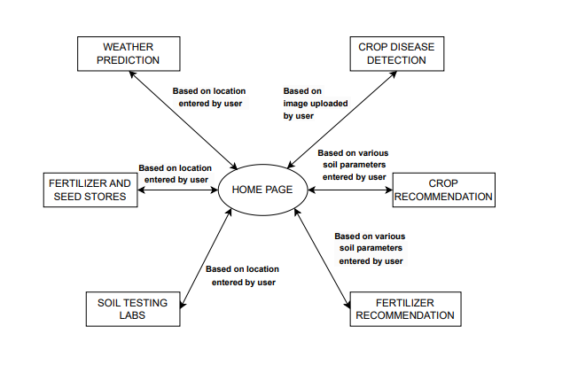
Fig. 1. Proposed Methuodology

As there are several modules for the project, they are listed below:

Crop Disease Detection
Within this module, there exists a concise audio prompt delivered in Hindi, aimed at facilitating understanding for farmers residing in India. The instruction entails the uploading of an image showcasing a crop afflicted with disease. By adhering to this guidance, users can efficiently submit visual data of the infected crop. Subsequently, the system undertakes the task of analyzing the uploaded image to discern and predict the specific ailment affecting the crop. This streamlined process ensures that farmers can readily engage with the system to diagnose crop diseases accurately, thereby empowering them with valuable insights to address agricultural challenges effectively. For this purpose CNN model is being used.
The steps that are used for this are as follows:
- Preprocess images from dataset.
- Train and load the model.
- Predict crop diseases from user uploaded images.

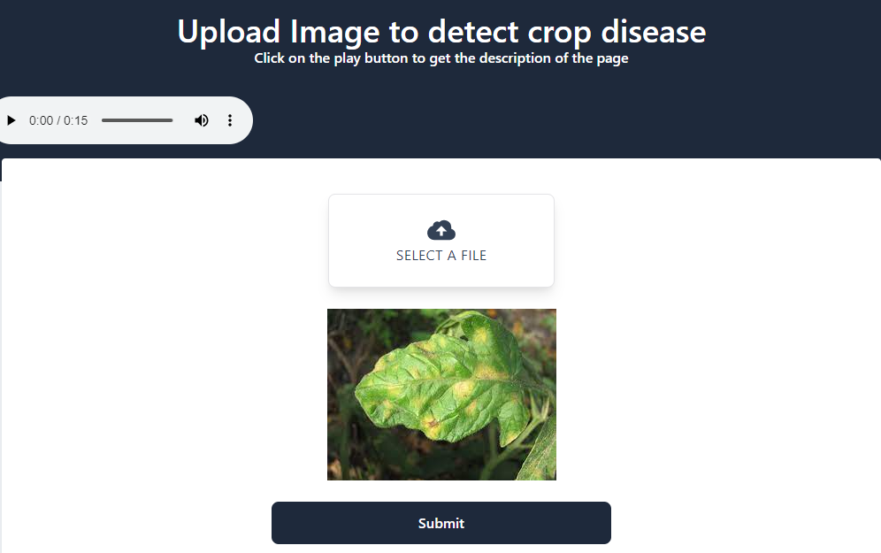
Fig. 2. Crop Disease Detection UI

Crop Recommendation
This module is equipped with an additional audio feature designed to guide users in entering crucial soil details, including location, pH value, potassium(K), nitrogen(N), and phosphorous(P) levels, all articulated in Hindi. Following the submission of these soil parameters, the system proceeds to analyze the information provided. Based on this comprehensive assessment, tailored crop recommendations are generated, aligning with the specific soil conditions inputted by the user. This holistic approach ensures that farmers receive personalized guidance on crop selection, optimizing agricultural productivity while accommodating diverse regional and environmental factors. By leveraging this intuitive interface, users can make informed decisions regarding crop cultivation, harnessing the power of technology to enhance agricultural outcomes.
The steps that are used for this are as follows:
- Train the model based on dataset and load it.
- Predict the crop which can be recommended for growing based on values of location, pH, N, P and K.

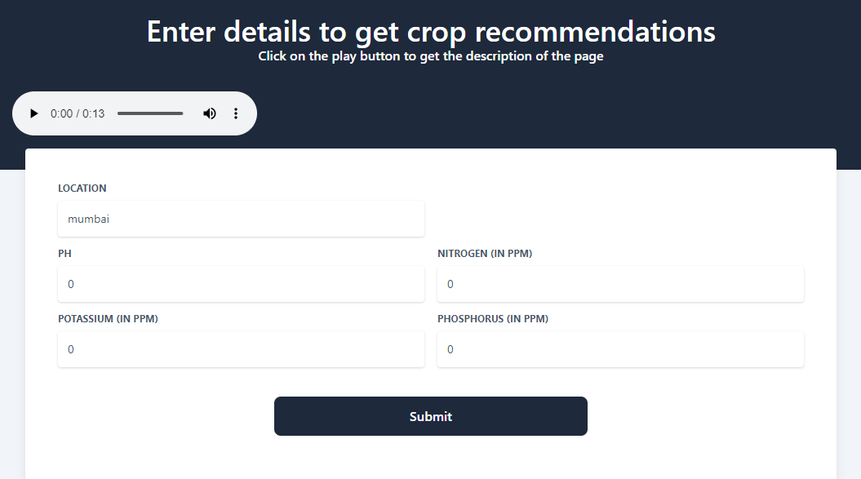
Fig. 3. Crop Recommendation UI

Fertilizer Recommendation
Within this module, users have the capability to input a range of crucial parameters essential for crop management. These include the geographic location, soil moisture levels, and concentrations of key nutrients such as nitrogen(N), potassium(K), and phosphorus(P), measured in parts per million (ppm). Additionally, users can specify the type of crop being cultivated, selecting from options such as barley, cotton, or wheat, as well as indicating the soil type, which may vary between black, loamy, or red soil. Once these detailed inputs are provided, the system undertakes a sophisticated analysis, considering both the specific requirements of the chosen crop and the current values of the soil parameters. Leveraging advanced algorithms, the system generates tailored fertilizer recommendations designed to address any nutrient deficiencies and optimize crop growth.
This comprehensive approach not only streamlines the decision-making process for farmers but also ensures that fertilizer application is precisely calibrated to meet the unique needs of each crop and soil type. By providing accurate and personalized recommendations, this module empowers farmers to enhance agricultural productivity while promoting efficient resource utilization and environmental sustainability.
The steps that are used for this are as follows:
- Pre-process the input data.
- Predict the fertilizer based on trained data model.

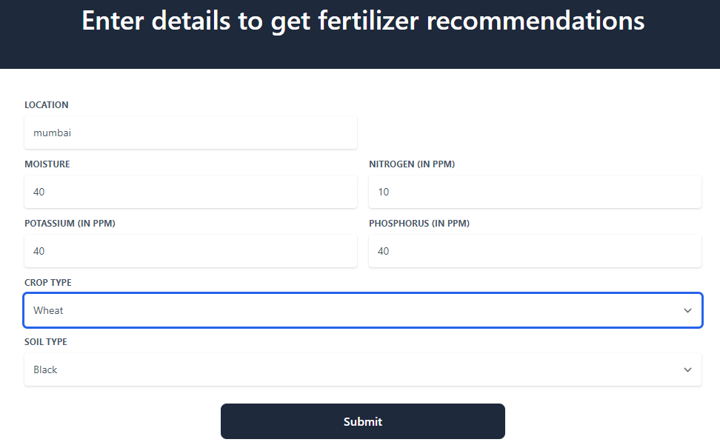
Fig. 4. Fertilizer Recommendation UI

Weather Forecast
In this module, users are provided with a seamless experience wherein they input their geographical location. This triggers a dynamic process within the system, as it swiftly connects to the 'Open Weather' API, a robust tool for accessing up-to-date weather information. Leveraging this integration, the system fetches a comprehensive array of weather data pertaining to the user's specified location. Once this data is retrieved, the system meticulously compiles and organizes it into an easily digestible format. Users are then presented with a detailed five-day weather forecast, offering invaluable insights into temperature trends, precipitation probabilities, wind speeds, and other pertinent meteorological factors. This forecast equips users with the foresight needed to plan their activities and make informed decisions based on anticipated weather conditions.
Furthermore, by utilizing the 'Open Weather' API, the system ensures the reliability and accuracy of the weather data provided, enhancing user trust and satisfaction. This seamless integration not only enhances the user experience but also underscores the system's commitment to delivering timely and relevant information tailored to the user's needs.is fetched using ‘Open Weather’ API, will display the 5 days data to the user.
The steps that are used for this are as follows:
- Take input from the user regarding their location.
- Generate analysis based on input.
- Format the received response and display it to the user.


Fig. 5. Weather Forecast UI

Soil Testing Labs
Upon user input, the system seamlessly integrates with the Google Maps API to retrieve pertinent data, facilitating the display of an interactive map showcasing the locations of soil testing laboratories. This collaborative functionality ensures that users can readily access valuable information regarding soil testing facilities in their vicinity. Leveraging the robust capabilities of the Google Maps platform, the system offers an intuitive and visually engaging interface, empowering users to explore and pinpoint relevant laboratories with ease. By streamlining the process of data retrieval and map presentation, the system enhances the user experience, fostering efficiency and convenience in accessing essential soil testing resources. Through this integrated approach, users are equipped with a comprehensive toolset for informed decision-making and effective navigation within the realm of soil analysis and testing services.

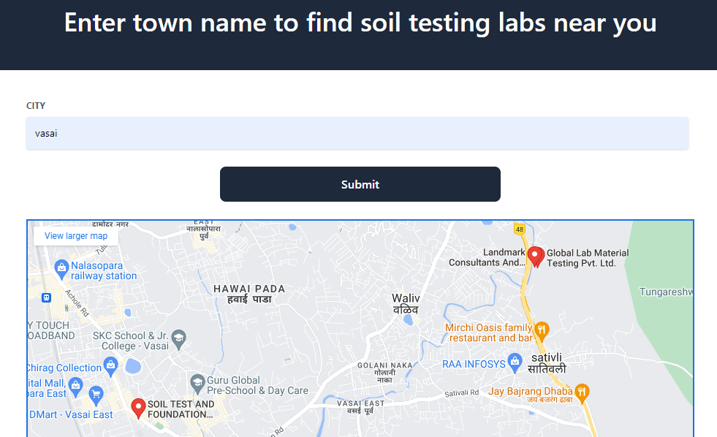
Fig. 6. Soil Testing Lab UI

Fertilizers and Seed stores
Upon user input regarding their location, the system seamlessly taps into the robust infrastructure of the Google Maps API to fetch relevant data, thereby orchestrating the presentation of an interactive map spotlighting the diverse array of Fertilizers and Seed stores. Through this symbiotic integration, users gain access to a dynamic visualization of stores specializing in agricultural supplies, particularly fertilizers and seeds. Harnessing the sophisticated features embedded within the Google Maps platform, the system orchestrates a captivating and user-centric interface, empowering individuals to navigate, explore, and pinpoint nearby stores with utmost ease and precision. By orchestrating an intricate interplay between data fetching mechanisms and map rendering functionalities, the system optimizes the user journey, facilitating seamless access to critical resources essential for agricultural endeavors. Through this harmonious fusion of technology and usability, users are empowered to make informed decisions and navigate the landscape of fertilizers and seed procurement with confidence and efficiency.

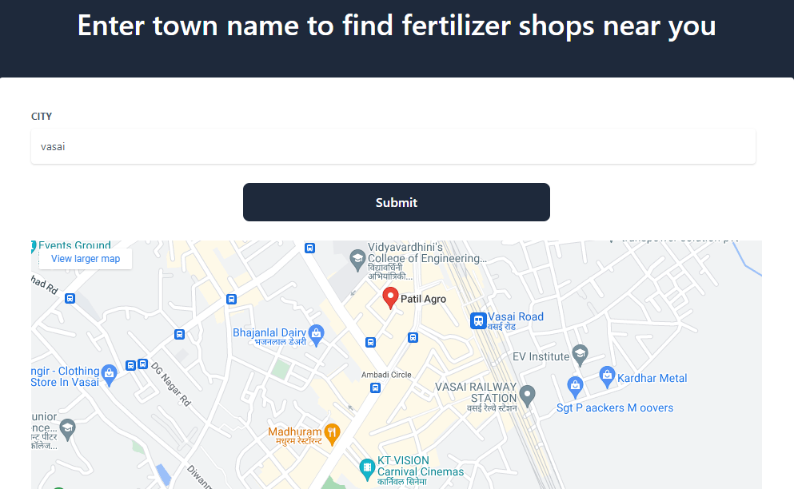
Fig. 7. Fertilizers and Seed stores UI

Results

Crop Disease Detection
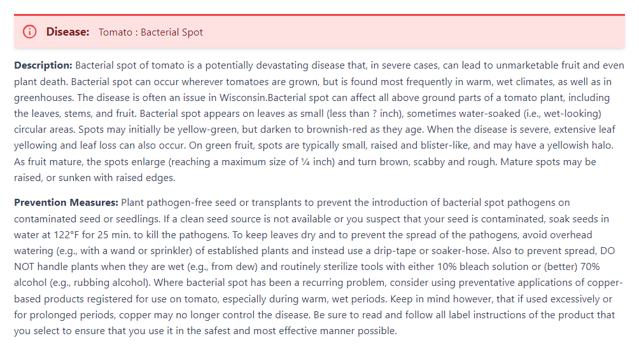
Fig. 8. Crop Disease Detection Result
Within this system, users can anticipate a comprehensive array of services aimed at addressing crop diseases effectively. Beyond merely predicting the name of the disease, the system goes the extra mile by furnishing detailed descriptions of the identified diseases, along with recommended preventive measures. Moreover, users will receive suggestions for pesticide supplements specifically tailored to combat the identified disease, complete with e-commerce links enabling direct procurement. This holistic approach not only diagnoses crop ailments but also empowers users with valuable insights and actionable recommendations to safeguard their crops. By integrating e-commerce functionality, the system streamlines the process of acquiring necessary pesticides, enhancing convenience and facilitating prompt intervention to protect crop health.

Crop Recommendation
Fig.9. Crop Recommendation Result

Upon obtaining detailed insights from the user, the system is poised to offer personalized crop recommendations. Through a thorough examination of the information provided by the user, the system meticulously assesses various parameters such as location, soil characteristics, climate conditions, and crop preferences. This comprehensive analysis enables the system to make informed decisions and select the most appropriate crop varieties that best match the specified criteria and meet the unique needs of the user. By leveraging these user-provided details, the system ensures that the recommended crops are well-suited to thrive in the given environmental and agricultural context, thereby optimizing yield potential and agricultural success.

Fertilizer Recommendation
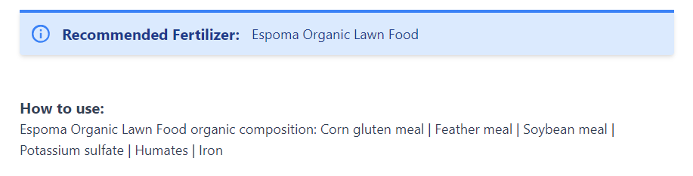
Fig.10. Fertilizer Recommendation Result

Upon the completion of user input, the system will engage in a comprehensive analysis to determine the most suitable fertilizer recommendation and offer detailed instructions on its application. Leveraging the data provided by the user, including factors such as soil composition, crop type, and environmental conditions, the system will meticulously evaluate various fertilizer options. Subsequently, based on this thorough assessment, the system will present the user with tailored fertilizer recommendations, ensuring optimal nutrient supplementation for the specified agricultural context. Additionally, the system will also mention the contents of the fertilizer. This holistic approach empowers users with actionable insights and best practices to maximize crop health and yield potential effectively.

Weather Forecast

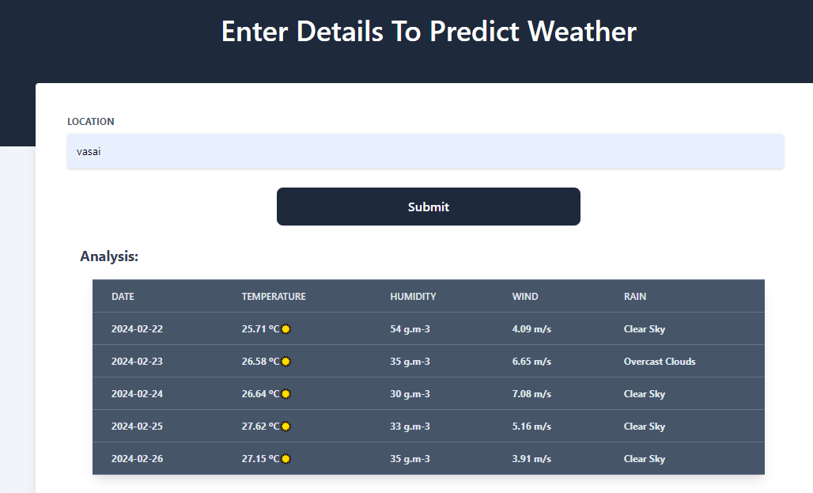
Fig. 11. Weather Forecast Result
By utilizing the 'Open Weather' API, the system ensures the reliability and accuracy of the weather data provided, enhancing user trust and satisfaction. This seamless integration not only enhances the user experience but also underscores the system's commitment to delivering timely and relevant information tailored to the user's needs.is fetched using ‘Open Weather’ API, will display the 5 days data to the user.

Conclusion
This module boasts an impressive capability to identify and classify a diverse range of 38 crop diseases, employing advanced algorithms that account for scenarios where the crop is healthy or when the image does not contain any crop at all. Additionally, users can benefit from fertilizer recommendations tailored to 11 different crops, along with considerations for 5 distinct soil types. Moreover, to enhance accessibility and comprehension for users from various linguistic backgrounds, the module offers translation functionality into multiple languages. This includes native Indian languages such as Assamese, Bengali, Bhojpuri, Gujarati, Marathi, Hindi, and more, facilitated through the integration of the 'Google Translate' API. By providing translations in multiple languages, the module ensures that users can fully grasp the information presented, fostering better understanding and engagement Authors and Affiliations.

References
- Suchandra Dutta, Shantanu Rakshit, Devayan Chatterjee, “Use of Artificial Intelligence in Indian Agriculture”, ICAR, Rajasthan.
- Sidhu, K.S., Singh R., Singh S., Singh G., “Data Science and Analytics in agricultural development”, ASEA, 2021.
- Gouravmoy Bannerjee, Uditendu Sarkar, Swarup Das, Indrajit Ghosh, “Artificial Intelligence in Agriculture: A Literature Survey”, IJSRCSAMS, 2018.
- V. Dharmaraj, C.Vijayanand, “Artifical intelligence(AI) in Agriculture”, IJCMAS, 2018.
- Shravani Pramod Ghadge, Prof. Jayshree Pasalkar, “Data Science in Agriculture”, IRJET, 2021.
- Robin Sharma, “Artificial Intelligence in Agriculture: A Review”, ICICCS 2021.
- Tanha Talaviya, Dhara Shah, Nivedita Patel, Hiteshri Yagnik, Manan Shah, “Implementation of Artificial Intelligence in Agriculture in Agriculture for Optimisation of irrigation and application of pesticides and herbicides”, 2020.
- Kunal Girdhar Patel, Mittal Sanjay Patil, “Artificial Intelligence in Agriculture”, IJRASET, 2022.
- Sakshi Pawar, “Artificial Intelligence in Agriculture”, ICSITS, IJERT, 2020.
- Neha, Pooja Gupta, Dayam Nadeem, Abuzar, Anam Elahi, “Artificial Intelligence in Agriculture”, ICICC, 2022
- Mark Ryan, Gohar Isakhanyan, Bedir Tekinerogan, “An interdisciplinary approach to artificial intelligence in agriculture”, NJAS, 2023.
- G Mahibha, P. Balasubramanian, “Impact of Artificial Intelligence with Special Reference to Agriculture Information research”, Current Agriculture Research Journal, 2023.
- Jiali Zha, “Artificial Intelligence in Agriculture”, Journal of Physics: Conference Series, CISAI 2020.
- S. Y. Liu, "Artificial Intelligence (AI) in Agriculture," in IT Professional, vol. 22, no. 3, pp. 14-15, 1 May-June 2020.
- K. Mridha and S. M. A. Hasan, "Artificial Intelligence (AI) for Agricultural Sector," 2021 International Conference on Control, Automation, Power and Signal Processing (CAPS), Jabalpur, India, 2021.
- A. Raikov and V. Abrosimov, "Artificial Intelligence and Robots in Agriculture," 2022 15th International Conference Management of large-scale system development (MLSD), Moscow, Russian Federation, 2022.
- McKinion, J.M., & Lemmon, H. E. (1985). Expert systems for agriculture. Computers and Electronics in Agriculture 1(1), 31-40.
- G. M. Pasqual, J. Mansfield, "Development of a prototype expert system for identification and control of insect pests," Computers and Electronics in Agriculture, vol.2 no. 4, pp. 263-276, 1988.

