Advancing Motorcycle Safety Through Helmet Detection and Accident Avoidance
Prof. Ramya B¹, Adishesh Ankanath R², Akshay R³, Amoghavarsha B⁴, Nidhi D⁵
¹Assistant Professor, Dept. of Electronics and Communication Engineering, Vidyavardhaka College of Engineering, Karnataka, India
²³⁴⁵Student, Dept. of Electronics and Communication Engineering, Vidyavardhaka College of Engineering, Karnataka, India

---------------------------------------------------------------------***---------------------------------------------------------------------

Abstract - This paper addresses the pervasive issue of road accidents in contemporary society, attributing them to factors such as rash and drunken driving, as well as non-compliance with traffic regulations. Proposing an innovative solution, we introduce a newly developed system designed to enhance rider safety. This system operates as a cost-effective and user-friendly protection mechanism, ensuring that the rider can only operate their two-wheeler when both sober and wearing the helmet. In the event of a severe accident, the system autonomously notifies emergency contacts, expediting the delivery of critical aid and medical care. The primary goal of this system is to significantly reduce injuries sustained by two-wheeler riders in road accidents. This system also incorporates a password based unlock and ignition system which enhances the security of the vehicle. This comprehensive approach addresses not only the prevention of accidents but also emphasizes the swift response and care necessary to mitigate the adverse consequences of such incidents.

Key Words: Accident detection, Alcohol detection, password based ignition, emergency alert message

1.INTRODUCTION

In a world where technology is the driving force behind safer and smarter solutions, the convergence of innovation and responsibility takes centre stage in the realm of personal safety and transportation. Smart helmets, once emblematic of protection, are now embarking on a transformative journey that extends beyond mere headgear. They are evolving into holistic guardians of well-being, blending cutting-edge technology with a commitment to safety and ethical conduct. This project explores the realm of smart helmets with a unique focus on their augmented safety features. At its core, the project delves into three pivotal aspects: alcohol detection, real-time emergency contact messaging, and proactive enforcement of helmet use. The objective is not only to optimize user experience but to foster responsible behaviour while maximizing safety. The integration of alcohol detection technology within these smart helmets represents a significant stride towards reducing accidents caused by impaired riding. Real-time alcohol detection coupled with instant alert mechanisms ensures that no journey begins under the influence. Furthermore, the automatic messaging system to emergency contacts, triggered in the event of an accident, adds an extra layer of assurance to riders and their loved ones. The project's approach extends to reinforcing safety measures at every step. The vehicle's ignition, tightly coupled with the helmet's condition and alcohol detection, sets forth a stringent standard for responsible and secure vehicle operation.
The objectives for the proposed project are:

- To ensure the rider wears a helmet before allowing bike ignition.

- To prevent ignition of vehicle if alcohol is detected on the rider.

- To send an alert SMS to a specified contact in case of alcohol detection and automatically dispatch an emergency alert message with the bike's location if an accident occurs.

- To implement a password-based ignition system for bike security.

2. HELMET DETECTION AND ACCIDENT AVOIDANCE

Introduce a sensor to identify the presence of a helmet on the rider's head and integrate it with the vehicle's ignition system, ensuring that the vehicle cannot be started if the helmet is not detected. Incorporate a breathalyzer or an alternative alcohol detection system into the vehicle, linking it to the ignition to disable the engine upon detecting alcohol. Establish a communication module using GSM to dispatch a message to a predefined emergency number when alcohol presence is detected. Employ an accelerometer and Gyro sensor to detect collisions, initiating an emergency response that sends a message containing the vehicle's location to a predetermined number in such events. Integrate a secure password system for the vehicle, necessitating the rider to input the correct password before starting the engine to ensure robust security and prevent unauthorized access.

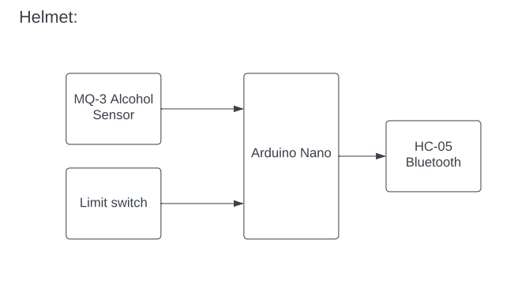
Figure 1: Helmet unit
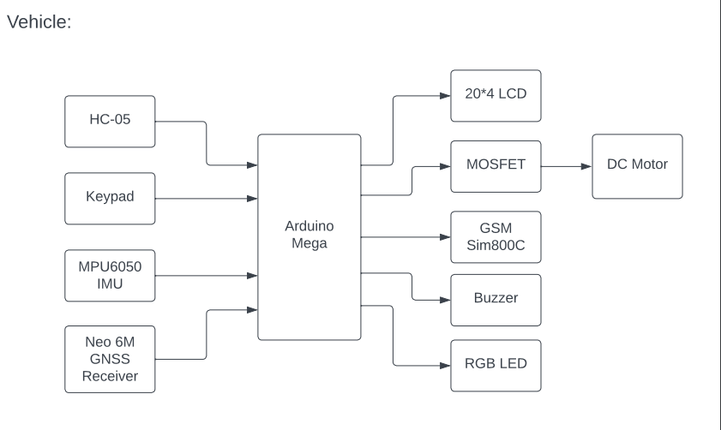
Figure 2: Vehicle unit

3. LITERATURE REVIEW

Aayush Doshi and Jubin Kamdar [1] proposed a system which employs advanced technologies, including accelerometers, vibration sensors, GPS modules, and GSM modules, to identify accidents, determine their precise location, and notify emergency services. The Arduino UNO serves as the microcontroller board. In the event of an accident, the ADXL335 Accelerometer detects the acceleration resulting from the collision. The GPS module provides accurate latitude and longitude coordinates, displaying the vehicle's current position and speed in knots on the LCD. If the accelerometer detects abnormal shaking or a sudden change in axis, an SMS is automatically sent to the designated mobile number specified in the code. This message includes the latitude and longitude information presented in Google Maps format. The specified mobile number receives the message, along with details about the specific accident location.
Kshirsagar Rajat et.al [2] developed a system, designed with a built-in switch to determine whether the rider is wearing a helmet. If the helmet is not worn, the two-wheeler will be prevented from starting, prioritizing rider safety. Additionally, the helmet is equipped with an alcohol detection system utilizing an alcohol detector to analyze the rider's breath for alcohol presence. If the alcohol levels exceed the permissible range, the ignition will be disabled, effectively preventing instances of drunk driving. The system comprises two main modules: a Helmet module and a Bike module. The Helmet module integrates sensors such as pressure sensors, alcohol sensors, and fall detection sensors, all connected to an Arduino Uno R3 processor. Meanwhile, the Bike module incorporates an Arduino Mega 2560 processor and communicates with the helmet module through RF transceivers. In the unfortunate event of an accident, the system employs GPS and GSM technology to relay the victim's location to both family members and nearby police stations.
Vivien Melcher et. al [3] proposed a system whose primary objective is to enhance emergency response by supplying health-related information to service centers and alerting riders about potential health risks. The user requirements for the system include advanced e-Call features, health monitoring capabilities, and feedback on physical activities. Key parameters considered in the system design include heart rate, pulse rate, respiration, consciousness level, impact on the head, stomach, and chest, preceding vital sign data, GPS data indicating accident location, speed before the accident, and a voice connection to the rider. The essential components of the i-VITAL system consist of an i-VITAL kit, which include helmets and garments equipped with bio-signal sensors, along with the user's mobile phone featuring an Android application. These components are interconnected through Bluetooth Low Energy technology to facilitate seamless communication. The helmet bio-signal sensor module incorporates sensors and signal conditioning circuits to capture vital signals from the user's head. Both the helmet and garment subsystems are equipped with Bluetooth communication modules, enabling wireless communication with the mobile phone for emergency call activation and data transmission.
Nataraja N et.al [4] proposed the development of a smart helmet system to enhance safety for motorbike riders. The proposed system comprises various modules seamlessly integrated into both the helmet and the bike. These modules include a helmet detection system, an accident avoidance detection module, and a signboard detection module. The helmet module's primary function is to ascertain whether the rider is wearing the helmet. If the rider is wearing the helmet, the module transmits signals to facilitate the ignition of the vehicle. Moreover, an integrated alcohol detection feature prevents the vehicle from starting in the event that the rider is under the influence of alcohol. The signboard detection module serves the purpose of issuing advance warnings regarding obstacles on the road through voice output and display on an LCD screen. This feature is implemented to heighten the rider's awareness of potential hazards. Additionally, the accident detection system is crafted to autonomously notify emergency contacts in the event of a crash, with the capability to differentiate between minor and major casualties.
Dr. M.Kiran Kumar et.al [5] explores the creation of a Smart Helmet-based Accident Detection and Notification System designed for two-wheeler motorcycles, leveraging the capabilities of the Internet of Things. The primary objective of the system is to address the prevalent issue of high road accident rates and the subsequent delay in providing emergency assistance, particularly for two-wheeler riders. The proposed Smart Helmet-based Accident Detection and Notification System comprises three essential modules: the Data Collection Module, the Accident Detection Module, and the Notification System Module. In the Data Collection Module, data on helmet rotation is gathered using the MPU6050 Accelerometer and Gyroscope Sensor affixed to the GISMO-VI Board, sending the collected information to the Accident Detection System. Abnormal rotation in all three axes signifies a potential accident, triggering the activation of the Notification System Module. The Accident Detection Module verifies significant changes in axis rotation indicative of an accident, confirming the incident and prompting the Notification System Module. In the event of a confirmed accident, the Notification System Module utilizes Python scripts to initiate calls and send SMS notifications to the designated emergency contacts through the Twilio API.
Aakriti Suman et.al [6] proposed a smart helmet system which incorporates various features to enforce road safety regulations, monitor rider sobriety, and detect accidents, while also providing emergency notification mechanisms. This system comprises of two units: A Helmet unit and A Vehicle unit. The Helmet unit includes a PIR sensor (HC-SR505) designed to detect human presence, which determines whether the rider is wearing a helmet or not. Additionally, it incorporates an MQ3 sensor for alcohol detection and an SOS button to activate the alarm system. The Helmet unit establishes a remote connection with the Vehicle unit. The Vehicle unit, powered by a LaunchXL microcontroller, features an alert system equipped with an accelerometer for accident detection. It also incorporates a GSM/GPRS unit responsible for transmitting emergency alert messages to the designated emergency contacts stored in the system and to the nearby police station.
Melanie Anthony et.al [7] developed a system which aims to address the rising number of road accidents caused by drunk driving, by creating a system that detects the presence of alcohol in the driver's system. The proposed system is designed to prevent the driver from operating the vehicle if they have consumed alcohol beyond the permissible limit. The key components of the system include an Arduino Uno microcontroller, an alcohol detection sensor (MQ-3), a GSM module for alerting authorities, a DC motor for controlling the vehicle's ignition system, a push-button switch to stop the emergency message in case of a minor or wrong incident, and an LED indicator that illuminates in case of alcohol consumption by the user.
Jeneetha Jebanazer et.al [8] proposed a system whose primary objective is to detect accidents and ensure timely assistance to the victims. The smart helmet utilizes sensors, cloud computing, and IoT connectivity to achieve this. The smart helmet system integrates multiple sensors to detect critical parameters such as the presence of the helmet using a touch sensor and alcohol consumption by the rider using an alcohol sensor. It uses an Arduino Uno microcontroller as the central processing unit to collect and process data from the sensors. The system also incorporates RF technology for data transmission between the helmet and the vehicle unit. This system uses a gyroscope sensor and a vibration sensor to detect accidents. In the event of an accident, the system automatically sends the location information to a server, enabling quick response and assistance using the GSM module for communication, a GPS module for location tracking, and Zigbee protocol for wireless data transmission.
Mohd Khairul Afiq Mohd Rasli et. al [9] developed a system whose primary objective is to enhance the safety of motorcyclists by integrating sensors into the helmet to prevent accidents and reduce fatalities. The smart helmet incorporates a Force Sensing Resistor to detect the rider's head and a Brushless Direct Current Fan as a speed sensor to monitor the motorcycle's speed. A 315 MHz Radio Frequency Module is used for wireless communication between the helmet and the motorcycle and the system is controlled by a PIC16F84a microcontroller. The helmet is designed to ensure that the motorcycle's engine starts only when the rider wears the helmet and buckles the safety belt. Additionally, an LED flashes to alert the rider if the motorcycle's speed exceeds 100 km/hour.
J Joy Mathavan et.al [10] proposed a system aimed at reducing motorcycle accidents and reporting them to emergency contacts. The proposed smart helmet system detects and reports accidents through a combination of sensors and communication modules. The system includes various components such as alcohol sensors, IR sensors, GSM modules, ignition relays, accelerometers, and displays. It operates in three modes: start mode, running mode, and accident mode. In the start mode, the system checks for proper helmet usage, absence of alcohol consumption, and the lifting of the side stand before allowing the ignition of the engine. During the running mode, a gyroscopic sensor continuously monitors the angle of inclination of the motorbike. If the gyroscope detects an angle greater than 90 degrees, the accident mode is activated, and the GSM module sends a message to the pre-registered emergency contact numbers. The system also allows for customization of the angle threshold and the ability to change the pre-registered phone number based on the rider's location. Additionally, the system includes a liquid crystal display screen to display the modes of operation and emergency messages. The proposed system aims to provide real-time accident detection and reporting capabilities to enhance the safety of motorcyclists.
Deekshitha K I and Pushpalatha S [11] proposed a smart helmet system designed to prevent accidents through the integration of various sensors and communication modules. The helmet unit includes alcohol and eye blink sensors, which are utilized to detect alcohol consumption and drowsiness, both of which are common factors contributing to accidents. The alcohol sensor is placed near the rider's mouth to detect alcohol concentration, while the eye blink sensor identifies drowsiness and triggers an alarm to alert the rider or communicate with caregivers. Additionally, the system incorporates a crush sensor for accident detection. The vehicle module consists of a GPS module, GSM module, RF receiver, MCU, and ignition switch. In the event of an accident, the GPS module acquires the coordinates of the accident site and sends them via the GSM module to a pre-saved number. The system also checks if the helmet has been worn and if the user has consumed alcohol before vehicle ignition.
Keesari Shravya et.al [12] proposed a smart helmet project designed to enhance the safety of bike riders through advanced features such as alcohol detection, accident identification, location tracking, hands-free functionality, and fall detection. The project consists of two main units: the helmet unit and the bike unit, both integrated with microcontrollers and connected via RF modules for communication. The working of the smart helmet involves several key steps. Firstly, the helmet unit initializes all ports and proceeds to accident detection using an accelerometer. If no accident occurs, it listens to the RF module continuously for data and checks whether the helmet is worn. If the helmet is not worn, a message is displayed prompting the rider to wear the helmet. The system also checks for alcohol consumption, and if the rider is found to be drunk, a message is sent to a registered number with the location, and the system prompts for a password to start the bike. In the event of an accident, the system stops all processes and sends a message with the location. The design and realization of the smart helmet involve the use of Arduino for the transmitter, which displays messages on an LCD and sends SMS to a registered number in the event of alcohol detection or an accident.

4. CONCLUSIONS

A Smart Helmet technology promotes adherence to safety standards, fostering responsible helmet use. The inclusion of alcohol detection addresses a key factor in preventing accidents and encourages responsible behaviour. The standout feature is accident detection with an automatic alert system, which, through advanced sensors and communication technologies, has the potential to reduce emergency response times during accidents. This feature enhances individual safety and contributes to the broader goal of creating safer road environments. However, challenges such as user acceptance, costs, and the need for standardized protocols must be addressed for widespread adoption. Future research should focus on overcoming these challenges and refining existing features for improved accuracy and reliability.

REFERENCES

- Aayush Doshi, Bhavya Shah and Jubin Kamdar, “Accilert – Accident Detection And Alert System.” International Journal of All Research Education and Scientific Methods (IJARESM), vol. 9, no. 11, 2021

- K. Rajat, F. Swaleha, T. Shubham, and S. K. Apte, “Life Saving Device: A Smart Helmet,” International Research Journal of Engineering and Technology, vol. 06, no. 03, Art. no. 2395–0056, Mar. 2019.

- Vivien Melchera, Frederik Diederichs, Rafael Maestre, Christian Hofmann, Jose-Maria Nacenta, Jos van Gent, Dragan Kusić, Boštjan Žagar, “Smart vital signs and accident monitoring system for motorcyclists embedded in helmets and garments for advanced eCall emergency assistance and health analysis monitoring”, Procedia Manufacturing, 3, 3208–3213. https://doi.org/10.1016/j.promfg.2015.07.871

- Nataraja N, Mamatha K S, Dr. Keshavamurthy, Dr. Shivashankar, "Smart Helmet", 2018 3rd IEEE International Conference on Recent Trends in Electronics, Information & Communication Technology (RTEICT-2018), May 18th and 19th, 2018.

- Dr. M. Kiran Kumar, Aniruddha Balbudhe, CH Sai Karthikeya, “Smart Helmet based Accident Detection and Notification System for Two-Wheeler Motor Cycles” E3S Web of Conferences. https://doi.org/10.1051/e3sconf/202339101149

- Suman, A. Parashar, A. Shukla and K. R. Shobha, "Aagaahi - A Smart Helmet," 2020 IEEE International Conference on Electronics, Computing and Communication Technologies (CONECCT), Bangalore, India, 2020, pp. 1-6, doi: 10.1109/CONECCT50063.2020.9198395.

- M. Anthony, R. Varia, A. Kapadia, and M. Mukhrjee, “Alcohol Detection System to Reduce Drunk Driving,”, International Journal of Engineering Research & Technology, vol. 9, no. 3, Art. no. 2278–0181, 2021.

- Jebanazer, A. Dhanasekaran, Y. Chinnaraj, and Y. Ravanan, “Smart Helmet for Accident Prevention and Detection,” International Research Journal of Engineering and Technology, vol. 08, no. 04, Art. no. 2395–0056, Apr. 2021.

- M. K. A. Mohd Rasli, N. K. Madzhi and J. Johari, "Smart helmet with sensors for accident prevention", 2013 International Conference on Electrical, Electronics and System Engineering (ICEESE), Kuala Lumpur, Malaysia, 2013, pp. 21-26, doi: 10.1109/ICEESE.2013.6895036.

- Mathavan, J. J., Wijesekara, V. K. D., Satheeskanth, N., Wanasinghe, W. M. U. J., Maathushan, M., & Wijenayake, V. V. (2022) “Smart helmet to start the motorbike and to prevent accidents” IOP Conference Series, 1258(1), 012051. https://doi.org/10.1088/1757-899x/1258/1/012051

- Deekshitha, K. I., & Pushpalatha, S. (2018) “Implementation of smart helmet”, International Journal of Engineering Research and Technology, 6(13). https://www.ijert.org/research/implementation-of-smart-helmet-IJERTCONV6IS13009.pdf

- K. Shravya, Y. Mandapati, D. Keerthi, K. Harika, and R. K. Senapati, “Smart helmet for safe driving,” E3S Web of Conferences, vol. 87, no. 01023, https://doi.org/10 .1051/e3sconf/20198701023

