Thermal and Structural Analysis
on Simulated Model of a Beam Dump

Wagh Amey Suresh
Department of Mechanical Engineering
MHSSCOE, Byculla

Keywords: Beam dump design, FEM, Thermal and Structural stress.

Abstract

This paper deals with the design, thermal and structural analysis for stopping the proton beam. A conical beam dump is being designed to handle the thermal and structural stresses resulting due to high heat load and hydraulic pressure of coolant, while handling 600 KW proton beam power in CW operation at 20 MeV energy. Pressure drop and heat transfer calculations are done considering spiral channel cooling system. The heat flux has been calculated by using Bi-Gaussian distribution density function of particles in beam. Nickel is selected as the beam dump material because of its favorable properties. In order to understand the thermal performance of beam dump a  finite element model has been developed to predict the steady state temperature and stress distributions within the beam stop material.

Nomenclature
CW : Continuous Wave
A : Cross sectional area (m²)
C_{l} : Specific heat at constant Pressure (KJ/ Kg.k)
E : Modulus of elasticity (pa)
f : Friction factor
g : Acceleration due to gravity ( m/s²)
h : Convective heat transfer coefficient (W/m²k)
k :Conductivity (W/m.k)
Nu : Nusselt number
P : Power (W)
p : Pressure (Pa)
Pr : Prandlt number
R : Radius (m)
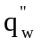 :Heat flux (W/m²)
T : Temperature (⁰C)
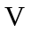 : Velocity (m/s)
Greek symbols
- : Thermal expansion coefficient (m/mk)
μ : Poisons ratio
: Density (Kg/m³)
σ : Surface tension (N/m)

1 INTRODUCTION
The beam dump is being designed to handle the thermal and structural stresses resulting due to high heat load and hydraulic pressure of coolant, while handling 600 KW proton beam power in the CW operation at 20 MeV energy. Density function of particles in beam can be predicted most accurately by Bi-Gaussian distribution [1], therefore the heat flux has been calculated using Bi-Gaussian distribution. To avoid target surface overheating, it is reasonable to produce the beam dump of conical shape that effectively extends its active area, since reducing the power density in the target by changing the beam characteristics will result in a larger target, which in some applications is undesirable.

There is a limit to the size of proton beams, which can be considered practical as well as engineering constraints on the target size [2]. Beam dump can be cooled by liquid agent, for example, Water or liquid metal. High thermal conductivity is important to provide good heat transfer in order to effectively cool the beam dump. Water is selected as cooling agent to keep design simple it also offers advantage like availability, cheap cost and comparatively easy temperature control. Coolant is circulated in a spiral channel coiled over the beam dump target. The cooling water is under pressure to prevent boiling, and heat transfer coefficient is based on the velocity of the water in the cooling channel. Water inlet temperature is taken as 20 ⁰C for the analyses. Pressure drop and heat transfer calculation are done using mean radius of coil [3]. The correlations used are of turbulent flow through helical coil with rectangular cross section. In order to understand the thermal performance of beam dump a  finite element model has been developed to predict the steady state temperature and stress distributions within the beam stop material. After obtaining the thermal solution, the thermal elements are converted to structural elements for stress analysis.
Properties (SI unit) | Nickel (ni)
Conductivity (K) (W/m.k) | 79.3
Density (ρ) (Kg/m³) | 8900
Specific heat (Cp) (J/Kg.k) | 445
Thermal Expansion coefficient  = α X10⁻⁶ (m/m.k) | 12.96
Modulus of elasticity  = E X10¹¹ (Pa) | 2.207

2 MODEL DESCRIPTIONS
To reduce the heat flux deposited in the beam dump target one needs to extend its operation surface. A good solution should be the target design of conical shape. The beam dump is 20 cm radius, 1.2 m long, and 5 mm thick cone with slope of 16.66 cm/cm i.e. apex angle 18.19 degrees. The conical end section would capture the central portion of the beam while flange at the base will stop wings of Gaussian distribution. Spiral cooling channel, assumed to coil over the beam dump, is selected since the cooling channel cross section area remains constant. Spacing between two channel i.e. wall thickness is 5 mm. Figure 1 shows the typical cooling scheme adopted for the thermal design.

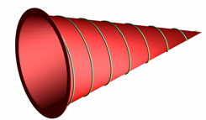
Figure 1 Spiral cooling channel over conical beam dump

2.1 Material Selection
Materials for the beam stop considered are based on thermal, mechanical and nuclear properties like, high resistance to the corrosion of cooling agent, high thermal conductivity, high melting and low boiling point [4]. Nickel have better thermo mechanical properties, it shows sufficient fatigue properties, fabrication ease for machining and welding. It has good corrosion resistance i.e. compatible for vacuum and cooling system. Because of these favorable properties nickel can be selected as the material for beam dump. Analyses are done using following properties [4], as listed in Table 1, for nickel.

Table 1 Thermo-physical properties

2.2 Mechanical design
Buckling calculation can be performed assuming an equivalent cylinder of mean diameter in place of the conical beam dump target. It gives satisfactory acceptable results [5]. Therefore thickness of the beam dump target has been calculated using ASME design criteria for buckling of long cylinders under external hydraulic pressure of coolant. The calculated nickel target thickness for 0.3 MPa external hydraulic pressures is 1.27 mm. The target thickness to withstand three times the external pressure is 1.84 mm. However, to assure safety nickel target thickness is set to 5 mm, for which allowable pressure is 28 bar.

3 POWER DISTRIBUTIONS IN THE BEAM
The power of beam fall on beam dump is depends on its current and energy. Energy distribution in the beam is not same in its cross section. Because of the beam shape, there is an bi-gaussian power distribution; particles density is, maximum at the center and decreases towards the edge of beam. Heat flux distribution is also dependent on the size of the beam. The intensity of the flux is inversely proportionate to the square of the beam size i.e. σ² in bi-gaussian distribution. The Heat flux on the beam dump by bi-Gaussian distribution is given by [1]-

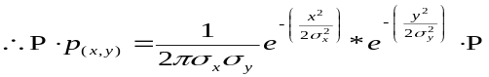

It is assumed that the heat flux variation is identical on both axes. The heat flux profile on the beam stop surface is dependent on the slope of the surface. Peak heat flux increases as the beam diameter reduces, maximum average heat flux for σ = 20 cm is 238 W/cm². The heat flux data is plotted along the centerline of the beam stop as shown in Figure 2

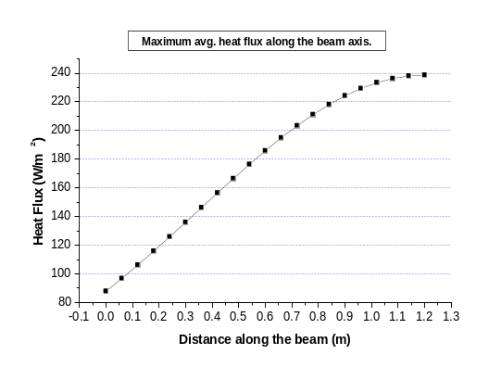
Figure 2 Heat flux along centerline length of cone

4 THERMAL MANAGEMENT
The thermal design is based on cooling with high-velocity water flow under sufficient static pressure to suppress boiling. The liquid agent used for cooling is water because it doesn’t need special pumping devices. Water is collected at the base of the cone and after the water pressure is reduced, returned to the water cart. Flow rate and pressure of the water are monitored at all times. A drop of pressure or insufficient flow rate will cause an emergency shutoff to prevent damage of the beam stop. The cooling system is not expensive and, in spite of low thermal conductivity, has very high specific heat. The flow and heat parameters are calculated as follows.
Beam characterstics  Energy  Current  Operation | 20 MeV  30 mA  (CW)continuous wave
Physical features  Target geometry  Target dimensions  Apex angle  Beam dump material  Coolant  Coolant flow arrangement  Cooling channel | Axisymmetric; conical shape  0.2 m ID  x 1.2 m length  x (5x10⁻³) m thick  18.92⁰  Nickel  Water (outside and vacuum inside),  Single Pass Forced Convection, Counter flow to Beam direction  Spiral. Cross section  = 0.005 x 0.12 m²
Thermal management  Heat removal  Peak heat flux  Film coefficient  Peak wall temperatures  Water conditions  Flow rate  Pressure drop  Velocity (average)  Temperature rise | 600 KW  238 W/ cm² Incident to surface  23800 W/m²k  107⁰C Water side, 241⁰C Beam side  145 lpm  1.3 bar  4 m/s  60⁰C

4.1 Flow Rate
The flow required to remove 600 KW power will be very large. In order to maintain this flow rate either cross-section area or velocity or both should be large. For this, velocity of water is taken 4 m/s and cross sectional dimensions of channel are 12 cm width and 5 mm height. Energy balance calculations are done using following equation [6]
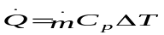

The friction factor is calculated using Ito’s correlation for curved coil having turbulent flow as follows [6].

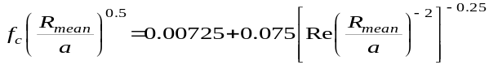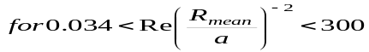
4.2 Heat Transfer
Schmidt’s correlation for Nusselt number for turbulent flow in helical coil is as follows [7].

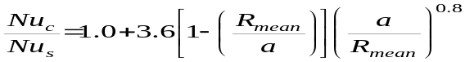
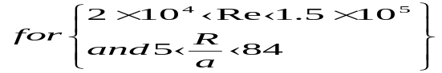
Here, a is hydraulic radius and R_{mean} is mean radius of cone. Nusselt number (Nu_{s}) is calculated using Dittus Boelter equation for turbulence flow in straight tube.

Using above correlations and formulae the initial parameters obtained for spiral cooling channel are determined. The values shown in Table 2 are used in the finite element analysis to find temperature distribution and Von Mises stresses in beam dump.

Table 2 Beam Dump design data

In order to understand the thermal performance of beam stop, a finite element model has been developed to predict the steady state temperature and stress distributions within the beam dump material. The model simulates the beam dump with 2D solid thermal elements, configure as axisymmetric model of conical shell, with cooling on the backside. After obtaining the thermal solution, the elements are converted to structural elements for stress analysis. A key feature of the model is the method of application of the heat load. A table is generated based on the bi-gaussian distribution of the beam and the deposition of heat into the beam dump for a given material and beam energy.

5 RESULTS AND DISCUSSION
The finite element axisymmetric model of conical beam dump target simulates the actual cooling geometry by applying a uniform film coefficient over the entire rear surface. Temperature distribution and von mises stresses in beam dump are obtained on simulated model of 1.2 m beam dump shown in Figure 3. Analysis is done on model using material properties of nickel, of 1.2 m long beam dump by applying Gaussian heat flux.

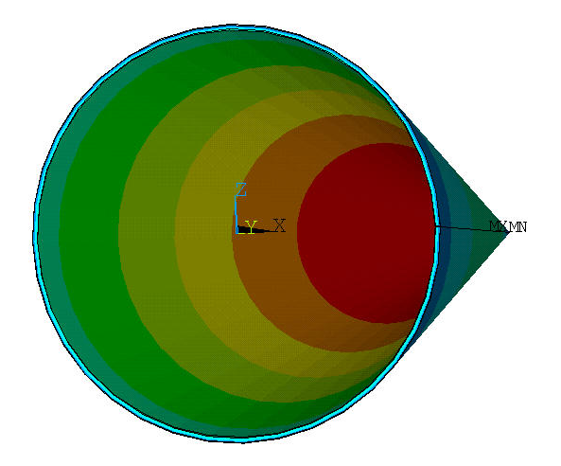

Fig 3 1. 2 m beam dump

The saturation pressure corresponding to 107⁰C is 1.29 bar; therefore 1.55 bar pressure is applied on the model for structural analysis that is 20 percent higher than the saturation pressure. Stress due to thermal and pressure loads in the Nickel beam dump is 216 MPa, which is in the range of hot rolled nickel plate yield strength i.e. 140-550 MPa. Nickel seems most convenient material for beam to dump the proton beam, since their material properties suit the requirement. The maximum temperature is observed near the tip of beam dump. It is observed that the beamside temperature increase with respect to centerline length is more than that of waterside temperature increase. Figure 3 shows the temperature distribution on waterside and beamside on graph.

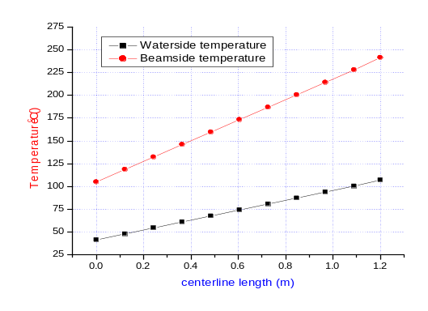
Fig 3 Centerline length vs. surface temperature of 1.2 m length beam dump

Heat flux is maximum at the tip when Gaussian heat flux distribution is considered. It is found that as the beam radius decreases the heat flux intensity increases at center. To avoid this if beam radius is increased, the beam dump size (beam dump radius) has to be increased, to incorporate the beam. For Gaussian heat flux distribution, it is observed that the waterside temperature due to beam power in the 1.2 m nickel beam dump, reaches to 107 ⁰C hence water has to be provided above corresponding saturation pressure. Table 3 shows the values of temperature and Von mises stresses in nickel beam dump.

Table 3 temperature and stresses in
beam dump
Power Distribution | 1.2 m Nickel Beam Dump
Power Distribution | Maximum Temperature (⁰C) |  | Von mises  stresses (Pa)
Power Distribution | Beamside | Waterside
Gaussian | 241 | 107 | 0.216x10⁹
Conclusions
The Bi-Gaussian method of power density distribution in beam for heat flux calculation is more close to the actual heat flux distribution. Reducing the power density in the beam dump by increasing the beam size will result in a larger beam dump. While reducing beam size to increase power density causes large temperature rise in beam dump posing difficulty in heat removal. Therefore conical shape of beam dump is most suitable solution. Nickel seems most convenient material for beam dump the proton beam, since their material properties suit the requirement. For Gaussian heat flux distribution, waterside temperature profile in 1.2 m beam dump waterside temperature crosses saturation temperature so water should be provided above saturation pressure. The saturation pressure corresponding to 107⁰C is 1.29 bar; therefore 1.55 bar pressure is applied on the model for structural analysis. In beam dump analyses, stress due to thermal and pressure loads in the Nickel beam dump is within the range of hot rolled nickel plate yield strength.

References
[1] T. Wangler, “Principle of RF Linear Accelerator”, John Wiley and Sons Inc. New York, [1998]
[2] D. Schrage et. al, “Conceptual Design of a 7 MeV RFQ LINAC for the Accelerator production of Tritium”, Los Alamos National Laboratory Report, May [1993], USA.
[3] S. Kakac, H. Liu, “Heat exchangers selection, rating, and thermal design”, CRC press, [1998, pp 73-107]
[4] W. M. Rohensenow, James p. Hartnett, “Handbook of heat transfer”, Mcgraw-Hill book company,[1973, pp13.1-13.73]
[5] M. S. Avilov, K. V. Gubin, et.al., “Project of High Power Stationary Neutron Target of Conical Shape ”, [EPAC 2002], France.
[6] S. Kakak, R. K. Shah, W. Aung, “Handbook of single phase convective heat transfer”, John Wiley and sons, [1987, pp 5.1-5.46]
[7] J. F. Harvey, P.E., “Theory and design of pressure vessels”, C.B.S. Publishers, [New Delhi, 2001]

