Design of Symptomatic and Remedial Standpoint on Saliva non-invasive Bio-sensor based health monitoring

Miss. Swati Halunde
Electronics and Telecommunication
SITCOE-YADRAV, ICHALKARNJI
India
swatihalunde@sitcoe.org.in

Ms.Sakshi More
Electronics and Telecommunication
SITCOE-YADRAV, ICHALKARNJI
India
sakshimore@gmail.com
Ms.Supriya Amane
Electronics and Telecommunication
SITCOE-YADRAV, ICHALKARNJI
India
supriyaamane4@gmail.com

Ms.Varsha Naik
Electronics and Telecommunication
SITCOE-YADRAV, ICHALKARNJI
India
naikvarsha470@gmail.com
Ms.Manasi Mane
Electronics and Telecommunication
SITCOE-YADRAV, ICHALKARNJI
India
manemansi321@gmail.com

Ms.Prajakta Tarlekar
Electronics and Telecommunication
SITCOE-YADRAV, ICHALKARNJI
India
tarlekarprajakta20@gmail.com

Abstract— Early disease prediction and early disease initial stages detection has been become necessary and will play vital role in society to save life. Early prediction and detection of initial stages of diseases will ease in treatment as well increase success rate to recover from disease or to stop the disease from achieving critical stage making difficult to recover for patients. Saliva play very important role for detection of diseases. Behavior, nature, change in saliva is being studied extensively by medication bio-makers for early diagnose of diseases, immune system, vitamins level, diabetes, cardiovascular disease, HIV, cancer, digestion issues. Paper proposes study of various researches done for the development and design of saliva bio-sensor for detection of diseases. Study and basic steps for development portable handy salivary test bio-sensor with instant result analysis to predict and diagnostic for early stage for various diseases is being implemented. The method will play very crucial role to prevent disease to being critical and complicated to treat or to prevent disease to become treatment out of reach. Portable wearable bio-sensor gadgets for personalized monitoring tracking of health will lead to diagnose and early predict of incoming diseases which lead to take correct measures precaution diet change correct diet to increase immunity, as prevention is much better option than cure individual’s needs health check-ups regularly.
Keywords— Bio-sensor, salivary cortisol, immunosensor, molybdenum disulfide, MQ137, differential pulse voltammetry, microcontroller.

Introduction (Heading 1)
Due to modern lifestyle and change in habitat of human, himself is exposing to severe diseases and health issues degrading health creating unfavorable environment losing his strong immunity leading an emerging of new viruses, diseases making lifespan short and declining the average life span of human. Running behind comfortable and easy lifestyle is exposure to early age heart-attacks, diabetes, brain strokes, weakening digestive system, exposure to various types of cancers, giving invitation to newer emerging viruses such as Covid19, Monkey pox, increase in brain stress, tensions, etc are causing lifespan of human to decrease and unpredictable uncertain health conditions. Rise in the cases death because of cardiac arrest due to high cholesterol at early age. Rise of sugar level in blood lead to diabetic due to over stress, tension and consumption of wrong diet at irregular time. Over consumption of junk food lead to improper nutrient less vitamin in body in turn increase in toxin level high in blood leads to various skin diseases, digestion issues, changes in hormones, increased stress leads to various diseases also various attack such as brain hemorrhage, strokes, decrease in eye sight, wrong diet and consumption of food at irregular intervals and weak digestive system leads to various types of cancer, concludes to minimize immunity more exposure and invitation to various diseases. To overcome such issues development and implementation of early prediction and early diagnostic system with health check-up at regular time interval with fast, portable diagnostic system becomes necessary to develop and implement. Saliva plays very important role for maintaining human health. Miniaturized battery powered portable Ultrasensitive user controlled non-invasive saliva test immune-sensor system is designed. Microcontroller with inbuilt ADC, DAC, and Bluetooth incorporated for wireless monitor on mobile app, multilayered sandwich formed structured transducer of AuNPs-MoS₂-AuNPs based on a screen printed electrode constructed using robust gold-sulfuric bond for sensing content in saliva and converting it in to electrical signals. Antibody immobilize on sandwich formed structured electrode via self assembled mono-layer of PEG. A portable system was obtained to demonstrate the application of immune-sensor for non-invasive test on human for salivary cortisol detection and monitoring of stress as well as fatigue. [1]. Oral cancer is sixth most frequently occurring cancer taking high mortality rate. Standard methods are expensive, painful as are invasive. Saliva for various multiple disease diagnose and health monitoring, strength of immune system detection is a promising technology as collecting saliva is easy and non-invasive approach and has potential to diagnose accurate and early. Saliva contains proteins, peptides, electrolytes, organic, and inorganic salts secreted by salivary glands and complimentary contributions from gingival crevicular fluids and mucosal transudates. Saliva’s direct contact with oral cancer lesions makes more specific and high sensitive screening methods, whereas more than hundreds of salivary bio-sensor-makers have already been identified cytokines, defensin-1, P53, cyfra21-1, tissue-polypeptide-specific-antigen. Dual-specificity-phosphate, spermidine, spermineN1 acetyl-transferase, profiling, cofilin-1, transferring. Using salivary biomarkers specifically for early oral cancer detection has attracted many researchers. Despite the fact oral cavity is easily accessible, most of oral cancer at early stages are failed to diagnose. Thus much of research efforts are being taken for development of non-invasive salivary cortisol bio-sensors by bio-makers. [2-5]. Saliva has been viewed as an important fluid for diagnostic of diseases from many past decades. Due to improved bio-technologies use of salivary diagnostics for various diseases is becoming more accurate and real. Salivary meta-bolomics is a new advancement in the field of salivary diagnostics includes analysis of a large array of low molecular weight endogenous metabolites present in the saliva for the detection of diseases. The development of Nano Sensor Test OFNASET by UCLA collaborative Oral Fluid Diagnostic research center for real-time, ultrasensitive with ultra specific detection of multiple salivary protein and nucleic acids detects the disease stages and conditions. Salivary diagnostic offers an easy, inexpensive, stress free, instant, painless approach to detect diseases. [3]. as diagnostic fluid Saliva offers distinctive advantages over serum as easy and non invasive approach. Liquid saliva diagnostic method may be useful for assessment of therapeutic levels of drugs, hereditary-disorders, auto-immune-diseases, malignant and infectious diseases, endocrine-disorders etc. monitoring of immune system response to viral infection including HIV, hepatitis may prove valuable in identification of infected individuals. Salivary diagnostic test can replace the serum test in coming future. [4]. A hybrid deep learning with a novel detection technique is incorporated to detect Chronic Kidney Diseases from saliva samples is compromising of Convolution Neural Network (CCN) and Support Vector Machine (SVM) classifier. Dynamic pooling approach along with a feature pruning algorithm is designed to detect kidney problems by examining the concentration of urea in the saliva samples. Results achieved the average accuracy of 97.67% with CNN-SVM network. Concentration of urea is increased in saliva with weakened kidney which leads the sensor output at higher analog voltage. [6]. the work proposed a novel 1-D CNN-SVM architecture incorporated with PSO algorithm for monitoring of kidney health using saliva sample non invasive approach. The urea concentration in saliva samples is monitored to detect CKD. Proposed technique achieved accuracy of 98.41% which is high as compared to conventional techniques. The hardware designed with combination of ammonia gas sensor MQ137, a gas sensing chamber, arduino uno for calibrating, measuring, comparing and displaying results of sample. When urea component in saliva comes in contact with urease enzyme, hydrolysis of urea takes place and urea converts in to ammonia gas. Depending on ammonia gas produced conductivity of sensor increases. This change in conductivity is convert to voltage according to value of voltage generated proportional to kidney health in percentage is defined. [7-8]. Portable Non-invasive bio-sensor for saliva test will play specific significance role for early detection of stages of diseases and early prediction of diseases such as cancer, organs health, immune systems, covid-19, allergies, HIV, health prediction, diabetes intensity identification and many more will become helpful to increase lifespan of human, early stage treatment of any disease possible not let the disease to reach critical or non treatment level such as lung cancer with fast results and higher accuracy of detection with low percentage of false diagnose reducing the death rate due to disease. [9]. Salivary analysis for chronic kidney disease detection using single-dimensional co-relational neural network with bidirectional long-term memory network based algorithm approach provides 98% accuracy to detect CKD. [10].

Ease of Use
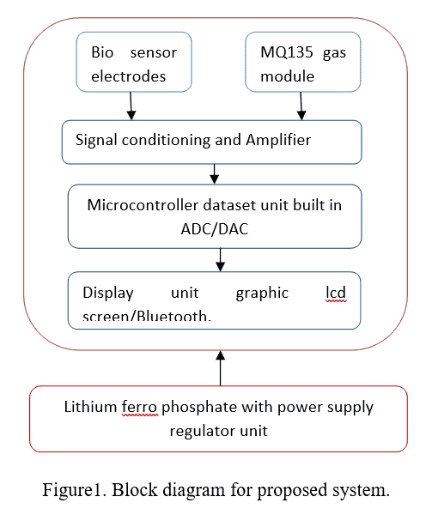
Psoriasis is to be a multi-systemic disease related to metabolic syndrome and diabetes. Presence of a structural alteration of proteins in saliva of patient with plaque psoriasis hypothesis is related to diabetes. Non-invasive salivary test technique ATR-FTIR can be useful for detection. [11]. Design and implementation of Non invasive systems for human health condition monitoring will have significant impact on the traditional invasive type testing methods. Many of non-invasive type kits are available in present days such as pulse-oximeter, ir based blood pressure measurement, heart rate measurement, etc. A basic building blocks for design portable handy lithium ferro phosphate battery powered printed circuit board incorporated with immune sensor, ammonia gas sensor, microcontroller, display based bio-sensor unit for detection and early prediction with non-invasive type, of various incoming diseases, immunity level sensing, vitamins deficiency sensing, sugar level is shown in (Figure 1). Cortisol is used on regular basis to measure psychological or physical stress by biomarkers. Due to non-invasive and point of care (POC) cortisol detection sensors system has heavy demand in medical application. The miniaturized portable DPV system can be developed for human salivary cortisol detection. Droplets of saliva are poured on bio-sensor electrodes; sensor will convert chemical reaction of saliva with electrodes to electrical voltage and current form. Output from electrodes, ammonia gas sensor will be in voltage form the strength of output voltage and current will depends and proportional to chemical reaction takes place in sensor and gas generated at gas sensor. This output voltage and current is passed through signal conditioning and amplifier to make signal to readable range to ADC of microcontroller. Analog to Digital conversion (ADC) then converts signal in digital form as to read by microcontroller with 16-bit binary value. Microcontroller will read data and compare with inbuilt database and display in ASCII user readable language. Digital to analog converter (DAC) is used to plot the graph on graphical display such as cro for analysis. Compared with different set point will give results for early prediction and early stage detection for various diseases, immunity, lack of vitamins, organs health, cancer detection and more. Saliva is the composition of ammonia, urea, uric acid, cholesterol, glucose, fatty acids, triglycerides, neutral lipids, steroid hormones, glycolipid, amino acid, mucin, lectin, glycol-protein, peroxidase, lysozyme, lactoferrin, drug monitoring and many more add-on with more than 700-800 microorganisms, testing and analyzing the concentration of all these content will be very helpful for early prediction and initial stages detection of many diseases.
A cost effective non-faradaic label-free cortisol bio-sensor using MoS₂ nano-sheets combined with a nano-porous flexible electrode wearable unit for detection and monitoring of analytes in transdermal sweat present an intriguing pathway to monitor glucose, peripheral blood and interstitial fluid with minimally invasive as they puncture skin in order of microns. Microcontroller based system monitors change in value of current for diagnose stage or intensity of disease. [12]. Heart failure is most rapidly growing cardiovascular condition almost more than 38 million individuals globally suffering. This can be achieved by combination of both blood and saliva test together. [13]. The system designed with IOT based biosensors portable incorporated with SVM model to semi-quantitative analyses for the classification of disease mainly used to diagnose COVID-19. The average accuracy of system was 98.5%. Proposed system was based on SEP-2 architecture. [14]. Present proposed work introduces forecasting of biosensors based point of care (POC) diagnostics with internet of things (IOT) based on fish-pry model testing of blood, saliva and breath. The Fish-Pry projections or S-curves enable insight into the relative technology maturity levels of emerging biosensors technology under consideration and forecasting their growth of usage. [15]. the measuring Salivary TNF-alfa levels results for screening, diagnosis of heart failure. Fast EIS, highly sensitive, accurate biosensors are able to detect TNF-alfa in saliva method has been described. The advantages of saliva as a diagnostic tool over serum offers painless, non-invasive stress-free collection, real time monitoring, point of care diagnosis, fast, accurate, make highly desirable healthcare system. Biosensors can represent a promising tool for instant cytokines detection. [16].

First, confirm that you have the correct template for your paper size. This template has been tailored for output on the A4 paper size. If you are using US letter-sized paper, please close this file and download the Microsoft Word, Letter file.

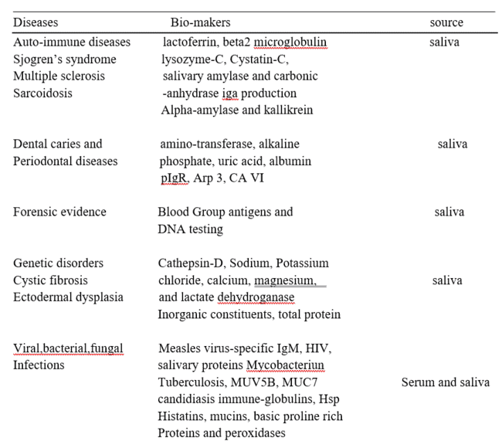

Bio-functionalized immune-sensors for cortisol can be used to investigate several mixtures in saliva such as sodium chloride, glucose, uric acid, glutamic acid, cyteine, bovine serum albumin and corticosterone. Bovine serum albumin represents macromolecular biological proteins and corticosterone. Cortisol is substance that can cause current response changes as per content level present in saliva. These changes are monitored and examine for prediction and detection of various abnormalities in human body via saliva. Thus immune-sensor has great potential for noninvasive approach real time human salivary based disease diagnose at POC for identification and monitoring human health conditions. [1].
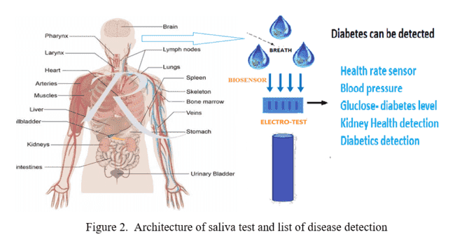

Diabetes detection
Diabetes is now-a-days commonly seen disease in human which affects health adversely, increased sugar level in blood is responsible for slow wound healing, skin diseases, unstable blood pressure, affecting eye sight, increase in stress, decrease in stamina and much more. Certain handy portable instruments like glucometers for testing diabetes at POC are invasive or partially invasive type as it uses blood sample to measure diabetes level in human body.

Unlike blood, saliva also has some chemical change with increase in sugar levels in blood as it contains residual amount of glucose. Non-invasive type sensors developed to measure electrochemical change in saliva proportional to concentration of fasting blood sugar levels in body. Sample of saliva is dropped on bio-sensor and according to electro-chemical reaction analog voltage is generated proportion to sugar level. This voltage is passed through amplifier converting voltage signal between 0-1 ranges. Obtained FBGL ranges are examined by different algorithm such as SVM-ANN, RBF-SVM for prediction of diabetes level. The range below 0.7 considered to be non-diabetic individual and FBGL range with greater than value 0.75 considered being a diabetic. This technique can have accuracy more than 85% which seems to be greater than invasive type of testing.

Kidney health detection
Globally more than 700 million individuals are reported suffering from chronic kidney disorder diseases. Conventional method of invasive type blood test is used to detect urea saturation in blood for detecting the percentage of kidney functioning. Another urine test method for detection of kidney failure is used concentration of albumin in urine increases with failure of kidney. This all are clinical methods also time consuming and costly. A non-invasive approach can detect the conditions of kidney fast, easy, accurate, pain-free approach.
With improper functioning of kidney filtration affect increasing urea content in saliva. This increased urea in saliva lead to generate ammonia gas when come in contact with bio-sensor. Concentration of ammonia gas generated gives proportional voltage levels increase in urea level in turn increases ammonia gas as a result sensor output voltage increases passed through amplifier and given to hybrid CNN-SVM algorithm. This signal is processed via CNN-SVM algorithm determining the percentage of kidney health displayed on display. Average accuracy obtained by this approach is 97%-98% which is highly accurate than other tests. This technique can also be useful for detection and prediction of different cancer and their stages.

Monitoring Drug Levels
Saliva fluid has become more popular as a technique for drug detection and monitoring. Saliva is tested for nicotine, cannabis, cocaine, phencyclidine, opioids, barbiturates, diazepines, amphetamines, and ethanol. Because the drug lasts the same length of time in saliva as it does in serum, its sheer presence is adequate for forensic reasons. Tobacco smoke exposure may be monitored using salivary nicotine levels. The most important metabolite Cotinine, a measure of nicotine in saliva, has been found very useful to be a marker of both active and passive smoking. Point of care and instant detection is very essential. Direct analysis of methamphetamine, cocaine, and methylenedioxy-methamphetamine can also be used to detect illegal drug use. A hydrophobic substance can be found in saliva.Because of its simplicity of collection, noninvasiveness, and drug stability, mouth spit is a biological-matrix utilized for drug testing of GHB levels. Furthermore, the levels of the medication in the saliva correspond with those in the blood.

Forensic Science
Forensics has traditionally relied on salivary analysis. The more than half of victims produce blood type antigens in their saliva, which can be utilized to detect any criminal suspects and fathers in paternity disputes. Salivary samples can be utilized for DNA testing since DNA is very stable in the dry condition. In situations of sexual assault and harassment, genetic analysis of DNA in saliva might be beneficial. For up to 60 minutes, foreign DNA might be detected in the victim's saliva, giving significant forensic evidence. Before stimulation of excretion with paraffin pledgets, cathepsin-D activity in CF patients' saliva is substantially greater than in healthy controls. Saliva salt, potassium, and chloride concentrations were substantially greater in cystic fibrosis patients than in healthy controls, indicating that saliva can be utilized to diagnose cystic fibrosis.
Autoimmune disorders detection
Autoimmune diseases are generally very uncommon type, our own immune system is attacking and degrading health but their effects on human health have significant effect and it may also be genetic based issues. Auto-immune diseases are classified by auto-antibodies with large number of antigenic targets, and are identified by serum/blood test which is invasive, painful, and time consuming process. The aim to develop the non-invasive type system capable of detecting and measuring auto-antibodies in saliva samples using a novel and highly sensitive point of care method for the detection of auto-antibodies using bio-electrodes will be having significant interest as it will be giving instant results as it is point of care type. The developed system has ability to detect and measure auto-antibodies of the IgG isotype to nuclear auto-antigens present in saliva of human, which might represent a novel approach for the detection of auto-antibodies as part of the diagnosis of auto-immune conditions.
Conclusion
Design of an ultrasensitive non-invasive and low-cost immune-sensor for health condition diagnose by testing saliva contents and chemical reaction for early detection of diseases will prove vital role in the field of medical and will provide significant change in method of detection and diagnosis of disease. The development and implementation of portable handy non-invasive bio-sensor testing kit for physical health diagnose of any user at any time gives instant results, painless, cost effective, effortless, time saving. Early prediction means early care and minimum treatment and lesser time required to recover from any disease or to stop further spreading of diseases to critical value or untreatable value lead to increase in percentage of average human lifespan. Portable biosensor for saliva test can diagnose kidney health, heart health, cholesterol level, cancer, skin diseases, diabetes, COVID-19, oral dental issues, viral diseases, immunity level and much more with higher accuracy percentage of diagnose as compared with conventional serum technology.

ACKNOWLEDGEMENT
We would like to express our deep and sincere gratitude to my Guide Miss. S. S. Halunde, Department of Electronics and Telecommunication Engineering, for guiding us to accomplish this project work. It was our privilege and pleasure to work under her able guidance. We are indeed grateful to her for providing helpful suggestion, from time to time. Due to her constant encouragement and inspiration we are able to present this project.
We express our deep gratitude to Dr P. S. Patil, Head of Electronics and Telecommunication Engineering Department, for his valuable guidance and constant encouragement. We are very much thankful to Dr. S A Khot, Principal, Sharad institute of technology college of engineering, Yadrav-Ichalkaranji for providing all the necessary facilities to carry out project work.
Last but not least we are thankful to our parents for their moral as well as financial support.

References
[1] Jingjing Liu and et all, Salivary Cortisol Determination on Smartphone-Based Differential Pulse Voltammetry System. Sensors MDPI, 5th march 2020.
[2] Yi-shing Lisa Cheng, Terry Rees and jhon Wright, A review of research on salivary biomarkers for oral cancer detection. Clinical and Translational Medicine, 2014.
[3] Narasimhan Malathi, Sabesan Mythili, and Hannah R. Vasanthi, Salivary Diagnostics: A Brief Review. Hindawi Publishing Corporation ISRN Dentistry, Volume 2014, Article ID 158786.
[4] L.Malathi, E.Rajesh, N. Aravindha Babu and Sudha Jimson. Saliva as a Diagnostic Tool. Biomedical and Pharmacology Journal, Vol. 9(2), 867-870 (2016).
[5] Zohaib Khurshid and et all. Role of Salivary Biomakers in Oral Cancer Detection. Article in Press.
[6] Bhaskar Navaneeth, M Suchetha. A dynamic pooling based convolutional neural network approach to detect chronic kidney disease. Elsevier Biomedical Signal Processing and Control 62 (2020) 102068.
[7] Bhasker Navaneeth, M. Suchetha. PSO optimized 1-D CNN-SVM architecture for real-time detection and classification applications. Computers in Biology and Medicine (2019).
[8] N.Bhaskar, S. M. A computationally efficient correlational neural network for automated prediction of chronic kidney disease. Elsevier july 10, 2020.
[9] Mohammad A. Javaid and et al. Saliva as a diagnostic tool for oral and systemic diseases. Journal of oral biology and craniofacial research 2015.
[10] Navaneeth Bhaskar, Suchetha M and Nada Y Philip. Time Series Classification based Correlational Neural Network with Bidirectional LSTM for Automated Detection of Kidney Disease. IEEE sensors journal 2020.
[11] Ugo Bottoni and et al. Infrared Saliva Analysis of Psoriatic and Diabetic Patients: Similarities in Protein Components. IEEE transactions on biomedical engineering, vol 63, no.2, feburary 2016.
[12] David Kinnamon and et al. Portable biosensor for monitoring cortisol in low-volume perspired human sweat. Scientific Reports 17 october 2017.
[13] Evanthia E. Tripoliti and et al. Point-of-Care Testing Devices for Heart Failure Analyzing Blood and Saliva Samples. IEEE Reviews in Biomedical Engineering, Volume 13. 17 march 2019.
[14] Valentina Bianchi and et al. IOT and Biosensors: A Smart Portable Potentiostat With Advanced Cloud-Enabled Features. IEEE Access October 14, 2021.
[15] Nasir j. sheikh and Omar Sheikh. Forecasting of Biosensor Technologies for Emerging Point of Care and Medical IoT Applications using Bibliometrics and Patent Analysis. Proceedings of PICMET 16: Technology Management for Social Innovation. 2016.
[16] Francesca G. Bellagambi and et al. Electrochemical biosensor platform for TNF cytokines detection in both artificial and human saliva: heart failure. Sensors and Actuators 2017-Elsevier.

[17] Y.-H.LeeandD.T.Wong,― Saliva: an emerging bio-fluid for early detection of diseases, American Journal of Dentistry, vol.22, no.4, pp.241–248,2009.
[18] T. Pfaffe, J. Cooper-White, P. Beyerlein, K. Kostner, and C. Punyadeera,― Diagnostic potential of saliva: current state and future applications, Clinical Chemistry, vol. 57,no. 5, pp.675–687,2011.
[19] J.M.Lee,E.Garon, and D.T.Wong,― Salivary diagnostics, Orthodontics and Craniofacial Research, vol. 12, no. 3, pp. 206– 211, 2009.
[20] S.Mittal, V.Bansal, S.Garg, G.Atreja, and S.Bansal, ― The diagnostic role of Saliva—a review. Journal of Clinical and Experimental Dentistry, vol. 3, no. 4, pp. e314–e320, 2011.
[21] D. Malamud, ― Saliva as a diagnostic fluid, Dental Clinics of North America,vol.55, no. 1, pp. 159–178,2011.

[22] M.Greabu, M.Battino, M.Mohoraetal. ―Saliva—a diagnostic window to the body, both in health and in disease, Journal of Medicine and Life, vol. 2, no. 2, pp. 124–132,2009.
[23] F. Ahmadi Motamayel, P. Davoodi, M. Dalband, and S. S. Hendi,― Saliva as a mirror of the body health, DJH Journal, vol.1, no.2, pp.1–15,2010.
[24] K. D. Bhoola, M. W. McNicol, S. Oliver, and J. Foran, ― Changes in salivary enzymes in patients with sarcoidosis, The New England Journal of Medicine, vol. 281, no. 16, pp. 877–879,1969.
[25] F. A. Scannapieco, P. Ng, K. Hovey, E. Hausmann, A. Hutson, and J. Wactawski-Wende,― Salivary bio markers associated with alveolarboneloss, the New York Academy of Sciences,vol.1098,pp.496–497,2007.
[26] P.N.Floriano, N.Christodoulides, C.S.Milleretal. ―Use of saliva-base dnano-biochip tests for acute myocardial infarction at the point of care: a feasibility study, Clinical Chemistry, vol. 55, no. 8, pp. 1530–1538,2009.
[27] M.Qvarnstrom, S.Janket, J.A.Jonesetal, ―Salivary lysozy mean d prevalent hypertension, Journal of Dental Research, vol. 87, no. 5,pp. 480–484, 2008.
[28] S.-J.Janket, J.H.Meurman, P.Nuutinenetal, ―Salivary lysozy mean d prevalent coronary heart disease: possible effects of oral health on endothelial dysfunction, Arteriosclerosis, Thrombosis, and Vascular Biology, vol.26,no.2,pp.433–434,2006.

