Effect of Excess Fluoride in Ground Water on Human Health and Fluorosis
Shalini Gupta^{1,2,4*}, Munish Kumar^{3,4}, Ruchi Agarwal^{1,4}, Vikas Jain¹, Kahkashan Begum^{2,4} and N. U. Siddiqui²
¹Department of Chemistry, Bareilly College, Bareilly-243005, Uttar Pradesh, India
²Department of Chemistry, G. F. College, Shahjahanpur-242001, Uttar Pradesh, India
³Department of Physics, K. C. M. T, Bareilly-243122, Uttar Pradesh, India
⁴M. J. P. Rohilkhand University, Bareilly-243006, Uttar Pradesh, India
Corresponding author: shalu123gupta21@gmail.com
Abstract: Fluoride is one of the most important geo-environmental issues in the coming days. The excessive ingestion of fluoride causes the disease, is called fluorosis. Present work deals with study of fluoride content in groundwater and its impact on human health.

Introduction
It is well known that the excess fluoride intake is responsible for dental and skeletal fluorosis. The problem of fluorosis has been known in India for a long time. The disease earlier called „mottled enamel” was first reported by Vishanathan [1] to be prevalent in human beings in Madras Presidency in 1933. Mahajan [2] reported a similar disease in cattle in certain parts of old Hyderabad state. However, Shortt [3] was the first to identify the disease as „fluorosis” in human beings in Nellore district of Andhra Pradesh. Fluoride is present in the teeth, bones, thyroid gland and skin of animals. It plays an important role on the formation of dental enamel and normal mineralization in bones but can cause dental fluorosis and adversely affect the central nervous system, bones, and joints at high concentrations [4]. The fate of fluoride in the soil environment and groundwater is of concern for several reasons. It is generally accepted that fluoride stimulates bone formation [5] and small concentration of fluorides have beneficial effects on the teeth by hardening the enamel and reducing the incidence of caries [6]. At lower levels (<2 mg/ml) soluble fluoride in the drinking water may cause mottled enamel during the formation of teeth, but at higher levels other toxic effects may be observed (Weast and Lide, 1990). Excessive intake of fluoride results in skeletal and dental fluorosis [7]. Severe symptoms lead to death when fluoride doses reach 250-450 mg/ml [8]. It has been found that the IQ of the children living in the high fluoride areas (drinking water fluoride > 3.15 mg/ml) was significantly lower [9]. Fluoride enters the human body mainly through the intake of water and to a lesser extent by food. The foods which are rich in fluoride include fish and tea [10]. Ingested fluorides are quickly absorbed in the gastrointestinal tract, 35-48% in retained by the body mostly in skeletal and classified tissues, and the balance is excreted largely in the urine. Chronic ingestion of fluoride rich fodder and water in endemic areas leads to development of fluorosis in animals e.g. dental discoloration, difficulty in mastication, bony lesions, lameness, de-ability and mortality [11]. Naturally occurring fluorides in groundwater are a result of the dissolution of fluoride containing rock minerals by water while artificially high soil fluoride levels can occur through contamination by application of phosphate fertilizers, sewage sludge, or pesticides [10].
India is one among the nation around the globe where health problems have been reported due to excessive fluoride in drinking water. WHO defines the safe limit of fluoride consumption is 1·5 parts per million (ppm), or mg/L [12]. But rock salt contains up to 157 parts per million. Due this reason the groundwater samples found concentrations as high as 48 mg/L. While an infrequent sprinkle can be good for helth while overconsumption, especially if combined with fluoride-rich water, poses an array of health threats that often go hidden. An estimated 62 million people in India in 17 out of 28 states are affected with dental, skeletal and/or non skeletal fluorosis. The endemic states with the percentage area affected are given in Table 1.
Table 1 · Indian states with area affected by fluoride poisoning
S.N | State | Area Affected (%)
1. | Assam | -
2. | Andhra Pradesh | >50
3. | Bihar | >30
4. | Delhi | < 30
5. | Gujarat | >50
6. | Haryana | >30
7. | Jammu & Kashmir | < 30
8. | Karnataka | >30
9. | Kerala | < 30
10. | Maharasthra | >30
11. | Madhya Pradesh | >30
12. | Orissa | < 30
13. | Punjab | >30
14. | Rajasthan | >50
15. | Tamil Nadu | >50
16. | Uttar Pradesh | >50
17. | West Bengal | -

Sources of Fluoride
Various sources of fluoride entering in the body are drinking water, food, industrial exposure, drugs and cosmetics etc. However, drinking water is considered as the major contribution to fluoride entering the human body.

1. Drinking Water
The major source of fluoride in the groundwater is fluoride bearing rocks from which it gets weathered and/or leached out and contaminates the water. Fluorides occur in three forms, namely, fluorospar or calcium fluoride (CaF₂), apatite or rock phosphate [Ca₃F (PO₄)₃ and cryolite (Na₃AlF₆). Concentration of fluorides is five times higher in granite than in basalt rock areas. Similarly, shale has a higher concentration than sandstone and limestone (Fig.1) [13]. Alkaline rocks contain the highest percentage of fluoride (1200 to 8500 mg/kg) [14].
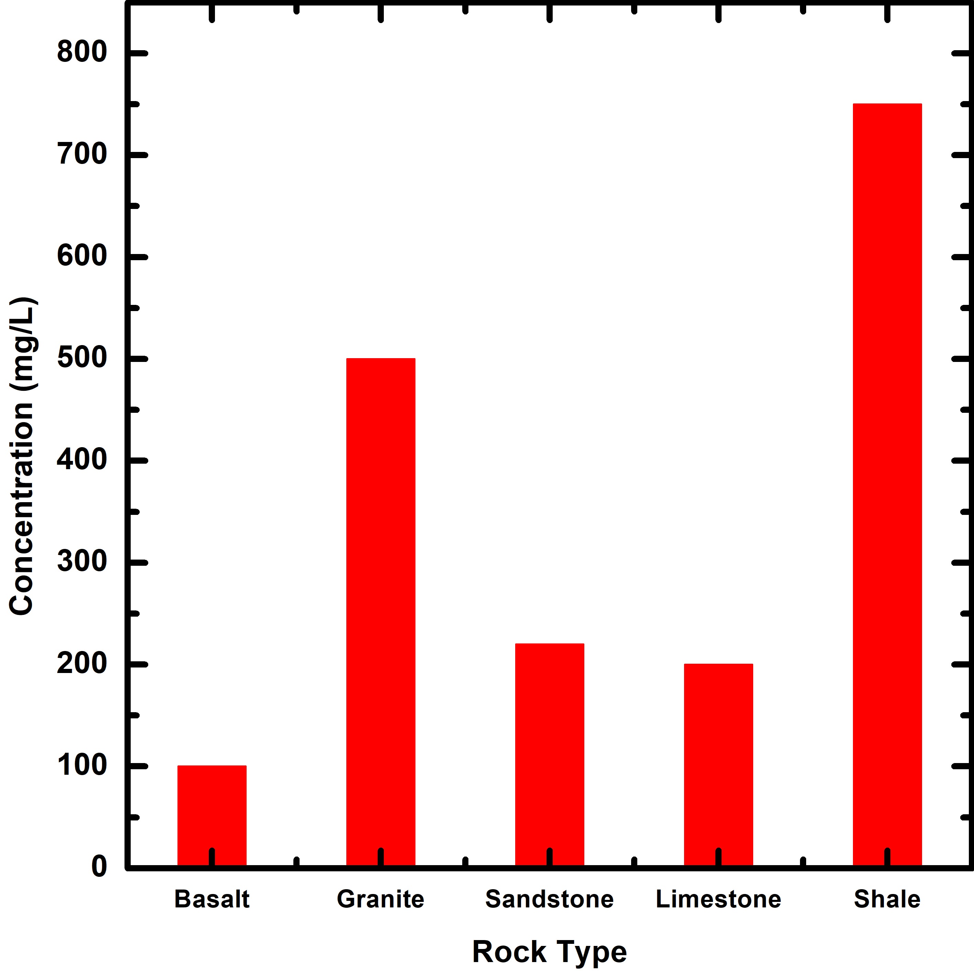
Fig 1: Average Concentration of Fluorine in main rock types
The geological survey of India has brought out considerable data which reveal that fluorite, topaz, apatite, rock phosphate, phosphatic nodules and phosphorites are widespread in India and contain high percentage of fluorides.

2. Food Items
Besides water, food items especially agricultural crops are heavily contaminated with fluoride as they are grown in the areas where the earth’s crust is loaded with fluoride bearing rocks. The fluoride content in food material mainly depends upon:
- fluoride level in soil
- fluoride level in atmosphere
- use of fertilizers and pesticides and other sources of contamination.
The fluoride content of some food items has been given in Table 2.

3. Industrial Exposure
Various industries involving the manufacture of phosphate fertilizers, aluminum extraction, fluorinated hydrocarbons (refrigerants, aerosol propellants etc.), fluorinated plastics (polytetrafluoroethylene etc.), petroleum refining and hydrogen fluoride manufacturing units are mainly responsible for airborne fluoride. Fluoride dust and fumes pollute the environment; inhaling dust and fumes is as dangerous as consuming fluoride containing food, water or drugs. Not only the industrial workers are affected but the people living in the vicinity of such industries may also get afflicted.

4. Drug and Cosmetics
The sodium fluoride containing drugs for Osteoporosis, Osteosclerosis and dental caries are in use for many years. The prolonged use of these drugs may cause fluorosis. Additionally, the toothpastes and mouth-rinses (whether labelled fluoridated or otherwise) also contain higher fluoride concentration. The fluoride content arising from raw materials used for the manufacturing of tooth-paste, namely, calcium carbonate, talc and chalk can have as high as 800-1000 mg/kg of fluoride. In the fluoridated brands of tooth-pastes, the fluoride content has been reported up to 1000-4000 mg/kg. Moreover, some of the mouth rinses are nothing but fluoridated water of a very high fluoride concentration.

Health Impacts and Fluoride

1. Optimum concentration of fluoride in drinking water
According to WHO standards, the fluoride in drinking water should be within a range that slightly varies above and below 1 mg/L [15]. In temperate regions, where water intake is low, fluoride level up to 1.5 mg/L is acceptable. The Ministry of Health, Government of India, has prescribed 1.0 and 2.0 mg/L as permissive and excessive limits for fluoride in drinking water, respectively. Table 3 shows different health impacts at varying fluoride concentrations [16] in drinking water.
Table 2 · Fluoride content in various food items
Food Item | Fluoride (mg/kg) | Food Item | Fluoride (mg/kg)
Cereals |  | Fruits
Wheat | 4.6 | Banana | 2.9
Rice | 5.9 | Mango | 3.2
Maize | 5.6 | Apple | 5.7
 |  | Guava | 5.1
Pulses |  | Beverages
Gram | 2.5 | Tea | 60 - 112
Soybean | 4.0 | Coconut water | 0.32 - 0.6
Vegetables |  | Spices
Cabbage | 3.3 | Coriander | 2.3
Tomato | 3.4 | Garlic | 5.0
Cucumber | 4.1 | Ginger | 2.0
Ladyfinger | 4.0 | Turmeric | 3.3
Spinach | 2.0 | Food from Animal Sources
Mint | 4.8 | Mutton | 3.0 - 3.5
Brinjal (egg plant) | 1.2 | Beef | 4.0 - 5.0
Potato | 2.8 | Pork | 3.0 - .5
Carrot | 4.1 | Fishes | 1.0 - 6.5

Table 3 · Concentration of fluoride in drinking water and its effects on human health
Fluoride Concentration (mg/L) | Effect
Nil | Limited growth and fertility
< 0.5 | Dental caries
0.5 - 1.5 | Promotes dental health, prevents tooth decay
1.5 - 4.0 | Dental fluorosis (mottling and pitting of teeth)
4.0 - 10.0 | Dental fluorosis, skeletal fluorosis (pain in neck bones and back)
> 10.00 | Crippling fluorosis

Various Forms of Fluorosis
The various forms of fluorosis arising due to excessive intake of fluoride are briefly discussed below:

1. Dental fluorosis
This form of fluorosis affects the teeth and mainly occurs in children. The natural shine or lustre of the teeth disappears. In the early stage, the teeth appear chalky white and then gradually become yellow, brown or black. The discoloration will be horizontally aligned on the tooth surface as lines or soots away from the gums. Tiny pits or perforations can be seen in the form of cavities on the surface of teeth. Dental fluorosis affects both the inner and outer surface of the teeth. One can become edentulous even as much younger age in the fluoride endemic areas. The disease has mostly cosmetic implications and has no treatment.

2. Skeletal fluorosis
Skeletal fluorosis affects the bones/skeleton of the body. Skeletal fluorosis can affect both young and old alike. One can have aches and pain in the joints. The joints which are normally affected by skeletal fluorosis are neck, hip, shoulder and knee that makes it difficult to walk and movements are painful. Rigidity or stiffness of joints also sets in. More worrisome is that skeletal fluorosis is not easily detectable until the disease attains an advanced stage. In severe cases, there is complete rigidity of the joints resulting in stiff spine, called as, Bamboo spine” and immobile knee, pelvic and shoulder joints.

3. Non-skeletal manifestations
The soft tissues of the body are may be affected by excessive consumption of fluoride. The symptoms include gastro-intestinal complaints, loss of appetite, pain in stomach, constipation followed by intermittent diarrhoea. Muscular weakness and neurological manifestations leading to excessive thirst tendency to urinate more frequently are common among the afflicted individuals. Cardiac problems may arise due to cholesterol production. Repeated abortions or still birth, male infertility due to sperm abnormalities are also some of the complications.

Prevention of Fluorosis
Excessive fluoride ingestion by human beings can be prevented by using the following approaches:
Using alternate water sources:
Alternate water sources include surface water, rainwater and low-fluoride groundwater.
Improving the nutritional status of population at risk:
Adequate calcium intake is directly associated with a reduced risk of dental fluorosis. Vitamin C ingestion also safeguards against the risk of fluorosis.
Defluoridation:
Removing excess fluoride from drinking water using different techniques such as Nalgonda method. This defluoridation method is based on the combined use of alum and lime in a two-step process.

References:
- Viswanathan, G.R., 1935, Annual Report Madras. Indian Council of Agricultural Research, New Delhi. (Quoted from Indian Institute of Science, 33A, 1, 1951).
- Mahajan, 1934. Annual Report. VIO Hyderabad State, 3, Indian Council of Agricultural Research, New Delhi.
- Shortt, W.E., 1937, Endemic Fluorosis in Nellore District, South India. Indian Medical Gazette, 72: 396.
- Agrawal, V., Vaish, A.K. and Vaish, P., 1997. Ground water quality: Focus on fluoride and fluorosis in Rajasthan. Current Sci. 73(9): 743-746.
- Richards, A., Moskilder, L. and Sogaard, C.H., 1994. Normal age-related changes in fluoride content of Vertebral trabecular bone-relation to bone quality. Bone 6:15-21.
- Fung, K., Zahang, Z., Wong, J. and Wong, M., 1999. Fluoride content in tea and soil from tea plantations and release of fluoride into tea liquor during infusion. Environ. Pollut. 104: 197-205.
- Czarnowski, W., Kerchniak, J., Urbanska, B., Stolarska, K., Taraszewska, M. and Muraszko, A., 1999. The impact of water borne fluoride on bone density. Fluoride 32(2): 91-95.
- Luther, S., Poulsen, L., Dudas, M. and Rutherford, P., 1995. Fluoride absorption and mineral stability in an Alberta soil interacting with phosphogypsum Leachate. Can. J. soil Sci. 83-94.
- Lu, Y., Sun, Z.R., Wu, L.N., Wang, X., Lu, W. and Liu, S.S., 2000. Effect of high fluoride water on intelligence in children. Fluoride 33(2): 74-78.
- EPA, 1997. Public Health Global for Fluoride in Drinking Water. Pesticide and Environmental Toxicology. Section Office of Environmental Health Hazard.
- Patra, R.C., Dwivedi, S.K., Bhardwaj, B. and Swarup, D., 2000. Industrial fluorosis in cattle and buffalo around Udaipur, India. Sci. Total Environ. 253: 145-150.
- Repot of Minstry Jal shakti, Contamination of ground water, 2022, https://pib.gov.in/PressReleasePage.aspx?PRID=1809264
- Athavale, R.N. and Das, R.K. (1999). Down to Earth, 8(6): 24-25
- Chand, D., 1999. Fluoride and human health- causes for concern. Indian J. Env. Prot., 19(2): 81-89.
- Meenakshi, Garg, V.K., Kavita, Renuka and Malik, A., 2004. Ground water quality in some villages of Haryana, India: Focus on fluoride and fluorosis. J. Hazardous Materials 106: 85-97.
- Prevention and Control of Fluorosis in India: Vol. 1 (Health Aspects) (Ed. Susheela, A. K.) Rajiv Gandhi National Drinking Water Mission, New Delhi.

