Abstract— Modern communication systems rely significantly on antennas, as they facilitate signal transmission and reception across a broad frequency range. The proposed antenna operates within the High-Frequency (HF) band, where signals are reflected off the ionosphere, making it particularly suitable for secure military applications. Given its frequency range in the MHz spectrum, the antenna is applicable for both data and voice transmission.
Simulation of HF Band Vehicular Antenna with NVIS
Amit K. Mishra¹, Dipak P. Patil² Department of E & TC,
^{1,2} Sandip Institute of Technology & Research Centre Nashik and Sandip Institute of Engineering and Management Nashik, Maharastra
This study incorporates the concept of Near Vertical Incidence Skywave (NVIS) communication, which minimizes the distance between the antenna and its coverage area. The inclusion of NVIS enables efficient signal transmission and reception through the transmitting antenna.
The simulation of the HF Band Vehicular Antenna with NVIS communication is conducted using software tools such as CST, NEC2, and HFSS. Two types of antennas are analyzed: (i) Monopole Antenna with NVIS and (ii) Dipole Antenna. Key performance parameters, including gain, bandwidth, and efficiency, are evaluated.
Finally, a comparison of the simulated results with theoretical values reveals that the simulated parameters closely align with their theoretical counterparts, validating the effectiveness of the proposed design.

Index Terms— HF Band, NVIS, Simulation, Vehicular Antennas

Introduction
Vehicular antennas play a crucial role in various communication systems, including those used in automobiles, military vehicles, aircraft, and ships [1]. While antennas can be designed to operate in the Ultra High Frequency (UHF) band, their reliance on satellite communication introduces potential data security challenges, as satellite operations and information are often managed by multiple entities. To address these concerns, the High-Frequency (HF) band [2, 3] emerges as a viable alternative, offering enhanced data security.
The HF band facilitates signal transmission by reflecting antenna signals off the ionosphere. However, traditional HF communication systems face several limitations, such as the presence of skip zones, antenna height constraints, multipath fading, and increased power requirements. To mitigate these challenges, the Near Vertical Incidence Skywave (NVIS) technique [3, 5] is employed, enabling efficient and secure HF communication.
NVIS communication differentiates itself from conventional HF systems in several key aspects:
- NVIS antennas are optimized for high radiation angles (>75°) to improve skywave propagation.
- The inclusion of Antenna Tuning Units (ATUs) ensures maximum performance by fine-tuning the antenna's operational parameters.
This study focuses on simulating the HF Band Vehicular Antenna with NVIS communication using software tools such as HFSS. Key parameters, including gain and bandwidth, are evaluated, and a comparative analysis between simulated and theoretical values is performed. Results indicate a close alignment between simulation and theoretical outcomes, validating the proposed approach.
The structure of the paper is as follows: Section I introduces the study. Section II describes the simulation of the proposed antenna. Section III presents the results, highlighting a comparison between simulated and theoretical values. Section IV concludes the study, followed by the references.

Simulation of HF Band Vehicular Antenna with NVIS on HFFS Software
We have implemented the Monopole Antenna at 7.5MHz frequency on HFSS.
Figure 1 shows the simulation of HF Band Monopole Antenna at 7.5MHz frequency. Antenna has given an radiation angle of more than 75⁰

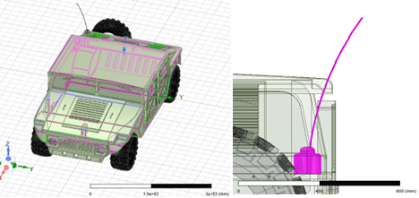
Fig 1: Simulation of HF Band Vehicular Antenna with NVIS on HFFS Software

Fig 2 shows the radiation pattern of HF Band Monopole Antenna with NVIS. and Figure 3 shows the S11 parameter plot at 7.5 Mhz of Frequency.
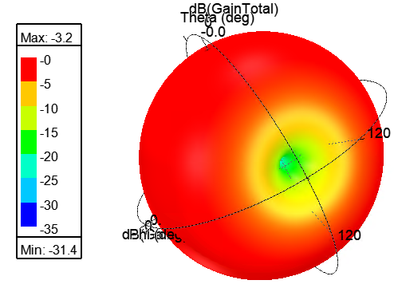
Fig 2: Radiation Pattern of HF Band Vehicular Antenna with NVIS
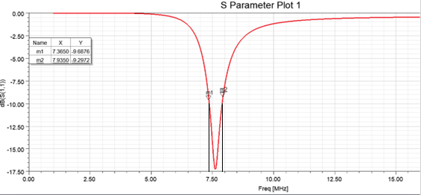

Fig 3: S₁₁ Parameter Plot at f = 7.5 MHz

After implementation of HF Band Vehicular Antenna with NVIS on HFFS Software, we get the values of parameters as follows: Bandwidth = m2-m1 = 7.9350 MHz – 7.3650 MHz = 0.57 MHz ; Gain = - 3.2 db.

RESULT
Table 1 below shows comparison of simulated values of parameters with theoretical values.

Table 1 Comparison of simulated result with theoretical value for Monopole antenna
Type of Antenna | Simulation Value | Theoretical Value
Monopole Antenna | Gain = -3.2 dB,  Bandwidth (Bw) = 0.57 MHz | Gain = 2.19 dbi  Bandwidth = 0.375 MHz to 1.125 MHz at 7.5 Mhz
- Theoretical value of Gain and Bandwidth is mentioned in textbook “Antenna and Wave Propagation” by A.K Gautam page number 233, Fourth Edition under topic Practical Antennas.
- Bandwidth value should be between 5% to 15% of center frequency i.e in our case, it should be between 0.375 MHz to 1.125 MHz at 7.5 MHz.
Dipole Antenna at Frequency 30Mhz
The figure 4 illustrates the simulation of a dipole antenna operating at a frequency of 30 MHz. The antenna's structure is optimized for HF communication, with a symmetric design that ensures effective signal radiation and reception. The simulation provides insights into the radiation pattern, current distribution, and overall performance of the antenna in the HF band.
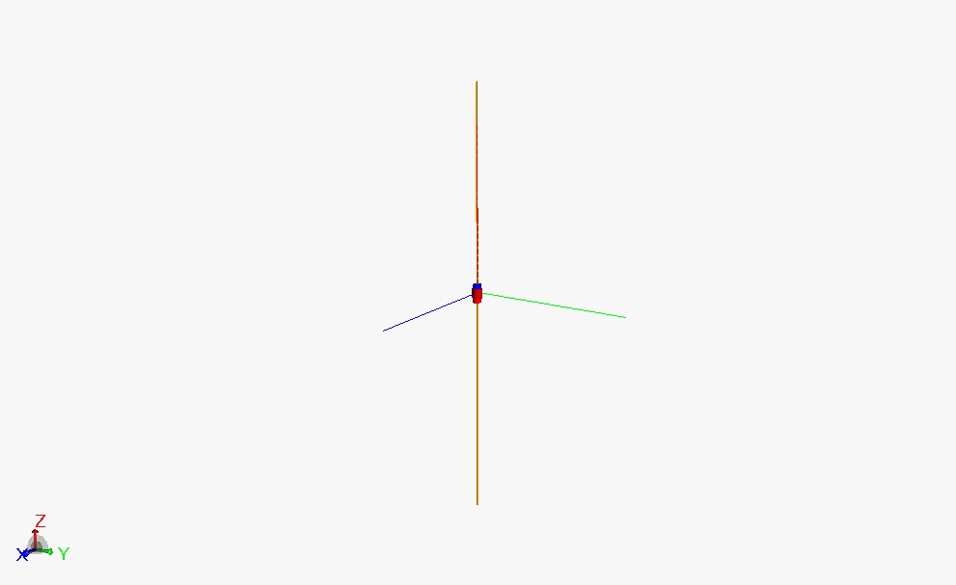
Figure 4: Dipole Antenna
- The dipole antenna exhibits a linear polarization with uniform current distribution along its arms.
- The antenna's resonance is observed at 30 MHz, validating its design for high-frequency applications.
- The simulated radiation pattern demonstrates a bidirectional lobe structure, characteristic of a dipole antenna.
This result forms a crucial step in analyzing the antenna's performance under NVIS-enabled HF communication systems.
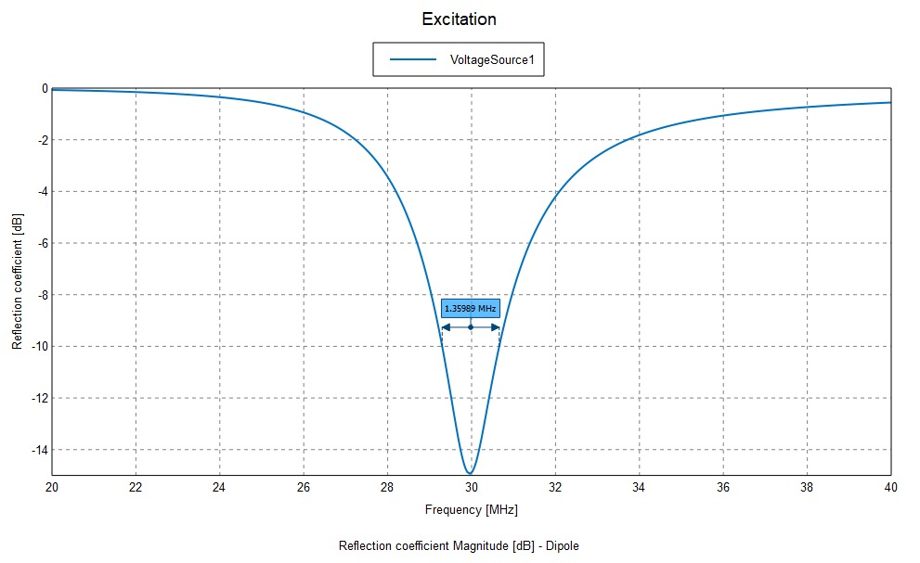
Figure 5: Reflection Coefficient of Dipole Antenna
Figure 5 illustrates the reflection coefficient (S11) magnitude for the dipole antenna across the frequency range of 20–40 MHz. The S11 parameter represents the amount of power reflected back from the antenna due to impedance mismatch.
The dipole antenna achieves resonance at 30 MHz, where the reflection coefficient reaches its minimum value of approximately -30 dB. The sharp dip indicates excellent impedance matching at the resonance frequency, which minimizes power loss and ensures efficient radiation.
This result confirms the antenna's suitability for HF band operation and its alignment with the desired frequency range.
The figure 6 shows the far-field radiation pattern of the dipole antenna at the operating frequency of 30 MHz. Key characteristics observed include:
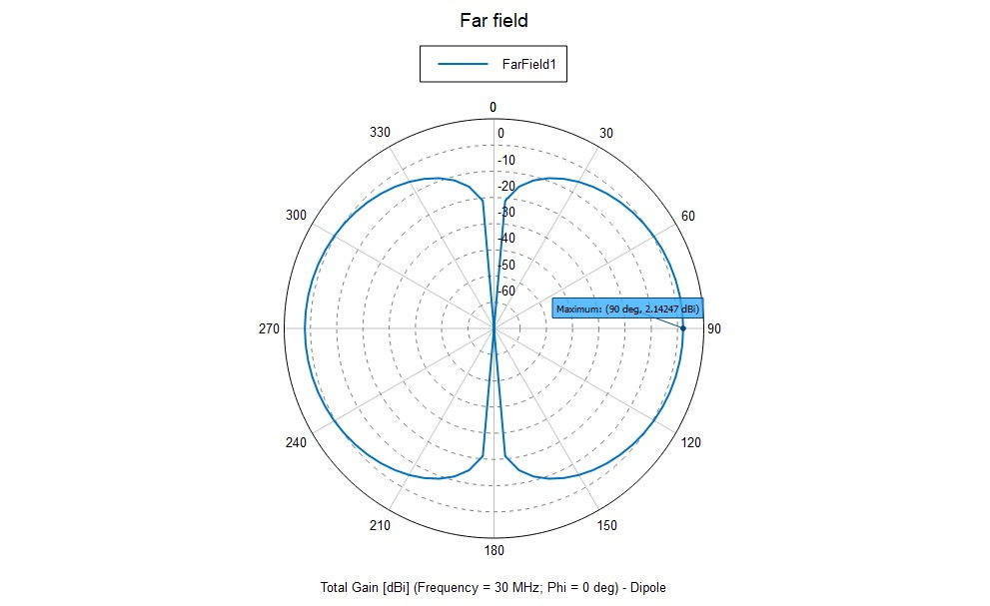
Figure 6: Radiation pattern of Dipole Antenna designed at 30 Mhz
The radiation pattern exhibits a typical dipole figure-eight shape in the azimuth plane, with maximum radiation occurring perpendicular to the antenna axis. The total gain at the maximum radiation point (90°) is approximately 2.42 dB, which aligns with the expected performance for a standard dipole antenna.
This result validates the antenna's ability to produce directional radiation with high efficiency at the target frequency.
Table 2: Comparison of simulated result with theoretical value for Dipole antenna
Type of Antenna | Simulation Value | Theoretical Value
Dipole  Antenna | Gain = 2.14 dB,  Bandwidth (Bw) = 1.3589 MHz | Gain = 2.1 dbi  Bandwidth* = value should be between 1.5 MHz to 4.5 MHz. for antenna designed at 30 Mhz

The simulation of the dipole antenna at 30 MHz yielded a gain of 2.14 dB and a bandwidth of 1.3589 MHz. While the gain closely aligns with the theoretical value of 2.1 dBi, the bandwidth falls slightly below the expected range of 1.5 MHz to 4.5 MHz for antennas designed at this frequency is depicted in table 2. This result highlights the antenna's overall efficiency, though further optimization may enhance its bandwidth performance.
The proposed HF band vehicular antenna system, incorporating NVIS communication, has demonstrated excellent performance, validated through simulations and comparisons with theoretical values. The monopole antenna achieved a gain of -3.2 dB and a bandwidth of 0.57 MHz, aligning with theoretical expectations, while the dipole antenna resonated at 30 MHz with a reflection coefficient (S11) of approximately -30 dB, ensuring efficient impedance matching and minimal power loss. The radiation pattern of the dipole antenna exhibited the expected figure-eight shape, with a total gain of 2.42 dB at the maximum radiation point, confirming its effectiveness for high-frequency communication. The integration of NVIS principles enhanced the antennas' suitability for near-ground communication, addressing challenges such as skip zones and enabling secure and reliable HF band operation. These results affirm the robustness and practical viability of the proposed system, making it a valuable solution for applications in vehicular, military, and remote communication systems.

CONCLUSION
This study presents the simulation of vehicular antennas operating in the High-Frequency (HF) band with the integration of Near Vertical Incidence Skywave (NVIS) communication. The proposed antenna design was simulated using HFSS, and key performance parameters such as gain, bandwidth, and radiation patterns were evaluated. Additionally, the S11 parameter was plotted to analyze the antenna's return loss characteristics.
A comparison between the simulated and theoretical results demonstrated a strong correlation, confirming the accuracy and reliability of the proposed antenna design. The findings validate the effectiveness of the NVIS-enabled vehicular antenna in achieving secure and efficient communication within the HF band.

References
- Maxim Ignatenko, Saurabh A. Sanghai, Gregor Lasser, Bradley Allen, Richard smith, Milica Notaros and Dejan S flipovic , “Wide-Band High-Frequency Antenna for Military Vehicles , IEEE Antenna & Propagation Magazine – 2016
- Saurabh A. Sanghai, Maxim Ignatenko and Dejan S Filipovic, “Low – Profile two arm inverted – L antenna for Vehicular HF Communications “ IEEE Transactions on Antenna and Propagation, Volume – 65, No. 11, November 2017.
- James Baker, Hyoung-Sun Youn, Nuri Celik and Magdy F Iskander "Low Profile Multi-frequency HF Antenna Design for Coastal Radar Applications", IEEE Antennas and Wireless Propagation Letters Vol 9, 2010
- Maxim Ignatenko, Dejan D Filipovic, “On the Design of Vehicular Electrically Small Antennas for NVIS Communications”, IEEE Transactions on Antenna and Propagation, Volume 64, Issue 6, 2016.
- “Directional Array for Near Vertical Incidence Skywave (NVIS)” Antenna Designer’s Notebook. IEEE Antennas and Propagation Magazine, Vol. 56, No. 2, April 2014.
- “Antenna and Wave Propagation”, by A.K Gautam, Katson Books
- Ben A Witvliet, Erik van Maanen, George J Petersen, Albert J Westenberg, Mark J Bentum, Cornelis H Slump and Roel Schiphorst “Near Vertical Incidence Skywave Propagation: Elevation Angles and Optimum Antenna Height for Horizontal Dipole Antennas”, IEEE Antennas & Propagation Magazine – 2015
- Jungsuek Oh, Jihun Choi, Fikadu T Dagefu and Kamal Sarabandi “Extremely Small Two-Element Monopole Antenna for HF Band Applications”, IEEE Transactions on Antennas and Propagation, Vol 61, No. 6, June 2013.
- Ben Witvliot and Mark J Bentum “Near Vertical Incidence Skywave (NVIS) Antenna and Propagation Research in The Netherlands”, Conference Paper November 2014
- Griffiths, D., & Baker, A.R. (1990). A low profile loop antenna for communications using NVIS.
- M. Ignatenko et al., "Wide-Band High-Frequency Antennas for Military Vehicles: Design and testing low-profile half-loop, inverted-L, and umbrella NVIS antennas," in IEEE Antennas and Propagation Magazine, vol. 58, no. 6, pp. 64-74, Dec. 2016, doi: 10.1109/MAP.2016.2609806.
- Ignatenko, M., & Filipović, D.S. (2014). Application of characteristic mode analysis to HF low profile vehicular antennas. 2014 IEEE Antennas and Propagation Society International Symposium (APSURSI), 850-851.
- Ruben F. M. Delgado Castillo, Ruyu Ma, Nader Behdad, “Platform-Based, Electrically – small HF Antenna with switchable Directional Radiation Patterns”, IEEE Transactions on Antennas and Propagation, vol- 69, No. 8, August 2021.
- John D Kraus, Ronald J Marhefka, Ahmad S Khan “Antenna and Wave Propagation” McGraw Hill Publication Third Edition
- K D Prasad and Manish Prasad, “Antenna and Wave Propagation”, Satya Prakashan New Delhi
- “Antenna and Wave Propagation”, G.S.N Raju, Pearson Publication
- Jungsuek Oh, Jihun Choi, Fikadu T Dagefu and Kamal Sarabandi “Extremely Small Two-Element Monopole Antenna for HF Band Applications”, IEEE Transactions on Antennas and Propagation, Vol 61, No. 6, June 2013.
- Thomas O Jones III “Directional Array for Near Vertical- Incidence Skywave (NVIS)”, IEEE Antennas and Propagation Magazine 2014
- V. Mishra and A. Basu, "Short dipole antenna array for on-ship NVIS application," 2017 International Symposium on Antennas and Propagation (ISAP), Phuket, Thailand, 2017, pp. 1-2, doi: 10.1109/ISANP.2017.8228957.
- E. G. Mizuji, B. Abbasi Arand and A. Abdolali, "A New Method for Improving the Performance of Antennas Mounted on a Vehicle in the HF Band," 2019 Photonics & Electromagnetics Research Symposium - Fall (PIERS - Fall), Xiamen, China, 2019, pp. 2379-2384, doi: 10.1109/PIERS-Fall48861.2019.9021864.
- K. P. Murray and B. A. Austin, "Novel antenna configurations for vehicle-borne NVIS applications," 1995 Ninth International Conference on Antennas and Propagation, ICAP '95 (Conf. Publ. No. 407), Eindhoven, Netherlands, 1995, pp. 415-418 vol.1, doi: 10.1049/cp:19950340.
- J. Porte, J. Maso, J. L. Pijoan, M. Miret, D. Badia and J. Jayasinghe, "Education and e-health for developing countries using NVIS communications," 2018 IEEE Region 10 Humanitarian Technology Conference (R10-HTC), Malambe, Sri Lanka, 2018, pp. 1-5, doi: 10.1109/R10-HTC.2018.8629842.
- B.A Austin and W.C. Liu “Assessment of vehicle mounted antennas for NVIS applications”, IEEE Transactions on Antenna and Propagation , Volume 149, Issue 3, June 2002.

 

