An Introductory Study on Perceptron in Deep Learning

*Aryan Panchal
Department of Computer Engineering, Rajiv Gandhi Institute of Technology, Mumbai, Maharashtra, India
aryan.panchal1204@gmail.com

- Abstract
Artificial Intelligence is one of the fastest growing fields in science and engineering and has a wide variety of applications ranging from the general fields like learning, perception and prediction to specific domains such as writing stories, proving mathematical theorems, driving a bus on a crowded street, diagnosing diseases and playing chess. This paper focuses majorly on the pictorial depiction of all the models which aid in understanding the fundamental working of a perceptron – the building block of a neural network. This paper further explores the concept of perceptron aggregation and the purpose of non-linear activation functions thus shedding light on the introductory concepts of deep learning and how individual perceptron aggregate together to form a working deep learning model.

Keywords— ARTIFICIAL INTELLIGENCE, PERCEPTRON, DEEP LEARNING, NEURAL NETWORK

- Introduction
Deep learning is not only used to generate faces but also synthetic environments. For example, generate images from a natural language like, I need a photo of an astronaut on a horse. Such prompts can be converted into visual form. Deep learning forms the very core of artificial intelligence. One can imagine artificial intelligence to the parent set of all the various forms of learning, be it machine learning or deep learning. One can define deep learning as the extraction of patterns from cleaned data using high functioning neural networks whereas machine learning can be defined as the ability to learn and comprehend without explicitly being programmed and artificial intelligence, as inferred earlier, is a parent shell encompassing all.

- The need of neural networks
Brief on the recent resurgence:
Since 1952, learning models have come into picture, ever since the term, “Artificial Intelligence” was coined at the Dartmouth conference, the rise of these intelligent systems has not halted but has skyrocketed.

Table 1. Factors leading to the resurgence

Big Data | Hardware | Software
Larger datasets | GPU’s | New models
Easier storage

- Perceptron
Perceptron is the building block of all neural network. A single neuron depicting forward propagation is called a perceptron. The general behaviour of a perceptron is production of a single binary output of either 0 or 1. Perceptron takes n number of binary inputs and produces a single output. It appears to be quite certain that a decision cannot be finalised by a single perceptron hence Multi-Layer Perceptrons can be used to achieve a greater sophistication in decision making. Through a combination of multiple layered perceptrons and by creating a connection within them in a network structure, these models can handle relatively complicated patterns and interlinking relationships in data thereby enabling tasks such as Image Processing and Natural Language Processing.

Figure 1. Rectilinear propagation of a Perceptron

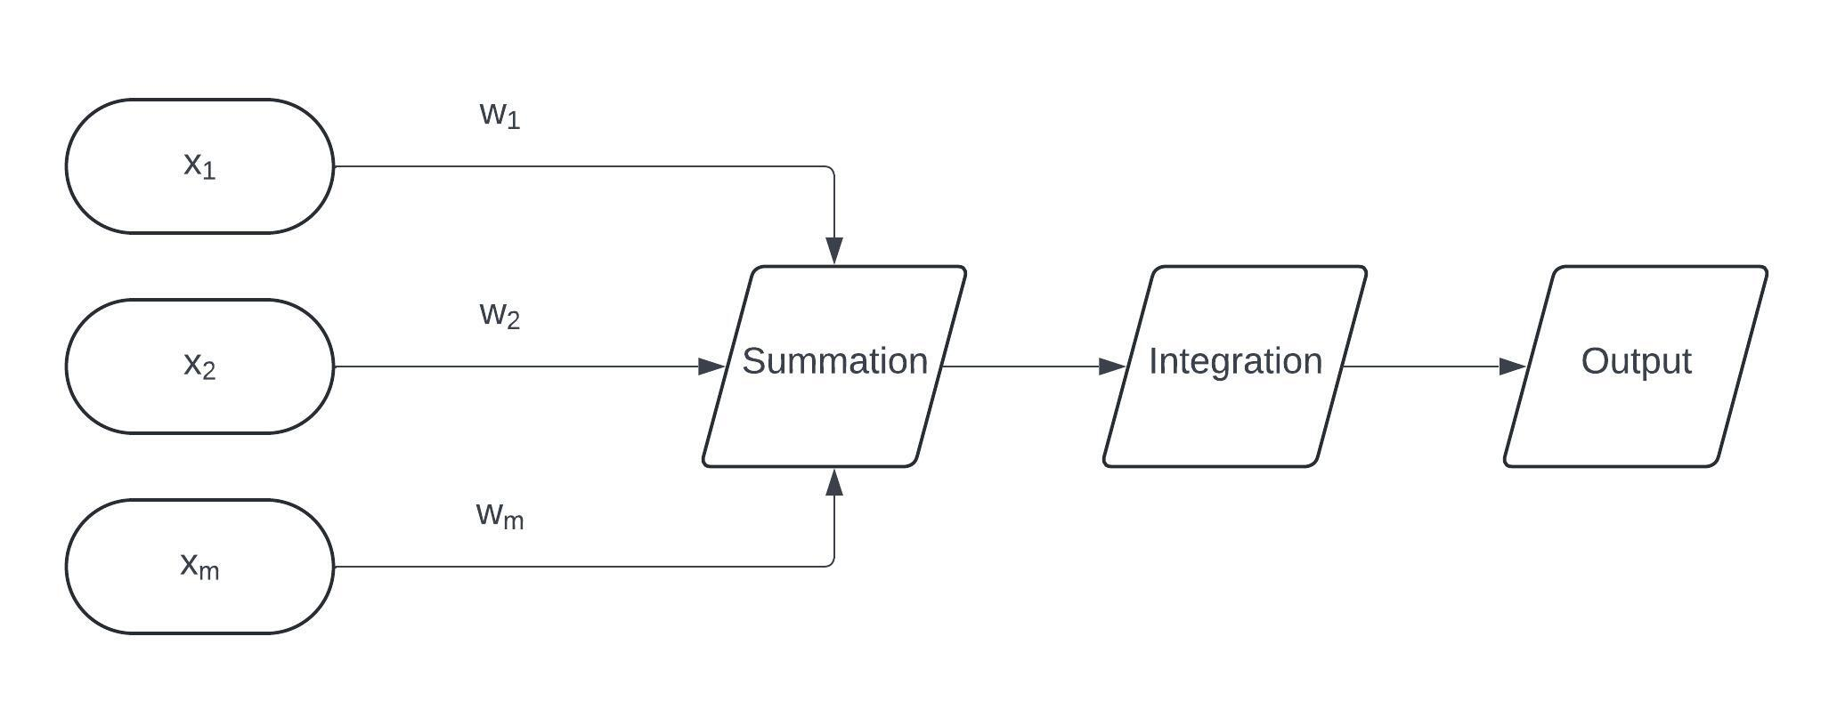

Here in the figure 1, x denotes the input values, w denotes the weights.

General formula for a perceptron is as follows:

Y = g (∑ ^{m}_{i=1} x_{i} * w_{i})

Where Y denotes the output, g denotes the non-linear activation function and x, w denotes the linear combination of the inputs. This equation represents the Perceptron.

- The purpose of non-linear activation functions
The purpose of non-linear activation functions is to introduce non-linearities into the network

Figure 2. Perceptron aggregation

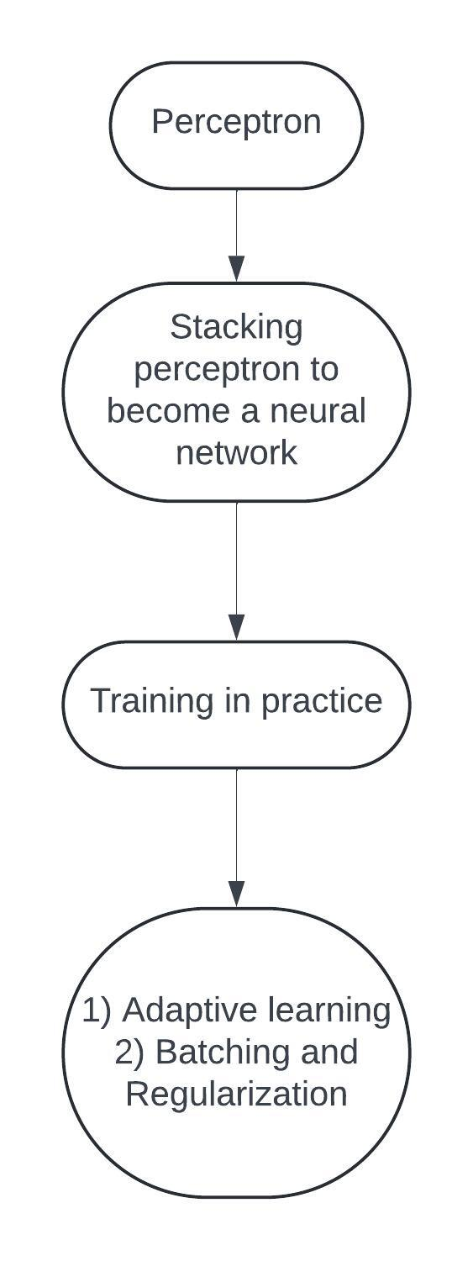
- Conclusion
This paper thus explores perceptron in a brief and introductory manner which clears basic concepts of deep learning and how perceptrons essentially functions and behave. Mathematical formulation provide a logical explanation to the workings of the perceptron thereby opening doors for further analysis and aiding research in the field of artificial intelligence.

- References
- F. K. Oduro-Gyimah, K. O. Boateng, P. B. Adu and K. Quist-Aphetsi, "Prediction of Telecommunication Network Outage Time Using Multilayer Perceptron Modelling Approach," 2021 International Conference on Computing, Computational Modelling and Applications (ICCMA), Brest, France, 2021, pp. 104-108, doi: 10.1109/ICCMA53594.2021.00025.
- X. Huang, Z. Liu, H. Liu and Z. Deng, "Nested perceptron model and its learning algorithm," 2023 3rd International Conference on Frontiers of Electronics, Information and Computation Technologies (ICFEICT), Yangzhou, China, 2023, pp. 288-293, doi: 10.1109/ICFEICT59519.2023.00056.
- A. Kurniawati, Y. K. Suprapto and E. M. Yuniarno, "Multilayer Perceptron for Symbolic Indonesian Music Generation," 2020 International Seminar on Intelligent Technology and Its Applications (ISITIA), Surabaya, Indonesia, 2020, pp. 228-233, doi: 10.1109/ISITIA49792.2020.9163723.

