ANALYZING AND ENHANCING YOUTUBE RANKING ALGORITHMS FOR VIDEO RECOMMENDATIONS

M.Hemalatha¹, K.Abineya²
^{1 &2}(PG & Research Department of Computer Science, Sri Ramakrishna College of Arts &Science, India
Corresponding Author: mhemalatha@srcas.ac.in

Abstract: In the rapidly evolving digital space, staying ahead is pivotal for video platforms. The dynamics of recommendation systems, responsible for curating a tailored experience for millions of users daily, become paramount in this pursuit. This study embarks on a comprehensive journey to dissect, simulate, and optimize the algorithms underpinning these recommendations. The proposed segments delve deeper into the specific objectives of this research endeavor. Analyzing YouTube's existing recommendation algorithms and leveraging a proposed model to create a user-friendly interface for the simulation of these algorithms. Testing and evaluating the efficacy of the enhanced algorithms against a benchmark dataset. The future of digital video platforms is intertwined with the evolution of recommended algorithm By enhancing the way platforms like YouTube recommend videos, this study aspires to contribute significantly to improving user experience and platform efficiency
Key Word: ranking algorithms; video recommendation; Analysis, efficiency

- Introduction

The digital age, marked by significant advancements in technology and a burgeoning online user base, has been characterized by the unprecedented growth of digital video platforms. Such platforms, led by juggernauts like YouTube, have reshaped the landscape of entertainment and media consumption. Digital video platforms, and more prominently YouTube, have metamorphosed into a central entertainment hub. The platform hosts content ranging from amateur home videos to professionally produced series, music videos, tutorials, news, and more. This diversification has expanded its user base, catering to varied tastes and preferences. YouTube's algorithm, which rewards engaging content, led to the rise of full-time content creators or 'YouTubers'. These individuals and organizations recognized the platform's potential and dedicated their efforts to producing content tailored to their audience. Consequently, YouTube became not just a place for casual viewing but a platform where careers were made, products were launched, and where influencers wielded considerable power over public opinion. The absolute volume of content uploaded every minute to platforms like YouTube makes content discoverability a formidable challenge. For new creators, flouting through the noise becomes increasingly difficult, and for viewers, finding relevant content amidst the vast sea of videos can be overwhelming. The challenge isn't just limited to content volume. The diverse user base, each with its unique set of preferences, poses another hurdle. A one-size-fits-all approach to content recommendation is not viable. Catering to the eclectic tastes of a global audience necessitates a sophisticated, adaptive, and intelligent recommendation system.

The Authoritative of Video Recommendation Systems: Enter video recommendation systems the unrecognized heroes behind a user's seamless navigation through the platform. These systems are crucial for several reasons: User Engagement: A tailored list of video suggestions means users spend more time on the platform, increasing viewer engagement. content Discoverability: For content creators, an effective recommendation system ensures that their content reaches its intended audience, even if they don't have millions of subscribers.

Ad Revenue: For the platform, increased engagement translates to more opportunities for ad placements, which is a significant revenue source. However, merely having any simple recommendation system isn't enough. It needs to be continuously refined, Understanding and predicting user behavior and preferences with precision.

Landscape of Content Consumption

Before the internet era, content consumption was largely passive. Consumers had limited channels, shows, or films to choose from, dictated primarily by broadcasters or cinema schedules. The digital revolution ushered in an era of content democratization. Now, not only are users spoilt for choice, but they also have the right to produce, share, and promote content. In this saturated space, merely hosting vast amounts of content isn't enough. The true challenge lies in directing users to satisfied that aligns with their interests, ensuring they are not overwhelmed or lost in the vast sea of options.

Personalization: The Key to User Experience

The human desire for personalized experiences isn't new. Historically, marketplaces and businesses have thrived when they've understood and catered to individual preferences. Digital platforms are no different. Video recommendations serve this very need, by analyzing past user behavior, preferences, and interactions to suggest content that is likely to be of interest. When a user logs onto a platform like YouTube and is immediately presented with videos that pique their interest, it creates a sense of connection and understanding. This personalized approach not only enhances user experience but also adopts a sense of loyalty and trust towards the platform.

The future of digital video platforms is intertwined with the evolution of recommendation algorithms. By enhancing the way platforms like YouTube recommend videos, this study aspires to contribute significantly to improving user experience and platform efficiency. The subsequent chapters promise a deep dive into the intricacies of the recommendation algorithms, their existing challenges, and potential enhancements, all aimed at a more refined and user-centric digital video experience.

Review of literature

James et al. offered a video recommendation system tailored for signed-in YouTube users, taking into account their past activity on the platform. This system is specifically designed around the challenges posed by a lack of metadata for many videos and the often-short interactions users have with the predominantly brief videos on YouTube In contrast to James et al., Tao et al. consider multimodal content relevance combined with user feedback for their recommendation system. Recognizing that different video parts may have varying levels of interest, their system covers a broader spectrum of recommendation factors.

Shumeet et al. adopt a distinct approach by analyzing the entire user-video graph on YouTube to render personalized recommendations. By exploiting YouTube's nature as a social online community, they utilize the Adsorption algorithm to propagate preference information efficiently. Their method does not rely on the analysis of video content but rather on the co-view patterns of users. The success of their recommendations is gauged against actual user behavior in a testing phase. Findings indicate that the Adsorption algorithm bolsters the efficiency of recommendations. Similar to Shumeet et al., Qin et al. also leverage the social network attributes of YouTube. They generate a YouTube Recommendation Network (YRN) that interlinks videos based on user comments

Amazon's Efficiency with Item-Item Recommenders - Linden, Greg et al. Amazon revolutionizes online shopping with its item based recommender systems. By focusing on item similarities over the conventional user-user approach, Amazon efficiently manages vast datasets, ensuring tailored product recommendations without extensive computational demands. Netflix: A Symphony of Diverse Recommender Systems - Gomez-Uribe, Carlos A., and Hunt, Neil: Netflix, a streaming behemoth, combines a plethora of algorithms to curate an unparalleled user experience. From suggesting trending content, evaluating user watching patterns, to recommending based on video similarities, Netflix's recommendation prowess hinges on an amalgamation of sophisticated machine learning techniques.

LinkedIn's Skillful Approach to Professional Networking - Roth, M. et al.:LinkedIn's "skills" section showcases the challenge and the platform's innovative response. By extracting user-declared skills, resolving ambiguities, and crowdsourcing redundancies, LinkedIn refines a vast skillset database. Their subsequent "skill inference algorithm" proactively suggests relevant skills to users. YouTube's Tailored Video Recommendation Davidson, J. et al.: YouTube's recommendation system stands testament to its commitment to offering individualized video suggestions. By fusing video metadata with user activity data and emphasizing a balance between relevance and diversification, YouTube ensures that users are constantly presented with engaging content that resonates with their preferences

- Material And Methods

The proposed framework for analyzing and enhancing YouTube's video recommendation algorithms, several database tables are designed to capture intricate details of various related entities. The first table, titled "ChannelProfile", stores information about different YouTube channels. It includes columns like Channel_id (which is the primary key), Channel_name, Channel_Rating, Channel_category, and total_subscribers. This table serves as a repository for metadata about each channel, enabling algorithms to draw inferences based on channel attributes like its rating and total subscribers.Further refining the recommendation process, there are tables designed to capture both the pre-stage and post-stage of collaborative filtering, named “Collaborative_filtering_PreStage" and "collaborative_Poststage" respectively. These tables incorporate details like video ratings, total views, region, click-through rate, video quality, and average watch duration. A separate table, "Collaborative_Result", synthesizes the collaborative filtering process outcomes,storing the collaborative result ID, video ID, video title, channel name, and user-specific count. Another table, "Content_Filtering", specifically focuses on content-based recommendation attributes, such as video titles and their associated counts.Additional tables, namely "Search Profile", "UserProfiles", and "VideoProfile", are essential for a comprehensive recommendation system. The "Search Profile" table logs user search behavior, including the timestamp, searched keyword, and category. "UserProfiles" provides a snapshot of user demographics with attributes like their username and region. Lastly, "VideoProfile" is an exhaustive repository for all video-related metadata, capturing elements like video title, description, tags, views, likes, dislikes, ratings, region, and other associated attributes. This systematic and detailed database design ensures that YouTube's recommendation algorithms have access to a breadth of data, facilitating more ccurate and relevant video suggestions for users.

Sequence Diagram
In the sequence diagram, the user initiates a search using a specific keyword. Upon this action, the system checks the video profiles to match the entered keyword with the user's area of interest. The system then employs content-based filtering to sort the videos based on their relevance, arranging them from the highest to the lowest keyword count. These sorted videos undergo a secondary ranking process through collaborative-based filtering, which considers various other parameters. Finally, the refined list of recommended videos is presented back to the user.

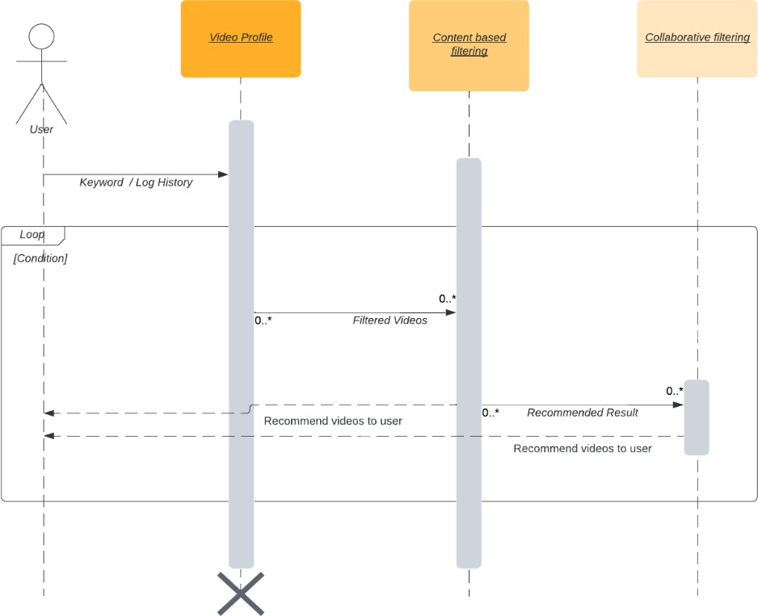

Figure 1. Sequence diagram

Database Design
The provided diagram illustrates a flow between various data entities involved in a video recommendation system. The "UserProfiles" entity, containing details like UserID, Username, and Region, interacts with the "VideoProfile" entity, which encompasses details such as Video ID, Title, Description, and various video metrics. Upon a user's search action, the "Content Filtering" entity filters videos based on relevant parameters like Video ID and keyword count. Subsequently, the "Collaborative filtering_PreStage" entity processes these filtered results, considering various parameters like video and channel ratings. The filtered videos then advance to the "collaborative Poststage" for re- ranking based on additional parameters, culminating in the "Collaborative Result" entity, which showcases the final recommended videos to the user.

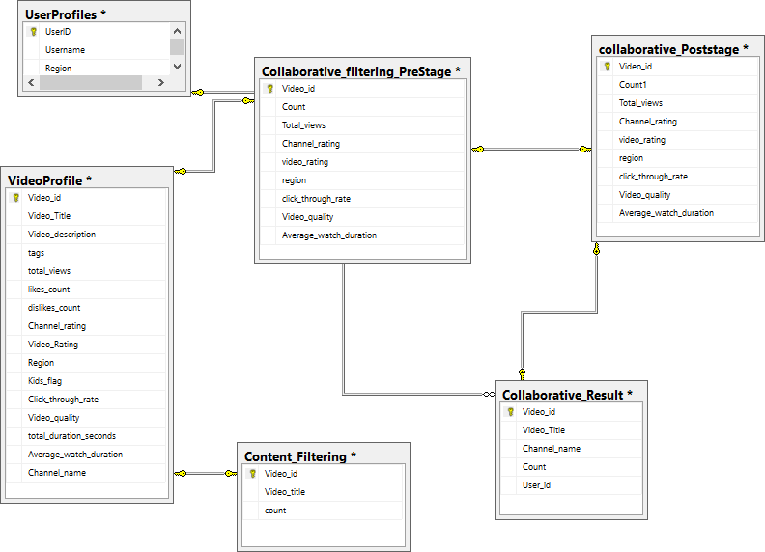

Figure 2 : Database Design

- Results and Discussion

Channel Profile
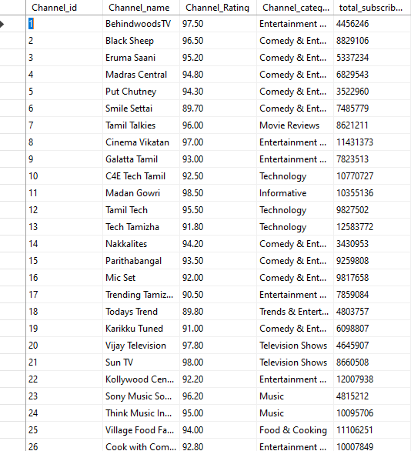

User Profile

User Profile offers a snapshot of an individual user, highlighting their unique identifier (User ID), the name or alias they use on the platform (Username), and the geographical area they are associated with or reside in (Region).
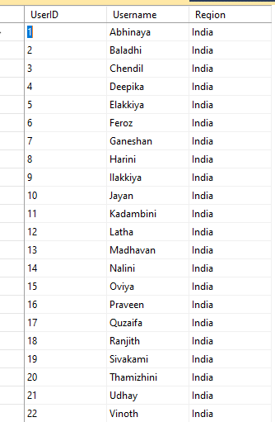

Video Profile

A Video Profile provides comprehensive details about a specific video content. It incorporates the video's unique identifier (Video id), title (Video Title), a brief summary or context (Video description), and associated keywords or topics (tags). The profile captures the video's performance metrics, such as the total number of views, likes, and dislikes. The assessment of the content can be inferred from the Video and Channel ratings. Geographical data is captured in the Region, while the Kids flag indicates its suitability for younger audiences. The Click through rate reveals viewer engagement, and the video's clarity is denoted by its quality. It also provides insights into viewer behavior with the total playback time (total duration seconds) and the average time a viewer spends on it (Average watch duration). Lastly, the associated channel or source is identified by the Channel name.

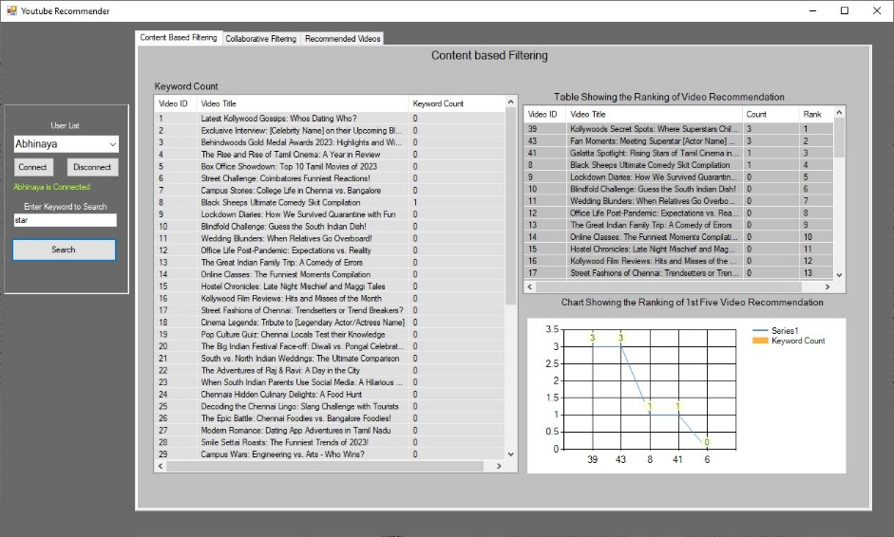

Initially, the code begins by preparing the data environment. It sets an iterative variable 'i' to zero and clears the 'lv_content' list view. Then, it fetches all the records from the 'VideoProfile' table. For each video profile record, the code extracts its Video_id and Video_Title and adds them to the 'lv_content' list view. It then initializes a keyword count variable (cnt) to zero. The code scans through key fields like Video_Title, Video_description, Channel_name, and tags, and for each field containing the user keyword (specified in 'txt_keyword.Text'), the count 'cnt' is incremented by one. After processing all the fields for a specific video record, the keyword count 'cnt' is appended as a subitem to the 'lv_content' list view. This loop continues until all the records in 'VideoProfile' are processed.
Finally, the code focuses on visual representation. It readies 'Chart1_content' by clearing its series and appending "Keyword Count" as its label. It then fetches the top 5 records from the 'content_filtering' table, again based on descending keyword count. For each of these records, the Video_title is added to a grid named 'grid1'. Additionally, the corresponding Channel_name for the video is fetched from 'VideoProfile' and also added to 'grid1' as a subitem. Moreover, the keyword count for each video is plotted as a point in 'Chart1_content's series, labeled with its Video_id. This provides a graphical representation of the videos with the highest keyword relevance.
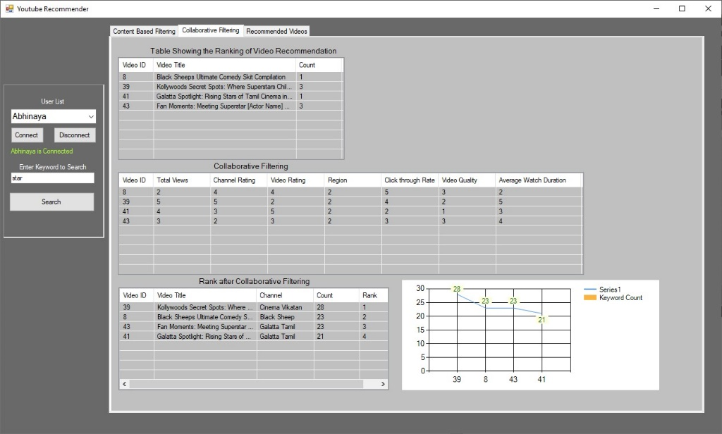

The process starts by clearing the 'lv_contentresult' list view, after which the function fetches all records from the 'content_filtering' table with a count greater than zero. If such records are found, each one is added to the 'lv_contentresult' list view with its associated Video_id, Video_Title, and Count values. The function then removes existing records from the 'Collaborative_filtering_PreStage' table and refills it using the items found in 'lv_contentresult'. As each item is added to the 'PreStage', it fetches related data from the 'videoprofile' table, updating attributes such as Total_views, Channel_rating, and Video_Rating when relevant data is available. The next phase involves removing records from the 'collaborative_Poststage' table, repopulating I with selected records from the 'PreStage', and only capturing the Video_id and Count1 values at this juncture.

Subsequently, the code embarks on a series of sorting and updating operations to rank the video content. It first retrieves the total number of records from 'Collaborative_filtering_PreStage' and stores this value in 'rec_length'. Then, it methodically ranks records based on different criteria: Total_views, Channel_rating, Video_rating, Click_through_rate, and Average_watch_duration. Each time, the ranked metrics from 'PreStage' are used to update corresponding values in the 'Poststage'. Additionally, user-centric preferences are incorporated by fetching a specific user's region from 'UserProfiles' and updating the 'Poststage' accordingly, alongside the video quality. The concluding steps focus on generating the final output. First, the function purges existing records from 'Collaborative_Result'. Then, records from 'collaborative_Poststage' are fetched and added to 'Collaborative_Result'. While doing so, the function also fetches related Video_Title and Channel_name from the 'VideoProfile' table and integrates them into the results if available. Moreover, it calculates a composite Count value for the 'Collaborative_Result' by summing up related values from 'collaborative_Poststage', offering a refined and ranked list of video recommendations for the user.
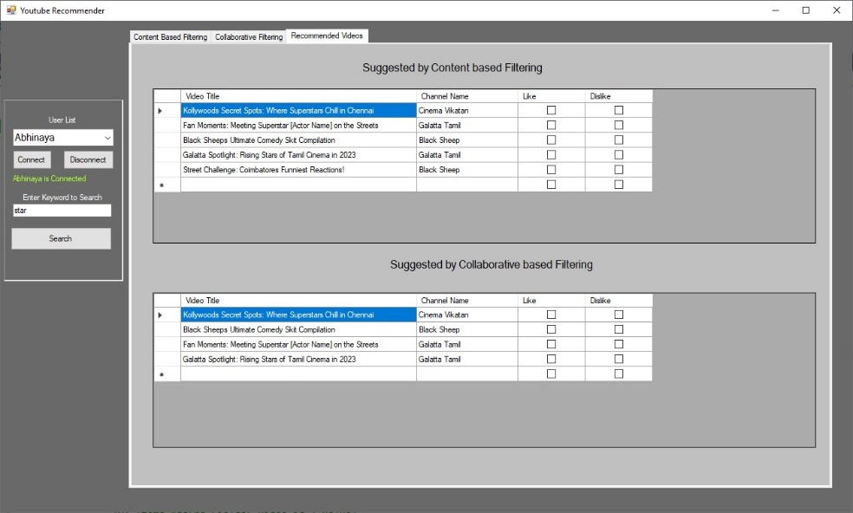

The provided interface showcases a YouTube Recommender system that employs two distinct video recommendation approaches: Content-based Filtering and Collaborative- based Filtering. While both methods aim to curate video suggestions tailored to the user's preferences, they differ fundamentally in their underlying principles and echanisms.Content-based Filtering primarily recommends videos based on the content's attributes and the user's previous interactions with similar content. For example, if a user frequently watches videos about "cinema spots," the system will suggest other videos with related themes or keywords. On the other hand, Collaborative-based Filtering relies on the preferences and behaviors of a broader user base. It gauges similarities between users and recommends videos based on what similar users have liked or watched. This method can be more effective as it utilizes the collective intelligence of multiple users and often provides diverse and yet relevant recommendations. The strong parameters mentioned suggest that the Collaborative-based Filtering in this system might be utilizing multiple metrics, like viewer ratings, click-through rates, and watch durations, making its recommendations potentially more robust and well-rounded than the Content-based approach.

- Conclusion

The realm of YouTube video recommendations is important in the digital age, where user retention and engagement directly correlate with the relevance and appeal of the suggested content. In our analysis of the YouTube Recommender system, we delved deep into two dominant algorithms: Content-based Filtering and Collaborative-based Filtering. Each brings its own set of merits to the table, catering to the user's preferences through different methodologies.
Content-based Filtering offers a specific personalized approach by aligning recommendations closely with the user's past interactions and the inherent attributes of the content. It serves as a mirror to the user's established preferences, ensuring that they are continually presented with content that resonates with their past choices. This method, while effective, can sometimes operate in a silo, limiting users to a particular type of content and potentially stifling the discovery of diverse content. Collaborative-based Filtering, on the other hand, harnesses the power of the community. By analyzing the preferences and behaviors of a myriad of users, it identifies patterns and similarities, thus recommending videos that peers with similar tastes have appreciated. This communal approach taps into a broader dataset, enhancing the probability of users discovering fresh and varied content that still aligns with their tastes. Moreover, the incorporation of robust parameters like viewer ratings, click-through rates, and watch durations further refines the recommendation quality, presenting a more holistic view.

In conclusion, while both algorithms hold their respective strengths, the Collaborative-based Filtering, with its community-driven approach and multifaceted parameters, emerges as a more comprehensive solution. It not only ensures relevance but also encourages content diversity, fostering an enriched viewing experience. As YouTube continues to evolve, the amalgamation of both these algorithms, backed by continuous enhancement and fine-tuning, will be pivotal in shaping a user-centric video recommendation ecosystem.

References
- Tsampoulatidis, I., Gkalelis, N., Dimou, A., Mezaris, V., & Kompatsiaris, I. (2011). High-level event detection system based on discriminant visual concepts. Proceedings of the 1st ACM International Conference on Multimedia Retrieval, 1-2.
- Davidson, J., Liebald, B., Liu, J., Nandy, P., Van Vleet, T., Gargi, U., Gupta, S., He, Y., Lambert, M., Livingston, B., & Sampath, D. (2010). The YouTube video recommendation system. Proceedings of the Fourth ACM Conference on Recommender Systems, September 26-30.
- Zhou, R., Khemmarat, S., Gao, L., & Wang, H. (2011). Boosting Video Popularity through Recommendation Systems. DBSocial '11: Databases and Social Networks, 13- 18.
- Baluja, S., Seth, R., Sivakumar, D., Jing, Y., Yagnik, J., Kumar, S., Ravichandran, D., & Aly, M. (2008). Video suggestion and discovery for YouTube: Taking random walks through the view graph. Proceeding of the 17th International Conference on World Wide Web, April 21-25.
- Qin, S., Menezes, R., & Silaghi, M. (2010). A Recommender System for YouTube Based on its Network of Reviewers. Social Computing (SocialCom), 2010 IEEE Second International Conference on, 323-328.
- Mei, T., Yang, B., Hua, X-S., & Li, S. (2011). Contextual Video Recommendation by Multimodal Relevance and User Feedback. ACM Transactions on Information Systems, 29(2).
- Renjie, Z., Khemmarat, S., & Gao, L. (2010). The impact of YouTube recommendation system on video views. Proceedings of the 10th Annual Conference on Internet Measurement, November 01-30.
- Jayavardhana Gubbi, Rajkumar Buyya, Slaven Marusic, and Marimuthu Palaniswami. Internet of things (iot): A vision, architectural elements, and future directions. Future generation computer systems, 29(7):1645-1660, 2013.
- Aristomenis S Lampropoulos and George A Tsihrintzis. Machine Learning Paradigms: Applications in Recommender Systems, volume 92. Springer, 2015.

