Website Development for doorstep service

Prof.Dhanashetti A.G., Ankita Hotkar
ENTC Department ,N.K.Orchid College of Engineering,Solapur.
amrutadhanshetti@orchidengg.ac.in
Abstract : — Being a salon client today is inconvenient. There is a strong, well-articulated need for a “one-stop-shop” online hub that connects clients to salons, putting all the information users need in one convenient place, on demand. Our system will help automate this process of record keeping as well as maintaining the staff records. When users sign in, they are directed to their dashboard, their one-stop shop for all salon-related information and functionality.
Keywords—Website, Door-step service, salon management, Scheduling, Dreamweaver

I.Introduction
Being a salon client today is inconvenient. You have to remember that you need to make an appointment, then hope you remembered during business hours, and finally scramble to find the phone number and take time out of your busy day to make the call. And never mind finding user reviews of local salons and stylists tracking those down somewhere on the web is a headache that most don’t even attempt. There is a strong, well-articulated need for a “one-stop-shop” online hub that connects clients to salons, putting all the information users need in one convenient place, on demand. There is a strong, well- articulated need for a “one-stop-shop” online hub that connects clients to salons, putting all the information users need in one convenient place, on demand. Scheduler, it will be a salon management tool that will allow salons to manage stylists and services, promote sales to customers, and track customer satisfaction Today is the era of digital technology and the development of technology. The rise of the INTERNET gives a boost in the digital field and India is also accepting it and runs many movements like digital India, UPI money transfer, and many more. There are various types of online websites available; ranging from online E- commerce websites (AMAZON), online trip booking websites. A beauty salon is an establishment dealing with cosmetic treatments for men and women. Other variations of this type of business include hair salons and spas

II. PROBLEM STATEMENT :

Equally surprising, many salons today are still using paper and pencil systems to schedule appointments and manage customers. These systems are grossly inefficient at sharing and syncing information, and are prone to costly human error. Salon Book promises to end the dependence on paper pencil systems, and put salons in control with an easy to use interface. Salon Book will be more than just an online scheduler; it will be a salon management tool that will allow salons to manage stylists and services, promote sales to customers, and track customer satisfaction. We need to develop a website which offers easy but secure accessibility and navigation, multiple user accessibility, easy maintenance and searching. This Website Development will help salon customer to so that they can easily bother slot and we may give the service at your comfort zone in your home.

III. USER GOALS AND OBJECTIVES

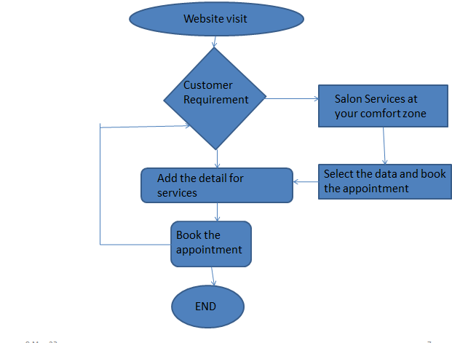
Fig:3.1 Flowchart for door step service business

III.1 USE CASES:
- Log in website
Ankita beauty hub:
- location (address) name:
- View and Edit Account information
- Make an appointment for:
(only female)
- Beauty salon home services
- **Allows users to make recurring appointments**
Cancel an appointment
- View Appointments
- Rate salon/stylist (can only rate Salons/Stylists after an appointment)
III.2 USE CASES OBJECTIVES OF THE WEBSITE
Salon account
- Edit Salon Account Information Add a Stylist Remove a Stylist
- Edit the services a stylist provides Add/remove beauty services
- your Salon offers View ratings of your salon
- View beauty ratings of your salon View/Print schedules Add and book your services

IV. System Working
The tab menu on the Home Page allows any visitor to view the top rated salons by four different categories, and filter these results by zip code. This feature finds all salons that meet the zip code criteria (if applicable, otherwise all salons), and for each salon, re- calculates each salons average rating across the four categories every time the page is loaded. This ensures the information is always maximally updated. Then it displays the salons that have the highest average ratings by category. Users can click on the salon’s name in order to get the address and phone number of the salon.
When users sign in, they are directed to their dashboard, their one-stop-shop for all salon-related information and functionality. At the dashboard they are reminded about their point’s total and upcoming appointments. The JavaScript pull-down menus give the page a clean look while still providing an abundance of information and functionality. The dashboard also defaults to the Salon Search aspect of the application, where users can search salons by name or location. Salons have a similar dashboard that is the root point for all use cases mentioned above.
Software languages used to develop this website are Hypertext Markup Language (HTML), Cascading Style Sheets (CSS), and Java script.
To design a website used website design software called as
Adobe Dreamweaver. It quickly creates and publishes web pages almost anywhere with web design software that supports HTML, CSS, JavaScript, and more.



Fig: 4.1 Adobe Dreamweaver Software

v.Reference code

<html lang="en">
<head>
<title>Salon Sociel | Hair-Nails-Unisex
</title>
<meta charset="utf-8">
<link rel="stylesheet" href="style/main.css">
</head>
<body>
<header>
<section class="logo">
<h1>Salon Sociel</h1>
<h3>Hair-Nails-Unisex</h3>
<nav>
<ul>
<li><a href="#">Home</a></li>
<li><a href="#">About</a></li>
<li><a href="#">Services</a></li>
<li><a href="#">Products</a></li>
li><a href="#">Portfolio</a></li>
<li><a href="#">Contact</a></li>
</ul>
</nav>
</header>
<!-- introductory content -->
<section class="intro">
<article>
<header>

Code to for sending messages from Whattsup
<Script>
Function simulate Mouse Events (element, event Name)
{
Var mouse Event=document. Create Event ('Mouse Events');
Mouse Event .init Event (event Name, true, true); element. Dispatch Event (mouse Event);
}

/*Schedule your message section starts here var now = new Date();
// Replace Hours, Mins and secs with your
// desired time in 24 hour time format e.g.
// var rt = new Date (now. get Full Year(), now. get Month(),
// now. get Date(), Hours, Minutes, Sec, 0) - now;
// to send message at 2.30PM New Date(now.getFullYear(),
now. get Month(), now.getDate(), 14, 30, 00, 0) - now;
if
(rt < 0)
{
rt += 86400000;
}
setTimeout(startTimer, rt);
Schedule your message section ends here*/
// Replace My Contact Name with the name
// of your WhatsApp contact or group e.g. title="Peter Parker" name = "My Contact Name" 'mousedown');
function
startTimer()
{
setTimeout(myFunc, 3000);
}
startTimer();

VI. Results:

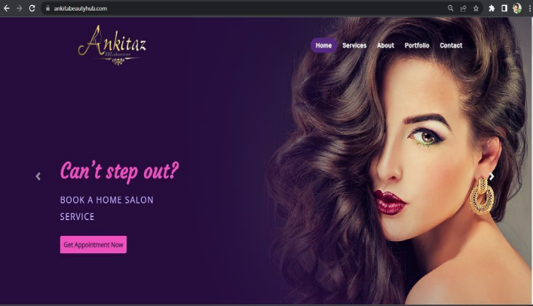

Fig. 6.1 Website Home page

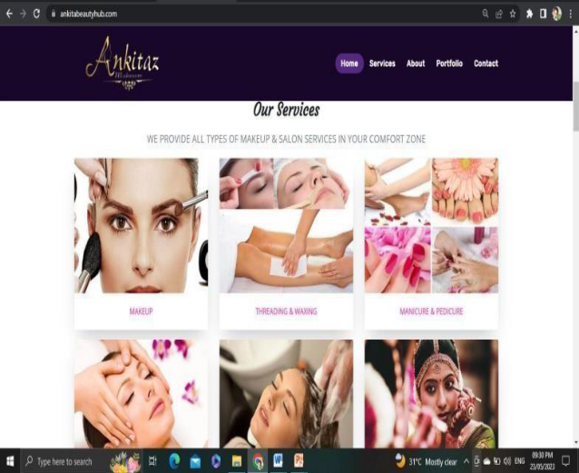
Fig.6.2 Services of the salon

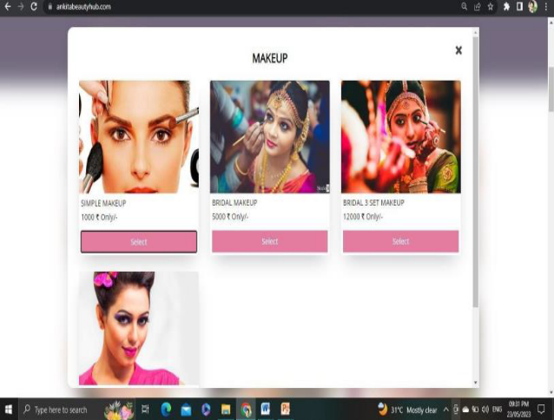
Fig.6.3 Selected the services

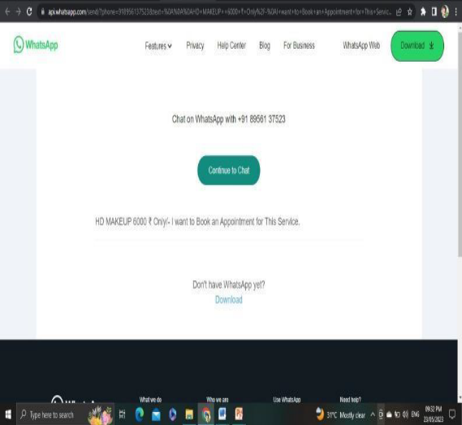
Fig.6.4After booking services

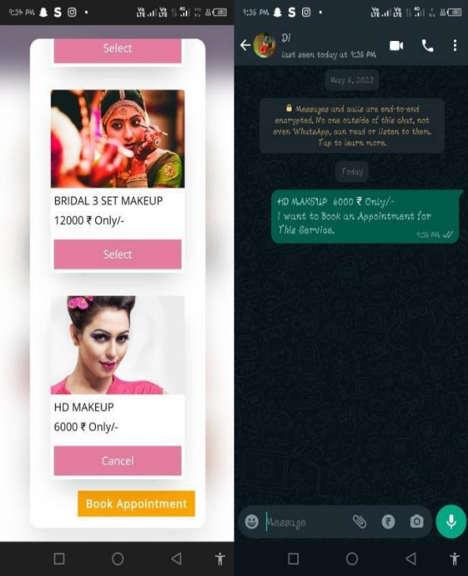
Fig.6.5Whattsup screenshot after booking done by client.

Conclusion:
This Website was a successful high-fidelity prototype of a Salon management and scheduling application. I successfully implemented all of the above mentioned use cases, and achieved clean interfaces that further enhance the user experience. There are many salons even in the current Digital age who still use the traditional methods of Book pencil for record keeping. Our system will help automate this process of record keeping as well as maintaining the staff records. Hence, we can conclude that our system is feasible in every aspect and it ameliorates the current book-pen methodology. While also ensuring the security of the data. The system can be implemented in any salon of your choice by making small tweaks to the code which makes it highly mobile.

References:

[1].Amador-Perez and R. A. Rodriguez-Solis, “Analysis of a CPW-fed annular slot ring antenna using DOE,” in Proc. IEEE Antennas Propag. Soc. Int. Symp., Jul. 2006, pp. 4301–4304
[2]. Ms. Jadhav Vaishali , Ms. Kumthekar Aarti V., Smart Hair Salon Management System, International Advanced Research Journal in Science, Engineering and Technology,Jan,2017
[3]. Jiuyuan Huo, Hong Qu, Ling Wu, Design and Implementation of Private Cloud Storage Platform Based on Open Stack, 2015 IEEEInternational Conference on Smart City/SocialCom/SustainCom (Smart City), 2015.
[4]. Tina Alberino”Beauty Industry Survival guide:A salon professional’s handbook”
[5]. V, A., S, A. K., RM, A., & S, G. (2019). “BOOKAZOR - an Online Appointment Booking System”. 2019 International Conference on Vision Towards Emerging Trends in Communication and Networking (ViTECoN). doi:10.1109/vitecon.2019.8899460
[6]. Adarsh Kumar Gulshan, Amir Khan,(2021) “Salon Management System”. 2021 International Journal of Creative Research Thoughts (IJCRT)
[7]. Maryani, Nindito, H., & Alianto, H. (2019). “Prototype Development For Online Reservation System in Barbershop and Salon Industry”. 2019 International Conference on Information Management and Technology (ICIMTech). doi:10.1109/icimtech.2019.8843836

