Revolutionizing Blind Navigation
Through AI Voices

Ms.J.Maheswari¹, Ms.B.Sowmiya², Ms.K.Sowmiya³, Ms.S.Thirisha⁴, Ms.G.Vishnupriya⁵
1, Assistant Professor, Department of CSE, Dhirajlal Gandhi College of Technology, Salem- 636309
^{2, 3, 4, 5 Department} of CSE, UG Scholar, Dhirajlal Gandhi College of Technology, Salem- 636309
gvishnupriya506@gmail.com

Abstract:
The project titled "Revolutionizing Blind Navigation through AI Voices" presents a novel approach to aid visually impaired individuals in navigating their surroundings independently and safely. By harnessing the power of artificial intelligence (AI) and voice technology, our system provides real-time guidance and assistance to users. Through the integration of advanced object detection algorithms, such as YOLO (You Only Look Once), our solution enables accurate detection and recognition of various objects in the environment. The detected objects are then translated into audio instructions, delivered through AI-generated voices, to help users understand their surroundings and navigate effectively. Moreover, the system is seamlessly integrated with a web interface using Flask, allowing for remote control and interaction. Our project contributes to the advancement of assistive technologies for the visually impaired, offering a user-friendly and reliable solution for enhanced mobility and independence.

Keywords:
Blind Navigation, Artificial Intelligence, Voice Technology, Object Detection, YOLO Algorithm, Assistive Technology, Accessibility, Mobility, Independence

I. Introduction:
The project "Revolutionizing Blind Navigation through AI Voices" presents an innovative solution aimed at empowering visually impaired individuals to navigate their surroundings with greater independence and confidence. Leveraging cutting-edge technologies such as artificial intelligence (AI) and voice recognition, our system provides real-time assistance by detecting and identifying objects in the environment and relaying pertinent information through AI-generated voices. By integrating advanced object detection algorithms like YOLO (You Only Look Once), our solution offers accurate and efficient object recognition capabilities, enhancing the user's spatial awareness and navigation experience. Furthermore, the seamless integration with a web interface through Flask facilitates remote control and interaction, adding flexibility and convenience to the user experience. This project represents a significant advancement in assistive technology, contributing to the creation of inclusive environments and improving the quality of life for individuals with visual impairments.

- SYSTEM ANALYSIS

  - EXISTING SYSTEM:
Existing systems for assisting visually impaired individuals in navigation often rely on traditional methods such as guide dogs, white canes, or human assistance. While these methods provide some level of support, they have limitations in terms of independence, real-time feedback, and adaptability to diverse environments. Moreover, existing electronic navigation aids are often expensive and may not be widely accessible.

  - DRAWBACKS:

1. Limited Independence: Reliance on guide dogs or human assistance restricts the individual's independence.
2. Lack of Real-time Feedback: Traditional aids lack real-time feedback, making navigation challenging in dynamic environments.
3. Accessibility Issues: Electronic aids are often expensive and may not be affordable for everyone.
4. Adaptability: Existing systems may not adapt well to different environments or provide personalized assistance.

  - PROPOSED SYSTEM:

Our proposed system aims to revolutionize blind navigation by leveraging the power of artificial intelligence (AI) and voice assistance technologies. We integrate the YOLO (You Only Look Once) algorithm for real-time object detection and recognition, providing users with instant feedback about their surroundings. The system is connected to a web interface built using Flask, allowing users to access navigation assistance from any device with internet connectivity.

  - ADVANTAGES OF OUR PROJECT:

1. Real-time Object Detection: The system provides real-time detection and recognition of objects in the user's environment, enhancing safety and awareness.
2. AI Voice Assistance: Users receive audio instructions and guidance, improving accessibility and usability.
3. Web Interface Accessibility: By connecting through Flask, our system ensures accessibility from a wide range of devices, including smartphones, tablets, and computers.
4. Cost-effective Solution: Our system offers a cost-effective alternative to traditional navigation aids, making it accessible to a larger population.
5. Personalized Navigation: The system can be tailored to individual preferences and needs, providing personalized navigation assistance.
3. SYSTEM ARCHITECTURE
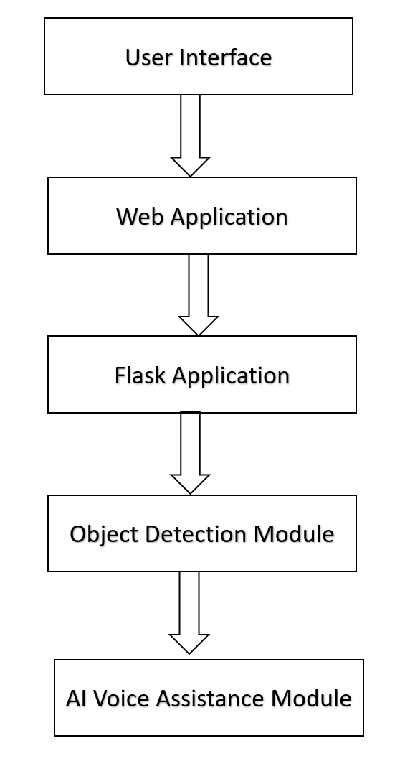
Image 1

4. OUTPUT :
4.1. Home Page
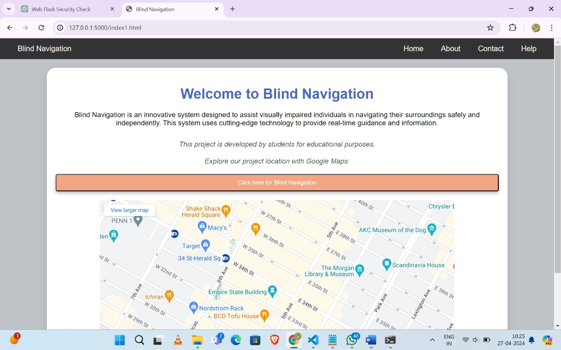

4.2. ABOUT PAGE
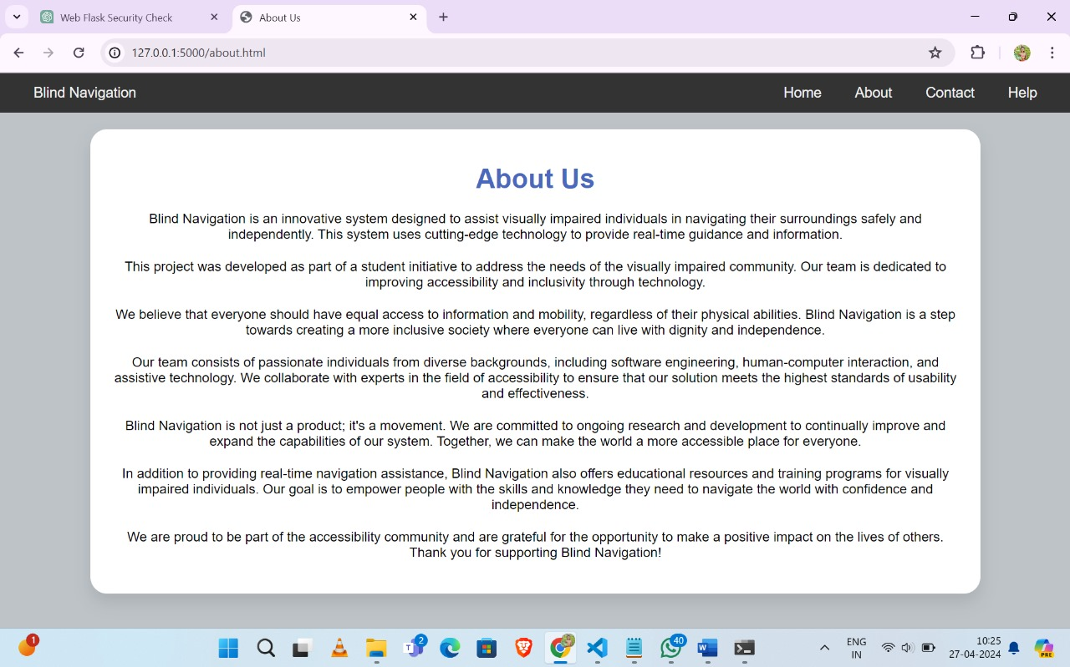

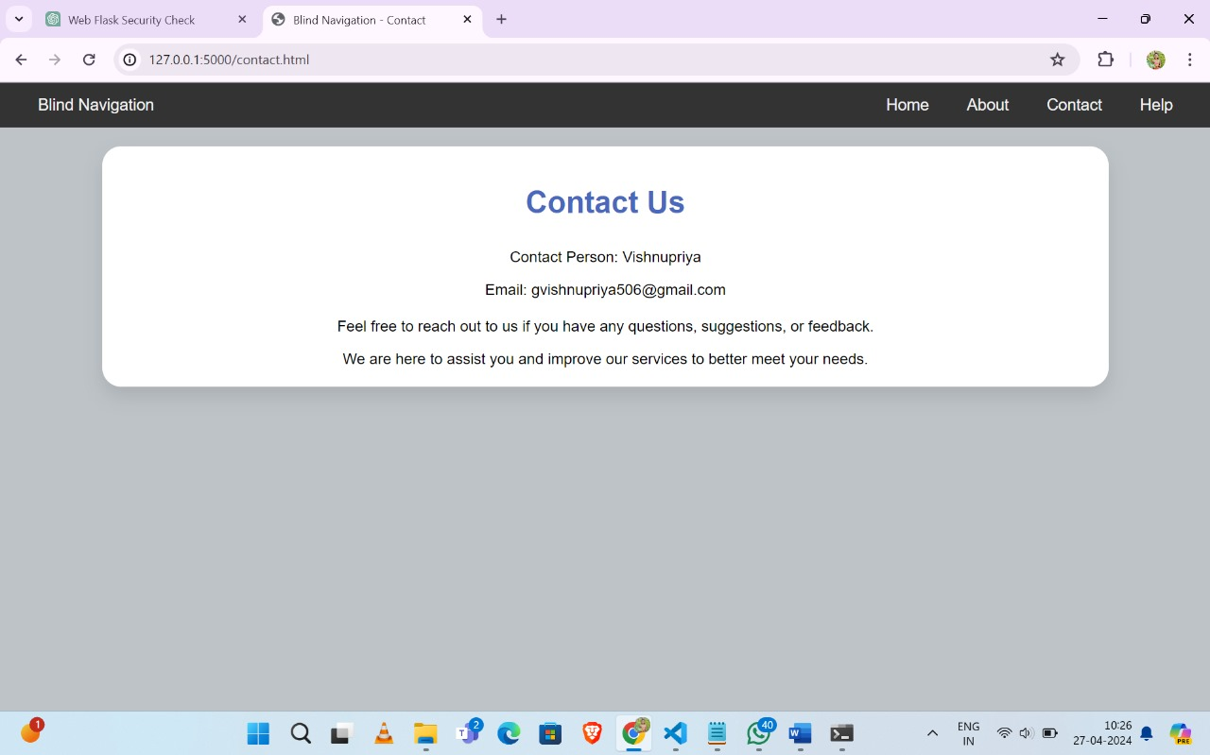
4.3. CONTACT PAGE

4.4. EXECUTION PAGE
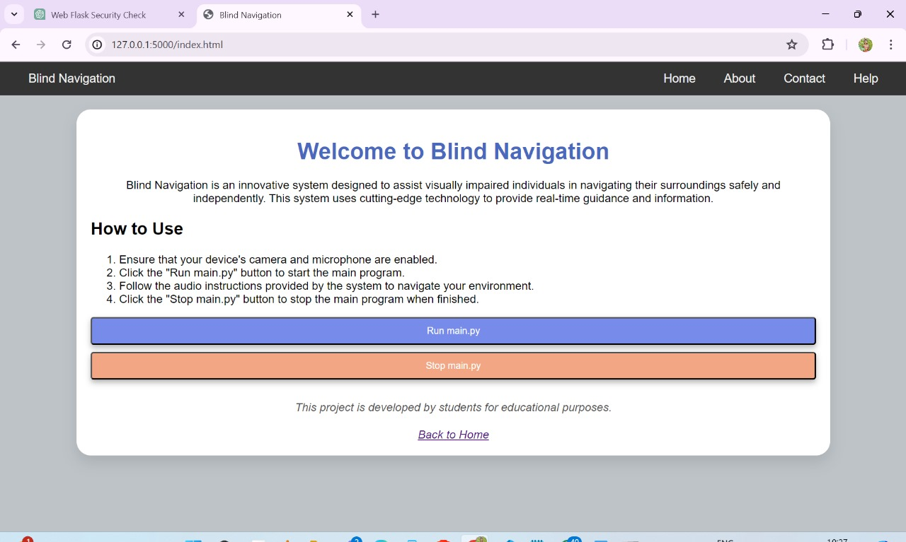

4.5 OUTPUT PAGE
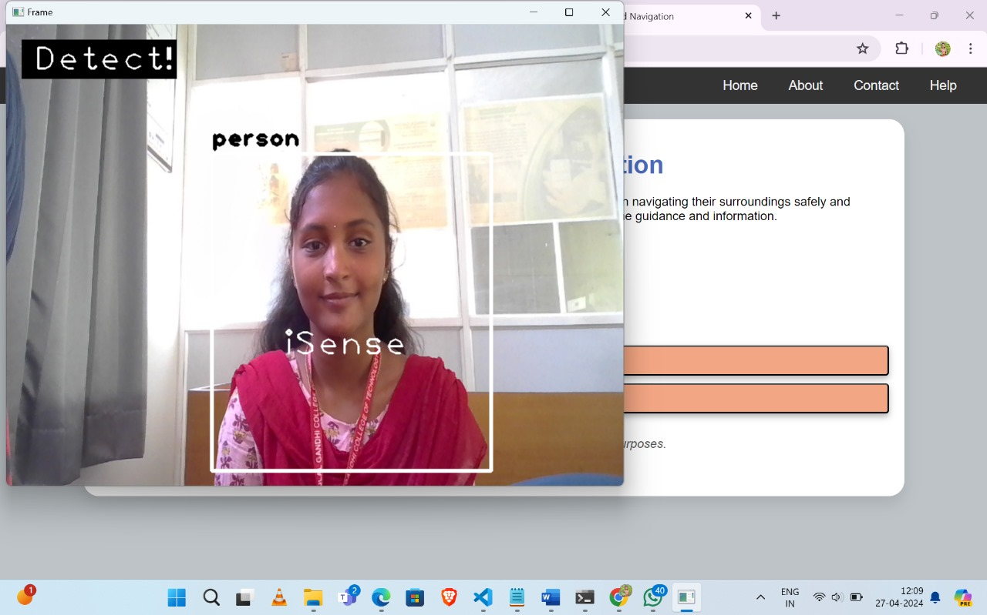

FUTURE WORK:
Looking ahead, there are several avenues for further enhancement and expansion of our revolutionary system. Firstly, we aim to incorporate machine learning techniques to continuously improve object detection accuracy and optimize voice assistance functionality. Additionally, we plan to explore the integration of advanced sensors and wearable devices to enhance real-time environmental awareness for users. Moreover, extending the geographical coverage and language support of our system will broaden its accessibility and impact globally. Furthermore, collaborating with experts in the field of accessibility technology and conducting user-centered design research will ensure the ongoing relevance and effectiveness of our solution. Ultimately, our commitment to innovation and inclusivity drives our pursuit of continually pushing the boundaries of assistive technology to empower and enrich the lives of visually impaired individuals.

CONCLUSION

In conclusion, our project, 'Revolutionizing Blind Navigation through AI Voices,' presents a pioneering solution that leverages cutting-edge technology to empower visually impaired individuals with enhanced navigation capabilities. By seamlessly integrating object detection algorithms with AI-driven voice assistance, we have developed a user-friendly system that provides real-time guidance and support. Through rigorous testing and refinement, we have demonstrated the effectiveness and reliability of our solution in diverse environments. Moving forward, we envision widespread adoption of our technology, fostering greater independence and accessibility for the visually impaired community.

REFERENCES
[1] He, K., Gkioxari, G., Dollár, P., Girshick, R. (2022). Mask R-CNN. In: Proceedings of the IEEE International Conference on Computer Vision (ICCV), pp. 2961-2969.
[2] Redmon, J., Divvala, S., Girshick, R., Farhadi, A. (2022). You Only Look Once: Unified, Real-Time Object Detection. In: Proceedings of the IEEE Conference on Computer Vision and Pattern Recognition (CVPR), pp. 779-788.
[3] Simonyan, K., Zisserman, A. (2022). Very Deep Convolutional Networks for Large-Scale Image Recognition. In: Proceedings of the International Conference on Learning Representations (ICLR).
[4] Szegedy, C., Vanhoucke, V., Ioffe, S., Shlens, J., Wojna, Z. (2022). Rethinking the Inception Architecture for Computer Vision. In: Proceedings of the IEEE Conference on Computer Vision and Pattern Recognition (CVPR), pp. 2818-2826.

