Comparative Analysis of Conventional and Diagrid Structural Buildings with plan Irregularity

ABSTRACT

Earthquakes plays an important part in the analysis and designing of structure . It takes long time to analyse and design structure manually under different loading conditions but with the help of software the analysis and construction of any structure can be done easily so with the help of STAAD PRO software we Compare the performance of Diagrid Structural Building and conventional structural buildinds with plan irregularities to analyze the stability of structure in seismic zone .Buildings with large height are more vulnerable to collapse due to high wind and earthquake load. The risk of failure in such a multistory building can be minimized by adopting lateral load resisting systems. In this study, modeling is done on irregular plan. For irregular plan, C-shape of plan and L-Shape of plan are considered. In this thesis, four models are analyzed, two diagrid frames, and two conventional frame models for C-Plan and L-Plan separately. The building consists twelve storey frame structure having total height 36m and storey height is kept 3 m for each floor. In this project the First Comparison done between diagrid structural system, and conventional frame structural system for C-Type and L-Plan separately and after that second overall comparison is between C-Plan and L- plan. Comparison has been done for different types of models for earthquake load case by considering various parameters like storey drift, absolute displacement, base shear, moment and axial forces.

STADD PRO stands for structural analysis and design software.M40 grade of concrete and Fe-500 steel as per IS 800:2007 were used. Load combinations are taken as per IS 1893:2002 code and method of analysis used is Linear response method and live load are taken according to IS-875. Earthquake zone 4 has been adopted for analysis. When diagrid are connected to the floor the fluctuations of results occurred between the floor. The value of Base shear in diagrid structure is smaller than the bare frames . The result of work showed that diagrid system resist lateral load more efficiently than conventional frame as it yields the least value for absolute displacement, storey drift, moment and axial force.

INTRODUCTION

In today’s trend, the rate of growth of population is increased day by day. Due to these increasing population rate the space required for land is insufficient. So, civil engineer construct a building in sufficient space and in sufficient plan. Due to sufficient space, height of building is kept to be maximum for accommodation. In old days these tall buildings only use for commercial purpose but now it is for commercial as well as residential purpose. There are many cases of damage of building from past earthquake all over the world. Due to their structural simplicity, buildings are particularly vulnerable to damage and can collapse when subjected to earthquake motion. In simple or conventional building, when height of building increases the lateral load resisting system (includes earthquake load and wind loads) becomes more important than the structural system that resists gravitational load. The simple buildings as its height increases due to intensity earthquake it experiences or it starts deforming its shape in the form buckling. And it causes the collapse of building
Therefore the response of structures to seismic activity has attracted the attention of engineers due to consequences that accompany the earthquakes. The introduction and improvement of computer technology gave lots of scope for researches and practicing engineers to study the use of earthquake resisting frame technology to reduce the damage caused to these structures.

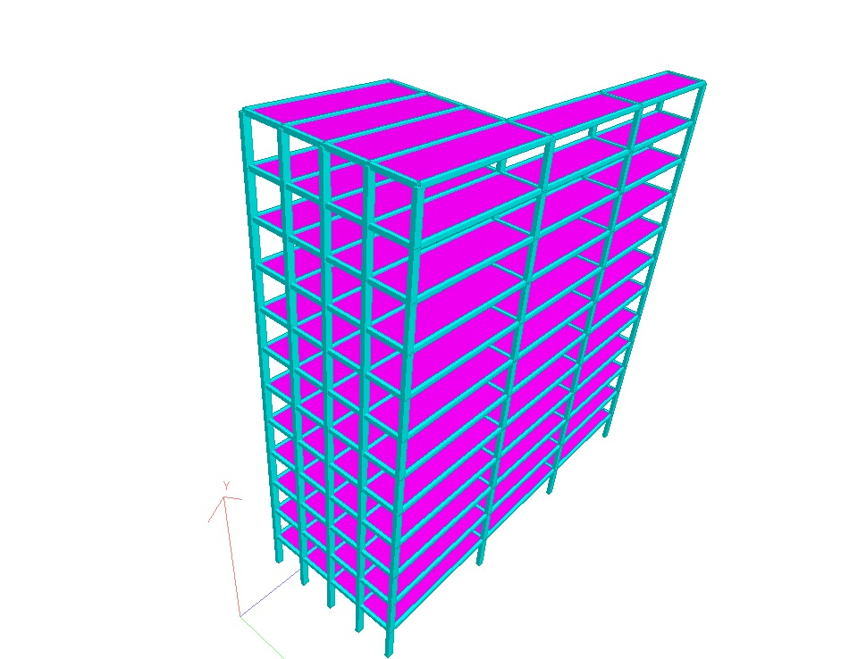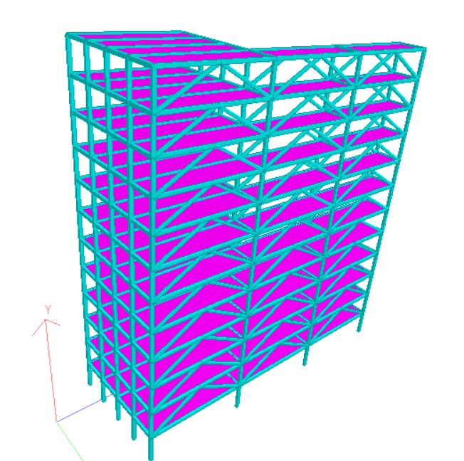
CONVENTIONAL L STRUCTURE DIGRID L STRUCTURE

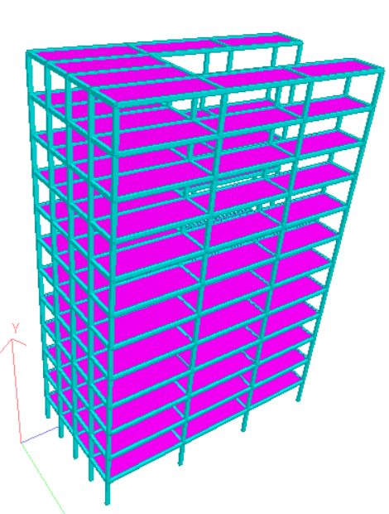
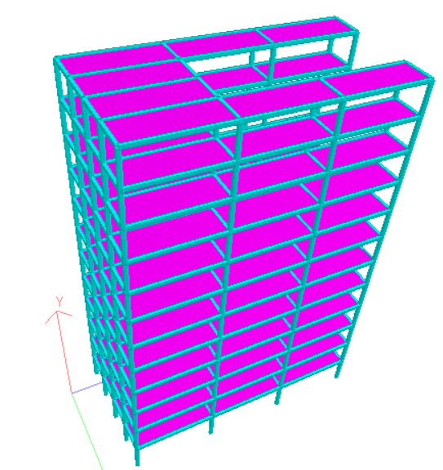
CONVENTIONAL C STRUCTURE CONVENTIONAL C STRUCTURE

LITERATURE REVIEW

Kyong Sun Moon[1] studied the influence of the different configurations of the diagonals on the behavior of diagrid structures. The design methodology is applied to a set of diagrid structures, 40, 50, 60, 70, and 80 storeys of a height tall building. The diagonal placed at various uniform angles or gradually changing along with the height of building. For determining the optimum uniform angle for each structures with different height.
Jinkoo Kim et al.[2] investigates the seismic performance of typical diagrid structure. In this 36 storey diagrid structure with various slopes of external braces were designed and seismic responses evaluated by nonlinear static and dynamic analysis. Also in this study the diagrid structure compare with tabular structure with same design loads. According to the analysis results, as shear lag effect increased due to increases of slopes of brace, the lateral strength decreased.
M. Shah et al.[3] studied the statistical analysis of tall building in india with height more than 150m or 40 storeys. Also in this study, parametric study and detailed comparison of diagrid frame system with conventional structures is carried for a regular plan. In this study seven steel buildings are considered. Analysis done by ETAB software. From this study it is observed that diagrid frame system has better solution for lateral load resisting system.
Chetan Pattar et al.[4] studied a asymmetrical building with C-Type and L-Type structural plan. The building considered to be 16storey. In this the structures are analyzed by dynamic linear method that is response spectrum method. The results obtained for diagrid frame compare with conventional building. From this study observed that L-type diagrid is best for design. L-Type diagrid structure is more efficient than C-plan. For storey shear C-Type diagrid is better choice.
Chittaranjan Nayak et al. [5] studied the earthquake and wind analysis for braced tube structure and diagrid structure. The diagrid structure also devided into circular, rectangular, square plan. For various plan structural area keeping same. The analysis is done by ETAB software. From all storey displacement and storey drift result we can say that all the storey drift (<H/500), where H is total height of building and storey displacement (<0.004 * h), where h is storey height values are within limits.
Nishith B. Panchal et al. [6] In this paper, the comparison study of 24, 36 and 60-storey height of diagrid structural system with a diagrid angle 50.2°, 67.4°, 74.5° and 82.1° is studied for seismic analysis. The comparison of seismic analysis of results in terms of top storey displacement, storey drift, time period, angle of diagrid and steel and concrete consumption is presented here.
Kiran Kamath et al.[7] studied performance on diagrid structures using nonlinear pushover analysis. For study, circular plan considered with aspect ratio 2.67 to 4.26. 59, 71, and 78 degrees three different angles of external brace considered with width of base is kept 12m. The nonlinear pushover behavior of the elements is modelled using plastic hinges based on moment- curvature relationship as described in FEMA 356 [2] guidelines.
Majid Morad et al. [8] studies the seismic behavior of diagrid system under near and far field earthquakes based on energy approach concept in order to achieve a better understanding of their earthquake behavior of the structure and the advantages of utilizing energy methods. 50 storey building frame is modeled by finite element method and its behavior is investigated through the Incremental Dynamic Analysis (IDA) method.
Tianxiang Li[9] studied the diagrid structure fused with shear link (dssl). It is an innovative earthquake resilient structural system. The work of DSSL is to combine the steel diagrid structural system with shear link. For dissipate the earthquake energy with the goal to minimize structural repair and downtime after strong earthquake shaking dssl is used for. The SLs are place between diamond‐shaped grid units and decoupled from the gravity system. To facilitate the design of the proposed DSSL system, the performance‐based plastic design (PBPD) procedure is extended to design a prototype building frame utilizing DSSL.
Giovanni Maria Montuori[10] studied framework for assessing the ‘‘local’’ structural issues in the design of diagrid multistorey buildings, and as a function of the diagrid geometry present a methodology for establishing the need for a specific secondary bracing structural system. For this 90 storey building are considered. In this the diagrid models are compare with or without SBS member design.
Saman Sadeghi et al. [11] studies the seismic behavior of diagrid frame and its seismic performance factors including the response modification coefficient (R-factor), the over- strength factor (Ω0) and the displacement amplification factor (Cd) based on the FEMA P695 methodology. In this over strength factor are determined by nonlinear static analysis method. Then, utilizing the structure by incremental dynamic analysis (IDA), the median collapse capacity and collapse margin ratio (CMR) of these models are calculated and their Cd factors are estimated using the computed R-factors

Salient Observation From Literature Review
- Diagrid structural frame system provides solution for lateral load resisting system in terms of lateral displacements, steel weight and stiffness.
- The diagrid structural frame system provides less quantity for steel which reduces steel weight along with the aesthetic appearance.
- In terms of comparison, the diagrid frame system shows less displacement, drifts than conventional system.
- Optimum diagrid angle is change with respect to the height of building.
- For more economical design of diagrid structure, the diagrid angle should be gradually steeper towards the base of the building.
- The diagrid structures with the diagonal brace angle between 60 to 70degrees is most efficient in resisting lateral (wind and earthquake) as well as gravity loads.
- The diagrid structure with a circular plan shape showed higher strength compare with square plan.
- For top storey shear, C-Type of diagrid structure plan is better choice than L-Type of plan.
- Considering storey stiffness, storey drift, L-Type diagrid structure is more efficient than C- Type structure

METHODOLOGY: -

The main contributions of this thesis for the high-rise buildings can be summarized as follows:
Diagrid system has high stiffness and strength to resist lateral load due to earthquake in high rise building. Diagrid system was the most efficient lateral load resisting system in earthquake load case based on displacement, storey drift, moment and axial force criteria. The forces are more in central column has been investigated. There is estimating earthquake forces on conventional frame model and different types of diagrid model and investigate the performance of the structures against earthquake.

1. consideration of C-type and L-type of plan.
2. consideration of conventional frame and diagrid frame.
3. Evaluation of the response of different models of building using STAAD Software.
4. Comparison of the response obtained by different parameter for C-Type and L-type of plan separately.

SCOPE OF THE PROJECT
- From earlier research work till now, Various researches have carried out work on diagrid structure and from this project we can study C-Type and L-Type irregular structure and also analyse digrid structure with and without plan irregularity in high buildings for C-Type and L-Type of structure.
- The comparison of the buildings with digrid structural system and conventional frame system under seismic loading for C-Type and L-Type plan using STAAD PRO software can be carried out to obtain the response in terms of parameters such as storey drift, displacement , basec shear and moment.

10. REFERENCES: -

[1] K. Moon, “Optimum Grid Geometry of Diagrid Structures for Tall Buildings”, Architectural Science Review, Vol. 51.3, 2008.
[2] J. Kim, Young-Ho-Lee, “Seismic Performance Evaluation of Diagrid System Building”,
[3] M.Shah, S. Mevada, V. Patel, “Comparative Study Of Diagrid Structures With 2012. Conventional Frame Structures”,ISSN:2248-9622,VOL.6, Issue 5,part-2,May 2016.
[4] C. Pattar, Prof. Smt. V. Gokak, “Analysis Of Diagrid With Plan Irregularity”, International research journal of Engineering and technology, Vol. 05, Issue 08, 2018.
[5] C. Nayak , S. Walke, and S. Kokare(2020), “Optimal Structural Design of Diagrid Structure for Tall Structure” Springer Nature Singapore Pte Ltd. 2020.V. K. Gunjan et al. (Eds.): ICRRM 2019 – System Reliability, Quality Control,Safety, Maintenance and Management, pp. 263– 271, 2020.
[6] Nishith B. Panchal, Dr. V. R. Patel, Dr. I. I. Pandya, “Optimum Angle of Diagrid Structural System’ International Journal of Engineering and Technical Research (IJETR)ISSN: 2321-0869, Volume-2, Issue-6, June 2014.
[7] K. Kamath H, S. Jose Camilo Karl Barbosa Noronha(2016), “An Analytical Study on Performance of a Diagrid Structure Using Nonlinear static Pushover Analysis” Perspectives in Science (2016).
[8] Majid Moradi, Moein Abdolmohammadi(2020), “Seismic fragility evaluation of a diagrid structure based on energy method” Journal of Constructional Steel Research 174 (2020) 106311.
[9] Tianxiang Li, T.Y. Yang, Genshu Ton (2018), “Performance‐based plastic design and collapse assessment of diagrid structure fused with shear link” Struct Design Tall Spec Build. 2019;e1589.
[10] Giovanni Maria Montuori, Elena Mele, Giuseppe Brandonisio, Antonello De Luca (2014), “Secondary bracing systems for diagrid structures in tall buildings” Engineering Structures 75 (2014) 477–488.
[11] Saman Sadeghi, Fayaz R. Rofooei(2018), “Quantification of the seismic performance factors for steel diagrid structures” Journal of Constructional Steel Research 146 (2018) 155–168.

