ORAL CANCER DETECTION USING DEEP LEARNING

Koustubha S,
Department of Electronics and Communication Engineering,
BGSIT, BG Nagara,
Karnataka, India
koustubhas38@gmail.com

Mrs. Srividya C N,
Department of Electronics and Communication Engineering,
BGSIT, BG Nagara,
Karnataka, India
srividyacn@bgsit.ac.in

Leela D C,
Department of Electronics and Communication Engineering,
BGSIT, BG Nagara,
Karnataka, India
chandrapadmayl@gmail.com

Namrata N Gowda,
Department of Electronics and
Communication Engineering,
BGSIT, BG Nagara,
Karnataka, India
namrathag8@gmail.com

Abstract: Oral cancer is a very serious, complex, and common type of cancer. Oral cancer ranks eighth globally in terms of cancer incidence in India, with 130,000 deaths reported annually. The tumor affects the tonsils, salivary glands, neck, face, and mouth. Numerous methods, including screening procedures and biopsies—which entail taking a small sample of body tissue and analyzing it under a microscope—can be used to identify oral cancer. The disadvantage of cancer cells is that they are hard to identify and quantify. For this reason, digital processing technology will be employed in this study to identify and classify cancer cells that have affected the oral cavity. State-of-the-art technology and an in-depth learning algorithm can be employed for early detection and categorization. This work employs the Zernike Moment, wavelet features, and the bag histogram of directed gradients as three techniques for character extraction. After the characteristics are obtained, the best texture characteristic is chosen using the fuzzy particle swarm optimization technique (FPSO). In the end, these features were classified using the Faster Region-based Convolution Neural Network (faster RCNN) classifier. to evaluate the efficiency, error, recall rate, precision rate, and classification accuracy of the recommended approach.
Keywords: GUI, faster region-based convolution neural network (RCNN) classifier, and fuzzy particle swarm optimization algorithm (FPSO).
- Introduction
It has been discovered that the cells supplying injured neighbouring tissues exhibit uncontrolled increased growth in mouth cancer. Less dead cells are discovered in the oral tissue at the early stages of oral cancer development, also referred to as ulcers. when the body's metabolism reveals the existence of dead cells, either throughout the affected area or in discrete areas. Although there are other forms of cancer, 90% of crab cells are referred to in medical terms as OSCCs, or oral squamous cell carcinomas. Furthermore, apart from clinical tumor models that are linked and lesion-free, biological models can be utilized to detect cancers in various parts of the body using visual patterns and characteristics without the need for staining. Before assessing the stage of oral cancer in the samples, machine learning techniques were employed to forecast distinct biological models for OSCC, which would categorize samples as either cancerous or non-cancerous. To assess the accuracy of the prediction, the model would utilize three validation test kits and different cancer stages. Employing sample validation could aid in predicting various stages of oral cancer by anticipating the development of lesions in the tissues and varying tumor sizes. The current procedure aims to create new methods for predicting the progression stage of oral cancer tumors. Oral cancer can develop in various locations such as the gums, the area behind the wisdom teeth, the inner parts of the cheeks and lips, the upper and lower sections of the mouth, and the front of the tongue. Symptoms of oral cancer include persistent ulcers or inflammations that may bleed or cause discomfort. Several habits can elevate the risk of oral cancer, including smoking and alcohol consumption. Both smoking and alcohol consumption are the top two behaviours that pose the highest risk for mouth cancer. In India, the practice of eating worms is so widespread that it can also damage the inside of the gums.
Faster R-CNN: Region-Based CNNs
Given that a fully connected layer of a convolution neural network (CNN) cannot handle many items and occurrence frequency. One method, therefore, would be to apply the CNN model to a region that has been selected via a sliding window brute force search. However, this approach has the drawback that the same item may be represented in images with varying aspect ratios and sizes. We have several region ideas when taking these parameters into account, and applying deep learning (CNN) to all of those regions would be quite costly computationally.
A two-stage deep learning object detector is used by the Faster R-CNN; first, it finds regions of interest, and then it sends these regions to a convolutional neural network. A support vector machine (SVM) is used to classify the feature maps that are produced. It is calculated to find the regression between the expected and ground truth bounding boxes. The Faster R-CNN's general architecture is shown below. The Faster R-CNN model employs the subsequent methodology: The ground truth bounding boxes of the picture are projected onto the feature map after the image has initially passed through the backbone network to produce an output feature map. Typically, a dense convolutional network such as ResNet or VGG16 serves as the backbone. The learnt features of the image are represented by a spatially dense Tensor in the output feature map. Every point on this feature map is then treated as an anchor. We create several boxes of various sizes and forms for every anchor. These anchor boxes are meant to capture things within the picture.
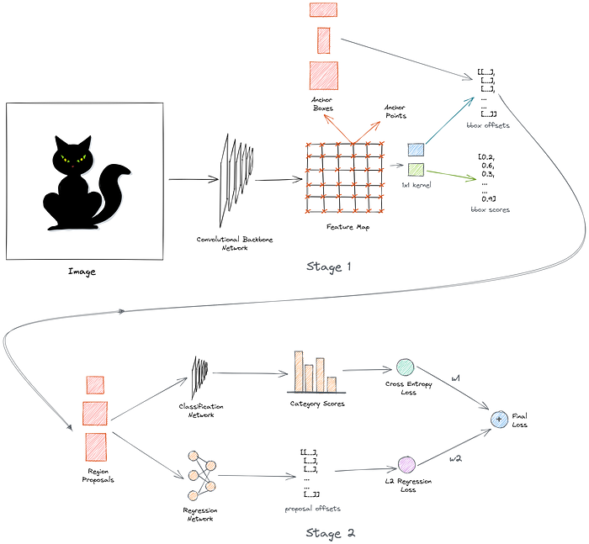

- Faster R-CNN Overall Architecture
The second stage builds on the concepts introduced in the first stage. During the second step, we are trained to forecast the object category in the suggested region using a basic convolutional network. To accommodate the varying sizes of the raw region suggestions, we implement ROI pooling to standardize them before feeding into the network. The network is taught to predict various categories using cross-entropy loss. Another network is utilized to anticipate the offsets of region proposals from the actual boxes. Furthermore, this network seeks to align the region recommendations with the actual boxes, utilizing L2 regression loss. By assigning weightage to both losses, we can calculate the final loss. We learn how to forecast offsets in addition to categories in Stage 2. This is known as multitask learning.
VGG16 Architecture
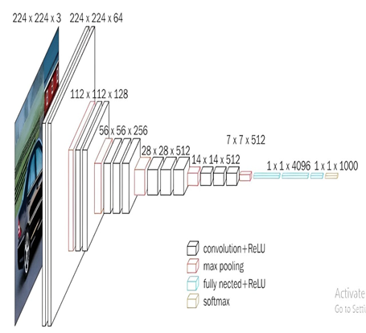
- VGG16 Architecture
- The VGG16 algorithm utilizes object identification and classification to accurately sort 92.7 percent of 1000 images into 1000 distinct categories. It is recognized as one of the preferred methods for classifying images due to its simplicity and support for transfer learning.
- The number 16 in VGG16 represents the presence of 16 weighted layers. Even though VGG16 comprises a total of 21 layers, including 16 convolutional layers, 5 Max Pooling layers, and 3 Dense layers, it specifically contains 16 weight layers or learnable parameter layers.
- VGG16 is designed to handle input tensor sizes of 224 x 224, 244 x 244 with three RGB channels.
- VGG16 is notable for emphasizing 3x3 filter convolution layers with a stride of 1 and utilizing minimal hyper-parameters. It consistently incorporates 2x2 filter maxpool layers with a stride of 2 and applies padding.
- The architecture maintains the same order of convolution and max pool layers throughout. Conv-1 Layer contains 64 filters, Conv-2 has 128 filters, Conv-3 includes 256 filters, while Conv-4 and Conv-5 each house 512 filters.
- Following the convolutional layers, three Fully-Connected (FC) layers are arranged, with the first two containing 4096 channels each and the third enabling 1000-way ILSVRC classification with 1000 channels for each class. The final layer is the Soft-max layer.
- Problem Statement
The current state of oral cancer diagnosis faces challenges in early detection and accurate categorization of tumours, hindering effective treatment and prognosis. Oral cancer, particularly Oral Squamous Cell Carcinomas (OSCC), manifests as uncontrollable cell enlargement, often detected at later stages through symptoms like inflammation and non-healing ulcers in oral tissues. Existing methods rely on biological and clinical models, including machine learning approaches, to predict different biological OSCC models and distinguish between non-cancerous and malignant samples. However, there is a need for an improved predictive tool that can precisely determine the stage of oral cancer growth. The challenge lies in developing robust predictive models capable of assessing tumour volume and identifying the presence of ulcers in oral tissues across various anatomical locations. Therefore, the challenge at hand is to develop and put into use a sophisticated predictive tool that uses biological models, clinical data, and machine learning approaches to reliably classify oral cancer stages according to tumour volume and ulcer existence.
- Objectives
- Collect the dataset from Kaggle Website (open source) and few Real dataset from RND for implementation.
- To develop Robust Predictive Model for oral cancer detection.
- Apply Deep Learning Algorithm to the model for effective validation.

- Methodology
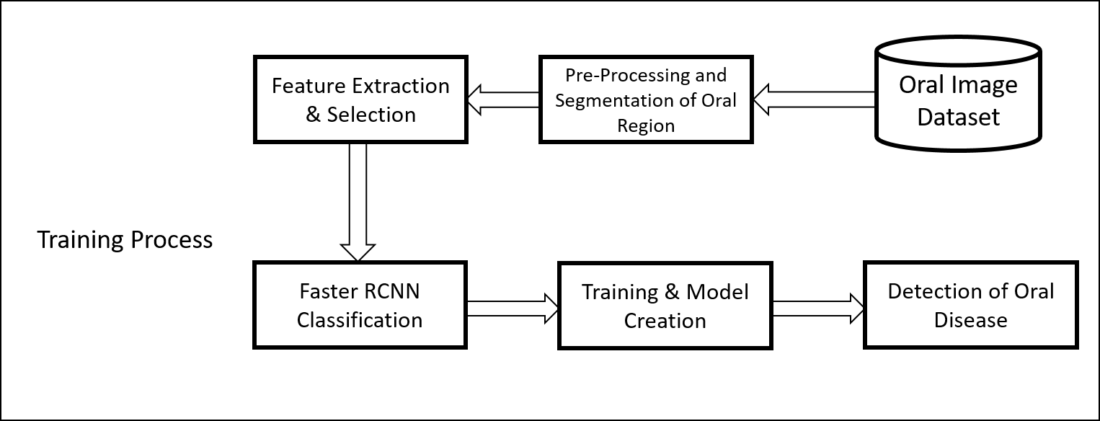
- Proposed Training System
The above figure depicts the general workflow for this project. The training process is depicted on the figure's upper side. All training oral cancer photos and relevant cancer kinds are included in the sample database. Next, take features from the areas affected by oral cancer. The retrieved characteristics are used to train the classifier model, which is then stored for further use. The testing process is depicted on the lower side of Figure 3.
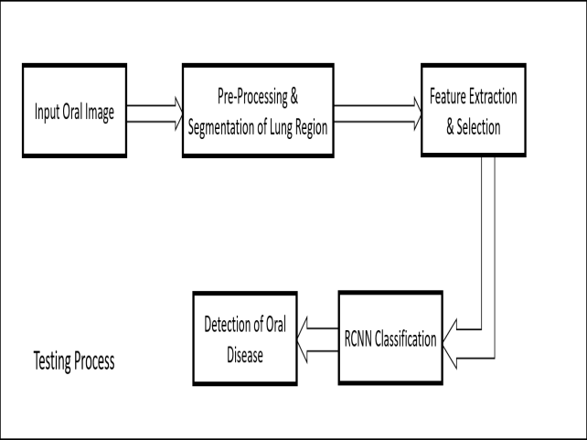
- Proposed Testing System
Figure 4 illustrates the testing system where samples undergo pre-processing methods to reduce noise and enhance clarity. After pre-processing, segmentation comes next. In order to calculate the unique features, all of the techniques are combined to retrieve features like texture and intensity. To shorten the execution time, a suitable feature is chosen after the features have been retrieved. Eventually, the chosen qualities are used to identify the disease and its effects. Finally, the Faster RCNN approach is used to classify and train the features.
- System Design

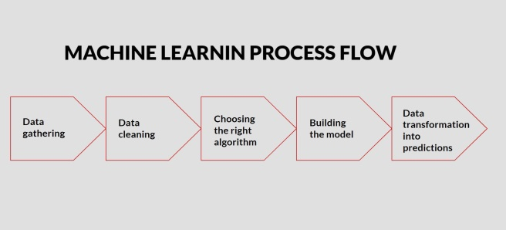
- Data Collection: The way we collect data depends on the type of project we aim to develop. For instance, if we are creating a machine learning project that relies on real-time data, we might build an Internet of Things system that harnesses various sensor data. The dataset can be sourced from diverse outlets such as files, databases, sensors, and more. However, the data collected may have missing values, exceptionally large values, unstructured text data, or noisy data, making it unsuitable for direct analysis. Consequently, we need to prepare the data to tackle these issues.
- Data Pre-Processing: The initial stage of data pre-processing involves cleansing the unrefined data, sourced from real-world data gathering and converted into a refined dataset. In other words, when data is gathered in an unprocessed form from various origins, it is not fit for analysis. Therefore, a set of steps is implemented to condense the data into a manageable, tidy dataset; this stage in the process is referred to as data pre-processing.
- Investigating the Best Model for the Type of Data: Using the pre-processed data, our primary objective is to train the best-performing model available.
- Using Data to Train and Test the Model: To begin model training, it must be divided into testing, validation, and training data segments. The "training data set" is utilized for classifier training; the "validation set" is used for parameter fine-tuning; and the "test data set" assesses the classifier's performance on new data. It's important to note that the classifier can only be trained using the training and/or validation sets, never the test data set, which remains accessible for testing purposes only.
- Module Design
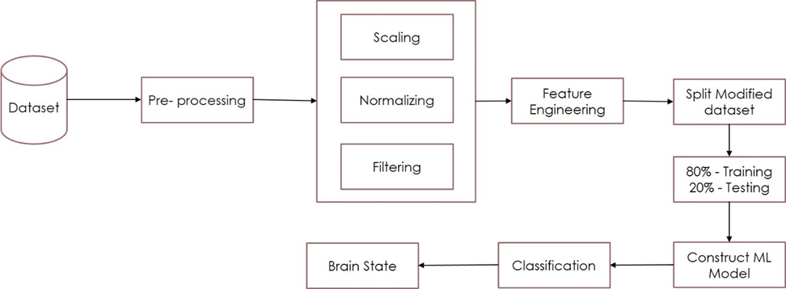
- Module Design
The above diagram shows the proposed system flow diagram. The input raw data is taken and under gone the pre-processing technique where the data are scaled, normalized, and filtered. Then they are split for training and testing purposes. After which the ML model is constructed and classified. After which the brain state is classified for a given dataset.
- Unit Design
Figure5. shows the unit diagram of the proposed system. The client or the user is respectively responsible for collecting the datasets and uses them for training. Then the input variables are selected and gives the general output of model accuracy and loss. Then the model is trained accordingly.

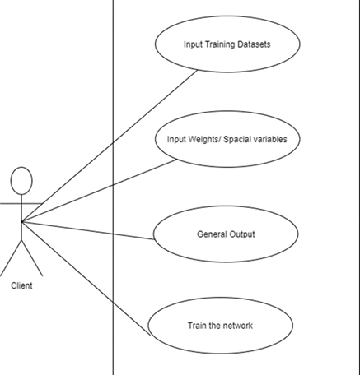
- Unit Design

- UML Design

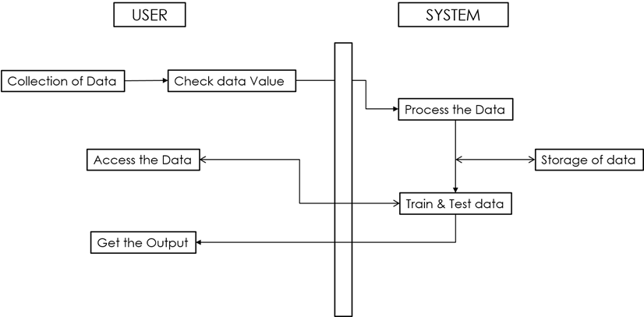

- UML Design

The UML design shows the step-by-step operations concerning the user and system. The complete integration is shown above. The user is responsible for the data collection and how the processing is done. Also, it is responsible for accessing the data. The system processes the data and stores it. The training and testing steps are followed here and give the output in either vales or graphical format.
- Workflow

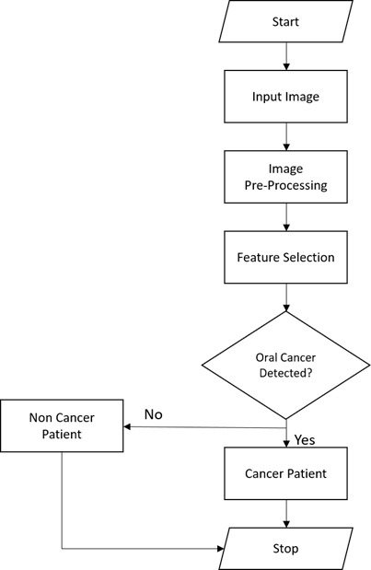

- Workflow of Project
- Result
- Faster RCNN Training
Training process is crucial to monitor the model's performance and adjust hyperparameters as needed to ensure optimal training and convergence. The model is trained with multiple epochs until the convergence or the validation loss stabilizes.
- Fuzzy Optimization Training
Fuzzy optimization can effectively handle uncertainties, imprecisions, and qualitative information, leading to robust and adaptive solutions for complex optimization problems. The images data is trained and generated with ML model with different epochs.
A comparison of both methods' training accuracy over a range of epoch values is shown in Tables 1 and 2. Metrics like precision, recall, and error rates are also computed and presented.

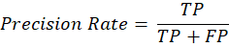
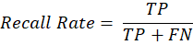
Where,
- The term "True Positives" (TP) denotes the quantity of accurately classified positive cases.
- The number of positively identified events that are mistakenly represented by P (False Positives).
- The number of positive cases that are mistakenly labeled as negative is known as False Negatives, or FN for short.

No. | Epoch | Accuracy | Precision Rate | Recall Rate | Error Rate
1 | 30 | 86.6 | 1 | 66.6 | 27.7
2 | 50 | 89.5 | 1 | 68.3 | 26.3
3 | 70 | 93.7 | 1 | 63.3 | 22.6
4 | 90 | 97.2 | 1 | 66.6 | 20.5
5 | 100 | 98.8 | 1 | 63.4 | 20.1

- Training Phase Values of Faster RCNN Model

No. | Epoch | Accuracy | Precision Rate | Recall Rate | Error Rate
1 | 30 | 82.6 | 1 | 68.5 | 29.4
2 | 50 | 86.4 | 1 | 66.3 | 26.6
3 | 70 | 89.7 | 1 | 65.2 | 26.3
4 | 90 | 92.3 | 1 | 67.7 | 25.1
5 | 100 | 93.6 | 1 | 61.1 | 23.9

- Training Phase Values of Fuzzy Model

- Testing Phase
In order to enhance user accessibility, a Graphical User Interface (GUI) has been developed for the model or proposed work. This implementation enables users to effortlessly run or test images. Utilizing Python's tkinter library, the GUI is designed to facilitate the testing phase. Figure 9 illustrates the GUI component of the project. The GUI contains specific buttons and predefined actions, illustrated in the figures below.

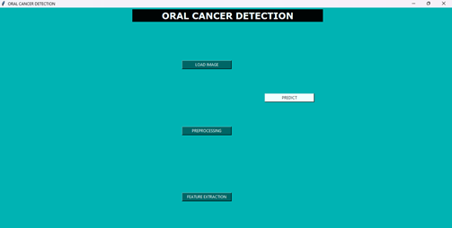
- Python GUI for Oral Cancer Detection

Overall, the expected outcome is a system capable of accurately earlier detection of oral cancer cells using advanced digital processing techniques and deep learning algorithms, with the efficiency of the system evaluated through various performance metrics

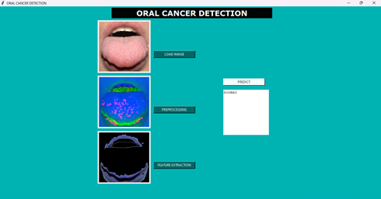
- Prediction of Normal Condition

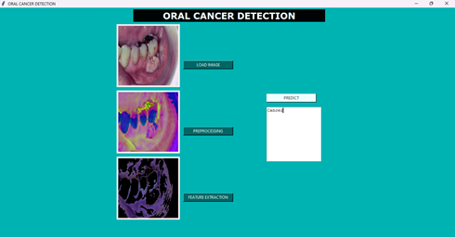
- Prediction of Oral Cancer Condition

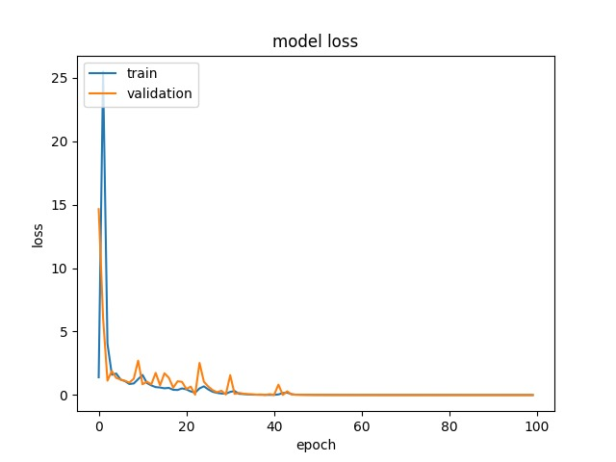
- Loss of Model

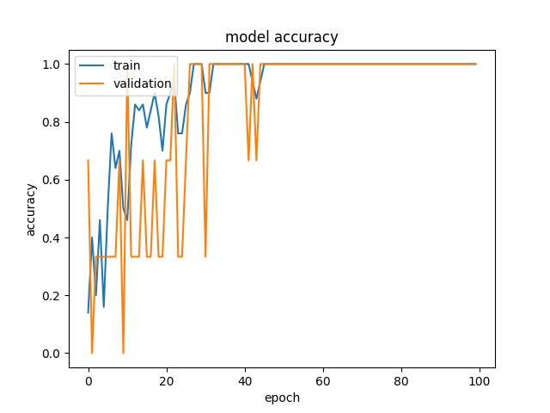
- Accuracy of the Model
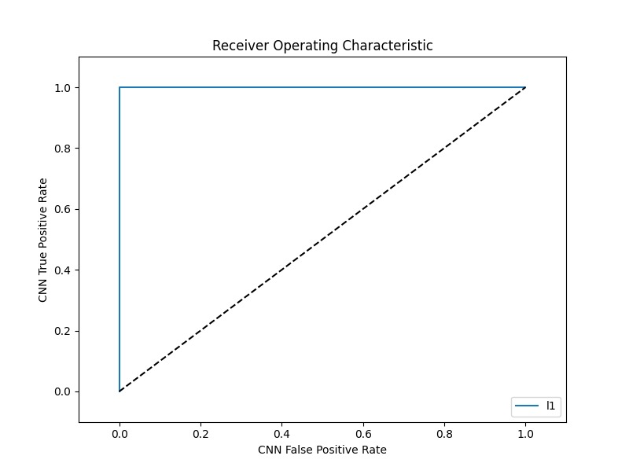
- True Positives v/s False Positives

- Conclusion
Especially in India, where it is the eighth most frequent cancer and causes a large number of fatalities annually, oral cancer is a major worldwide health concern. Effective diagnostic techniques are required due to the complexity and severity of oral cancer, since conventional methods such as biopsies and screenings are not always able to accurately identify and categorize cancer cells. In order to overcome these obstacles, our work uses digital processing technologies to identify and categorize cancer cells in the oral cavity early on. The combination of cutting-edge technologies and an intelligent learning algorithm shows a viable path toward improving diagnostic abilities. The efficiency of classification can be improved by using Faster RCNN for the extracted characteristics
References
- Roshan Alex Welikala, Paolo Remagnino et. al., “Automated Detection and Classification of Oral Lesions Using Deep Learning for Early Detection of Oral Cancer,” Annu. Rev. Neurosci., Digital Object Identifier 10.1109/ACCESS.2020.3010180, VOLUME 8, 2020
- Shipu Xu, Chang Liu, Yongshuo Zong et al., “An Early Diagnosis of Oral Cancer based on Three-Dimensional Convolution Neural Networks”, http://creativecommons.org/licenses/by/4.0/ VOLUME 7, 2019 IEEE 10.1109/ACCESS.2019.2950286
- Amy F. Ziober,Kirtesh R. Patel,Faizan Alawi, Phyllis Gimotty,4 Randall S. Weber, MichaelM. Feldman,Ara A. Chalian,Gregory S. Weinstein,Jennifer Hunt, and Barry L. Ziober, Identification of a Gene Signature for Rapid Screening of Oral Squamous Cell Carcinoma, American Association for Cancer (2018).
- Tabassum Begum, Prof. Gayatri Mugli, Oral Cancer Prediction Using Machine Learning, Volume:05/Issue:08/August-2023, International Research Journal of Modernization in Engineering Technology and Science.
- Dr. K. Padmavathi, C. Deepa, A Predictive Model for Early Detection of Oral Cancer via Adaboost Classification Technique”, International Journal for Multidisciplinary Research (IJFMR), Volume 5, Issue 4, July-August 2023.
- Panigrahi S, Das J, Swarnkar T. Capsule network based analysis of histopathological images of oral squamous cell carcinoma. J King Saud Univ Comput Inform Sci. (2020) doi: 10.1016/j.jksuci.2020.11.003
- Sunny S, Baby A, James BL, Balaji D, Rana MH, Gurpur P, et al. A smart tele-cytology point-of-care platform for oral cancer screening. PLoS ONE. (2019) 14:e0224885. doi: 10.1371/journal.pone.0224885
- Nanditha BR, Geetha A, Chandrashekar HS, Dinesh MS, Murali S. An ensemble deep neural network approach for oral cancer screening. Int J Online Biomed Eng. (2021) 17:121. doi: 10.3991/ijoe.v17i02.19207
- Jubair F, Al-karadsheh O, Malamos D, Al Mahdi S, Saad Y, Hassona Y. A novel lightweight deep convolutional neural network for early detection of oral cancer.
- Kouznetsova VL, Li J, Romm E, Tsigelny IF. Finding distinctions between oral cancer and periodontitis using saliva metabolites and machine learning. Oral Diseases. (2021) 27:484–93. doi: 10.1111/odi.13591 82. Welikala RA, Remagnino P, Lim JH, Chan CS, R.

