A STUDY ON JOB SATISFACTION AMONG EMPLOYEES IN PROCONNECT LOGISTICS LTD
M Kathir Ahamed^{#1}, M Manoj Kumar^{*2}
#MBA Student & Jerusalem College of Engineering, Chennai
**Assistant Professor MBA, Jerusalem College of Engineering, Chennai.

¹kathirahamed17@gmail.com
²Manoj@jerusalemengg.ac.in

Abstract
The study is undergone at PROCONNECT LOGISTICS LTD, CHENNAI The project focuses on the employee’s job satisfaction level. Employee loyalty can be defined as employees being committed to the success of the organization and believing that working for this organization is their best option. If the employee’s expectations are fulfilled (or) the employees get higher than what he/she feels with satisfied. The main objectives of this paper are to assess job satisfaction and To Analyze the factors contributing to an improvement in employee job satisfaction. To study the employee’s perception towards the organization(Proconnect logistics, To identify the impact of employee’s job satisfaction on their performance. In this study, 118 employee’s responses were been taken as a sample. Percentage analysis, Correlation analysis, Regression, and Weighted average have been incorporated for research analysis. The study helped and reveals the level of job satisfaction of employees the various factors provided in the organization. This study clearly shows that employees in an organization are more or less satisfied with their jobs. The organization should consider the salary, relationship of employees and supervisors, training and development, and give more opportunities to the new employees.
Keywords — Salary package, Training & development, career growth, etc…..

Introduction
Employee Job satisfaction is a population concept in industrial and organizational psychologyEmployee job satisfaction serves as a cornerstone for various organizational outcomes, including enhanced productivity, reduced turnover rates, and improved overall performance. Understanding the factors influencing job satisfaction is imperative for crafting effective strategies that align with employees' needs and expectations. By conducting this study, we aim to gain valuable insights into the employee job satisfaction, thereby facilitating informed decision-making and targeted interventions to a more engaged and motivated workforce.
Through a comprehensive examination of diverse variables such as organizational culture, compensation, work-life balance, communication effectiveness, Training and development. This study endeavours to uncover the multifaceted nature of employee job satisfaction. By analyzing these factors, we aim to identify areas for improvement within our organization's work environment.

REVIEW OF LITERATURE
Alok Singh and Priyanka Gupta (2021) Organizational Support and Employee Job Satisfaction: A Study in Indian Banking Sector. This study investigated the impact of organizational support on employee job satisfaction in the Indian banking sector. It found that perceived support from the organization, including training opportunities and career development initiatives, significantly influenced job satisfaction levels among bank employees.
Rohit Gupta and Sangeeta Patel (2020) Impact of Compensation and Benefits on Employee Job Satisfaction: Evidence from Indian Manufacturing Sector. This study examined the influence of compensation and benefits on employee job satisfaction in the Indian manufacturing sector. It revealed that competitive compensation packages and additional benefits positively correlated with higher levels of job satisfaction among employees.
Neha Singh and Amit Sharma (2020) Impact of Employee Benefits on Job Satisfaction: A Study in Indian Healthcare Sector. This study investigated the impact of employee benefits, such as healthcare coverage, retirement plans, and leave policies, on employee job satisfaction in the Indian healthcare sector. It found that comprehensive benefits packages positively influenced job satisfaction levels among healthcare professionals.

RESEARCH METHODOLOGY
Research Methodology is the systematic way to solve the research problem it gives an idea of various steps systematically and objectively adopted by the researcher.
Research design: Research design is a plan, structure, and strategy of investigations to obtain answers to the research questions.
Descriptive Research: Descriptive research is defined as a research method that describes the characteristics of the population or phenomenon.

ANALYSIS
TABLE I
Gender
 |  | Frequency | Percent | Valid Percent | Cumulative Percent
Valid | Male | 71 | 60.2 | 60.2 | 60.2
Valid | Female | 47 | 39.8 | 39.8 | 100.0
Valid | Total | 118 | 100.0 | 100.0

INFERENCE: The above table it shows that out of 118 employees, 71% are male and 47% are female.

TABLE II
Are you satisfied with your current salary package?
 |  | Frequency | Percent | Valid Percent | Cumulative Percent
Valid | Very satisfied | 10 | 8.5 | 8.5 | 8.5
Valid | Satisfied | 49 | 41.5 | 41.5 | 50.0
Valid | Neutral | 43 | 36.4 | 36.4 | 86.4
Valid | Dissatisfied | 13 | 11.0 | 11.0 | 97.5
Valid | Very dissatisfied | 3 | 2.5 | 2.5 | 100.0
Valid | Total | 118 | 100.0 | 100.0

INFERENCE: The above table shows that out of 118 employees, 10% are very satisfied, 49% are satisfied, 43% are neutral, 13% are dissatisfied and 3% are very dissatisfied.

TABLE III:
How would you rate the organizational support for maintaining a healthy work-life balance?
 |  | Frequency | Percent | Valid Percent | Cumulative Percent
Valid | Excellent | 16 | 13.6 | 13.6 | 13.6
Valid | Good | 66 | 55.9 | 55.9 | 69.5
Valid | Average | 32 | 27.1 | 27.1 | 96.6
Valid | Poor | 4 | 3.4 | 3.4 | 100.0
Valid | Total | 118 | 100.0 | 100.0

INFERENCE: The above table it shows that out of 118 employees, 16% are excellent, 66% are good, 32% are average, 4% are poor and 0% are very poor.

CORRELATION:
Correlations
 |  | 24. How often do you feel motivated to perform well in your job? | 9. How satisfied are you with your job?
24. How often do you feel motivated to perform well in your job? | Pearson Correlation | 1 | .400**
 | Sig. (2-tailed) |  | .000
 | N | 118 | 118
9. How satisfied are you with your job? | Pearson Correlation | .400** | 1
9. How satisfied are you with your job? | Sig. (2-tailed) | .000
9. How satisfied are you with your job? | N | 118 | 118
**. Correlation is significant at the 0.01 level (2-tailed).

INFERENCE: From the above table, we can find that the significant value is 0.000, which is less than the table value of 0.05, So the Null hypothesis is rejected and the Alternative hypothesis is accepted. Therefore, there is a relationship between satisfaction with their job and feeling motivated to perform well in their job.

REGRESSION:
ANOVAª
Model |  | Sum of Squares | df | Mean Square | F | Sig.
1 | Regression | 79.980 | 4 | 19.995 | 39.444 | .000^{b}
1 | Residual | 57.282 | 113 | .507
1 | Total | 137.263 | 117
a. Dependent Variable: 18. How likely are you to recommend Proconnect Logistics Ltd. As a great place to work with your friends or acquaintances?
b. Predictors: (Constant), 21. How effectively does the organization recognize and address employee concerns and feedback? 19. How well do you feel the organization recognizes and appreciates employee contributions? 20. How satisfied are you with the opportunities for career growth and advancement at Proconnect Logistics Ltd.? 16. How would you rate the level of employee involvement in decision-making?

INFERENCE: From the above table, we can find that the significant value is 0.05 is greater than the table value of 0.000 (0.05>0.000). Hence H1 is rejected and H0 is accepted. There is an impact of recommendations on Pro Connect logistics, recognizing and appreciating employees, opportunities for career growth, involvement in decision-making, and employee concern & feedback.

WEIGHTED AVERAGE:
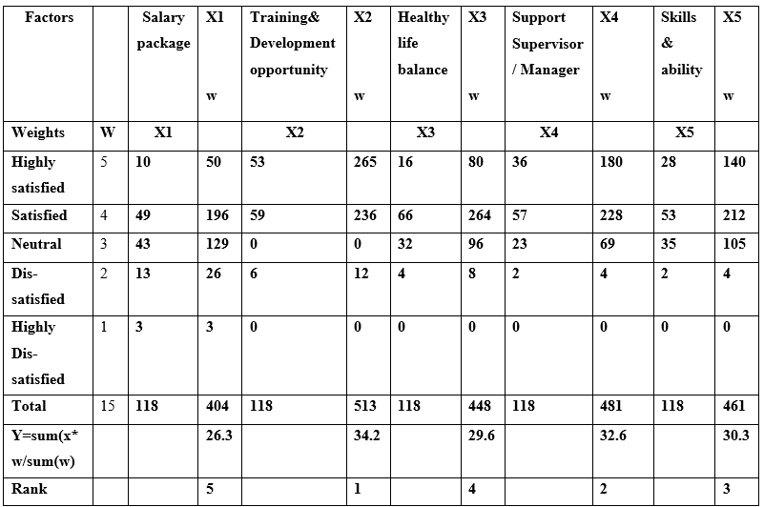

INFERENCE: Training and development opportunities provided by the company are more weightage among other factors as 34.2 and it is considered as the training and development opportunities that benefit the employees most by the organization. So, it is ranked as the highest. The salary package, healthy work-life balance, Support by supervisor / Manager, Skills & abilities in Pro connect Logistics Ltd.

FINDINGS
CORRELATION:
From the above table, we can find that the significant value is 0.000, which is less than the table value of 0.05, So the Null hypothesis is rejected and the Alternative hypothesis is accepted. Therefore, there is a relationship between satisfaction with their job and feeling motivated to perform well in their job.

REGRESSION:
The significant value is 0.05 is greater than the table value of 0.000 (0.05>0.000). Hence H1 is rejected and H0 is accepted. There is an impact of recommendations on Pro Connect logistics, recognizes and appreciates employees, opportunities for career growth, involvement in decision-making, and employee concern & feedback.

WEIGHTED AVERAGE:
Training and development opportunities provided by the company are more weightage among other factors as 34.2 and it is considered as the training and development opportunities that benefit the employees most by the organization. So, it is ranked as the highest. The salary package, healthy work-life balance, Support by supervisor / Manager, Skills & abilities in Pro connect Logistics Ltd.

Conclusions
In this study titled "A Study on Job Satisfaction among employees in Pro Connect Logistics Ltd," a descriptive research design was employed to investigate the factors influencing employee job satisfaction. The sample size initially comprised 118 employees. The data were gathered from both primary and secondary sources, with primary data collected via questionnaires distributed among employees and secondary data sourced from websites and other relevant sources.

ACKNOWLEDGMENT

I would like to thank to Dr. M. MALA, M.A, M. Phil., and CEO, of Jerusalem College of Engineering for the sustained support in providing all the resources required to complete the project.

I would like to extend my thanks to DR. RAMESH.S, MTech, Ph.D., Principal, Jerusalem College of Engineering for their support in providing all the resources to complete the project.

I wish to regard my sincere thanks to DR.S. MUTHUMANI, MCS, MBA, M.Phil.,
Ph.D., Head of the Department, Department of Management Studies, Jerusalem College of Engineering Chennai for his moral support and continuous encouragement.

I wish to send my sincere thanks to Mr. MANOJ KUMAR M B.E, MBA Assistant Professor of the Department of Management Studies, project guide, and all the Faculty members of the MBA department for their valuable advice and kind cooperation without which the project report would not have emerged as a successful one.

I am grateful to my friends who have rendered their helping hands to do this project report successfully. I also express my sincere gratitude to my parents for their moral support and financial help who were responsible for my stand at this point.

References
1. P. Green, “The perceived influence on organizational productivity: a perspective of a public entity,” Problems and Perspectives in Management, vol. 14, no. 2, pp. 339–347, 2016.View at: Publisher Site | Google Scholar
2. A. B. Shmailan, “The relationship between job satisfaction, job performance and employee engagement: an explorative study,” Business Management and Economics, vol. 4, no. 1, pp. 1–8, 2016.View at: Google Scholar
3. A. Hira and I. Waqas, “A study of job satisfaction and its impact on the performance in the banking industry of Pakistan,” International Journal of Business and Social Science, vol. 3, no. 19, pp. 174–179, 2012.View at: Google Scholar
4. J. K. Singh and M. Jain, “A study of employees’ job satisfaction and its impact on their performance,” Journal of Indian Research, vol. 1, no. 4, pp. 105–111, 2013.View at: Google Scholar
5. R. Shahu and S. V. Gole, “Effect of job stress and job satisfaction on performance: an empirical study,” AIMS International Journal of Management, vol. 2, pp. 237–246, 2008.View at: Google Scholar
6. P. E. Spector, Job Satisfaction: Application, Assessment, Causes, and Consequences, SAGE, Thousand Oaks, CA, USA, 1997.

