Design and Implementation of Retinal Eye Disease Detection Based on Machine Learning

Dr. Sanjay Asutkar
Electronics and communication Engineering
TulsiramjiGaikwad-Patil College of Engineering & Technology
Nagpur, India
sanjay.ece@tgpect.com
Prof.khushal Masarkar
Electronics and communication Engineering
TulsiramjiGaikwad-Patil College of Engineering & Technology
Nagpur, India
kushal.ece@tgpect.com

Meenakshi Atalkar
Electronics and communication Engineering
TulsiramjiGaikwad-Patil College of Engineering & Technology
Nagpur, India
atalkarmeenakshi1@gmail.com

Abstract disease, retinal vein occlusion (blockage of a retinal vein), or diabetes mellitus, which induces fragility in blood vessels, making them prone to damage. The presence of hemorrhages in the retina serves as a primary indicator of diabetic retinopathy. The severity of the disease can be assessed based on the number and morphology of these hemorrhages. This study aims to achieve several objectives, including the detection of blood vessels, identification of hemorrhages, and classification of diabetic retinopathy into traditional, moderate, and non-proliferative stages (NPDR).

Keywords—Hemorrhage, Diabetic retinopathy, image processing.

Introduction
In recent times, globally, there has been a rise in age-related and society-associated diseases such as diabetes. According to the World Health Organization (WHO), diabetic retinopathy accounts for 4.8% of the 37 million cases of blindness worldwide. It has been identified as a major cause of blindness in countries where diabetes is not well managed. Early detection and diagnosis are crucial in reducing the incidence of visual impairment. Various eye diseases, including retinal disorders, can be detected through retinal fundus photography. The retina, a sensitive part of the eye responsible for transmitting vision information to the brain, is particularly affected by diabetes, leading to visual loss.

Regular medical check-ups with specialized facilities for detecting and monitoring diabetic diseases like retinopathy are essential. Retinal hemorrhage, a common symptom, is typically diagnosed using a fundus camera to examine the eye's interior. A fluorescent dye may be injected beforehand to facilitate a detailed examination of the retinal blood vessels by the administering ophthalmologist.

Traditionally, human specialists manually identified diabetic retinopathy symptoms through digital color fundus images, relying on methods like ophthalmoscopy or fundus photography. However, this approach requires highly skilled professionals and is prone to inaccuracies, especially when screening large numbers of images due to the increasing prevalence of diabetes. To alleviate the burden on healthcare workers and improve screening efficiency, various methods utilizing medical digital image processing have been proposed for diagnosing diabetes-related diseases such as diabetic retinopathy.
Diabetic retinopathy is a significant complication of diabetes mellitus, characterized by hemorrhages and exudates in the retina. Diabetes itself is a metabolic disorder where the body's energy, derived from glucose produced during food digestion, is disrupted. Normally, the pancreas produces insulin, a hormone that facilitates glucose absorption into cells. In individuals with diabetes, either insufficient insulin is produced or the body's cells do not respond effectively to it, leading to elevated blood glucose levels. Consequently, excess glucose is excreted in urine, depriving the body of its primary energy source despite high blood glucose levels.

Literature Review
The authors introduced a novel technique for hemorrhage detection comprising three main steps: noise reduction from fundus images, vessel removal, and elimination of the fovea, followed by detection of shape, area, aspect ratio, density, and mean intensity [1]. This approach addresses the challenges associated with identifying pink lesions in retinal fundus images and mitigates false detections on blood vessels by proposing a new filter to distinguish between pink lesions and blood vessels [2]. Diabetic retinopathy poses a significant global health concern, being the leading cause of blindness. Current estimates suggest that 54 million Americans have diabetes, with a considerable number unaware of their condition. Globally, the World Health Organization (WHO) reports that 347 million individuals are affected by diabetes, with approximately 25,000 people losing their vision due to diabetic retinopathy annually [3]. The condition arises from microvascular changes in the retina and can lead to blindness if left untreated. Manual examination of fundus images to assess morphological changes associated with diabetic retinopathy, such as microaneurysms, exudates, blood vessels, hemorrhages, and macular alterations, is time-consuming and tedious [4]. The proposed method was evaluated using the DRIVE and DIARETDB1 databases and compared with existing approaches. The segmentation technique achieved a mean accuracy of 98.7%, with a 99% accuracy rate in detecting diseased images. [5].

This paper presents a computerized technique for detecting hemorrhages, aimed at assisting in the diagnosis of diabetic retinopathy. Template matching is utilized for hemorrhage detection, while the technique employs vicinity growing segmentation to identify the appropriate length of the hemorrhage. The study aims to enhance automated hemorrhage detection methods to aid in diabetic retinopathy diagnosis, with reported sensitivities of 80% and 90% for abnormal cases, respectively [6].
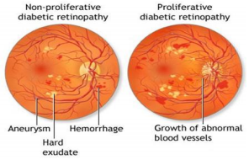
Fig. 2: (a) Proliferative DR.(b) Non-proliferative DR
Two types of diabetic retinopathy (DR) in Figure 1: Non-Proliferative and Proliferative. Non-Proliferative Diabetic Retinopathy (NPDR) typically exhibits mild or minimal symptoms, with lesions such as microaneurysms, exudates, and hemorrhages being indicative. The detection of retinal hemorrhages is particularly helpful in identifying NPDR, highlighting the significance of early detection to improve automated screening systems. In NPDR, structural damage may occur at the back of the eye, leading to blood vessel rupture.
Proliferative Diabetic Retinopathy (PDR) represents an advanced stage, characterized by the growth of fragile new blood vessels in the eye that can bleed, potentially leading to blindness. Initially, individuals with DR may not perceive any changes in their vision, but the condition can worsen over time, posing a threat to their vision. Treatment for diabetic retinopathy varies depending on the disease's stage and severity, tailored to each patient's needs..
II. TECHNIQUE
Method:
Step 1: Read the entire retinal photo and extract the green channel.
Step 2: Apply adaptive histogram equalization to enhance the image quality.
Step 3: Remove the background using histogram equalization.
Step 4: Eliminate salt and pepper noise using Median Filtering.
Step 5: Convert the resulting image from the previous step into a binary image using thresholding.
Step 6: Utilize shape-based parameters such as Area, Eccentricity, and Perimeter for the extraction of red lesions.
Step 7: Eliminate false positives through histogram analysis.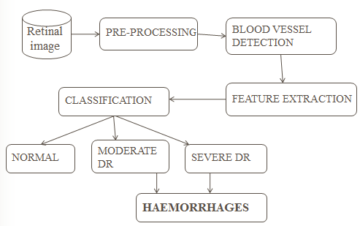
Fig.3 Block Digram

In this proposed method, the input comprises an RGB scale retinal photograph. The RGB photograph consists of three unbiased channels: red, green, and blue. Fig.3 illustrates an RGB image and its three distinct components. It is evident from the RGB image’s channels that the green channel contains the most information regarding the red lesions. Therefore, the green channel of the RGB scale retinal image is utilized for further processing. The proposed system comprises three modules:
- Pre-processing:
The input of the automated system is a color fundus retinal image obtained from the internet. This stage addresses the issue of illumination variation in the captured image. The pre-processing steps include:
1) Resizing: The retinal images are resized into smaller dimensions to avoid overloading and reduce processing time.
i) Color to Green Channel Extraction: Conversion of RGB color fundus images into green channel.
ii) Median Filter: Application of a median filter to reduce impulsive distortions and suppress noise without significant blurring of edges.
iii) Adaptive Histogram Equalization: Used to enhance contrast and improve the quality of the retinal image, particularly addressing uneven illumination issues.
B. Blood Vessel Detection:
After enhancing the contrast of the image and applying a median filter for noise reduction, a designed matched filter is utilized to detect blood vessels. The process involves generating a binary image through thresholding. A matrix is then created to store the matched filter’s count responsible for detecting specific pixels of blood vessels. The grey level values of pixels are checked against a threshold to determine if they belong to blood vessels.
C. Feature Extraction:
Texture analysis is employed to extract feature values from the input images. Features such as entropy, entropy filter, grey level co-occurrence matrix, and range are utilized to quantify intuitive qualities related to spatial variations in pixel intensities.
D. Classification:
The selection of a classification method depends on the dataset size. For small datasets, a low variance classifier like Naïve Bayes may suffice, whereas for larger datasets, a high variance and low bias classifier such as KNN or Support Vector Machine (SVM) is preferred. Classification of hemorrhages is based on the area and size of pixels extracted during feature extraction, offering increased accuracy on larger datasets.
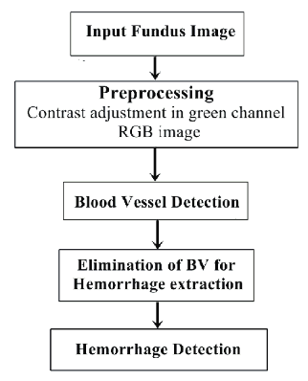
Fig. 4 Flow chart of Hemorrhage Detection

Conclusion:
Medical imaging, aided by digital image processing, plays a crucial role in medical disorder diagnosis. The proposed algorithm aims to detect hemorrhages at an early stage, particularly targeting patients with diabetic retinopathy using fundus images.

References
[1] Dolly Sahu, Sachin Meshram, “Automatic Detection of Hemorrhages Using Image Processing Technique”, International Journal of Engineering Sciences & Research Technology, ISSN: 2277-9655, 2016.
[2] Ruchir Srivastava, Lixin Duan, Damon W. K. Wong, Jiang Liu, Tien Yin Wong, “Detecting retinal microaneurysms and hemorrhages with robustness to the presence of blood vessels”, Elsevier, computer methods and programs in biomedicine 138, 2017.
[3] Falguni Thakkar, Rajvi Parikh, “A Survey on Automatic Detection of Diabetic Retinopathy Exudates from Retinal Fundus Images”, International Journal of Advanced Research in Computer and Communication Engineering, ISSN (Online) 2278-1021, Vol. 5, Issue 5, 2016.
[4] Javeria Amin, Muhammad Sharif, and Mussarat Yasmin, “A Review on Recent Developments for Detection of Diabetic Retinopathy”, Hindawi Publishing Corporation Scientifica Volume 2016, 6838976, 2016.
[5] Ishmeet Kaur & Lalit Mann Singh, “A Method of Disease Detection and Segmentation of Retinal Blood Vessels using Fuzzy C-Means and Neutrosophic Approach”, Imperial Journal of Interdisciplinary Research (IJIR), ISSN: 2454-1362, Vol-2, Issue-6, 2016.
[6] Reshma M. M., Chavan M. S, “Detection of Hemorrhage from Fundus Images using Hybrid Method”, International Journal of Computer Applications (0975 – 8887), Volume 107 – No 12, 2014. I. S. Jacobs and C. P. Bean, “Fine particles, thin films and exchange anisotropy,” in Magnetism, vol. III, G. T. Rado and H. Suhl, Eds. New York: Academic, 1963, pp. 271–350.
.

