Effect of excessive fluoride in ground water on human health and fluorosis
Munish Kumar^{3,4}, Shalini Gupta^{1,2,4*}, Ruchi Agarwal^{1,4}, Kahkashan Begum², Vikas Jain¹, and N. U. Siddiqui²
¹Department of Chemistry, Bareilly College, Bareilly-243005, Uttar Pradesh, India
²Department of Chemistry, G. F. College, Shahjahanpur-242001, Uttar Pradesh, India
³Department of Physics, K. C. M. T, Bareilly-243122, Uttar Pradesh, India
⁴M. J. P. Rohilkhand University, Bareilly-243006, Uttar Pradesh, India
Corresponding author: shalu123gupta21@gmail.com
Abstract: The issue of fluoride in the geo-environment is one of the most important geo-environmental issues in the coming days. The excessive ingestion of fluoride causes the disease, is called fluorosis. The excessive ingestion of fluoride can result in the development of fluorosis, which is a disease that causes bone loss. The present study focuses on fluoride content in groundwater and its health effects.

Introduction
It is commonly recognized that dental and skeletal fluorosis are caused by excessive fluoride consumption. In India, the issue of fluorosis has long been recognized. In 1933, Vishanathan [1] observed that the condition known as "mottled enamel" was common among people in the Madras Presidency. A similar sickness in cattle was described by Mahajan [2] in several areas of the former Hyderabad state. However, in the Andhra Pradesh area of Nellore, Shortt [3] was the first to diagnose the illness in humans as “fluorosis”. Animal teeth, bones, thyroid glands, and skin all contain fluoride. At excessive concentrations, it can cause dental fluorosis and negatively impact the central nervous system, bones, and joints in addition to playing a significant role in the production of dental enamel and normal mineralization in bones [4]. For a number of reasons, the fate of fluoride in groundwater and the soil environment is concerning. It is widely acknowledged that fluoride promotes the growth of new bone [5], and that fluoride at low concentrations benefits teeth by strengthening enamel and lowering the risk of dental cavities [6]. While mottled enamel may result from soluble fluoride in drinking water at smaller concentrations (<2 mg/ml), greater concentrations may have additional harmful consequences (Weast and Lide, 1990). Dental and skeletal fluorosis is caused by excessive fluoride consumption [7]. Fluoride dosages between 250 and 450 mg/ml cause fatal effects [8]. Children who lived in locations with high fluoridation (drinking water fluoride > 3.15 mg/ml) had considerably lower IQs [9]. Water is the primary way that fluoride enters the human body, with food coming in second. Tea and fish are among the meals high in fluoride [10]. Fluorides that are ingested are rapidly absorbed in the gastrointestinal tract, with the body retaining 35–48% of them primarily in skeletal and classified tissues. The remainder is primarily eliminated through urine. Animals that consume fluoride-rich water and feed on a regular basis in endemic areas acquire fluorosis, which manifests as tooth discoloration, difficulty chewing, bone lesions, lameness, disability, and death [11]. Artificially high soil fluoride levels can arise from pollution by the use of phosphate fertilizers, sewage sludge, or pesticides. Naturally occurring fluorides in groundwater are caused by the dissolving of fluoride-containing rock minerals by water [10]. One country in the world where health issues have been linked to high fluoride levels in drinking water is India. WHO defines the safe limit of fluoride consumption is 1·5 parts per million (ppm), or mg/L [12]. But rock salt contains up to 157 parts per million. Due this reason the groundwater samples found concentrations as high as 48 mg/L. While an infrequent sprinkle can be good for helth while overconsumption, especially if combined with fluoride-rich water, poses an array of health threats that often go hidden. An estimated 62 million people in India in 17 out of 28 states are affected with dental, skeletal and/or non skeletal fluorosis. The endemic states with the percentage area affected are given in Table 1.
Table 1 · Indian states with area affected by fluoride poisoning
S.N | State | Area Affected (%)
2. | Andhra Pradesh | >50
3. | Bihar | >30
4. | Delhi | < 30
5. | Gujarat | >50
6. | Haryana | >30
7. | Jammu & Kashmir | < 30
8. | Karnataka | >30
9. | Kerala | < 30
10. | Maharasthra | >30
11. | Madhya Pradesh | >30
12. | Orissa | < 30
13. | Punjab | >30
14. | Rajasthan | >50
15. | Tamil Nadu | >50
16. | Uttar Pradesh | >50

Sources of Fluoride
Various sources of fluoride entering in the body are drinking water, food, industrial exposure, drugs and cosmetics etc. However, drinking water is considered as the major contribution to fluoride entering the human body.

1. Drinking Water
Fluoride-containing rocks are the main source of fluoride in groundwater, when the mineral weathers and/or leaches out to contaminate the water. Fluorides can be found in three different forms: cryolite (Na₃AlF₆), apatite (Ca₃F (PO₄)₃), and fluorospar (CaF₂). Granite rock has a five times greater fluoride concentration than sections of basalt rock. In the same way, shale is more concentrated than limestone and sandstone (Fig. 1) [13]. The largest amount of fluoride (1200–8500 mg/kg) is found in alkaline rocks [14].
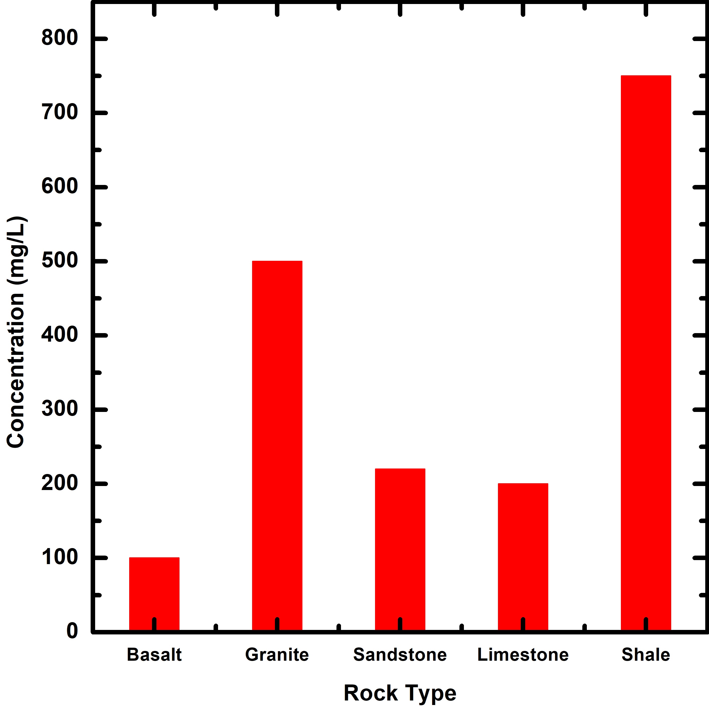
Fig 1: Average Concentration of Fluorine in different types of main rock

Significant data from the Indian Geological Survey show that fluorite, topaz, apatite, rock phosphate, phosphatic nodules, and phosphorites are prevalent in India and contain high levels of fluorides.

2. Food Items
In addition to water, food products, particularly agricultural crops, are highly contaminated with fluoride since they are grown in regions of the earth's crust that are rich in minerals that contain fluoride. Food material's fluoride content is mostly determined by the fluoride level in soil, atmosphere and different teams that are uses for growing the crops. Excess use of artificial substance increases the level of fluoride in the food materials. The fluoride content of various foods has been categorized in Table 2.

3. Industrial Exposure

Airborne fluoride is mostly produced by a number of industries, including those that produce phosphate fertilizers, extract aluminum, manufacture hydrogen fluoride production facilities, refining petroleum, and producing fluorinated hydrocarbons (refrigerants, aerosol propellants, etc.). The environment is contaminated by fluoride dust and fumes; breathing in these particles is just as risky as ingesting food, drink, or medication that contains fluoride. Not only are industrial workers impacted, but nearby residents may also experience health problems related to these areas.

4. Drug and Cosmetics
For many years, medications containing sodium fluoride have been used to treat tooth caries, osteoporosis, and osteosclerosis. Fluorosis may result from certain medications' long-term use. Furthermore, mouthwashes and toothpastes with higher fluoride concentrations are available, regardless of whether they are labeled as fluoridated or not. The amount of fluoride found in the raw ingredients used to make tooth paste, such as talc, chalk, and calcium carbonate, can reach as high as 800-1000 mg/kg. Fluoride concentrations in fluoridated tooth paste brands have been observed to reach 1000–4000 mg/kg. Furthermore, fluoridated water with a very high fluoride content is all that some mouth rinses contain.

Health Impacts and Fluoride

1. Consumption of water with optimal fluoride concentration
According to WHO guidelines state that fluoride levels in drinking water should be somewhat above and below 1 mg/L [15]. It can be acceptable to have fluoride levels up to 1.5 mg/L in temperate locations when water intake is minimal. The government of India's Ministry of Health has set permissive and excessive levels for fluoride in drinking water at 1.0 and 2.0 mg/L, respectively. The health effects of varied fluoride concentrations [16] in drinking water are displayed in Table 3.

Table 2 · Different food items contain different levels of fluoride
Food Item | Fluoride (mg/kg) | Food Item | Fluoride (mg/kg)
Cereals |  | Fruits
Wheat | 4.6 | Banana | 2.9
Rice | 5.9 | Mango | 3.2
Maize | 5.6 | Apple | 5.7
 |  | Guava | 5.1
Pulses |  | Beverages
Gram | 2.5 | Tea | 60 - 112
Soybean | 4.0 | Coconut water | 0.32 - 0.6
Vegetables |  | Spices
Cabbage | 3.3 | Coriander | 2.3
Tomato | 3.4 | Garlic | 5.0
Cucumber | 4.1 | Ginger | 2.0
Ladyfinger | 4.0 | Turmeric | 3.3
Spinach | 2.0 | Food from Animal Sources
Mint | 4.8 | Mutton | 3.0 - 3.5
Brinjal (egg plant) | 1.2 | Beef | 4.0 - 5.0
Potato | 2.8 | Pork | 3.0 - .5
Carrot | 4.1 | Fishes | 1.0 - 6.5

Table 3 · Limit absorption of fluoride through drinking water and related diseases effects on human health
Fluoride Concentration (mg/L) | Effect
Nil | Partial growth and productiveness
< 0.5 | Dental caries
0.5 - 1.5 | Safe limit for dental health
1.5 - 4.0 | Starting of dental fluorosis
4.0 - 10.0 | Dental fluorosis, skeletal fluorosis (pain in body)
> 10.00 | Crippling type fluorosis

Types of Fluorosis

Following is a brief discussion of the various forms of fluorosis resulting from excessive fluoridation:

1. Influence of fluoride on the teeth: Dental Fluorosis

This type of fluorosis primarily affects children's teeth. The teeth's inherent luster or shine fades. The teeth first have a powdery white appearance before eventually turning yellow, brown, or black. On the tooth surface, the discoloration will appear as lines or soots that are horizontally oriented with respect to the gums. Cavities, or tiny pits or perforations, are visible on the surface of teeth. Dental fluorosis impacts the teeth's inside and external surfaces. In fluoridated settings, edentulous people might develop at a much younger age. There is no cure for the illness, which primarily affects appearance.

2. Influence of fluoride on the Skeletal: Skeletal fluorosis

The body's skeleton and bones are impacted by skeletal fluorosis. Both young and old can be affected by skeletal fluorosis. Joint aches and pains are possible. The neck, hip, shoulder, and knee joints are typically impacted by skeletal fluorosis, which makes walking unpleasant and difficult. Joint rigidity or stiffness also develops. What's more concerning is that skeletal fluorosis is difficult to identify until the condition reaches a more advanced state. Severe cases cause total joint rigidity, which results in an immobile pelvic, shoulder, and knee joints as well as a stiff spine known as the "Bamboo spine."

3. Influence of fluoride on the non-skeletal manifestations

A diet high in fluoride may have negative effects on the body's soft tissues. Gastrointestinal issues, appetite loss, stomach pain, and constipation followed by sporadic diarrhea are some of the symptoms. Among those affected, neurological symptoms and muscular weakness that causes excessive thirst and an increased need to urinate are typical. The synthesis of cholesterol may be the cause of cardiac issues. Other concerns include male infertility brought on by defective sperm, and recurrent miscarriages or stillbirths.

Prevention of Fluorosis
Excessive fluoride ingestion by human beings can be prevented by using the following approaches:
Using alternate water sources:
Alternate water sources also helpful to reduce the fluoride ingestion by the human beings. It may include surface water, rainwater and low-fluoride groundwater.
Improving the nutritional status of population at risk:
A lower incidence of dental fluorosis is closely correlated with adequate calcium ingestion. Consuming vitamin C also reduces the chance of developing fluorosis.
Defluoridation:
This is process of removing extra quantity of fluoride with in safe limit of human body from drinking water using different methods such as Nalgonda method. It is two step well-known defluoridation process is based on the combined use of alum and lime.

References:
- G. R. Viswanathan, Annual Report Madras of Indian Council of Agricultural Research, New Delhi. (Quoted from Indian Institute of Science, 33A, 1, 1951).
- Mahajan, 1934. Annual Report. VIO Hyderabad State, 3, Indian Council of Agricultural Research, New Delhi.
- W. E. Shortt, Endemic Fluorosis in Nellore District, South India. Indian Medical Gazette, 72: 396 (1937).
- V. Agrawal et al., Ground water quality: Focus on fluoride and fluorosis in Rajasthan. Current Sci. 73(9): 743-746 (1997)
- A. Richards et al., Normal age-related changes in fluoride content of Vertebral trabecular bone-relation to bone quality Bone 6:15-21 (1994).
- K. Fung et al., Fluoride content in tea and soil from tea plantations and release of fluoride into tea liquor during infusion. Environ. Pollut. 104: 197-205 (1999).
- W. Czarnowski et al., The impact of water borne fluoride on bone density. Fluoride 32(2): 91-95 (1999).
- S. Luther et al., Fluoride absorption and mineral stability in an Alberta soil interacting with phosphogypsum Leachate. Can. J. soil Sci. 83-94 (1995).
- Lu, Y., Sun, Z.R., Wu, L.N., Wang, X., Lu, W. and Liu, S.S., Effect of high fluoride water on intelligence in children. Fluoride 33(2): 74-78 (2000).
- EPA, 1997. Public Health Global for Fluoride in Drinking Water. Pesticide and Environmental Toxicology. Section Office of Environmental Health Hazard.
- R. C. Patra et al., Industrial fluorosis in cattle and buffalo around Udaipur, India. Sci. Total Environ. 253: 145-150 (2000).
- Repot of Minstry Jal shakti, Contamination of ground water, 2022, https://pib.gov.in/PressReleasePage.aspx?PRID=1809264
- R. N. Athavale et al., Down to Earth, 8(6): 24-25 (1999).
- D. Chand, Fluoride and human health- causes for concern. Indian J. Env. Prot., 19(2): 81-89 (1999).
- Meenakshi Garg et al., Ground water quality in some villages of Haryana, India: Focus on fluoride and fluorosis. J. Hazardous Materials 106: 85-97 (2004).
- Prevention and Control of Fluorosis in India: Vol. 1 (Health Aspects) (Ed. Susheela, A. K.) Rajiv Gandhi National Drinking Water Mission, New Delhi.

