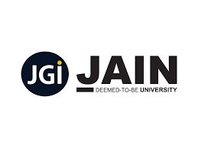5th km, NH - 209,Jakkasandra Post, Bengaluru - Kanakapura Rd,

Bengaluru, Karnataka 562112

CERTIFICATE OF PARTICIPATION

THIS CERTIFICATE IS HEREBY AWARDED TO

sir. TM

Has as participated in a Faculty Development Programme on “**corse1 GenAI**” organised by Department of Information Science & Engineering, Jain (Deemed-to-be University) held on 22 - 27 jul.

GroupGroupGroup

*JGI-2024-1721538295551410000*