1. Measure web application response time before and during the test run.

The response time of udemy.com before the load test was 591.80 milliseconds and during the test run was 682.90 milliseconds.

1. Did the load test have an impact on web application response time?

Yes, I see a delay of approximately 400 milliseconds.

**Before the test:**

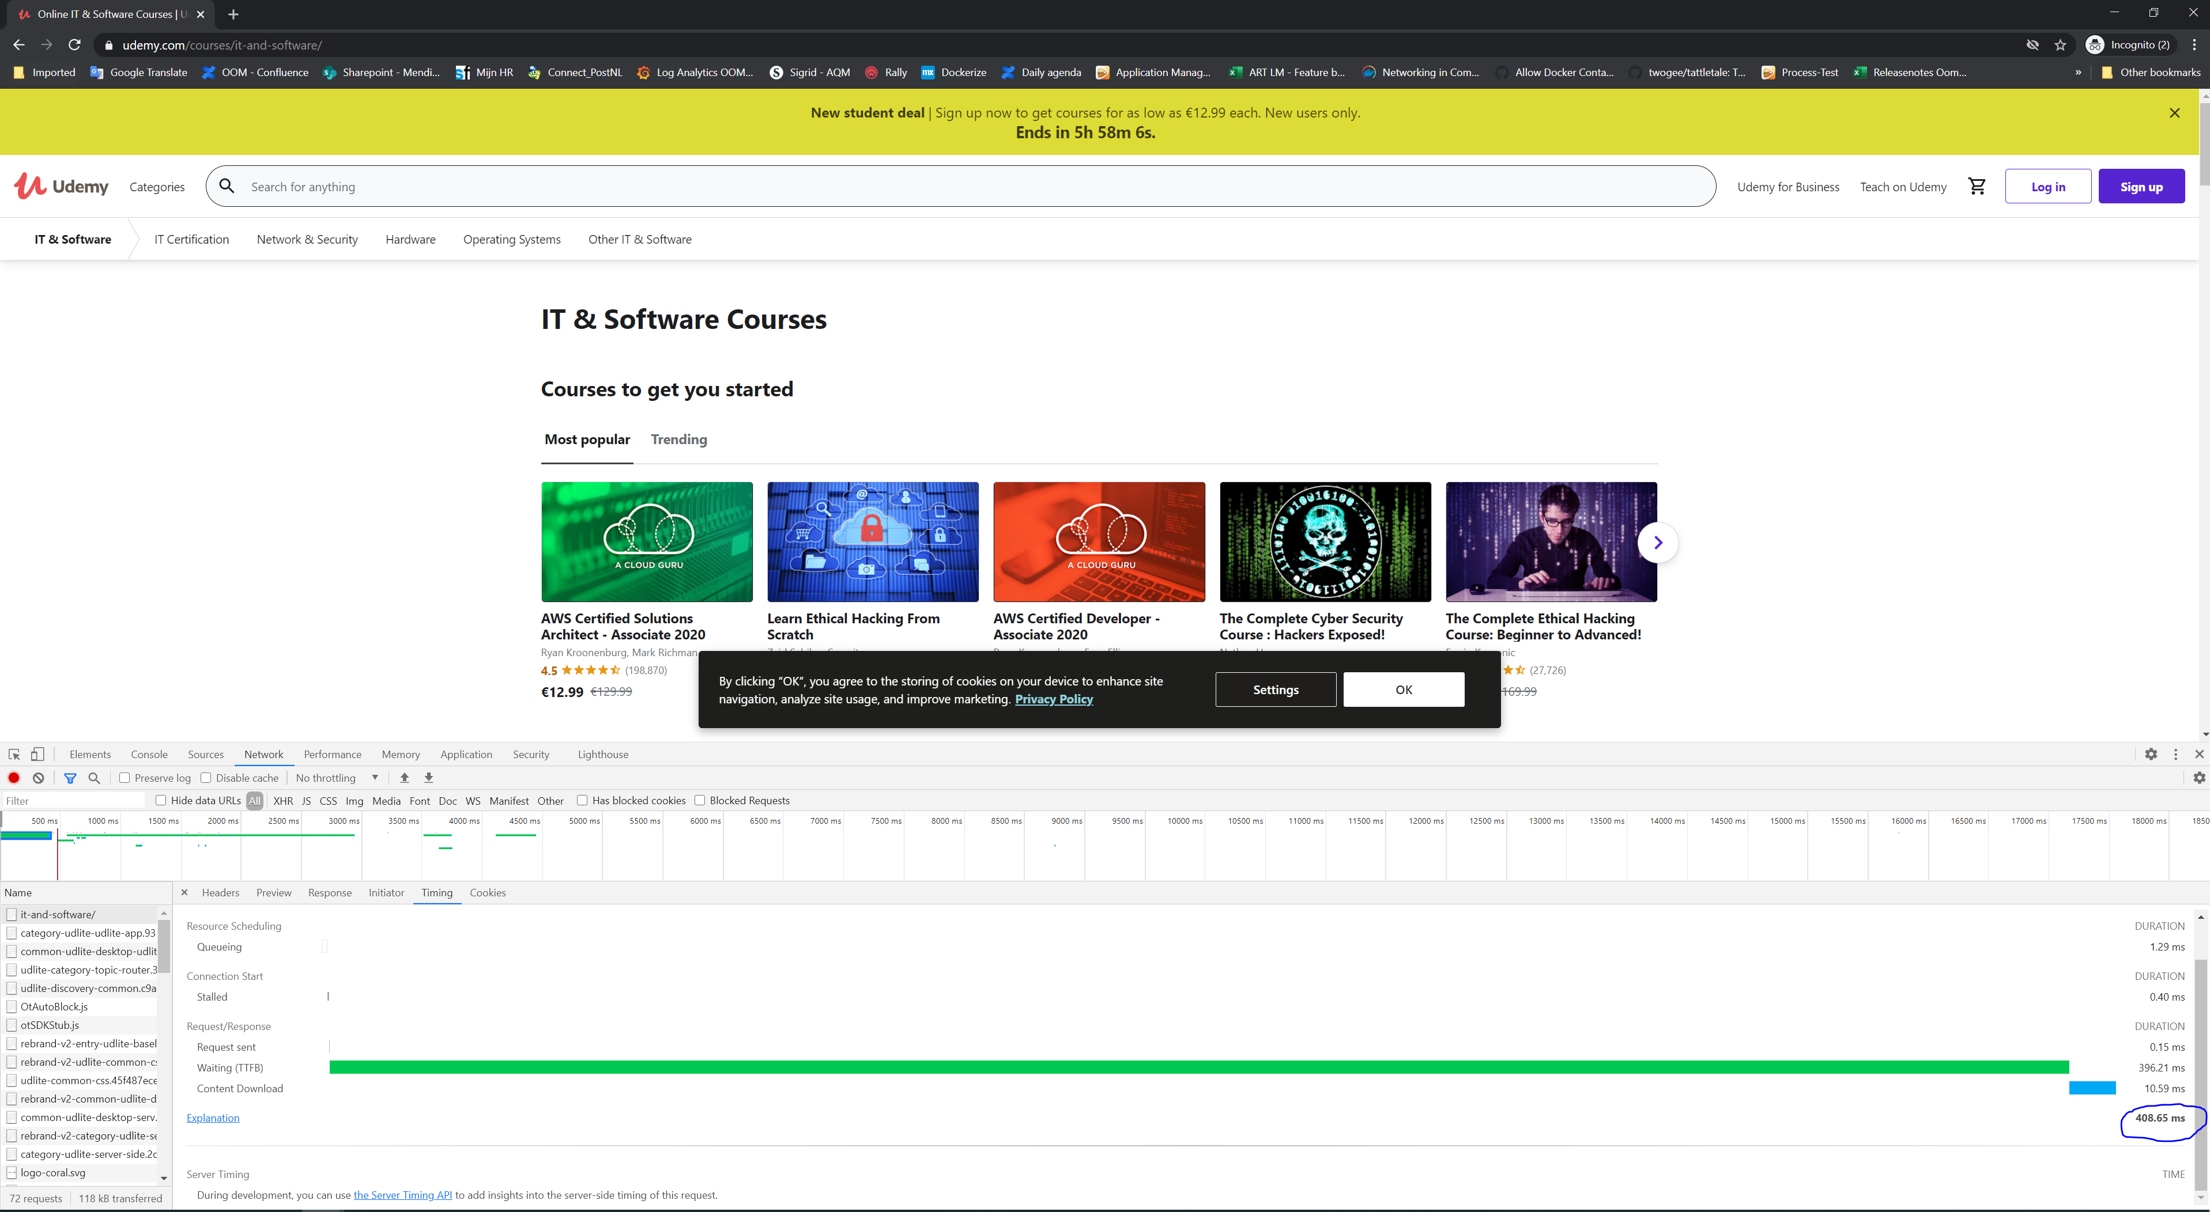

**During the test:**

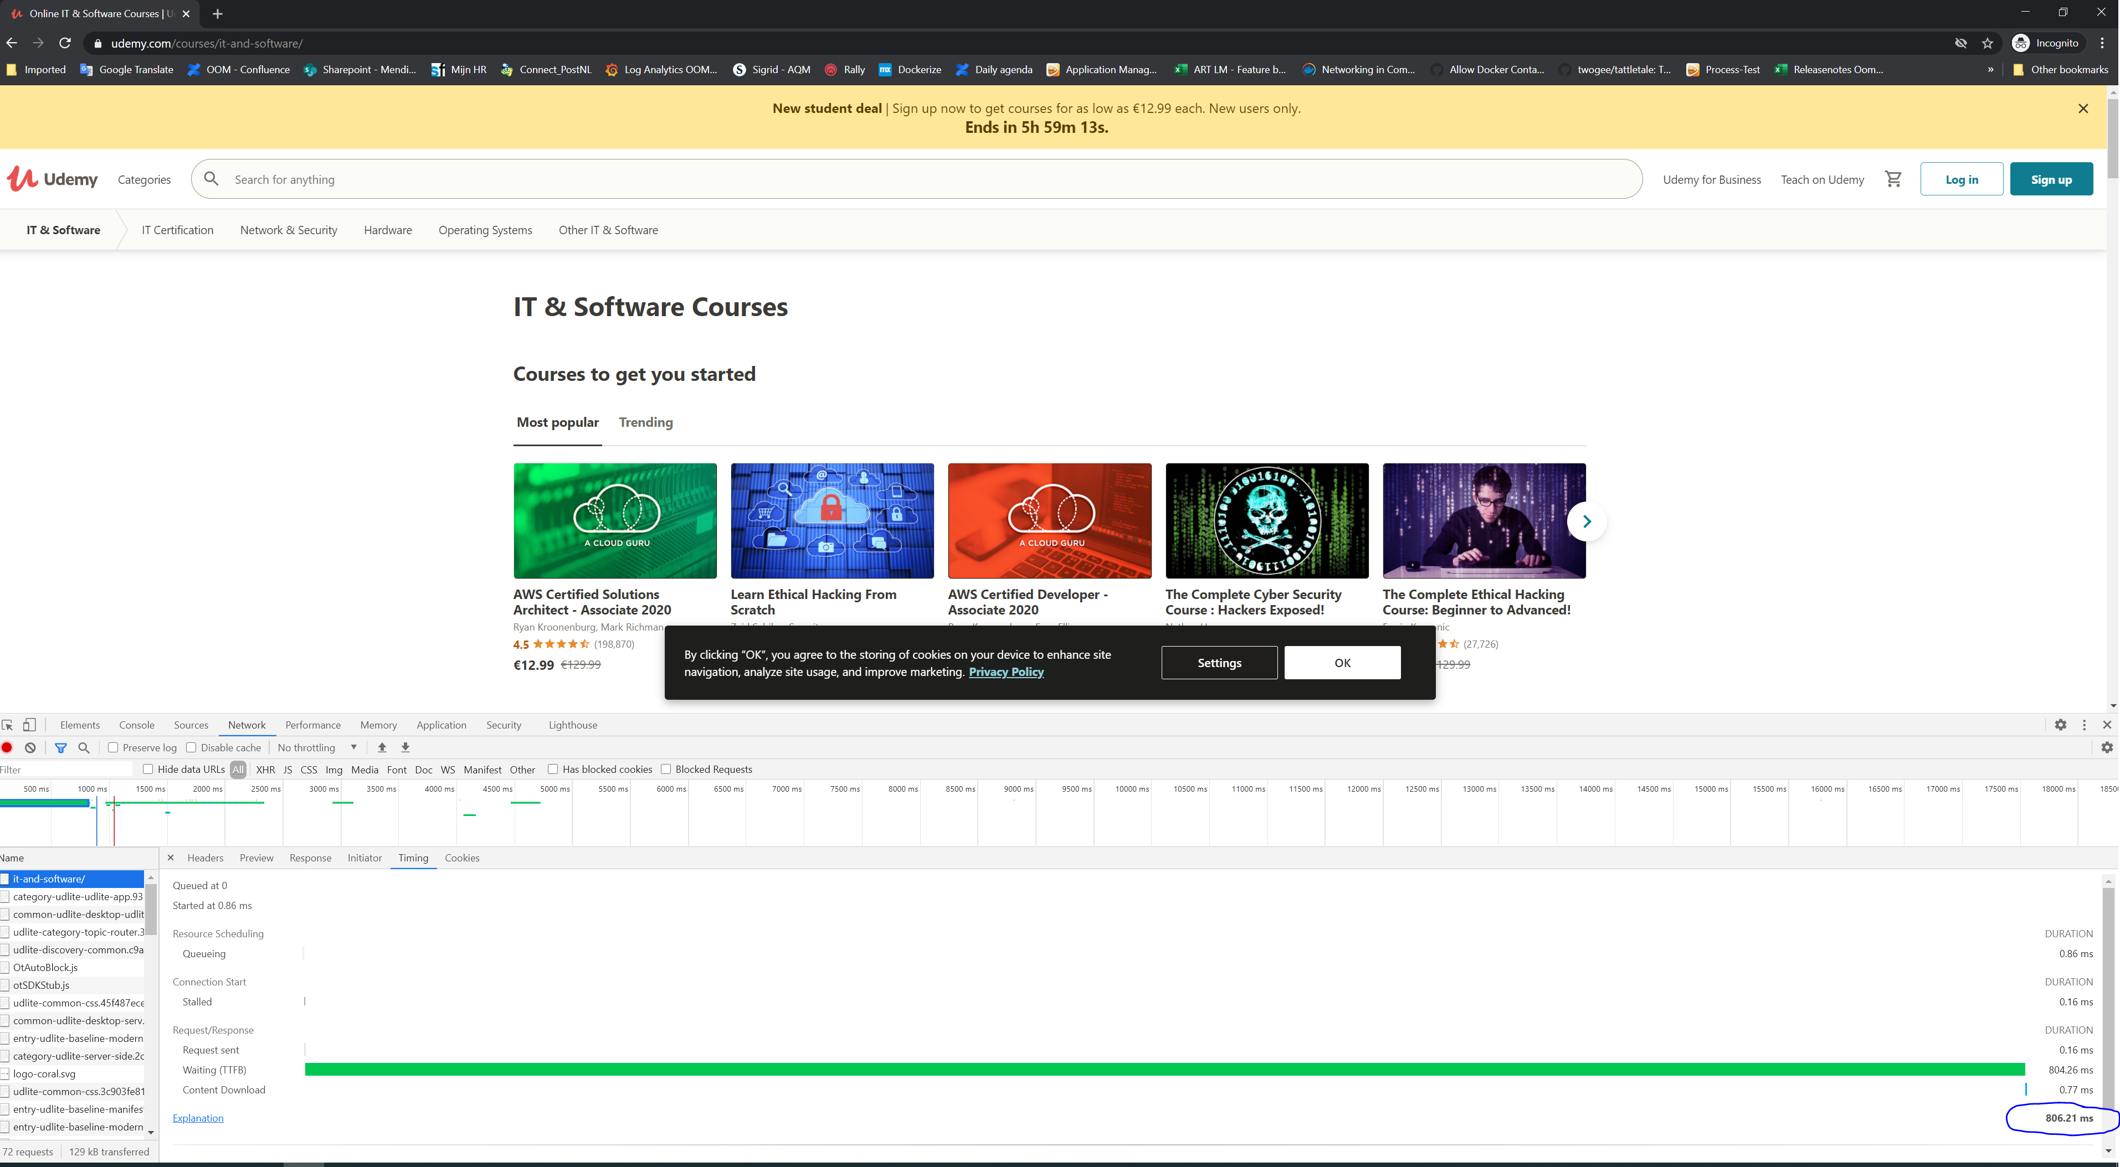

1. What is the optimal application response time for modern-day web applications?

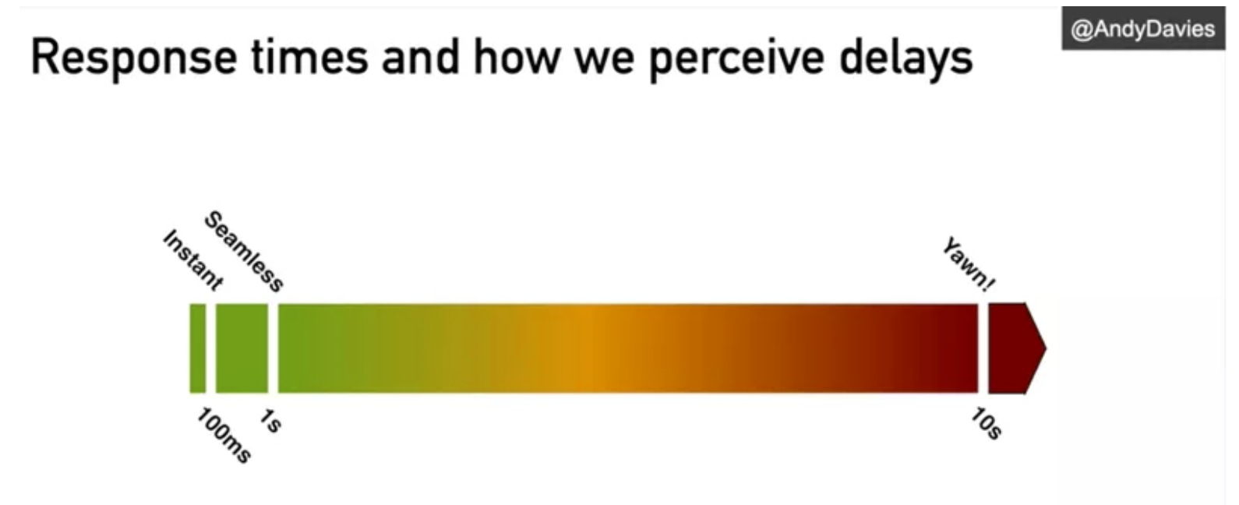

Currently, the standard the Yawn period had been reduced to 7 to 8 second mark.

* UI response times should be as fast as possible.
  + Application launch, i.e., time when the user initiates to start the application, in < 10 sec
  + Response to user action in <= 1 sec
    - 0.2 sec gives the felling of instantaneous response.
    - 1.0 second is about the limit for user's flow of thought to stay uninterrupted, even though the user will notice the delay. Normally, no special feedback is necessary for delays < 1 sec, but the user does lose the feeling of operating directly with the System.
  + Generating a report, e.g. requesting a batch report job to be run, in < 30 seconds
  + For any responses > 5 sec, the System should provide feedback indicating when it expects to be done, otherwise users will not know what to expect.
    - 10 sec is about the limit for keeping the user's attention focused. For longer delays, users will want to perform other tasks while waiting for the System to finish, so they should be given feedback indicating when the computer expects to be done.
    - Feedback during the delay is especially important if the response time is likely to be highly variable since users will then not know what to expect.
* Alert(s) latency
  + Alerts should be visible in < 10 sec and not exceed 60 sec.
  + As a rule of thumb, the average alert latency should be < 60 sec in a well-performing system, but event latency of between 60 to 90 sec is also acceptable.

1. Responses received during load testing:

|  |  |
| --- | --- |
| Response code | Message |
| 429 | Too many requests |
| 443 | Failed to respond |