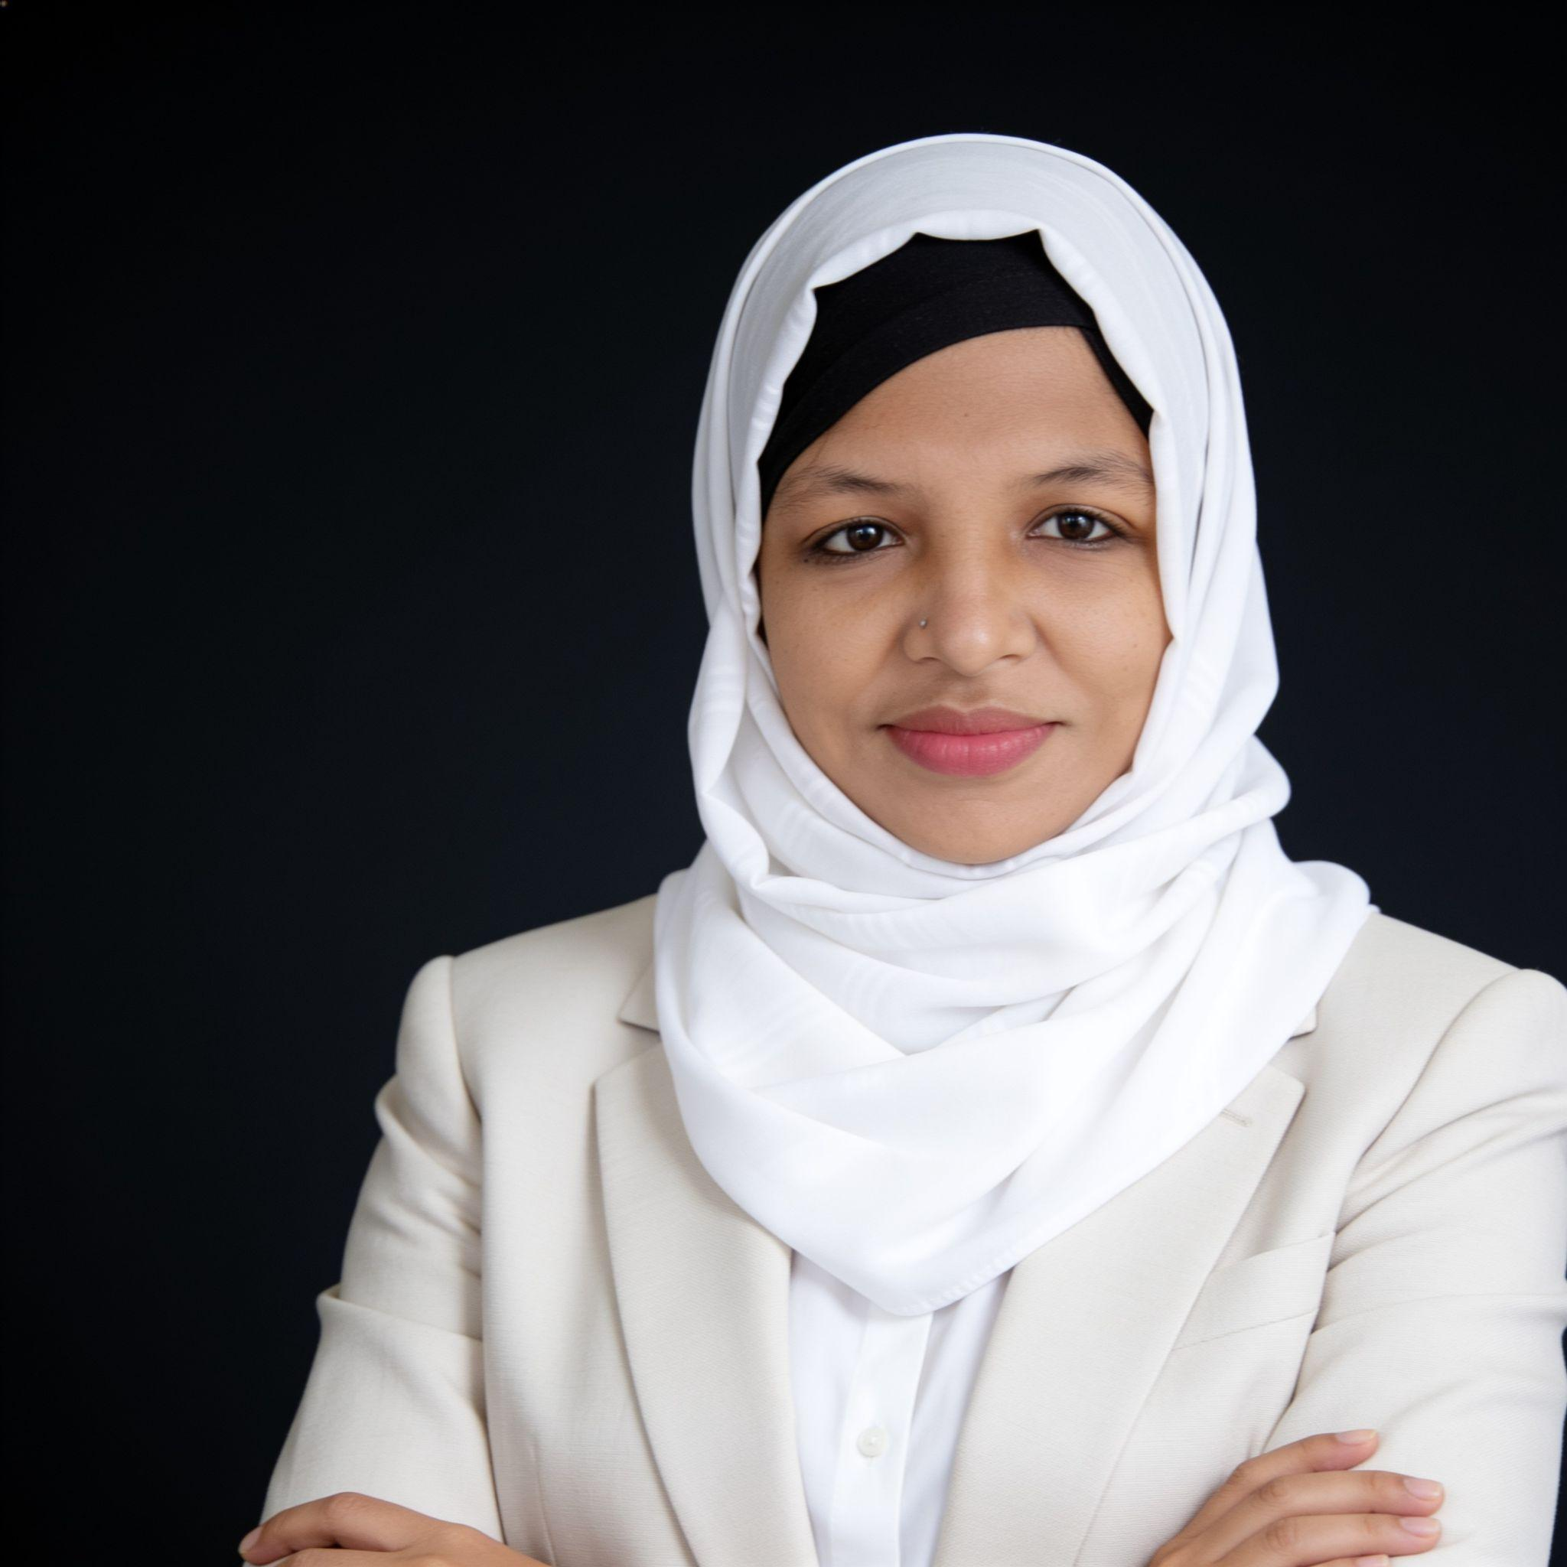
Tuhin Sultana
Head of Marketing | Senior Brand Strategist & Marketing Leader

01890323059 | sultana.kabir@gmail.com | linkedin.com/in/tuhinsultana
221 West Nakhalpara, Tejgaon, Dhaka, Bangladesh
https://tuhinsultana.github.io/

EXECUTIVE SUMMARY
FMCG marketing leader with 16+ years building brands across Juice, Dairy, Snacks, Personal Care, and Cosmetics. Track record of double-digit sales growth, award-winning campaigns, and full P&L ownership across multiple brand portfolios at once. Strong across ATL/BTL/digital, NPD, trade marketing, and team leadership.
CORE COMPETENCIES
Brand Strategy & Portfolio Management • NPD • GTM Planning • Packaging & Pricing • ATL/BTL/Digital Campaigns • Consumer Insights • Trade Marketing • Budget & ROI Management • Agency Management • Team Leadership • P&L Accountability
KEY ACHIEVEMENTS
- 10% sales growth and +2 point market share gain in Juice at Akij Food & Beverage.
- Managed BDT 100+ crore portfolio across Juice, Dairy, and Snacks with full P&L ownership.
- Built the award-winning Frutika "Inspiring Purity" campaign — 2 Digital Marketing Awards (2017).
- Led full GTM overhaul and relaunch of Frutika (2019–2020): repositioning, packaging, NPD, 360° campaign.
- Ran Farm Fresh Children's Day activation — 22,000+ families reached annually, TOMA up 2–3% YoY.
- Took Aarong Laban from concept to launch — NPD, packaging, pricing, and full campaign.
- Independently launched American cosmetic brands in Bangladesh — GTM, retail, and communication strategy.
- Built and led teams of 4–5 direct and 200+ indirect reports across multiple organisations.
- Managed agencies, media houses, and production teams across simultaneous multi-brand campaigns.
FEATURED PROJECTS
Frutika Islamic Genius • Farm Fresh Children's Day • Frutika Inspiring Purity • Frutika Breakthrough Campaign • Picasso Tiles Launch • Farm Fresh Colony Drive • Frutika Unveiling Purity • Aarong Dairy Laban • Tibet Soap New Packaging Launch
WORK EXPERIENCE
Strategic Planning Head | Plan B — S. Quader GroupDec 2022 – Present
- Lead brand strategy, portfolio planning, and integrated ATL/digital campaigns for multiple FMCG clients.
- Manage agencies, creative briefs, and ROI-focused campaign execution.
Deputy Director – Marketing | Remark HBSep–Nov 2022 (Contract)
- Led marketing strategy for NIOR (makeup & skincare) — positioning, packaging, communications.

Group Category Head / Brand Manager | Akij Food & Beverage Ltd.2016–2021
- Full P&L ownership of BDT 100+ crore portfolio across Juice, Dairy, and Snacks.
- Led NPD, packaging, pricing, and portfolio management across multiple brands.
- Ran 360° campaigns across ATL/BTL/digital; delivered 10% sales growth and +2 point market share.
Brand Marketing Manager | BTIJan–Nov 2015
- Led brand strategy, corporate communications, and integrated campaigns.
Brand Manager / Assistant Brand Manager | Aarong Dairy2013–2014
- Managed full NPD pipeline from concept through packaging, pricing, and launch.
Brand Manager – Private Label | ACI Logistics (Shwapno)Jan–Feb 2016
- Developed private-label FMCG products — sourcing, packaging, pricing, merchandising.
Sr. Brand Executive / Brand Executive | Akij Food & Beverage Ltd.2008–2013
- Led brand campaigns and trade promotions; built core expertise in trade marketing and BTL execution.
Brand Strategy Planner | Roop2007–2008
- Developed brand strategy and activation plans for consumer brand clients.
EDUCATION
Bachelor of Business Administration (BBA) — Marketing (Major), HRM (Minor)
East West University, Dhaka | 2003–2007 | CGPA: 3.64 / 4.00 | Dean's List Honour
Higher Secondary Certificate (HSC) — Business Studies
Dhaka Commerce College | 2001 | First Division
Secondary School Certificate (SSC) — Science
Bharateshawi Homes High School | 1999 | First Division
PROFESSIONAL TRAINING & CERTIFICATIONS
Brand Strategy • Leadership & Strategic Planning • NPD • GTM • Digital Marketing • Campaign Management • Design Thinking • Finance for Non-Finance Managers
SKILLS
Marketing: Consumer Insights, Market Research, Competitor Analysis, Budget Management
Creative & Digital: AI Tools, Photoshop, Illustrator, Canva, Digital Campaigns
Software: MS Office, MS Project
Languages: Bengali (Fluent), English (Fluent), Hindi (Conversational)

