DOCUMENT HISTORY AND INFORMATION

History of Amendments:
Date | Version | Modified Section | Summary of Change | Author
17/10/2024 | 0.1 | ALL | Initial Draft | Lê Chí Trường

Distributed for Review
This document has been distributed for the following to review:
Name | Title & Company | Issue Date | Revision
Approvals
This document requires the following approvals:
Name | Signature | Title | Issue Date

Associated Documents
This document is associated with the following other documents:
Name | Title and Originator’s Reference | Source | Issue Date | Version

Contents
1 Introduction 3
2 Purpose 3
3 Scope 3
4 Definitions, Acronyms and Abbreviations 3
5 Overview 3
5.1 Use case diagram 3
5.2 Entity relationship diagram 5
6 Functionality Requirements 6
6.1 Order management 6
6.1.1 List Order 6
6.1.2 Add New Order 6
6.1.3 Edit order information 7
6.1.4 Delete order 8
7 Non-functional requirements 8
7.1 Performance 8
7.2 Scalability 9
7.3 Security 9
7.4 Portability 9
7.5 Audit 9
7.6 Error handling 9
7.7 Infrastructure 9
7.8 Look and feel 10
7.9 Legal 10
7.10 Training 10
7.11 User Documentation & Help Screen Requirements 10
7.12 Support & Supportability 10
7.13 Reliability 10
7.14 Design Constraints 11
7.15 Purchased Components 11
7.16 Interfaces 11
7.17 Test 11
7.18 Data 11

Introduction
Currently, Fshop does not have a centralized system to comprehensively manage order information. This leads to data fragmentation and difficulty controlling user order information. This system requirements document is part of the order management system implementation project for Fshop. This system will provide a centralized data warehouse, allowing administrators to easily manage user orders, decentralize permissions and maintain security throughout the system.

Purpose
The purpose of this document is to provide a detailed description of the functional and non-functional requirements of the order management system in a system such as Fshop. This function allows administrators and users with advanced rights to manage order lists, add new ones, modify and delete them in the system.

Scope
The order management function will include the following activities:
- View order list.
- Allows administrators to manage orders (add, edit, delete).
- Manage order status (Confirmed/unconfirmed).

Definitions, Acronyms and Abbreviations
<TBD>

Overview

Use case diagram
The following use cases are required to be included in Order Management.
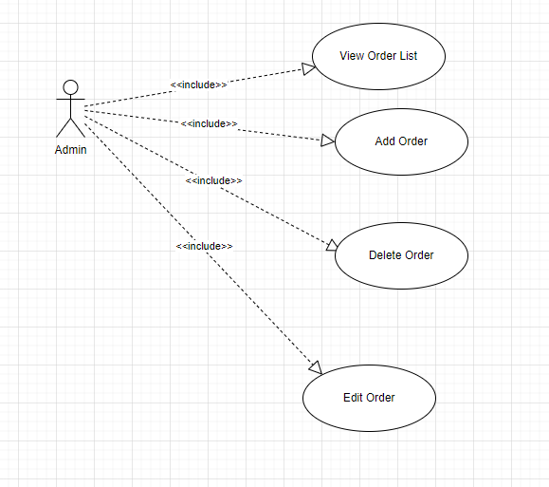

UC | Name | Description
UC001 | Order management | The order management function allows administrators or systems to manage order information and activities

Entity relationship diagram
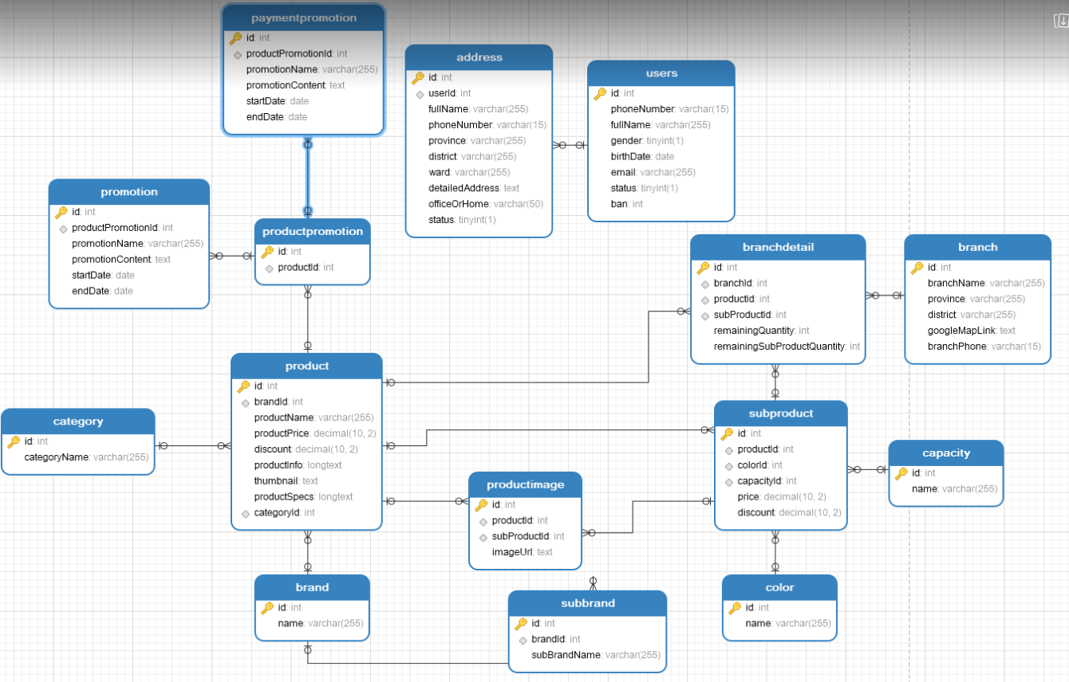

https://gyazo.com/2d5137e9e507d5a773d11d7a6ba8801e

# | Entity | Description
1 | Product | Information about products, including price, specifications, and description.
2 | Users | List of all users in the system.
3 | Address | List of all addresses used in the system.
4 | Category | Product categories in the system.
5 | Promotion | Details of promotional programs for products.
6 | Service | List all services
7 | ProductPromotion | Relationship between products and promotional programs.
8 | Branch | Information about branches where products are sold.
9 | BranchDetail | Detailed inventory information at each branch.
10 | SubProduct | Information about sub-brands of the products.
11 | SubBrand | List all Towns in the system
12 | Capacity | Product capacity.
13 | Color | Product color.
14 | ProductImage | List of product images.
15 | PaymentPromotion | Information about payment promotion programs.

Functionality Requirements

Order management

List Order
Administrators can access order management from the system's main navigation bar. After entering the list interface, the system will display full order information such as order id, full name, email, phone number, order details, total amount, order status and order date.

Users can search for other orders using the search bar located in the upper right corner, allowing search by order person's name, email or phone number.
There are also filters that allow admins to filter orders by date or order status. The list is paged, each page displays up to 20 orders, making management easier when there are many orders.

NOTE: Above listing, filtering, sorting and marking an in-active record to active behaviors are standard features in a list screen in the whole system.

Add New Order
If the user clicks on the ‘Add Order’ button in the upper right corner of the ‘Order List’ screen, an entry form will appear for adding a new order.

By default, all fields should be blank, and all checkboxes should be un-ticked.

There are some rules on this screen:
- Mandatory fields
  - Customer Name
  - Email
  - Phone Number
  - Product(s)
  - Quantity
  - Delivery Address
  - Payment Method (e.g., Credit Card, Cash, Bank Transfer)
  - Order Status (e.g., Pending, Shipped, Delivered)
  - Delivery Date

- Unique fields
  - Order ID: The system will auto-generate a unique Order ID for each new order.
- Email validation: The system will check the email format when entering. If the email is invalid (e.g., missing the "@" or ".com" characters), an error message will be displayed directly below the email field that reads: "Please enter a valid email address."

- Phone number validation: The system will check the phone number format, requesting a valid sequence (e.g., 10 digits for Vietnamese phone numbers). If the phone number is invalid, an error message will appear below the phone number field saying: "Invalid phone number. Please enter the correct format."
- Product and Quantity selection: The system will only allow adding valid products from the inventory. The selected quantity should not exceed the available stock. If a user tries to add a quantity that is not available, an error message will display: "Selected quantity exceeds available stock."

- Delivery Date: The system will not allow the user to select a past date for delivery. If a past date is selected, the system will display an error message: "Please select a future delivery date."

- Payment Method: If a payment method is not selected, the system will display a message: "Please select a payment method."

When an administrator enters incorrect or incomplete information, the system will disable the "Save" button until all information is correctly filled in. After providing valid information, the user can click the "Save" button to add the new order. If all the data is valid, the order will be created and displayed in the order list.

- If the user clicks on the ‘Back’ button, they will return to the Order List screen.

NOTE: This is a standard behavior across the entire system. After a user clicks on the ‘Back’ button in a Details screen, the related List screen should be displayed.

Edit order information
By clicking the Edit icon (pencil) in the line corresponding to the order in the list. After clicking the edit icon, an edit form will display with the same information fields as when adding a new order:

- Customer Name: Administrators can edit the customer's name. The system does not specifically check this field but ensures that it is not blank. If left blank, an error message will display: "Customer name cannot be blank."

- Email: If the administrator changes the email, the system will validate the email format similar to when adding a new order. If the email is invalid, an error message is displayed: "Please enter a valid email address." The system will also check if the new email already exists in the system and display an error message: "This email already exists in the system."

- Phone Number: Administrators can update the phone number for the order. The system will check the phone number format, ensuring it matches a valid sequence. If the phone number is invalid, an error message will display: "Invalid phone number. Please enter the correct format."

- Product(s): Administrators can change the product(s) in the order. The system will check the availability of the product. If the selected product is no longer available, an error message will display: "Product not available in stock."

- Quantity: Administrators can update the product quantity. The system ensures that the updated quantity does not exceed available stock. If the quantity exceeds stock, the system will display: "Selected quantity exceeds available stock."

- Delivery Address: Administrators can edit the delivery address for the order. If the address is left blank, the system will display: "Delivery address cannot be blank."

- Delivery Date: Administrators can update the delivery date, but it must be in the future. If a past date is selected, an error message will appear: "Please select a future delivery date."

- Payment Method: If necessary, the administrator can change the payment method (Credit Card, Cash, Bank Transfer). The system ensures that one payment method is selected. If not, the message "Please select a payment method" will appear.

- Order Status: The administrator can update the order status (e.g., Pending, Shipped, Delivered). If the order status is changed to 'Delivered,' the system will ensure that the delivery date is either today or in the past.
After editing, the administrator clicks the Update button to save the changes. If any field contains invalid information, the system will display the appropriate error message and prevent saving until all information is valid.
- If the user clicks on the Back button, they will be returned to the Order List screen.

NOTE: This is a standard behavior across the system. After clicking the ‘Back’ button on a Details screen, the corresponding List screen should be shown.

Delete order
Administrators can delete orders from the system by clicking the Delete icon (trash can) in the line corresponding to the order in the list. When clicking the delete icon, the system will display a confirmation message with the content:

"Are you sure you want to delete this order? All related information will be permanently deleted and cannot be recovered."

If the administrator selects OK, the system will perform a check:

- If the order is still in progress (e.g., Pending, Shipped, or awaiting delivery), the system will not allow the deletion and will display the error message: "The order cannot be deleted because it is still in progress."

- If the order has been completed or canceled and has no active bindings, the system will delete the order from the database. After successful deletion, the order list will be refreshed, and a message "Order deleted successfully" will appear on the screen.

- If the user selects Cancel, the system will not delete the order and will return to the order list screen.

NOTE: This is a standard behavior across the system. After deleting an order, the system should refresh the list to reflect the current status.

Non-functional requirements

Performance
Requirements relating to Performance
No. | Requirement
1. | The system must ensure a response time of no more than 5 seconds for adding, editing, and deleting data.
2 | The system must support concurrent processing of at least 100 users at a time without performance degradation.

Scalability
Requirements relating to Scalability
No. | Requirement
1. | The system must be scalable to serve up to 10,000 users without affecting performance.

Security
Requirements relating to Security
No. | Requirement
1. | The system must use a standard secure authentication and authorization mechanism, such as OAuth 2.0 or JWT.

Portability
Requirements relating to Security
No. | Requirement
1. | The system must be compatible with all modern browsers such as Google Chrome, Firefox, Microsoft Edge.

Audit
Requirements relating to Audit
No. | Requirement
1. | None required at present.

Error handling
Requirements relating to Error handling
No. | Requirement
1. | The system must display detailed messages to the user when an error occurs, and save error information in the log file.

Infrastructure
Requirements relating to Infrastructure
No. | Requirement
1. | All services inside Service Directory are expected to be hosted under https for security purposes. Shaw-trust to confirm if they can provide an appropriate SSL infrastructure.

Look and feel
Requirements relating to Look and feel
No. | Requirement
1. | The system's interface should be easy to use, follow modern UI/UX design principles, and have user-friendly colors.

Legal
Requirements relating to Legal issues
No. | Requirement
1. | None required at present.

Training
Requirements relating to Training
No. | Requirement
1. | There must be documentation and video instructions on how to use the system for end users and administrators.

User Documentation & Help Screen Requirements
Requirements relating to User Documentation
No. | Requirement
1. | A help icon will be provided in the corner of the user management screen, allowing administrators to click to download a detailed help page on the functions of adding new, editing, deleting and granting permissions to users. Help content clearly explains each step of these functions, including error handling instructions. This document will be updated and maintained by the document management department. This requirement will be implemented in phase 2 of the project.

Support & Supportability
Requirements relating to Support
No. | Requirement
1. | The system must have 24/7 support service during the testing period and a 6-month warranty after official deployment.

Reliability
Requirements relating to Reliability
No. | Requirement
1. | The system must ensure continuous operation 24/7 with service downtime not exceeding 99.9% per month.

Design Constraints
Requirements relating to Design
No. | Requirement
1. | The system design must follow object-oriented design principles and be scalable when new features are added.
2. | The system design must ensure integration with external systems through APIs.

Purchased Components
Requirements relating to Components
No. | Requirement
1. | None required at present.

Interfaces
Requirements relating to Interfaces
No. | Requirement
1. | The system must support communication via RESTful API to external applications.

Test
Requirements relating to Testing
No. | Requirement
1. | There must be a comprehensive testing plan that includes functional testing, security testing, and load testing.

Data
Requirements relating to Data
No. | Requirement
1. | The system must store user data and sensitive information according to AES-256 encryption standard.

