DOCUMENT HISTORY AND INFORMATION

History of Amendments:
Date | Version | Modified Section | Summary of Change | Author
12/10/2024 | 0.1 | ALL | Initial Draft | Nguyễn Hoàng Tú

Distributed for Review
This document has been distributed for the following to review:
Name | Title & Company | Issue Date | Revision
Approvals
This document requires the following approvals:
Name | Signature | Title | Issue Date

Associated Documents
This document is associated with the following other documents:
Name | Title and Originator’s Reference | Source | Issue Date | Version

Table of contents

1 Introduction 4
2 Purpose 4
3 Scope 4
4 Definitions, Acronyms and Abbreviations 4
5 Overview 4
5.1 Use case diagram 4
5.2 Entity relationship diagram 6
6 Functionality Requirements 7
6.1 Filter Product 7
6.1.1 Device Selection in Search 7
6.1.2 Display Product List After Device Selection 8
6.1.3 Filter by Price Range 9
6.1.4 Filter by Manufacturer (Brand) 11
6.1.5 Filter by Specific Attributes 13
6.1.6 Sorting Options 14
7 Non-functional requirements 14
7.1 Performance 14
7.2 Scalability 15
7.3 Security 15
7.4 Portability 15
7.5 Audit 15
7.6 Error handling 15
7.7 Infrastructure 15
7.8 Look and feel 16
7.9 Legal 16
7.10 Training 16
7.11 User Documentation & Help Screen Requirements 16
7.12 Support & Supportability 16
7.13 Reliability 16
7.14 Design Constraints 17
7.15 Purchased Components 17
7.16 Interfaces 17
7.17 Test 17
7.18 Data 17

Introduction
Currently, Fshop does not have a centralized system to comprehensively manage user information. This leads to data fragmentation and difficulty in controlling user permissions. This system requirements document is part of a project to implement a user management system for Fshop. This system will provide a centralized data warehouse, allowing administrators to easily manage user information, assign permissions, and maintain security throughout the system.

Purpose
The purpose of this document is to provide a detailed description of the functional and non-functional requirements of the user management system in a system such as Fshop. This function allows administrators (Admin) and users with advanced rights to manage user lists, add new, modify, delete and grant rights to users in the system.

Scope
The product filtering system will include the following functions:
- Select the type of product to filter, including devices such as laptops, monitors, tablets, televisions, and PCs.
- Allows users to apply detailed filters by selected product type, including price, brand, screen size, storage capacity, and more.
- Supports sorting products by criteria such as price, popularity, and reviews.
- Allows pagination and display of product lists matching selected filters.

Definitions, Acronyms and Abbreviations
<TBD>

Overview

Use case diagram
The following use cases are required to be to be included in the User Management
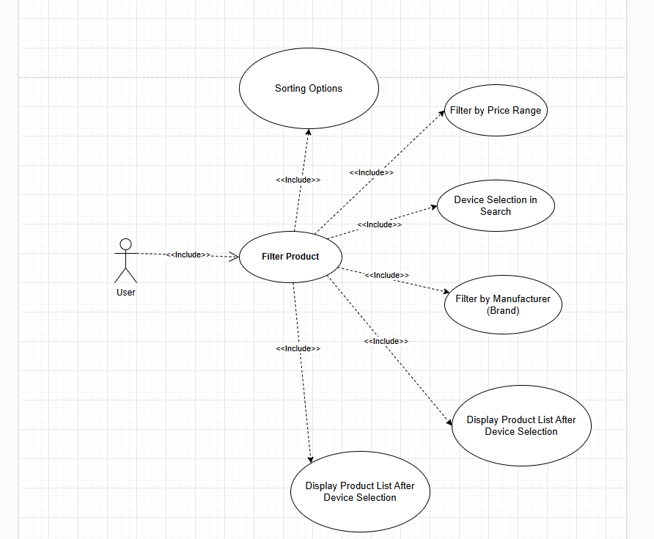

UC | Name | Description
UC001 | Filter Product | The function allows users to filter product lists based on criteria such as product type, price, brand, condition (new/old), and other typical attributes to quickly find suitable products. with need.

Entity relationship diagram
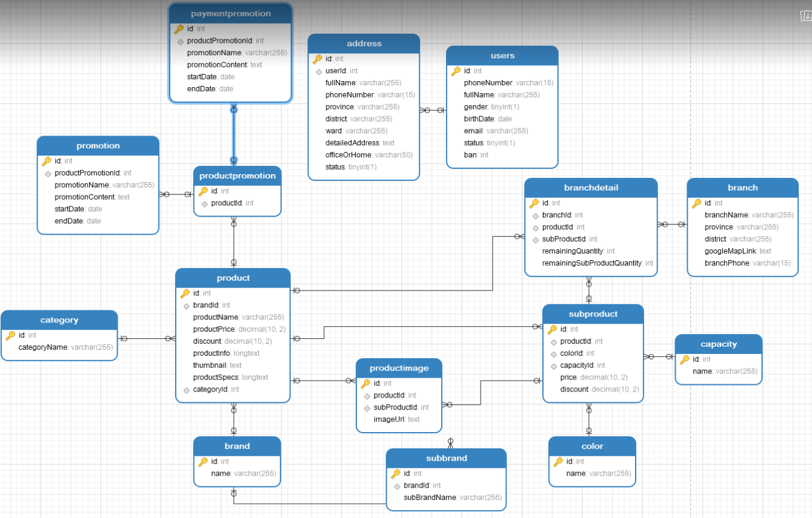

https://gyazo.com/2d5137e9e507d5a773d11d7a6ba8801e

# | Entity | Description
1 | Product | Information about products, including price, specifications, and description.
2 | Users | List of all users in the system.
3 | Address | List of all addresses used in the system.
4 | Category | Product categories in the system.
5 | Promotion | Details of promotional programs for products.
6 | Service | List all services
7 | ProductPromotion | Relationship between products and promotional programs.
8 | Branch | Information about branches where products are sold.
9 | BranchDetail | Detailed inventory information at each branch.
10 | SubProduct | Information about sub-brands of the products.
11 | SubBrand | List all Towns in the system
12 | Capacity | Product capacity.
13 | Color | Product color.
14 | ProductImage | List of product images.
15 | PaymentPromotion | Information about payment promotion programs.

Functionality Requirements

Filter Product

Device Selection in Search
The system provides users with the ability to select a product type from a search bar or drop-down menu.

Product types include:

- Laptop
- Screen
- Tablet
- Tivi
- PC
- Other electronic devices

When the user selects a device type from the search bar or available list, the system will automatically:

- Displays a list of products that match the selected device type.
- Update detailed filters corresponding to device type.

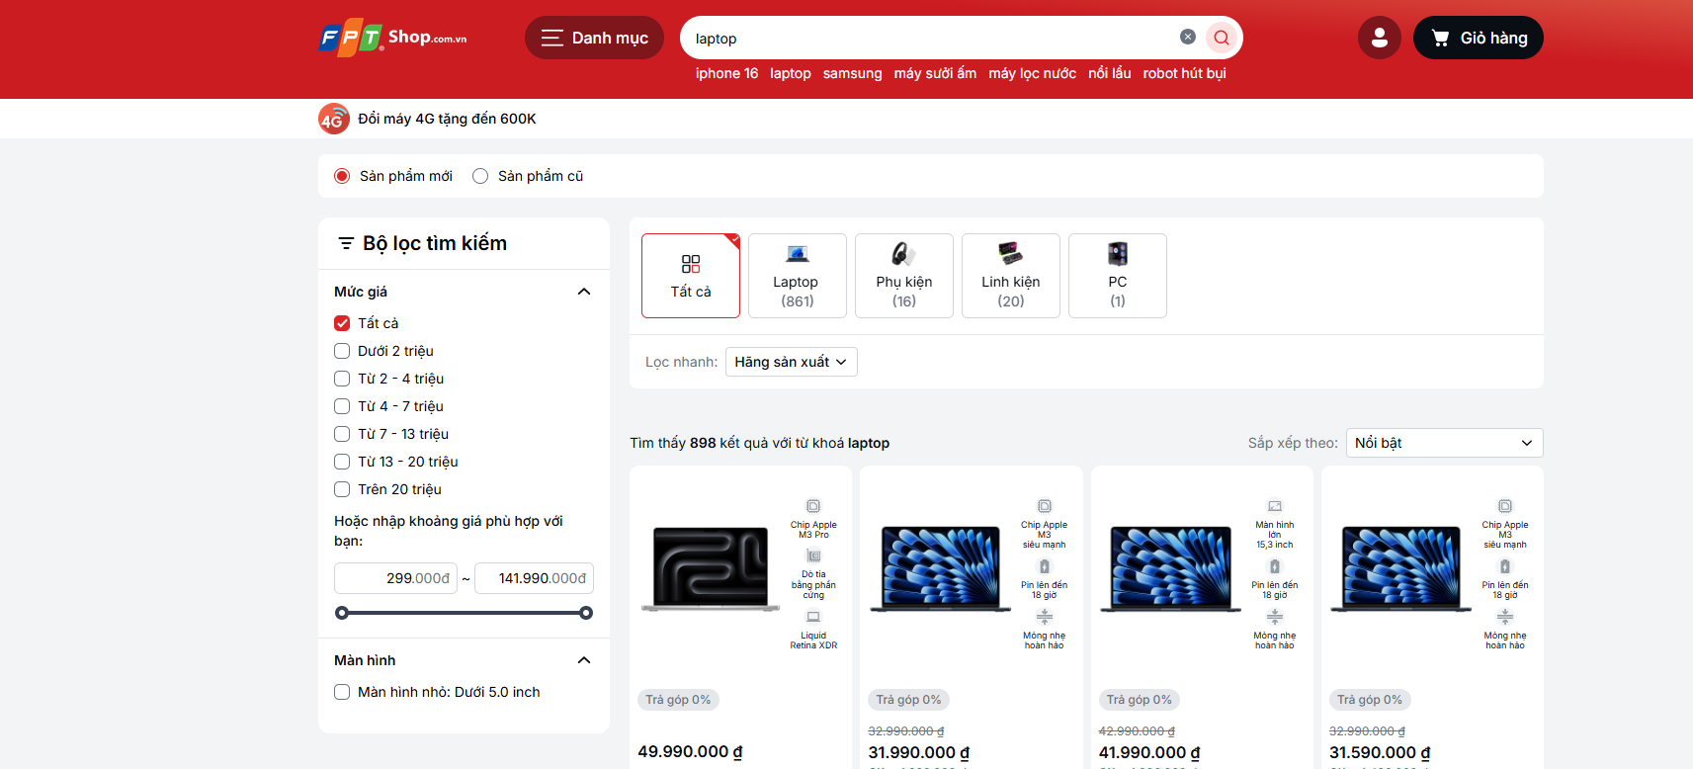

After selecting the device type, the system will automatically update detailed filters corresponding to the selected product type.

Selecting device type before filtering helps ensure that users only see filters and product listings that match the product type they are searching for. This helps reduce the number of irrelevant filters, improving the user experience.

Display Product List After Device Selection
After the user selects the device type, the system will display a list of products belonging to that category.

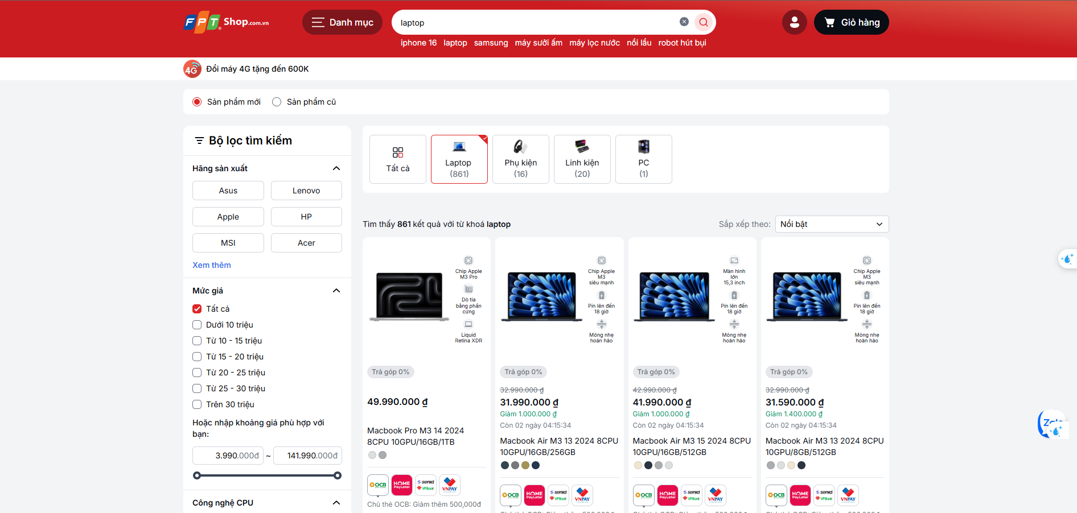

Displayed product information includes: product name, price, brand, stock status (in stock/temporarily out of stock), and promotion information.

All products will be displayed on a single page without pagination. Users can scroll down to see all products in the selected category.

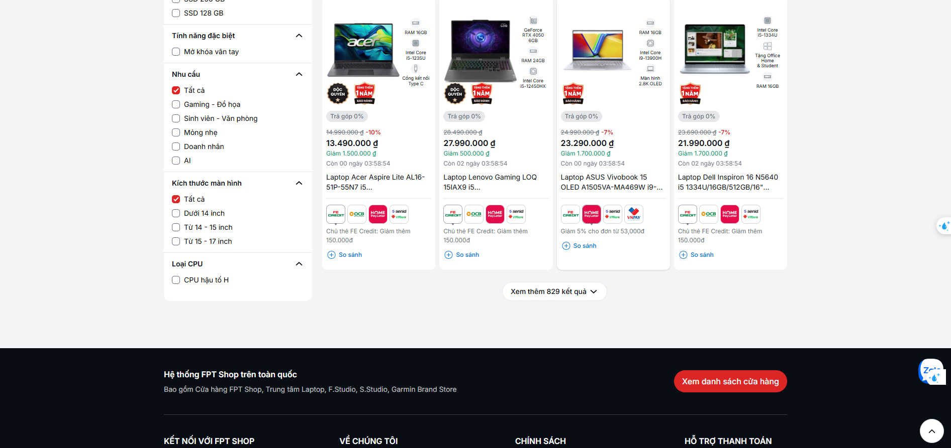

Filter by Price Range
The system provides fixed price ranges for users to choose from, including the following prices:

After editing, the administrator clicks the Update button to save the changes. If any information is invalid, the system will display the corresponding error message and will not allow updating the information until all information is valid.

- Under 10 million
- From 10 - 15 million
- From 15 - 20 million
- From 20 - 25 million
- From 25 - 30 million
- Over 30 million

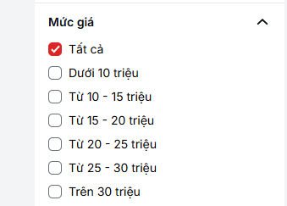

Additionally, users can also enter custom price ranges by entering minimum and maximum values. Another way is to lock the price bar to adjust the price you want.

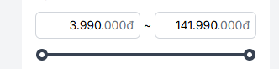

After the user selects or enters a price range, the system refreshes the product list to display only products within the selected price range.

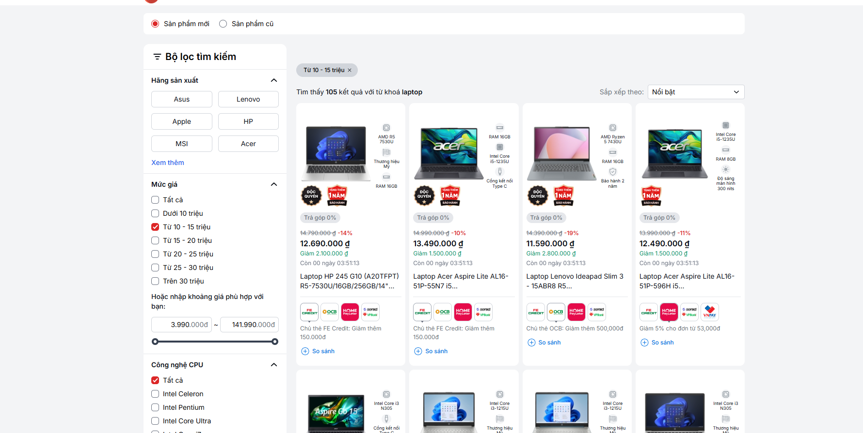

If there are no products matching the price range, the system will display the message "Sorry, we couldn't find any matching products".

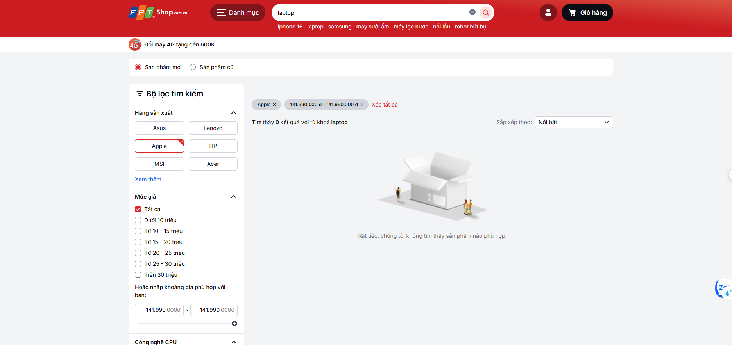

Filter by Manufacturer (Brand)
The system provides brand filters suitable for each selected product type, for example:

- Laptops: Dell, HP, Lenovo, Asus, Apple.

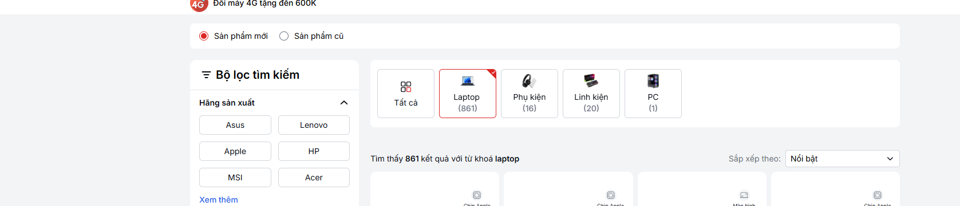

- Phone: Samsung, Apple, Oppo, Xiaomi.
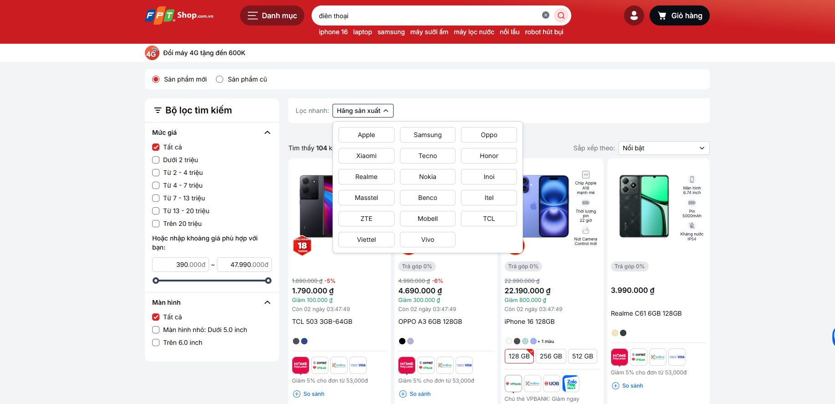

- Screen: LG, Samsung, Acer, Dell.

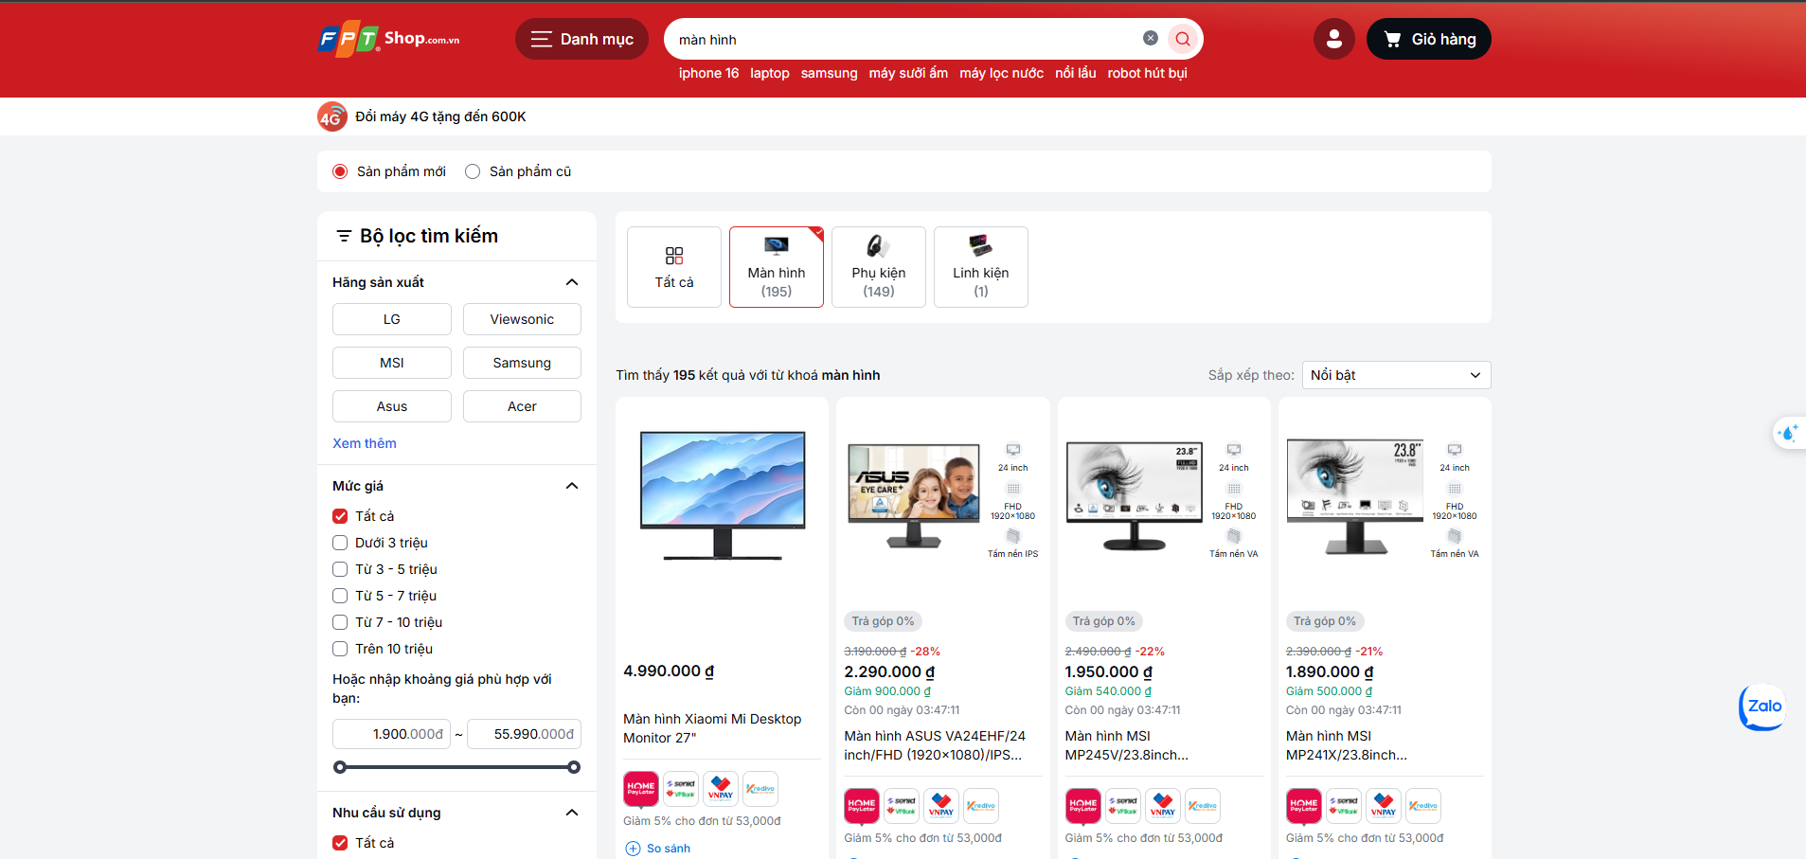

Users can select one or more brands to limit the displayed product list.

After selecting a brand, the system will refresh the product list to display only products from the selected brands.

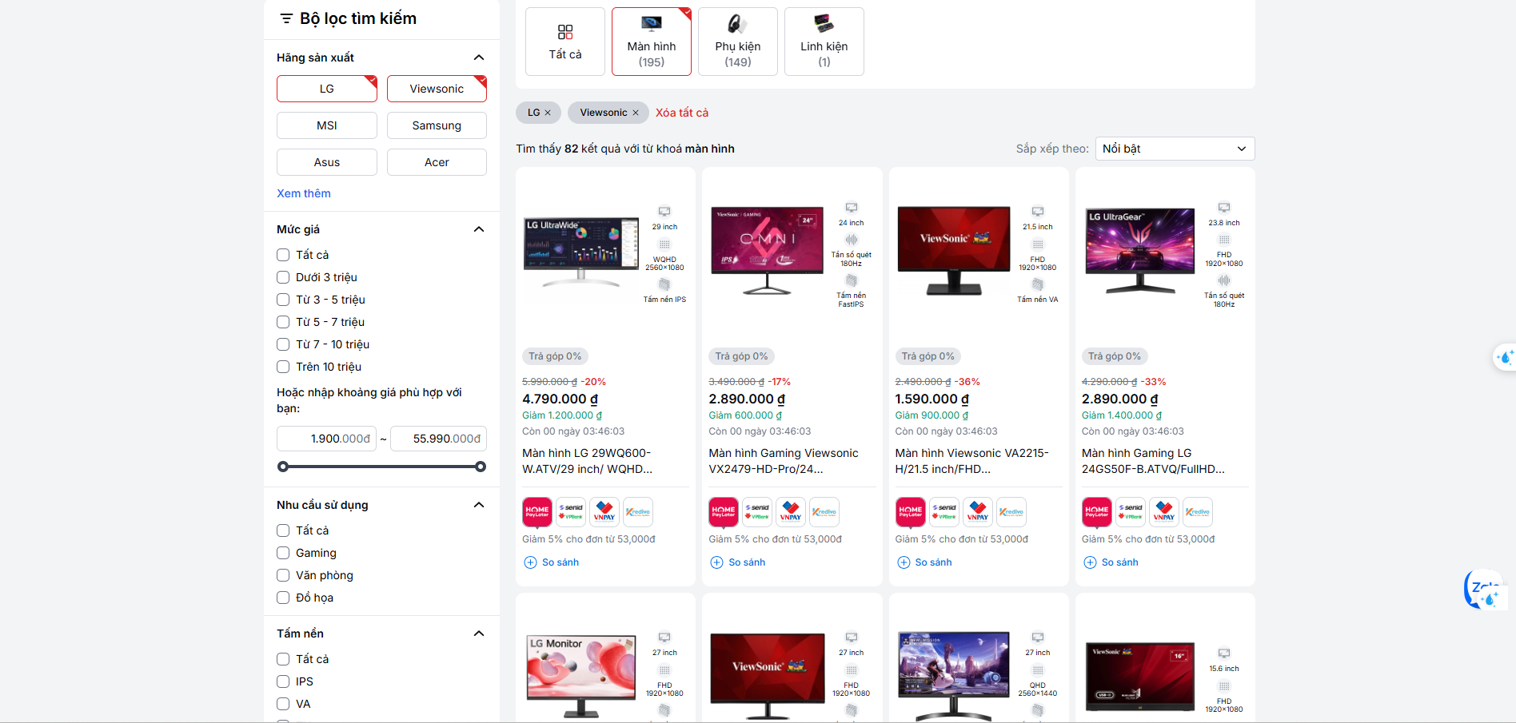

If there are no products matching the price range, the system will display the message "Sorry, we couldn't find any matching products".

Filter by Specific Attributes
The system supports specific filters for each device type. For example:

- Laptop: RAM, CPU, hard drive capacity, needs, screen size.
- Screen: Screen size, resolution, needs, panel type.
- Phone: Chipset, battery capacity, operating system, camera, network support, connectivity.

Users can select specific attributes from the filter list for each device type.

The system will refresh the product list to display only products that meet the selected attributes.

Sorting Options
The system provides sorting options for product lists so users can easily compare and choose. Sorting criteria include:

- Featured: Sort product lists by popularity, based on factors like sales volume, high ratings, or high views.
- Lowest price: Sort the product list by price from low to high, helping users find products that suit the most economical budget.
- Highest Price: Sort product lists by price from high to low, suitable for users who want to see premium products or high-value options.
- 0% installment payment: Filter and sort the list to only display products that support 0% installment payment options, suitable for users interested in interest-free installment payments.

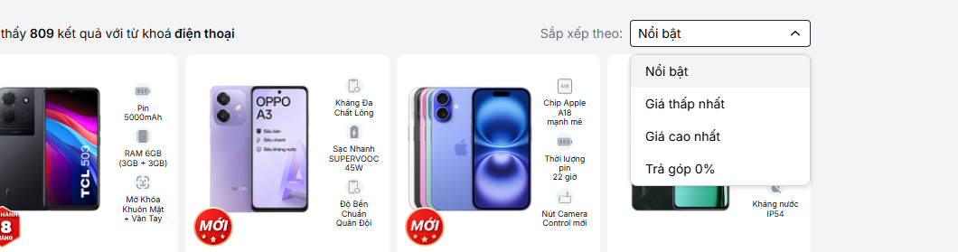

The system provides filters for product status, allowing users to easily choose between New Products and Old Products.

- New products: Only display products that are unused, unopened, and in brand new condition.
- Used products: Show only used products or used products that are being resold at a reduced price.

The goal of this function is to provide flexibility in product search and selection, helping users easily find the desired product according to personal preferences or financial needs.

Non-functional requirements

Performance
Requirements relating to Performance
No. | Requirement
1. | The system must ensure a response time of no more than 5 seconds for adding, editing, and deleting data.
2 | The system must support concurrent processing of at least 100 users at a time without performance degradation.

Scalability
Requirements relating to Scalability
No. | Requirement
1. | The system must be scalable to serve up to 10,000 users without affecting performance.

Security
Requirements relating to Security
No. | Requirement
1. | The system must use a standard secure authentication and authorization mechanism, such as OAuth 2.0 or JWT.

Portability
Requirements relating to Security
No. | Requirement
1. | The system must be compatible with all modern browsers such as Google Chrome, Firefox, Microsoft Edge.

Audit
Requirements relating to Audit
No. | Requirement
1. | None required at present.

Error handling
Requirements relating to Error handling
No. | Requirement
1. | The system must display detailed messages to the user when an error occurs, and save error information in the log file.

Infrastructure
Requirements relating to Infrastructure
No. | Requirement
1. | All services inside Service Directory are expected to be hosted under https for security purposes. Shaw-trust to confirm if they can provide an appropriate SSL infrastructure.

Look and feel
Requirements relating to Look and feel
No. | Requirement
1. | The system's interface should be easy to use, follow modern UI/UX design principles, and have user-friendly colors.

Legal
Requirements relating to Legal issues
No. | Requirement
1. | None required at present.

Training
Requirements relating to Training
No. | Requirement
1. | There must be documentation and video instructions on how to use the system for end users and administrators.

User Documentation & Help Screen Requirements
Requirements relating to User Documentation
No. | Requirement
1. | A help icon will be provided in the corner of the user management screen, allowing administrators to click to download a detailed help page on the functions of adding new, editing, deleting and granting permissions to users. Help content clearly explains each step of these functions, including error handling instructions. This document will be updated and maintained by the document management department. This requirement will be implemented in phase 2 of the project.

Support & Supportability
Requirements relating to Support
No. | Requirement
1. | The system must have 24/7 support service during the testing period and a 6-month warranty after official deployment.

Reliability
Requirements relating to Reliability
No. | Requirement
1. | The system must ensure continuous operation 24/7 with service downtime not exceeding 99.9% per month.

Design Constraints
Requirements relating to Design
No. | Requirement
1. | The system design must follow object-oriented design principles and be scalable when new features are added.
2. | The system design must ensure integration with external systems through APIs.

Purchased Components
Requirements relating to Components
No. | Requirement
1. | None required at present.

Interfaces
Requirements relating to Interfaces
No. | Requirement
1. | The system must support communication via RESTful API to external applications.

Test
Requirements relating to Testing
No. | Requirement
1. | There must be a comprehensive testing plan that includes functional testing, security testing, and load testing.

Data
Requirements relating to Data
No. | Requirement
1. | The system must store user data and sensitive information according to AES-256 encryption standard.

