DOCUMENT HISTORY AND INFORMATION

History of Amendments:
Date | Version | Modified Section | Summary of Change | Author
17/10/2024 | 0.1 | ALL | Initial Draft | Tran Duy Tan

Distributed for Review
This document has been distributed for the following to review:
Name | Title & Company | Issue Date | Revision
Approvals
This document requires the following approvals:
Name | Signature | Title | Issue Date

Associated Documents
This document is associated with the following other documents:
Name | Title and Originator’s Reference | Source | Issue Date | Version

Tables of Contents
1 Introduction 3
2 Purpose 3
3 Scope 3
4 Definitions, Acronyms and Abbreviations 3
5 Overview 3
5.1 Use case diagram 3
5.2 Entity relationship diagram 4
6 Functionality Requirements 6
6.1 Category Management 6
6.1.1 View Categories 6
6.1.2 Add New Category 6
6.1.3 Edit Category 7
6.1.4 Delete Category 8
6.1.5 Reorder Categories 9
6.1.6 Search Categories 9
7 Non-functional requirements 10
7.1 Performance 10
7.2 Scalability 10
7.3 Security 11
7.4 Portability 11
7.5 Audit 11
7.6 Error handling 11
7.7 Infrastructure 12
7.8 Look and feel 12
7.9 Legal 12
7.10 Training 12
7.11 User Documentation & Help Screen Requirements 12
7.12 Support & Supportability 13
7.13 Reliability 13
7.14 Design Constraints 13
7.15 Interfaces 13
7.16 Test 14
7.17 Data 14

Introduction
Currently, Fshop does not have a centralized system to comprehensively manage user information. This leads to data fragmentation and difficulty in controlling user permissions. This system requirements document is part of a project to implement a user management system for Fshop. This system will provide a centralized data warehouse, allowing administrators to easily manage user information, assign permissions, and maintain security throughout the system.

Purpose
The purpose of this document is to outline the functional and non-functional requirements for the category management feature of the admin panel on the FPT Shop website. This feature enables administrators to manage product categories, ensuring that users can easily navigate through different sections of the website.

Scope
The category management function allows administrators to create, update, delete, and organize categories displayed on the FPT Shop website. This includes high-level categories (such as Electronics, Home Appliances, etc.), as well as subcategories (like Apple Store, Samsung Store, etc.).

Definitions, Acronyms and Abbreviations
• Admin: A user with privileges to manage content on the FPT Shop website.
• Category: A grouping of products displayed on the website.
• Subcategory: A subset of a main category (e.g., "Apple Store" under "Mobile Phones").

Overview

Use case diagram
The following use cases are required to be to be included in the Category Management.
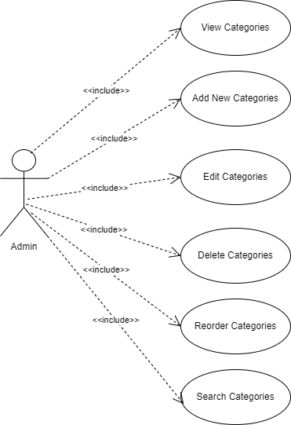

Entity relationship diagram

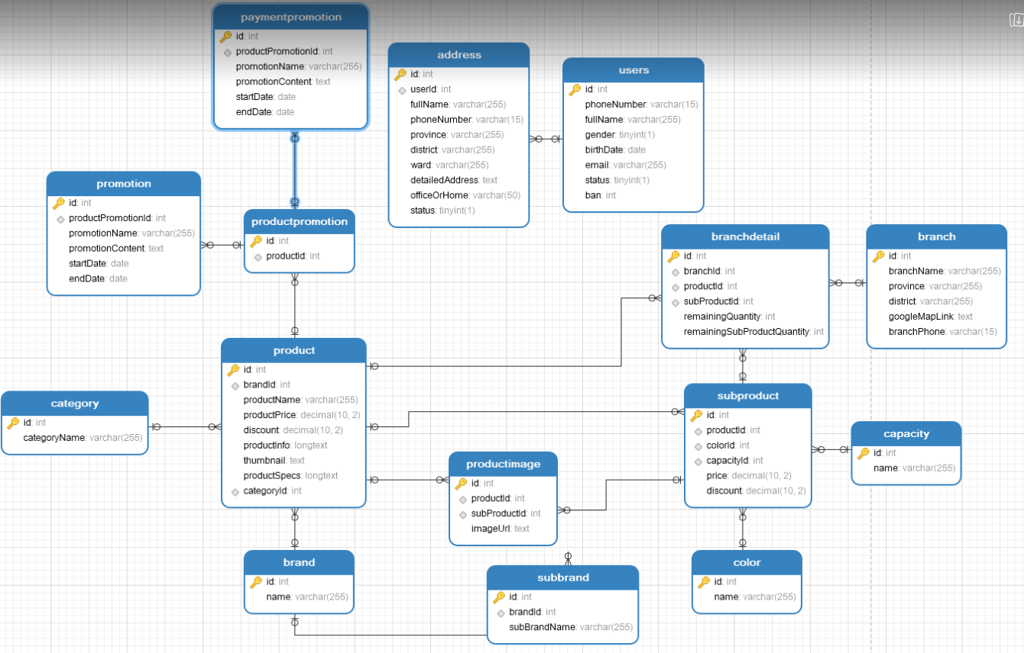

# | Entity | Description
1 | Product | Information about products, including price, specifications, and description.
2 | Users | List of all users in the system.
3 | Address | List of all addresses used in the system.
4 | Category | Product categories in the system.
5 | Promotion | Details of promotional programs for products.
6 | Service | List all services
7 | ProductPromotion | Relationship between products and promotional programs.
8 | Branch | Information about branches where products are sold.
9 | BranchDetail | Detailed inventory information at each branch.
10 | SubProduct | Information about sub-brands of the products.
11 | SubBrand | List all Towns in the system
12 | Capacity | Product capacity.
13 | Color | Product color.
14 | ProductImage | List of product images.
15 | PaymentPromotion | Information about payment promotion programs.

Functionality Requirements

6.1 Category Management

6.1.1 View Categories
• Description: Admins can view the list of all available categories and subcategories in the system.
• Pre-condition:
Admin is logged into the admin panel.
Admin has necessary permissions to view category management options.
• Post-condition:
- All categories and subcategories are displayed in a hierarchical format (with indentation for subcategories).
- Categories are accompanied by relevant information such as name, icon, and parent category (if applicable).
• Input:
None, the system fetches all categories from the database.
• Output:
- Display of categories with the following attributes:
- Category Name
- Category Icon (if any)
- Parent Category (if subcategory)
- Number of Products Associated with the Category
• Detailed Steps:
- Admin navigates to the category management section in the admin panel.
- System fetches all categories and subcategories from the database.
- The system displays categories in a hierarchical structure (with options to expand/collapse subcategories).
- Admin can click on a category to view additional details or edit options.
• Priority: High.

Add New Category
• Description: Admins can add a new category to the website, either as a main category or a subcategory under an existing category.
• Pre-condition:
Admin is logged into the admin panel.
Admin has necessary permissions to add new categories.
• Post-condition:
- The new category is created and added to the category hierarchy in the system.
- The category is immediately visible on the user-facing website, unless marked as inactive.
• Input:
- Category Name (mandatory)
- Parent Category (optional, for subcategories)
- Category Icon (optional, can be uploaded or selected from a set of icons)
- Status (Active/Inactive)
- Description (optional)
• Output:
A confirmation message indicating the successful creation of the category.
The new category appears in the category list.
• Detailed Steps:
- Admin clicks on the “Add New Category” button.
- A form is presented where the admin enters the following:
- Name of the category.
- (Optional) Select a parent category if this is a subcategory.
- (Optional) Upload or choose an icon for the category.
- (Optional) Set status as "Active" or "Inactive."
- Admin clicks "Submit."
- The system validates that the category name is unique within its level (main or subcategory).
- The system saves the new category to the database.
- The system updates the category list and provides a success notification.
• Priority: High.

Edit Category
• Description: Admins can edit the details of an existing category, such as its name, icon, or parent category.
• Pre-condition:
Admin is logged into the admin panel.
Admin has necessary permissions to edit categories.
• Post-condition:
The updated category information is saved in the system, and the category is updated on the website.
• Input:
    - Existing category to be edited.
    - New values for any or all of the following:
    - Category Name (mandatory)
    - Parent Category (optional, to change the hierarchical structure)
    - Category Icon (optional)
    - Status (Active/Inactive)
    - Description (optional)
• Output:
Confirmation message indicating successful edit.
Updated category displayed in the list.
• Detailed Steps:
    - Admin selects a category from the list and clicks the “Edit” button.
    - The system displays the existing details of the selected category.
Admin modifies any of the fields, such as changing the category name or uploading a new icon.
    - Admin submits the changes.
    - The system validates the inputs (e.g., ensuring the category name remains unique within its hierarchy).
    - The system saves the changes to the database and updates the category list.
    - The system provides a success notification.
• Priority: Medium.

Delete Category
• Description: Admins can delete a category or subcategory from the system.
• Pre-condition:
Admin is logged into the admin panel.
Admin has necessary permissions to delete categories.
• Post-condition:
The selected category is deleted from the system.
All associated products are moved to an "Uncategorized" section, or admin is prompted to reassign them to another category.
• Input:
Selected category for deletion.
• Output:
Confirmation prompt before deletion.
Success or failure message indicating the result of the action.
• Detailed Steps:
    - Admin selects a category from the list and clicks the “Delete” button.
    - The system prompts the admin with a confirmation message: “Are you sure you want to delete this category? Any products under this category will need to be reassigned or moved to ‘Uncategorized.’”
    - Admin confirms the deletion.
    - The system checks if the category contains any subcategories or associated products:
    - If yes, the system asks if the admin wants to move those items to a different category or delete them as well.
    - Upon confirmation, the system deletes the category from the database.
    - The system updates the category list and provides a success notification.
• Priority: Medium.

Reorder Categories
• Description: Admins can change the order of categories and subcategories to control how they are displayed on the website.
• Pre-condition:
Admin is logged into the admin panel.
Admin has necessary permissions to reorder categories.
• Post-condition:
The new order of categories is saved, and the updated structure is reflected on the website.
• Input:
Drag-and-drop actions or manual input to change category order.
• Output:
Confirmation message indicating successful reorder.
Updated category order is displayed in the list.
• Detailed Steps:
    - Admin selects a category from the list.
    - Admin either drags and drops the category to a new position or enters a new position value.
    - The system saves the new order.
    - The system updates the category display on the website.
    - A success notification is shown.
• Priority: Low.

Search Categories
• Description: Admins can search for a category or subcategory by name or keyword.
• Pre-condition:
Admin is logged into the admin panel.
Admin has necessary permissions to access category management.
• Post-condition:
The system displays a list of categories that match the search query.
• Input:
Search query (name, keyword, or part of a category name).
• Output:
List of categories that match the search criteria.
• Detailed Steps:
    - Admin enters a keyword or category name into the search bar.
    - The system searches for matching categories.
    - The system displays a list of results, including relevant subcategories.
    - Admin can click on a result to view or edit the category details.
• Priority: Medium.

Non-functional requirements

Performance
Requirements relating to Performance
No. | Requirement
1. | The system should ensure quick response times for category management actions. Based on standard testing environments, the expected performance is as follows:  - Add Category: The system should allow the admin to add a new category (assuming around 5 fields: category name, parent category, icon, status, description) within 3-5 seconds. The first operation may take up to 10 seconds due to initial loading, but subsequent operations should take less than 5 seconds.  - View Categories: For displaying the list of categories (up to 1000 categories), the initial response time may take up to 15 seconds, while subsequent view operations should take less than 10 seconds.  - Edit/Delete Category: Response times for editing or deleting categories should not exceed 5 seconds.  - Validation of Inputs: All validation processes for category fields (such as unique category names) should not exceed 2 seconds.
2 | The system should be able to handle 20-50 concurrent users performing category management tasks without significant degradation in performance.

Scalability
Requirements relating to Scalability
No. | Requirement
1. | The category management system should be able to scale to handle the increasing number of categories as well as growing numbers of concurrent admin users. The system should ensure that performance remains optimal even with a larger volume of categories and users.

Security
Requirements relating to Security
No. | Requirement
1. | Standard authentication and authorization mechanisms should be employed. Only authorized users (admins) should have access to category management functionality, and role-based access control should ensure that sensitive operations such as deleting categories are restricted to high-level admins.

Portability
Requirements relating to Security
No. | Requirement
1. | The category management system should function properly across multiple browsers and devices, particularly Internet Explorer 6.0 or later, and Firefox. Compatibility with newer browsers (Chrome, Edge, Safari) should also be ensured.

Audit
Requirements relating to Audit
No. | Requirement
1. | None required at present.

Error handling
Requirements relating to Error handling
No. | Requirement
1. | The system should provide proactive notifications in the event of errors during category management tasks. For instance:  - Validation errors (e.g., duplicate category names) should be communicated clearly to the admin.  - Critical errors (e.g., database connection failures) should trigger alerts to the system administrator.  - Errors should be logged for further diagnosis.

Infrastructure
Requirements relating to Infrastructure
No. | Requirement
1. | All communications between the admin panel and the category management system should be secured using HTTPS. SSL/TLS certificates should be implemented to encrypt data exchanges, ensuring security.

Look and feel
Requirements relating to Look and feel
No. | Requirement
1. | The category management interface should be consistent with the overall look and feel of the FPTShop admin panel. This includes following modern UI standards with easy-to-use features, responsive design, and adherence to branding guidelines. Consistent styling similar to the mockups provided for other sections should be maintained.

Legal
Requirements relating to Legal issues
No. | Requirement
1. | None required at present.

Training
Requirements relating to Training
No. | Requirement
1. | None required at present.

User Documentation & Help Screen Requirements
Requirements relating to User Documentation
No. | Requirement
1. | An icon should be available in the category management panel to provide access to a help section. This section will contain documentation on how to add, edit, delete, and manage categories. The help content should be maintained by the admin team.

Support & Supportability
Requirements relating to Support
No. | Requirement
1. | Fully support during UAT and 3 month warranty support

Reliability
Requirements relating to Reliability
No. | Requirement
1. | The system should be available 24/7 without failure. Any unhandled exceptions or crashes within the category management service must be addressed promptly. Proper error handling should prevent any downtime due to unexpected issues.

Design Constraints
Requirements relating to Design
No. | Requirement
1. | The design of the category management system should adhere to best practices for UI and UX, ensuring a smooth experience for admins. The system should be designed in a modular way to facilitate future updates or feature expansions.
2. | The system’s design should also be compliant with other core systems at FPTShop (e.g., the product management system), ensuring interoperability and data consistency across the platform.
Purchased Components
Requirements relating to Components
No. | Requirement
1. | None required at present.

Interfaces
Requirements relating to Interfaces
No. | Requirement
1. | None required at present.

Test
Requirements relating to Testing
No. | Requirement
1. | None required at present.

Data
Requirements relating to Data
No. | Requirement
1. | None required at present.

