DOCUMENT HISTORY AND INFORMATION

History of Amendments:
Date | Version | Modified Section | Summary of Change | Author
12/10/2024 | 0.1 | ALL | Initial Draft | Nguyễn Hoàng Tú

Distributed for Review
This document has been distributed for the following to review:
Name | Title & Company | Issue Date | Revision
Approvals
This document requires the following approvals:
Name | Signature | Title | Issue Date

Associated Documents
This document is associated with the following other documents:
Name | Title and Originator’s Reference | Source | Issue Date | Version

Table of contents

1 Introduction 4
2 Purpose 4
3 Scope 4
4 Definitions, Acronyms and Abbreviations 4
5 Overview 4
5.1 Use case diagram 4
5.2 Entity relationship diagram 6
6 Functionality Requirements 7
6.1 User management 7
6.1.1 List User 7
6.1.2 Add New User 7
6.1.3 Edit user information 8
6.1.4 Delete user 8
6.1.5 Grant permissions to users 9
7 Non-functional requirements 9
7.1 Performance 9
7.2 Scalability 9
7.3 Security 10
7.4 Portability 10
7.5 Audit 10
7.6 Error handling 10
7.7 Infrastructure 10
7.8 Look and feel 10
7.9 Legal 11
7.10 Training 11
7.11 User Documentation & Help Screen Requirements 11
7.12 Support & Supportability 11
7.13 Reliability 11
7.14 Design Constraints 11
7.15 Purchased Components 12
7.16 Interfaces 12
7.17 Test 12
7.18 Data 12

Introduction
Currently, Fshop does not have a centralized system to comprehensively manage user information. This leads to data fragmentation and difficulty in controlling user permissions. This system requirements document is part of a project to implement a user management system for Fshop. This system will provide a centralized data warehouse, allowing administrators to easily manage user information, assign permissions, and maintain security throughout the system.

Purpose
The purpose of this document is to provide a detailed description of the functional and non-functional requirements of the user management system in a system such as Fshop. This function allows administrators (Admin) and users with advanced rights to manage user lists, add new, modify, delete and grant rights to users in the system.

Scope
The user management function will include the following activities:
- View list of users.
- Allows administrators to manage users (add, edit, delete).
- Grant and manage role-based access.
- Manage user activation status (Active/Inactive).

Definitions, Acronyms and Abbreviations
<TBD>

Overview

Use case diagram
The following use cases are required to be to be included in the User Management
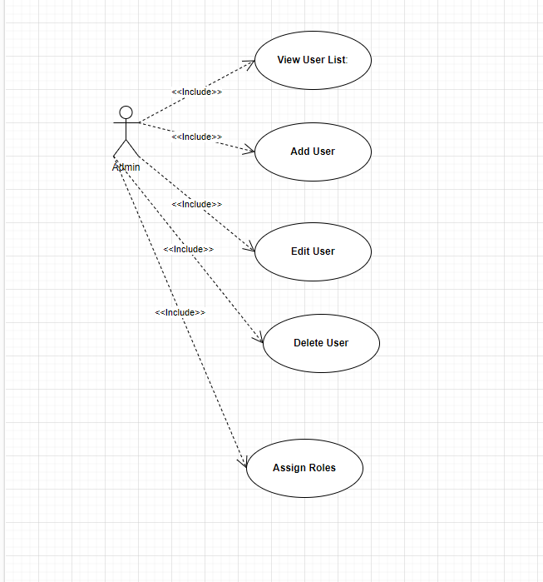

UC | Name | Description
UC001 | User management | The user management function allows administrators or systems to manage user information and activities

Entity relationship diagram
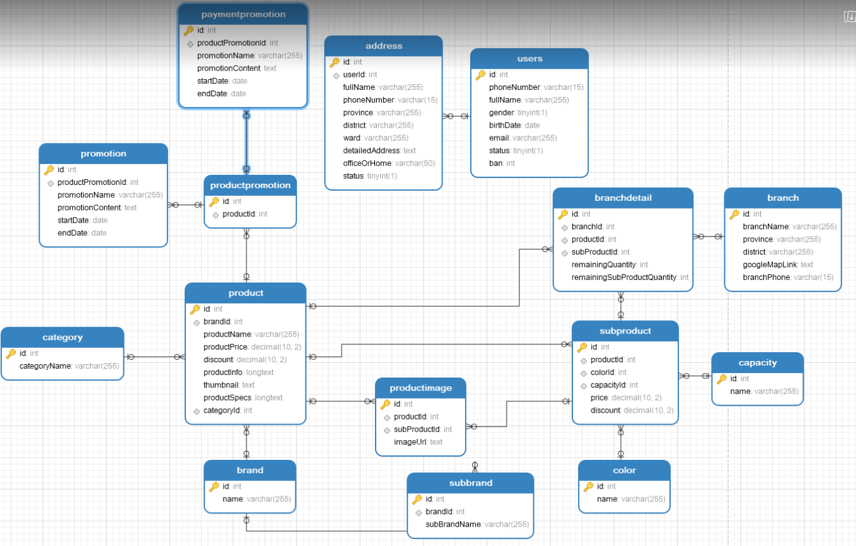

https://gyazo.com/2d5137e9e507d5a773d11d7a6ba8801e

# | Entity | Description
1 | Product | Information about products, including price, specifications, and description.
2 | Users | List of all users in the system.
3 | Address | List of all addresses used in the system.
4 | Category | Product categories in the system.
5 | Promotion | Details of promotional programs for products.
6 | Service | List all services
7 | ProductPromotion | Relationship between products and promotional programs.
8 | Branch | Information about branches where products are sold.
9 | BranchDetail | Detailed inventory information at each branch.
10 | SubProduct | Information about sub-brands of the products.
11 | SubBrand | List all Towns in the system
12 | Capacity | Product capacity.
13 | Color | Product color.
14 | ProductImage | List of product images.
15 | PaymentPromotion | Information about payment promotion programs.

Functionality Requirements

User management

List User
Administrators can access user management from the system's main navigation bar. After entering the list interface, the system will display full user information such as full name, email, phone number, role, activation status and registration date.

Users can search for other users using the search bar located in the upper right corner, allowing searches by name, email or phone number.

Besides, there are filters that allow administrators to filter users by role or activation status. The list is paginated with each page displaying up to 20 users, making it easier to manage when there are many users.

NOTE: Above listing, filtering, sorting and marking an in-active record to active behaviors are standard features in a list screen in the whole system.

Add New User
If user clicks on ‘Add User button in the upper right corner of ‘User list’ screen, ‘After pressing the button, an input form will appear.

By default, all of fields should be blank, all check boxes should be un-ticked.

There are some rules on this screen:
- Mandatory fields
  - Full Name
  - Email
  - Password
  - Address
  - Birth
  - Role (Administrator, Salesperson, Customer)
  - Activation status (active now or not activated)

- Unique fields
  - Full Name
- Email: The system will check the email format when entering. If the email is invalid (for example, missing the "@" or ".com" character), an error message will display directly below the email field that reads: "Please enter a valid email address." The email must also be unique in the system. If the email already exists, the system will display the message: "This email already exists in the system."

- Password: Password must meet the minimum security requirements of at least 8 characters, including at least one letter, one number and one special character. If the password is not strong enough, the system will display an error message below the password field that reads: "Password must have at least 8 characters, including letters, numbers, and special characters."

- Phone number: The system will check the phone number format, asking to enter a valid number sequence (for example, 10 digits for Vietnamese phone numbers). If the phone number is invalid, an error message will appear below the phone number field saying: "Invalid phone number. Please enter the correct format."

When an administrator enters malformed information in any field, the system will not allow the form to be submitted ("Save" button will be disabled) until all information is entered correctly. After filling in the correct information, the administrator clicks the "Save" button to complete the process of adding a new user. If all the information is valid, the account will be created and displayed in the user list.

- If user clicks on ‘Back’ button, it will come back to the User List screen.

NOTE: It is a standard behavior in the whole system. After user clicks on ‘Back’ button in a Details screen, the related List screen should be shown.

Edit user information
By clicking the Edit icon (pencil) in the line corresponding to the user in the list. After clicking the edit icon, an edit form will display with the same information fields as when adding a new user:

- Username: Administrators can edit the user's full name. The system does not specifically check this field but checks if it is blank, and displays the error message: "Full name cannot be blank."

- Email: If the administrator changes the email, the system will check the email format similar to when adding a new user. If the email is invalid, an error message is displayed: "Please enter a valid email address." The system will also check if the new email already exists in the system and display an error message: "This email already exists in the system."

- Phone number: Admin can update phone number for users. The system will check the phone number format similar to when adding a new user. If the phone number is invalid, an error message will be displayed: "Invalid phone number. Please enter the correct format."

- Role: If you have permission, the administrator can change the user's role from the dropdown list (Admin, Salesperson, Customer). The system will not allow administrators to lower their own role (if they are the highest Administrator).

- Status: Administrators can change a user's activation status (enable or disable account). If a user is disabled, they will not be able to log in to the system.

After editing, the administrator clicks the Update button to save the changes. If any information is invalid, the system will display the corresponding error message and will not allow updating the information until all information is valid.

Delete user
Administrators can delete users from the system by clicking the Delete icon (trash can) in the line corresponding to the user in the list. When clicking the delete icon, the system will display a confirmation message with the content:

"Are you sure you want to delete this user? All related information will be permanently deleted and cannot be recovered."

If the administrator selects OK, the system will perform a check:

- If the user has any orders that are incomplete or related to current business activities, the system will not allow deletion of the user and displays the error message: "The user cannot be deleted because it is still related to unprocessed orders."

- If the user has no bindings, the system deletes the user from the database. After successful deletion, the user list will be refreshed and the message "User deleted successfully" will be displayed on the screen.

Grant permissions to users
Administrators can change user permissions by selecting the user who needs permission and clicking the Edit icon (pencil). In the edit form, the admin can select a new role from the Roles dropdown (Admin, Salesperson, Customer).

Requirements when granting permission:
- The system will not allow administrators to grant Administrator rights to users if that administrator does not have the highest rights (Super Admin).
- The system will not allow administrators to lower their own rights. If an administrator is the only Administrator in the system, they will not be able to downgrade their permissions to avoid having no one to manage the system.
- If the user's permissions have been changed, after pressing the Update button, the system will save the user's role change history for ease of tracking.

If any information is invalid or does not have enough permissions to change, the system will display the corresponding error message.

Non-functional requirements

Performance
Requirements relating to Performance
No. | Requirement
1. | The system must ensure a response time of no more than 5 seconds for adding, editing, and deleting data.
2 | The system must support concurrent processing of at least 100 users at a time without performance degradation.

Scalability
Requirements relating to Scalability
No. | Requirement
1. | The system must be scalable to serve up to 10,000 users without affecting performance.

Security
Requirements relating to Security
No. | Requirement
1. | The system must use a standard secure authentication and authorization mechanism, such as OAuth 2.0 or JWT.

Portability
Requirements relating to Security
No. | Requirement
1. | The system must be compatible with all modern browsers such as Google Chrome, Firefox, Microsoft Edge.

Audit
Requirements relating to Audit
No. | Requirement
1. | None required at present.

Error handling
Requirements relating to Error handling
No. | Requirement
1. | The system must display detailed messages to the user when an error occurs, and save error information in the log file.

Infrastructure
Requirements relating to Infrastructure
No. | Requirement
1. | All services inside Service Directory are expected to be hosted under https for security purposes. Shaw-trust to confirm if they can provide an appropriate SSL infrastructure.

Look and feel
Requirements relating to Look and feel
No. | Requirement
1. | The system's interface should be easy to use, follow modern UI/UX design principles, and have user-friendly colors.

Legal
Requirements relating to Legal issues
No. | Requirement
1. | None required at present.

Training
Requirements relating to Training
No. | Requirement
1. | There must be documentation and video instructions on how to use the system for end users and administrators.

User Documentation & Help Screen Requirements
Requirements relating to User Documentation
No. | Requirement
1. | A help icon will be provided in the corner of the user management screen, allowing administrators to click to download a detailed help page on the functions of adding new, editing, deleting and granting permissions to users. Help content clearly explains each step of these functions, including error handling instructions. This document will be updated and maintained by the document management department. This requirement will be implemented in phase 2 of the project.

Support & Supportability
Requirements relating to Support
No. | Requirement
1. | The system must have 24/7 support service during the testing period and a 6-month warranty after official deployment.

Reliability
Requirements relating to Reliability
No. | Requirement
1. | The system must ensure continuous operation 24/7 with service downtime not exceeding 99.9% per month.

Design Constraints
Requirements relating to Design
No. | Requirement
1. | The system design must follow object-oriented design principles and be scalable when new features are added.
2. | The system design must ensure integration with external systems through APIs.

Purchased Components
Requirements relating to Components
No. | Requirement
1. | None required at present.

Interfaces
Requirements relating to Interfaces
No. | Requirement
1. | The system must support communication via RESTful API to external applications.

Test
Requirements relating to Testing
No. | Requirement
1. | There must be a comprehensive testing plan that includes functional testing, security testing, and load testing.

Data
Requirements relating to Data
No. | Requirement
1. | The system must store user data and sensitive information according to AES-256 encryption standard.

