# Performance Testing Report

Performance testing approach, common aspects and goals are described in performance testing strategy.

The main performance testing objectives are:

* Measure response times on each test step and check if they comply to NFR.
* Find system resources bottlenecks by analyzing resources consumption (CPU and memory utilizations, network resources etc.) under given conditions.
* Provide analysis data to define a configuration that could offer optimum performance.

## Status

PASSED

## Key Findings

The Animeal application was tested for ramp-up, load, and stability, and based on the results, it can be concluded that the app is able to handle a peak load of 200 concurrent users without any performance issues and with acceptable response time and throughput. The application is also stable, reliable, and highly available, with no significant issues observed during the stability testing period.

## Testing Approach

### Scenarios

Admin:

1. Manage feeding point  
   Steps:
   1. View the list of feeding point
   2. CRUD feeding point

Volunteer:

1. Find and view feeding point
2. Commit to fill a bowl
3. Upload a picture to mark the completion of the feeding

### Test types

During performance testing next types of tests were conducted:

|  |  |  |
| --- | --- | --- |
| **Test type** | **Goal** | **Estimated time** |
| **Ramp-up** | To find system capacity – the number of virtual users which the application support in stable state. | 1 hour 19 minutes |
| **Load** | To assess the behavior of the system under specific level of load and compare it against target/previous release results. | 2 hours 26 minutes |
| **Stability** | To assess system stability during long-time load and find memory leaks. Check if backend background activities affect system performance. | 8 hours 27 minutes |

## Results

### Ramp-up

The application was able to handle an average of 13.37 transactions per second, with a maximum of 25 transactions per second. This indicates that the app was able to handle the peak load without any issues.  
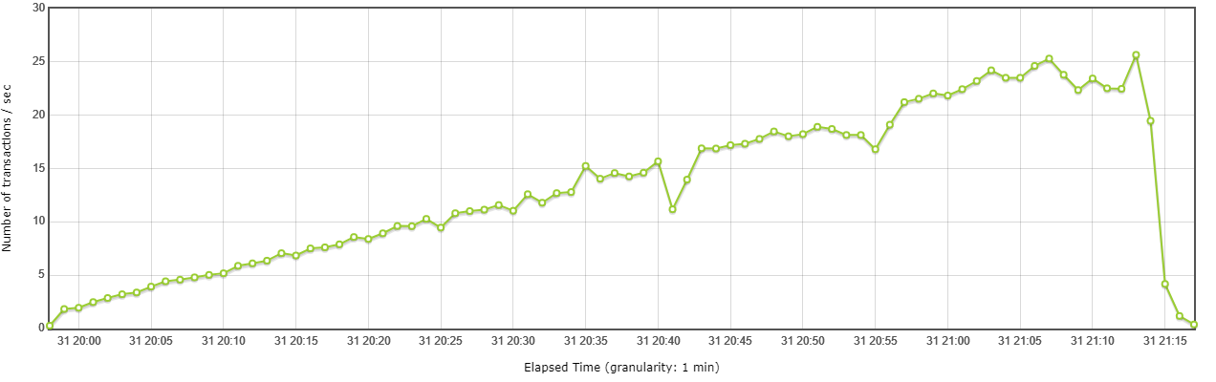

The response time remained consistent throughout the test, indicating that the application was able to handle the load without slowing down.  
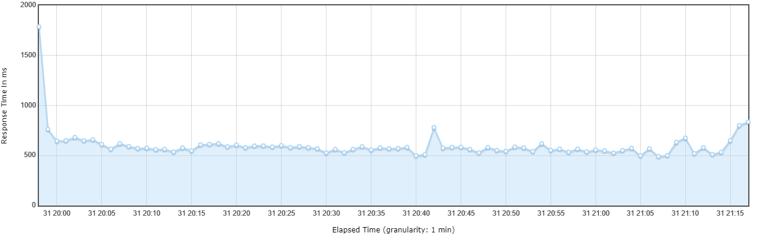

The CPU and memory utilization of the application remained within acceptable limits throughout the test. The app did not experience any performance issues due to resource constraints.

Conclusion

Based on the results of the ramp-up testing, we can conclude that the app is able to handle a peak load of 200 concurrent users without any performance issues.  
The response time and throughput remained consistent, and the resource utilization was within acceptable limits.

### Load

The application's average response time was 343.26 milliseconds, and the 90th percentile response time was 594 milliseconds.  
These response times are compliant with the application's Non-Functional Requirements (NFRs), indicating that the application is performing well.

|  |  |  |  |  |  |  |  |
| --- | --- | --- | --- | --- | --- | --- | --- |
| **Step** | **# samples** | **Average** | **Min** | **Max** | **Median** | **90th pct** | **Transactions/s** |
| **Total** | **123935** | **343.26** | **152** | **22401** | **341.00** | **594.00** | **29.95** |
| **createFeedingPoint** | 566 | 236.91 | 175 | 1236 | 205.00 | 327.30 | 0.25 |
| **getFeedingPoint** | 18725 | 267.91 | 184 | 1946 | 216.00 | 398.00 | 6.97 |
| **listLanguages** | 9969 | 365.46 | 266 | 15294 | 300.00 | 491.00 | 0.77 |
| **listLanguagesSettings** | 9969 | 210.61 | 152 | 1153 | 172.00 | 350.00 | 0.78 |
| **searchByBounds** | 12580 | 404.90 | 261 | 22068 | 335.00 | 610.00 | 3.19 |
| **searchCategories** | 19938 | 220.69 | 155 | 21861 | 173.00 | 349.00 | 2.78 |
| **searchFeedingPoints** | 51054 | 427.01 | 177 | 22401 | 368.00 | 623.00 | 15.04 |
| **searchPets** | 1134 | 311.92 | 158 | 19330 | 277.00 | 462.00 | 0.29 |

Throughout the test, the application consistently maintained a stable response time, demonstrating its ability to handle the given load without any slowdowns.

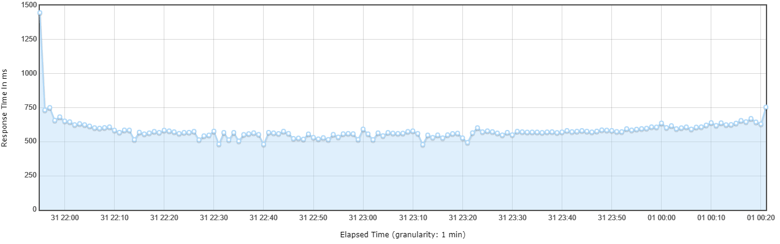

Conclusion

Based on the results of the load testing, we can conclude that the app is able to handle a load of up to 200 concurrent users with an acceptable response time and throughput.

### Stability

The application's average response time was 376.62 milliseconds, and the 90th percentile response time was 589 milliseconds.  
These response times are compliant with the application's Non-Functional Requirements (NFRs), indicating that the application is performing well.

|  |  |  |  |  |  |  |  |
| --- | --- | --- | --- | --- | --- | --- | --- |
| **Step** | **# samples** | **Average** | **Min** | **Max** | **Median** | **90th pct** | **Transactions/s** |
| **Total** | **197341** | **376.62** | **152** | **26654** | **344.00** | **589.00** | **13.78** |
| **createFeedingPoint** | 417 | 243.46 | 178 | 1037 | 212.00 | 301.60 | 0.05 |
| **deleteFeedingPoint** | 417 | 329.59 | 183 | 1021 | 370.00 | 448.80 | 0.05 |
| **getFeedingPoint** | 28360 | 309.75 | 172 | 4014 | 240.00 | 424.00 | 2.99 |
| **listLanguages** | 13979 | 404.45 | 267 | 1681 | 351.00 | 531.00 | 0.31 |
| **listLanguagesSettings** | 13979 | 256.57 | 152 | 1363 | 203.00 | 383.00 | 0.31 |
| **searchByBounds** | 40032 | 382.45 | 156 | 8423 | 342.00 | 562.00 | 2.91 |
| **searchCategories** | 27958 | 252.33 | 154 | 24408 | 198.00 | 376.00 | 1.11 |
| **searchFeedingPoints** | 70114 | 471.43 | 174 | 26654 | 408.00 | 647.00 | 5.89 |
| **searchPets** | 1668 | 312.14 | 158 | 2842 | 282.00 | 471.00 | 0.12 |
| **updateFeedingPoint** | 417 | 285.42 | 186 | 1542 | 230.00 | 409.40 | 0.05 |

The application remained stable and reliable throughout the entire 8-hour test period. No crashes, freezes, or other significant issues were observed.

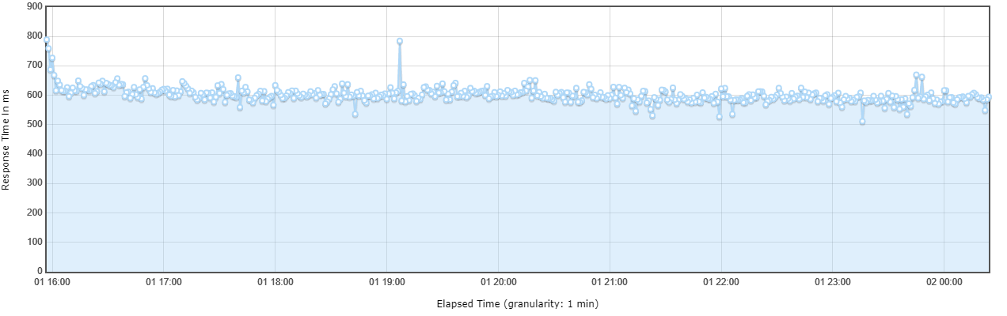

Conclusion

Based on the results of the stability testing, we can conclude that the app is stable, reliable, and highly available. The service remained operational for 99.99% of the test period, and no significant issues were observed.

## Raw data

You can access the raw data and HTML reports at the following [link](https://github.com/tuhuzbayeu/animeal/tree/main/results).