Coding Sample OUTPUT, v1

Jordan Tuia

# Outputs by outcome variables

## Outcome A: OS in intervention

### Figure 1A

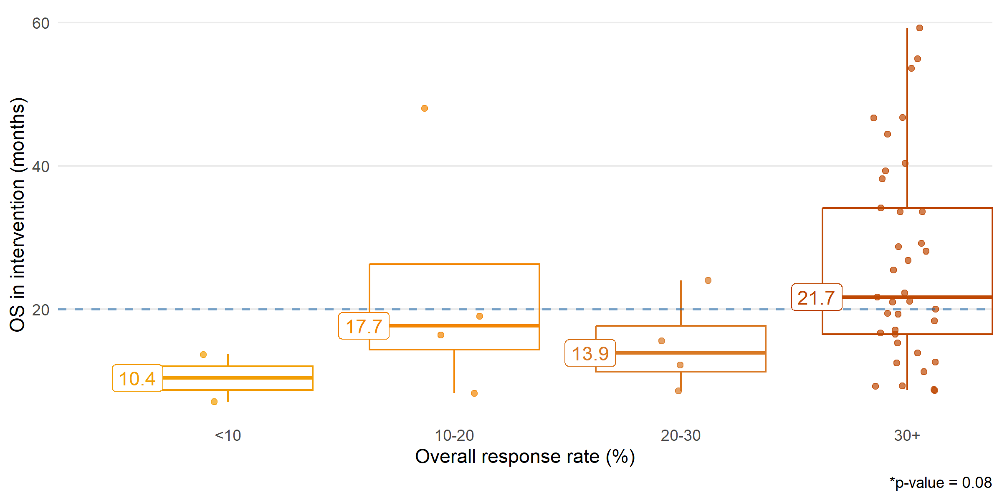

### Table 1A

| rr_cat | median | percentile.25 | percentile.75 | min | max |
| --- | --- | --- | --- | --- | --- |
| factor | numeric | numeric | numeric | numeric | numeric |
| <10 | 10.4 | 8.8 | 12.0 | 7.1 | 13.7 |
| 10-20 | 17.7 | 14.4 | 26.2 | 8.3 | 48.0 |
| 20-30 | 13.9 | 11.3 | 17.7 | 8.6 | 24.0 |
| 30+ | 21.7 | 16.5 | 34.1 | 8.7 | 59.2 |

### Figure 2A

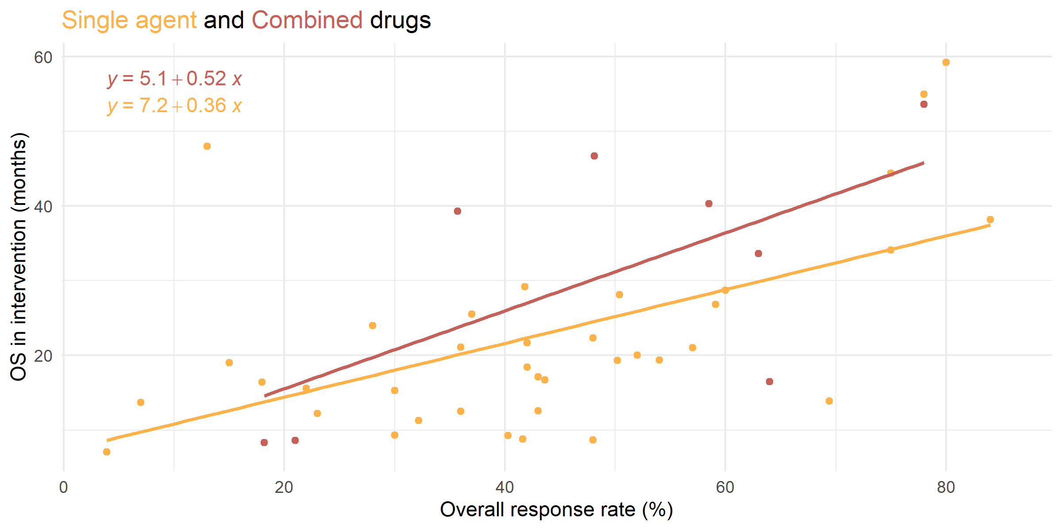

### Model 1A

**Monotherapy**

Call:  
lm(formula = get(outcome_var) ~ rr_intervention, data = .)  
  
Residuals:  
 Min 1Q Median 3Q Max   
-18.286 -6.598 -1.609 3.649 36.093   
  
Coefficients:  
 Estimate Std. Error t value Pr(>|t|)   
(Intercept) 7.23294 4.38502 1.649 0.107753   
rr_intervention 0.35956 0.09156 3.927 0.000373 ***  
---  
Signif. codes: 0 '***' 0.001 '**' 0.01 '*' 0.05 '.' 0.1 ' ' 1  
  
Residual standard error: 11.19 on 36 degrees of freedom  
 (18 observations deleted due to missingness)  
Multiple R-squared: 0.2999, Adjusted R-squared: 0.2804   
F-statistic: 15.42 on 1 and 36 DF, p-value: 0.0003729

**Combination**

Call:  
lm(formula = get(outcome_var) ~ rr_intervention, data = .)  
  
Residuals:  
 Min 1Q Median 3Q Max   
-21.997 -6.312 -4.375 7.802 16.495   
  
Coefficients:  
 Estimate Std. Error t value Pr(>|t|)   
(Intercept) 5.1206 12.0306 0.426 0.683   
rr_intervention 0.5215 0.2243 2.325 0.053 .  
---  
Signif. codes: 0 '***' 0.001 '**' 0.01 '*' 0.05 '.' 0.1 ' ' 1  
  
Residual standard error: 13.17 on 7 degrees of freedom  
 (3 observations deleted due to missingness)  
Multiple R-squared: 0.4358, Adjusted R-squared: 0.3552   
F-statistic: 5.408 on 1 and 7 DF, p-value: 0.05297

### Model 2A

Call:  
lm(formula = get(outcome_var) ~ rr_intervention * type, data = dat1)  
  
Residuals:  
 Min 1Q Median 3Q Max   
-21.997 -6.520 -1.683 4.817 36.093   
  
Coefficients:  
 Estimate Std. Error t value Pr(>|t|)   
(Intercept) 5.1206 10.5356 0.486 0.6294   
rr_intervention 0.5215 0.1964 2.655 0.0111 *  
typeSingle 2.1124 11.4645 0.184 0.8547   
rr_intervention:typeSingle -0.1619 0.2179 -0.743 0.4614   
---  
Signif. codes: 0 '***' 0.001 '**' 0.01 '*' 0.05 '.' 0.1 ' ' 1  
  
Residual standard error: 11.54 on 43 degrees of freedom  
 (21 observations deleted due to missingness)  
Multiple R-squared: 0.3703, Adjusted R-squared: 0.3264   
F-statistic: 8.43 on 3 and 43 DF, p-value: 0.000161

### Model 3A

Call:  
lm(formula = get(outcome_var) ~ rr_intervention + type, data = dat1)  
  
Coefficients:  
 (Intercept) rr_intervention typeSingle   
 11.691 0.390 -5.783

## Outcome B: Difference in OS

### Figure 1B

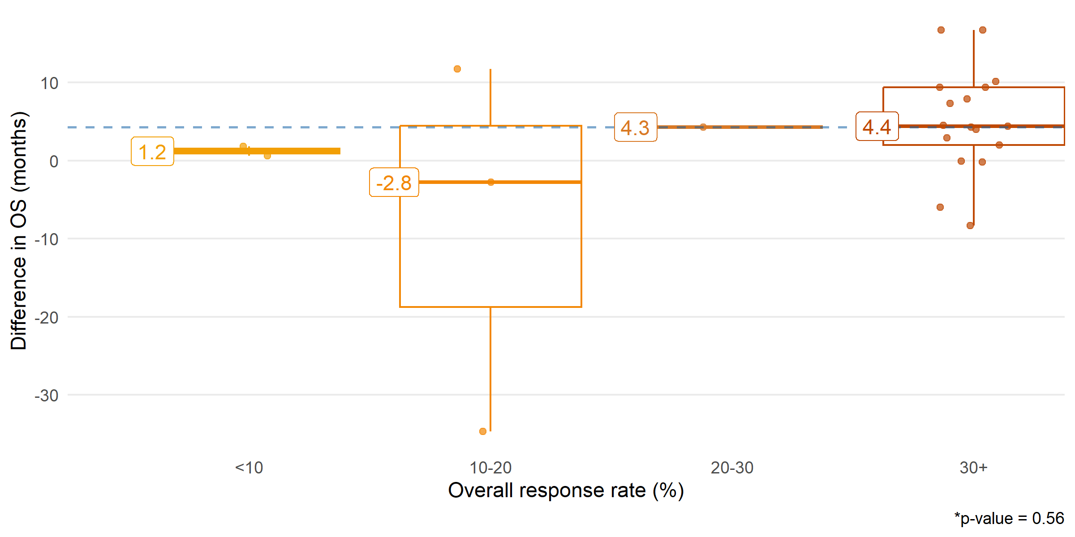

### Table 1B

| rr_cat | median | percentile.25 | percentile.75 | min | max |
| --- | --- | --- | --- | --- | --- |
| factor | numeric | numeric | numeric | numeric | numeric |
| <10 | 1.2 | 0.9 | 1.5 | 0.6 | 1.8 |
| 10-20 | -2.8 | -18.8 | 4.5 | -34.7 | 11.7 |
| 20-30 | 4.3 | 4.3 | 4.3 | 4.3 | 4.3 |
| 30+ | 4.4 | 2.0 | 9.4 | -8.3 | 16.7 |

### Figure 2B

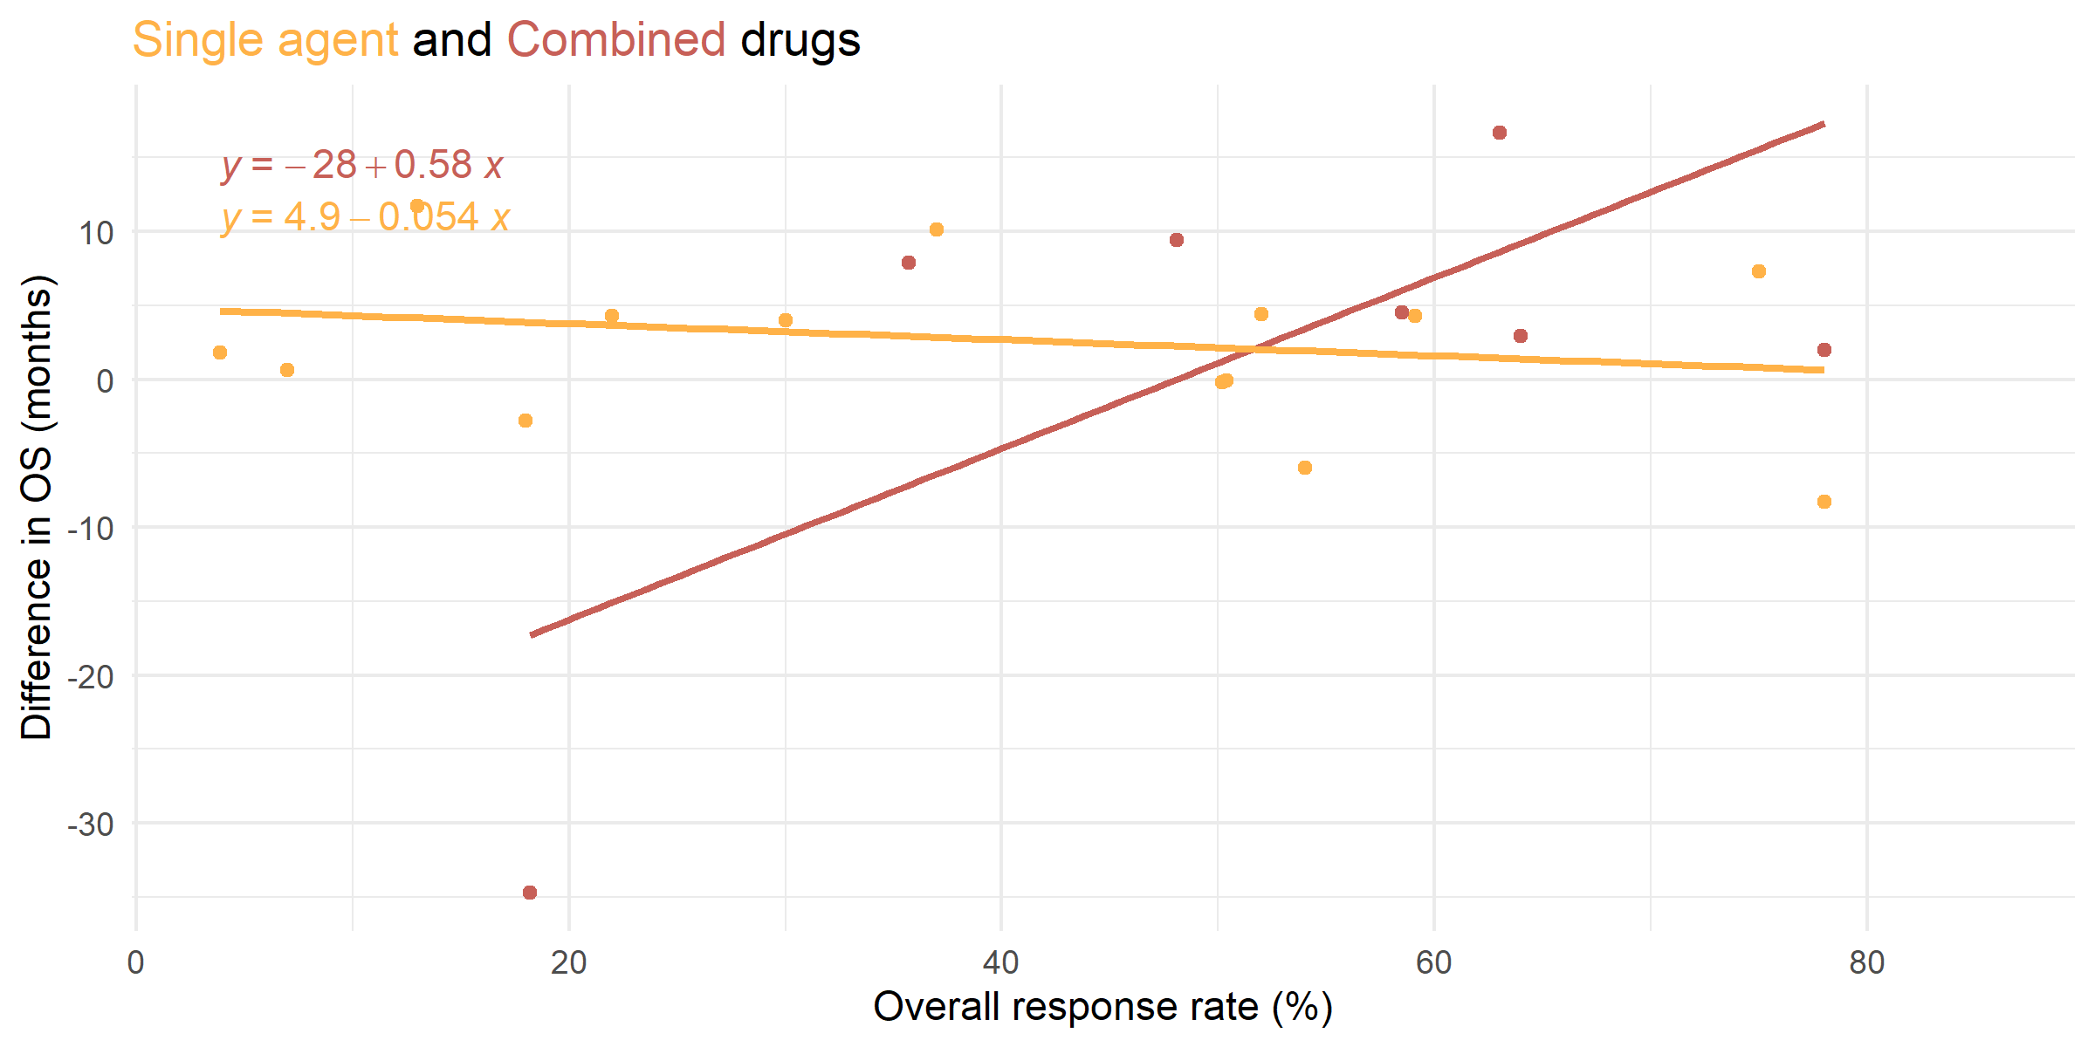

### Model 1B

**Monotherapy**

Call:  
lm(formula = get(outcome_var) ~ rr_intervention, data = .)  
  
Residuals:  
 Min 1Q Median 3Q Max   
-8.9410 -3.3640 0.6332 4.5754 7.5453   
  
Coefficients:  
 Estimate Std. Error t value Pr(>|t|)  
(Intercept) 4.85950 3.03207 1.603 0.133  
rr_intervention -0.05421 0.06616 -0.819 0.427  
  
Residual standard error: 5.801 on 13 degrees of freedom  
 (41 observations deleted due to missingness)  
Multiple R-squared: 0.04911, Adjusted R-squared: -0.02403   
F-statistic: 0.6714 on 1 and 13 DF, p-value: 0.4273

**Combination**

Call:  
lm(formula = get(outcome_var) ~ rr_intervention, data = .)  
  
Residuals:  
 Min 1Q Median 3Q Max   
-17.414 -8.564 3.266 8.395 15.060   
  
Coefficients:  
 Estimate Std. Error t value Pr(>|t|)   
(Intercept) -27.8169 14.7229 -1.889 0.1077   
rr_intervention 0.5786 0.2610 2.217 0.0685 .  
---  
Signif. codes: 0 '***' 0.001 '**' 0.01 '*' 0.05 '.' 0.1 ' ' 1  
  
Residual standard error: 13.07 on 6 degrees of freedom  
 (4 observations deleted due to missingness)  
Multiple R-squared: 0.4503, Adjusted R-squared: 0.3587   
F-statistic: 4.915 on 1 and 6 DF, p-value: 0.06848

### Model 2B

Call:  
lm(formula = get(outcome_var) ~ rr_intervention * type, data = dat1)  
  
Residuals:  
 Min 1Q Median 3Q Max   
-17.4138 -5.0971 0.6332 7.1972 15.0605   
  
Coefficients:  
 Estimate Std. Error t value Pr(>|t|)   
(Intercept) -27.8169 9.8829 -2.815 0.01106 *   
rr_intervention 0.5786 0.1752 3.303 0.00374 **  
typeSingle 32.6764 10.8949 2.999 0.00737 **  
rr_intervention:typeSingle -0.6328 0.2017 -3.137 0.00543 **  
---  
Signif. codes: 0 '***' 0.001 '**' 0.01 '*' 0.05 '.' 0.1 ' ' 1  
  
Residual standard error: 8.774 on 19 degrees of freedom  
 (45 observations deleted due to missingness)  
Multiple R-squared: 0.3712, Adjusted R-squared: 0.2719   
F-statistic: 3.739 on 3 and 19 DF, p-value: 0.02885

### Model 3B

Call:  
lm(formula = get(outcome_var) ~ rr_intervention + type, data = dat1)  
  
Coefficients:  
 (Intercept) rr_intervention typeSingle   
 -2.2578 0.1014 0.9155

## Outcome C: PFS in intervention

### Figure 1C

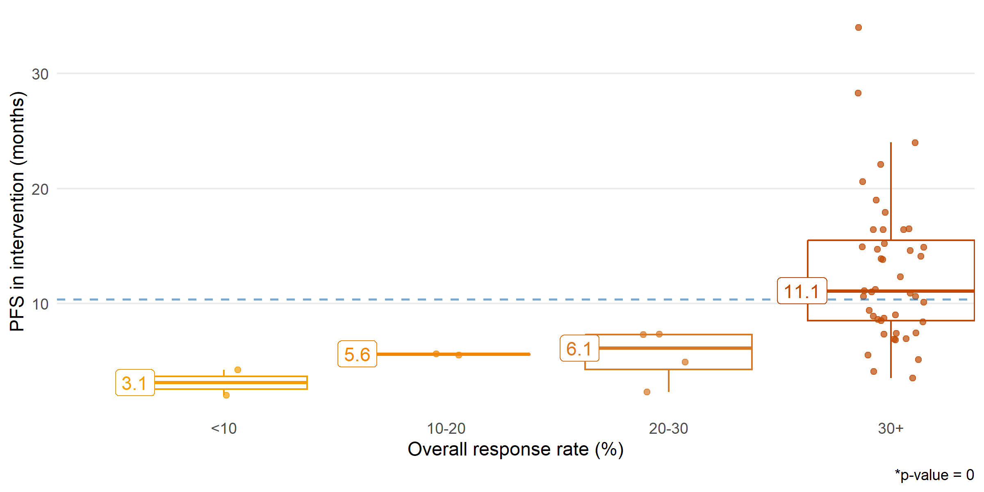

### Table 1C

| rr_cat | median | percentile.25 | percentile.75 | min | max |
| --- | --- | --- | --- | --- | --- |
| factor | numeric | numeric | numeric | numeric | numeric |
| <10 | 3.1 | 2.5 | 3.6 | 2.0 | 4.2 |
| 10-20 | 5.5 | 5.5 | 5.6 | 5.5 | 5.6 |
| 20-30 | 6.1 | 4.2 | 7.3 | 2.3 | 7.3 |
| 30+ | 11.1 | 8.5 | 15.5 | 3.5 | 34.0 |

### Figure 2C

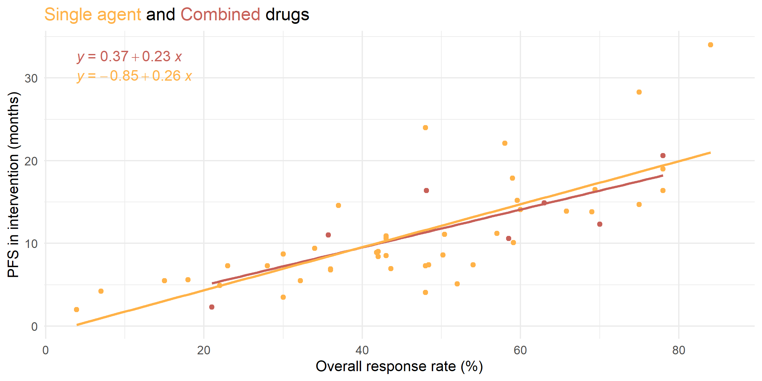

### Model 1C

::: panel-tabset **Monotherapy**

Call:  
lm(formula = get(outcome_var) ~ rr_intervention, data = .)  
  
Residuals:  
 Min 1Q Median 3Q Max   
-7.5663 -3.0900 -0.8781 1.7883 13.0154   
  
Coefficients:  
 Estimate Std. Error t value Pr(>|t|)   
(Intercept) -0.85104 1.85648 -0.458 0.649   
rr_intervention 0.25995 0.03705 7.016 1.38e-08 ***  
---  
Signif. codes: 0 '***' 0.001 '**' 0.01 '*' 0.05 '.' 0.1 ' ' 1  
  
Residual standard error: 4.607 on 42 degrees of freedom  
 (12 observations deleted due to missingness)  
Multiple R-squared: 0.5396, Adjusted R-squared: 0.5286   
F-statistic: 49.22 on 1 and 42 DF, p-value: 1.381e-08

**Combination**

Call:  
lm(formula = get(outcome_var) ~ rr_intervention, data = .)  
  
Residuals:  
 Min 1Q Median 3Q Max   
-4.0836 -2.9441 0.1177 2.4055 5.0262   
  
Coefficients:  
 Estimate Std. Error t value Pr(>|t|)   
(Intercept) 0.37055 4.00052 0.093 0.9292   
rr_intervention 0.22876 0.06968 3.283 0.0168 *  
---  
Signif. codes: 0 '***' 0.001 '**' 0.01 '*' 0.05 '.' 0.1 ' ' 1  
  
Residual standard error: 3.462 on 6 degrees of freedom  
 (4 observations deleted due to missingness)  
Multiple R-squared: 0.6424, Adjusted R-squared: 0.5828   
F-statistic: 10.78 on 1 and 6 DF, p-value: 0.01676

### Model 2C

Call:  
lm(formula = get(outcome_var) ~ rr_intervention * type, data = dat1)  
  
Residuals:  
 Min 1Q Median 3Q Max   
-7.5663 -3.0569 -0.6676 1.9185 13.0154   
  
Coefficients:  
 Estimate Std. Error t value Pr(>|t|)   
(Intercept) 0.37055 5.17570 0.072 0.9432   
rr_intervention 0.22876 0.09014 2.538 0.0145 *  
typeSingle -1.22158 5.48151 -0.223 0.8246   
rr_intervention:typeSingle 0.03119 0.09708 0.321 0.7494   
---  
Signif. codes: 0 '***' 0.001 '**' 0.01 '*' 0.05 '.' 0.1 ' ' 1  
  
Residual standard error: 4.48 on 48 degrees of freedom  
 (16 observations deleted due to missingness)  
Multiple R-squared: 0.5531, Adjusted R-squared: 0.5252   
F-statistic: 19.8 on 3 and 48 DF, p-value: 1.709e-08

### Model 3C

Call:  
lm(formula = get(outcome_var) ~ rr_intervention + type, data = dat1)  
  
Coefficients:  
 (Intercept) rr_intervention typeSingle   
 -1.0995 0.2557 0.4481

## Outcome D: Difference in PFS

### Figure 1D

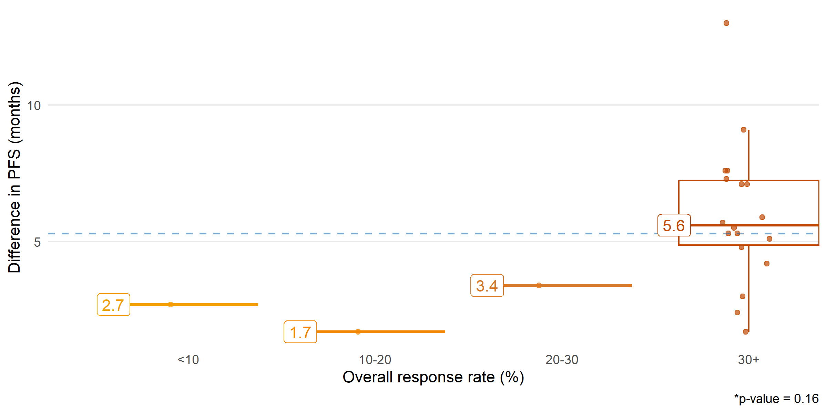

### Table 1D

| rr_cat | median | percentile.25 | percentile.75 | min | max |
| --- | --- | --- | --- | --- | --- |
| factor | numeric | numeric | numeric | numeric | numeric |
| <10 | 2.7 | 2.7 | 2.7 | 2.7 | 2.7 |
| 10-20 | 1.7 | 1.7 | 1.7 | 1.7 | 1.7 |
| 20-30 | 3.4 | 3.4 | 3.4 | 3.4 | 3.4 |
| 30+ | 5.6 | 4.9 | 7.2 | 1.7 | 13.0 |

### Figure 2D

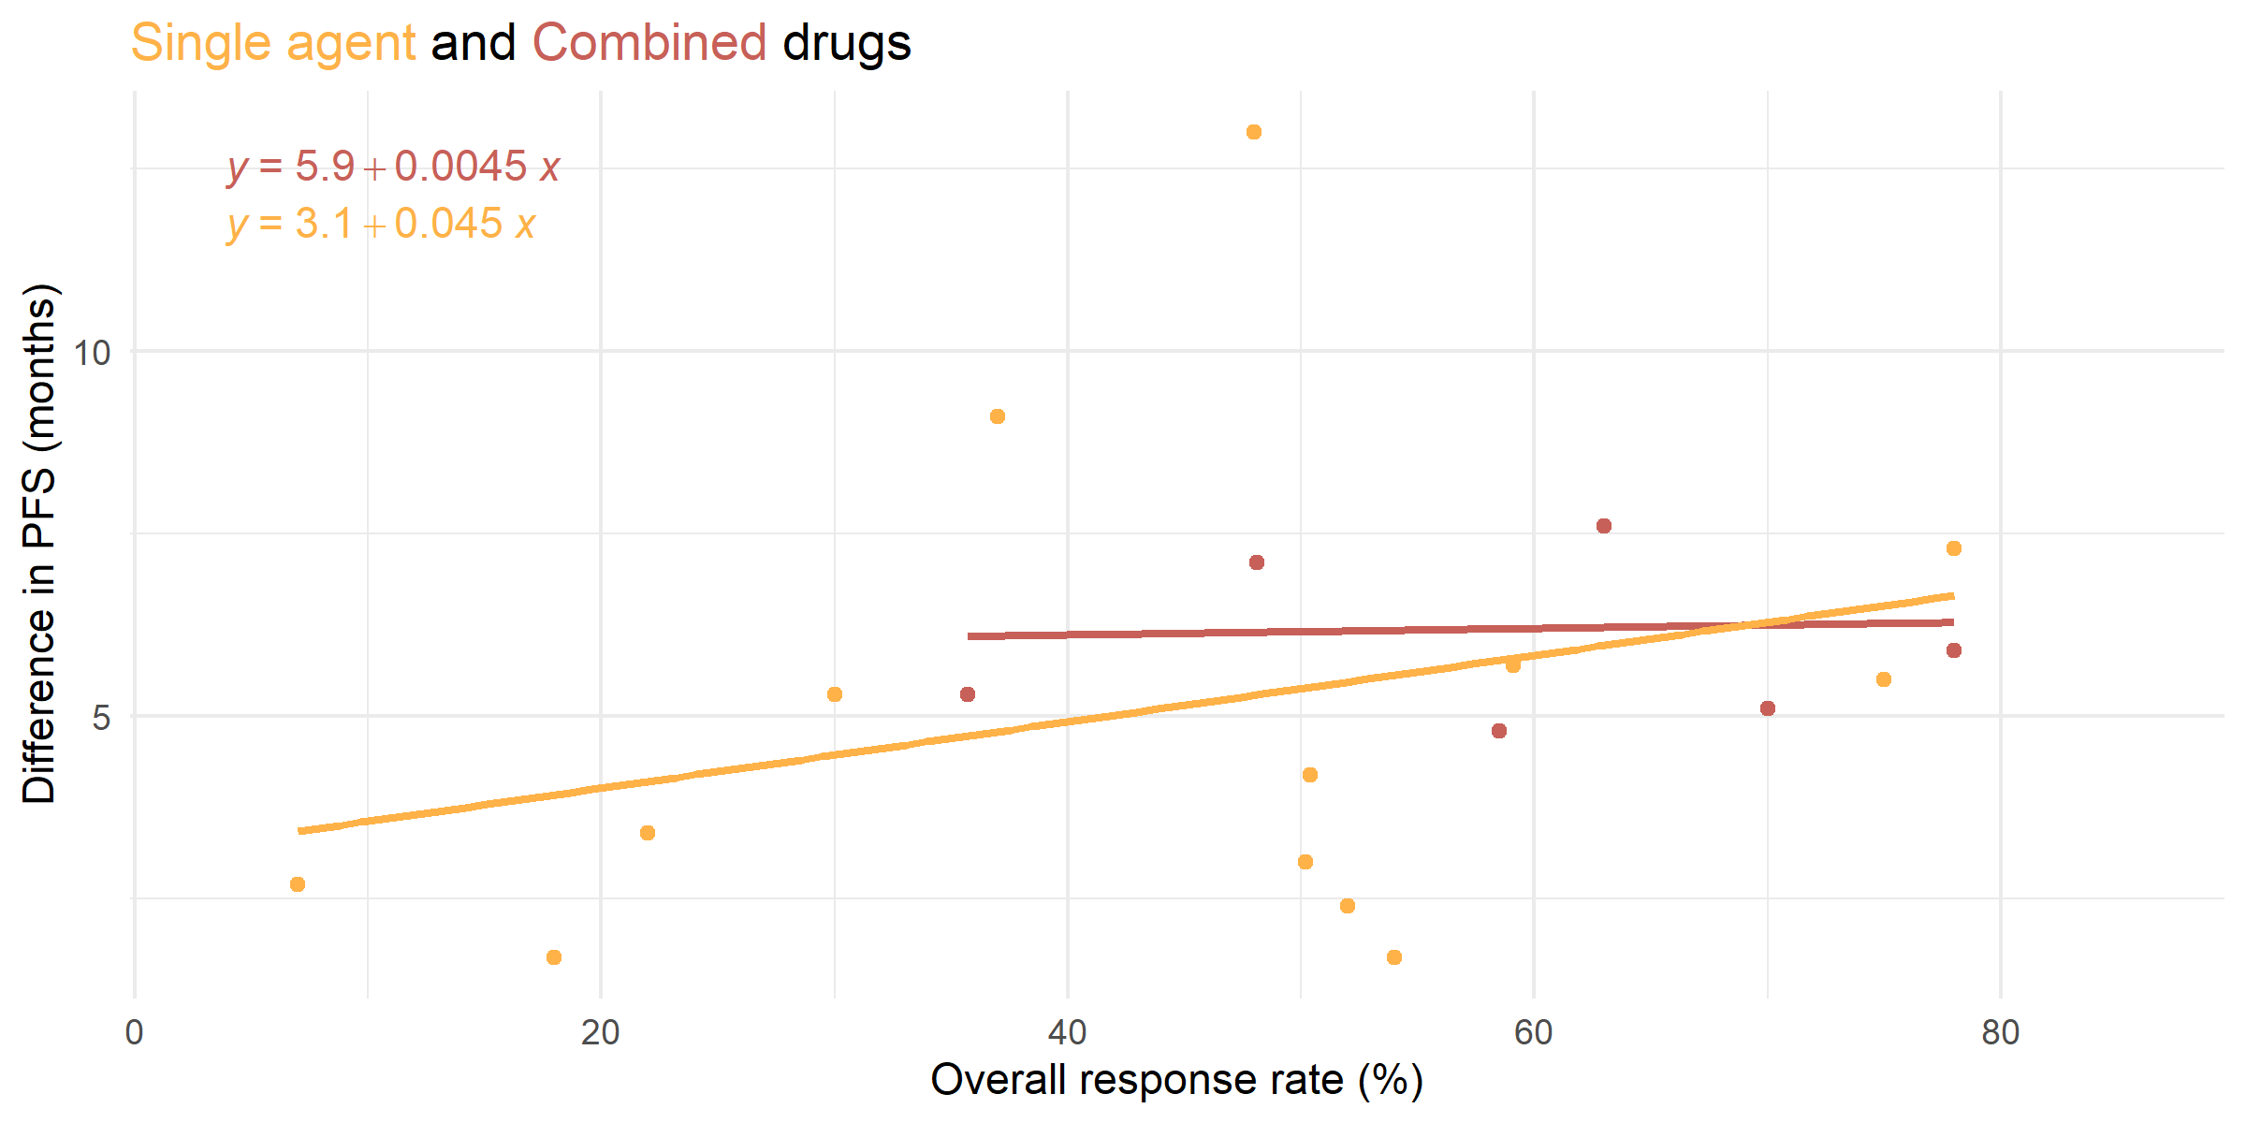

### Model 1D

**Monotherapy**

Call:  
lm(formula = get(outcome_var) ~ rr_intervention, data = .)  
  
Residuals:  
 Min 1Q Median 3Q Max   
-3.8632 -1.9693 -0.7168 0.7825 7.7097   
  
Coefficients:  
 Estimate Std. Error t value Pr(>|t|)  
(Intercept) 3.10732 2.12029 1.466 0.168  
rr_intervention 0.04548 0.04326 1.051 0.314  
  
Residual standard error: 3.174 on 12 degrees of freedom  
 (42 observations deleted due to missingness)  
Multiple R-squared: 0.08432, Adjusted R-squared: 0.008016   
F-statistic: 1.105 on 1 and 12 DF, p-value: 0.3139

**Combination**

Call:  
lm(formula = get(outcome_var) ~ rr_intervention, data = .)  
  
Residuals:  
 1 3 4 7 9 10 11   
-0.7935 1.3842 1.3842 0.9509 -1.3956 -1.1472 -0.3830   
  
Coefficients:  
 Estimate Std. Error t value Pr(>|t|)   
(Intercept) 5.933633 2.353093 2.522 0.0531 .  
rr_intervention 0.004479 0.038660 0.116 0.9123   
---  
Signif. codes: 0 '***' 0.001 '**' 0.01 '*' 0.05 '.' 0.1 ' ' 1  
  
Residual standard error: 1.325 on 5 degrees of freedom  
 (5 observations deleted due to missingness)  
Multiple R-squared: 0.002677, Adjusted R-squared: -0.1968   
F-statistic: 0.01342 on 1 and 5 DF, p-value: 0.9123

### Model 2D

Call:  
lm(formula = get(outcome_var) ~ rr_intervention * type, data = dat1)  
  
Residuals:  
 Min 1Q Median 3Q Max   
-3.8632 -1.1995 -0.7079 0.9509 7.7097   
  
Coefficients:  
 Estimate Std. Error t value Pr(>|t|)  
(Intercept) 5.933633 4.905736 1.210 0.243  
rr_intervention 0.004479 0.080599 0.056 0.956  
typeSingle -2.826315 5.241180 -0.539 0.597  
rr_intervention:typeSingle 0.041001 0.088957 0.461 0.651  
  
Residual standard error: 2.762 on 17 degrees of freedom  
 (47 observations deleted due to missingness)  
Multiple R-squared: 0.1117, Adjusted R-squared: -0.04509   
F-statistic: 0.7123 on 3 and 17 DF, p-value: 0.558

### Model 3D

Call:  
lm(formula = get(outcome_var) ~ rr_intervention + type, data = dat1)  
  
Coefficients:  
 (Intercept) rr_intervention typeSingle   
 3.93193 0.03814 -0.49483