**Python document for Metadata mapping**

**Prerequisites**

1. Download and install python

<https://www.python.org/downloads/> (I have worked with Python 2.7.11)

1. Add python path to system variable
2. Install Python Package manager (PIP) to add modules to Python.

<https://pip.pypa.io/en/stable/installing/>

To install pip,

**download**[**get-pip.py**](https://bootstrap.pypa.io/get-pip.py)**.**[**[2]**](https://pip.pypa.io/en/stable/installing/#id8)

**python get-pip.py**

**Set PATH variable again to include : C:\Python27\Scripts – folder where PIP is available**

1. Install “python-docx” add-in module to process word documents.

**pip install python-docx**

Pip –proxy user:password@proxy.server:port install python-docx

1. Add add on to write excel file

**pip install xlsxwriter**

Pip –proxy user:password@proxy.server:port install xlsxwriter

1. Read Visual map and copy all tables in visual map and create new document at some location copy tables in that file and save it eg : C:\Users\l070028\desktop\VisualMap.docx
2. Read IFS document copy all tables in section 2.4 Positive response attribute and paste it into new docx file and save it : C:\Users\l070028\desktop\IFS.docx

**How run script**

1. Start cmd go to python path eg : C:\Users\l070028\python27
2. Run script file python script-file-path (C:\Users\l070028\Desktop\doc.py) C:\Users\l070028\desktop\VisualMap.docx C:\Users\l070028\Desktop\IFS.docx C:\Users\l070028\Desktop\metadatadocx.xlsx "Portfolio performance SMA Report" "BTFG$UI_PERF_LIST.PRD_PRDDET"
3. And run the script check excel document generated on desktop when script will finish to run

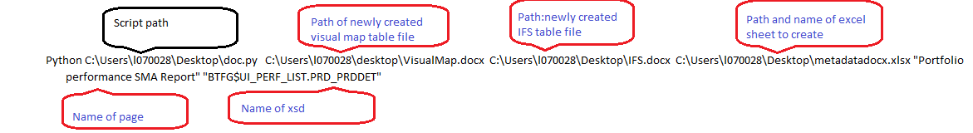

**Future Scope**

1. Create text file which contains all argument with 50 entries so that 50 excel files will get created at a time
2. Script is not tested with multiple scenarios need to test it and do required changes