**Native XMLHttpRequest approach**

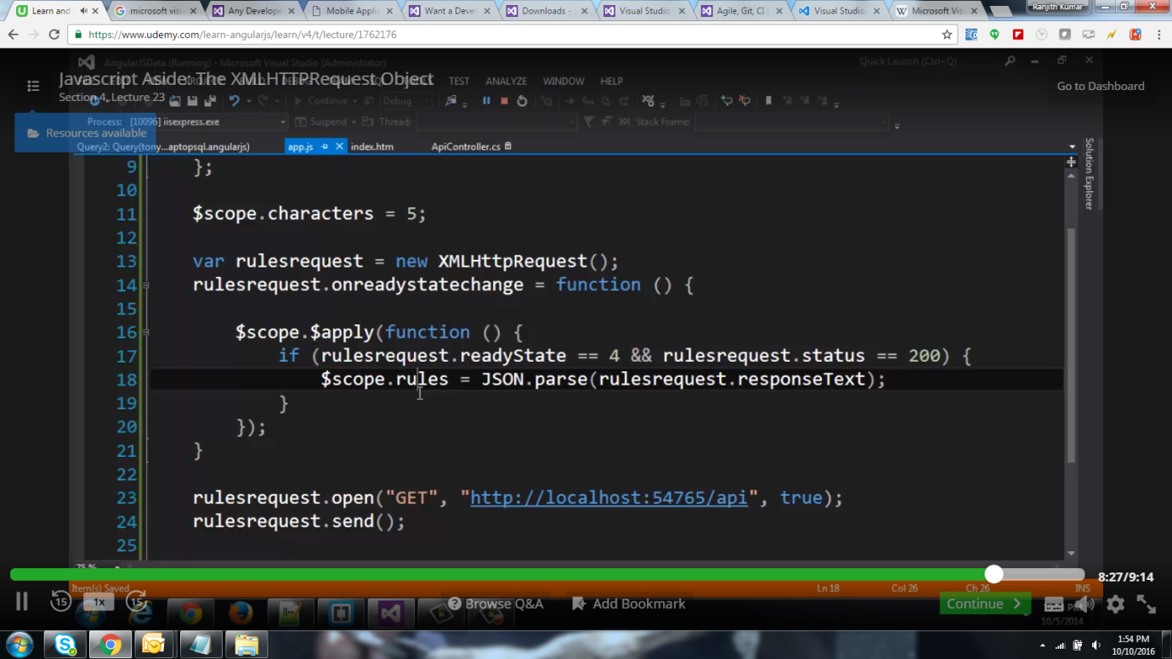

**Angular wrapper service for XMLHttpRequest approach - $http.get() / $http.post()**

