**Sentence**

|  |
| --- |
| Id: string |
| Name: string |
| Vi: string |
| En: string |
| State: number |

**Group**

|  |
| --- |
| Id: string |
| Name: string |
| Description: string |
| Sentences: Sentence[] |
| Priority: string (vi | en) |
| Count: number |
| UpdatedAt: Date |
| CreatedAt: Date |

**Pages:**

1. List
   1. Search a group
   2. Add group
   3. Delete group
   4. Update & details group > go to Group details page
   5. Practice > go to Practice page
   6. Back home
2. Group details
   1. Save
   2. Auto generate a new form for adding sentence (limit 20 sentence in a group)
   3. Form input
   4. Search a sentence
   5. Back home
3. Practice
   1. Next
   2. Input enlish
   3. Back home

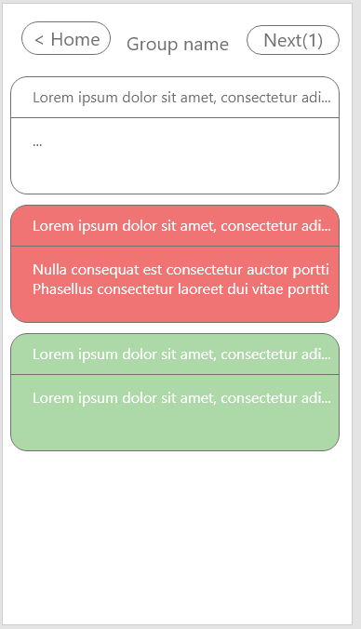

Details:

|  |  |  |  |  |  |  |  |  |  |
| --- | --- | --- | --- | --- | --- | --- | --- | --- | --- |
| 🞏 | # | Name | Description | Total sentence | Priority | Practice count | Created at | Updated  at | Action |
| 🗹 | 1 | Email |  | 19 | vi | 2 | 27/8/2022 8:51 AM | 27/8/2022 8:51 AM | Edit, Remove |
|  |  |  |  |  |  |  |  |  |  |