Report for “The Not-Hogdog Classifier”

Members of the group:

* Víctor García Fernández 405653
* Que Le Ba 369342

**1. Introduction**

We have implemented a multilayer perceptron (MLP) binary classifier that classifies images into 2 classes: “laptop” or “not laptop”, depending on whether a laptop is present in those images.

In order to do that, we’ve had to create our own data set of images and our own model

**2. Procedure**

* Creating our own data set of images

Gathering a set of images large enough to train our model. We downloaded more images than we needed, keeping in mind that we would have to filter out manually images that wouldn’t show a clear laptop.

After the selection, we ended up having 1400 images: 500 to train each class, plus 200 for testing each class as well.

* Designing our own model: we have organised the images in 2 folders, “training_data” and “testing_data”, and inside each of them, 2 folders “laptops” and “notlaptops”, containing laptop and not laptop images, respectively

We have designed our model with 3 layers convolution layers with a ReLuactivation, followed by max-pooling layers. On top of it we add two fully-connected layers, adding up for a total of 5 layers.

A graph of the model, showing the mentioned layers, is presented in the next page.

We set the size of the batches in 32 images.

We implemented the training with different number of epochs: 25, 50, 75 and 100, and wrote down the different results.

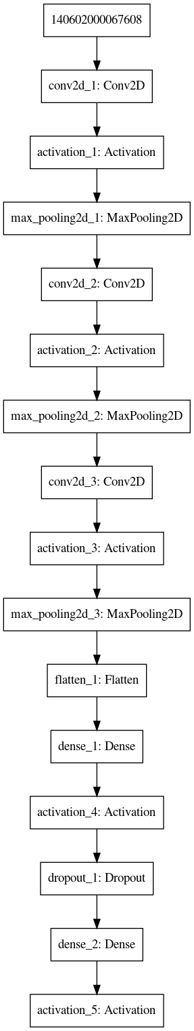

**3. Results**

Epochs: 25

Laptops: correct: 176, incorrect: 20

Not laptops: correct: 176, incorrect: 23

Epochs: 50

Laptops: correct: 165, incorrect: 31

Not laptops: correct: 190, incorrect: 8

Epochs: 75

Laptops: correct: 165, incorrect: 35

Not laptops: correct: 187, incorrect: 12

Epochs: 100

Laptops: correct: 174, incorrect: 25

Not laptops: correct: 189, incorrect: 10

New results:

Epochs: 25

Laptops: correct: 165, incorrect: 35

Not laptops: correct: 190, incorrect: 10

Epochs: 50

Laptops: correct: 159, incorrect: 41

Not laptops: correct: 192, incorrect: 8

Epochs: 75

Laptops: correct: 174, incorrect: 26

Not laptops: correct: 187, incorrect: 13

Epochs: 100

Laptops: correct: 174, incorrect: 25

Not laptops: correct: 189, incorrect: 10