1. STUDENT NAME

Thomas Toal

1. URL to STUDENT WEB SITE

<http://cis-linux2.temple.edu:8080/fa21_3308_tuj55883/index.html#/blog>

6. DATA ENTRY ERRORS

a) Error: Duplicate user_role PK 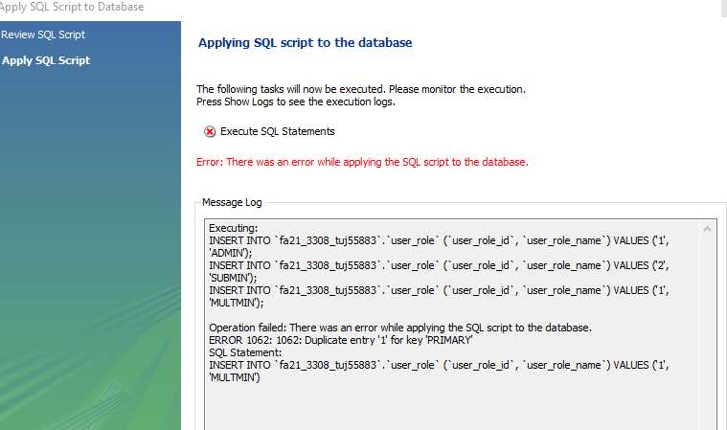

c) Error: Cannot delete a user_role record that’s referenced by a web _user record 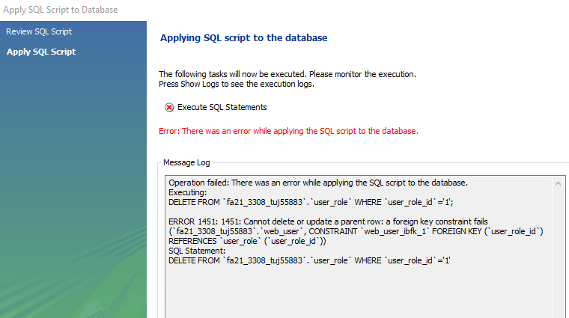

d) Invalid web_user FK in “other” record

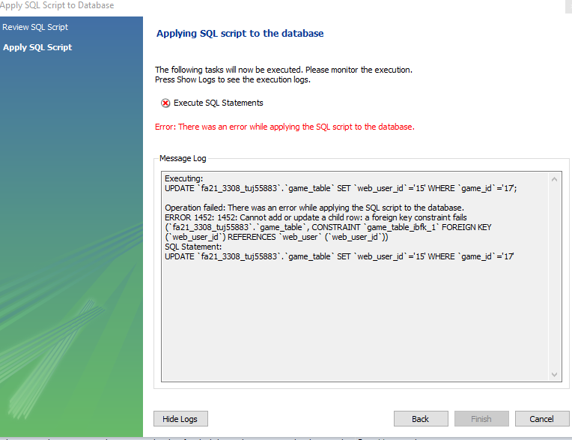

e) Error trying to delete a web_user record that’s referenced by an “other” record

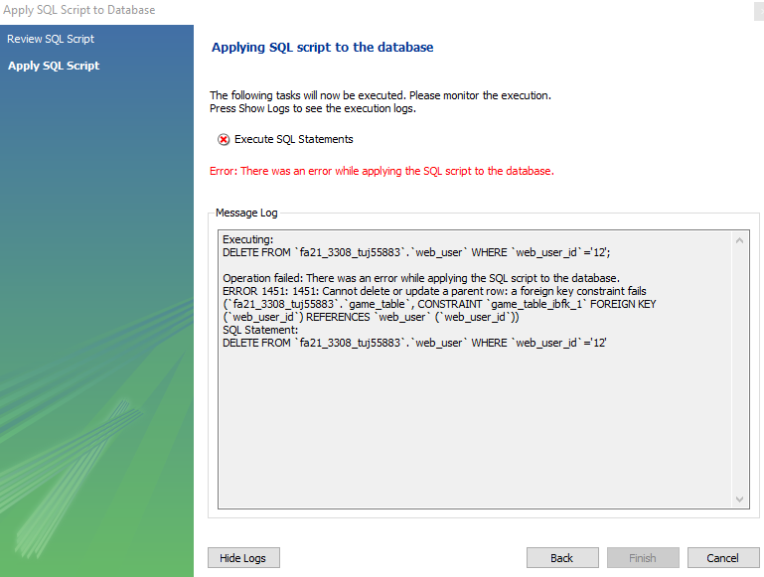

7. SELECT STATEMENTS

a) USER_ROLE: all rows, all columns, sorted by user_role_id.

b) WEB_USER: all rows, all columns, sorted by web_user_id.

c) WEB_USER JOINED WITH USER_ROLE: all rows, certain columns, sort

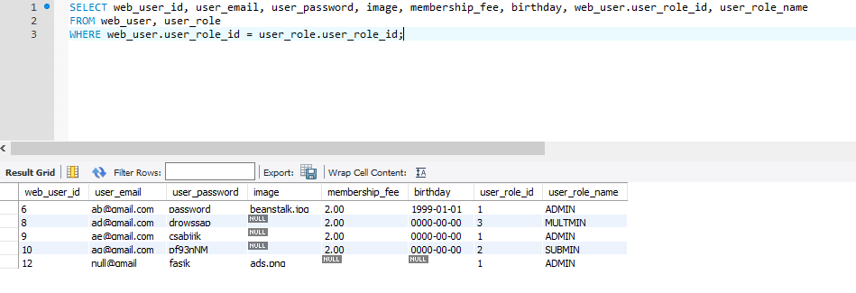

f) “OTHER”: all rows, all columns, sorted by the id of your “other” table.

g) “OTHER” JOINED WITH WEB_USER all rows, certain columns, sorted.

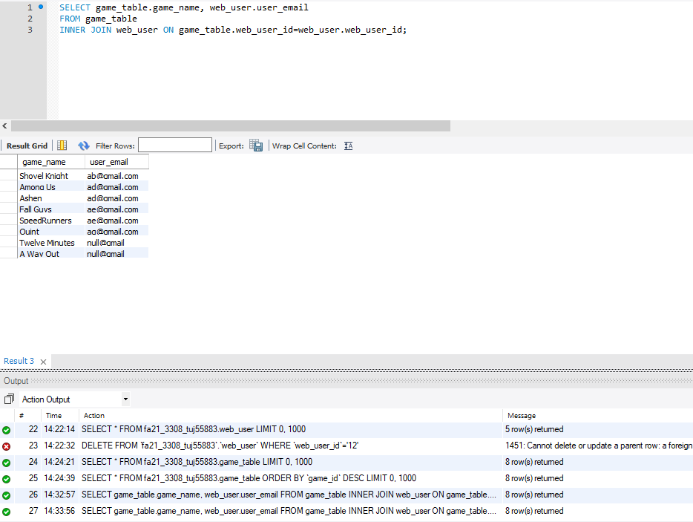

h) “OTHER” JOINED WITH WEB_USER some rows, certain columns, sorted.

