**Project design**

**MAIN SCREEN**

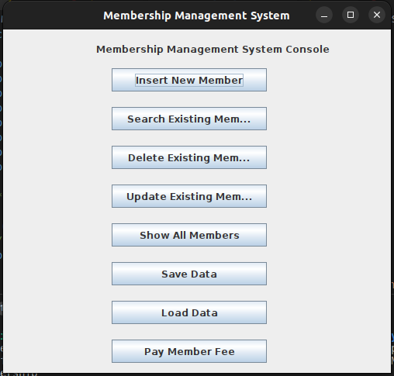**INSERT MEMBERS SCREEN**

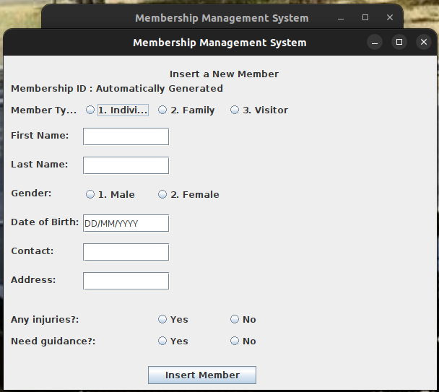**SEARCH EXISTING MEMBERS SCREEN**

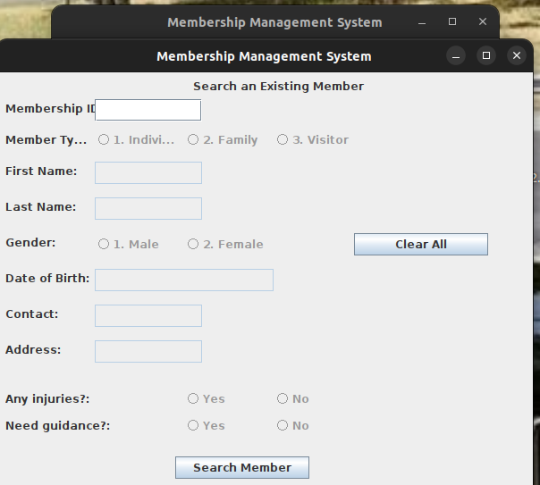**DELETE EXISTING MEMBERS SCREEN**

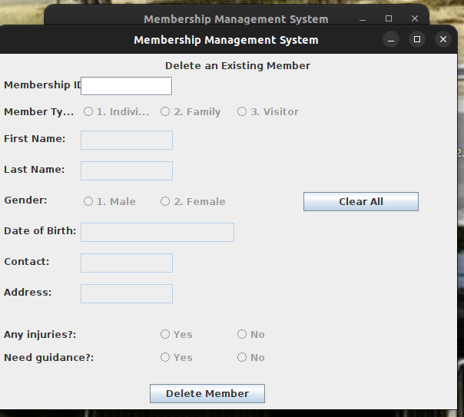**UPDATE EXISTING MEMBERS DETAILS**

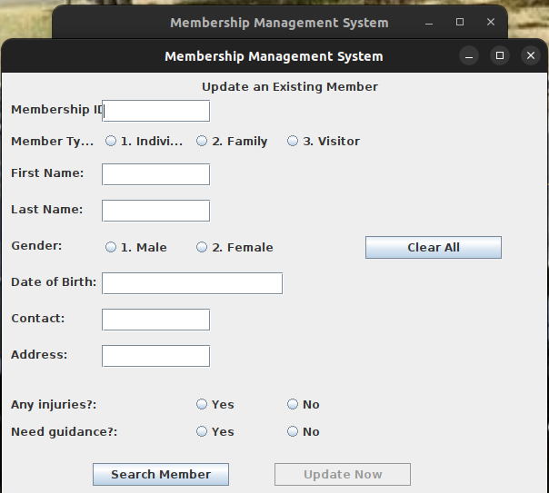**PAY MEMBERSHIP FEE SCREEN**

