ASSIGNMENT 2

1. Load data. Cleaning data - Present steps... and corresponding code
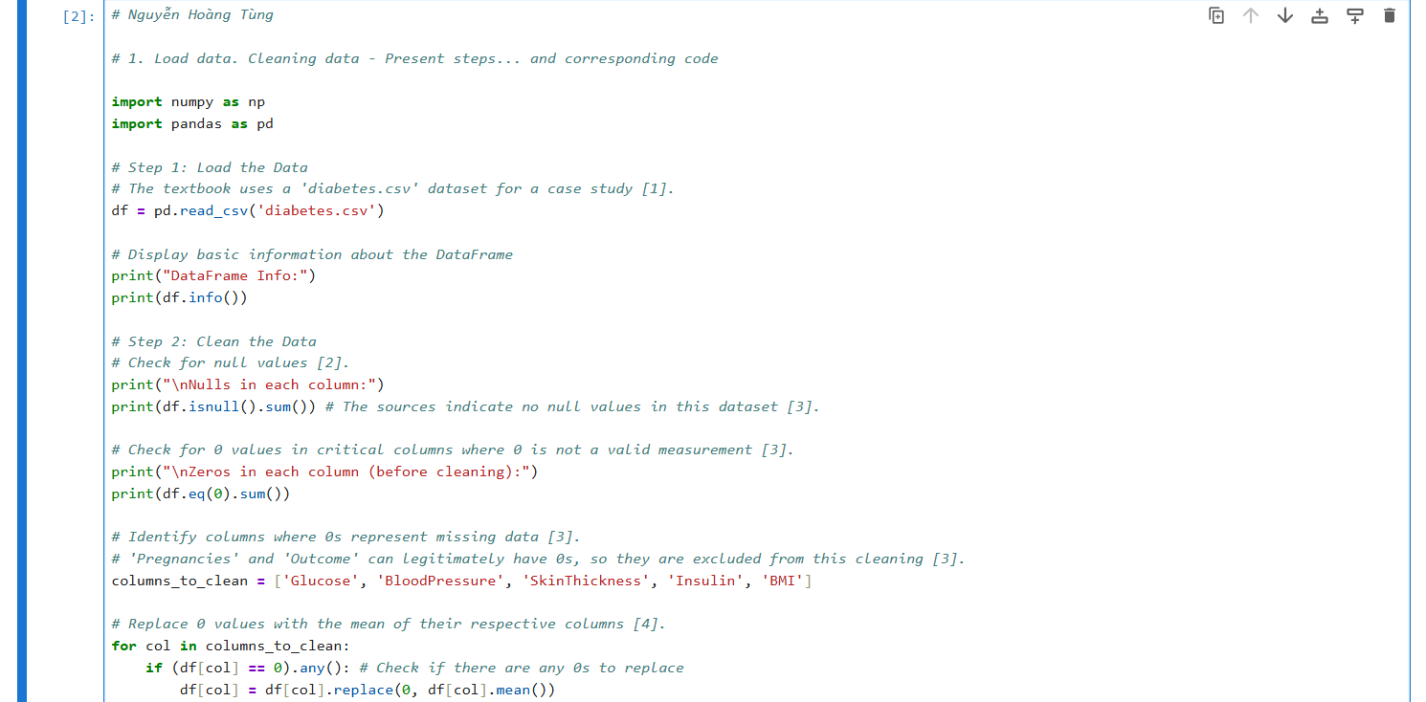
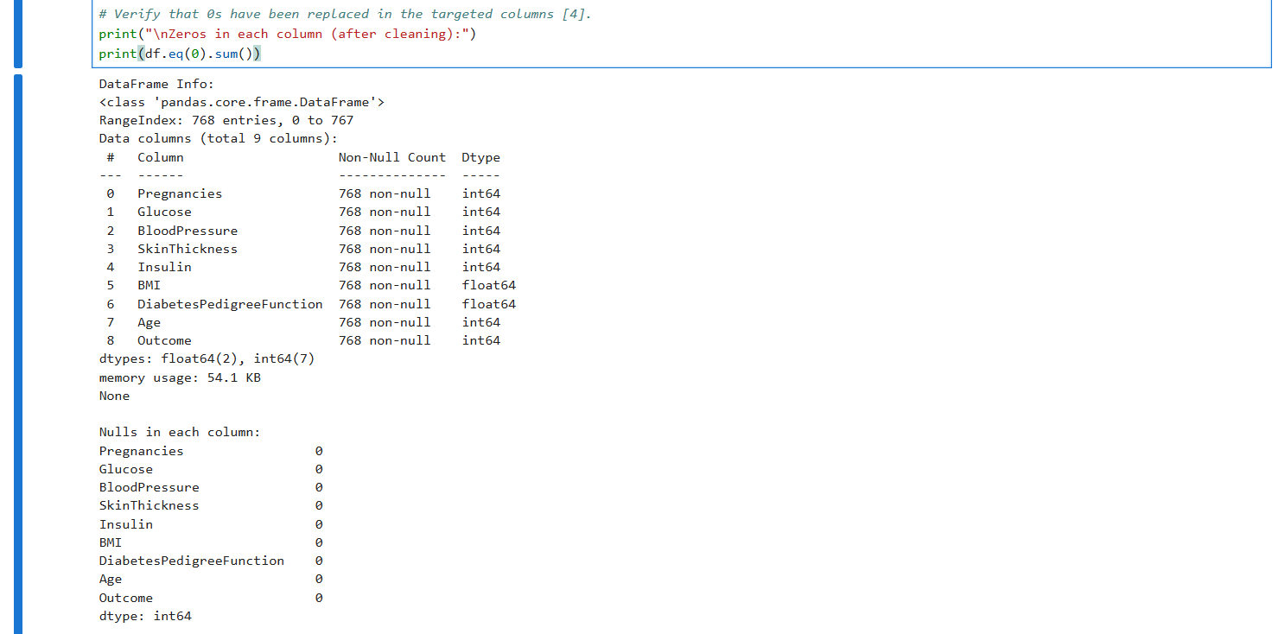
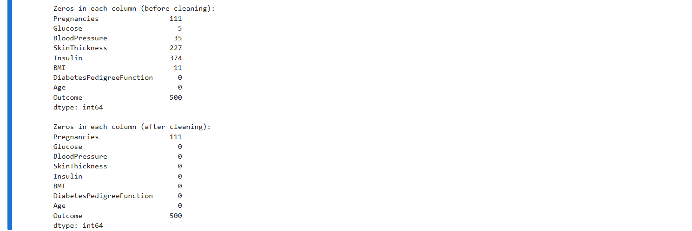

2. Select 5 features (not 3) and Using 5 models in Basic Machine
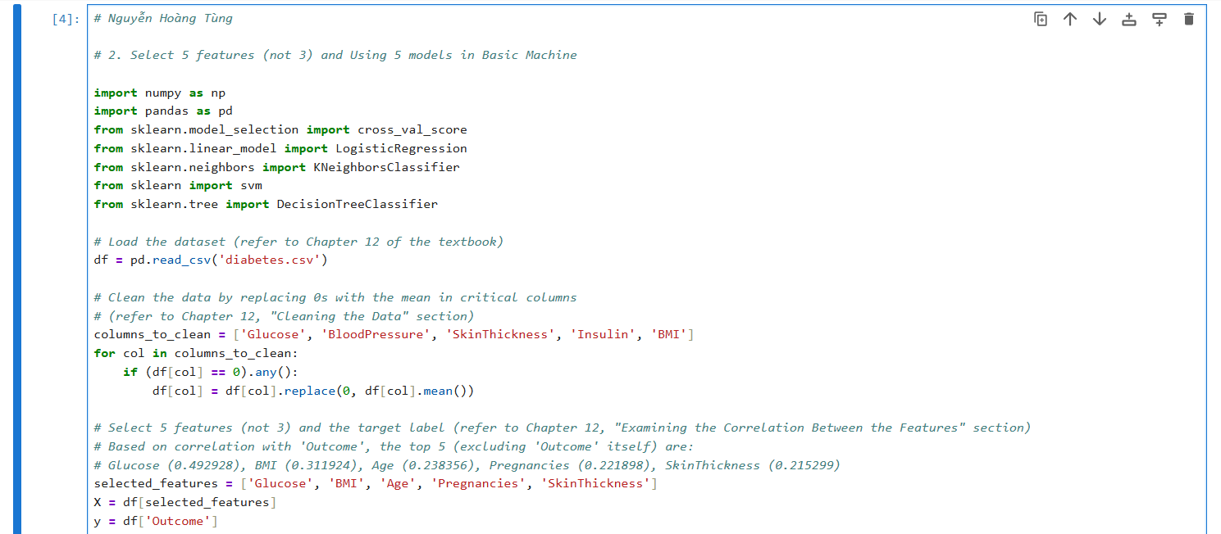
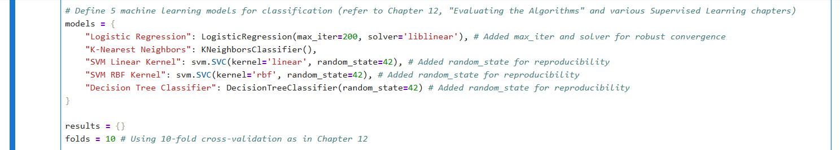
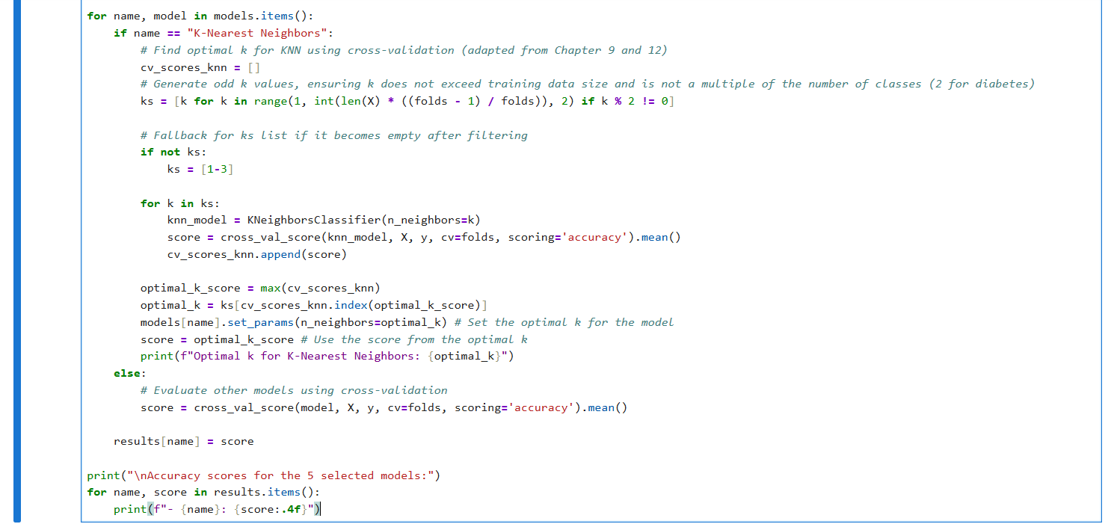
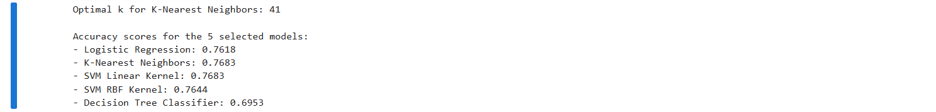

3. Evaluate and compare with metrics: accuracy, mae, mse, rmse. Explain metrics
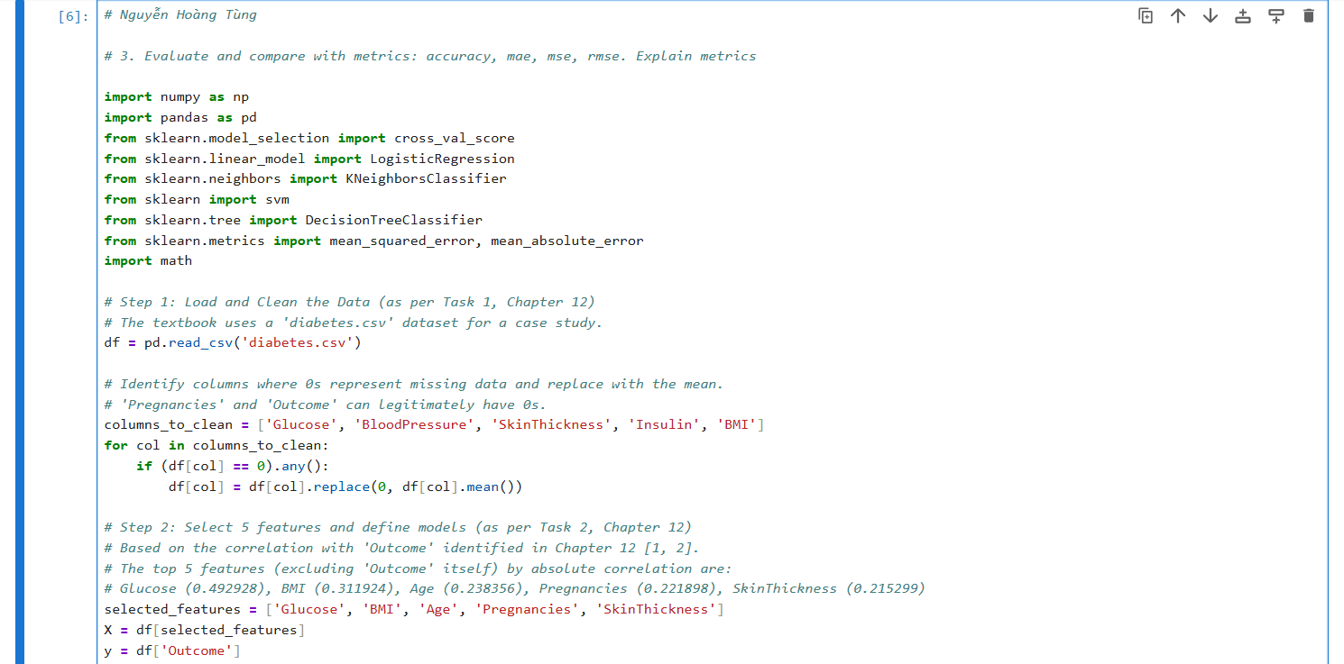
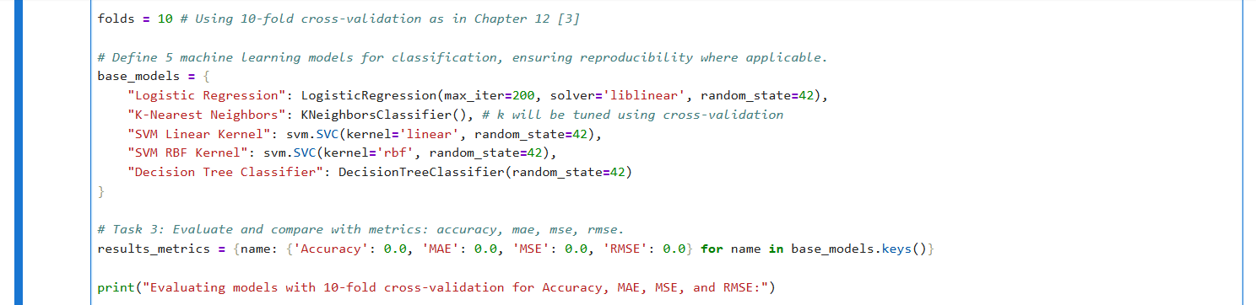
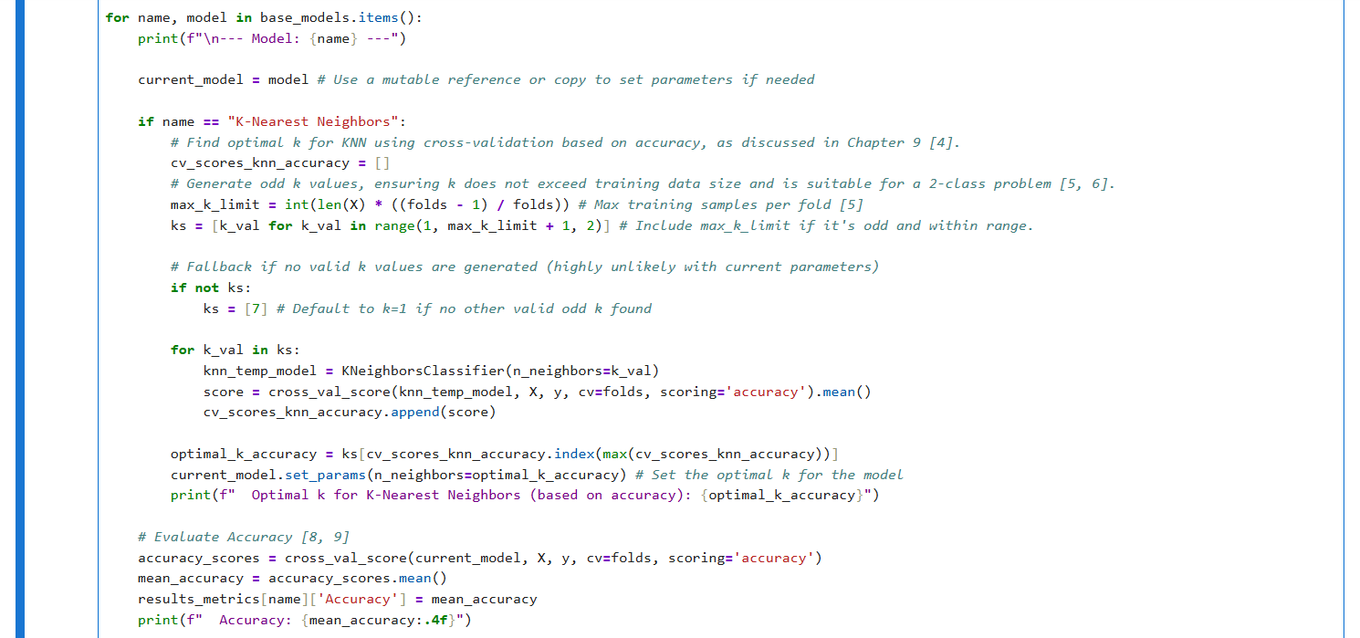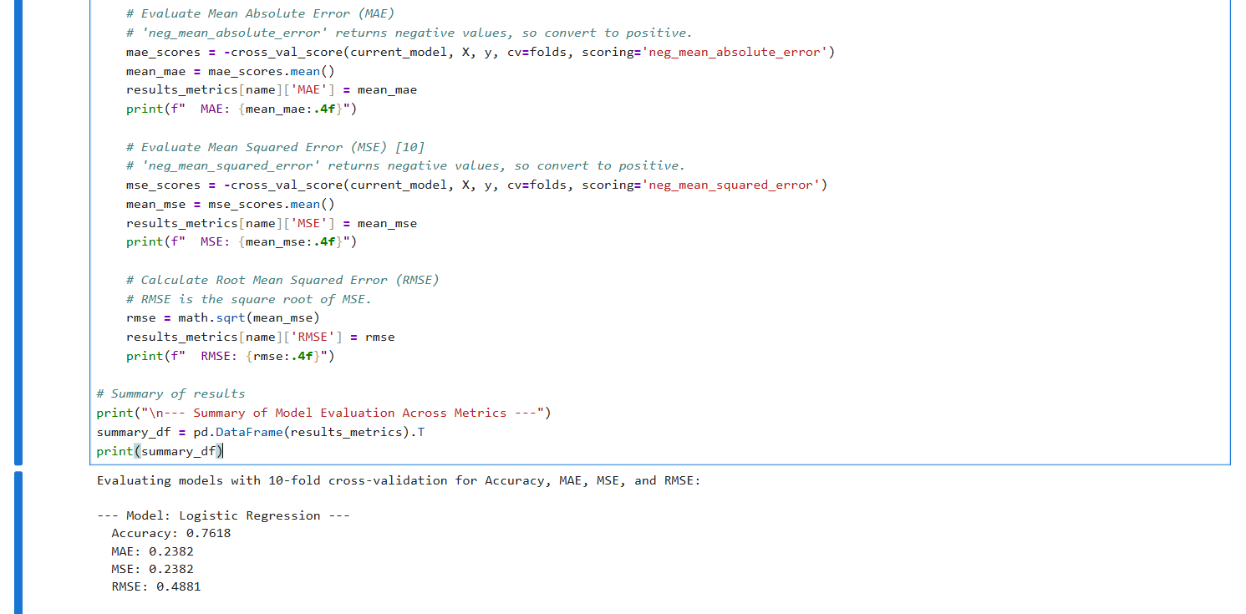
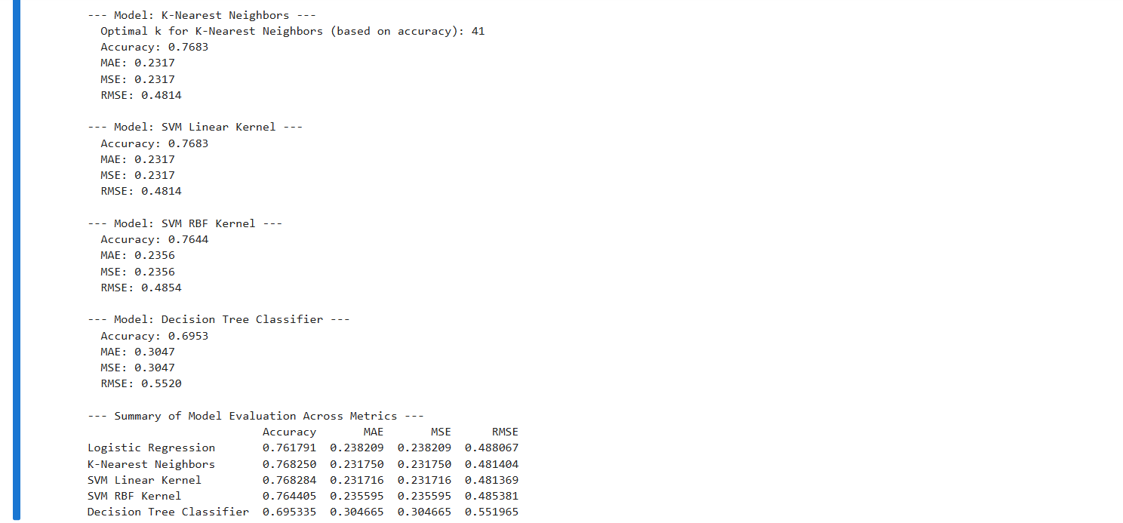
- Accuracy
  - Definition: Accuracy is a metric primarily used for classification problems and is defined as the sum of all correct predictions divided by the total number of predictions. Mathematically, it is calculated as (True Positives + True Negatives) / (True Positives + True Negatives + False Positives + False Negatives).
  - Interpretation: A higher accuracy score indicates that the model is making more correct predictions. In the context of the diabetes prediction case study (a binary classification problem where the outcome is either 0 for non-diabetic or 1 for diabetic), accuracy measures how many times the model correctly identifies whether a person is diabetic or not.
  - Insight: While easy to understand, accuracy can be misleading for skewed datasets (where one class significantly outnumbers the other). For example, if 99% of patients are non-diabetic, a "dumb algorithm" that always predicts "non-diabetic" would achieve 99% accuracy but be useless in identifying actual diabetic cases. The score() function in Scikit-learn can be used to compute accuracy.
- Mean Absolute Error (MAE)
  - Definition: The sources do not explicitly define Mean Absolute Error (MAE) in a dedicated section. However, it is a common metric used to measure the average magnitude of the errors between predicted and actual values. It is calculated as the average of the absolute differences between the predictions and the actual values.
  - Interpretation for this task: Although MAE is typically used for regression problems (where the output is a continuous value), when applied to a binary classification problem (like predicting 0 or 1 for diabetes), it can be interpreted as the average absolute difference between the true binary label and the predicted binary label. If the model makes a hard prediction (0 or 1), an incorrect prediction results in an absolute error of 1, and a correct prediction results in an absolute error of 0. Thus, for binary classification with hard predictions, MAE is equivalent to the misclassification rate (which is 1 minus accuracy). A lower MAE indicates better model performance.
- Mean Squared Error (MSE)
  - Definition: Mean Squared Error (MSE) is a metric that calculates the average of the squares of the errors. It is calculated by taking the difference between each predicted value and its corresponding actual value, squaring these differences, and then averaging the squared results.
  - Interpretation for this task: Like MAE, MSE is typically used for regression problems. However, the textbook also mentions "misclassification error (MSE)" in the context of K-Nearest Neighbors, suggesting its use for classification. For a binary classification problem with hard predictions (0 or 1), an incorrect prediction results in a squared error of 1 (e.g., (1-0)^2 = 1 or (0-1)^2 = 1), and a correct prediction results in a squared error of 0. Therefore, for binary classification with hard predictions, MSE is also equivalent to the misclassification rate (1 minus accuracy). A lower MSE indicates better model performance, penalizing larger errors more significantly due to the squaring operation.
- Root Mean Squared Error (RMSE)
  - Definition: The sources do not explicitly define Root Mean Squared Error (RMSE). However, it is derived directly from MSE. RMSE is the square root of the Mean Squared Error.
  - Interpretation for this task: As with MAE and MSE, RMSE is primarily used for regression problems to provide an error metric in the same units as the target variable. For a binary classification task where MSE simplifies to the misclassification rate (1 minus accuracy), RMSE would be the square root of that value, i.e., sqrt(1 - accuracy). RMSE provides an average error magnitude, with larger errors contributing disproportionately more to the overall score due to the squaring within MSE. A lower RMSE indicates better model performance.

4. Visualize and show with 5 types of diagrams
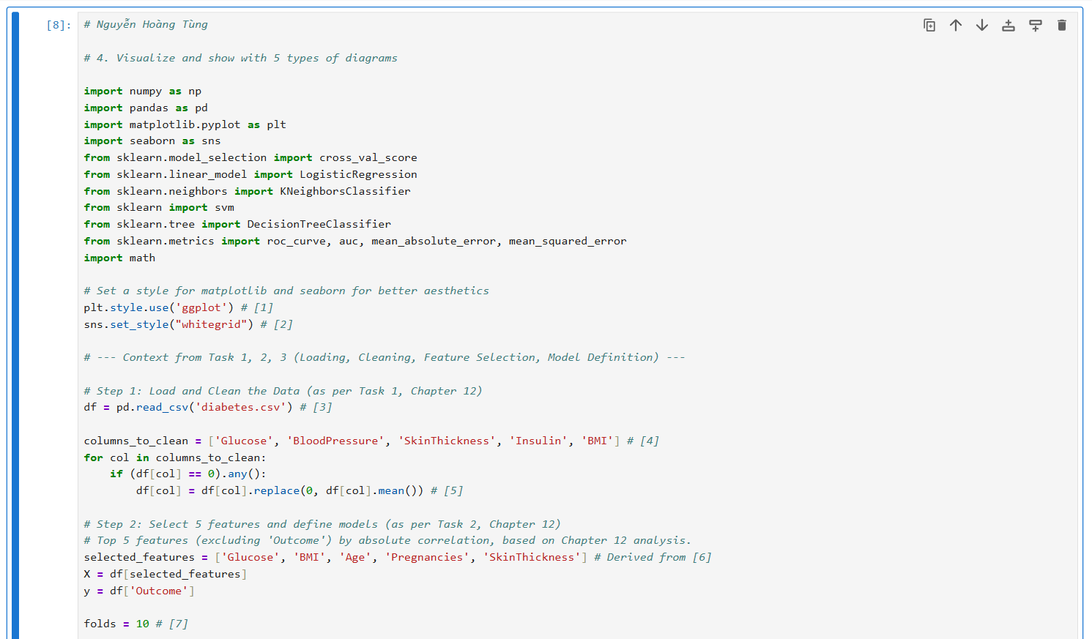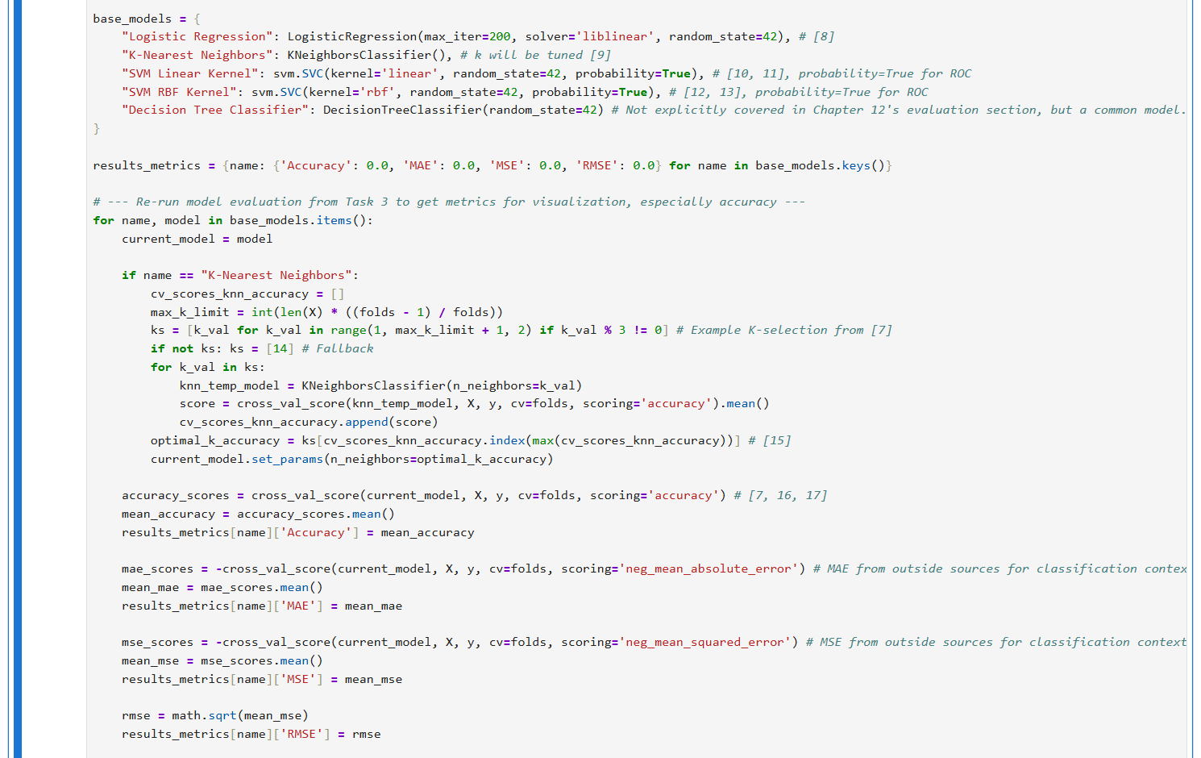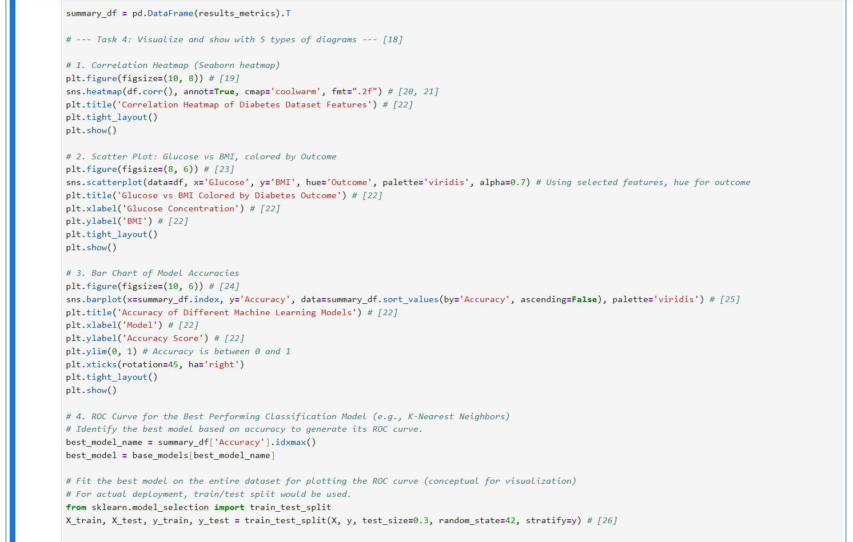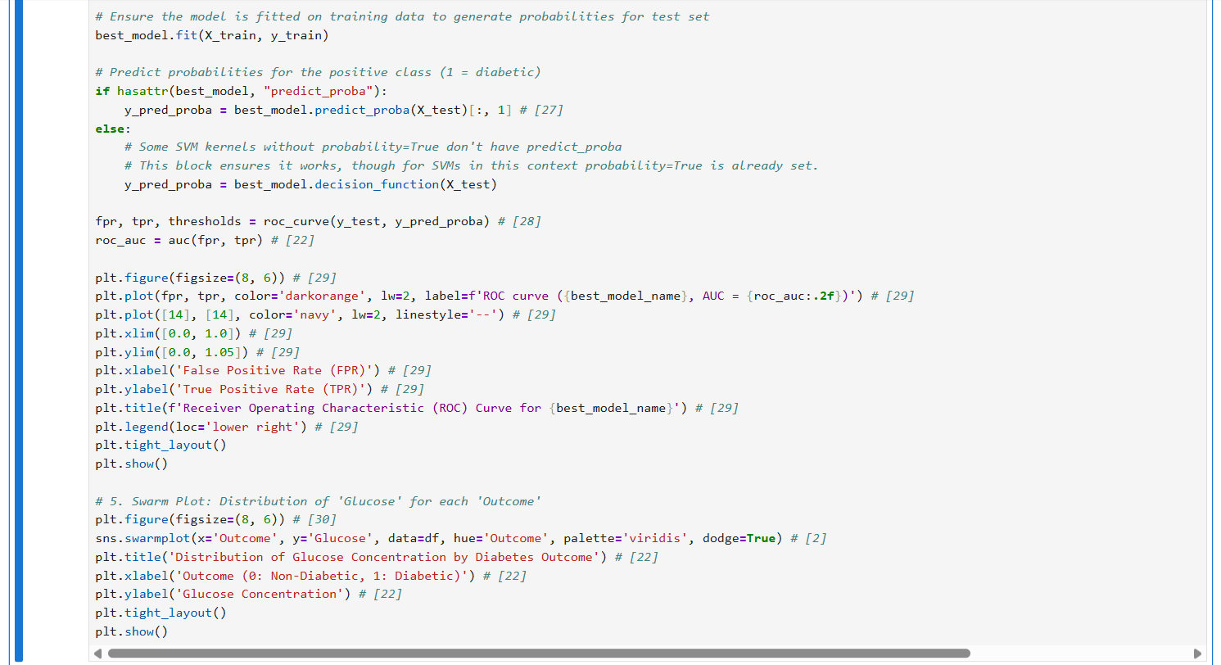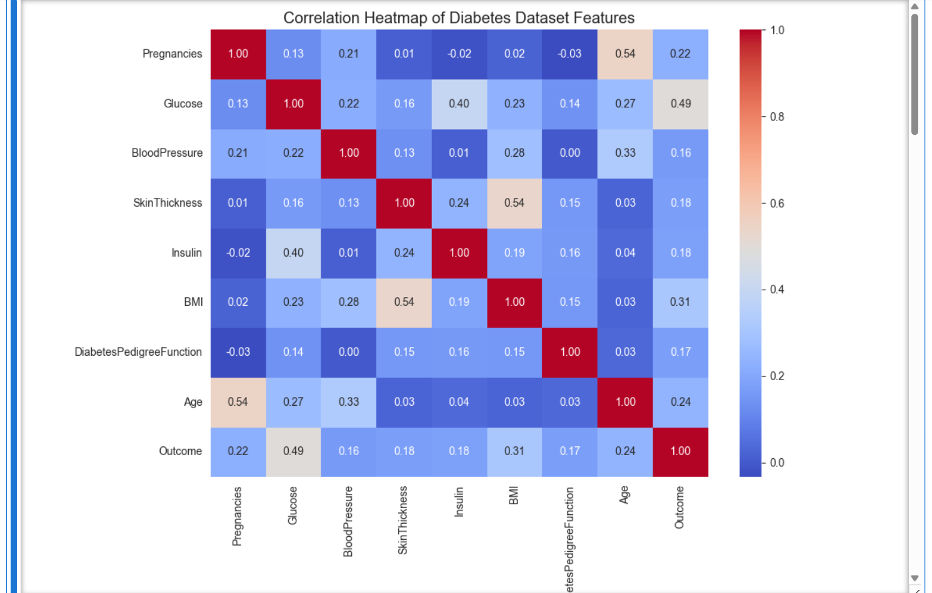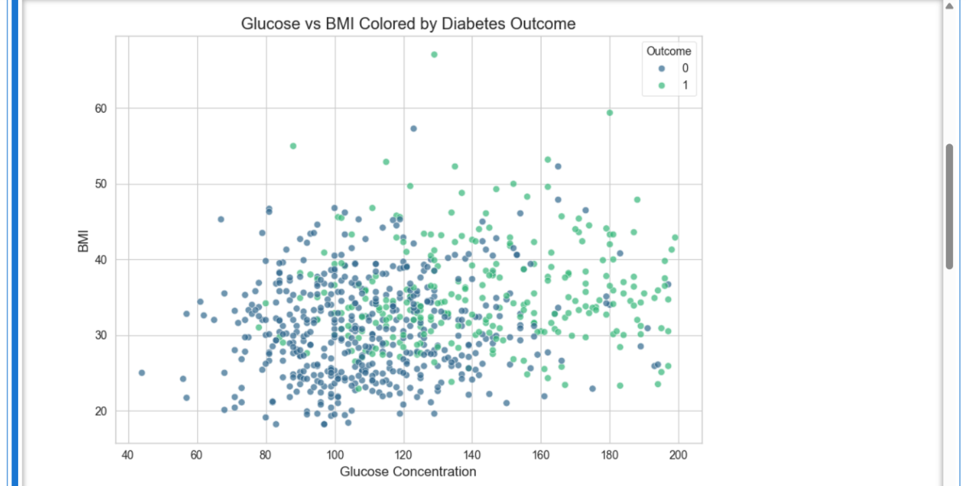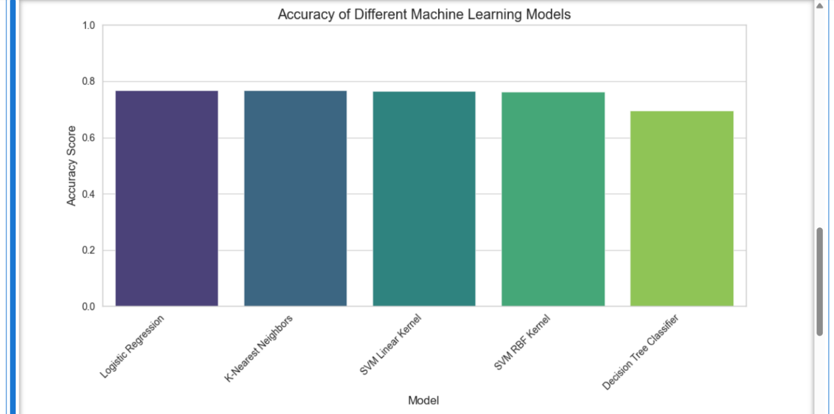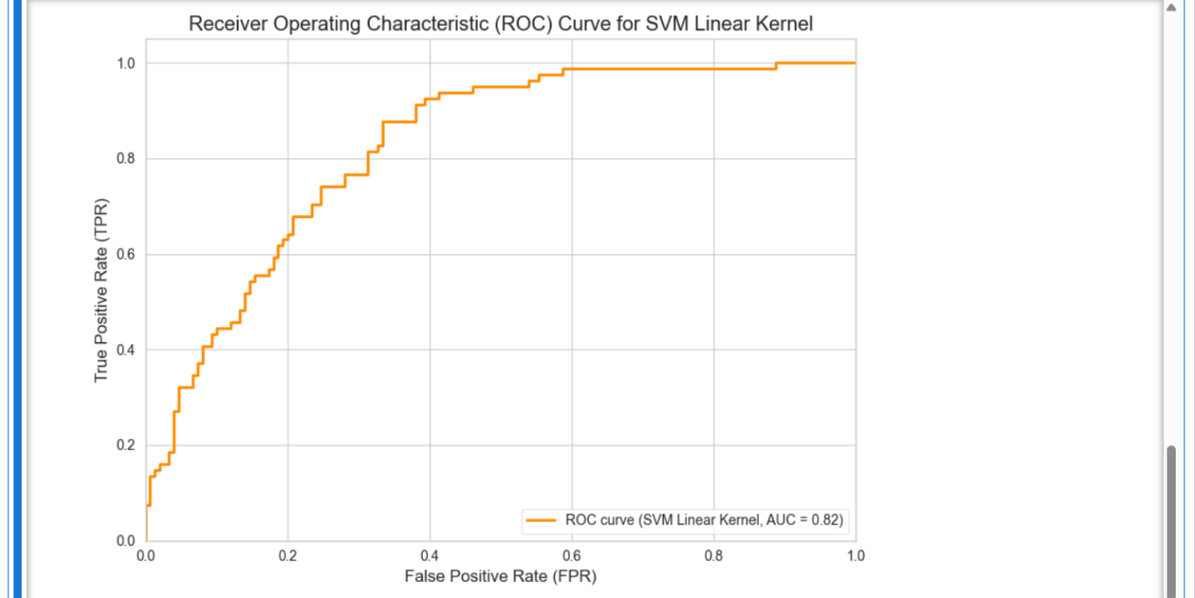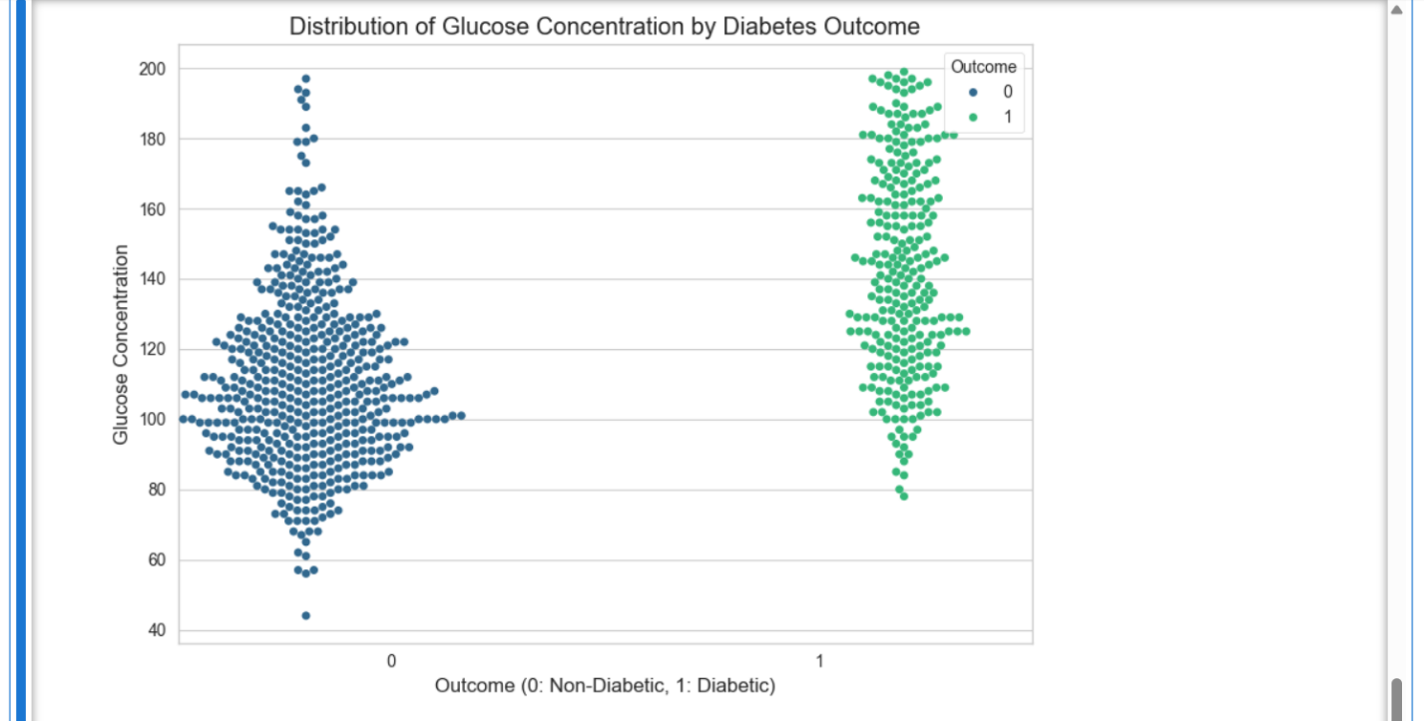

4. Select the best one for deploying on web
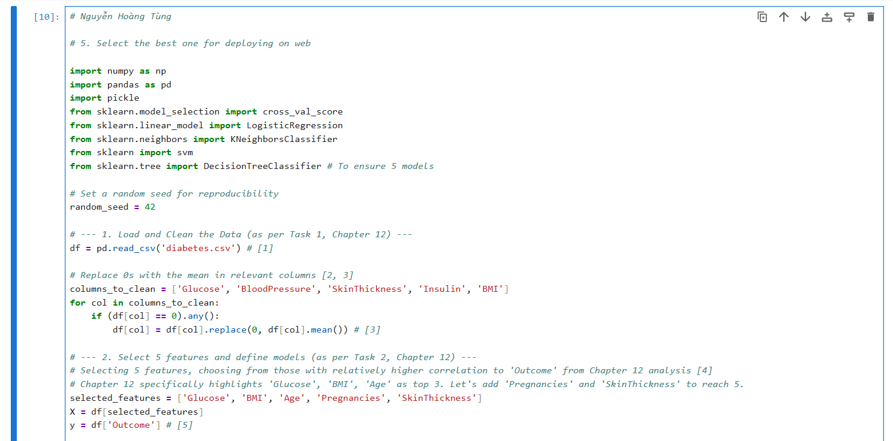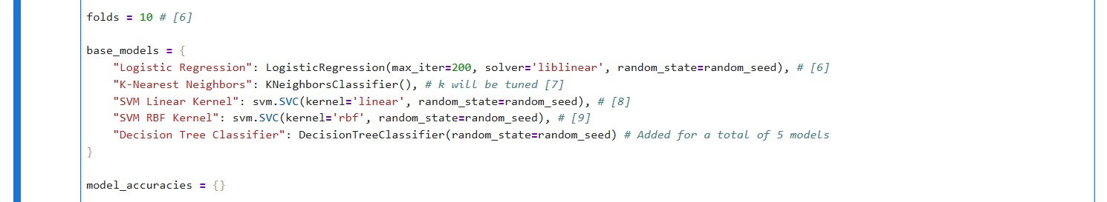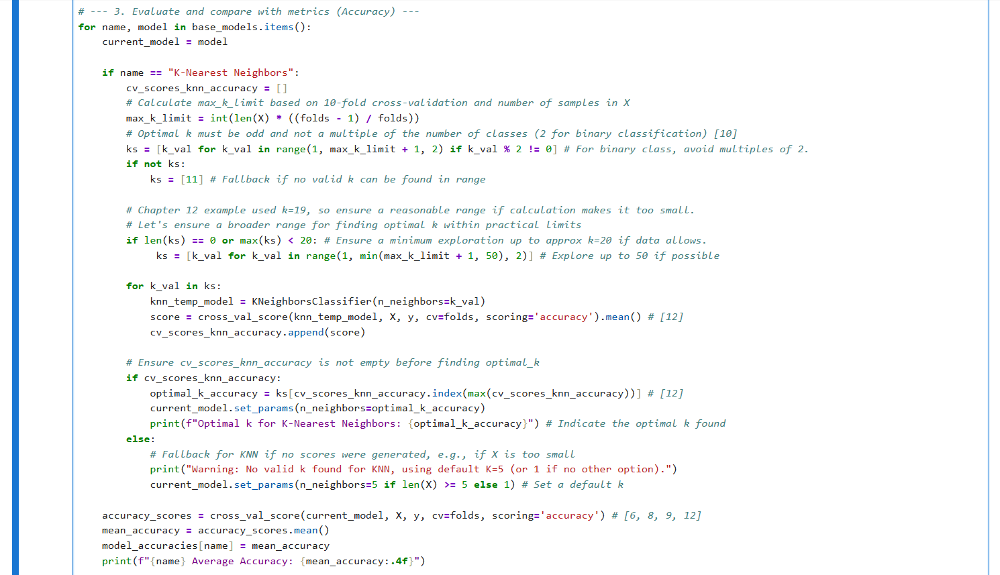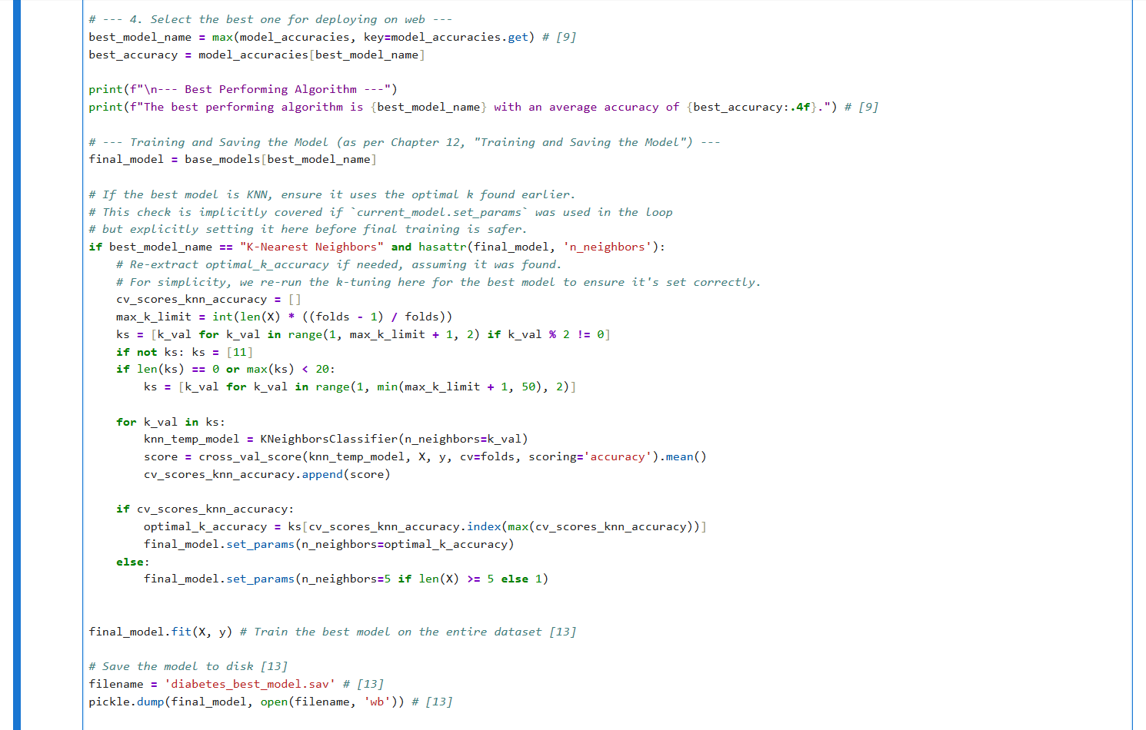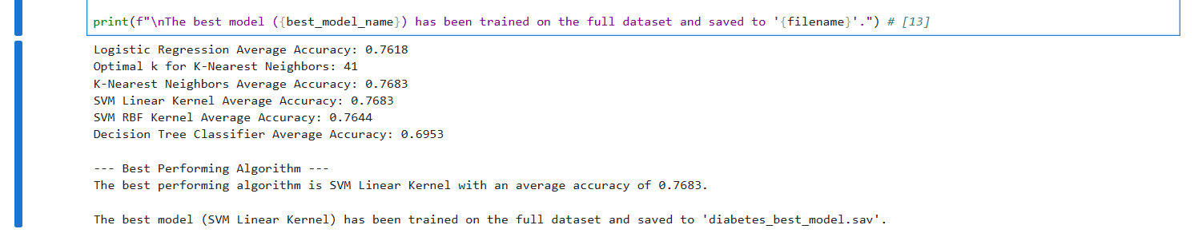

5. Deploy on web via Flask and other technology

