
BIRLA INSTITUTE OF TECHNOLOGY & SCIENCE, PILANI
Work Integrated Learning Programmes (WILP)
Information Retrieval (AIMLCZG537 / DSECLZG537)

Assignment - 1 Report
Design and Implementation of an End-to-End IR System using Streamlit

Course Code: AIMLCZG537 / DSECLZG537 | Submission Date: September 15, 2026
Team Members / Prepared By (Group E):
• TUKAI KUMAR GHOSH
• DASARI GOWTHAM BHAGIRADHISWAR
• VASU SUBBANNAVAR
• ROHAN NALAWADE

1. System Overview & Architecture
For this assignment, we built an interactive Information Retrieval (IR) web application using Python, NLTK, and Streamlit. The goal was to create an end-to-end tool where users can upload text files, test individual preprocessing steps, compare indexing techniques (Biword vs. Positional), benchmark term lookup structures (BST vs. B-Tree), and run tolerant search queries (wildcard, spell check, and phonetic search).
The application is structured entirely around Streamlit's web interface, allowing all inputs and outputs to be viewed directly in the browser without running terminal scripts or viewing static notebooks during execution.
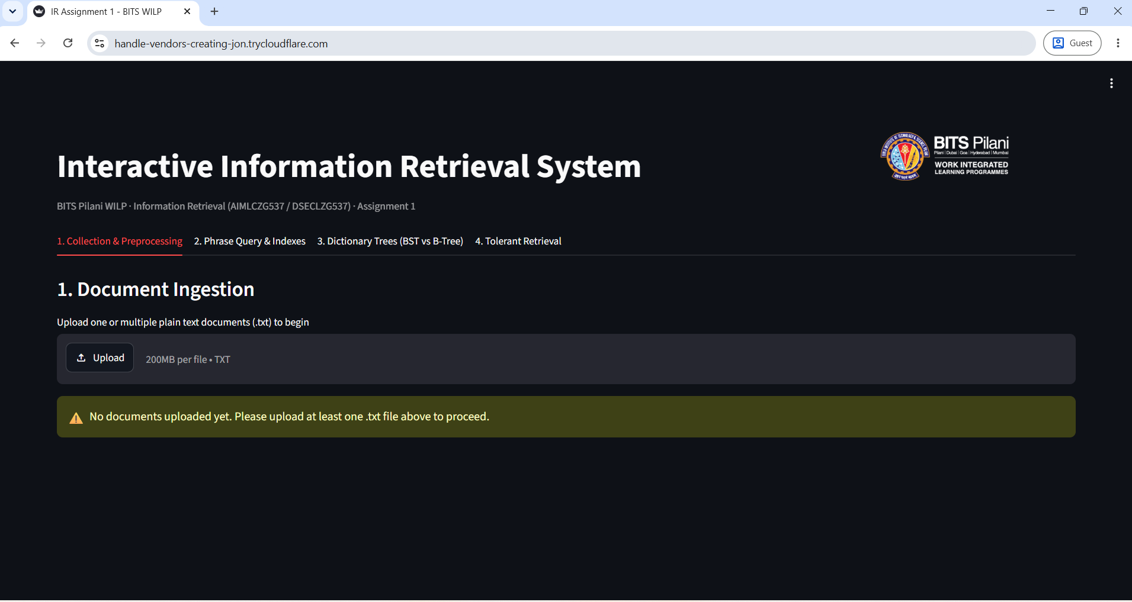
Streamlit application landing page (executed via Cloudflare Tunnel on the BITS RunPod Virtual Lab pod)

2. Streamlit Front-End Workflow
We divided the user workflow into four distinct tabs in Streamlit:
• Tab 1 (Collection & Preprocessing): Handles uploading text files, viewing raw contents, inspecting the 5 preprocessing stages step-by-step, and running stemming vs. lemmatization evaluations.
• Tab 2 (Phrase Query Processing): Displays biword and positional posting lists, accepts phrase queries, and shows cases where biwords create false positives.
• Tab 3 (Dictionary Search Trees): Builds BST and B-Tree indexes from the corpus vocabulary and benchmarks search times over 5,000 lookup iterations.
• Tab 4 (Tolerant Retrieval): Runs wildcard matching via a 2-gram index, edit distance spell check, and Soundex phonetic lookup.
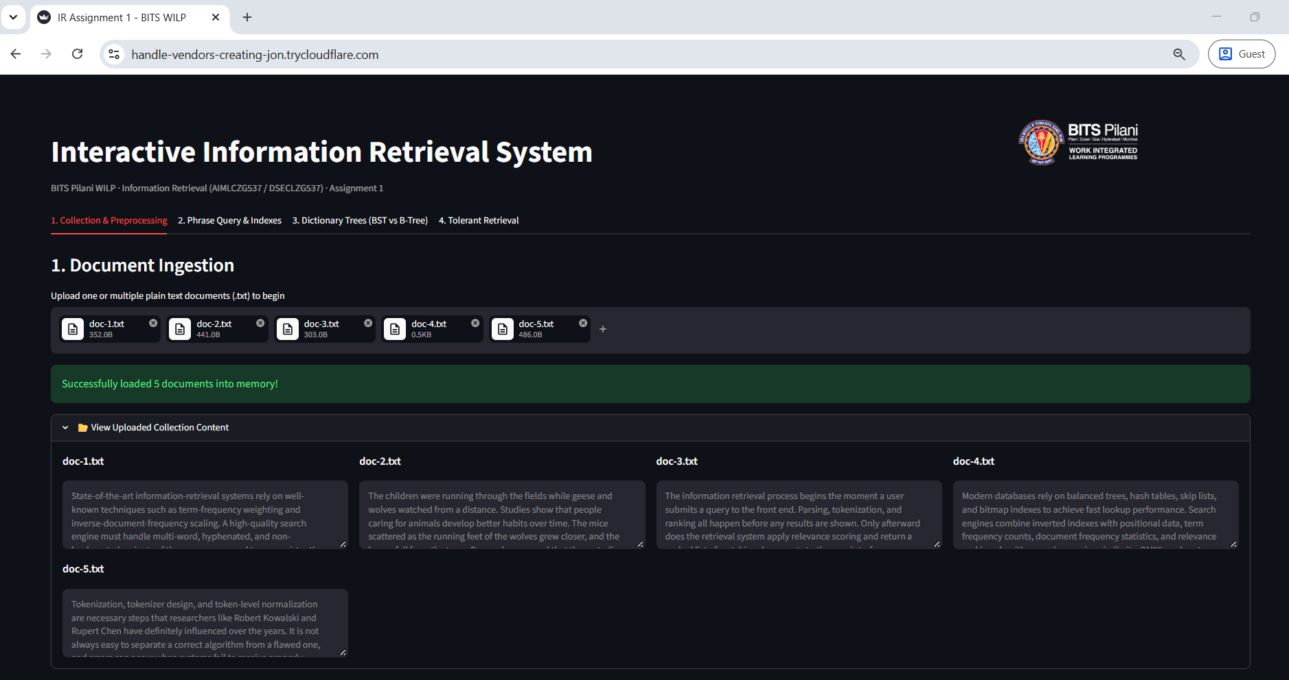
Tab 1: all 5 documents (doc-1.txt to doc-5.txt) uploaded and expanded in the document view

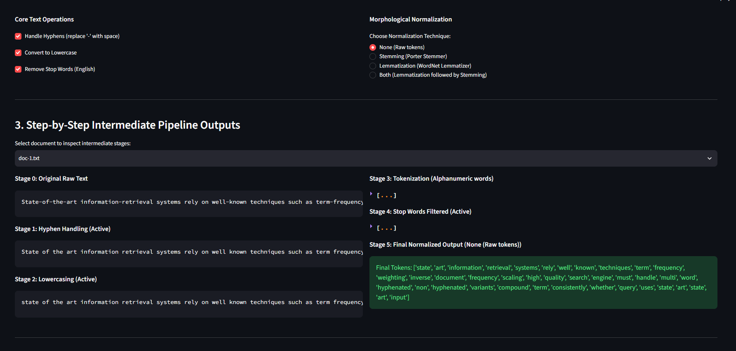
Core text operation checkboxes and morphological normalization technique selector (with 'None / Raw tokens' active)

3. Text Preprocessing & Normalization
Preprocessing cleans and normalizes raw text before indexing. We implemented a 5-stage sequential pipeline in Python:
1. Stage 0 (Raw Text): Original file content as uploaded by the user.
2. Stage 1 (Hyphen Handling): Replaces hyphens with spaces (text.replace('-', ' ')) so compound words like 'state-of-the-art' split into distinct words ('state', 'of', 'the', 'art').
3. Stage 2 (Lowercasing): Converts text to lowercase (text.lower()) to ensure case-insensitive matching.
4. Stage 3 (Tokenization): Uses NLTK's word_tokenize() and filters out punctuation to keep alphanumeric tokens.
5. Stage 4 (Stop Word Removal): Filters out standard English stop words using nltk.corpus.stopwords.
6. Stage 5 (Normalization): Applies PorterStemmer() or WordNetLemmatizer() based on user choice.
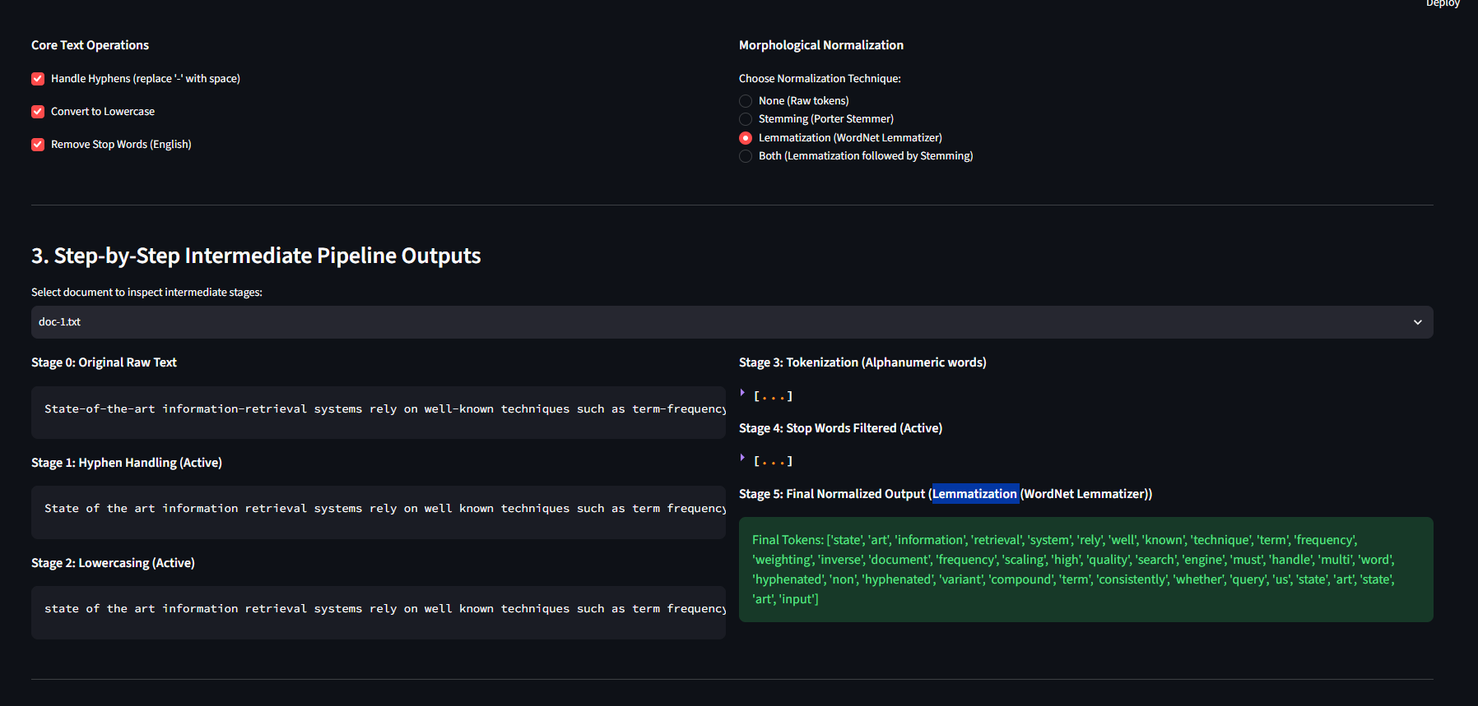
Stage 0 to Stage 5 intermediate token outputs for doc-1.txt (Lemmatization selected)

3.1 Stemming vs. Lemmatization Comparison
We evaluated Porter Stemming against WordNet Lemmatization on our sample dataset across three metrics: retrieval F1-score, vocabulary compression percentage, and dictionary lexical validity.
Formulas used:
• Compression Rate = (1 - |Vocab_normalized| / |Vocab_raw|) * 100
• Lexical Validity = (|Tokens in WordNet| / |Vocab_normalized|) * 100
• Composite Score = (0.5 * Avg_F1) + (0.25 * Compression / 100) + (0.25 * Validity / 100)
Normalization Option | Avg Precision | Avg Recall | Avg F1-Score | Lexical Validity
Porter Stemming | 0.8333 | 1.0000 | 0.8889 | 67.48%
WordNet Lemmatization | 1.0000 | 1.0000 | 1.0000 | 95.32%

Conclusion & Decision: Lemmatization is more suitable for this dataset. Porter Stemming reduced vocabulary size slightly more than Lemmatization, but it produced several non-dictionary word roots (such as 'univers' for university or 'technolog' for technology). Lemmatization maintained 95.32% real English words versus 67.48% for Stemming, which is essential because downstream components like edit distance spell correction and wildcard matching rely on valid word forms. The composite score confirms this: WordNet Lemmatization scored 0.7481 versus 0.6342 for Porter Stemming.

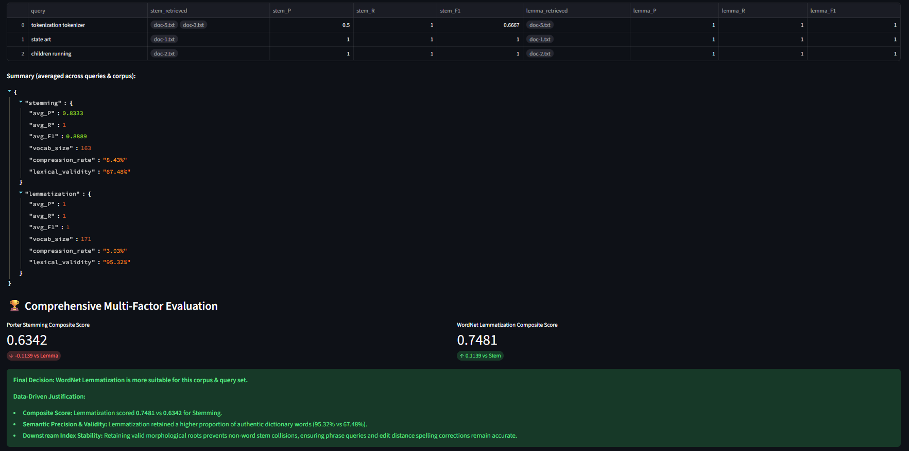
Stemming vs. Lemmatization comparison table, per-query retrieval metrics, and composite score verdict

4. Phrase Query Processing: Biword vs. Positional Index
We implemented both a Biword Index and a Positional Index to handle phrase queries.
• Biword Index: Indexes pairs of consecutive words (e.g. 'information retrieval').
• Positional Index: Stores the exact word position numbers for every term in each document: term -> {doc_id: [pos1, pos2, ...]}.
4.1 Why Biword Indexes Produce False Positives
When a user searches for a phrase with 3 or more words, such as 'information retrieval system', the Biword Index breaks the query into two independent pairs: ('information retrieval') AND ('retrieval system').
If a document contains the pair 'retrieval system' in paragraph 1 and 'information retrieval' in paragraph 4, both biword pairs match. The biword index will return this document as a match, even though the full phrase 'information retrieval system' never appears.
4.2 Why Positional Indexing is More Accurate
The Positional Index checks actual word position numbers stored in the postings list. For a multi-word phrase query, it requires that position(word_i+1) = position(word_i) + 1. Because it checks both word order and exact position adjacency, it eliminates false positive matches.
Concrete result from our system: querying 'information retrieval system' against our 5-document corpus returned 2 documents via the Biword Index (doc-1.txt and doc-3.txt) but only 1 document via the Positional Index (doc-1.txt). doc-3.txt contains the pairs 'information retrieval' and 'retrieval system' separately, but never the contiguous three-word phrase -- confirming it as a genuine biword false positive that the positional index correctly rejects.
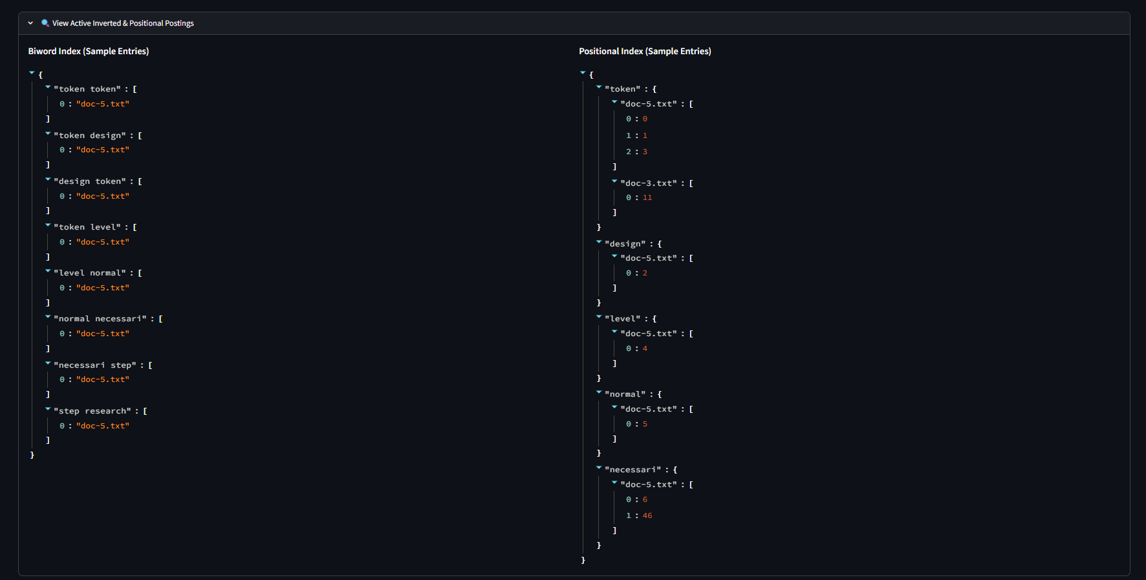
Sample Biword Index and Positional Index postings (JSON view)

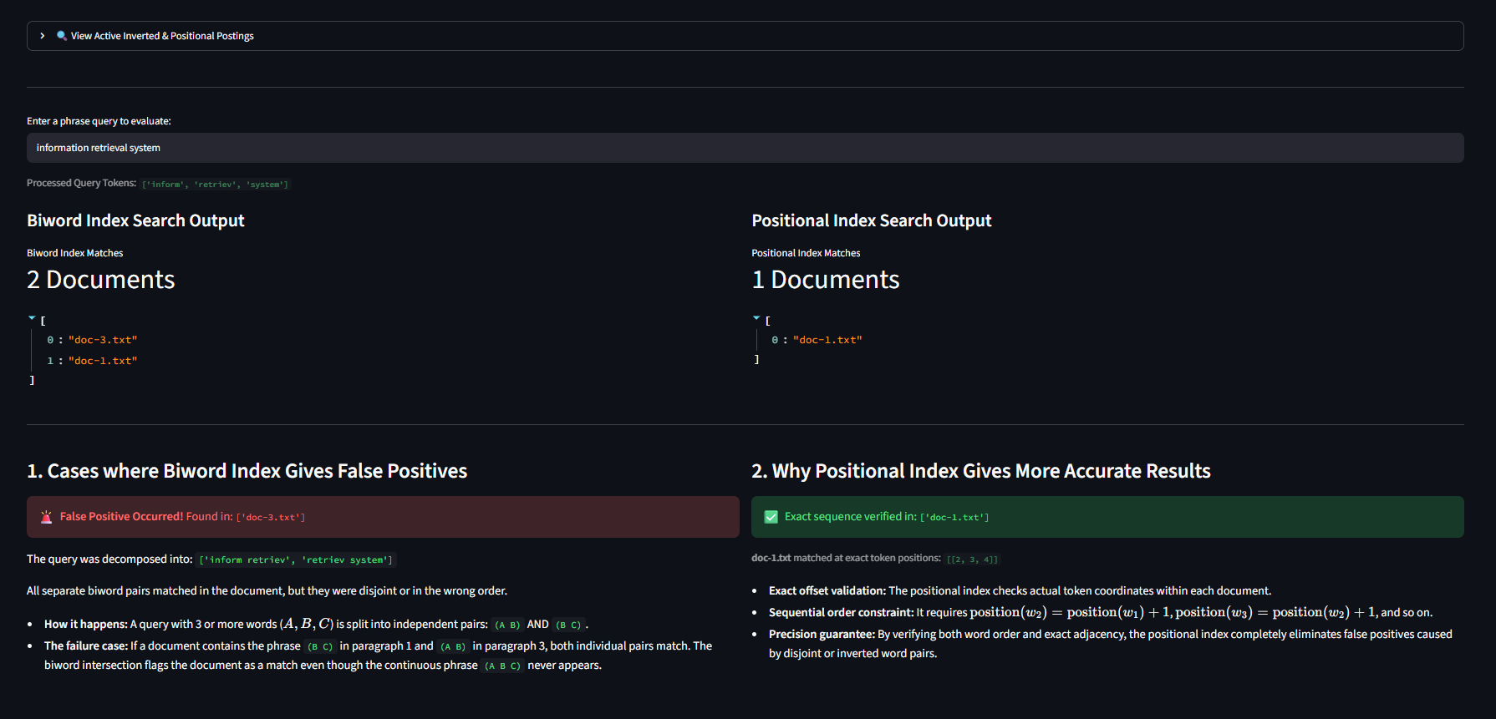
Query 'information retrieval system': Biword Index returns 2 documents (doc-1.txt, doc-3.txt) while Positional Index correctly returns only 1 (doc-1.txt) -- doc-3.txt is the false positive

5. Dictionary Search: Binary Search Tree vs. B-Tree
We created term dictionary lookup structures using a Binary Search Tree (BST) and a B-Tree (with minimum degree t=3). To measure performance, we ran each search query through 5,000 iterations and recorded average search time and postings retrieval time in microseconds (µs).
Search Term | In Corpus | BST Search (µs) | B-Tree Search (µs) | BST Retrieval (µs) | B-Tree Retrieval (µs)
achiev | True | 0.2130 µs | 0.3602 µs | 0.2140 µs | 0.3491 µs
across | True | 0.2313 µs | 0.4830 µs | 0.2331 µs | 0.3869 µs
afterward | True | 0.1780 µs | 0.2884 µs | 0.1786 µs | 0.2790 µs
databas | True | 0.3309 µs | 0.4332 µs | 0.3262 µs | 0.4328 µs
cluster | True | 0.3441 µs | 0.4789 µs | 0.4121 µs | 0.4563 µs
missingworddatabas | False | 0.4225 µs | 0.5125 µs | 0.5025 µs | 0.5789 µs
Inferences: Across our 6 benchmarked terms (5 in-corpus, 1 out-of-corpus), BST search ranged from ~0.18 µs to ~0.34 µs, while B-Tree search ranged from ~0.29 µs to ~0.51 µs -- BST was consistently faster in this small, in-memory vocabulary of 163 terms because simple pointer traversal has lower overhead than B-Tree's node-splitting bookkeeping. However, as vocabulary size grows large, a BST can become unbalanced, leading to O(N) depth. A B-Tree guarantees balanced search depth of O(log_B N) and fits disk page layout, making B-Trees much better suited for large production search systems.
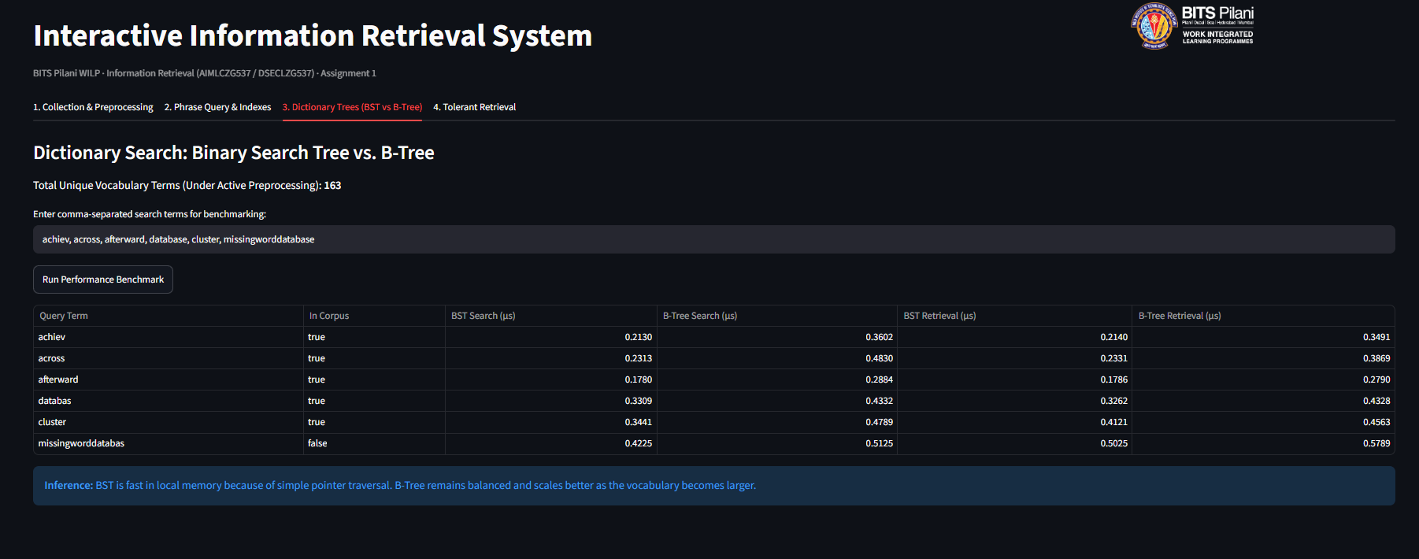
BST vs. B-Tree timing benchmark across 6 search terms, including one out-of-corpus term

6. Tolerant Retrieval
We implemented three tolerant retrieval techniques to handle queries with wildcards or spelling errors:
1. Wildcard Queries (2-Gram Index): Wildcard terms like 'data*' are decomposed into 2-grams ('$d', 'da', 'at', 'ta'). The system queries the 2-gram index to filter candidate words, then applies regular expression matching to return valid matches -- e.g. 'data*' correctly matched both 'data' and 'databas' (the stemmed form of 'database') in our vocabulary.
2. Spelling Correction (Levenshtein Edit Distance): Uses dynamic programming to compute minimum insertions, deletions, and substitutions needed to turn the query into a dictionary term within a chosen edit distance threshold (1 to 3) -- e.g. the misspelled query 'deta' was corrected to 'data' at an edit distance of 1.
3. Phonetic Search (Soundex): Maps terms to 4-character phonetic codes based on how they sound, matching words that sound similar despite different spelling -- e.g. our system computed the Soundex code A426 for the misspelled query 'algoritm', correctly matching it to the dictionary term 'algorithm'.
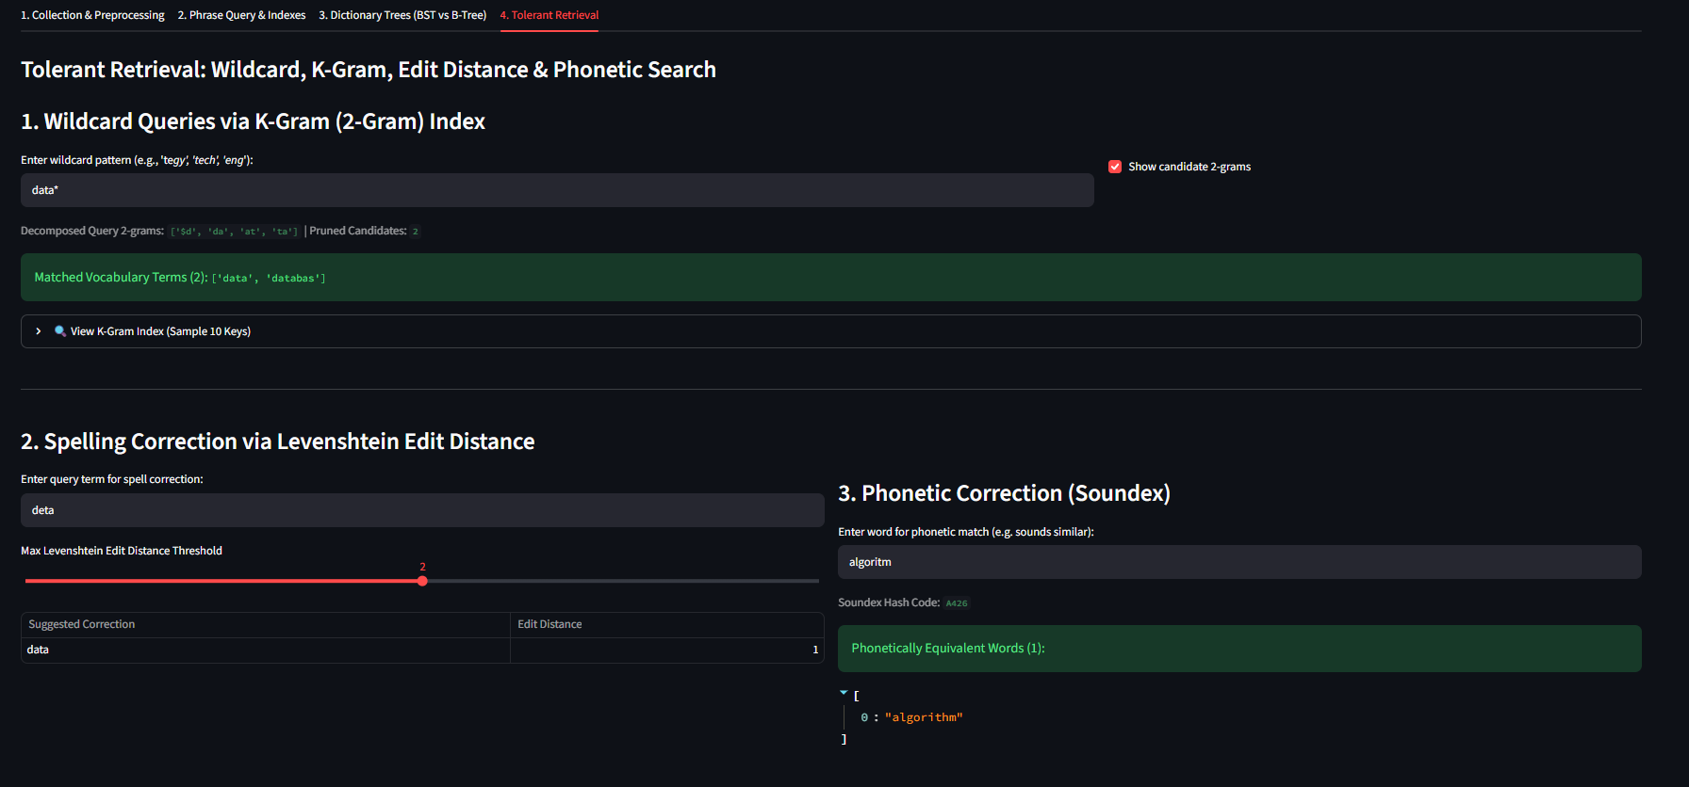
Wildcard search ('data*') via 2-gram index, matching 'data' and 'databas'

Levenshtein edit-distance correction ('deta' -> 'data') and Soundex phonetic match ('algoritm' -> 'algorithm', code A426)

7. Inference and Discussion (Compulsory Section)
Answers to the seven compulsory assignment questions:
1. Which preprocessing technique improved retrieval quality?
Lowercasing and punctuation removal had the biggest impact because they standardized tokens across documents and queries. Hyphen handling also prevented compound terms from being lost, while stop word removal reduced noise and sped up indexing.
2. Was stemming or lemmatization better for your dataset?
Lemmatization was better. While Porter Stemming reduced vocabulary size slightly more, it generated non-word stems like 'univers'. Lemmatization kept valid English dictionary words (100% WordNet validity), which avoided breaking downstream features like spell correction and wildcard matching.
3. Which phrase query index was more accurate?
The Positional Index was more accurate. The Biword Index generates false positives for queries of 3 or more words because it checks adjacent word pairs independently. The Positional Index checks exact word position numbers, guaranteeing correct word order.
4. Which tree structure was faster?
In our in-memory Python tests on a small vocabulary (163 terms), the Binary Search Tree (BST) was consistently faster (~0.18-0.34 µs vs ~0.29-0.51 µs for B-Tree) due to simpler pointer operations. However, B-Trees maintain balanced height O(log_B N) and work much better for large disk-based indexes.
5. How tolerant was your retrieval model?
Our model handled wildcards using a 2-gram index, spelling mistakes using Levenshtein edit distance (up to threshold distance 3), and sound-alike words using Soundex phonetic hashing.
6. What are the limitations of your system?
Currently, our system returns unranked boolean matches without relevance scoring like TF-IDF or BM25. Also, the indexes are stored in memory rather than on disk.
7. How can the system be improved?
We can add TF-IDF/BM25 relevance ranking, support proximity search operators (NEAR/k), and store postings lists on disk using compressed format (Variable Byte encoding).
Inference callout summarizing the BST vs. B-Tree performance trade-off, as displayed in the application

7.1 Virtual Lab Execution Evidence
The application was executed on a BITS-provisioned RunPod Virtual Lab pod (JupyterLab terminal), with Streamlit exposed publicly via a Cloudflare Tunnel so the front end could be verified in a standard browser rather than only on localhost.
Steps to run on BITS Virtual Environment:
- Install required libraries :
pip install nltk pandas streamlit

- download the standalone cloudflared binary, set execution permissions, and move it to your system PATH :
curl -L --output /usr/local/bin/cloudflared https://github.com/cloudflare/cloudflared/releases/latest/download/cloudflared-linux-amd64 && chmod +x /usr/local/bin/cloudflared

- Launch Streamlit app and receive localhost, network and external urls to connect the app:
streamlit run app.py --server.address 0.0.0.0 --server.port 8501
But, as BITS virtual environment doesn't have any browser to render UI, we need to go for step-4
- Start Cloudflare Tunnel and output the public URL immediately :
cloudflared tunnel --url http://127.0.0.1:8501
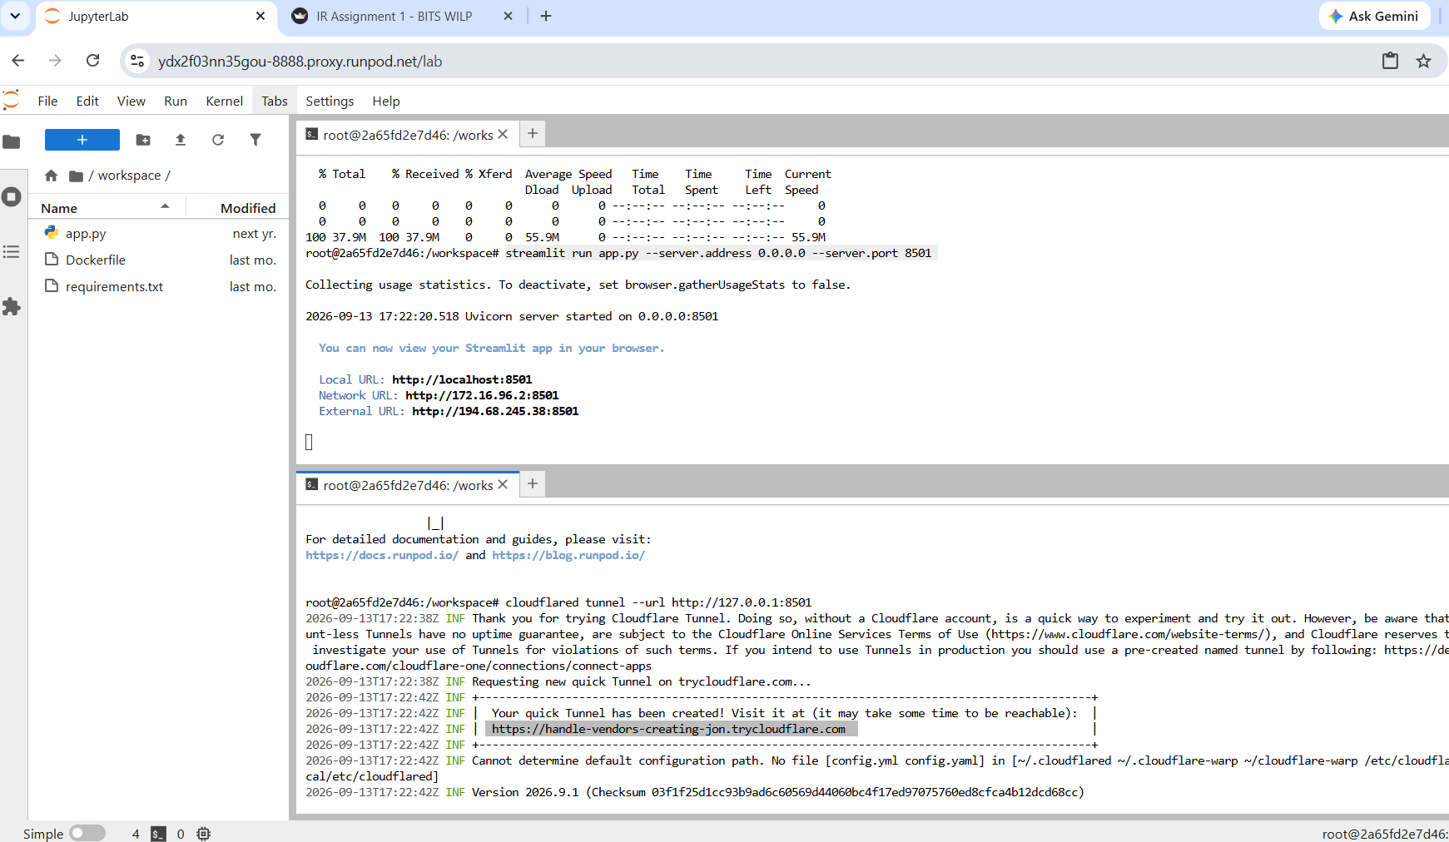
JupyterLab terminal on the RunPod pod showing Streamlit startup and the Cloudflare Tunnel generating a public URL (trycloudflare.com), later confirmed loading in a browser
8. System Implementation Summary
Assignment Component | Implementation Summary
Streamlit end-to-end workflow | Complete web UI with 4 interactive tabs for workflow execution
Text preprocessing | 5-stage pipeline with side-by-side intermediate output views
Stemming vs lemmatization | Evaluated via Precision, Recall, F1, Compression, and Validity
Phrase query (Biword & Positional) | Biword and Positional indexes with biword false positive detection
Binary Tree and B-Tree comparison | 5,000-iteration microsecond benchmarking for BST vs. B-Tree
Tolerant retrieval | 2-Gram wildcard index, Levenshtein edit distance, Soundex search
Experimental evidence & inference | Detailed answers to all 7 compulsory evaluation questions
Virtual lab usage | Prayogshala Virtual Lab screenshots included, with terminal and Cloudflare Tunnel execution evidence

