Name: Tukaram Chate
PRN: 2608470120210
Name: Raje Pratham Amar
PRN: 2608470120148

Question 2
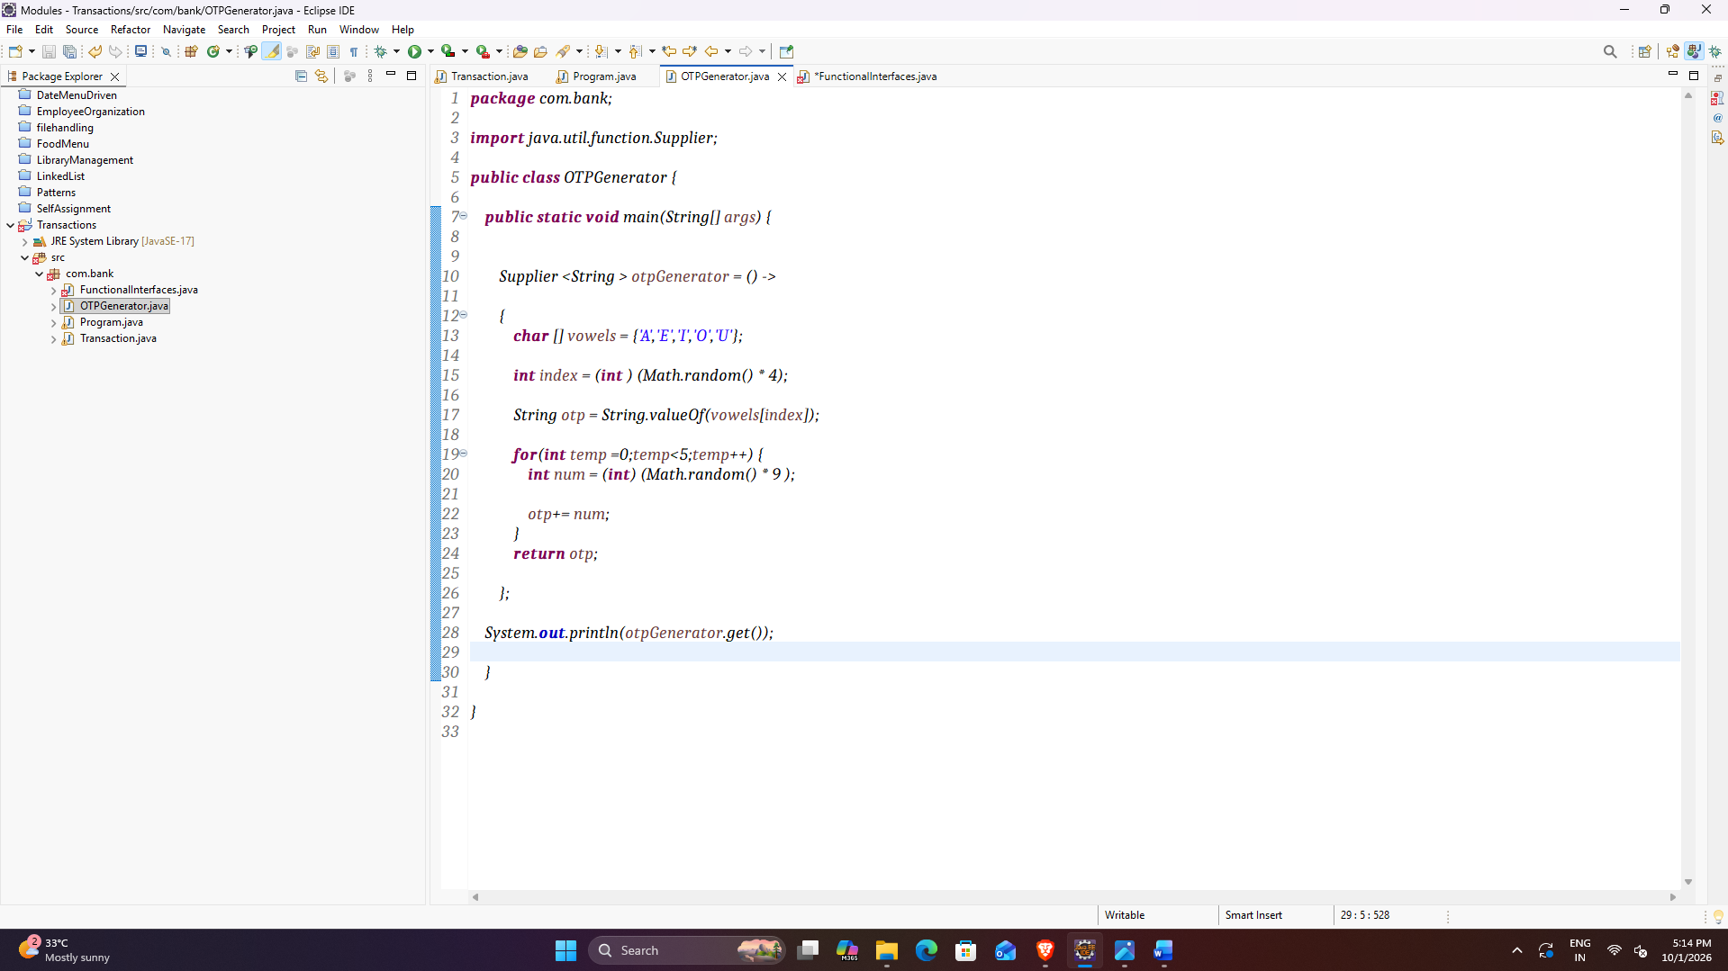
Question 3
1

