**PROJECT-NAME: Remo’s restaurent**

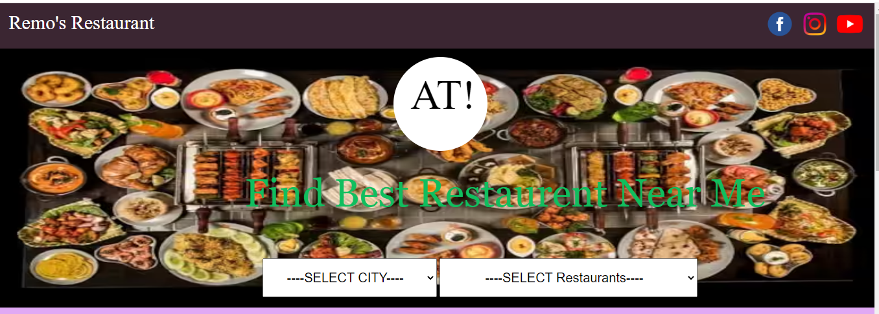

**\*OVERVIEW:** It is a Restaurent website for Dine and Wine,

from Tea Coffee,Breakfast,Lunch,Snaks,Dinner and Baar.

**HOME PAGE:**

# LOGO

# ICONS - Logo

# SEARCH BAR for Restaurents city wise

# DEALS - (Meals)

# FOOTER – ( CONTACT US , HELPLINES , BRIEF DESCRIPTION

ABOUT THE RESTAURENT , SOCIAL-MEDIA

ICONS)

1. **REGISTRATION FORM:**

# E-MAIL ADDRESS

# Phone Number

**3. MAIN PAGE:**

# FILTERS - ( Types of varieties food: )

# IMAGES OF THE CHOSEN FOOD WITH DETAILS LIKE -

( Food type and what ingridients and etc)

# ON CLICKING THE IMAGE - (MULTIPLE IMAGES OF THE

FOOD WILL APPEAR FROM DIFFERENT ANIMATIONS

# PRODUCT DESCRIPTION - FOOD NAME ,

PRICE , DISCOUNT% (IF ANY) , SIZE CHART ,

DELIVERY OPTIONS , FOOD DETAILS,

SPECIFICATIONS , RATINGS , CUSTOMER REVIEWS

WITH IMAGES (IF ANY )

1. **PAYMENT PAGE:**

# ADDRESS SELECTION

# PAYMENT METHOD - (PHONEPE , GOOGLE PAY , BHIM UPI ,

CREDIT/DEBIT CARD , NET – BANKING.