# 🌌 Tulasi Portfolio Website

A modern futuristic personal portfolio website built using HTML, CSS, JavaScript, AOS Animations, and Boxicons with a premium neon purple UI theme.

# 🚀 Live Demo

Add your deployed GitHub Pages link here:

```bash
https://tulasi-lakkimsetti.github.io/portfolio
✨ Features
- 🌌 Galaxy Video Background
- 💜 Neon Purple Theme
- ⚡ Smooth AOS Animations
- 📱 Fully Responsive Design
- 👨‍💻 About Section
- 🛠 Skills Section
- 🚀 Projects Showcase
- 📬 Functional Contact Form
- 📄 Download CV Button
- 🔗 Social Media Integration
- 🎨 Modern Glassmorphism UI

🛠 Technologies Used
- HTML5
- CSS3
- JavaScript
- AOS Animation Library
- Boxicons
- Web3Forms API
📸 Screenshots
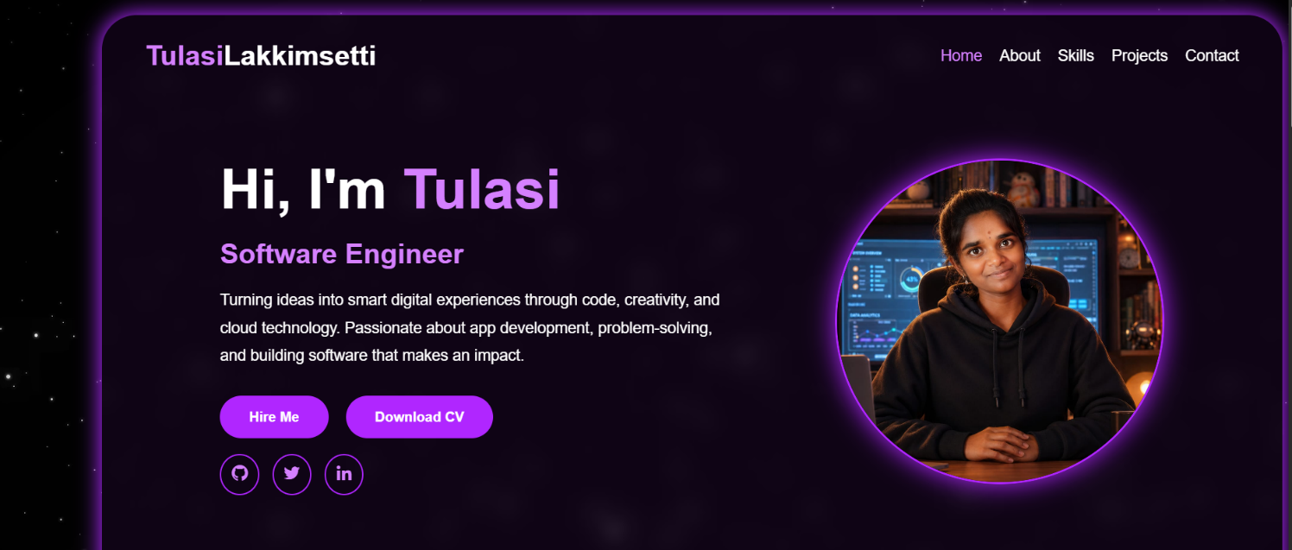
👨‍💻 Author
Tulasi Lakkimsetti
- GitHub:
https://github.com/tulasi-lakkimsetti

