**EduTutor AI: Personalized Learning with Generative AI and LMS Integration**

**Team ID:**  LTVIP2025TMID33694

**Submitted by:**Thota Lakshmana Naga Durga Hanuman

Pavan N

Prem Kumar Manepalli

Pulagam Tulasi Rani

**1. Introduction**

EduTutor AI is an intelligent educational assistant designed to enhance student learning using AI-generated content, interactive quizzes, personalized feedback, and curated video resources. This system simulates a Learning Management System (LMS) integrated with Generative AI capabilities.

# 2. Objective

- Provide personalized learning support through topic-based quizzes  
- Enable students to track their progress  
- Allow educators to monitor student performance  
- Deliver learning content through YouTube course recommendations  
- Use AI-powered models to dynamically generate quiz questions

# 3. Key Features

**Student Features:**- Registration and login with session tracking  
- Quiz generation based on entered topic  
- Instant feedback and score display  
- Quiz history tracking  
- Curated YouTube video courses for self-study  
  
**Educator Features:**  
- Educator login  
- Monitor all student quiz activity  
- View per-topic performance  
  
**AI Capabilities:**- Generates multiple-choice quizzes using large language models  
- Explains concepts and analyzes text via Gradio UI  
- Extracts questions from uploaded PDFs

# 4. Technology Stack

Frontend : Streamlit  
Backend : FastAPI  
AI Models : IBM Granite 3.3 2B Instruct  
ML Library : Hugging Face Transformers, PyTorch  
Extras : Gradio, PDFPlumber  
Deployment : Local using virtual environment

# 5. System Architecture

User → Streamlit Interface → FastAPI Backend → AI Model (Granite) → Output Response

# 6. How It Works

1. User logs in as student or educator  
2. Students enter a topic and number of questions  
3. A POST request is made to the backend /generate-quiz/ endpoint  
4. The IBM Granite AI model processes the prompt and returns quiz questions  
5. Students select answers and submit to see score  
6. Scores are saved and shown in Quiz History  
7. Educators can monitor student quiz performance

# 7. Course Library

- Introduction to AI: https://youtu.be/2ePf9rue1Ao  
- Python Programming: https://youtu.be/_uQrJ0TkZlc  
- Data Structures: https://youtu.be/bum_19loj9A  
- Machine Learning: https://youtu.be/GwIo3gDZCVQ  
- Deep Learning: https://youtu.be/aircAruvnKk  
- Natural Language Processing: https://youtu.be/8rXD5-xhemo

# 8. Screenshots

Get Started Screen



Login/Register

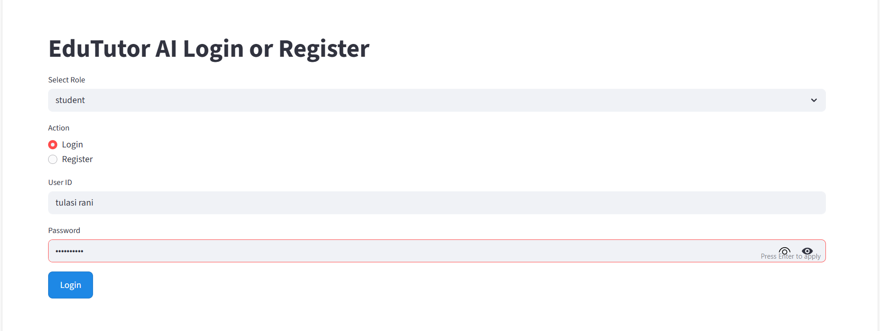

Dashboard

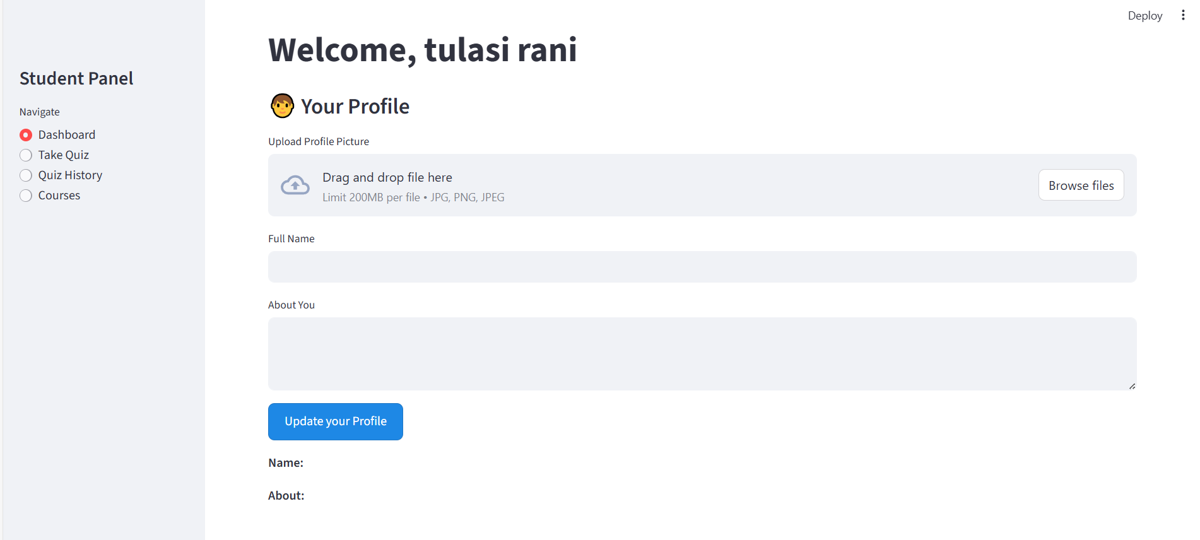

Take Quiz

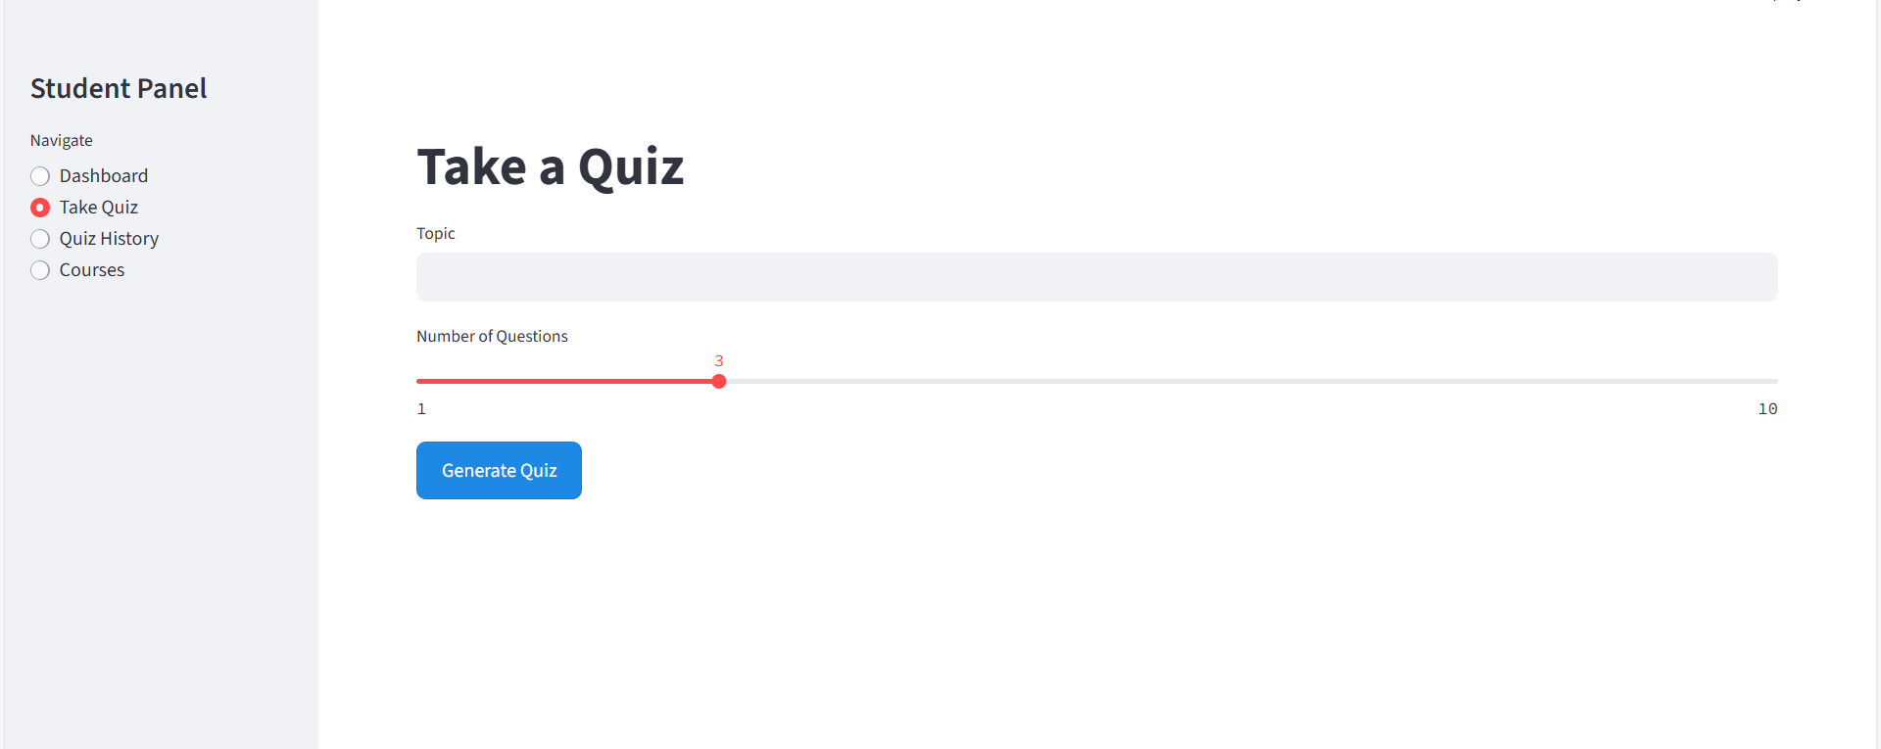

Quiz History

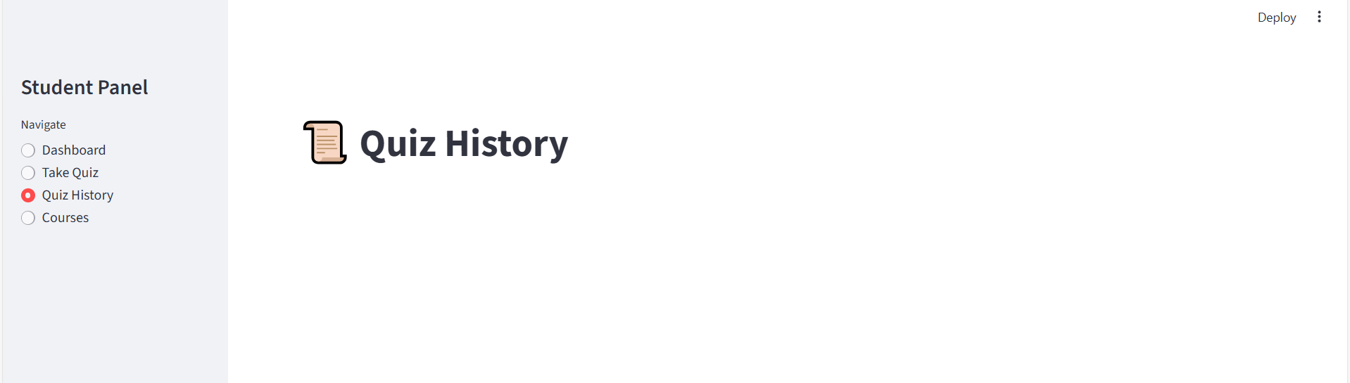

Courses

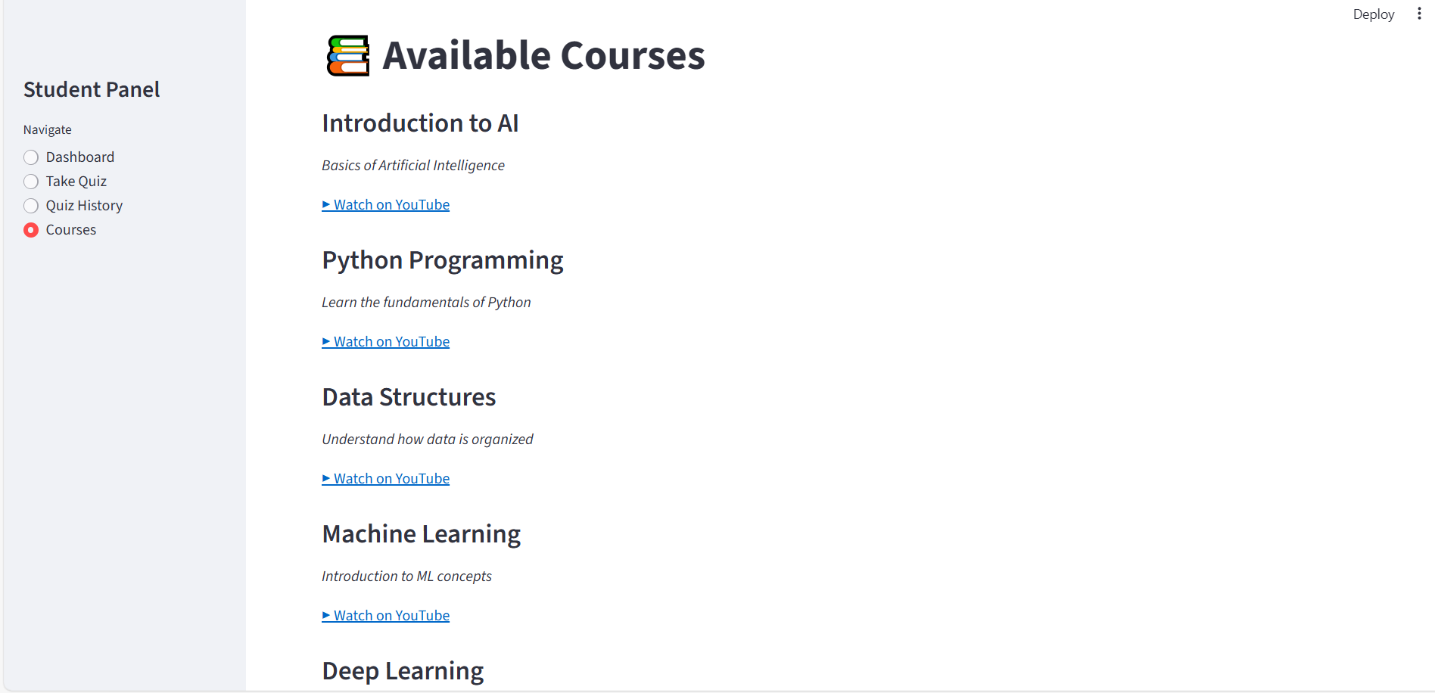

Profile Upload

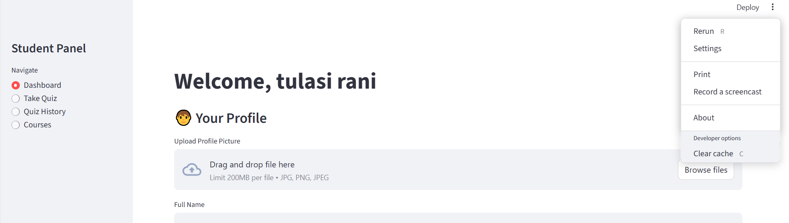

9. Setup & Installation

**1. Create and activate virtual environment:** python -m venv venv  
 .\venv\Scripts\activate  
  
**2. Install dependencies:**  
 pip install -r requirements.txt  
  
**3. Run the backend:** uvicorn backend:app --reload  
  
**4. In another terminal, run frontend:** streamlit run app1.py

# 10. Conclusion

EduTutor AI is an innovative and practical educational tool that leverages the power of Generative AI to personalize learning. It simplifies content delivery, encourages topic mastery, and helps both students and educators monitor academic growth in a smart and interactive way.